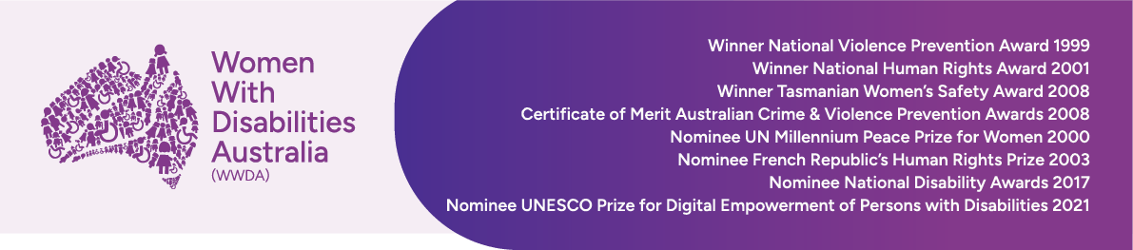

Reasonable or Necessary?
Debating changes to the NDIS

Sophie Cusworth, Chief Executive Officer
Women With Disabilities Australia (WWDA)

National Press Club, Canberra
10 August 2026

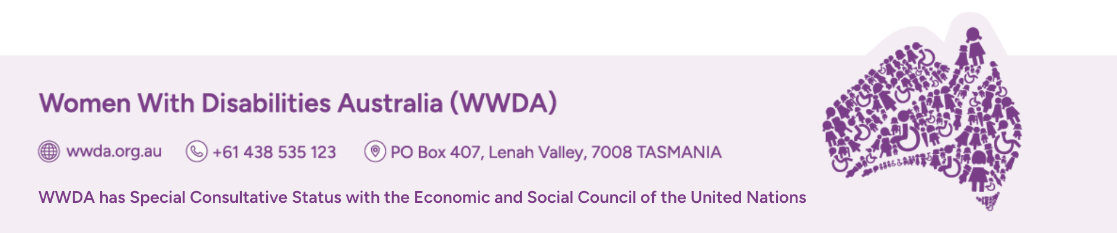
This Government has said gender equality is central to its agenda.
If we truly care about gender equality in this country, then we must care about the NDIS.
Gender equality is about choices, and right now, the Government is making a choice that will push women into crisis.
The changes proposed by this Bill will have profound impacts for women - across areas like paid and unpaid care, violence, economic security, and health.
If these issues sound familiar, it is because they are the priority areas under our national plan for gender equality.
And this bill is set to undermine progress on each one. We know reform is necessary.
But this bill is one of the most dangerous options on the table. It creates foreseeable risks for women, and gender-diverse people with disability and those who support us.
Because this Bill does not create sustainability. It creates crisis.
So, let’s consider the reality for women with disability now; how this Bill will deepen inequality; and what is actually needed for positive reform.
For women on the Scheme, the NDIS makes safety, independence and an ordinary life possible.
It also supports carers - who are overwhelmingly women - to rest, stay well, and take part in the economy.
When the NDIS works as it should, it gives people with disability and those who support us, choice, control, dignity and authorship over our own lives.
But we also need to be honest about the issues.
The NDIS is leaving many women behind.
Women make up around half of disabled people in Australia. But we are only 38 per cent of NDIS participants.
We are underdiagnosed with disability the Scheme recognises, more likely to live with conditions it does not properly see, and when we finally get through the door, we receive less funding on average than men. So, when the Government proposes major changes to access, eligibility, and supports, it is doing so within a system that already disadvantages women.
This Bill would allow the Government to use an assessment tool to decide who can access the Scheme.
But when assessments rely on tick-box measures, women are more likely to be missed - not because our needs are lower, but because the system isn’t built to see them.
It would also require people to show they have tried “all appropriate treatment” before they can receive NDIS support.
But we know women already face barriers to treatment in the healthcare system.
In a recent survey of our community, 75 per cent of respondents said they had experienced health insecurity in the past six months.
They had delayed or missed medical appointments, or gone without medication, because they simply could not afford it.
When access to support depends on proving you’ve tried all “appropriate” treatments first, it creates a “pay to prove” model - and people who can’t access that evidence lose out.
This Bill would allow the Agency to suspend a person’s supports if they aren’t contactable, without properly considering risk or safety.
But a woman experiencing violence may be unreachable because she has changed phones, fled her home or entered safe accommodation as part of a safety plan. Cutting off her supports could remove what she needs to stay safe
Let’s consider the power to cut support for social and community participation, by 50%.
The Government says this won’t affect participants’ health and safety.
But for women with disability, that simply is not true. More than half have experienced physical or sexual violence since the age of 15, and the Disability Royal Commission showed that isolation increases risk of violence, neglect and exploitation. For us, social and community participation is a safeguard.
The support that gets you out of the house, and to be seen when something is wrong.
The support that helps you get to the supermarket, or to the GP: the conduit for other health and safety services.
Yet the cut would apply regardless of individual circumstances, without considering if a person has any other way to leave the house – and with no public analysis of its impact on women.
This Government has committed to ending violence against women in one generation, but this Bill cuts the very supports that help women with disability stay safe.
We also know that the Bill will increase unpaid care and push more women out of the labour market.
Women with disability already earn less than men, in large part because women provide the majority of unpaid care in this country.
And over 40% of primary carers are people with disability.
We talk a lot about the costs of the NDIS, but not what that cost enables, what it offsets, and the costs of the unpaid care that too often fills the gaps.
In 2020, the cost of replacing unpaid care with paid support was estimated at around $78 billion dollars. That’s more than twice the cost of the NDIS over the same period.
And when systems fail to support people, those needs do not disappear.
They shift - onto households, and crisis systems. Onto mothers, daughters, partners and families, often at the cost of their own economic participation.
This is not a question of savings. This is a question of who bears the cost.
The NDIS was meant to change this.
When former Prime Minister Julia Gillard introduced the Scheme she said it would transform the lives of people with disability, families and carers. She said it was ‘ambitious, and necessarily so’.
The NDIS was meant to move us away from crisis-driven, inequitable, underfunded supports.
It was meant to recognise the right of people with disability to live ordinary lives.
It was also meant to support those who support us, by redistributing care work, in recognition that carers - mostly women - were already at breaking point.
And at its best, the NDIS has done this.
It has given dignity in private life and an ordinary place in public life.
And it has improved the lot of women in this country.
But this Bill backslides from those wins and compounds gender inequality. And there is no public analysis of those impacts.
There is also a fundamental sequencing problem.
The 2023 NDIS Review gave the Government a roadmap for reform.
And the sequence was clear: Build supports outside the NDIS first. Then make changes to access, planning and supports. But this Bill cuts first.
It will force people off the NDIS when there is nowhere else to go. That is not reform. That is neglect.
There are still no details on the future of supports for adults outside the NDIS. No plan to fix the gaps between disability supports, health, and other systems.
The Review recommended a national home and community care program, called HACC, and a consistent approach to aids and equipment outside the NDIS.
This would mean people could access things like personal care, social supports, or a wheelchair even if they weren’t on the Scheme.
It said supports like this would make the system fairer and take pressure off the NDIS, supporting people sooner, avoiding higher support costs later and allowing people with disability and those who support us, to stay connected to work and community.
The review estimated that if just one person got all of the right supports through HACC and didn’t need the NDIS, that funding could cover HACC supports for 10 people.
But this Bill is being pushed through the Parliament before foundational supports have even been designed.
We are not asking the Government to do nothing.
We are asking the Government to do this properly.
That means three things:
- Transparency: a public, gender impact assessment to understand how these changes will affect women with disability, unpaid carers, and the care workforce.
- System readiness: Governments must deliver supports outside the Scheme before making changes to the NDIS. Parliament’s own Senate Committee, in its Interim Report, has agreed, and
- Partnership: with the disability community to build reform that is safe, fair and evidence based. Because disabled people are not passive recipients of systems like the NDIS. We are also policymakers, we are lawyers, we are economists. And we must be partners in reform.
And if we are serious about gender equality in Australia, we must protect the NDIS. That means making deliberate choices:
- to invest in supports,
- build systems that work, and
- to ensure the burden of broken systems does not fall back onto women.

