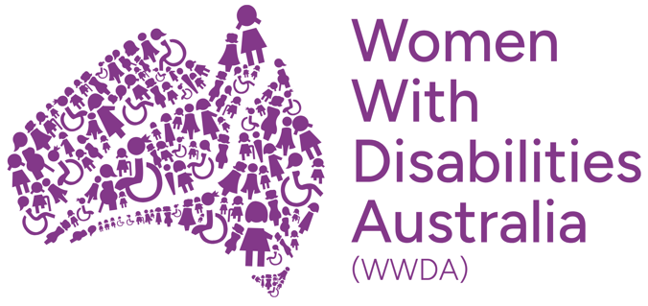

Submission
Making Disability-Specific Violence Visible: Disability-Responsive Implementation of the Second Action Plan
For submission to Consultation on the Second Action Plan (National Plan to End Violence against Women and Children 2022-2032)

Department of Social Services

Women With Disabilities Australia (WWDA)
July 2026

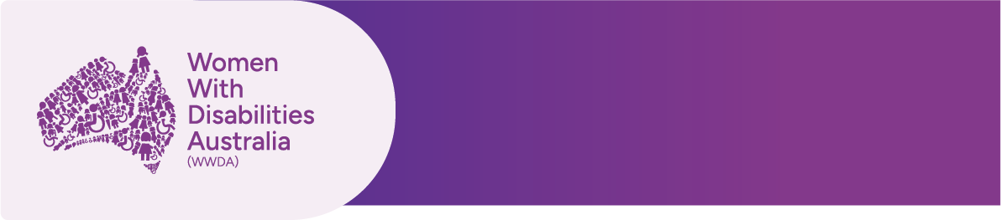

Publishing information
The moral rights of the authors have been asserted.
Women With Disabilities Australia [WWDA] (2026). Making Disability-Specific Violence Visible: Disability-Responsive Implementation of the Second Action Plan. Submission prepared for the public consultation on the Second Action Plan under the National Plan to End Violence against Women and Children 2022–2032. July 2026. Written by Dr. Diana Piantedosi, Senior Manager, Policy & Advocacy: Hobart, Tasmania.
Authorised by: Sophie Cusworth, Chief Executive Officer
Author: Dr. Diana Piantedosi, Senior Manager, Policy & Advocacy

Acknowledgement of Country
The authors acknowledge the traditional owners of the land on which this publication was produced. We acknowledge First Nations people's deep spiritual connection to this land. We extend our respects to community members and elders past, present and emerging.

Submission contact
Sophie Cusworth
Chief Executive Officer, Women With Disabilities Australia
E: officeadmin@wwda.org.au

About WWDA
Women with Disabilities Australia (WWDA) is the National Disabled People’s Organisation and National Women’s Alliance for women, girls and gender-diverse people with disability in Australia. WWDA is governed, run, led, staffed by, and constituted of women, girls and gender-diverse people with disability. Our work is grounded in a human rights framework across civil, political, economic, social and cultural rights.

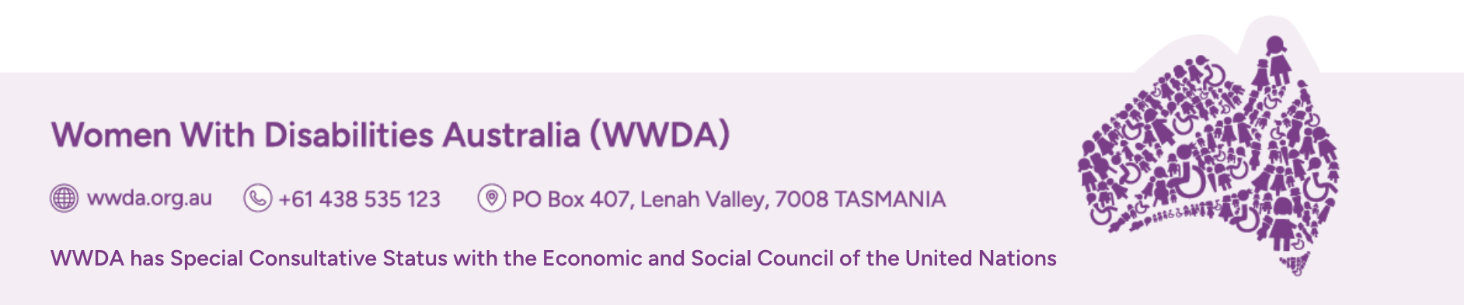

Endorsements

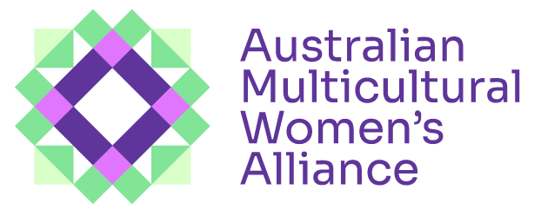 | 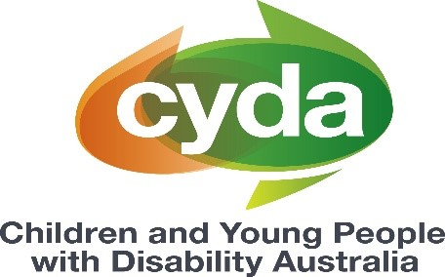
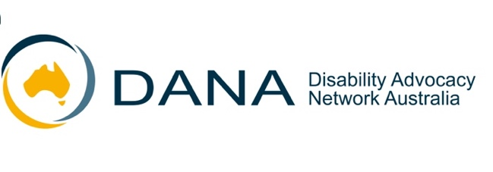 | 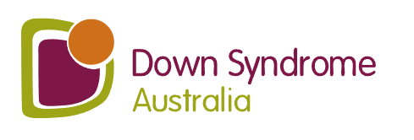
 | 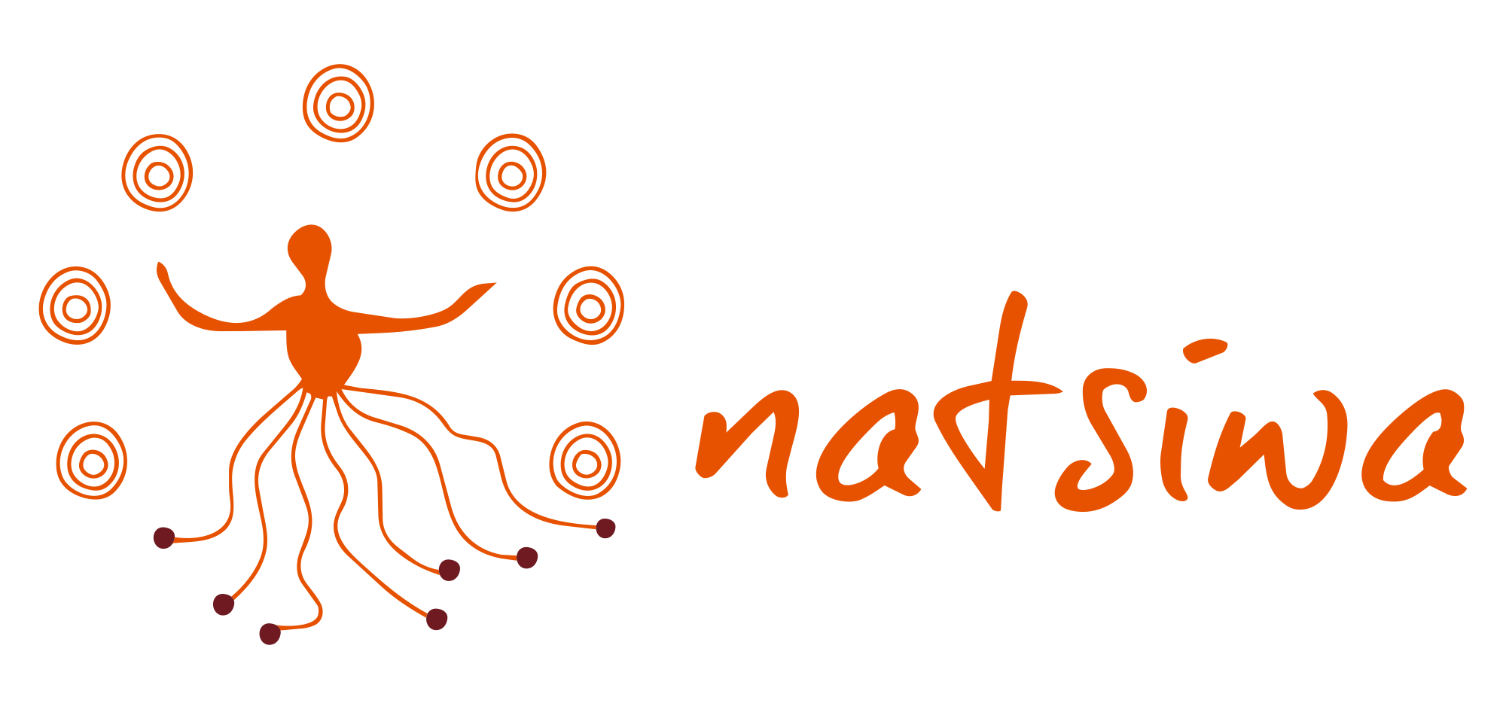
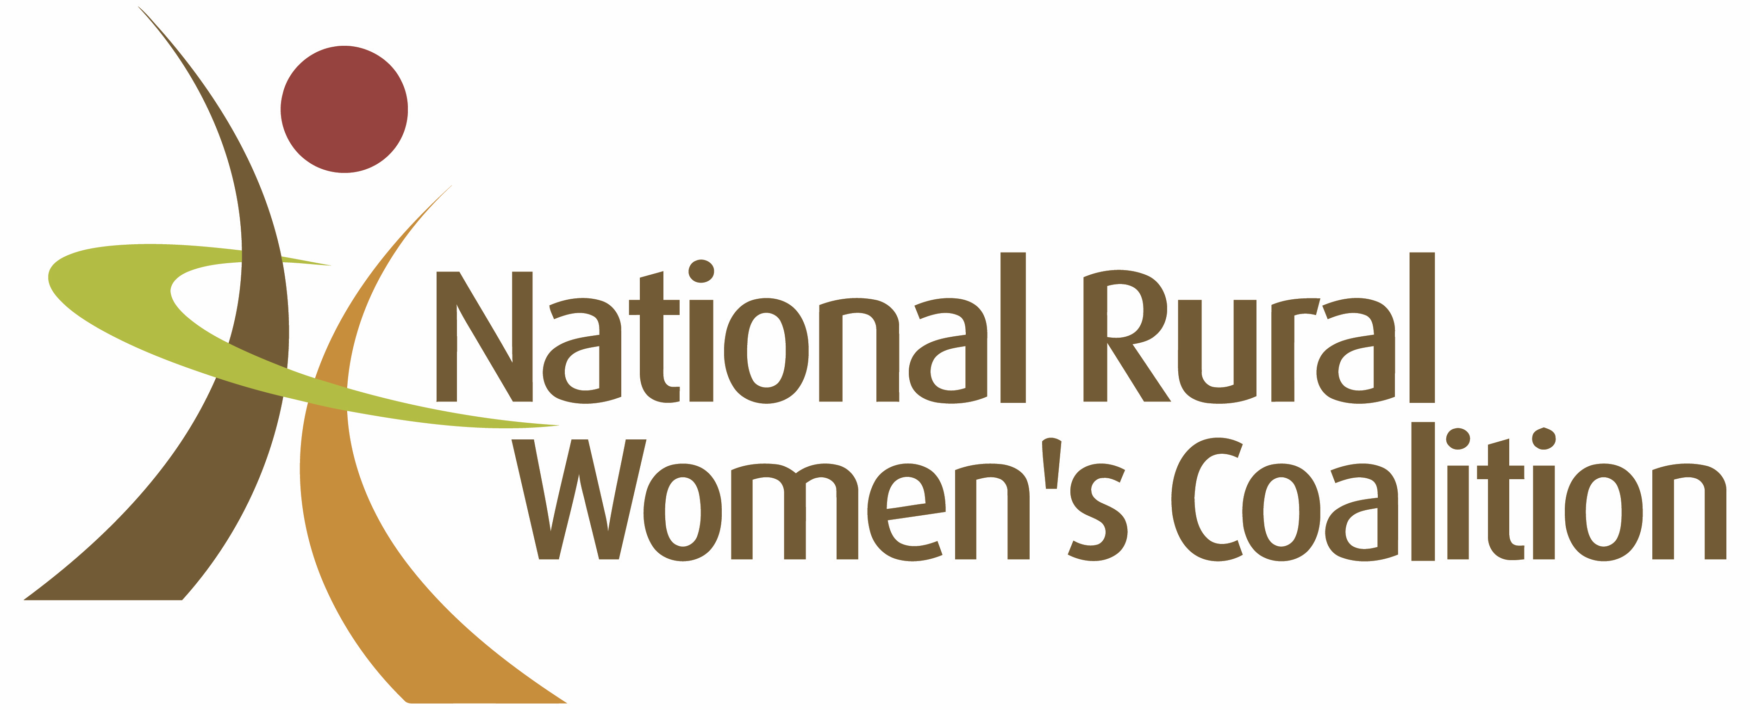 | 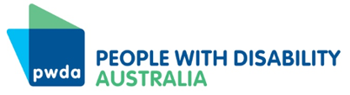
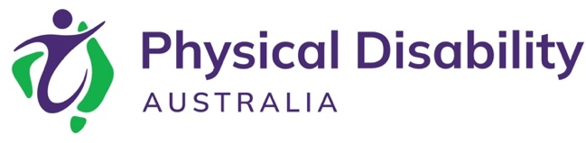 | 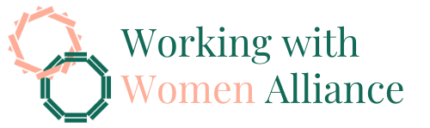

Introduction
This submission builds directly on WWDA’s 2025 election platform, which called for dedicated funding for a disability-led, DRO-based gender-based violence working group to support implementation of the National Plan to End Violence against Women and Children 2022–2032. In line with that ask, WWDA is seeking ongoing, dedicated funding to act as a funded partner to government through a DRO-led working group and related mechanisms over the life of the Second Action Plan.
WWDA has been a long-standing leader in advancing the rights of women, girls and gender-diverse people with disability in the context of domestic, family and sexual violence, through numerous projects, publications, submissions and advocacy initiatives. Key examples of this work include:
- Neve, an accessibility-first web-based resource co-designed with over 200 women and gender-diverse people with disability and those who support them
- Our Site, an online platform co-designed with over 100 women and gender-diverse people with disability
- WWDA Position Statement 2: The Right to Decision-Making
- Disability Royal Commission: WWDA’s Submission on Guardianship and Financial Management
- Response to Restrictive Practices Issues Paper of the Royal Commission into Violence, Abuse, Neglect and Exploitation of People with Disability.
- Redressing Reproductive Violence Against Women with Disability: Justice Beyond the Royal Commission
- Submission on Sexual and Reproductive Rights of Women and Girls with Disability to the Royal Commission into Violence, Abuse, Neglect and Exploitation of People with Disability
- Statement: Depo-Provera Class Action
- WWDA and PWDA Demand Justice for Women with Disabilities in Joint Submission to ALRC
- Submission to the Senate Legal and Constitutional Affairs Committee on Sexual Consent Laws
- WWDA Economic Equality and Security Infodocs (Gender-Based Violence)
WWDA’s publications set out a comprehensive suite of recommendations across the full breadth of the National Plan. This submission is intentionally different. Rather than restating the full body of WWDA’s previous advice, it adopts a focused approach, outlining where WWDA is well placed to partner directly with government to embed a substantive disability-focus.
The Disability Lens on the First Action Plan broadened implementation by identifying disability-specific perspectives across its 10 actions. The Second Action Plan should embed this work from the outset and fund disability-led support to translate it into implementation, monitoring and continuous improvement.
WWDA recognises the costs and risks of repeatedly asking people who have experienced violence and trauma to take part in consultations. The priorities in this submission therefore draw on WWDA’s existing work with members and supporters, individual advocates at the system interface, and other Disabled People’s Organisations and Disability Representative Organisations. We are advocating for action on what this work has already shown by addressing the targeted conceptual, system and practice gaps identified here.
Trauma-informed consultations require dedicated wrap-around supports, clear feedback loops, and a targeted approach in which victim-survivors can see that the advice they provide is making an impact. Honouring the stories and expertise shared with WWDA therefore also requires us to advocate for appropriate resourcing, so that we can work meaningfully and safely with our community and with government to genuinely shift the needle on gender-based violence. To demonstrate the key focus areas for such a funded partnership, this submission provides a set of targeted responses to selected consultation questions, each framed with a view to the role WWDA could play, if funded to do so, in progressing the Second Action Plan and the next phase of the National Plan.

Key recommendation

WWDA recommends that the Australian Government provide ongoing, dedicated funding for a disability-led gender-based violence working group to support the design and implementation of the Second Action Plan across prevention, early intervention, response, recovery and healing. WWDA should lead the group in partnership with DPOs and DROs, with appropriately paid women, girls and gender-diverse people with disability contributing relevant lived and policy expertise.

If funded, WWDA would work in partnership with DROs and government to:
- Make disability-specific violence visible in law and data.
- Position income and community participation as essential safeguards.
- Build accessible early help pathways around disabled women’s realities.
- Strengthen accountability, monitoring and feedback loops across the Second Action Plan.

Consultation questions addressed
This submission does not respond to every consultation question. Instead, it provides a focused response to selected questions where WWDA is well placed to support the design and implementation of the Second Action Plan, if funded to do so:
Sub-Recommendation | Consultation questions primarily addressed
1. Make disability-specific violence visible in law and data | Priority Area 1: Victim-survivors  - What service or system responses would make the biggest difference to victim-survivors’ safety, wellbeing, healing and recovery?  - What current or emerging issues should the Second Action Plan address, including in relation to coercive control and technology-facilitated abuse?  - What gaps remain in addressing the needs of diverse communities, including Aboriginal and Torres Strait Islander people?  Priority Area 5: System integration and workforce  - What evidence, workforce or system gaps should the Second Action Plan prioritise to strengthen implementation and improve outcomes over time?
2. Position income and community participation as essential safeguards | Priority Area 1: Victim-survivors  - What service or system responses would make the biggest difference to victim-survivors’ safety, wellbeing, healing and recovery?  - What helps people access support earlier, and what barriers prevent people from seeking help or engaging with systems and services?  - What current or emerging issues should the Second Action Plan address, including in relation to coercive control and technology-facilitated abuse?  Priority Area 2: Prevention and early intervention  - What gaps remain in addressing the needs of diverse communities, including Aboriginal and Torres Strait Islander people?
- What would make the biggest difference in preventing and ultimately ending violence?
- How can existing efforts to prevent violence be strengthened or built upon at the individual, community, organisational, institutional and societal levels?
- What prevention and early intervention approaches appear most promising or effective, and what is needed to strengthen or expand them?
- What emerging issues should the Second Action Plan address in relation to primary prevention and early intervention?

Priority Area 5: System integration and workforce
- What would make the biggest difference in creating a more coordinated and connected system response for people affected by violence against women and children and other forms of gender-based violence and people using violence?

3. Build accessible early help pathways around disabled women’s realities | Priority Area 1: Victim-survivors  - What service or system responses would make the biggest difference to victim-survivors’ safety, wellbeing, healing and recovery?  - What helps people access support earlier, and what barriers prevent people from seeking help or engaging with systems and services?  Priority Area 5: System integration and workforce  - What approaches or models appear most effective in improving collaboration, coordination and information sharing across services, systems and programs?  - What supports do specialist and universal services need to provide inclusive, accessible and responsive services?
4. Strengthen accountability, monitoring and feedback loops across the Second Action Plan | Priority Area 1: Victim-survivors  - What gaps remain in addressing the needs of diverse communities, including Aboriginal and Torres Strait Islander people?  Priority Area 5: System integration and workforce  - What would make the biggest difference in creating a more coordinated and connected system response for people affected by violence against women and children and other forms of gender-based violence and people using violence?  - What approaches or models appear most effective in improving collaboration, coordination and information sharing across services, systems and programs?  - What workforce capabilities, supports, or conditions are most needed to strengthen prevention, early intervention, response and recovery?  - What evidence, workforce or system gaps should the Second Action Plan prioritise to strengthen implementation and improve outcomes over time?

1. Make disability-specific violence visible in law and data
Current family, domestic and sexual violence laws, policies and data do not consistently recognise the full range of violence experienced by women, girls and gender-diverse people with disability. These approaches often focus on violence occurring within an intimate partner relationship. This leaves out violence perpetrated in support relationships, service settings, institutions, group homes, respite centres, boarding houses and other domestic or care-related settings.
The Disability Royal Commission identified this gap and recommended disability-inclusive definitions of family and domestic violence. These definitions should recognise all relevant relationships, disability-based violence and the domestic settings where people with disability experience harm. When systems fail to name violence by a support worker, carer, co-resident, service provider, guardian or substitute decision-maker as violence, they may treat it as a service issue, workplace matter, provider compliance concern or administrative problem. This narrows access to legal recognition, crisis support, service pathways, safety planning, data collection and accountability.
WWDA has highlighted definitions influence more than legal language. They shape what experiences are named as violence, abuse and neglect, and they guide the design of crisis responses, including financial support to reach safety. For example, WWDA welcomes the leaving family violence payment being made permanent because it recognises that money can be a condition of safety. However, eligibility is also tied to leaving a violent intimate partner relationship. That leaves a gap for women with disability who experience violence in other relationships or settings. The person causing harm may be another family member. It may be a co-resident in group assisted living. Her need for safety is just as urgent, but the pathway to support may be narrowed. Likewise, the current package is worth $5,000, while the average cost of leaving abuse in Australia is estimated at around $18,000. For people with disability, the cost can be even higher, including when leaving requires moving or replacing assistive technology and equipment.
Current approaches also define coercive control, reproductive violence and economic abuse too narrowly. Disability-specific coercive control can include withholding or manipulating assistive technology, communication support, medication, personal care, mobility support, transport or access to services. WWDA supports disability-inclusive definitions and practice guidance. Further disability-led consultation is needed to assess potential benefits and risks of standalone coercive control offences, including perpetrator misidentification. Governments should recognise forced sterilisation, forced contraception and menstrual suppression as reproductive control and gender-based violence when they occur without free, prior and informed consent.
The way Australia currently understands and measures economic abuse similarly requires disability-specific recognition. National measures record the percentage of women and men who have experienced economic abuse by a current or previous cohabiting partner since the age of 15. Even on this narrow measure, 4.6 per cent of women with disability have experienced economic abuse, compared with 2.4 per cent of women without disability. However, this measure misses economic abuse by family members, co-residents, support workers, service providers and others in positions of trust.
WWDA’s 2025 Economic Security and Employment Survey found that 41.8 per cent of respondents reported economic abuse. This points to a broader pattern of control than current national measures capture. It also shows why government should involve disability-led expertise in the design of evidence, monitoring and implementation under the Second Action Plan. Governments and data agencies need to ask the right questions, in accessible ways, about the forms of violence women and gender-diverse people with disability experience.
A funded disability-led gender-based violence working group would give government a practical mechanism to draw on WWDA and DRO expertise throughout implementation of the Second Action Plan. This work requires dedicated funding for design, implementation and coordination, so the group can contribute to delivery, monitoring and evaluation rather than operate as an unfunded advisory role.

Working in partnership with government, the group should:
- identify where current legal, policy and data definitions fail to recognise disability-specific violence
- develop disability and gender responsive indicators for the Second Action Plan
- advise on practice guidance for support-based coercive control, reproductive violence, economic abuse and abuse in service settings
- advise on how national data can capture violence beyond intimate partner relationships
- translate WWDA and DRO evidence into practical tools for policy, service design, monitoring and evaluation.

Impact: This would support government to implement the Second Action Plan with clearer definitions, better data and stronger disability-responsive practice. It would also ensure women, girls and gender-diverse people with disability help shape the systems designed to recognise, prevent and respond to violence.

2. Position income and community participation as essential safeguards
Safety depends on the conditions that allow women, girls and gender-diverse people with disability to seek help, leave unsafe settings and rebuild. Income, housing, transport, communication, assistive technology, disability supports, community connection and trusted relationships all shape whether a person can recognise violence, disclose harm and reach safety.
Understandings of quality and safeguarding must also move beyond the absence of harm. A safe life includes autonomy, dignity, participation and self-determination. For women, girls and gender-diverse people with disability, this means having the supports, relationships and resources needed to make decisions, move through the community, communicate privately and maintain connections beyond paid services or closed settings.
Social and community participation is a core violence prevention safeguard. It reduces isolation, strengthens informal support, builds self-advocacy and creates pathways to leave unsafe situations. Inclusion in ordinary community life creates relationships beyond service providers. Those relationships can help identify harm, ask questions, provide support and connect a person to help when something goes wrong. Segregated settings increase risk because they can cut people off from independent complaints processes, police, advocacy, legal support and trusted networks. When a person’s housing, daily support, transport, communication or access to the community depends on the same setting or provider, it can become much harder to raise concerns or leave an unsafe situation.
For this reason, income support, the Disability Support Pension, NDIS supports, foundational supports, housing and transport should be recognised as systems that shape safety, prevention, response and recovery outcomes. They are not specialist violence services, but they form part of the broader safety infrastructure around women, girls and gender-diverse people with disability. For example: public transport is not a violence prevention service, yet safe transport design considers lighting, visibility, staffing, surveillance, mobility and accessible routes because these features affect whether people can move safely through the community. Income, disability support, housing and transport systems should be approached in the same way. Their core purpose may sit outside violence prevention, but their design can increase or reduce isolation, dependence, visibility, mobility and access to help. This is the basis for WWDA’s concern about partner income tests, joint means testing and proposed reductions to social and community participation supports through the NDIS Bill. These are income support and disability policy settings, but they have direct consequences for violence prevention because they shape whether disabled women can maintain connection, move safely, access support and leave unsafe situations.
Governments should abolish partner income tests and joint means testing for income support payments. These settings can increase financial dependence, keep disabled women tied to unsafe relationships, and make it harder to leave violence. Harsh taper rates and conditionality can also undermine safety where they reduce income, increase administrative burden or punish people for circumstances shaped by disability, violence or caring responsibilities.
Governments also need to account for how decisions in one part of government affect safety outcomes in another. Proposed reductions to disability supports may be framed as NDIS sustainability measures, but they can also increase isolation, reduce community participation and remove the regular contact that helps women, girls and gender-diverse people with disability be seen, known and able to report harm. WWDA’s submission on the NDIS Amendment Bill warned that cuts to social, civic and community participation, caps, ratios, lower-cost alternatives and tighter reassessment may isolate women and gender-diverse people, reduce natural safeguards and shift unpaid care onto women. WWDA also made clear that community participation creates visibility, connection, safety and routes to help.
The Second Action Plan should require gendered disability safety impact assessments before governments implement major reforms to disability supports, income support, housing or transport. This includes asking whether reforms reduce access to community participation, communication support, transport, assistive technology, advocacy or practical assistance needed to seek safety. A prevention plan cannot sit apart from disability reform when disability reform shapes the conditions that make violence easier to hide or harder to leave.
As outlined in Section 1, crisis payments and family violence supports should also reflect the relationships and settings in which women, girls and gender-diverse people with disability experience violence. Disabled women may need to leave violence by a co-resident, family member, support worker or service provider, not only an intimate partner. Section 2 builds on that point by emphasising that crisis support will only be effective if income, housing, transport and disability supports are available when a person needs to leave.

Working in partnership with government, the group should:
- identify where income support, DSP, NDIS, foundational supports, housing and transport settings increase isolation, dependence or exposure to violence
- advise on the gendered safety impacts of NDIS and foundational support reforms
- develop guidance to inform future impact analyses which must recognise community participation as prevention, response and recovery infrastructure
- support cross-system accountability so reforms in one system do not increase isolation, unpaid care, economic dependence or violence risk in another
- translate WWDA and DRO evidence into practical tools for funding, program design, service delivery and monitoring.

Impact: This would help implement a whole-of-government approach in the Second Action Plan, with a clearer view of the systems that shape safety before crisis occurs. It would also support governments to test whether policy choices across disability, income, housing and transport strengthen safety, or make violence easier to hide and harder to leave.
3. Build accessible early help pathways around disabled women’s realities
Women, girls and gender-diverse people with disability need early help pathways that reflect their actual lives, not generic referral models. Many pathways still assume a person can safely use a phone, travel alone, access money, communicate privately, read standard information and name their experience as violence. These assumptions can exclude the people who most need earlier support. Services must be physically, digitally, sensory and communication accessible. This includes Easy Read, access to Supported Decision Making, plain English, text-to-speech, interpreters, flexible contact options, accessible appointment settings and safe ways to attend without the person causing harm knowing. People should not have to prove their access needs before they can participate safely. Access should be built into service design from the start.
As outlined in Sections 1 and 2, violence against women, girls and gender-diverse people with disability may occur in support relationships, service settings, housing arrangements, family relationships and other contexts beyond intimate partner violence. Early help pathways must account for this. A woman may avoid disclosing violence because the person causing harm controls her care, transport, communication, income, medication, assistive technology, housing or decision-making arrangements. Referral models must not assume the person seeking help can safely make a phone call, leave the house alone, attend an appointment, access money, use online information privately or speak freely in front of a support person.
This also matters for disability reform. WWDA’s NDIS Bill submission raised concern that proposed section 40A would allow the NDIA to suspend a participant’s plan where the Agency has made reasonable attempts to contact them and they remain uncontactable. If the participant remains uncontactable after 90 days, the NDIA could suspend their plan. In a family violence context, being uncontactable may be a safety measure, not disengagement. For example, when women enter refuge or protective hiding, family violence practitioners may conduct technology safety checks and replace phones to limit unsafe contact pathways. There may be information-sharing protocols in place, but these do not operate consistently across jurisdictions because of privacy and data protection settings. Suspending supports in these circumstances could remove the very disability supports a woman needs to stabilise, communicate safely, attend appointments, secure housing and remain protected. The Second Action Plan should therefore require governments to test whether disability, income and service-system reforms understand the safety reasons a person may be difficult to contact.
Supported decision-making is also a safety measure. It helps women make decisions about their own lives, bodies, risks and safeguards, with support guided by their will and preferences. This matters where systems, services, families or substitute decision-makers frame control as protection, or make decisions about safety without the person most affected leading those decisions.
Rights education should be understood as prevention. Many people with disability do not receive accessible information about what constitutes violence, how to make a complaint, what support is available, or what to do when the person causing harm also provides care or access to the community. Accessible information is not only a communication output; it is central to prevention and early intervention. It gives people the language, confidence and pathways to recognise harm earlier and seek support before a crisis escalates.
WWDA’s Neve website shows what disability-led accessible safety information can look like in practice. Neve uses Easy Read-first design, plain English, text-to-speech, larger text options and a Calm Space for sensitive content. It shows that access, safety and control over how people receive information must shape design from the start.
Building on the recommendation in Section 1, the working group should help government extend investment in Neve from accessible resources into implementation. The group would help ensure disability-led evidence and tools, including lessons from Neve, inform early help pathways, referral design and workforce practice across the Second Action Plan.

Working in partnership with government, DROs and services, the group should:
- co-design early help and navigation pathways that reflect disabled women’s access, safety and support realities
- develop referral tools that recognise violence beyond intimate partner relationships
- advise on accessible information, safe-contact and referral standards across family violence and universal services, including legal, health, housing, disability, banking, financial services and telecommunications
- advise on funding for disability-informed outreach and in-reach, delivered with relevant community-controlled and specialist organisations, to reach isolated communities and people facing cultural, language and other access barriers
- extend lessons from Neve and other disability-led resources into practical tools for service design, workforce development and early intervention
- identify unintended safety consequences of proposed reforms, including NDIS changes that may affect contact, communication, transport, support continuity or a person’s ability to seek help safely.

Impact: This would help government strengthen early intervention under the Second Action Plan by carrying existing disability-led work into the systems people use when they need help. It would also help government test whether reforms in connected systems, such as the NDIS, create barriers to safety before those barriers become embedded in policy or practice.

4. Strengthen accountability, monitoring and feedback loops across the Second Action Plan
The Second Action Plan needs disability-responsive implementation architecture, not only disability-inclusive language. Naming women, girls and gender-diverse people with disability in the Plan will not be enough unless government also builds the mechanisms needed to implement, test and improve actions over time.
As outlined in Sections 1 to 3, key implementation risks sit across definitions, data, income, disability support, community participation, early help pathways, accessible information and connected reforms such as the NDIS Bill. Government needs a way to identify these risks during implementation, not only after harm has occurred.
A disability-led gender-based violence working group would give government an ongoing mechanism for disability-led advice, implementation support, monitoring and evaluation across the life of the Second Action Plan. The group would support government to implement disability-responsive actions, test whether those actions are working and identify where changes are needed. Government would retain responsibility for delivery, funding and accountability.
This mechanism would also reduce reliance on repeated, unfunded and potentially retraumatising consultation with victim-survivors. Genuine co-design requires time, access, payment, clear influence, safe participation and reporting back on what changed because people were involved. This must include age-appropriate participation by girls and young people with disability, supported by representative organisations with relevant child- and youth-specific expertise. Women, girls and gender-diverse people with disability should not be asked to keep restating the same gaps without seeing how their evidence changes policy, funding, services and practice.
Accountability also needs to address fragmented complaint and safeguarding systems. People with disability often have to navigate different complaint pathways across disability services, family violence services, sexual violence services, housing, health, justice, income support and safeguarding bodies. These systems can be difficult to understand, inconsistent across jurisdictions and poorly coordinated when violence occurs across more than one setting or relationship.
The Second Action Plan should support a no-wrong-door complaints approach. People with disability should be able to raise concerns wherever they first seek help, with coordinated referral and response pathways across relevant systems. This is especially important where a person does not know whether their experience will be treated as violence, abuse, neglect, poor service quality, workplace misconduct or a safeguarding issue.
Monitoring should assess whether disability-specific violence is recognised, whether services are accessible, whether referral pathways work and whether disabled women experience safer and earlier access to support. It should also track whether actions under the Second Action Plan reduce isolation, strengthen community connection and improve access to independent advocacy, accessible information and supported decision-making.
Accountability should include transparent reporting on what changed because women, girls and gender-diverse people with disability were involved. This means reporting not only on consultation numbers, but on decisions, funding, guidance, indicators, service design and practice changes shaped by disability-led evidence.
Building on the recommendation in Section 1, the working group should help government turn disability-led evidence into practical accountability, monitoring and feedback mechanisms for the Second Action Plan.

Working in partnership with government and DROs, the group should:
- develop CRPD-aligned human rights outcomes and indicators, connected to Australia’s Disability Strategy and relevant Disability Royal Commission recommendations, to track whether the Second Action Plan is improving safety for women, girls and gender-diverse people with disability
- advise on monitoring measures for disability-specific violence, accessible services, referral pathways, complaints and safeguarding responses
- coordinate with child- and youth-specific representative organisations and participation mechanisms so actions across early childhood education, schools and youth services form part of the broader disability-responsive implementation framework
- support feedback loops that show what changed because women, girls and gender-diverse people with disability were involved
- identify implementation gaps early, including where mainstream actions are not reaching disabled women safely or accessibly
- advise on no-wrong-door complaint and referral pathways across disability, violence, health, housing, justice and income support systems.

Impact: This would help government move from consultation to accountable implementation. It would also give the Second Action Plan a practical way to measure whether its actions are improving safety, access and early support for women, girls and gender-diverse people with disability.

Language note
This submission reflects the overlapping experiences of marginalisation experienced by women, girls, nonbinary and gender-diverse people in our membership and broader community. Though these groups will experience gender discrimination and marginalisation, not all identify as women. WWDA‘s submission may reflect the specific experiences of trans, non-binary and gender-diverse people with disability. However, the experiences of trans, non-binary and gender-diverse people with disability warrant specific and direct exploration, including the distinct forms of gender-based violence they experience and the barriers they face in accessing safety and support. WWDA recognises the limitation in aggregating our submission at a broader level of gender-marginalised people. WWDA aims to work in coalition with, rather than replicate the core work of organisations who represent and advocate for LGBTQIA+ people with disability.
This submission uses ‘person first’ language (for example: women with disability). We acknowledge people describe their experience of disability in different ways, and for many people, ‘identity first’ language is a source of pride and resistance.

References

Women With Disabilities Australia [WWDA]. (2025). 2025 Federal Election Platform. https://wwda.org.au/2025-federal-election-platform/
Australian Government Department of Social Services. (2026, July 7). Disability lens on the First Action Plan 2023–2027. https://www.dss.gov.au/national-plan-end-violence-against-women-and-children/resource/disability-lens-first-action-plan-2023-2027-0
Australian Government Department of Health, Disability and Ageing. (2025, November 27). Recommendation 8.24 – Disability-inclusive definition of family and domestic violence. https://www.health.gov.au/resources/publications/disability-royal-commission-progress-report-2025/volume-8-criminal-justice-and-people-with-disability/recommendation-824-disability-inclusive-definition-of-family-and-domestic-violence
Australian Government Department of Social Services. (2026, July 1). Leaving Violence Program. https://www.dss.gov.au/safety-programs-prevention-and-evidence/leaving-violence-program
SBS World News. (2017, November 13). Cost of fleeing violent relationship is $18,000 and 141 hours: ACTU. SBS News. https://www.sbs.com.au/news/article/cost-of-fleeing-violent-relationship-is-18-000-and-141-hours-actu/s46y8lg0c
Hay, K., & Fox, R. (2026, February). Coercive control in the Victorian context: Continuing the conversation. Safe and Equal. https://safeandequal.org.au/wp-content/uploads/Safe-and-Equal_Coercive-control-position-paper_February-2026-FINAL.pdf
Women With Disabilities Australia [WWDA]. (2022). Submission on Sexual and Reproductive Rights of Women and Girls with Disability to the Royal Commission into Violence, Abuse, Neglect and Exploitation of People with Disability. https://wwda.org.au/our-resources/publication/disability-royal-commission-wwdas-submission-on-sexual-and-reproductive-rights/
Australian Government. (2024, March). Baseline report. Working for Women. https://genderequality.gov.au/baseline, see indicator 1.1.11.
Women With Disabilities Australia [WWDA]. (2026, March 4). WWDA Economic Equality and Security infodocs. https://wwda.org.au/our-resources/publication/wwda-ees-survey-infodocs/
Jervis-Bardy, D. (2026, May 23). Labor’s NDIS overhaul will leave participants more ‘isolated’ and ‘segregated’, former royal commissioner warns. The Guardian. https://www.theguardian.com/australianews/2026/may/23/albanese-government-ndis-legislation-cuts-changes-reform-australians-moreisolated
Women With Disabilities Australia [WWDA]. (2026, May). Gendered risks of the NDIS Amendment Bill 2026: Submission and supporting evidence paper prepared for the Senate Community Affairs Legislation Committee inquiry into the National Disability Insurance Scheme Amendment (Securing the NDIS for Future Generations) Bill 2026. https://wwda.org.au/our-resources/publication/gendered-risks-of-the-ndis-amendment-bill-2026/
Women With Disabilities Australia [WWDA]. (2021). WWDA submission to the Senate Standing Committee on Community Affairs inquiry into the purpose, intent and adequacy of the Disability Support Pension. https://wwda.org.au/wp-content/uploads/2021/07/WWDA_Sub_DSP_July2021_FINAL.docx
WWDA (2026, May).
WWDA (2021).
Parliament of Australia, Senate, Community Affairs Legislation Committee. (2026, June 10). National Disability Insurance Scheme Amendment (Securing the NDIS for Future Generations) Bill 2026 [Committee Hansard]. https://parlinfo.aph.gov.au/parlInfo/search/display/display.w3p;query=Id%3A%22committees%2Fcommsen%2F29672%2F0000%22
WWDA (2026, May).
WWDA (2026, May).
Australian Government Department of Health, Disability and Ageing. (2025, November 27). Recommendation 6.6 – Supported decision-making principles. https://www.health.gov.au/resources/publications/disability-royal-commission-progress-report-2025/volume-6-enabling-autonomy-and-access/recommendation-66-supported-decision-making-principles?language=en
Inclusion Australia. (2024). Supported decision making. https://www.inclusionaustralia.org.au/topic/supported-decision-making/
Women With Disabilities Australia [WWDA]. (2024). Neve. https://www.neve.wwda.org.au.

