No Cuts Before Alternative Supports Available
  - Joint Statement by Disability Representative Organisations
2 July 2026

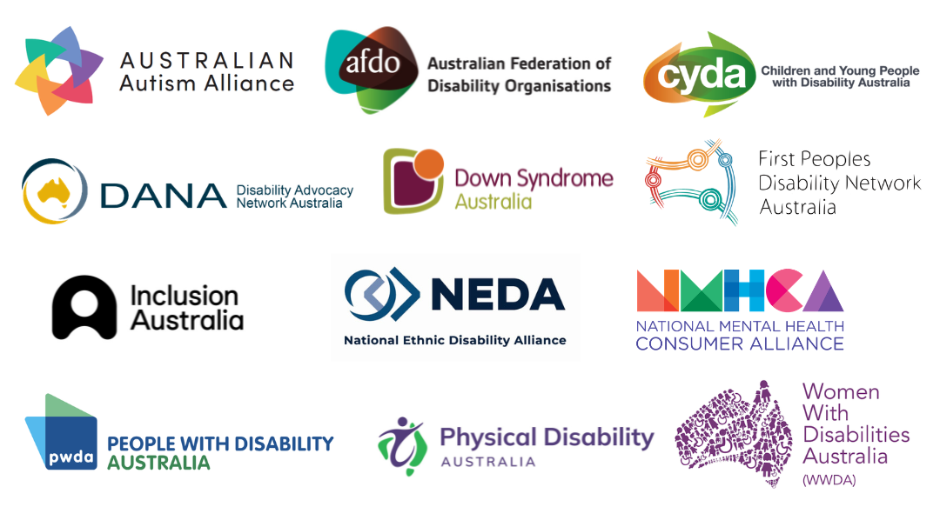

Disability Representative Organisations (DROs) continue to engage with developments relating to the NDIS Amendment Bill, including the Senate Inquiry Interim Report, the reopening of submissions, and amendments recently passed through Parliament.

We welcome the Committee's recognition that proposed changes to the NDIS should not proceed before governments deliver their agreed investment in foundational supports outside the Scheme. The Committee's recommendation acknowledges that supports outside the NDIS are an essential part of the broader disability support system and must be developed prior to any changes taking effect.

This aligns with our stated position that supports outside the NDIS are a critical part of the broader disability ecosystem and should be available before any reforms proceed that may reduce or restrict access to the NDIS. Importantly, those supports must be co-designed with people with disability, properly tested, fully funded, and operational before reforms that may reduce or restrict NDIS access take effect.

At the same time, this recognition does not resolve the significant concerns that remain about the Bill. We remain deeply concerned by the Committee's recommendation that the Bill be passed without substantive changes. Recommendations relating to a future roadmap and additional detail in the Explanatory Memorandum do not address the core risks identified by people with disability and our organisations. An Explanatory Memorandum is not legislation, and a roadmap is not an enforceable safeguard.

Reforms must consider and uphold Australia's commitments under the UN Convention on the Rights of Persons with Disabilities and should be implemented in a manner that protects the rights, dignity, inclusion and full participation of people with disability. We support calls on the government to address the human rights concerns over the NDIS changes, including those raised by the Parliamentary Joint Committee on Human Rights (PJCHR).

As currently drafted, the Bill reduces supports, restricts access to the Scheme, increases isolation, and shifts costs and caring responsibilities onto people with disability, families and other service systems. Some changes may also occur without sufficient regard to individual circumstances, creating risks to safety, wellbeing and inclusion.

While we acknowledge the amendments passed this week respond to some concerns raised by the disability community, they provide limited safeguards. Similarly, the extended inquiry timeline remains inadequate given the scale and impact of the proposed reforms. We hope the Senate Inquiry will use this time to genuinely consider the evidence presented by the disability community.

Since the release of the NDIS Review, Disability Representative Organisations have consistently argued that continuity of support must be the first priority in designing and sequencing changes. No person should lose access to disability supports until appropriate, accessible and effective alternatives are available.

Our organisations will continue to seek more constructive engagement and advocate for reforms that uphold the rights, inclusion and wellbeing of people with disability.

About our organisations
This statement was developed by DROs with coordination support from Disability Advocacy Network Australia (DANA) in their role as the National Coordination. DROs are funded by the Department of Health, Disability and Ageing to represent people with disability.

The following organisations have contributed to and/or expressed their support for this joint position statement

- Australian Autism Alliance
- Australian Federation of Disability Organisations
- Children and Young People with Disability Australia
- Disability Advocacy Network Australia
- Down Syndrome Australia Consortium
- First Peoples Disability Network Australia
- Inclusion Australia
- National Ethnic Disability Alliance
- National Mental Health Consumer Alliance
- People with Disability Australia
- Physical Disability Australia
- Women With Disabilities Australia

