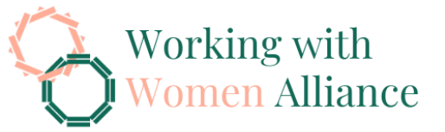

Committee Secretary
Senate Standing Committees on Community Affairs
PO Box 6100
Parliament House
Canberra ACT 2600
29.05.2026

Submission to the Senate Inquiry on the National Disability Insurance Scheme Amendment (Securing the NDIS for Future Generations) Bill 2026
The Working with Women Alliance (WwWA) writes to raise concerns regarding National Disability Insurance Scheme Amendment (Securing the NDIS for Future Generations) Bill 2026. Our submission is informed by our work on women’s economic equality and safety, with a particular focus on how these proposed reforms will impact women and gender-diverse people with disability.
WwWA is concerned about the extremely limited timeframe provided for submissions to this inquiry. The Bill was referred on 14 May 2026, with submissions closing on 1 June 2026, allowing only 11 business days for stakeholders to analyse and respond. This timeframe is insufficient given the scale and complexity of the proposed reforms. The Bill exceeds 100 pages, accompanied by an Explanatory Memorandum of nearly 300 pages.
This compressed timeframe does not allow for meaningful engagement or consultation with the disability community or the community more broadly and is not consistent with accessible or inclusive consultation practices. This is especially concerning given the profound impacts these reforms will have for people with disability. Reforms of this scale must be developed through meaningful co-design and comprehensive consultation, particularly with women with disability and carers, who will experience the greatest impacts.
WwWA urges the Committee to extend the submission deadline and undertake inclusive consultation processes, including public hearings, to ensure people with disability and their representative organisations can engage meaningfully. The current timeline makes it highly likely that many people directly affected by these reforms will be unable to contribute. People with disability have effectively been given weeks to understand and respond to changes that affect their essential supports and daily lives.
As a member of the National Women’s Alliances, WwWA stands alongside Women with Disabilities Australia (WWDA) and support their submission (https://wwda.org.au/our-resources/publication/gendered-risks-of-the-ndis-amendment-bill-2026) to this inquiry and recognise the critical importance of their expertise. The impacts of these reforms will not be shared evenly, with women and girls with disability less likely to be found eligible for the NDIS than men and at heightened risk of exclusion under tightened access and eligibility settings. Apparent savings will not remove need, but instead displace costs into other systems, including health, housing and crisis services.
We therefore call for the Government to publish a comprehensive gender impact assessment that examines the impacts of the proposed reforms on women and girls with disability, including current and prospective NDIS participants who are already experiencing unmet need, and demonstrates how the reforms will avoid further entrenching existing gender inequalities. The current impact analysis identifies some risks but does not fully articulate their extent, deferring key responses to future co-design processes. Greater transparency is required regarding the risks Government has identified and accepted, who will bear those costs, and how these risks will be mitigated, including in relation to safety, reduced workforce participation and increased pressure on other service systems.
These reforms must also be considered within other interconnected policy architecture including the National Plan to End Violence against Women and Children 2022–2032, the Working for Women Strategy, Closing the Gap targets, and the implementation of accepted Disability Royal Commission recommendations. The NDIS is critical enabling infrastructure across these frameworks, particularly in supporting the safety and economic participation of women with disability. Changes that reduce access to supports or increase uncertainty risk undermining progress against these national commitments, particularly at a pivotal moment as the Second Action Plan under the National Plan is being developed. Without clear alignment, there is a significant risk that reforms will shift pressure onto already stretched systems and erode the effectiveness of coordinated government efforts to improve outcomes for women with disability.
We thank the Committee for considering these concerns and welcome continued engagement.
Yours sincerely,
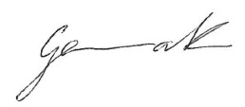
Dr Gemma Killen
Executive Director
Working with Women Alliance
equality.policy@WwWA.org.au
https://wwwa.org.au/

