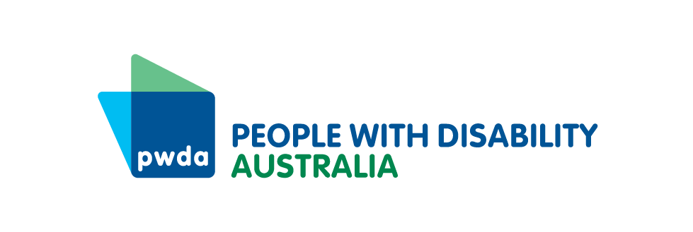
3 February 2026

DRO's respond to Government Agreement on Disability Supports

DROs cautiously welcome Thriving Kids delay; warn national consistency, and demonstrable readiness are critical across all reforms

Joint Statement
Australia’s Disability Representative Organisations (DROs) acknowledge an agreement has been reached between the Federal, State and Territory Governments regarding hospital funding and disability supports, including the Thriving Kids initiative, that will have implications for the supports people with disability have access to across their lifespan and across Australia.
While Government announcements have focused on Thriving Kids, the bigger issue is whether governments are prepared to deliver a functional, nationally consistent Foundational Supports system (including Thriving Kids) that works alongside the National Disability Insurance Scheme (NDIS) and Thriving Kids. These reforms are required in parallel so people with disability can access support outside the NDIS and avoid growing service gaps and inequity in different jurisdictions.
While the short delay to the commencement of the Thriving Kids rollout to October 2026 is cautiously welcomed, we emphasise the critical need for all levels of Government to use this time wisely. The disability sector has consistently called for sufficient time to enable genuine co-design across all jurisdictions, development of strong safeguards, workforce planning, and appropriate piloting and testing prior to large-scale implementation. This delay must be used to strengthen readiness and address known gaps in the program.
This is consistent with feedback from families, educators and health professionals, including responses gathered through national surveys conducted by Children and Young People with Disability Australia and the Australian Autism Alliance, which indicate that key parts of the system are not yet ready for transition at scale. This concern has also been reflected in prior inquiry and reform processes, where people with disability and their families have consistently called for greater safeguards, clarity and accountability in system reform.
National Cabinet has agreed to Thriving Kids being fully operational by 1 January 2028, with $2bn being contributed by the Commonwealth, matched by states and territories. DROs understand the importance of ensuring states and territories can operationalise supports according to local contexts, but are concerned that without any details on whether governments will publish an implementation plan, national standards or undertake public reporting on progress over the next two years, families will continue to experience the same uncertainty about what supports will be available and when.
Disability Representative Organisations emphasise that last week’s agreement sits in the context of ongoing negotiations and reforms that are not just about Thriving Kids. They will determine how broader Foundational Supports and the NDIS work together to deliver disability supports across the lifespan. There remains significant uncertainty about how General and Targeted Supports will be funded, delivered and governed across jurisdictions. With responsibilities split between the Commonwealth and states and territories, clear and transparent intergovernmental agreements are essential, alongside public clarity about how these systems will interact and what pathways will exist as people’s needs change over time.
Disability Representative Organisations are calling on all governments to commit to a nationally consistent Foundational Supports framework, underpinned by minimum service standards, transparent intergovernmental agreements, robust oversight and accountability mechanisms and clear public implementation plans and reporting. Without these commitments, people with disability and families risk facing fragmented systems, inconsistent access and widening service gaps.
Governments must also commit to national safeguarding mechanisms that interact with all Foundational Supports, including Thriving Kids. These mechanisms must embed crisis-response and escalation pathways, including clear referral mechanisms, rapid review processes and coordination with health, mental health and community services, so those experiencing acute stress or system breakdown can access timely, wraparound support without falling between programs or jurisdictions.
These reforms extend well beyond a single program. They will shape how children, families and people with disability access supports across health, education and community systems nationally, and how Foundational Supports interact with the NDIS over time. The decisions made about Thriving Kids now will have long-term consequences for equity, access and outcomes.
At the same time, NDIS planning reforms are progressing under the New Framework Planning. This makes sequencing critical. Foundational Supports must be operational, accessible and adequately resourced before any changes shift support boundaries between systems. No person with disability should lose access to support or be redirected into community systems that are not yet ready to meet demand. This is particularly important for children, who may experience changes to NDIS eligibility criteria from mid-2027 onwards.
Communities experiencing intersecting disadvantage are particularly vulnerable during system transitions. Families who already face barriers navigating current systems due to language, cultural background, disability type, geographic location, or other intersecting factors will be most at risk when support boundaries shift. Redirecting these families to community systems without addressing existing access barriers will compound inequity and risk leaving children and families without essential supports.
If these reforms are not properly designed and funded, the impacts will not be contained within the disability sector. Pressure will shift to hospitals and emergency departments, schools managing unmet support needs, and health and aged care systems responding to issues that should be addressed earlier through appropriate community-based disability supports.
Call to action
Disability Representative Organisations call on all governments to urgently commit to the following actions:
Provide public clarity and transparency on how Foundational and Targeted Supports will be funded, delivered and governed, including how Thriving Kids as a Commonwealth program will align with State and Territory delivery, how these supports will interact with the NDIS, and what pathways will exist as people’s needs change over time.
Guarantee national consistency and equity by establishing a nationally coordinated Foundational Supports framework with minimum service guarantees, a requirement for supports to be best practice and disability affirming, confirming whether funding models, eligibility settings and access pathways will differ across jurisdictions, and preventing postcode-based inequity and fragmented service pathways.
Ensure workforce readiness before large-scale rollout of any reforms, including Thriving Kids, through targeted investment, training, role clarity and workforce support mechanisms, particularly in regional, remote and culturally diverse communities where service shortages already exist.
Workforce training must build capability to work effectively across diversity, including cultural competency, gender-responsive practice, disability-affirming approaches for all disability types, and understanding how intersecting identities shape support needs.
Deliver operational safeguards and continuity of support by publishing clear transition arrangements, defined responsibilities across systems, transparent escalation and review processes, and accessible public information, ensuring no child or person with disability experiences a loss, delay or reduction of support during reform implementation.
Reframe reform communications to be accessible, strengths-based, disability and neuro-affirming, aligned with the National Autism Strategy, and grounded in lived experience, while actively challenging deficit-based narratives.
Disability Representative Organisations have reached out to the government to get further direct clarity and remain ready to work constructively with governments to ensure reforms are co-designed with people with disability, children and families, strengthen coordination across systems, and deliver real, lasting improvements in access to disability supports across the lifespan and across Australia.
The following organisations have contributed to and/or expressed their support for this joint position statement:
- Australian Autism Alliance
- Australian Federation of Disability Organisations
- Children and Young People with Disability Australia
- Community Mental Health Australia
- Disability Advocacy Network Australia
- Down Syndrome Australia
- First People's Disability Network Australia
- Inclusion Australia
- National Ethnic Disability Alliance
- People with Disability Australia
- Physical Disability Australia
- Women With Disabilities Australia
Quote attributable to Megan Spindler-Smith, Acting CEO, People with Disability Australia
This is bigger than Thriving Kids. It is about whether all governments are prepared to build a disability support system that works for our whole community. If Foundational Supports are rushed, badly implemented or poorly sequenced with changes to the NDIS, people with disability risk being left without the support they need and the pressure will shift to hospitals, schools and aged care. Getting it right will change lives.
Quote attributable to Jenny Karavolos, Co-Chair, Australian Autism Alliance
We welcome the decision to delay Thriving Kids but delay alone doesn’t make reform safe. This is an opportunity for governments and the disability community to work together to ensure that no child is left with fewer supports, greater risk, or nowhere to turn when systems change. Timelines must be readiness-based, not date-based. A phased rollout with staged pilots, workforce preparation and independent evaluation is essential to protect children, build trust, and ensure these reforms are safe and sustainable.
Quote attributable to Skye Kakoschke-Moore, CEO, Children and Young People with Disability Australia
Families have been very clear with us. 79 per cent of those we surveyed said the original Thriving Kids timeline was too short. This extra time needs to be used to work directly with families and communities to design supports that children actually need, including access to allied health, assistive technology and tailored programs that respond to local circumstances. Families are also asking what support will look like as children grow older. We need clear answers to that question.
Quote attributable to Catherine McAlpine, CEO, Inclusion Australia
It is essential General Foundation Supports are considered and implemented carefully in this process as well, as they underpin the direction forward for many people with disability and their families. Access to peer support, self-advocacy and decision supports is critically important for people with an intellectual disability to truly exercise choice and control in their lives.
Quote attributable to Lara Kissin, Acting CEO, National Ethnic Disability Alliance (NEDA)
System reforms always hit hardest for families navigating intersecting barriers. A family from a culturally and linguistically diverse background with a child with disability isn’t just navigating disability systems, they’re doing so across language barriers, cultural differences in how disability is understood, and often with limited prior knowledge of available supports. When information isn’t available in community languages, when co-design doesn’t actively engage diverse communities, when workforce training doesn’t include cultural competency, these families fall through the gaps. This delay must be used to build equity into the foundations.

