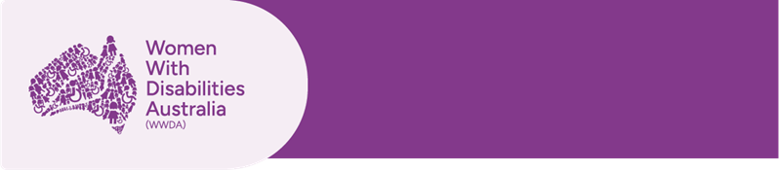

Report
The 18th Session of the United Nations Conference of States Parties on the Convention on the Rights of Persons with Disabilities (COSP18)
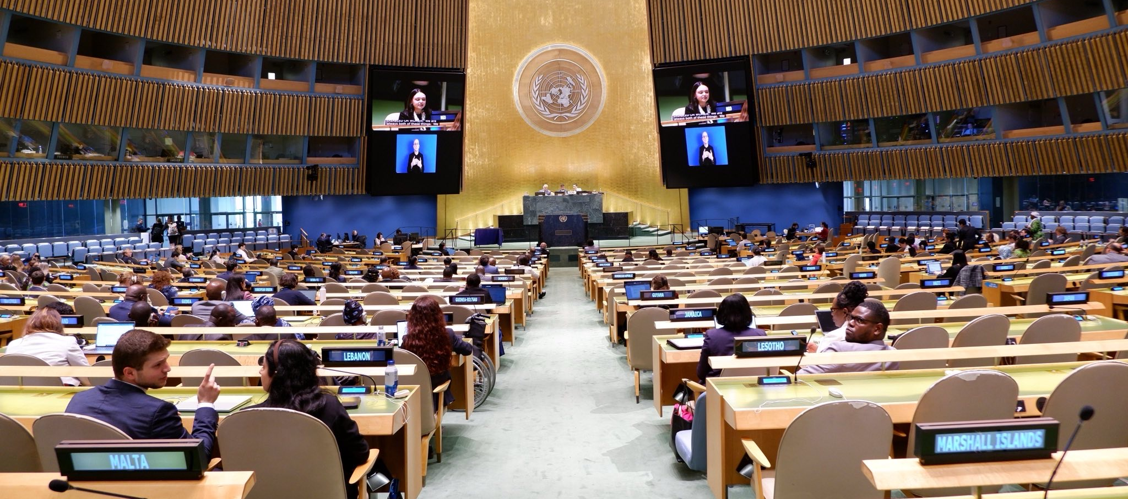

Image: Sophie Cusworth speaking in session at COSP18.

10 – 12 June 2025
New York City, New York, USA
Women With Disabilities Australia (WWDA), July 2025

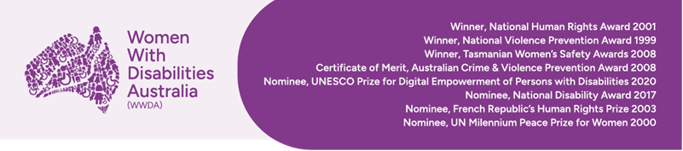

Publishing information
The moral rights of the authors have been asserted.
Women With Disabilities Australia (2025, July) ‘Report: The 18th Session of the United Nations Conference of States Parties on the Convention on the Rights of Persons with Disabilities (COSP18)’. WWDA: Melbourne, Victoria.

Acknowledgements
WWDA acknowledges the traditional owners of the land on which this publication was produced. We acknowledge Aboriginal and Torres Strait Islander people’s deep spiritual connection to this land. We extend our respects to community members and Elders past, present and emerging.
This document was written by Sophie Cusworth, for and on behalf of Women With Disabilities Australia.
WWDA receives part of its funding from the Australian Government, Department of Social Services (DSS). WWDA acknowledges and thanks DSS for its support.

Contact
Sophie Cusworth (Chief Executive Officer, Women With Disabilities Australia)
E: officeadmin@wwda.org.au

Disclaimer
The views and opinions expressed in this publication are those of Women With Disabilities Australia (WWDA) and not necessarily those of our functioning bodies. All possible care has been taken in the preparation of the information contained in this document. WWDA disclaims any liability for the accuracy and sufficiency of the information and under no circumstances shall be liable in negligence or otherwise in or arising out of the preparation or supply of any of the information aforesaid.
This work is copyright. Apart from any use as permitted under the Copyright Act 1968 (Cth), no part may be reproduced without written permission from Women With Disabilities Australia.
© 2025 Women With Disabilities Australia (WWDA).
ABN: 23 627 650 121

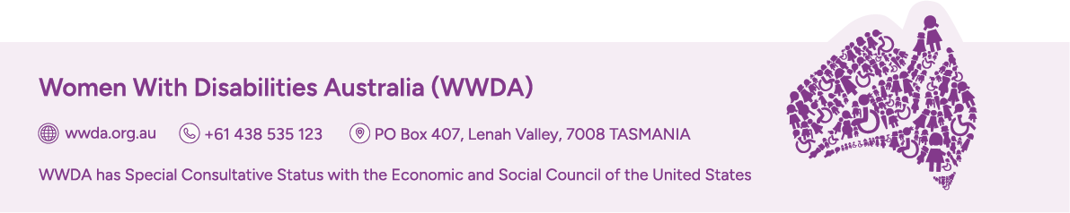

About Women With Disabilities Australia (WWDA)
Women with Disabilities Australia (WWDA) is the National Disabled People’s Organisation (DPO) and National Women’s Alliance (NWA) for women, girls, feminine identifying, and non-binary people with disabilities in Australia. As a DPO and an NWA, WWDA is governed, run, led, staffed by, and constituted of, women, girls, feminine identifying, and non-binary people with disabilities. Our organisation operates as a transnational human rights organisation - meaning that our work, and the impact of our work, extends beyond Australia. WWDA’s work is grounded in a human-rights based framework which links gender and disability issues to a full range of civil, political, economic, social and cultural rights.
WWDA uses the term ‘women and girls with disabilities’, on the understanding that this term is inclusive and supportive of women and girls with disability along with feminine-identifying and non-binary people with disability in Australia.
Organisations of Persons with Disabilities (OPDs) are recognised around the world, and in international human rights law, as self-determining organisations led by, controlled by, and constituted of, people with disability. OPD’s are organisations of people with disability, as opposed to organisations which may represent people with disability. The United Nations Committee on the Rights of Persons with Disabilities has clarified that States should give priority to the views of OPDs when addressing issues related to people with disability. The Committee has further clarified that States should prioritise resources to organisations of people with disability that focus primarily on advocacy for disability rights and, adopt an enabling policy framework favourable to their establishment and sustained operation.¹

¹ Committee on the Rights of Persons with Disabilities (2018) General comment No. 7, UN Doc No. CRPD/C/GC/7.

Introduction
Women With Disabilities Australia (WWDA) Chief Executive Officer, Sophie Cusworth, recently attended the 18th Session of the Conference of States Parties to the Convention on the Rights of Persons with Disabilities (COSP18) at the United Nations Headquarters in New York, 10–12 June 2025. WWDA’s participation was funded by the Australian Government through the Supporting Participation Program, which enables people with disability and their representative organisations to contribute to international disability rights forums.

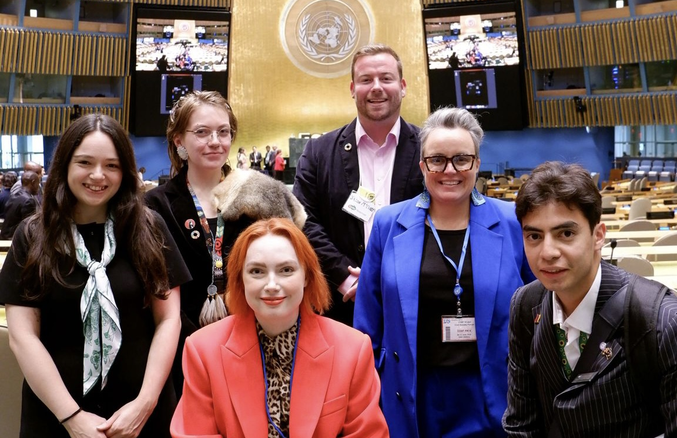
Image: Delegates in session at COSP18. From left to right: Sophie Cusworth (CEO, WWDA), Gi Brown (CYDA delegate/advocate), Elly Desmarchelier (QAI delegate/advocate), Jason McCurry (Programs Manager, CYDA), Clare Gibellini (Policy Officer, WWDA attending as an NDRP delegate), and Alexander Tofler (AFDO delegate/advocate).

About COSP
The Conference of States Parties (COSP) is an annual meeting where Governments that have signed up to the Convention on the Rights of Persons with Disabilities (CRPD) discuss human rights issues. It brings together governments, Disabled People’s Organisations, civil society, and international agencies to review progress and advance disability rights globally.
The theme for COSP18 was “Enhancing public awareness of the rights and contributions of persons with disabilities for social development leading up to the Second World Summit for Social Development”. It also focused on three sub-themes:
- Empowering persons with disabilities and enhancing social development policies through innovative financing,
- Leaving no one behind: using AI as a tool for supporting inclusivity to strengthen the participation of persons with disabilities,
- Recognising and addressing the rights of Indigenous persons with disabilities and their role in advancing disability inclusion.
Sophie was selected to attend alongside a number of other Australian representatives. As a WWDA delegate, she contributed an intersectional perspective, advocating for the inclusion of gender in disability rights discussions.

Participation in the Civil Society Forum
Before the official proceedings of COSP, delegates had the opportunity to attend the Civil Society Forum. The Civil Society Forum was hosted by the International Disability Alliance, as a way to facilitate discussions among civil society representatives (including NGOs and Disabled People’s Organisations). The sessions followed the themes for COSP, with the addition of a session on the impact of anti-diversity political narratives and the Global Financial Situation on the work of the disability community.
At the Civil Society Forum, Sophie read a statement on behalf of WWDA member Tahlia-Rose Vanissum, a Woppaburra woman and First Nations and Gender Justice advocate. The statement addressed the misalignment of Western disability models with Indigenous ways of being, the impacts of colonisation on cultural values of care, reciprocity and collective responsibility, inequitable access to justice and services, and the distance between mainstream feminist and disability rights movements and the priorities of First Nations communities.

Participation at COSP18
Sophie had the opportunity to deliver an intervention during the General Debate, emphasising the need for intersectional approaches and the meaningful participation of women and girls with disabilities. She called for States Parties to implement human rights legislation with positive duties, embed intersectionality in policy-making, and reject anti-gender and anti-rights rhetoric. She also attended roundtables on the sub-themes of COSP.
Sophie also had the opportunity to attend a number of side events, including:
- 20 Years of UNCRPD: Addressing Multiple and Intersectional Forms of Discrimination and Stigma against Women and Girls with Disabilities (UN Women),
- Ending Restrictive Practices Against First Nations People with Disability (People with Disability Australia),
- Inclusive Motherhood: Breaking Barriers, Empowering and Advocating for the Equal Reproductive Rights of Women with Disabilities (Permanent Mission of Lithuania),
- Standing Up for Disability Inclusion & Funding in a Time of Adversity: A Global Response from the US Disability Community (Disability Rights International and US International Council on Disabilities),
- Global Voices, Local Impact: Future of Women Leaders with Disabilities in Advancing Disability Rights (Sightsavers, UN Women, UNFPA, and UNOHCR), and
- Workshop: Gender on the Legal Capacity Agenda (Women Enabled International)
Throughout these events, Sophie was able to connect with advocates and organisations of women and gender-diverse people with disability from around the world, and learn about local advocacy efforts and policy solutions.

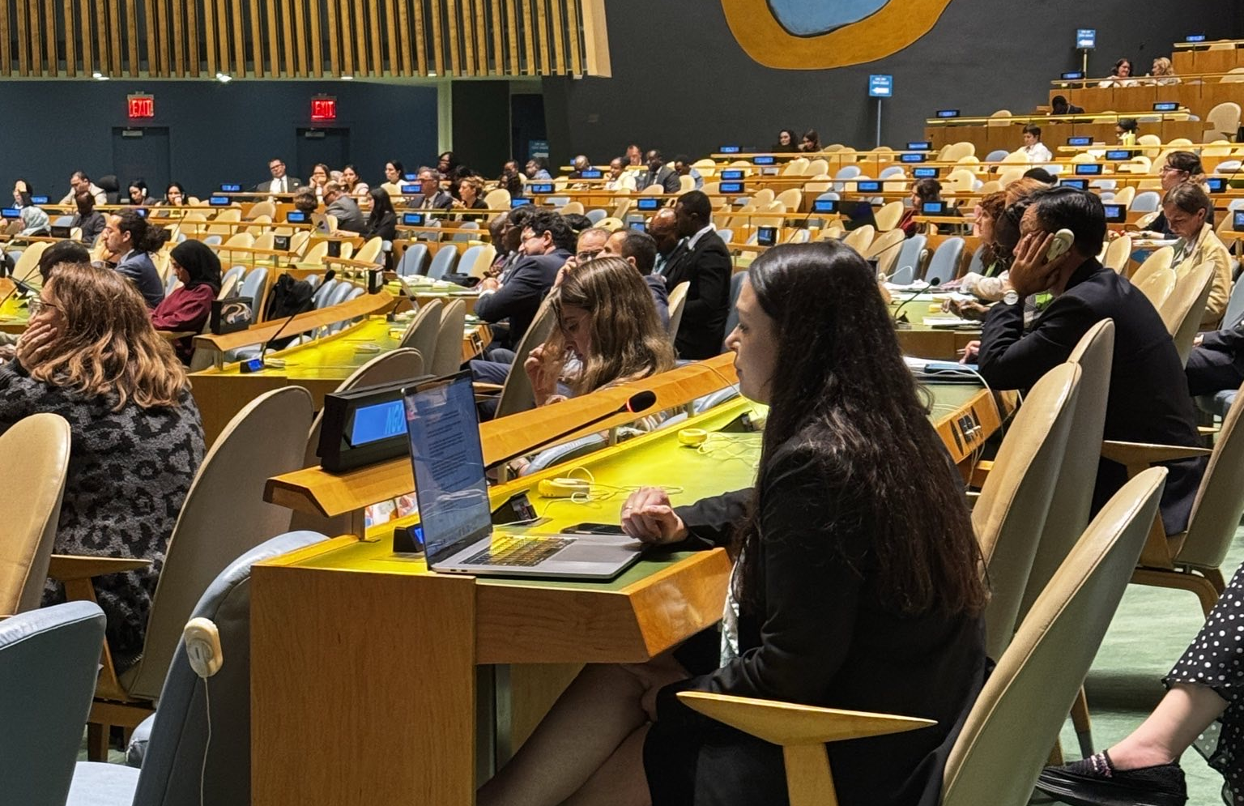
Image: Sophie Cusworth sitting in session at COSP18.

Outcomes
Through participation at COSP18, WWDA had the opportunity to:
- Raise the profile of women and girls with disabilities in global policy discussions,
- Highlight the importance of intersectionality, especially regarding gender,
- Hear from governments and Disabled People’s Organisations from across the world,
- Learn about best practices in advancing disability rights in other jurisdictions,
- Share Australian perspectives, initiatives and innovations,
- Share about WWDA’s advocacy and resources, and
- Build connections for future collaboration.
WWDA’s attendance at COSP18, supported by the Supporting Participation Program, ensured that the voices and priorities of women and girls with disabilities were represented at the highest international level. Our contributions reinforced the need for inclusive, intersectional, and rights-based approaches to disability policy and practice to promote the rights of people with disability across the globe. Collaborative discussions allowed for mutual exchange of ideas, strategies for advocacy, and policy solutions to promote the rights of women, girls and gender-diverse people with disabilities in both international and national contexts.

