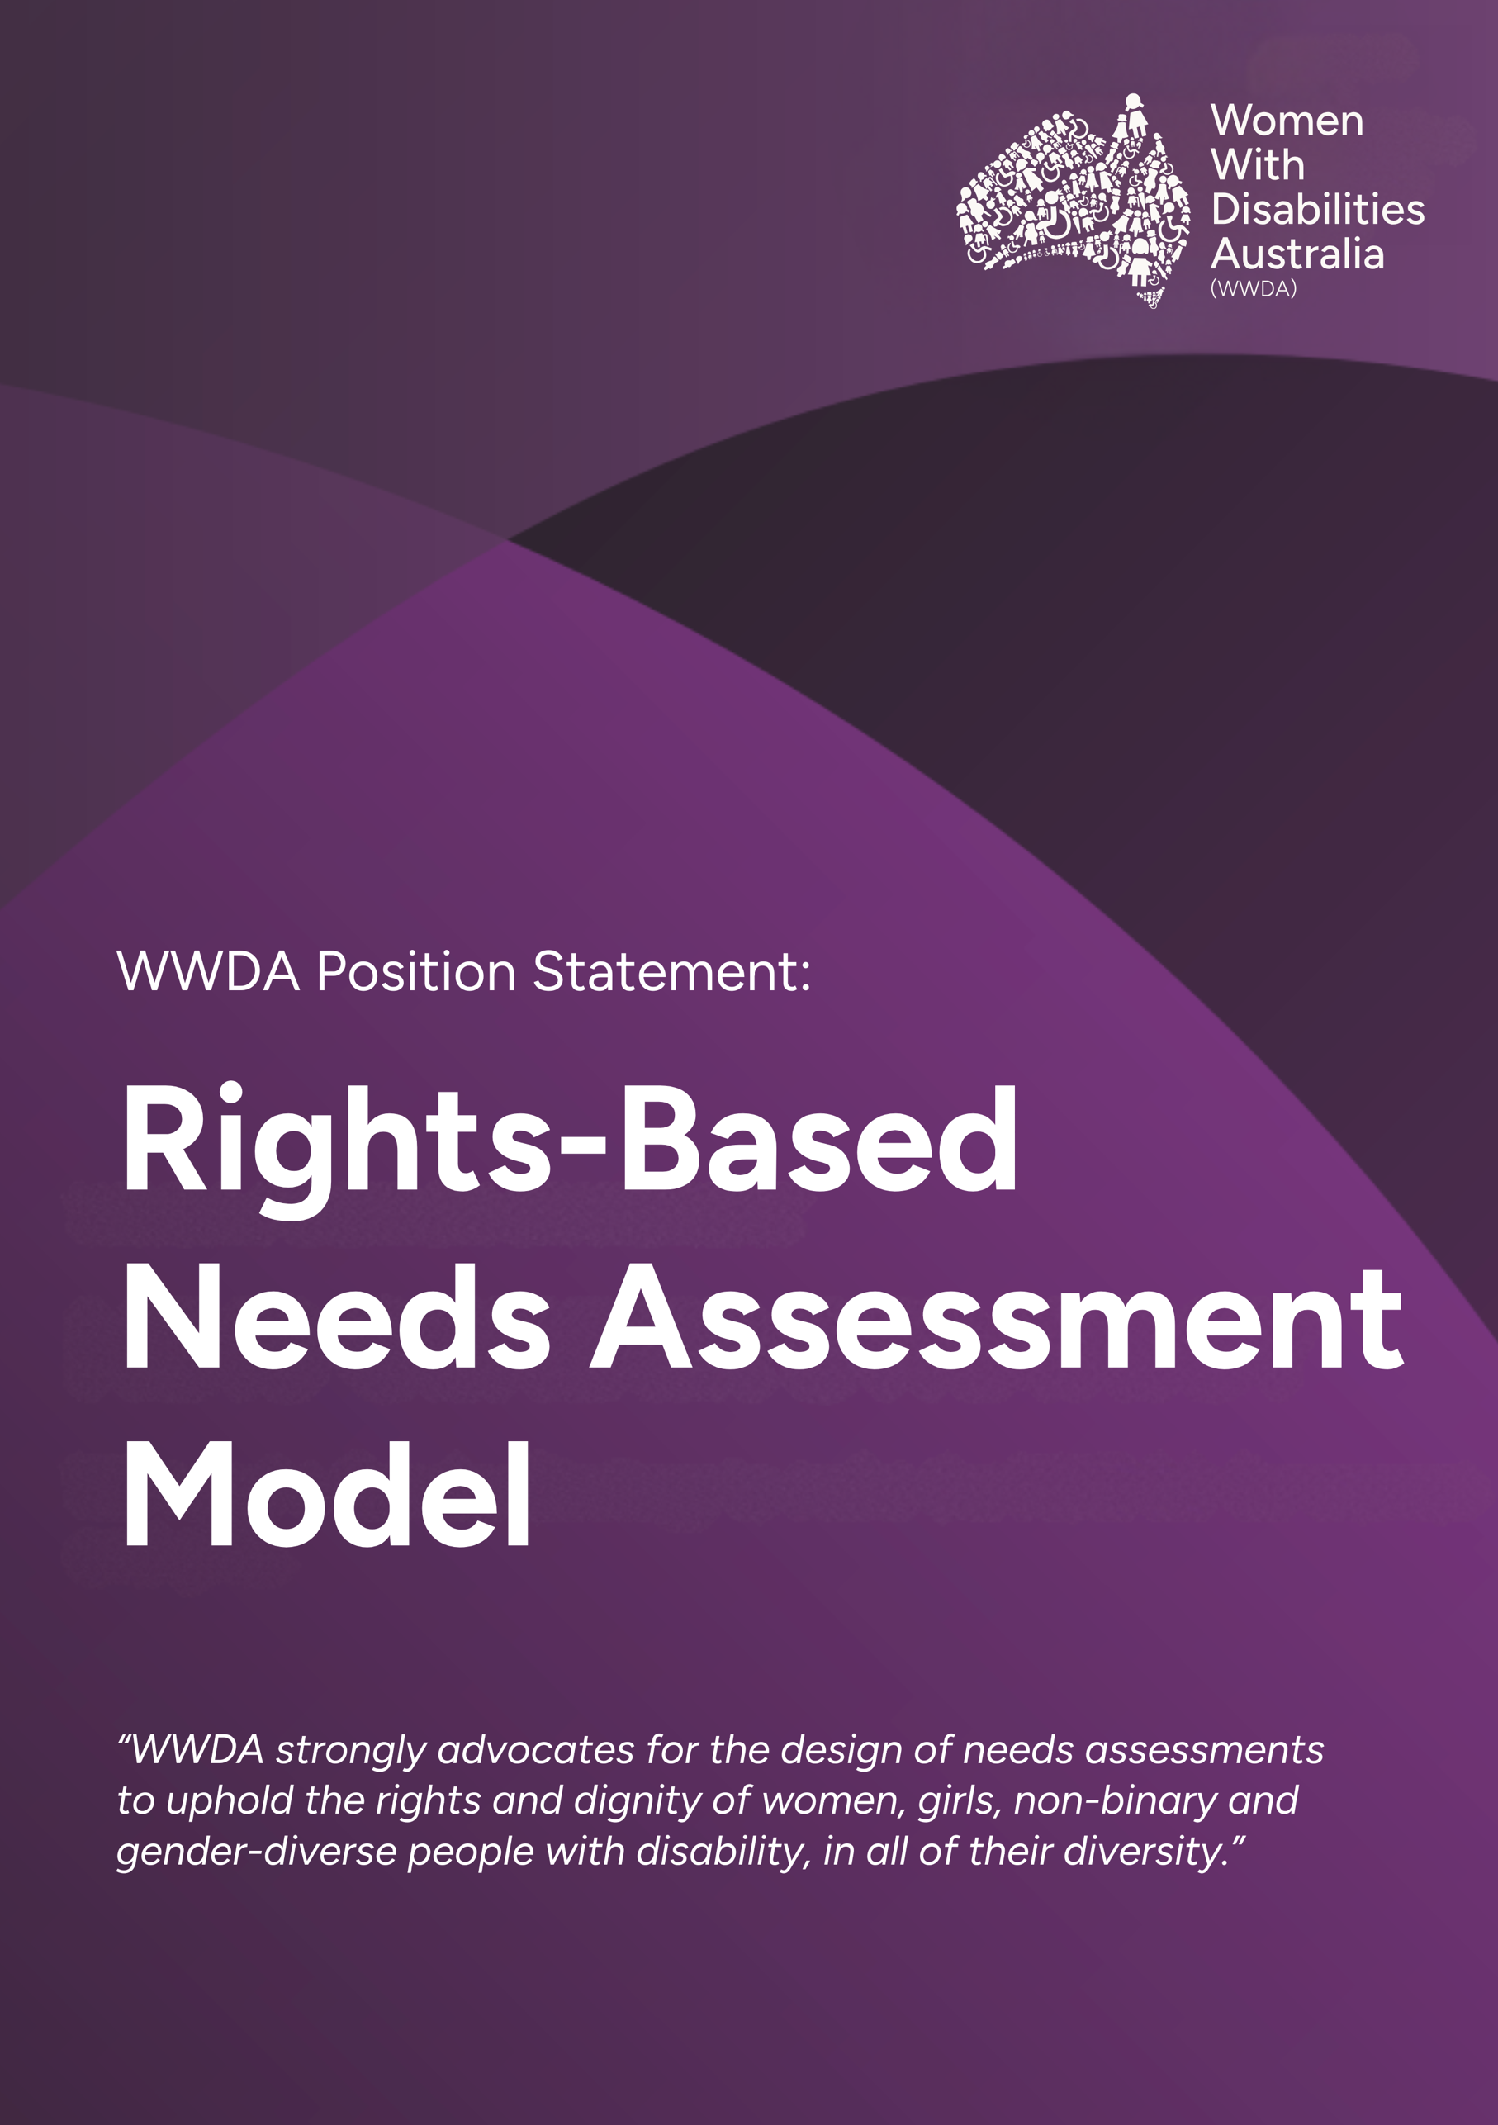

POSITION STATEMENT: Women With Disabilities Australia
Human Rights-based Needs Assessment Model

Women With Disabilities Australia (WWDA) acknowledges the Australian Government's commitment to reforming the National Disability Insurance Scheme (NDIS) and recognises the need for fair, transparent, and consistent decision-making processes in needs assessments. In keeping this commitment, WWDA strongly advocates for the design of needs assessments to uphold the rights and dignity of women, girls, non-binary and gender-diverse people with disability, in all of their diversity.
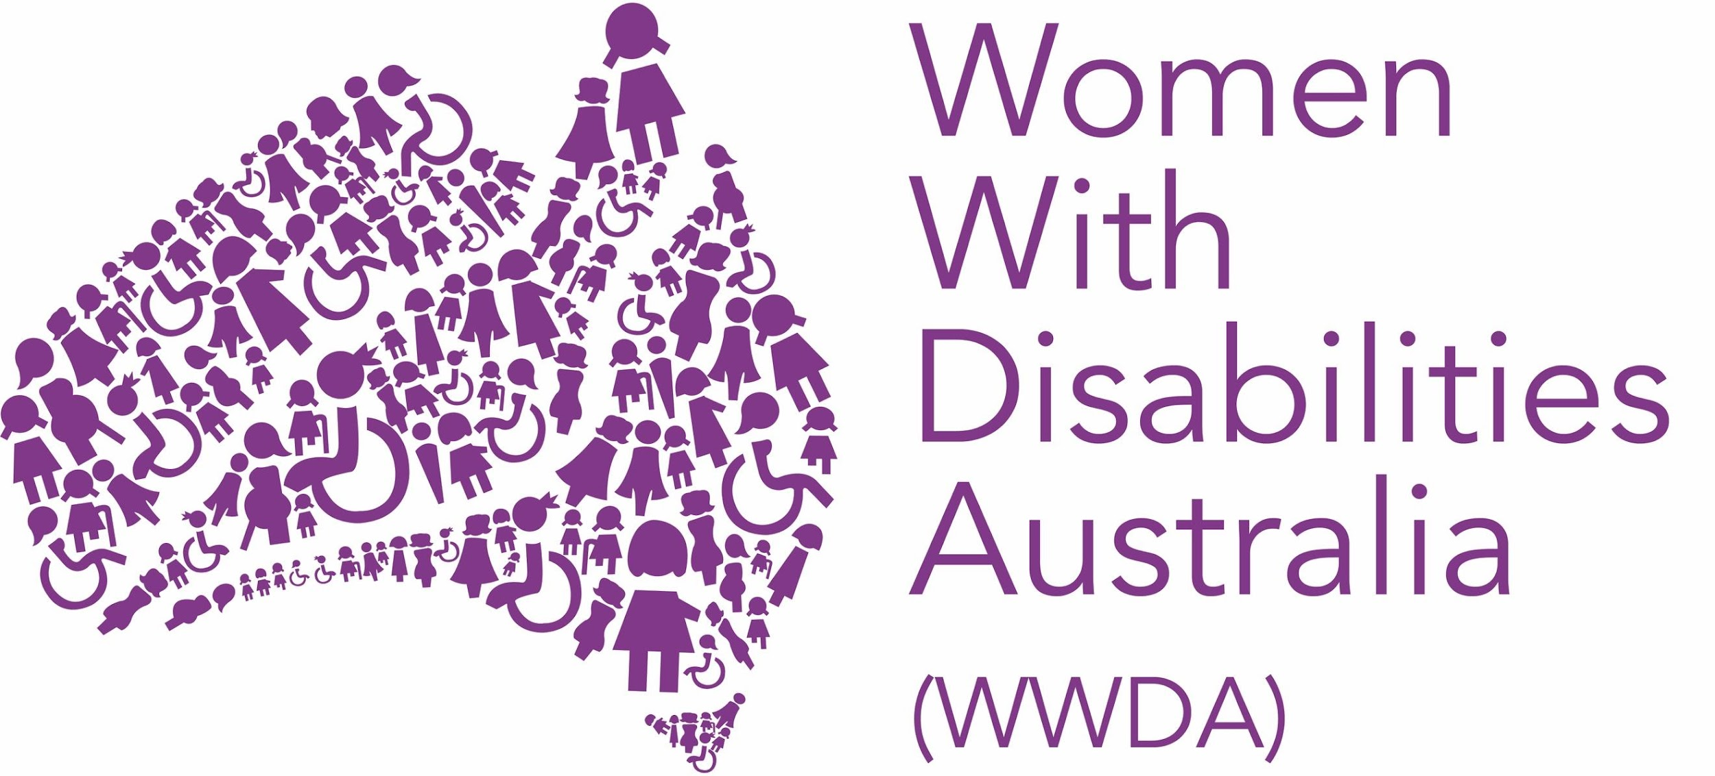
In this position statement, WWDA outlines key principles for a human rights-based needs assessment model, identifies critical issues that must be addressed, and provides recommendations for implementation. Our goal is to ensure that the needs assessment process is equitable, person-centred, and truly reflective of the varied needs of the disability community. We aim to work constructively with the Government to develop a gender responsive, human rights-based model of needs assessment that reflects the diversity of our members.

The issue
From age 15, the likelihood of NDIS access is gendered. Male access requests are approved at far higher rates than female applicants and those gendered ‘other’ by the NDIA. Despite women comprising of approximately half of Australians with disabilities, we represent only 37% of NDIS participants. This underrepresentation stems from various systemic barriers, including gender biases in disability diagnosis, the NDIS's emphasis on conditions more frequently diagnosed in males, and societal expectations that can hinder women's self-advocacy. Scheme data also indicates that from age 15, female participants receive smaller budgets for supports than male participants. WWDA is concerned that this reflects a failure of the current needs assessment and planning processes, to be responsive to the support needs of women, girls, non-binary and gender diverse people.
1 of 7
Women with disabilities often face compounded disadvantages, experiencing higher rates of poverty, unemployment, and social isolation. WWDA have led the call for the NDIA to adopt a Gender Strategy to address these issues. We remain concerned that these conditions may be further entrenched without a gender responsive, human rights-based model of needs assessment.

What we know
On December 17, 2024, the Government released a statement regarding progress in implementing NDIS reforms. These updates include a commitment to deliver support needs assessments at no cost to people with disability and their families, the establishment of a dedicated multi-disciplinary workforce to conduct these assessments, and funding for consultation and design towards a new early intervention pathway for children under 9. While elements of these developments are promising, WWDA maintains a cautious stance on their implementation.

Key principles for a human rights-based model of needs assessment
WWDA advocates for a needs assessment model that is socio-contextual and human rights-based, in line with the United Nations Convention on the Rights of Persons with Disabilities (UNCRPD). This approach focuses on the interaction between disability and environmental barriers, rather than solely on medical diagnosis or individual functioning. It is crucial that the assessment process recognises the diverse experiences of people with disability, particularly the specific barriers faced by women, girls, non-binary and gender-diverse people.
WWDA advocates for a needs assessment model that:
- Recognises intersectionality and diversity.
The assessment process must be responsive to the needs of marginalised communities and address systemic biases. This includes considering gender-specific experiences and barriers faced by women, girls, non-binary and gender-diverse people with disability.
- Ensures active participation of people with disability and their support networks.
People with disability must be involved in generating evidence for their own assessments. This should include peer-supported self-assessment options and providing draft assessment reports to participants for review and amendment before finalisation. For people with complex support needs, the needs assessment process must include the people that know them best.
2 of 7
2
- Equally weights lived experience alongside other forms of evidence.
In establishing needs, self-assessment components must be considered with equal weight alongside other forms of evidence provided by healthcare or other trusted professionals and independent assessors.
- Accounts for fluctuating and episodic disability.
Assessments must recognise that some experiences of disability are episodic and may vary based on different environments and circumstances.
- Considers environmental factors and is responsive to life course changes.
Assessments should examine how various environments and life experiences facilitate or limit a person's ability to perform daily activities and participate in society. This must account for regionality/ rurality, experiences of violence and changing circumstances, for example parenting responsibilities, key education and employment transitions as well as changes through the lifespan (including puberty and menopause).

What would this look like?
On February 5, 2025 the NDIA announced a ‘Request for Tender’ for adult support need assessment tools (16 years and over) and a ‘Request for Information’ for understanding children's support needs. This marks the beginning of a five-year transition, said to be aimed at improving the fairness and equity of NDIS budgets. The new approach seeks to reduce the burden on participants by eliminating the need for self-sourced reports and evidence, which the Agency says will lead to more equitable budgets and greater flexibility in support arrangements. However, the effectiveness of these changes will depend on ongoing engagement with the disability community.
The Explanatory Memorandum of the NDIS Bill 1 intended for the support needs assessment to be “co-designed with the disability community” to ensure “needs are assessed in a holistic and sensitive way”. Additionally, the NDIS Review emphasised the importance of a “whole of person” approach. WWDA is concerned that these intentions may be compromised by the tight timelines for reform proposed. There is no single tool that could accurately determine needs for the broad range of disability experiences. In considering existing validated tools through the information gathering process, WWDA urges the Government to exercise caution in selecting 'off the shelf' tools that may reproduce medical biases affecting our community.
3 of 7
The disability community must remain involved in selecting the tools for use by independent Needs Assessors who are recruited by the NDIA. Likewise, we recommend that use of any approved tools form only one of a three-part Needs Assessments process, consistent with recommendations of the NDIS Review Co-Group.
- Self-Assessment
Incorporating self-assessment as a form of evidence in determining needs aligns with the commitment of the NDIS to supporting active participation and control. WWDA is concerned that people with disabilities are more likely to under-estimate their needs. This is particularly acute for women and girls, who are socialised to understate their needs in situations where negotiation is required. Recognising disabled people as authorities in living with disabilities and valuing lived experience requires self-assessment to be given equal weighting alongside other forms of evidence.
- Engagement with existing trusted professionals and support networks
For many people with disabilities, particularly women, it takes years to develop a trusted relationship with the health and other professionals in their lives. Further, it can take considerable time for health professionals to develop a comprehensive understanding of the person’s condition and needs. The needs assessment must engage with existing health and allied professionals, and anyone else the person requests.
- Independent needs assessment paid for by the NDIA
The independent person conducting the needs assessment must have specific qualifications, skills and training to fulfil the role. This must include the skills to conduct assessments that are gender-specific, culturally sensitive, trauma-informed, disability-specific and rooted in human rights principles of dignity, equality and mutual respect.
4 of 7

Recommendations for implementation
To address these concerns and ensure a gender responsive human rights-based approach to needs assessments, WWDA recommends:
- Ongoing commitment to co-design throughout the process: Ensure genuine co-design mechanisms are established with people with disability, including women, girls, and gender-diverse people. Co-design should underpin the development of processes for assessment, approved tools, and be maintained throughout the implementation and ongoing evaluation process.
- Piloting, evaluation and gradual implementation: Implement a comprehensive piloting phase with diverse cohorts of people with disability before full rollout, with transparent evaluation and adjustment processes. Ensure there is a gradual implementation timeline to allow for thorough testing and refinement of the Needs Assessment model.
- Independent assessor experience and training: Work in partnership with Disability Representative Organisations (DROs) to agree on comprehensive training requirements and recruitment processes for assessors, prioritising those with lived experience of disability and ensuring gender diversity. Assessors must have demonstrated experience with the specific form of disability they are assessing. WWDA acknowledges that many people with disabilities experience barriers to higher education. We strongly recommend that pathways for entry into these roles prioritise people with disabilities themselves, who have had experience working with other people with disabilities, and comprehensive training, over specific tertiary qualifications.
- Flexibility in assessment process: Allow for multiple tools that reflect diverse disability experiences to inform independent assessments. These should be undertaken on terms negotiated with participants, including funding appropriate time for completion.
5 of 7
- Equally weighted self-assessments: The view of the independent assessor should not be prioritised above evidence from existing practitioners and participants’ own self-assessment of needs. These forms of evidence should be interpreted holistically in maintaining the NDIA’s commitment to a person-centred approach.
- Draft assessments reviewed: People must be able to review the draft of the needs assessment prepared independently, before it is finalised and sent to the NDIA. This ensures there is the opportunity to correct any misunderstandings that could result in delayed access to critical supports.
- Transparency and accountability: Develop clear guidelines on how assessment results will be used to determine budgets, with ongoing monitoring and evaluation of outcomes made public.
- Appeals process: Establish a robust, accessible, and independent appeals process for assessment outcomes. There must be a clear process that allows the person to request a re-assessment.

Conclusion
WWDA is committed to working constructively with the Government to develop a needs assessment model that upholds the rights, dignity, and diverse experiences of women, girls, and non-binary and gender-diverse people with disability. The critical issues outlined must be addressed to create a fair, transparent, and person-centred assessment process that truly supports the goals of the NDIS. WWDA will continue to collaborate with DROs and Government in consultation and co-design processes to ensure that the voices and experiences of our members are central the design of Needs Assessments.

6 of 7

References
7 of 7

Piantedosi, D., Molnar, L., Panisset, M., Wilding, R. (2024). There is overwhelming gender bias in the NDIS – and the review doesn't address it. The Conversation. https://theconversation.com/there-is-overwhelming-gender-bias-in-the-ndis-and-the-review-doesnt-address-it-220042
Yates, S., Carey, G., Malbon, E., & Hargrave, J. (2022). Women make up half the disability population but just over a third of NDIS recipients. The Conversation. https://theconversation.com/women-make-up-half-the-disability-population-but-just-over-a-third-of-ndis-recipients-173747
Yates, S., Carey, G., Hargrave, J., Malbon, E., & Green, C. (2021). Women’s experiences of accessing individualized disability supports: gender inequality and Australia’s National Disability Insurance Scheme. International Journal for Equity in Health, 20: 243, 1- 14. https://doi.org/10.1186/s12939-021-01571-7
National Disability Insurance Agency [NDIA], (2024). Quarterly Reports, Table E.107: Average annualised committed supports and average payments by gender and age group as at 30 September 2024 – National. https://dataresearch.ndis.gov.au/reports-and-analyses/quarterly-report-supplements.
Women With Disabilities Australia [WWDA]. (2024). WWDA's Position Statement: NDIS Gender Strategy. https://wwda.org.au/our-resources/publication/wwdas-position-statement-ndis-gender-strategy/
Department of Social Services [DSS] (2024). Putting participants back at the centre of the NDIS. https://ministers.dss.gov.au/media-releases/17186
Waddington, L., & Priestley, M. (2021). A human rights approach to disability assessment. Journal of International and Comparative Social Policy, 37(1), 1-15, doi:10.1017/ics.2020.21; Yates, S., Carey, G., Hargrave, J., Malbon, E., & Green, C. (2021). Women’s experiences of accessing individualized disability supports: gender inequality and Australia’s National Disability Insurance Scheme. International Journal for Equity in Health, 20: 243, 1- 14. https://doi.org/10.1186/s12939-021-01571-7
Ibid
National Disability Insurance Agency [NDIA], (2025). New tools to better understand participants’ support needs. https://www.ndis.gov.au/news/10581-new-tools-better-understand-participants-support-needs
Parliament of Australia. (2024). National Disability Insurance Scheme Amendment (Getting the NDIS Back on Track No. 1) Bill 2024. https://parlinfo.aph.gov.au/parlInfo/search/display/display.w3p;query=Id%3A%22legislation%2Fems%2Fr7181_ems_f83281ef-0f46-4fbb-a59f-2e19439dcacb%22
National Disability Insurance Scheme Review. (2023). Working Together to Deliver the NDIS: Final Report. https://www.ndisreview.gov.au/resources/reports/working-together-deliver-ndis
NDIS National Disability Insurance Scheme Review. (2023). Working Together to Deliver the NDIS: Supporting Analysis. https://www.ndisreview.gov.au/resources/reports/working-together-deliver-ndis-supporting-analysis
Yates, S., Carey, G., Hargrave, J., Malbon, E., & Green, C. (2021). Women’s experiences of accessing individualized disability supports: gender inequality and Australia’s National Disability Insurance Scheme. International Journal for Equity in Health, 20: 243, 1- 14. https://doi.org/10.1186/s12939-021-01571-7

