Asia-Pacific Ministerial Conference on

the Beijing+30 Review

Post Event Report

November 2024
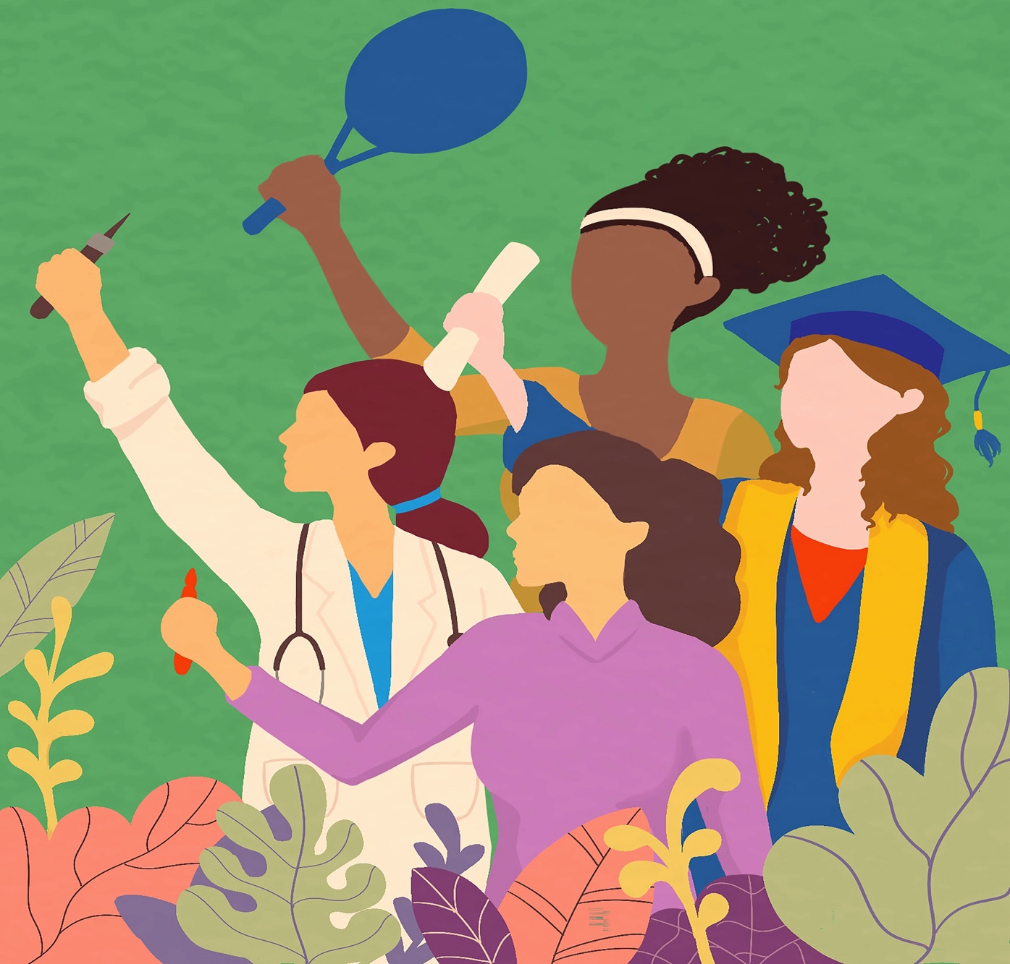
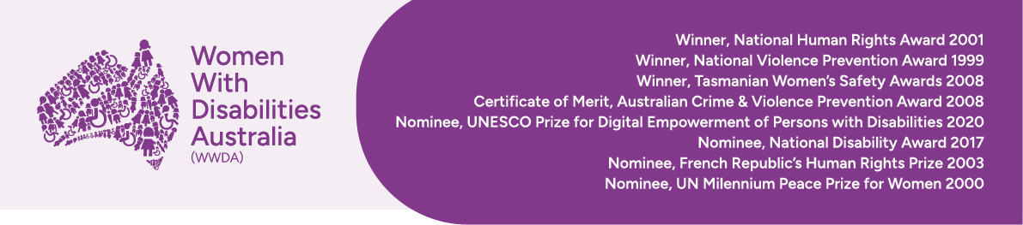

Publishing Information

Women With Disabilities Australia (WWDA) (2024). Asia-Pacific Ministerial Conference on
the Beijing+30 Review Post-Event Report December 2024. WWDA: Hobart, Tasmania.

Acknowledgments

WWDA acknowledges the traditional owners of the land on which this publication was produced. We acknowledge Aboriginal and Torres Strait Islander people’s deep spiritual connection to this land. We extend our respects to community members and Elders past, present and emerging.

This document was written by Clare Gibellini, for and on behalf of Women With Disabilities Australia (WWDA).

Cover Image: Untitled Artwork from the Beijing +30 Digital Art Competition.

Women with Disabilities Australia (WWDA) receives part of its funding from the Australian Government, Department of Social Services (DSS). WWDA acknowledges and thanks DSS for its support.

Contact

Women with Disabilities Australia (WWDA)
PO Box 407, Lenah Valley, 7008 Tasmania, Australia
Phone: +61 438 535 123
Email: officeadmin@wwda.org.au
Web: www.wwda.org.au
Facebook: www.facebook.com/WWDA.Australia
Twitter: www.twitter.com/WWDA_AU

Disclaimer

The views and opinions expressed in this publication are those of Women with Disabilities Australia (WWDA) and not necessarily those of our funding bodies. All possible care has been taken in the preparation of the information contained in this document. WWDA disclaims any liability for the accuracy and sufficiency of the information and under no circumstances shall be liable in negligence or otherwise in or arising out of the preparation or supply of any of the information aforesaid.

This work is copyright. Apart from any use as permitted under the Copyright Act 1968, no part may be reproduced without written permission from Women With Disabilities Australia (WWDA).

© 2021 Women With Disabilities Australia (WWDA).

ABN: 23 627 650 121

About Women With Disabilities Australia (WWDA)

Women With Disabilities Australia (WWDA) is the award winning, national Disabled People’s Organisation (DPO) and National Women’s Alliance (NWA) for women, girls, feminine identifying and non-binary people with disabilities in Australia. As an OPD, WWDA is run by and for women, girls, feminine identifying and non-binary people with disability.

WWDA uses the term ‘women and girls with disability’, on the understanding that this term is inclusive and supportive of women and girls with disability along with feminine identifying and non-binary people with disability in Australia.

WWDA represents more than 2 million women and girls with disability in Australia, has affiliate organisations and networks of women with disability in most States and Territories, and is recognised nationally and internationally for our leadership in advancing the rights and freedoms of all women and girls with disability. Our organisation operates as a transnational human rights organisation - meaning that our work, and the impact of our work, extends much further than Australia. WWDA’s work is grounded in a human-rights based framework which links gender and disability issues to a full range of civil, political, economic, social and cultural rights.

Organisations of Persons with Disabilities (OPDs) are recognised around the world, and in international human rights law, as self-determining organisations led by, controlled by, and constituted of, people with disability. OPD’s are organisations of people with disability, as opposed to organisations which may represent people with disability. The United Nations Committee on the Rights of Persons with Disabilities has clarified that States should give priority to the views of OPDs when addressing issues related to people with disability. The Committee has further clarified that States should prioritise resources to organisations of people with disability that focus primarily on advocacy for disability rights and, adopt an enabling policy framework favourable to their establishment and sustained operation.

Contents

Asia-Pacific Ministerial Conference on 1
the Beijing+30 Review 1
Post Event Report 1
November 2024 1
Publishing Information 2
Acknowledgments 2
Contact 2
Disclaimer 2
3
About Women With Disabilities Australia (WWDA) 3
Contents 4
1. Introduction 5
2. Key Activities 7
Preparatory activities, meetings, and networking. 7
Official program and related activities 7
Other meetings and networking 13
3. Individual Experience – Clare Gibellini 14
4. Outcomes for WWDA 15
5. Language Shifts and Emerging Concerns 16
5. Appendices 17
Appendix A. CSO Forum Climate Change Round Table Report 17
Appendix B. Australia – Beijing+30 Regional Review Meeting - National Statement 18
Appendix C. Making Rights Real for Women at the Margins (panellist comment – Clare Gibellini) 19
Appendix D. Speakers Corner Comments – Clare Gibellini 21
Appendix E. Women with Disabilities Statement 23

1. Introduction

In November 2024, Women with Disabilities Australia (WWDA) staff member Clare Gibellini attended the Asia-Pacific Ministerial Conference on the Beijing+30 Review and the preceding Civil Society Forum held in Bangkok, Thailand from the 17th to 21st of November, as a member of the Australian Government delegation, representing WWDA. It marked the 30th anniversary of the Fourth World Conference on Women and the adoption of the Beijing Declaration and Platform for Action (1995)

The Australian delegation was led by Ms Padma Raman PSM, Executive Director of the Office for Women, representing Senator the Hon. Katy Gallagher, Minister for Women. Other members included:
- Ms Stephanie Copus Campbell, Australia's Ambassador for Gender Equality
- Dr Anna Cody, Australia's Sex Discrimination Commissioner
- Ms Joslyn Eades-Tass, National Aboriginal and Torres Strait Islander Women’s Alliance

Convened by the United Nations Economic and Social Commission for Asia and the Pacific (ESCAP) in collaboration with UN Women Regional Office for Asia and the Pacific, the conference brought together ministers, senior officials, representatives from civil society organisations, youth organisations, academia, the private sector, UN entities, and other key stakeholders from across the Asia-Pacific region.

Prior to the ministerial conference, a Civil Society Organisation (CSO) Forum was held from 17 to 18 November 2024, bringing together diverse groups from across the region under the theme "Resist, Reclaim and Transform"

The forum was a vital platform for civil society engagement in the Beijing +30 process, addressing key aspects of the ongoing struggle for gender equality. Participants took part in discussions on resisting growing opposition to gender equality and deliberate restrictions on civil society spaces. They also strategised on reclaiming rights and holding institutions accountable for their actions and human rights obligations.

The Ministerial Conference aimed to achieve several key objectives. It sought to evaluate the progress made in implementing the Beijing Declaration and Platform for Action across the Asia-Pacific region over the preceding five years. The conference also focused on examining current and emerging challenges, some of which were not identified issues when the Platform for Action was initially developed such as climate change and technology-facilitated gender-based violence (TFGBV).

There were opportunities to identify good practices and determine priority actions necessary for achieving gender equality. Additionally, the conference provided a platform for participants to explore various policy options and strategies to realise gender equality goals. A crucial objective was to build regional consensus on priority actions to accelerate the implementation of existing commitments. Finally, the conference aimed to consolidate regional inputs for the upcoming sixty-ninth session of the Commission on the Status of Women, ensuring that the Asia-Pacific perspective would be well-represented in global discussions on gender equality.
The conference focused on four main thematic areas:
- Advancing women's economic empowerment through employment, decent work, social protection and entrepreneurship
- Strengthening women's participation and leadership in Asia and the Pacific
- Sustainable strategies for responding to and preventing violence against women and girls
- Accelerating gender equality through gender-transformative actions

Discussions at the conference also brought to light several persistent challenges that continue to hinder progress towards gender equality in the region. These included the disproportionate burden of unpaid care work that falls on women, significantly impacting their economic opportunities and overall well-being, and the ongoing inequalities in access to rights, opportunities, and resources, which perpetuate gender disparities across various sectors.

The critical issue of violence against women and girls, and the emergence of technology-facilitated gender-based violence was discussed at length, as was the need for more effective prevention and response strategies. Additionally, the conference addressed the growing impact of climate change and environmental challenges on women's security and well-being, recognising the unique vulnerabilities faced by women in the context of environmental degradation and climate-related disasters.

This was Clare’s first attendance at a regional review, and her participation allowed her to grow her international and Australian connections, broaden her networks, gain new skills, and solidify her existing expertise.

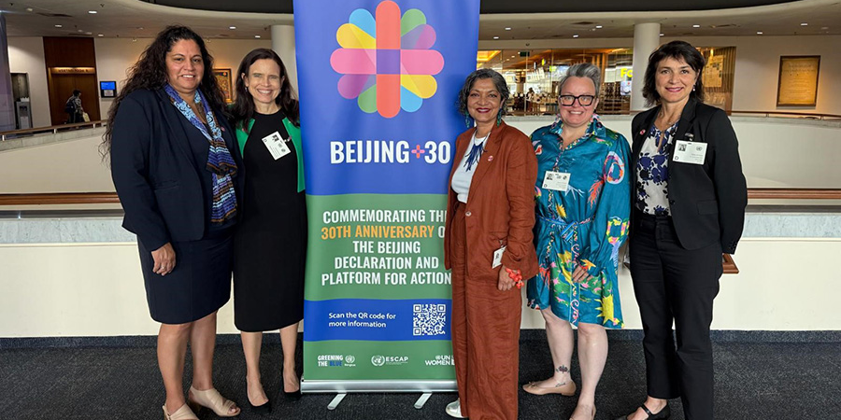

Photo: The Australian Government Delegation
L-R Joslyn Eades-Tass, Stephanie Copus Campbell, Padma Raman PSM, Clare Gibellini, Dr Anna Cody

2. Key Activities

Clare participated in both the CSO Forum and the Ministerial Conference through multiple avenues, including in-person side events, development of the statement by women and girls with disabilities, as well as attending the official program of meetings and events. These activities are outlined below.

Preparatory activities, meetings, and networking.

Prior to attending the conference, WWDA delegate Clare participated in several meetings organised by the National Women’s Alliance to develop the Beijing+30 Australian NGO report. Further information was provided by Sophie Cusworth, CEO of WWDA. This document is a comprehensive report on the status of gender equality in Australia, focusing on the implementation of the Beijing Platform for Action (BPfA) from 2020 to 2025.

The report covers five key areas:
- Shared Prosperity and Decent Work
- Freedom from Violence
- Participation, Accountability and Gender Responsive Institutions
- Gender, Climate Change, Disasters and Environmental Management
- Peaceful and Inclusive Societies

The report concludes with recommendations for future action, emphasising the need for sustained commitment, investment in equitable policy approaches, and collaboration across government, business, and civil society to achieve gender equality in Australia.

Official program and related activities

CSO Forum - Day One

The opening of the CSO forum for the Beijing+30 Asia and the Pacific Review began with a powerful session titled "Journeying through 30 years of Beijing and Beyond," featuring representatives from the women's movement across the region. This 30-minute segment provided a comprehensive overview of the Beijing Platform for Action's journey, from its inception to the present day which was particularly informative for delegates attending a review for the first time.

Key speakers included Kumi Samuel from Women's Media Collective & DAWN, who reflected on Beijing's vision and the promise of 1995, and Cai Yiping from DAWN, who discussed the progress and challenges encountered since Beijing. The session continued with Asel Dunganaeva and Eng Chandy presenting the current reality of women's rights, followed by Villaney Remengesau from Palau Resource Institute emphasising the urgency of the present moment. Prabhleen Tuteja from The YP Foundation then outlined pathways forward to fulfill Beijing's promises.

The opening concluded with remarks from Christine Arab, Regional Director of UN Women Asia Pacific Regional Office, and Srinivas Tata, Director of the Social Development Division at ESCAP, both of whom underscored the importance of this review process and the need for continued commitment to gender equality in the region, particularly in light of global trends towards reversals of women’s rights.

Session two focused on grounding the thematic priorities of the upcoming Ministerial Conference. Facilitated by Misun Woo from APWLD and Irum Shujah from Digital Rights Foundation, this 25-minute session explored four critical areas of concern for women's rights and gender equality in the region. Sepali Kottegoda from Women and Media Collective and Asia Pacific Women's Watch addressed the crucial need for advancing women's economic justice and rights, decent work, and social protection. The session also explored strategies for boosting women's leadership, representation, and political participation, as well as approaches to end discrimination and sexual and gender-based violence against women in all their diversities.

Lastly, the discussion touched upon future-forward strategies for gender equity, with a particular focus on the pressing issues of climate change and digitalisation. The overview was designed to set the stage for in-depth discussions and strategic planning in preparation for the Ministerial Conference, to ensure that civil society perspectives and priorities were effectively represented in the Beijing +30 review process.

Following the discussions, participants moved into various sub regional caucuses, which are smaller groupings of countries within the Asia-Pacific region that come together to discuss shared priorities and challenges related to gender equality and women's empowerment. These caucuses are valuable opportunities for countries with shared geographic, cultural, or developmental contexts to collaborate effectively. They enable participants to identify common issues and priorities specific to their sub-region, creating a more focused approach to regional challenges. Clare attended the Pacific caucus facilitated by Nalini Singh (Fiji Womens Rights Movement) and Antonia Lilii (First Union)

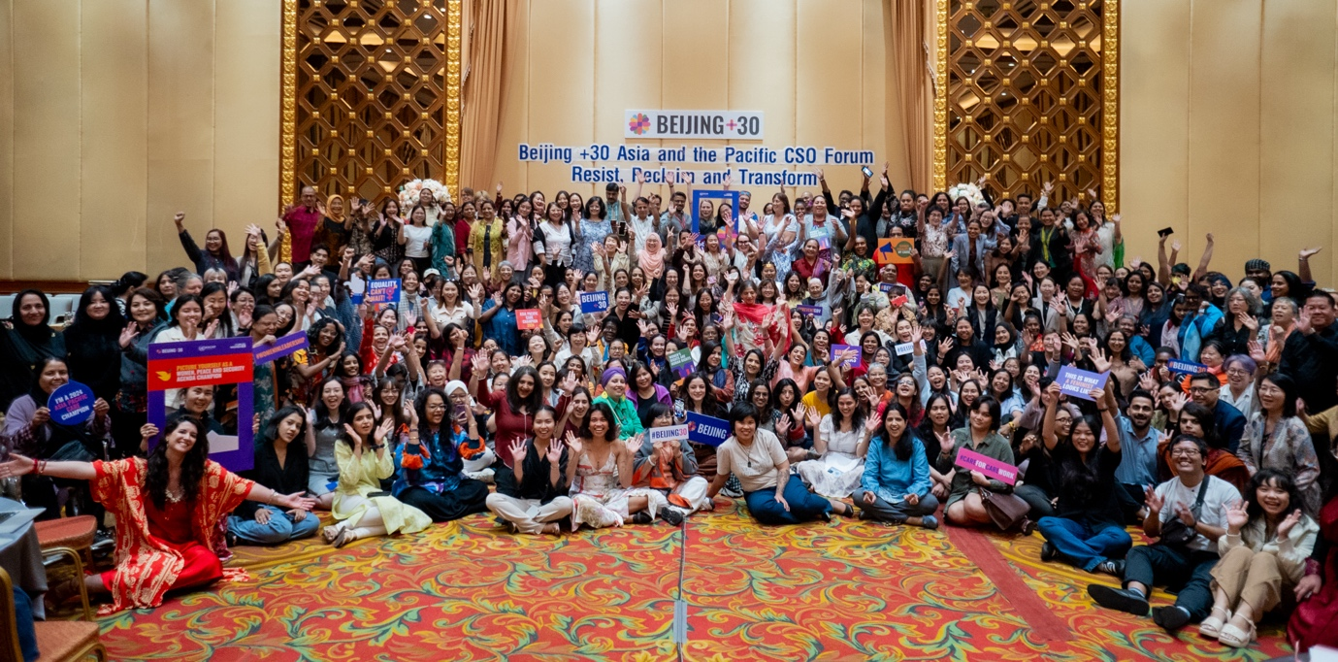
Photo: The delegation attending the Civil Society Forum

Workshops

Shifting Narratives – IPPF, One Future Collective, APASRHR and ILGA Asia
This workshop tackled anti-gender and anti-rights ideologies that have been shaped by traditional, religious and nationalist frameworks. There was a focus on challenges faced by marginalised communities such as the Dalit community in India, and undocumented migrants in the Asia Pacific region. Speakers also talked about the lack of reproductive rights and sexual health discussions in crisis settings and the intersection of economic justice, decent work and women’s choices.
Participants were given the opportunity to explore ways to challenge these barriers and create strength in the feminist movement.
These included:
- Developing strategies to shift narratives and give marginalised communities a stronger voice in public discourse
- Building consensus amongst all stakeholders to reject policies that oppress and suppress the rights of women in some communities
- Identifying narratives and stories that can be promote and advocated for in democratic spaces.

CSO Forum - Day Two

The second day of the CSO forum took place within the ESCAP building. In the morning session rapporteurs from the various Sub Regional Caucuses and workshops reported back to the wider delegation on outcomes from previous day’s activities.

From the Pacific Caucus, there were several issues identified. Women in the Pacific face significant economic challenges and persistent inequalities, the ratio of women to men in the workforce has declined with a large proportion of women engaged in informal employment. Additionally, most Pacific countries lack equal remuneration laws, with only Kiribati and the Marshall Islands having such legislation. Political representation remains low, with women holding only 20.8% of parliamentary seats in the Asia-Pacific region and it has only been this past decade that women became represented across all Pacific governing bodies. Of significant concern is the climate crisis which disproportionately affects women and girls in the Pacific, impacting their security, well-being, and access to education and clean water. The climate crisis is already leading to land loss and forced migration for many people in the region.

Gender-based violence remains a pressing issue, with many Pacific nations lacking comprehensive legislation against various forms of violence and lack of access to justice. The digital divide is significant, with the Pacific Island region having the world's lowest mobile internet penetration rate at 18%. Mental health has emerged as a critical concern, with mental disorders now being the leading health risk for girls aged 5-14 in every Pacific Island.

Following the reports, there were two moderated discussions. The first focused on linking local, regional, and global efforts towards a gender-just future and was facilitated by Alexa Johns from APA and Cai Yiping from DAWN, with prominent speakers including Sima Bahous, Executive Director of UN Women, representatives from the Beijing +30 Steering Committee, and Sharanya Sekaram from EveryStory Sri Lanka, representing the Young Feminist Forum.

The second discussion, titled "Taking the Future Forward Towards a Gender Just Asia Pacific," was facilitated by Clarice from Asia Pacific Mission for Migrant and Surbhi from The YP Foundation. This session included a plenary discussion covering various aspects of feminist engagement in multilateralism. Gita Sen from DAWN provided an overview of trends, challenges, and opportunities for the feminist movement. Maitree from Feminist Manch discussed movement building in preparation for CSW69 and the revitalisation process. Nurjan Khavdsyelyem from MONFEMNET National Network in Mongolia addressed bringing global and regional issues to the national level.

The session concluded with insights on linkages with other processes such as the Conference of Parties (COP) on Climate, International Conference on Population and Development (ICPD), and Financing for Development (FfD), presented by Dr. Yasmine from QZ Catalyst, Selita Pulini from Pasifika Network Loss and Damage, and Misun Woo from Asia Pacific Forum on Women, Law and Development.

Lastly, five 60 minute breakout sessions were held, each focusing on a particular thematic area:
- Climate Change
- Digitalisation
- Financing
- Women, peace and security
- Sexual and reproductive health rights

Clare facilitated the session on climate change, which was attended by approximately 50 people. The session looked at three key questions:
- What are the critical issues that need to be addressed?
- What are our future engagement plans / what opportunities are there for synergy?
- What support do we need (beyond funding)?

Post workshop Clare provided a report back to the wider delegation on what had been discussed in the session, which is attached to this document as Appendix A.

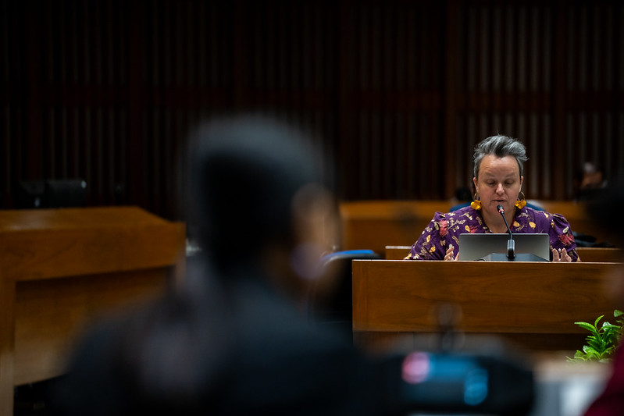
Photo: Clare delivering the report from the Climate Change Roundtable
Ministerial Conference – Day One

The conference opening session included opening addresses, election of officers, and adoption of the agenda. The Executive Secretary of ESCAP opened the session, followed by remarks from other senior officials. The Conference then elected a Chair and Vice-Chairs from among its members, after which the Chair delivered remarks and presented the provisional agenda for adoption.

From here the conference moved to agenda item 2, focusing on reviewing progress made towards the implementation of the Beijing Declaration and Platform for Action and identifying priorities for accelerated action in Asia and the Pacific. Following the panel, member States presented their national statements, followed by associate members, permanent observers, intergovernmental organisations, United Nations entities, and civil society organisations.

The afternoon session continued with country statements. As with many other UN processes, time limits were imposed to keep the proceedings on track. Ministerial-level delegates were given five minutes, other government delegates four minutes, and all other delegates three minutes.
Ms Padma Raman PSM, Executive Director, Office for Women gave the country statement for Australia (Appendix B). The statement acknowledged the need for countries to push back on those seeking to reverse the human rights of women and girls, particularly sexual and reproductive health and rights. It also outlined Australia’s progress on the BPfA implementation since the last review submitted in 2019, reflecting on the significant legislative, policy, and structural reforms that have taken place to progress gender equality in Australia.

Ministerial Conference – Day Two

The second day began with agenda item 3, which consisted of four roundtable discussions on key themes:
- women's economic empowerment through employment, decent work, social protection, and entrepreneurship.
- strengthening women's participation and leadership in Asia and the Pacific
- sustainable strategies for responding to and preventing violence against women and girls in an era of uncertainty
- accelerating gender equality through gender-transformative actions that bridge divides and smoothen key transitions.

Each roundtable included about 45 minutes of panel discussion followed by interventions from the floor.

Ministerial Conference – Day Three

The final day of the conference focused on agenda item 5. This item involved the consideration and adoption of the conference report. The draft report, document ESCAP/MCBR/2024/L.1, was presented for review and approval by the delegates.

Following the adoption of the report, the Executive Secretary delivered a closing statement. The Chair delivered closing remarks before formally concluding the session. This final day provided an opportunity for delegates to reflect on the discussions and commitments made over the previous two days. There was also a formal closing ceremony featuring local musicians and a video created over the five days, which Clare was asked to take part in and can be found here.

After the conference, the Chair's summary, prepared by the secretariat, was circulated among members and associate members for comments. This summary captured the key points, decisions, and future actions agreed upon during the conference, ensuring a comprehensive record of the proceedings and outcomes of this significant regional review of the Beijing Declaration and Platform for Action

Side Events and Exhibitions

Throughout the conference Clare contributed to several side events.

Changemakers Forum – Advancing the Rights of Women and Girls with Disabilities
Hosted by ESCAP and UN Women

The side event showcased changemakers - women with disabilities across Asia and the Pacific who are breaking down barriers, advocating for rights, and leading transformations within their communities and countries. It featured successful interventions by governments and emphasised the role of various sectors in promoting the rights of women with disabilities. The event promoted inclusion and leadership of women and girls with disabilities, sharing successful strategies, the benefits of allyship and collective action, and addressing intersectionality.
Attendees heard about the issues and barriers faced by women with disabilities as well as practical and replicable solutions, including stories of successful implementation.
Clare co-presented with Dr Anna, Sex Discrimination Commissioner and talked about her experiences of co-leadership on high level advisory groups such as the Oversight Council of the National Autism Strategy. She emphasised the need to move from participation to active presence, and how this can be a mechanism to effect change in the broader community’s attitudes and behaviours and improve inclusion.

Clare asked leaders to address their own unconscious bias, address the uncomfortable feeling that will inevitably follow and take active steps towards providing equitable opportunities for women with disabilities to become active leaders at all levels. She also called for consideration of systemic intersectional barriers, and prioritising of opportunities, access and resources.

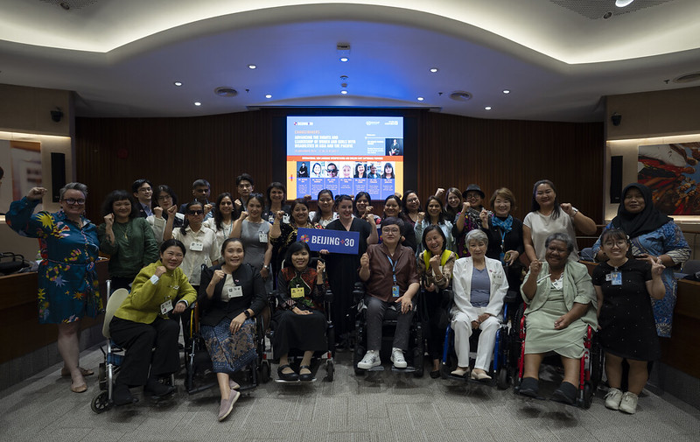
Photo: Panellists and attendees at the Changemakers Side Event
Shifting Power: Making Rights Real for Women at the Margins
Rising Flame, CREA, Women's Fund Asia, Point of View and Mariwala Health Initiative

The event identified on the challenges faced by marginalised women in the Asia-Pacific region, including those with disabilities, sex workers, LGBTQI+ individuals, and indigenous women. It focused on key areas such as women's economic empowerment, participation in power and decision-making, technology-facilitated gender-based violence, and the impact of the climate crisis on marginalised women. The driver behind the event was ensuring that the rights of marginalised women were recognised and addressed, advocating for their leadership beyond mere participation, and holding key stakeholders accountable

The panel style event featured a discussion with speakers from various organizations across the region. These included Shahzadi Pirzado from Pakistan, Nidhi Goyal from India, Riddhima Sharma from India, and Shuchi Tripathi representing Women's Fund Asia. The discussion was moderated by Niluka Gunawardena from Sri Lanka. Clare participated also in the panel, leading the conversation on climate change (Appendix C).

Speakers’ Corner
UN Women
The #Beijing30 Speakers’ Corner was an open platform dedicated to amplifying diverse voices in the conference. Designed as a space for interactive dialogue and community engagement, the Speakers' Corner invited all participants - whether speakers, panellists, or attendees, to actively contribute ideas, share impactful stories, and collectively envision pathways toward gender equality and inclusion.

The Speakers' Corner was an inclusive environment where everyone, regardless of their role, could step forward to speak, connect, and inspire. Through this platform, the conference encouraged dialogue that bridged experiences across sectors, regions, and communities.

Clare participated in the Speakers’ Corner on the final day, where she continued the discussion on amplifying the leadership of women with disabilities and what was needed to do this sustainably. Her comments can be found at Appendix D.

Other meetings and networking

During the conference Clare attended several additional meetings that took place to address the specific concerns of women and girls with disabilities.

Disabled feminist leaders from across the Asia-Pacific region organised a meeting with Lopa Banerjee, Director of the Civil Society Division at UN Women. This meeting focused on the unique experiences of women and girls with disabilities in UN spaces and discussed strategies to ensure their full participation. The leaders shared their insights on the barriers they face and proposed concrete actions to enhance inclusion and representation of women with disabilities in UN processes and decision-making forums.

Another significant meeting was held with Miyeon Kim from the UN Committee on the Rights of Persons with Disabilities (CRPD). This session provided an opportunity for participants to offer feedback on the conference's accessibility and inclusivity measures. Attendees discussed ways to improve future events, addressing issues such as physical accessibility, communication support, and meaningful participation of women with disabilities in all aspects of the conference.

Lastly, an informal gathering of women with disabilities took place to develop a strategic intervention for the main program. This group worked collaboratively to craft a powerful statement that would raise visibility of women and girls with disabilities at the conference, ensuring their voices and perspectives were prominently featured in the broader discussions on gender equality and women's empowerment. The statement (Appendix E) was well received by many delegates who congratulated the group on their work.

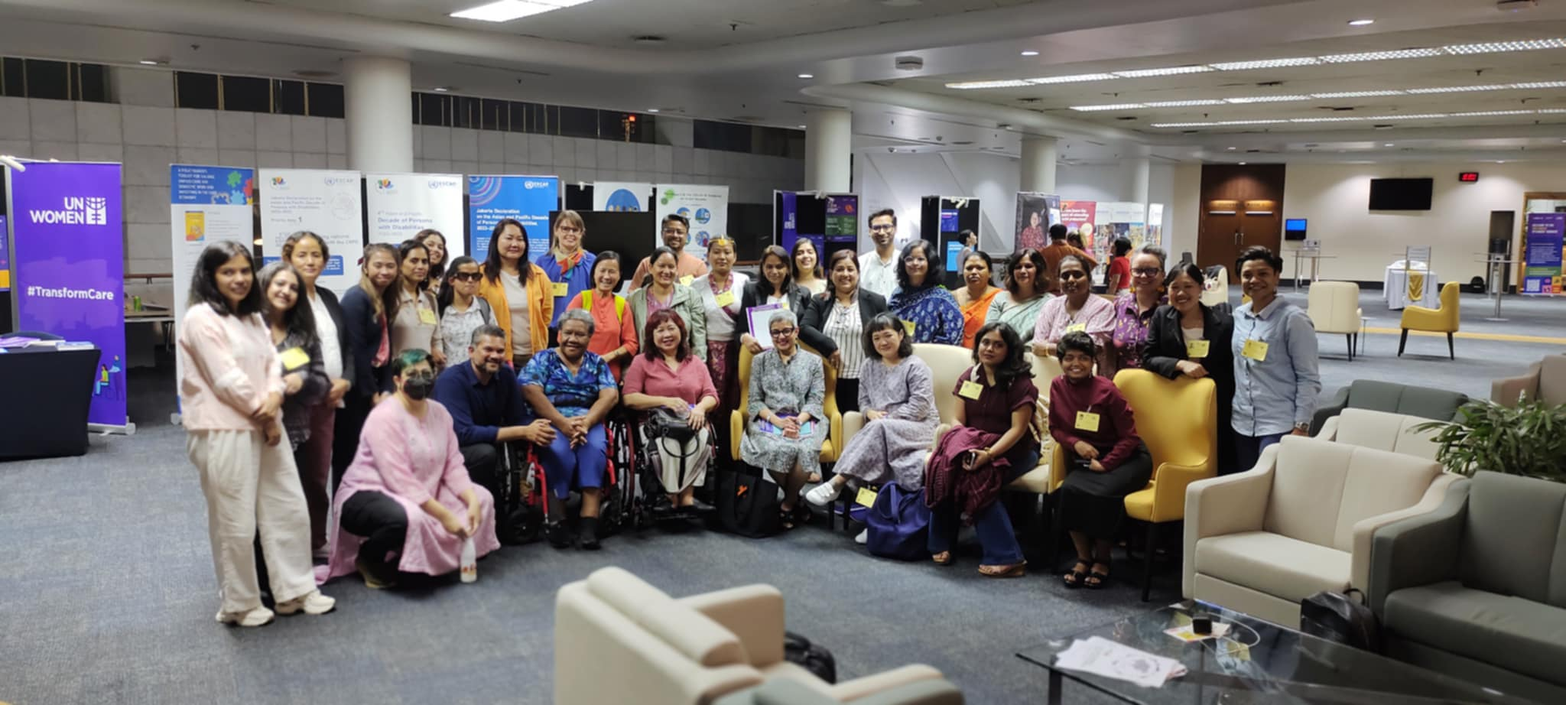
Photo: Women with Disabilities group meeting with Lopa Banerjee (UN Women)

3. Individual Experience – Clare Gibellini

It was an incredible privilege to participate in such a significant event marking the 30th anniversary of the Fourth World Conference on Women. The conference provided a unique opportunity for me to reflect on progress and challenges in advancing gender equality both in Australia and across the region.

As part of the Australian delegation, I was able to contribute to strong representation and engagement for our region. One of the most valuable aspects of the conference for me was the engagement with various thematic discussions. As a delegate, I had the opportunity to engage in these discussions, sharing Australia's perspectives and most importantly learning from other countries' experiences. The conference also provided ample networking opportunities during breaks and side events, allowing for informal exchanges with delegates from across the Asia-Pacific region.

Most significantly, the conference enhanced my understanding of UN processes and the nuances of language and negotiation in international forums. Observing the careful crafting of statements, the time-limited interventions, and the collaborative effort in adopting the conference report provided invaluable insights into the intricacies of multilateral diplomacy. This experience has undoubtedly strengthened my capacity to contribute effectively to future international engagements on behalf of Australia.

Unfortunately, it must be acknowledged that in many UN processes and events, women and girls with disabilities still face significant barriers which prevent their full and equal participation. They are often overlooked in both disability-focused and women-focused initiatives within the UN system and this invisibility perpetuates multiple and intersecting forms of discrimination.

Despite efforts to include women with disabilities in intergovernmental meetings and consultative processes, their representation remains limited. Many UN resolutions, recommendations, and guidelines fail to explicitly address the unique needs and perspectives of women with disabilities. For example, UN Security Council Resolution 1325 on Women, Peace and Security does not reference women with disabilities, nor do its succeeding resolutions. This omission in key policy documents leads to their exclusion from important decision-making processes.

Additionally, women and girls still face numerous obstacles such as physical accessibility, communication barriers such as lack of access to sign language interpretation outside of main sessions, lack of accessible information formats and limited support services to enable independent participation. They also face increased financial constraints, which prevents travel to many UN meetings and conferences.

Women with disabilities experience compounded discrimination on multiple grounds, including gender and disability. Their experience of intersectional discrimination is often not adequately addressed in UN mechanisms, leading to a failure to recognise their specific needs and the barriers they face. It is crucial for the UN system to begin to actively include women with disabilities in all aspects of its work, from policy development to program implementation. It will require a concerted effort to remove barriers and provide necessary accommodations – otherwise, the voices of women and girls with disabilities will continue to be unheard and excluded in UN processes.

4. Outcomes for WWDA

WWDA's participation in the Asia-Pacific Ministerial Conference on the Beijing+30 Review strengthened existing partnerships and forged new connections. Clare engaged with diverse international stakeholders, exchanging ideas and strategies that bolstered WWDA's network of allies. The conference provided a platform for WWDA to showcase its leadership in disability rights advocacy, particularly during thematic roundtables on climate change.

By actively participating in various sessions and discussions, WWDA enhanced its visibility within the international community. This exposure has created opportunities for future collaborations and increased influence, enabling WWDA to further its mission of promoting rights and inclusion for women with disabilities in the Asia-Pacific region.

5. Language Shifts and Emerging Concerns

During the course of the conference there were specific conversations focusing on the care economy and its impact on women. Throughout, there was a tendency to refer to women and girls with disabilities as the recipients of care rather than active contributors. This pervasive societal perception of women and girls with disabilities as burdens or solely recipients of care undermines their potential as active contributors to society and the economy. It also reinforces stereotypes that limit their opportunities for independence and self-determination, contributing to their exclusion from decision-making processes about their own lives and care.

Women with disabilities face significant challenges in the care economy, both as caregivers and care recipients. These stem from ongoing discrimination based on gender and disability status, limiting their economic opportunities and independence.

The unpaid care work burden disproportionately affects women with disabilities, with 35% of primary carers who are women also having a disability themselves. This caregiving role can be physically and emotionally demanding, leaving little time for self-care or paid employment. Employment opportunities for women with disabilities are further limited by a lack of flexible work options, discriminatory hiring practices, and inaccessible work environments. These factors contribute to economic disadvantages and financial dependence. The lack of comprehensive support systems, including insufficient access to affordable and accessible healthcare services, limited availability of childcare and eldercare services, and lack of inclusive infrastructure, add to these challenges.

It is concerning that the language used to discuss these issues reinforced the perception of women with disabilities as passive recipients of care rather than active agents in their own lives. This framing perpetuates harmful stereotypes and hinders progress towards true equality and inclusion. The only time women and girls with disabilities were not framed in this way was when they themselves were discussing their experiences within the care economy.

Addressing these concerns requires a commitment to a rights-based approach that recognises the agency and potential of women with disabilities, challenges stereotypes, and develops inclusive policies supporting both caregivers and care recipients. It is crucial to shift the narrative and ensure that women with disabilities are seen as capable, valuable contributors to society, deserving of equal opportunities and respect.

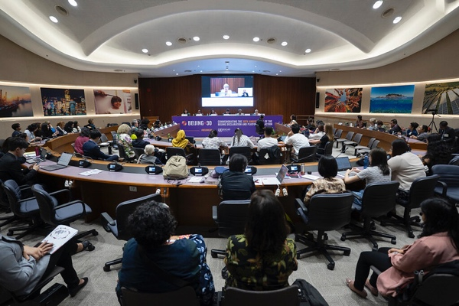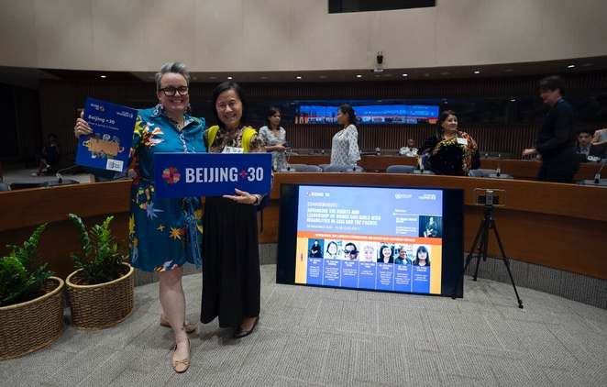
Photo: Panellists and attendees at the Changemakers Side Event

5. Appendices

Appendix A. CSO Forum Climate Change Round Table Report

Climate change is not gender-neutral; its impacts disproportionately affect women and girls, particularly those in marginalized and vulnerable communities. Women and girls often bear the brunt of climate-induced disasters, food and water insecurity, and displacement due to existing social, economic, and cultural inequalities.
These challenges limit their access to resources, decision-making processes, and resilience-building opportunities. Addressing climate change must therefore incorporate a gender-inclusive lens, ensuring that women and girls are not only protected but are empowered as agents of change in shaping sustainable solutions.
Key Issues:
- Disproportionate Impact: Women and girls are often the primary caregivers and providers of food and water, making them more vulnerable to climate-related resource shortages.
- Limited Representation: Women, particularly those from Indigenous and minority communities, are underrepresented in climate decision-making processes.
- Barriers to Education and Knowledge Sharing: Climate-induced crises exacerbate existing barriers to education for girls, reducing their future opportunities and limiting their ability to contribute to climate solutions.
- Loss of Indigenous Knowledge: Indigenous women, who are often stewards of traditional ecological knowledge, face cultural and environmental losses that further marginalise their voices.
- Economic and Financial Inequalities: Women face systemic barriers in accessing financial resources, leaving them disproportionately excluded from climate finance mechanisms.
- Corporate Control of Food Systems: The increasing corporate control of food systems, including through the use of GMOs, undermines community-led food sovereignty and endangers the cultural and nutritional value of Indigenous and traditional foods.
Recommendations:
- Education for All: Implement inclusive education programs that ensure women, girls, and marginalised communities are aware of their rights, equipped with knowledge about climate risks, and empowered to advocate for solutions.
- Accountable Climate Finance Policies: Adopt climate finance mechanisms that hold polluters responsible and ensure that funds are transparent, accessible, and equitable, prioritising support for women-led and community-based initiatives.
- Acknowledge and Value Indigenous Knowledge: Recognise the vital contributions of Indigenous women to climate resilience, integrating their knowledge into policymaking while respecting and preserving their cultural heritage.
- Inclusive Decision-Making: Ensure all voices, including women, girls, Indigenous peoples, and other marginalised groups, are represented at every level of climate decision-making, fostering inclusive and equitable governance.
- Community-Led Solutions and Regional Collaboration: Promote and fund community-driven climate adaptation and mitigation projects while creating pathways for regional collaboration that prioritise shared knowledge, resources, and mutual support.
- Support Women Entrepreneurs: Provide funding, training, and access to markets for women who develop local climate solutions, enabling them to monetise their innovations and contribute to economic resilience in their communities.
- Build Food System Resilience: Safeguard Indigenous and traditional food systems by investing in sustainable agriculture, seed preservation, and community food programs that protect biodiversity and cultural practices.
- Prevent Corporate Dominance in Food Systems: Implement policies to regulate corporate influence over food systems, including restrictions on GMO proliferation, ensuring that food sovereignty remains with local communities and prioritises sustainability and equity.
- Recognise that climate change is not a stand-alone issue, it’s impacts are felt through every issue that faces women and girls. We must ensure climate change is part of every conversation about issues facing women and girls.
Expanding the scope of climate action to include these recommendations will help to build a more inclusive, equitable, and resilient future that uplifts women and girls while safeguarding cultural, environmental, and community assets. It is more than a moral imperative. It is a strategic necessity if sustainable change is to be achieved. Women are key to climate resilience, and their leadership and contributions must be fully supported and valued.

Appendix B. Australia – Beijing+30 Regional Review Meeting - National Statement
Theme: Australia’s progress in implementing the Beijing Declaration and Platform for Action
Time: maximum 4 minutes
Words: 611
As Executive Director in Australia’s Office for Women, I am honoured to be here representing Australia and the Minister for Women. Australia values our longstanding ties with nations across Asia and the Pacific and are proud that Asia-Pacific cultures are so embedded in the fabric of our nation - through our relationships and the migrant women now calling Australia home.
The Beijing Declaration and Platform for Action was a commitment from us all to strive to achieve gender equality in all dimensions of life. We have come far in the fight for women’s human rights and gender equality. Yet 30 years on, no country, including Australia, has fully realised the Beijing agenda. Beijng+30 gives us the opportunity to hold ourselves accountable and strengthen regional cooperation to achieve a more safe, inclusive and equitable future for all women and girls, for which all of society benefits.
Australia has put gender equality at the heart of policy and decision-making. This year, the Australian Government launched Working for Women, our first national strategy for gender equality. It outlines the Government’s vision of an Australia where people are safe, treated with respect, have choice and access to resources, and can achieve equal outcomes no matter their gender.
Australia’s national review for Beijing+30 reflects significant legislative, policy, and structural reforms implemented since Beijing+25. For the first time in Australia’s history, our Federal Parliament is gender balanced. Our Minister for Women is also the Minister for Finance - a decision that ensures gender is embedded in all government budget decisions.
We have made early childhood education and care cheaper and made our Government Paid Parental Leave scheme longer, more flexible and more gender equal. We are increasing women’s participation in higher education and skills with a focus on sectors where women are underrepresented. And we have achieved the lowest national gender pay gap on record at 11.5 per cent. As a nation however, we still have work to do.
Australia continues to face a national crisis of violence against women and children. To address this, we are investing $4 billion to support Australia’s Second National Plan to End Violence against Women and Children and are working to move from responding to violence to preventing violence. We, like all nations, are facing the challenges of climate change and the heightened risk to women and girls - in Australia, in the Pacific and around the world.
The Australian Government has committed to net zero emissions by 2050. And we are partnering with the Pacific to bring global attention to the region’s urgent and unique climate challenges - to elevate Pacific voices and accelerate global action on climate change. Globally - we are witnessing and responding to war, violent conflict, political and economic insecurity and the wind back of reproductive rights.
Achieving gender equality and protecting women’s human rights demands consistent and vigilant action. Now is the time to strengthen our determination. We will not stand for any regression in women’s rights. These rights have been so fiercely advocated for, so strongly fought for, and agreed upon internationally – we must not let our efforts backslide. The Australian government’s enduring and enhanced commitment to achieving gender equality is vital to ensuring the progress we’ve made is not only preserved but expanded upon.
The realisation of gender equality means a just, safer, more stable and prosperous world for everyone and we must ensure the world continues to push forward to that shared resolve. Full sexual and reproductive health and rights are human rights. They are not negotiable. Australia will continue to work towards ensuring every person, everywhere, is respected and empowered to make decisions for themselves and to have access to the service they want and need.

Appendix C. Making Rights Real for Women at the Margins (panellist comment – Clare Gibellini)

Thank you for the opportunity to discuss this hugely important issue of climate change impacts for women at the margins.
When I work with various agencies in climate change policy I am often presented with the line “disasters don’t discriminate”. Nonsense. More specifically, patriarchal, colonial nonsense.
We here in this room, we here online, we know they do.
Globally, climate change is a magnifier of existing inequalities, disproportionately affecting women and gender diverse people due to entrenched social, economic, and political disparities. We represent 80% of those displaced by climate disasters. But representation in disaster planning and climate resilience programs remains alarmingly low.
I will just speak briefly to some of the marginalised groups.
Women with Disabilities: Physical and systemic barriers making it harder for us to access emergency services, shelters, or evacuation routes. We are often excluded from preparedness planning and relief and recovery efforts, leaving us four times more likely to die or be injured. We’re not included in training and decision-making that would enable us to build resilience against climate impacts.
Indigenous Women: Indigenous women possess deep traditional ecological knowledge, yet they are consistently sidelined in climate governance. Their communities are among the hardest hit by climate events that erode territories, destroy crops, homes, and livelihoods, exacerbating poverty and social vulnerabilities and displacement​. It disrupts traditional lands and resources, undermining livelihoods, food security, and cultural practices.
Their voices, the sharing of ancestral knowledge are not heard. And if it is heard, it is certainly not listened to or valued. Thousands of years of management and adaptation knowledge is too easily dismissed.
LGBTQIA+ Women and Gender diverse people: These individuals frequently face discrimination in accessing emergency services or shelters during crises. Relief and recovery services may exclude or stigmatise nontraditional family structures, leaving them without adequate support​. The risk of all forms of violence increases exponentially, but there are no safe paths to justice.
2. Health and Wellbeing
Climate-induced health crises, such as heatwaves, malnutrition from food insecurity, and the spread of diseases, disproportionately affect marginalised women. Poor access to healthcare , including sexual and reproductive health care amplifies these risks. Women at the margins already face challenges in obtaining accessible health services, amplified during emergencies​. We saw this during the C19 pandemic where health professionals weighed the value our lives against the lives of non-disabled people and decided who was more worthy of treatment.
3. Economic Disempowerment
Climate disruptions often hit informal sectors hardest, where marginalised women are overrepresented. Loss of livelihoods in agriculture, fishing, or market trading disproportionately impacts Indigenous women and those in rural areas.​
LGBTQIA+ women may also experience compounded economic precarity due to systemic exclusion from resources and opportunities​.
4. Gender-Based Violence
Displacement and resource scarcity linked to climate disasters increase the risk of gender based violence, including sexual and domestic violence. Shelters and camps often lack safety measures, and cultural stigmas can prevent reporting and pathways to justice​
5. Exclusion from Decision-Making
Women from marginalised groups are excluded from decision-making roles in climate adaptation and mitigation planning, despite their unique perspectives skills and contributions. This exclusion perpetuates inequities and limits the effectiveness of climate solutions​. It perpetuates the idea of our passivity, of our lack of autonomy and agency.

So what do we need?
- Strengthen Representation in Decision-Making: Women, especially those at the margins, must be included in planning and policymaking. And we need to be more than visible. We need to be given space to have an active presence, to be able to influence decisions and policy.
- Allocate Gender-Responsive Climate Finance: Financing must prioritise the specific needs of women. Significant portions of global climate finance neglect gender equality objectives. Governments and organisations must ensure that future investments are both gender-responsive and inclusive.
- Hold those responsible, accountable. Ensure that the burden of financing climate response falls squarely on the shoulders of those who are responsible for the current crisis. And ensure that we can access a fair, transparent and accountable system.
- Develop Inclusive Disaster Policies: We need laws and frameworks that explicitly address the needs of marginalised women. Local and community based solutions are key, and I refer to my colleague Pratima’s assertion that it is more than just the geographical location we are talking about. We’re talking about cultural groups, and identities also. Because we know that we are not always included in the places in which we live.
- Leverage and Value Traditional Knowledge: Indigenous women’s ecological knowledge is a vital resource in adapting to climate change. This wisdom must be integrated into formal climate strategies to build resilience.
- Equitable Access to Resources and Training: Capacity-building programs that offer marginalised women access to tools, technology, and education on sustainable practices to empower them as key agents of change in their communities.
The inclusion and strengthening of marginalized women in climate action is not only a moral imperative but also a strategic necessity. When we lead, as seen in grassroots initiatives worldwide, our communities are safer, stronger, and more resilient. We know who the real rebuilders and reconnectors are. We deserve to be part of the solution.
Thank you.

Appendix D. Speakers Corner Comments – Clare Gibellini

Thank you for coming along today, I’m sure many of you are feeling like me and in need of a good lie down.
I don’t want to spend too much time today talking ‘at you’ but rather with you and have a really good conversation instead. I also want to say that I want this to be a safe space, for everyone to learn and share. So, if you have a question on disability, or leadership you’ve always wanted to ask but have been too afraid to, please consider this as your permission to do so. I’m very hard to offend, and I also want you to walk away feeling you have learnt something new.

In the leadup to this conversation I was doing a lot of reflection about leadership of people with disabilities, and in particular, leadership of women with disabilities and those of us who have intersecting identities. And having been here this week, I really do feel that it is a conversation that we need to have more often.

The active presence of people with disability in neighbourhoods, schools, workplaces and government is a mechanism to effect change in the broader community’s attitudes and behaviours and improve inclusion. In the Changemaker side event yesterday I spoke about how many people use the term ‘visibility’ when it comes to the inclusion of women at the margins. Again, I want to ask us to adopt a wider term.

I want to move us from simply existing in spaces to that of having an ‘active presence’. Let’s encompass the concepts of participation and recognition along with visibility, and step beyond a presumed passivity and lack of agency. This is about making our voices not just heard, but counted and influential in the decisions and development of policies and programs that impact us.

To kick off the conversation I want to share three key concepts that I think are essential in developing effective and sustainable leadership of women at the margins in mainstream spaces.

The first is, no surprise, accessibility.

Accessibility transforms leadership from a space of exclusion to one of empowerment, creating environments where all voices can shape the future. It’s the mechanism to ensure everyone can participate fully and effectively in all aspects of decision-making, governance, and advocacy. And it’s so much more than a ramp at the front door.
Of course we need to ensure that people can be physically present in the space that we are working in. But accessibility also covers communication in all its formats. It includes the delivery of information and resources. It also includes the sensory environment, and the time allocated for meetings and responses. It includes the timing of meetings, and the format in which they are held.

There’s also a conversation that’s not often had about financial compensation and it’s impacts on accessibility. So often we are asking people to share their experiences or insight and we’re not valuing them in a financial way. So people often have to weigh up the cost of participating. When you are not factoring in financial compensation you are preventing people from attending, and therefore limiting the diversity of voices and information.

Engaging in tokenism is also a form of inaccessibility – it can be very lonely being the only person at the table who has your lived experience. Not having someone else at that same table who ‘gets it’ can make it hard to speak up, and you can be left feeling like the experience is tokenistic. Especially if you then have no ability to impact decisions made.

Instead I want to see the organisers of these spaces make sure that there is room for more than one person. This also gives them the opportunity to access a broader range of information, and safeguards against loss of knowledge that is held by one person. As we know, life happens, and so much can be lost if that one person can no longer participate.

The second concept is around lived experience. At the moment in Australia we are having a conversation around lived experience and lived expertise, and whether the two are different. Of course, we absolutely must have people who have lived experience at all of the tables. But in Australia we are having conversations about whether this is enough.

We have been talking about changing this concept into lived expertise. The idea behind lived expertise is that while it is important to have lived experience – for example indigeneity, disability, belonging to the LGBTQIA+ community amongst others, it is also incredibly important to ensure people representing the marginalised group have some form of experience of working within or alongside the systems they are trying to change, and that they also have a wider connection to the community to push for widespread change, not just change based on their own experience.

We’ve been talking about how just choosing people based on lived experience can potentially be harmful to the people who are invited into the spaces, causing further trauma and hampering progress. It can also lead to loss of faith and relationships with stakeholders because both sides have unrealistic expectations of what is achievable.

It’s important for the people in the spaces to also understand the barriers faced by both sides, and what can practically be achieved. Even half a step forward is forward momentum. That’s not about lowering our appetite for change!!

The third concept I want to cover is succession planning.

So often amongst marginalised groups of people there is significant internal struggle for limited spaces at the table. And those who do get access quickly become entrenched, sometimes staying in those positions for lengthy periods of time. This has two main effects. Firstly, those who remain at the table are provided the opportunity to build relationships with decision makers and gather knowledge and insight over time. The more this occurs, the further away they move from the experience of the everyday person.

Additionally, consistently having the same people in positions prevents the establishment of sustainable succession plans. Emerging leaders become frustrated that they cannot progress, and in my opinion we lose an important opportunity. The more voices we have in our movements, the louder and stronger those voices become.

I also strongly believe that in keeping those emerging leaders from taking their place there is a risk that long term leaders become part of the system they are trying to change. We need emerging leaders to keep us (the established leaders) in check, because we can become complacent and not be aware of when we need to switch from advocacy to activism.

Instead, those who represent their communities should ask ‘if I am given a seat at the table, can I have a spare’, opening up the space for emerging leaders. Those within the systems seeking our engagement should factor this into their planning. It also addresses the previous issue of being the lone voice in the room.

In general, attitudes can be explicit or implicit, but both affect behaviour towards another. I think it’s time we get real about our own roles in the development of the leadership of women at the margins. It’s the responsibility of all of us, we all need to take steps if we want to see the leadership movement grow.

In conclusion, I encourage all leaders to address their own unconscious bias. To look around the table and identify who is missing. Sit with the uncomfortable feeling that will inevitably follow and take active steps towards providing equitable opportunities for women with disabilities to become active leaders at all levels.

To consider systemic intersectional barriers, and prioritise opportunities, access and resources. Equity is the means to equality.

Appendix E. Women with Disabilities Statement

Dear all,
Disability is a human experience. It is not a checkbox, nor is it a singular moment or condition—it is a reality that intersects with all aspects of life, from cradle to grave. It is time the world embraced this truth.

As defined by the CRPD, disability includes long-term impairments that, in interaction with various barriers, hinder full and effective participation in society on an equal basis with others.

Beyond physical disabilities, many lived with invisible disabilities—psychosocial, intellectual, neurodivergent conditions, deafblindness — hidden yet profoundly shaping their lives. This also includes disabilities linked to ageing. Disability is a human experience of living.

Now, look around this room today—do you see our diversity? Are we sitting here as peers, as leaders? We remain critically under-represented, and it's with profound impact on us.

For us, these barriers are compounded by systemic inequalities. With limited access to education, healthcare, employment, and justice diminishes our quality of life. It strips us of our autonomy and opportunities. With heightened risks of poverty, gender-based violence, or exclusion from policymaking, our lived realities are often ignored.

Indigenous and caste marginalised women with disabilities face compounded discrimination due to the intersection of their indigenous identity.

Leadership and decision-making must be inclusive—it must include those of us with disabilities. These opportunities remain inaccessible.

Thirty years ago, the Beijing Declaration called for transformational leadership rooted in diversity and inclusivity. Are we there yet?

Reforms for inclusion often fail due to missing preconditions—universal accessibility and reasonable accommodations. These are not optional; they are foundational to building inclusive systems.

Accessibility is about building connections to enable us to oppose ableism and centring on our self-autonomy and determination. It must be a human-centered approach that sees accessibility as a commitment to equity, empathy, and inclusion. We aren’t just a DEI indicator.

Beyond physical infrastructure, accessibility must include digital and informational access. In the age of global connections, we need nuanced and inclusive approaches more than ever. We want supported decision-making, not substituted decision-making and we need alternative communication models to be recognised.

These are the foundation for all of us to connect with each other. Without accessibility, the path to leadership is denied for us. We will not have our voice to shape decisions that impact our lives.

With global eyes on the care economy, it highlights these critical gaps. It’s principles of self-determination and autonomy outlined in the CRPD are not fully realised as we never had our voice in it. This mismatch perpetuates fractured systems that fail to uphold our agency and our autonomy over our own lives. We need economic empowerment and participation.

To be represented at all levels, deliberate state action is needed to establish quotas or mandates for disability inclusion. Investing in leadership training. Aligning domestic frames with the Beijing Platform for Action and CRPD must guarantee equal opportunities for women with disabilities.

Global frameworks like the SDGs, Incheon Strategy, Jakarta Declaration, and ASEAN Enabling Master Plan—all built upon human rights treaties—we must mainstream the harmonisation of it. Indigenous women with disabilities need to be prioritised, with measures ensuring their access to leadership and self-representation as outlined in CRPD Articles 6 and 21. Collaboration across sectors is essential to amplify our voices.

Narratives on women’s leadership must be reshaped.

We can create a future where we are not just in the room as participants. But are instrumental in shaping it together with you. We are leaders, visionaries, and the agents of change you need for an inclusive future.

The time is now to resist exclusion, reclaim our spaces, and transform systems.

We are reclaiming, “Nothing about us, without us.”

