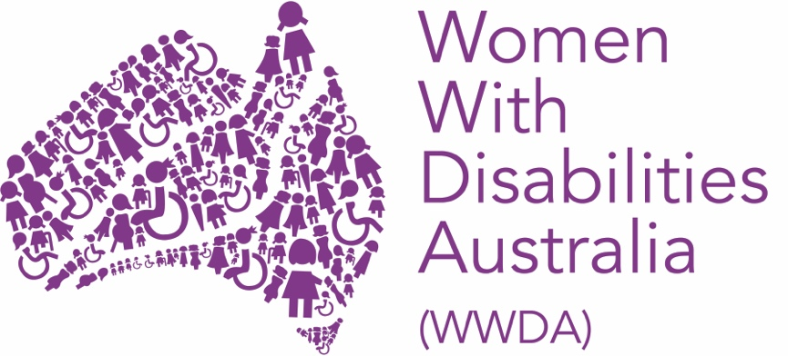

WOMEN WITH DISABILITIES AUSTRALIA (WWDA)

17th Session of the Conference of States Parties

Post-Event Report

July 2024

PUBLISHING INFORMATION

Women With Disabilities Australia (WWDA) (2024). ‘Report from the 17th Session of the Conference of States Parties.’ July 2024. WWDA: Hobart, Tasmania.

Acknowledgments

WWDA acknowledges the traditional owners of the land on which this publication was produced. We acknowledge Aboriginal and Torres Strait Islander people’s deep spiritual connection to this land. We extend our respects to community members and Elders past, present and emerging.

This document was written by Clare Gibellini, for and on behalf of Women With Disabilities Australia (WWDA).

Women with Disabilities Australia (WWDA) receives part of its funding from the Australian Government, Department of Social Services (DSS) and the Office for Women (OFW). WWDA acknowledges and thanks DSS and the OFW for its support.

Contact

Women with Disabilities Australia (WWDA)
PO Box 407, Lenah Valley, 7008 Tasmania, Australia
Phone: +61 438 535 123
Email: officeadmin@wwda.org.au
Web: www.wwda.org.au
Facebook: www.facebook.com/WWDA.Australia
Twitter: www.twitter.com/WWDA_AU

Disclaimer
The views and opinions expressed in this publication are those of Women with Disabilities Australia (WWDA) and not necessarily those of our funding bodies or the Australian Government.

CONTENTS
WOMEN WITH DISABILITIES AUSTRALIA (WWDA) 1
PUBLISHING INFORMATION 2
Acknowledgments 2
Contact 2
Disclaimer 2
INTRODUCTION 4
KEY ACTIVITIES 6
1. Preparatory activities, meetings, and webinar 7
2. Official program and related activities 8
3. Attendance at parallel and side events 12
5. Other Activities 16
Conclusion: Key Outcomes and Benefits 18

INTRODUCTION

In March 2024, Women with Disabilities Australia (WWDA) staff member Clare Gibellini attended the 17th Session of the Conference of States Parties (CoSP17) held at the United Nations in New York from the 11th to 13th of June, as a delegate on behalf of WWDA.

The Conference of States Parties (CoSP17) is the principal global conference exclusively dedicated to the promotion of the rights of persons with disabilities. CoSP is instrumental in promoting disability rights, documenting the reality of the lives of people with disabilities lives throughout the world, and shaping global standards on equality and the empowerment of people with disabilities.
COSP17 was held at the United Nations (UN) Headquarters from 11 to 13 June 2024. It is one of the most important meetings of people with disability in the world. It brings together organisations to discuss the UN Convention on the Rights of Persons with Disabilities, including:
- governments
- human rights institutions
- disability and civil society organisations.
The civil society delegates who represent their various countries are independent from government and business sectors. They bring their unique stories of lived experience to the world stage.
This year’s theme was “Rethinking disability inclusion in the current international juncture and ahead of the Summit of the Future”. There were three subthemes:
- Sub theme 1: International cooperation to promote technology innovations and transfer for an inclusive future, which was co-chaired by: Sri Lanka Vice President of the bureau and a civil society representative
Sub theme 2: Persons with disabilities in situations of risk and humanitarian emergencies, which was co-chaired by: Georgia Vice President of the bureau and a civil society representative
Sub theme 3: Promoting the rights of persons with disabilities to decent work and sustainable livelihood, which was co-chaired by: Greece Vice President of the bureau and a civil society representative

This session of the conference was heavily impacted by austerity measures implemented due to the UN liquidity crisis and had an estimated 14,000 people attend throughout the two weeks.

For many years, WWDA, alongside other organisations representing people with disability, has engaged in the work of the Australian government and the United Nations on the CRPD, the Sustainable Development Goals (SDGs) and past annual sessions of the Conference of States Parties.

For CoSP17, WWDA sent one delegate, Clare Gibellini (Policy Officer) who utilised her diverse skill sets to represent women and gender diverse people with disability, as well as the various issues currently facing all people with disability, both in Australia and internationally. Clare was selected to attend through the Department of Social Services’ Supporting Participation by Representatives of People with Disability in Key International Forums on Human Rights program.

This was Clare’s third attendance at CoSP, and her participation allowed her both to solidify her international and Australian connections, broaden her networks, gain new skills, and solidify her existing expertise.

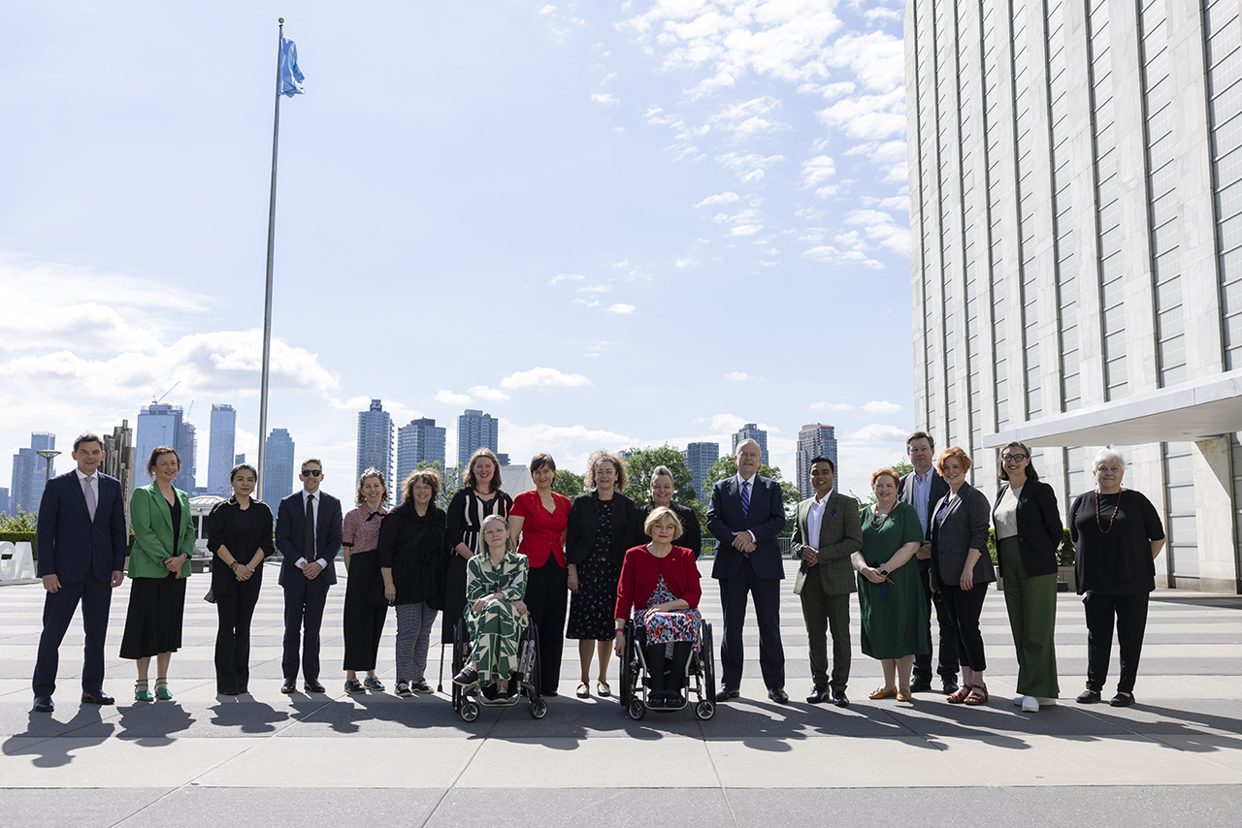

Photo of some members of the Australian Civil Society Delegation, Australian Government delegates and Minister Bill Shorten.

KEY ACTIVITIES

WWDA staff participated in CoSP17 through multiple avenues, including online and in person side events, as well as attending the official program of meetings and events. These activities are outlined below.

Prior to attending the conference, WWDA delegate Clare met with various organisations of people with disability, and wider networks to gather information on the key concerns and issues for women with disability to take to CoSP17. This included conversations with various groups of under-represented women with disability such as young women and gender diverse people, culturally and linguistically diverse (CALD) women, Aboriginal and Torres Strait Islander women and others.

Some of the key issues that emerged through this process included:

- Intersectionality and ensuring under-represented women with disability were not only included but acknowledged in their specific skills and the specific conditions faced.

- Lack of access to affordable, reliable assistive technology and accessible timely information.

- The significant risks faced by multiply marginalised communities such as the LGBTQIA+ community through the increasing weaponisation of social media.
- The significant barriers that women with disabilities face in economic participation and financial independence. This includes systemic and attitudinal barriers to entrepreneurship.

- The impact of ongoing humanitarian crises around the world, and the widespread abuse of rights afforded to persons with disabilities under both the Universal Declaration of Human Rights (UDHR) and the Convention on the Rights of Persons with Disabilities (UNCRPD).

- The right to inclusion in post conflict and disaster recovery and solution building, to ensure the rights of women with disabilities are upheld and protected.

1. Preparatory activities, meetings, and networking.

Prior to attending the conference, WWDA delegate Clare participated in several meetings organised by the Department of Social Services, to discuss the collective attendance in New York of representatives from various Non-Government Organisation’s (NGO’s) and the Australian Government. These sessions included information on the conference, who would be attending, internationalising our issues and unpacking the subthemes of the conference. Clare presented to the delegates on sub theme 2: Persons with disabilities in situations of risk and humanitarian emergencies

In late May, Clare attended the pre-CoSP departure briefings with DSS and DFAT to prepare for the event, as well as reviewing resources from previous CoSP events, and the background notes of each of the subthemes.

Clare also met with representatives from ILGA World, to develop a combined intervention relating to Subtheme 1: International cooperation to promote technology innovations and transfer for an inclusive future. Both ILGA World and WWDA felt there was a need to highlight the impacts of social media on multiply marginalised groups of persons with disabilities.

Prior to the start of the Conference, Clare attended a Welcome Reception hosted by Hon. Bill Shorten MP, Minister for the National Disability Insurance Scheme and Minister for Government Services, and Ambassador, James Larsen, Permanent Representative of Australia to the United Nations. It was a fantastic event attended by Civil Society delegates and various Australian Government representative and provided an excellent opportunity for discussions and networking.

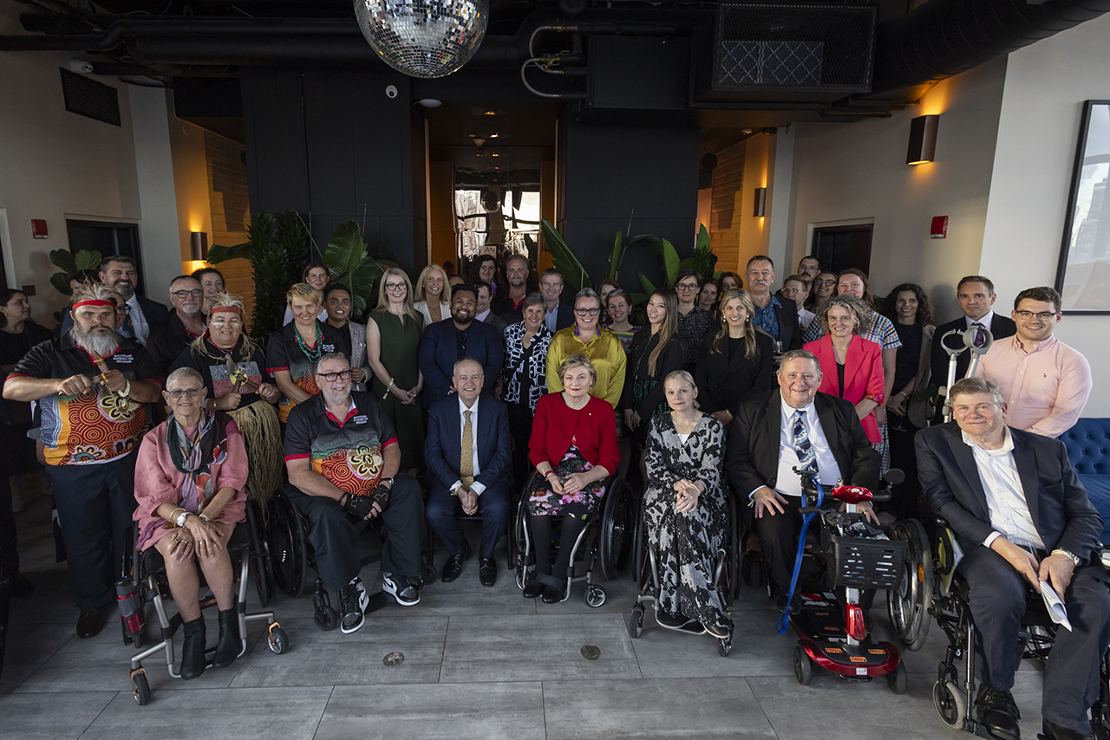
Photo: Attendees of the Welcome Reception hosted by Hon Bill Shorten MP, Minister for the National Disability Insurance Scheme and Minister for Government Services, and Ambassador James Larsen, Permanent Representative of Australia to the United Nations.

On the 10th of June, The Civil Society Coordination Mechanism (CSCM), which is facilitated by the International Disability Alliance, hosted a Civil Society Forum (CSF), as an addition to the COSP, to leverage the opportunity to amplify the voices, and facilitate active participation, of people with disabilities.
The Civil Society Forum follows a format of a “People’s Assembly” or a Townhall meeting. Following a brief opening, three substantive sessions were held. The sessions focused on specific pre-determined topics. They reflected the three COSP Themes, as above, and focused on the civil society perspectives and issues Civil Society Organisations (CSOs) deem most appropriate under each theme. At the Civil Society Forum, Clare delivered an intervention related to Subtheme 2: Persons with disabilities in situations of risk and humanitarian emergencies, which can be found at the end of this document.

Tuesday the 11th of June saw the commencement of the full conference, and there were many fantastic side events that ran during this time. WWDA was again selected to deliver an intervention, and this took place on the second day. The intervention was delivered on behalf of WWDA and ILGA World, and can be found at the end of this document.

External to her role at WWDA, Clare is the Co-Chair for the Oversight Council of the National Autism Strategy, and took part in the Australian government side event on the Strategy.

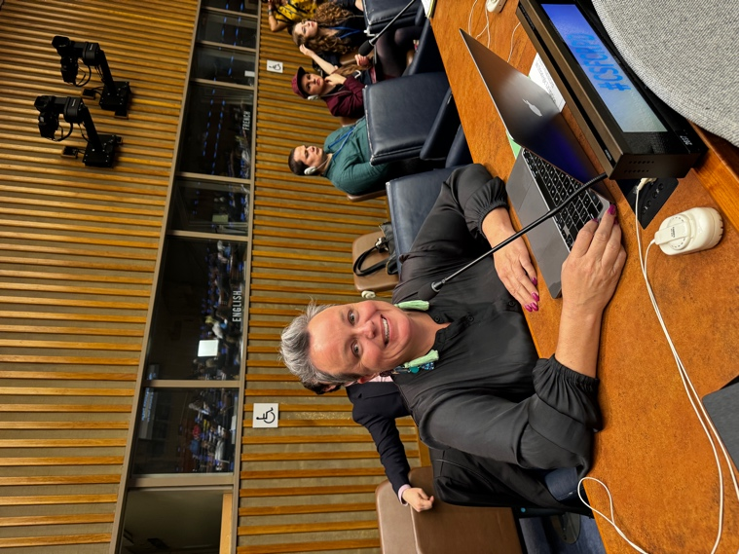
Photo: Clare about to deliver the Civil Society Forum intervention
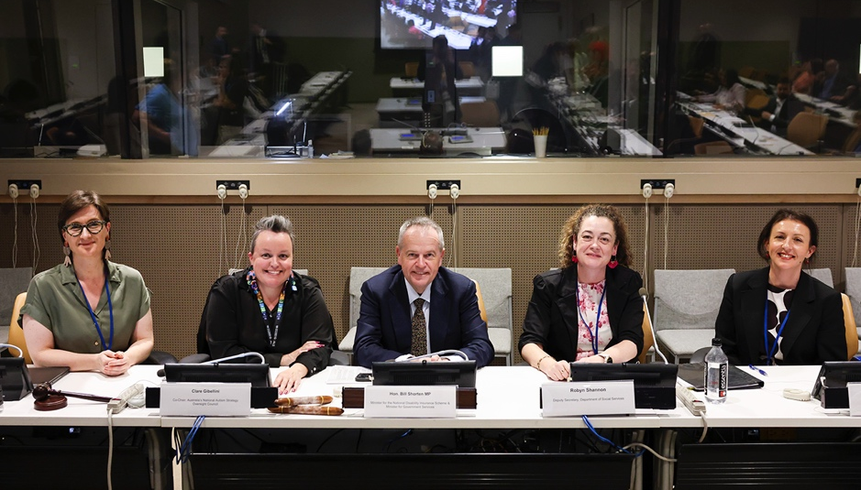
Photo: Panelists at the Australian Government Side Event on the National Autism Strategy

2. Official program and related activities

The official program began on June 11th, beginning with opening remarks before the general debate. The running of the session was heavily impacted by austerity measures in place due to the UN liquidity crisis. This meant that not all attendees were able to be on the main floor of the General Assembly, and there were very limited passes for wheelchair users.

The first day of the Conference also focused on organisational matters such as election of members of the CRPD Committee, and introduction of official documents. The Hon. Minister Bill Shorten gave two statements, one on behalf of the Australian government in its own right, and one on behalf of MIKTA, a cross-regional grouping of G20 member nations established in 2013, with the idea that – working together – nations could bridge divides between developed and developing nations and build consensus on issues which would be relevant to all regions. Member states are Mexico, Indonesia, Republic of Korea, Turkey and Australia.

The General Debate ran throughout the conference, and key speakers outlined a series of action items and discussions focusing on equality, empowerment, furthering the rights of people with disabilities and the Summit of the Future, the key theme for the year. The key action items suggested included increasing participation and employment in peacebuilding and decision-making roles; addressing the rollback of some rights, discrimination and violence in humanitarian crises; bridging the digital divide; and collaborating with governments, civil society, and the tech industry to ensure persons with disability are not further disadvantaged through advances in digital technology.

Overall, speakers called for a global commitment to advancing disability rights and empowering persons with disabilities through various initiatives, partnerships, and policy changes across different countries and regions.

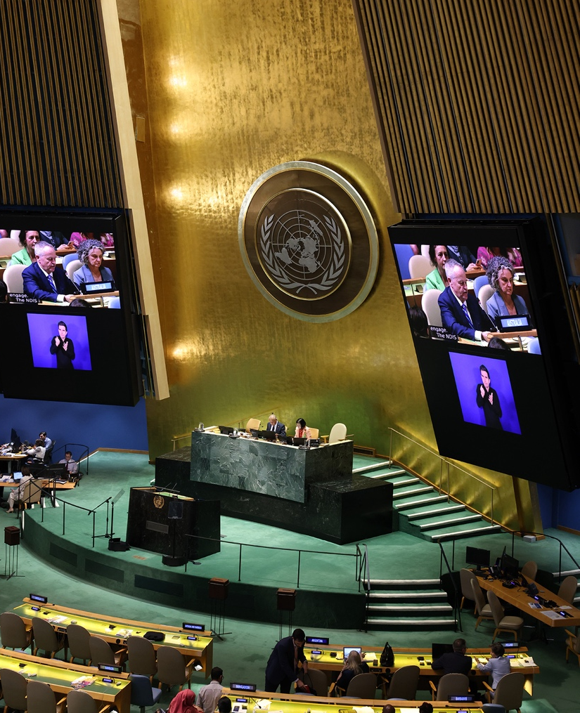
Photo: Minister Shorten delivering a statement on behalf of the Australian Government.

3. Side Events

WWDA hosted an online side event on the 11th of June entitled ‘Accessibility First Approach for Online Space. It covered the process used by WWDA to ensure full accessibility in its Neve website design, and presented our new website by and for women, girls, and gender diverse people with disabilities on violence prevention. WWDA staff shared our process of co-design and co-production in developing a lived experience and accessibility first approach to online spaces.

Additionally, Clare attended the following side events:

The Rights of Persons with Disabilities in Strategic Litigation
The side event raised awareness for organisations of people with disabilities about employing litigation on the rights of persons with disabilities as a strategic tool to promote, develop and entrench these rights. In addition, it demonstrated to State parties to the Convention on the Rights of Persons with Disabilities (CRPD) how ratification of the Optional Protocol can improve the implementation of the CRPD, contributing to the ratification campaign by the Office of the High Commissioner for Human Rights (OHCHR).
For the WWDA delegate, it was a fantastic opportunity to learn more about how change could be achieved through litigation, and a better understanding of the importance of the Optional Protocol in practice. The delegate also learned how other states parties were using this mechanism on a large and small scale to effect change within their communities.

Accessible Crisis Preparedness and Crisis Communication
This side event looked how effective crisis communication is a vital aspect of crisis preparedness, facilitating communication among stakeholders, the general public, and the media during times of social disruption. Coordinated communication enhances credibility, reduces ambiguity, combats the spread of rumours, and empowers the public to contribute to crisis management efforts. Attending the event was an eye-opener. The speakers drove home how crucial it is to have inclusive crisis preparedness and communication for people with disabilities. They talked about the need for accessible infrastructure and effective communication channels, and they emphasised involving disabled persons and their representative organisations in crisis planning. Speaker points on including disability in human rights discussions during emergencies were particularly impactful. There were also great insights into how international human rights treaties can advance disability rights. The overall message was clear: we need to create tailored responses that address the specific needs of people with disabilities and ensure they are consulted and empowered as agents of change.

Developing and Promoting Implementation of the UNCRPD and Disability Rights across the Commonwealth: Promoting CDPF Disability Inclusion Action Plan
The meeting addressed the gains made in developing support for and progress that will be made if the Action Plan is adopted, and how the Action Points could be implemented across the 56 countries of the Commonwealth. Inclusive decision-making processes, accessibility, and action plans were identified as key priorities for prioritising disability inclusion in global governance. Speakers also stressed the importance of involving disabled people in decision-making processes and addressing the impact of skewed GDP on disability inclusion.
For the WWDA delegate, who is also a member of the CDPF Executive, it was a great opportunity to watch the process of adoption and possible implementation taking part, and to connect with the Commonwealth Assistant Secretary.

Development of Australia’s National Autism Strategy: Achieving a Vision of an Inclusive Society for all Autistic People of All Ages Living In Australia
The WWDA delegate is also the Co-Chair of the National Autism Strategy and supported the delivery of the side event. The event was an opportunity to discuss the development of the Strategy. Speakers shared with other countries, the United Nations, civil society, and all interested stakeholders what they have learned about the benefits of working with Autistic people in the development of the Strategy, along with frank conversations about the challenges faced by all stakeholders.
The discussion enabled the sharing of best practices to promote disability inclusion, equity, and rights in the context of rethinking disability inclusion at the current international juncture ahead of the United Nations Summit of the Future. Feedback from attendees was positive, and the delegate has since connected with international colleagues who are interested in furthering the conversation.

The Future of Disability Rights is Feminist
This event looked at cross-movement solidarity with the women’s rights and feminist movement. The disability rights and women’s rights and feminist movements hold many similar values, while having much to learn from each other. These movements also have access to complementary levers of power that we can share to help interjectionally advance human rights norms and standards, ensure accountability for those standards, promote justice, and seek creative and innovative ways to tackle the world’s increasingly urgent issues.
The delegate found the event to be highly useful in understanding other methods of awareness raising and advocacy work that could be harnessed to progress the disability rights movement. She also felt that the concepts of cross-movement solidarity, intersectionality, and shared power are incredibly useful tools that can be by women, girls, and gender diverse people with disabilities from around the world towards these visions.

Promoting the rights of persons with disabilities to decent work and sustainable livelihood: lessons from the front line and what this means for states, the UN and Civil Society.
This event focussed on the need for inclusive policies and legislation to ensure equal employment opportunities for persons with disabilities. They highlighted the importance of a human rights-based approach, repealing discriminatory laws and policies, and equipping individuals with the skills to thrive in the workplace. Insights were shared on changing mindsets, engaging all stakeholders, and valuing neurodiversity. Speakers also discussed barriers faced by neurodivergent individuals in the workplace and the importance of universal design and meeting society halfway to support their inclusion.

Innovation and Inclusion: Global Perspectives on Supporting Autistic People in Society
The conversation centred around the importance of recognising and embracing the complexity of neurodiversity, moving away from a medical model, and amplifying the voices of non-speaking autistic individuals. Speakers emphasised the need for inclusive policies, equal access to healthcare, and a more accepting society. They also highlighted the importance of understanding and supporting autistic people, addressing evolving needs across various life stages, and involving the disability community in government policies and strategies. The conversation emphasised the need for better support for autistic individuals across various life stages, including access to assessment and support in the criminal justice system, housing, and public transportation.
It was encouraging to see the global work being done to deliver better outcomes for autistic people, and to see the work being mirrored in the Australian strategy that is under development.

Access to Justice through the CRPD Optional Protocol
This side event focused on the Optional Protocol to the Convention on the Rights of Persons with Disabilities (CRPD), a complaints mechanism, through which the Committee on the Rights of Persons with Disabilities (Committee) can receive and consider complaints from individuals who claim to have had their CRPD rights violated. These complaints are called ‘individual communications’. Only 100 State Parties have ratified the Optional Protocol. While the findings made in individual communications are non-binding, the complaint process and the final decisions by the Committee can serve as powerful advocacy tools to advance the understanding and implementation of the CRPD.

This side event focused on
- Advocacy tools and strategies to persuade State Party ratification of the Optional Protocol.
- Overview of the complaints pathway, including the role of the NHRIs in dealing with complaints domestically and the role of community legal centres in representing complainants.
- How complaints build jurisprudence and establish a living and dynamic interpretation of the CRPD.
- Individual remedies available through the OP process, or as a result, of an individual communication.
- Ways in which Committee ‘decisions’ can be utilised in systemic advocacy to drive implementation of the CRPD.

For Clare, it was an excellent way to improve her knowledge about both the Optional Protocol, and the best ways to use it, particularly when combined with the earlier session on strategic litigation.

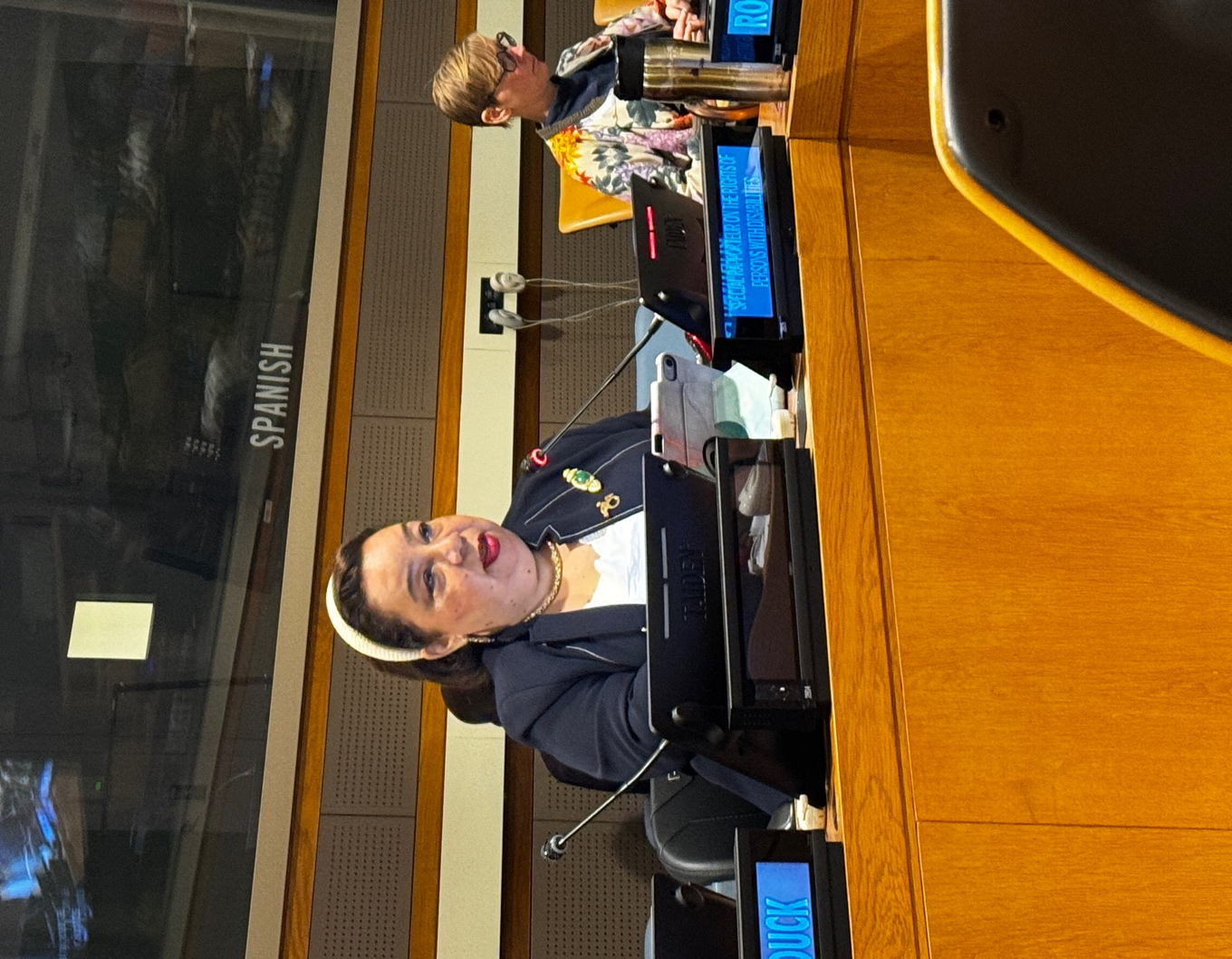
Photo: The Special Rapporteur on the Rights of Persons with Disabilities, Ms Heba Hagrass presenting at a side event.

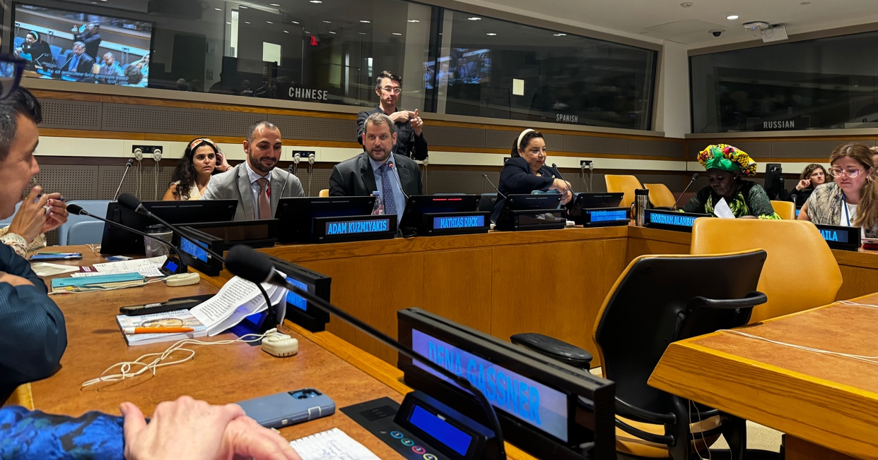
Photo: Side event: Promoting the rights of persons with disabilities to decent work and sustainable livelihood
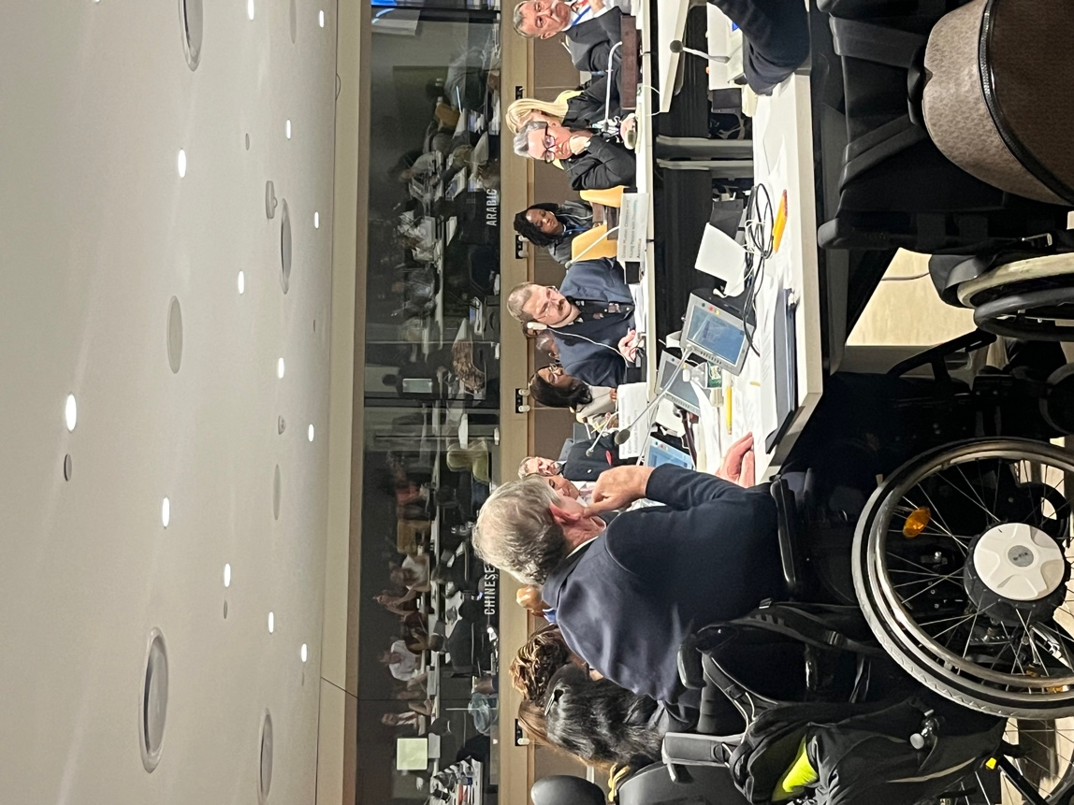
Photo: Side event: Developing and Promoting Implementation of the UNCRPD and Disability Rights across the Commonwealth

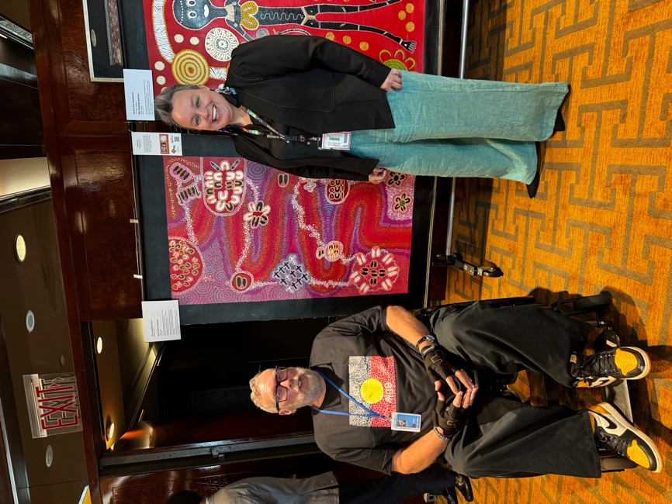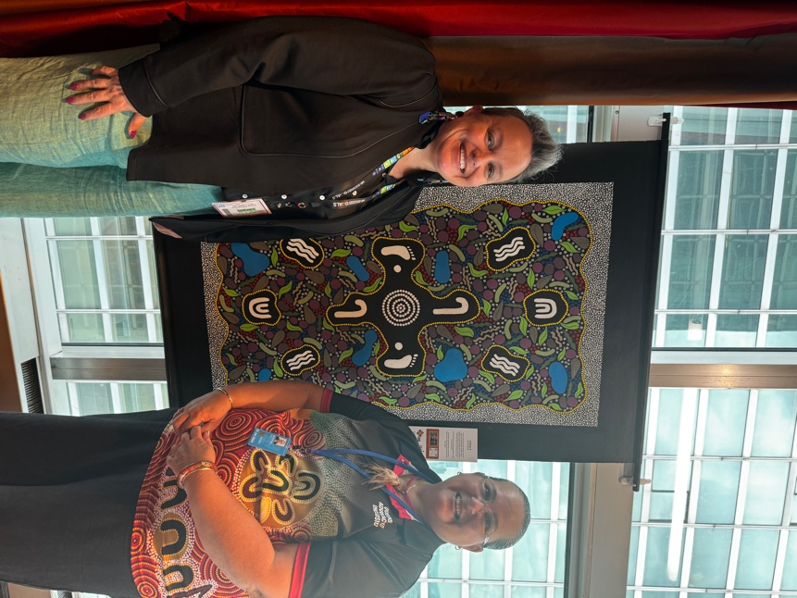
Photos: With Uncle Paul Calcott and Aunty Paula Wootton at the QAI side event and Art Exhibition

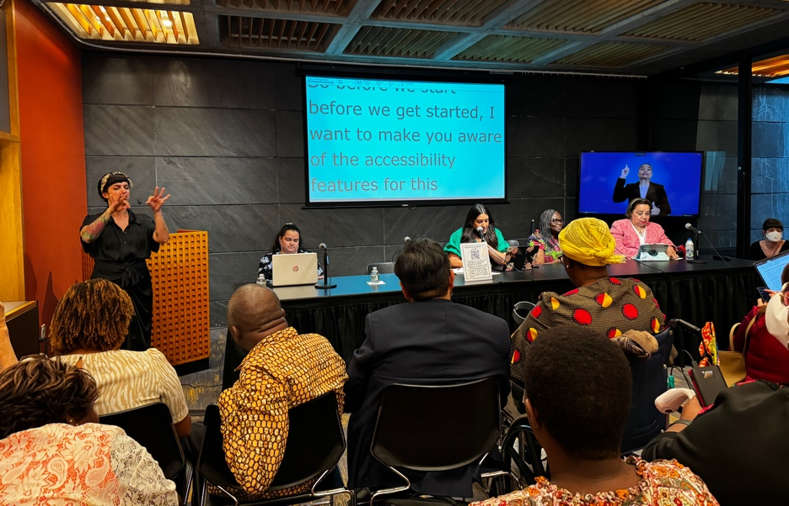
Photo: Side Event: The Future of Disability Rights is Feminist

4. Other Activities

Over the conference, Clare met with various other organisations and advocates, some of whom had reached out to WWDA, others were known through personal networks or through COSP15. These included:

Autistic Leaders Dinner
Attending the Autistic Leaders dinner with global Autistic and autism community leaders was a remarkable opportunity to connect with influential figures in the autism advocacy community. It was attended by representatives from the United States, Malta, Australia, New Zealand and Ireland. This informal event provided a platform for exchanging insights and discussing strategies to enhance the inclusion and support of autistic individuals worldwide. A significant highlight of the evening was the introduction of two Australia youth delegates to the group. These young advocates shared their unique perspectives and experiences, adding valuable voices to the conversation. Their participation underscored the importance of youth involvement in advocacy and policymaking, and it was inspiring to see the global leaders warmly welcome and engage with them.

Commonwealth Disabled Peoples Forum (CDPF) and States Parties Meeting to Further Discuss the Inclusion of a Disability Action Plan in the Agenda at Commonwealth Heads of State Meeting (CHOGM) in October
The meeting with the Commonwealth Disabled People's Forum (CDPF) and States Parties was a pivotal moment in advancing the agenda for disability inclusion. The primary focus was on incorporating a comprehensive Disability Action Plan into the agenda for the upcoming Commonwealth Heads of Government Meeting (CHOGM) in October. The discussions were robust, with delegates from Uganda, Barbados, Canada, the UK, Malta and Australia emphasising the need for a cohesive strategy to address the rights and needs of people with disabilities across the Commonwealth. The meeting highlighted the collective commitment to ensuring that disability issues are prioritized and addressed at the highest levels of government, paving the way for more inclusive policies and practices within member states.

Meeting with Representatives of the Brazilian Government and Trade Unions
Meeting with representatives of the Brazilian government and trade unions was an exciting opportunity to build on existing relationships, establish new partnerships and collaborative efforts. The discussions centred around shared goals of enhancing disability rights and inclusion within Brazil, with a focus on employment. A key outcome of this meeting was the agreement to participate in a significant event scheduled for September, which aims to bring together various stakeholders to further these objectives. This upcoming event promises to be a critical platform for exchanging best practices, fostering international cooperation, and driving forward the agenda for disability employment and inclusion in Brazil.

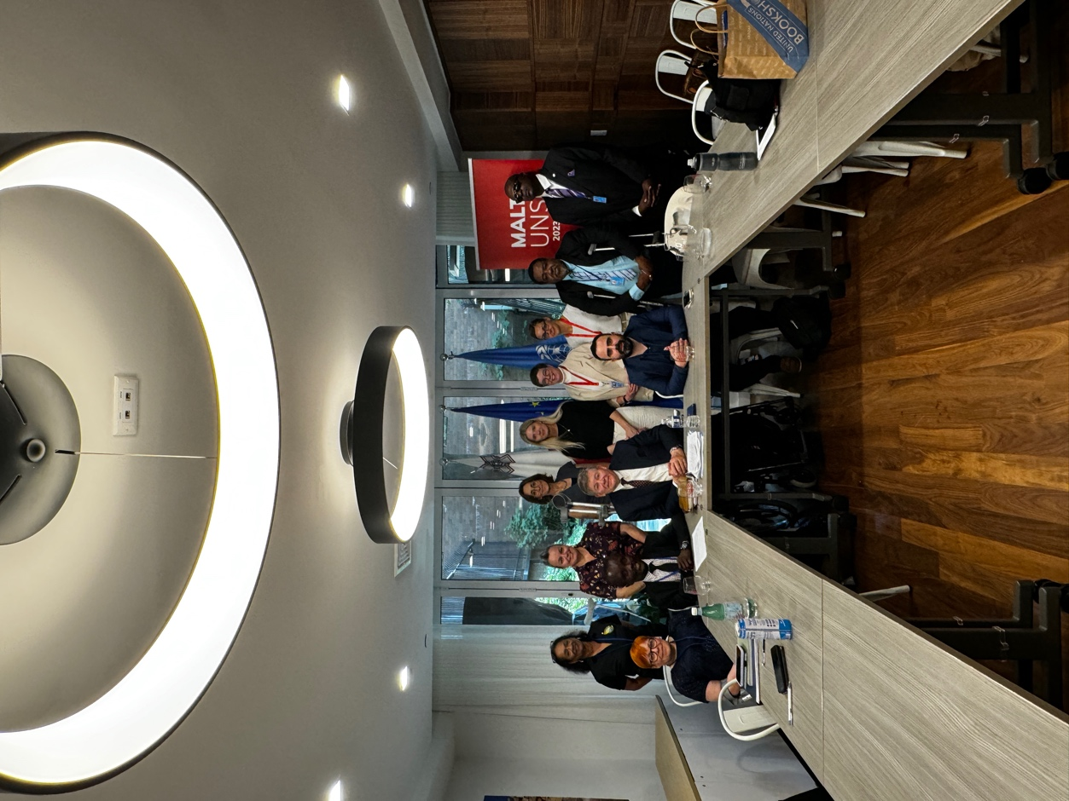
Photo: Attending the CDPF and States Parties Meeting

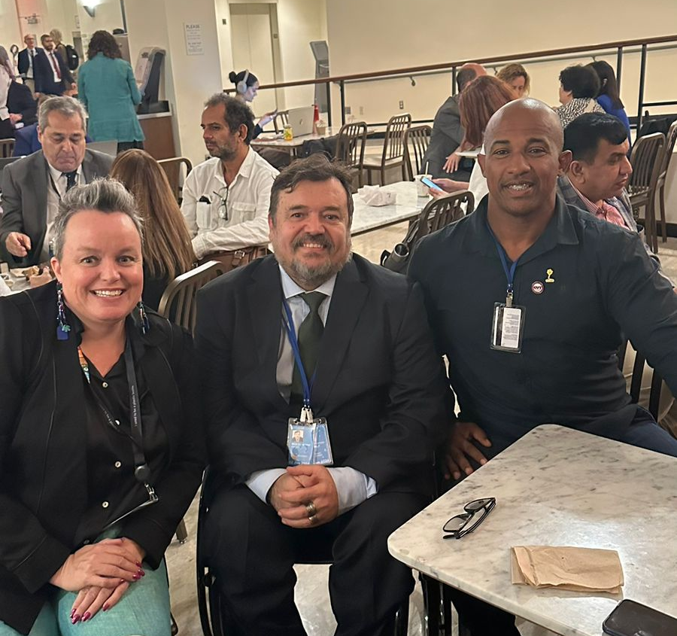
Photo: Meeting with Emerson Damasceno and Carlos Maciel from Brazil

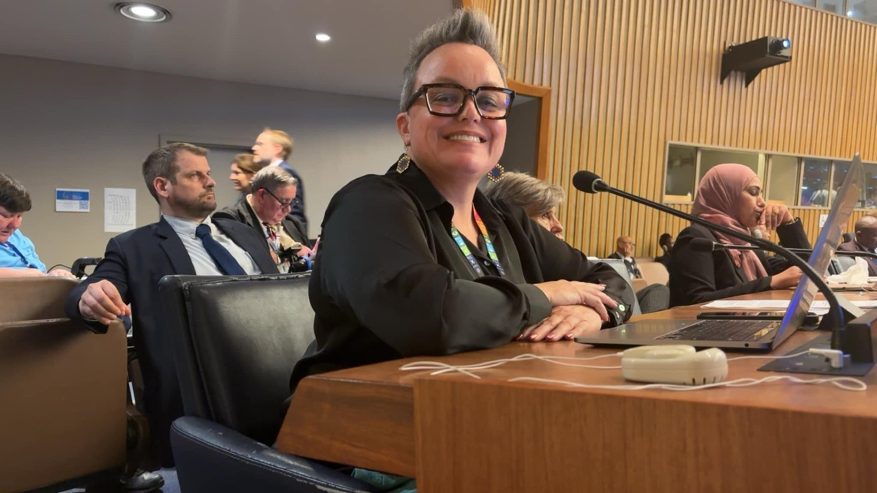

Photo: Clare waiting to deliver the joint intervention with WWDA and ILGA World.

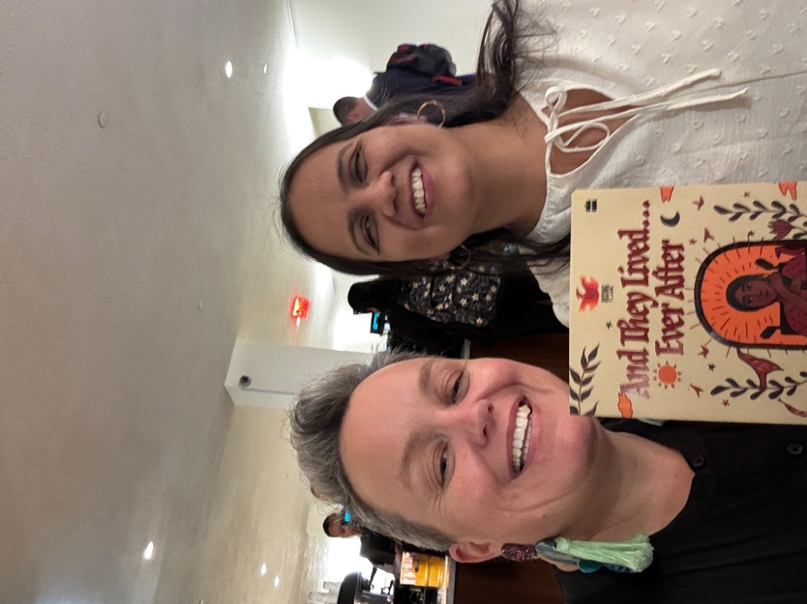
Photo: Clare with Nidhi Goyal from Rising Flame (India) holding a fantastic book produced by her organisation

6. Conclusion: Key Outcomes and Benefits from CoSP17

Individual Outcomes

Attending CoSP17 allowed delegates to play a pivotal role in assisting their colleagues from other nations in advocating with their respective governments. Drawing on Australia's frameworks and policies in disability inclusion, the Australian delegates shared valuable insights and practical experiences with their international peers. The mutual exchange of knowledge between delegates from different nations proved beneficial in helping delegates understand how to effectively implement strategies within their own national contexts. For example, the Australian delegates spoke to their experience with comprehensive policy development and community engagement, which provided concrete examples of how to navigate governmental advocacy.

Additionally, the Clare organised and participated in networking events where she introduced her colleagues to influential stakeholders and representatives from international organisations such as ILGA and WEI. These introductions helped build critical connections that can support ongoing advocacy efforts. By acting as connector and mentor, the WWDA delegate was able to enhance the collective capacity of the international community to advocate for disability rights and inclusion. This collaborative spirit ensures that the benefits of CoSP17 extend beyond the conference itself, creating a lasting impact on global disability advocacy efforts.

Following on from CoSP, the Clare attended the executive meeting of the Commonwealth Disabled People’s Forum in Nairobi, which included a three day training session for youth advocates from African nations. She was able to use her improved knowledge of the CRPD, and the language and ways of working of the UN, to build the capacity of these emerging leaders so that they can better make use of mechanisms such as the CRPD to advocate within their own communities.

Finally, attending CoSP17 provided Clare with a profound understanding of global efforts and contexts in the realm of disability rights and inclusion. Immersed in a diverse environment, she was exposed to a myriad of international initiatives, policies, and best practices, which broadened her perspective beyond the Australian context. Engaging with global leaders, policymakers, and advocates allowed her to grasp the varied challenges and innovative solutions being implemented worldwide. This enriched understanding equips her with the ability to contribute more effectively to national and international forums, bringing a nuanced and informed perspective that bridges local experiences with global strategies, ultimately enhancing the collaborative efforts towards achieving disability inclusion and human rights on an international scale.

Outcomes for WWDA

Engagement in CoSP17 built upon WWDA's connections with global partners, fostering new relationships and strengthening existing ones. By participating in various sessions, panels, and networking events, the WWDA delegate had the opportunity to interact with a wide range of international stakeholders, including representatives from prominent organisations, policymakers, and fellow advocates. These interactions facilitated the exchange of ideas, best practices, and collaborative strategies, enabling WWDA to build upon its robust network of allies and supporters. The connections formed at CoSP17 are instrumental in creating opportunities for joint initiatives and partnerships, furthering WWDA's mission to promote the rights and inclusion of women with disabilities on a global scale.

WWDA's active participation at CoSP17 supported its visibility within the international community. By sharing their expertise and experiences in various forums and discussions, the WWDA delegate showcased the organisation's ongoing leadership and commitment to advancing disability rights. This visibility promoted WWDA’s role as a key player in the global disability advocacy landscape and attracted attention from potential partners and supporters. The exposure gained at CoSP17 has opened doors for increased collaboration and influence, enabling WWDA to amplify its impact and continue its contribution to international efforts aimed at achieving equity and inclusion for women with disabilities.

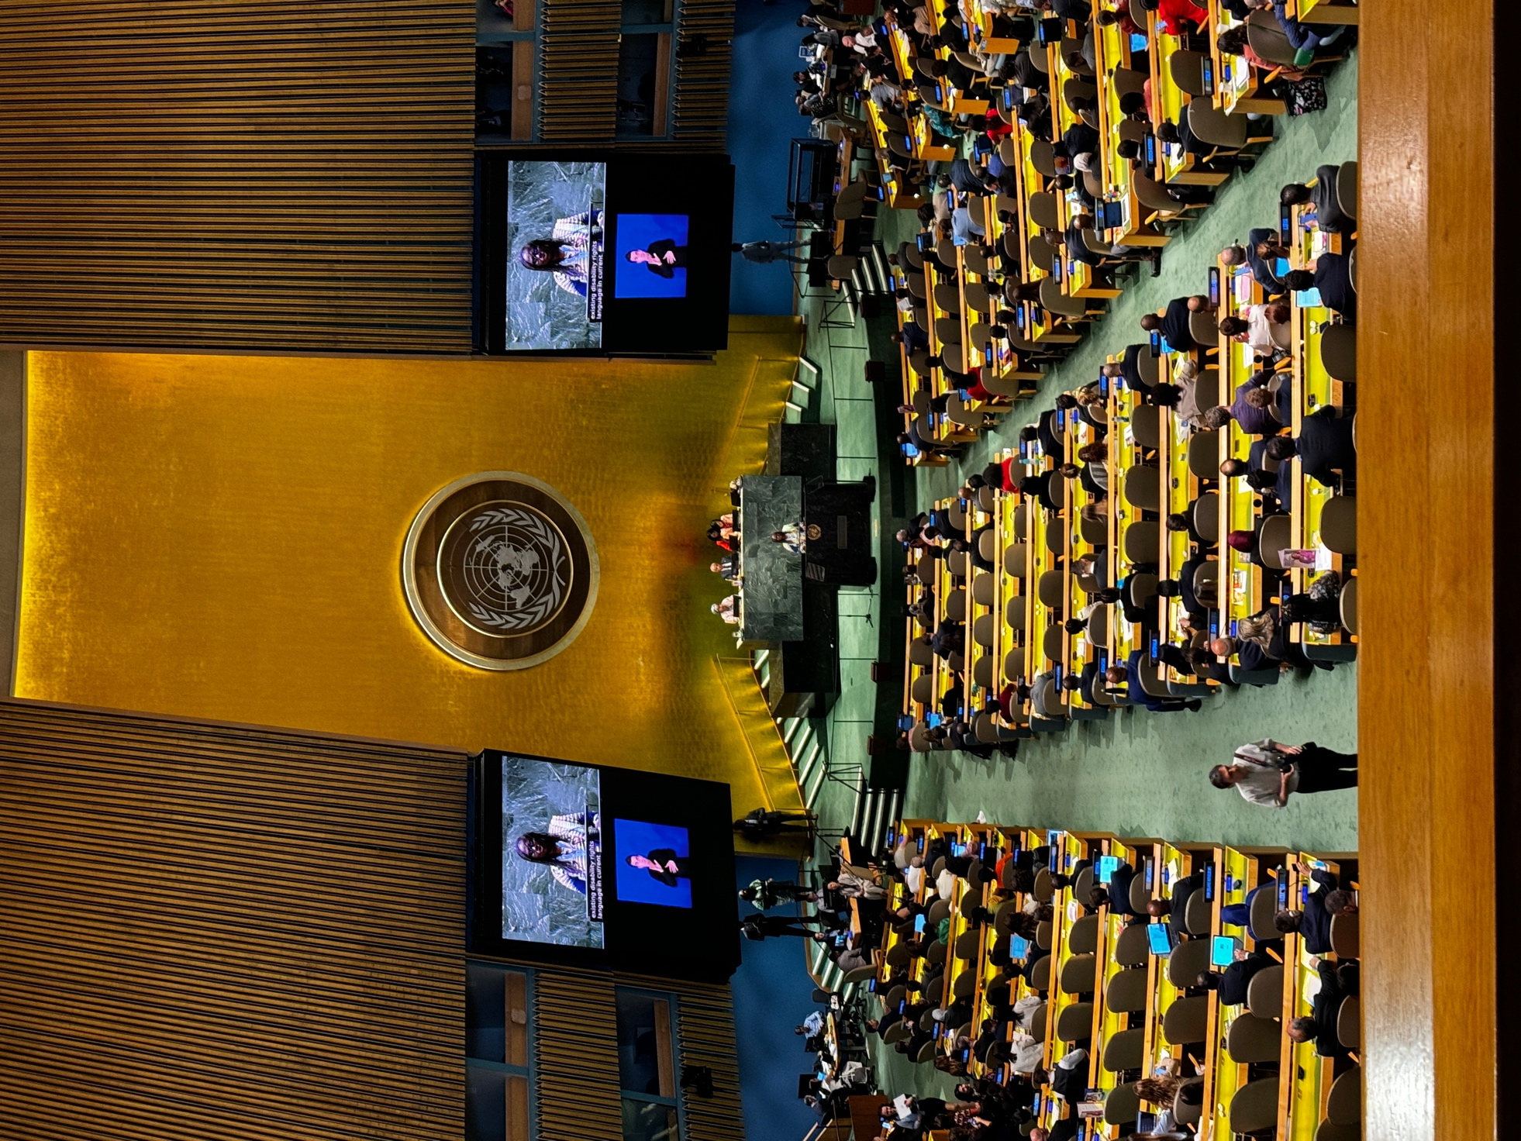
Photo: The General Assembly Hall during the Opening Ceremony of CoSP17

