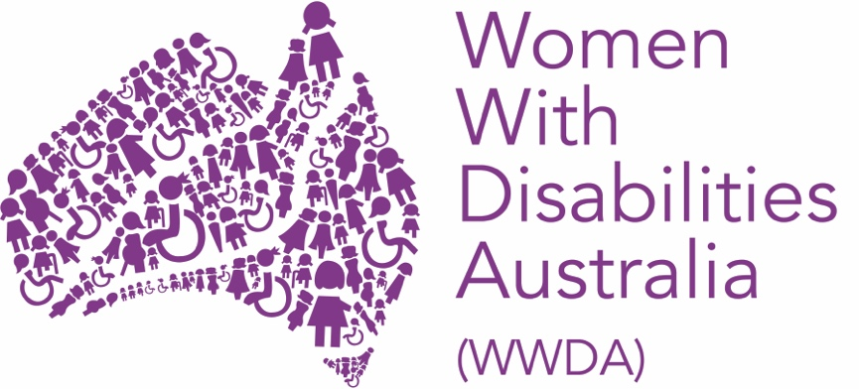

WOMEN WITH DISABILITIES AUSTRALIA (WWDA)

67th Session of the Commission on the Status of Women (CSW)

Post-Event Report

April 2023

PUBLISHING INFORMATION

Women With Disabilities Australia (WWDA) (2023). ‘Report from the 67th Session of the Commission on the Status of Women.’ April 2023. WWDA: Hobart, Tasmania.

Acknowledgments

WWDA acknowledges the traditional owners of the land on which this publication was produced. We acknowledge Aboriginal and Torres Strait Islander people’s deep spiritual connection to this land. We extend our respects to community members and Elders past, present and emerging.

This document was written by Margherita Dall’Occo-Vaccaro, for and on behalf of Women With Disabilities Australia (WWDA), with assistance from WWDA member and CSW delegate Kelly Cox.

Women with Disabilities Australia (WWDA) receives part of its funding from the Australian Government, Department of Social Services (DSS) and the Office for Women (OFW). WWDA acknowledges and thanks DSS and the OFW for its support.

Contact

Women with Disabilities Australia (WWDA)
Contact: Carolyn Frohmader, Executive Director
PO Box 407, Lenah Valley, 7008 Tasmania, Australia
Phone: +61 438 535 123
Phone: +61 438 535 535
Email: officeadmin@wwda.org.au
Web: www.wwda.org.au
Facebook: www.facebook.com/WWDA.Australia
Twitter: www.twitter.com/WWDA_AU

Disclaimer
The views and opinions expressed in this publication are those of Women with Disabilities Australia (WWDA) and not necessarily those of our funding bodies or the Australian Government.

CONTENTS
INTRODUCTION 4
KEY ACTIVITIES 6
1. Preparatory activities, meetings, and webinar. 7
2. Official program and related activities 9
3. Hosting WWDA’s in person parallel event 12
4. Attendance at parallel and side events 13
5. Key meetings with other organisations 17
6. Communications 17
CONCLUSION: KEY OUTCOMES AND BENEFITS 19

INTRODUCTION

In early March 2023, Women With Disabilities Australia (WWDA) staff member, and youth delegate, Margherita Dall’Occo-Vaccaro and WWDA Member Kelly Cox attended the 67th Session on the Commission on the Status of Women (CSW67) held at the United Nations in New York from the 6th to 17th of March, as delegates on behalf of WWDA. Kelly, her support worker, and Margherita attended for the first week of CSW67, returning to Australia on the 13th of March. Due to the limited funding made available by the Office for Women ($15,000 from WWDA’s existing National Women’s Alliances (NWA) funding), coupled with the additional expenses related to accessibility and reasonable adjustment requirements, WWDA delegates were only able to participate in the first week of CSW67. Other National Women’s Alliances attending CSW were able to attend and participate in the full two weeks of CSW67.

The Commission on the Status of Women (CSW) is the principal global intergovernmental body exclusively dedicated to the promotion of gender equality and the empowerment of women. The CSW is instrumental in promoting women’s rights, documenting the reality of women’s lives throughout the world, and shaping global standards on gender equality and the empowerment of women. Over the past two decades, the Commission on the Status of Women has systematically reviewed progress in the implementation of the twelve critical areas of concern identified in the the Beijing Declaration and Platform for Action (BPFA) at its annual sessions, and has adopted action-oriented recommendations, in the form of agreed conclusions, to facilitate increased implementation at all levels.

The annual CSW conference brings together State Parties, non-governmental organisations (NGO’s), and other representatives to discuss gender equality. During the second week of CSW, State Parties negotiate the Agreed Conclusions. This year’s theme was “Innovation and technological change, and education in the digital age for achieving gender equality and the empowerment of all women and girls”. This session of the conference is the first one to be hosted in person post the COVID-19 pandemic and had an estimated 8,000 people attend throughout the two weeks.

For many years, WWDA, alongside other organisations representing people with disability, has engaged in the work of the Australian government and the United Nations on the Beijing Platform for Action, the Millennium Development Goals (MDGs) and past annual sessions of the Commission on the Status of Women.

For CSW67, WWDA sent two delegates who worked together with their diverse skill sets to represent women and gender diverse people with disability, as well as the various issues currently facing women and gender diverse people with disability, both in Australia and internationally. This year, CSW67 had low attendance and representation from women with disability, which meant that Kelly and Margherita’s attendance was particularly important to ensure tangible outcomes for women with disability and to keep other Australian delegates attuned to and supportive of the rights of women, girls and gender diverse people with disability.

Both delegates attended CSW for the first time, which allowed them both to solidify their international and Australian connections, broaden their networks, gain new skills, and solidify their existing expertise.

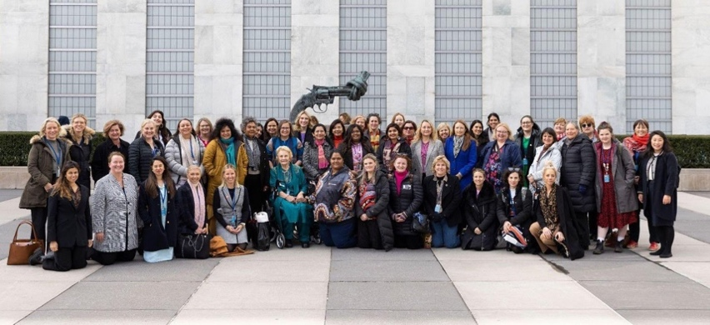

Photo of some members of the Australian Civil Society Delegation.

KEY ACTIVITIES

WWDA delegates participated in CSW67 through multiple avenues, including hosting an event in person, as well as attending the official program of meetings and events. These activities are outlined below.

Prior to attending the conference, WWDA delegates Margherita and Kelly, met with various organisations of people with disability, and wider networks to gather information on the key concerns and issues for women with disability to take to CSW67. This included conversations with various groups of under-represented women with disability such as young women and gender diverse people, culturally and linguistically diverse (CALD) women, Aboriginal and Torres Strait Islander women and others.

Some of the key issues that emerged through this process included:

- Intersectionality and ensuring under-represented women with disability were not only included but acknowledged in their specific skills and the specific challenges faced.

- Ensuring the conversation on sexual and reproductive rights included a wide range of perspectives and moved forward to discuss the needs and wants of women with disabilities, not just ensuring their fundamental rights.
- Violence in all its forms on people with disability, specifically violence which is not traditionally labelled as such, such as violence inflicted by doctors, service systems and carers.

- The right to co-design and ensuring the creation of tools, resources, and services for women with disability are led by women with disability.

1. Preparatory activities, meetings, and webinar

Prior to attending the conference, WWDA delegates, Margherita and Kelly participated in several meetings organised by Helen Dalley-Fisher from the Equality Rights Alliance (ERA), to discuss the collective attendance in New York of representatives from various Non-Government Organisation’s (NGO’s) and the Australian Government. These sessions included information on the conference, who would be attending, internationalising our issues and language sessions on the Zero Draft. Margherita and Kelly were also able to engage with the NGO representatives on the Australian Government Delegation, Ms Kaylee Anderson and Ms Hannah Robertson.

The delegates organised strategic meetings with the International Disability Alliance (IDA), Women Enabled International (WEI), YWCA Australia and other individual advocates on disability, many of whom the WWDA delegates had met at the 15th session of the Conference of State Parties on the CRPD (CoSP15) which they also attended. The outcomes and specifics of these meetings have been outlined further below.

WWDA youth delegate, Margherita Dall’Occo also applied to deliver a formal statement or intervention during the official meeting program and was successful. Margherita spent time preparing this statement prior to the beginning of the conference.

In early February, WWDA ran a joint pre-CSW webinar with ERA to prepare any Australian delegates or other interested people by sharing the experiences of three young women with technology, and examining how complicated the relationship between people with disability and technology is. Margherita spoke alongside Claire Bertholli and Amy Marks, both WWDA Youth Network Members and young women who have experience in various forms of technology. The webinar is available on the WWDA channels and YouTube. Hosting the webinar allowed WWDA to start platforming its attendance at CSW67 in New York and raising issues regarding women with disability.

During the first two days of the conference, Helen Dalley-Fisher from ERA held a CSW language session with both NGO representatives and many civil society representatives attending. WWDA’s delegates found this session highly informative and believe that it would have been beneficial for the delegation to attend this session before arriving in New York or contributing to the Zero Draft. Helen was able to explain in a very clear and detailed way what the aims were, the differences between agreed language and proposing new language, the impact of these differences, and what the process is during CSW to get the entire document finalised by each member state. Helen also explained that certain terms are used, and others aren’t. For example, ‘women in ALL their diversity’ is commonly used instead of using ‘intersectionality’ or listing marginalised groups so that certain cohorts are not excluded.

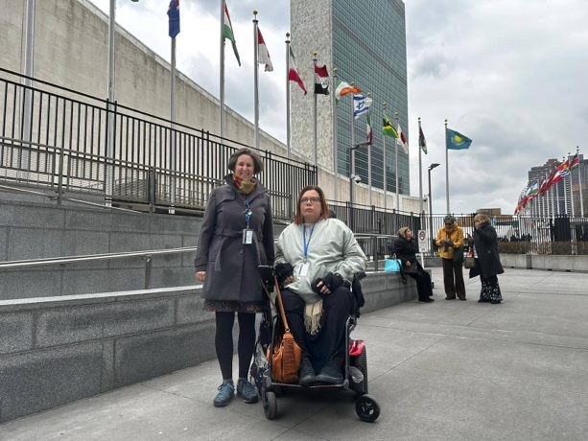

Photo of Helen Dalley-Fisher (left) and Kelly Cox (right) outside of the UN building.

2. Official program and related activities

The official program began on March 6th, with this year having a particular high level of attendees, tickets were required for the opening and the first two days of general discussion. WWDA’s delegates were able to get tickets for both and attended the opening session as well as parts of the discussions throughout the week.

The opening began with various United Nations representatives speaking and highlighting key issues including gender bias in artificial intelligence, and highlighting the alarming signs related to climate food insecurity. António Guterres, the Secretary General of the United Nations notably opened the session by stating that we are moving further away from gender equality, with it being currently around 300 years away. As women with disability, WWDA’s delegates strongly reflected on this, thinking about how far away equality would be for us, and under-represented groups of women and gender diverse people with disability. The Secretary General continued to say that to equalise power for women and girls around technology, we need better education, full participation and to create safe digital spaces.

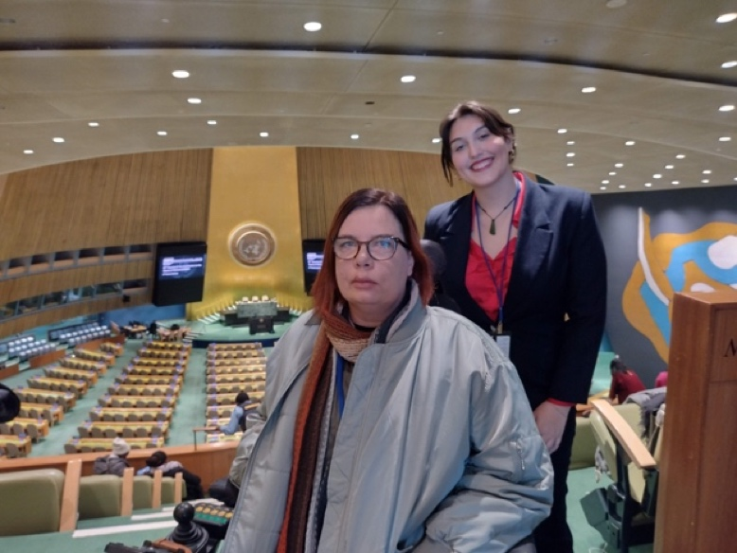

Photo of Kelly (left) and Margherita in the General Assembly.

In attending the general discussion and official program, delegates were able to listen to the views of various state parties and their perspectives on gender equality and technology. There was a wide range of opinions, both conservative and progressive shared.

The Pacific region and various forums from the Pacific were represented, with many talking about how the cost of technological innovation in other areas of the world has many negative impacts on the Pacific, specifically through climate change and prevalence of disasters. WWDA delegates both felt that this was particularly important to amplify on their return to Australia, both because of Kelly’s work in the area and intervention at CoSP15, and because of how directly it impacts the work of Australia.

The Australian delegation led by Senator the Hon. Malarndirri McCarthy spoke on technological issues facing women specifically those faced by Indigenous, regional and rural women. WWDA’s delegates were very excited and honoured to have the Hon. Malarndirri McCarthy lead the delegation, as the first ever Indigenous Australian woman to do so. This was a huge step forward in representation, and signified how important this issue is. Considering the high proportion of Indigenous women who have disability, for WWDA, this is a topic that overlaps and is relevant to so much of our work.

There was concern among the delegation, particularly civil society delegations, on the lack of attendance by Australia’s Minister for Women, the Hon. Katy Gallagher. It was wonderful to have an Indigenous woman lead the delegation, however WWDA’s delegates believe that there could have been significant additional benefit by having Australia’s Minister for Women attend.

Helen, in collaboration with the NGO representatives and the Australian Government Office for Women organised daily de-briefings for all Australian civil society delegates at the end of every conference day. The Australian Ambassador for Gender Equality, Stephanie Copus Campbell, also attended a few of these debriefs. These were valuable and allowed delegates to engage with other civil society representatives, share learnings from sessions and engage with each other, however, the sessions were not always accessible due to the accessibility of the rooms within the UN building. Further, WWDA delegates found that due to this being the first in person CSW following the pandemic, it was difficult to voice issues and concerns with other Australian civil society, as so many issues were a priority and various organisations were particularly busy with their own conference agendas. There was some agreement with inaccessibility and disorganisation and agreement to raise these issues for next year.
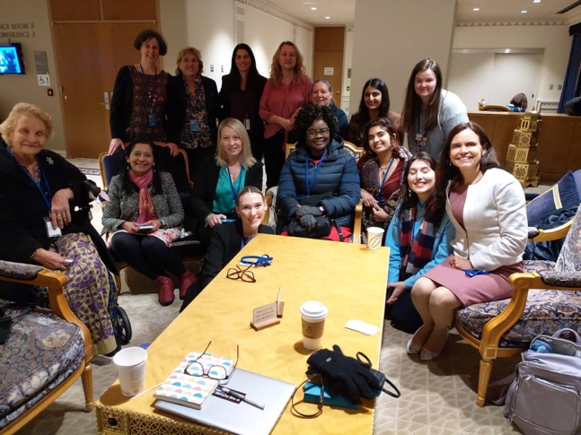
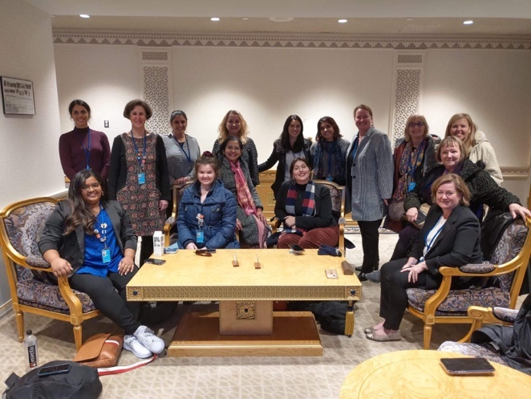

Photos of Australian Civil Society and Government debriefs, with Australian representatives including Ambassador for Gender Equality Stephanie Copus Campbell.

The Ambassador and Permanent Representative of Australia to the UN, The Honourable Mr Mitch Fifield hosted a reception for the Australian Government and civil society organisations at the Permanent Mission of Australia to the United Nations on the Sunday evening before the opening of the conference. It was valuable to meet various other civil society representatives, however the official government delegation had not all arrived yet and WWDA’s delegates were unable to hear from other speakers. Kelly and Margherita faced a few access issues at the Permanent Mission and so were unable to meet and network with other participants to their full capacity.

the Permanent Mission of Australia to the United Nations event 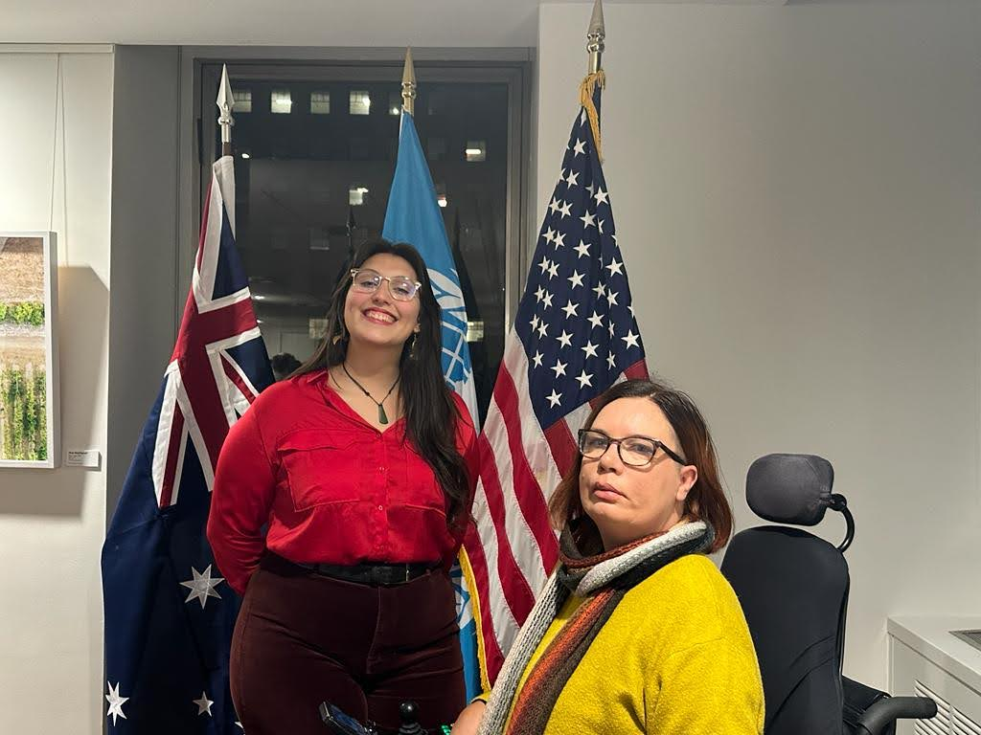

Photo of Margherita and Kelly at the Permanent Mission of Australia to the United Nations event on the Sunday evening.

Although WWDA’s proposal to submit an intervention during the general discussion was accepted, this unfortunately took place in the second week of the conference, when WWDA’s delegates were no longer present. Instead of speaking in person, Margherita pre-prepared a video intervention which was played during the general discussion section for NGO interventions. The intervention is available on the WWDA website or can be viewed on the UNTV site. Margherita talked about technology for women with disability, specifically access to technology, accessible spaces and calling on the commission to set up a permanent working group on technology and disability, as well as to “facilitate a safe, accessible and inclusive way for women with disabilities to participate in the planning, co-design and development of all current and future technology and digital spaces”.

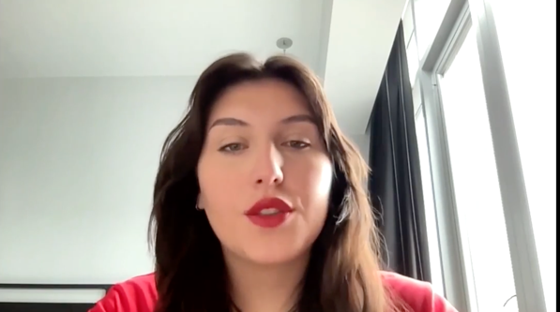

Screenshot from video intervention played on the 15th of March during the General Discussion.

3. Hosting WWDA’s in person parallel event

During CSW67, WWDA hosted an event, on ‘Using Technology to Advance the Sexual and Reproductive Rights of Women With Disability’. Kelly and Margherita from WWDA and Anastasia Holoboff from Women Enabled International (WEI) spoke on a panel as part of the event and videos were pre-prepared by Australian disability advocates Jax Brown, Dr Angela Williams and Katharine Annear. The event was open to all NGOCSW registrants, online and in person.

Presenters spoke about the main priorities for women, girls, feminine identifying and non-binary persons with disability in relation to sexual and reproductive rights, the different experiences of women and gender diverse people in accessing sexual and reproductive health services and technologies and the importance of representation in this area due to those different experiences.

The event was well attended but WWDA did experience various issues with the accessibility of the venue, particularly the wheelchair entrance, the physical distance of the venue from the UN building, elevators, and organisation of chairs in the room. Despite several efforts to do so, WWDA staff had difficulty getting in contact with NGOCSW and the administration for the event venue to gather information on the accessibility of the room beforehand. The allotted time to set up and pack down was also very short which made it difficult to troubleshoot problems when they became apparent. Accessibility for all women with disability is something that WWDA has always advocated for, and will continue to advocate for, at all UN events. Overall, the event was highly successful, prompting much discussion among attendees. The event, the recording is available on WWDA’s website along with two other recordings of virtual events that WWDA also ran as part of the NGOCSW conference. See:

https://wwda.org.au/2023/03/csw67-our-site-a-website-made-by-and-for-women-with-disabilities-recording-now-available/

https://wwda.org.au/2023/03/in-person-event-using-technology-to-advance-our-sexual-and-reproductive-rights-recording-now-available/

https://wwda.org.au/2023/03/csw67-wwda-lead-empowering-women-with-disability-in-the-digital-age-recording-now-available/

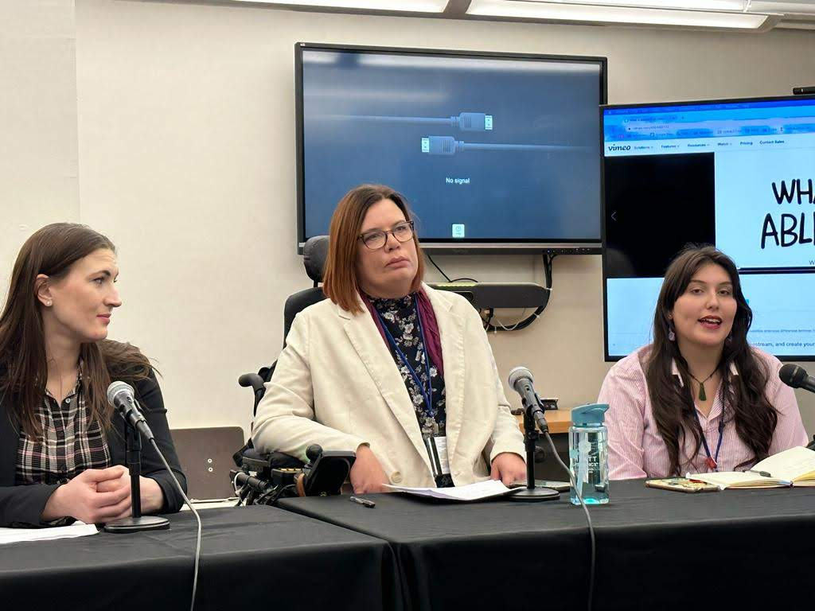

Photo of Anastasia (left), Kelly (middle) and Margherita (right) on the panel.

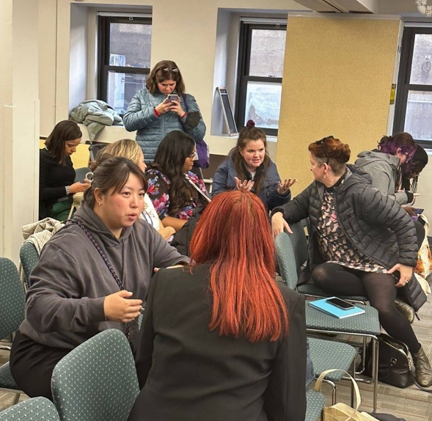

Photo of some of the attendees at WWDA’s in person parallel event

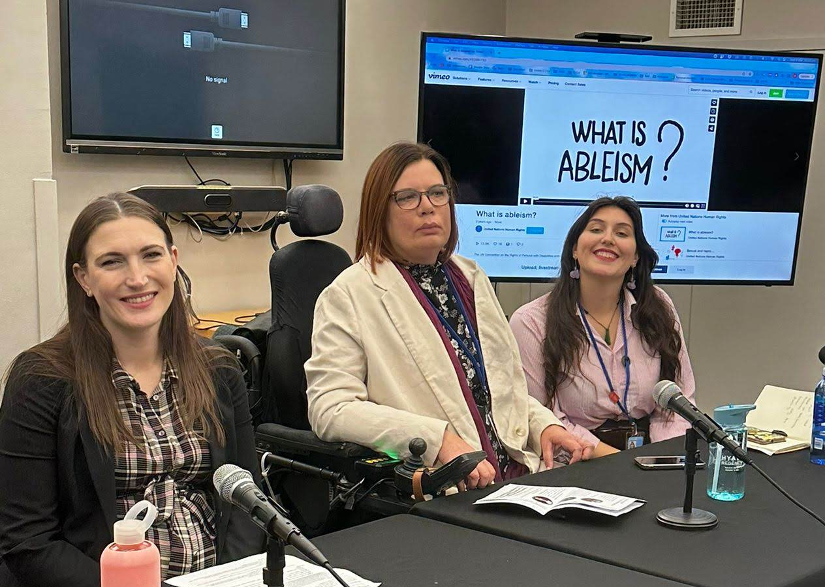

Photo of Anastasia, Kelly and Margherita on the panel, smiling.

4. Attendance at parallel and side events

As well as hosting an in person parallel event, WWDA delegates attended various official UN side events hosted by governments or UN entities, as well as various civil society ran parallel events through NGOCSW. Likely due to a low attendance of disability organisations, and the inaccessibility issues at CSW, there were few events specifically on disability. However, many events were still relevant to WWDA’s work.

Over the week, delegates participated in the below side events:

- Rural Women’s Conversation Circles Hosted by the National Rural Women’s Coalition (NRWC).

This event was a conversation circle which included facilitated conversations of the experiences of rural women internationally. WWDA’s delegate Kelly was a main facilitator of this event, supported by Karina McKey. She says, ‘it was quite challenging as it felt like asking people to recall traumatising times and having to lead on quickly to the following question’. There was very little time to allow people to speak fully, and it was clear at times individuals had a lot to say. The women that left an impression were from Nepal, India, and Ghana as WWDA delegates learned that some flood prone areas in Ghana supply only very basic row boats to people with disability to get to safety.

The woman from Ghana was angry that when flooding occurs, men are given assistance to get back to work or get business up and running while women are given kitchen aids. She said women often have their own small business and supplying support such as $800 grants rather than kitchen supplies would help them get their stalls back up and running so they can buy their own kitchen supplies.

An elderly woman from India spoke in detail about how COVID-19 had impacted communities, led to worsened poverty, and ultimately led to children being sold into forced marriages and/or trafficked. A woman from New Orleans spoke about the long-term impact of Hurricane Katrina and how ultimately it led to the local government equivalent losing all its money and not being able to afford the police department and as a result New Orleans is now “the murder capital of the United States.”

Overall, the many stories and resulting consequences highlighted how urgent it is to address the impact of climate change.

- Youth Experts on Innovation and Advancing Gender Equality through Technology Hosted by Plan International Canada, Young Diplomats of Canada and For a: Network for Change.

Panellists included Caroline Hung, a tech developer from Plan International, Fahreen Budhwni and Iknoor Khaira from Young Diplomats of Canada and Kashvi Chandok ffor aFora. As a youth led event, the young women talked about how gender inequality in technology, particularly in Artificial intelligence (AI) and Science, technology, engineering, and mathematics (STEM) are impacting young women, and solutions going forward. Margherita was able to network and interact with other young women through this event, however, she felt they could go more in depth with some youth issues.

- Digital Transformation in the Pacific – Opportunities and Challenges for Feminist Organisations Hosted by Brown Girls Woke, Fiji Women’s rights Movement, FemLink Pacific, Sista, Voice for Change and the International Women’s Development Agency.

Panellists included Doris Tulifau from Brown Girls Woke, Samoa, Nalini Singh from the Fiji Women’s Rights Movement and Yasmine Bjornum from Sista, Vanuatu. The panel spoke about the increasing issues of keeping women and particularly young women and girls safe in the Pacific, the various issues affecting the Pacific such as climate change, access to technology and services. This was a particularly important event as delegates were able to engage and discuss with women in in the Asia-Pacific region on the empowerment of young women and girls.

- How Can Technology Enhance the Dignity of Women in Prison? Hosted by Human Rights Commission of New Zealand and the Māori Women’s Welfare League.

Panellists included Saunoamaali’I Karanina Sumeo, New Zealand’s Equal Opportunities Commissioner, Prue Kapua, the Immediate Past President of the Māori Women’s Welfare League and Whiti Timutimu, the Chief Adviser in the Justice Sector Directorate. This side event was particularly moving with Margherita having grown up in New Zealand, and many of the topics paralleling the issues Aboriginal and Torres Strait Islander women face in Australia. It was wonderful to see an event on women in prison, and one hosted by a country so close to Australia, who’s issues are similar in many ways.

- Unlocking the Future of Gender Equality and Sexual and Reproductive Health and Rights Through Technology Hosted by the governments of Luxemburg, Nepal, Spain, the Centre for Reproductive Rights and Fòs Feministia.

This event had panellists from various governments and countries, all of whom were experts or advocates in sexual and reproductive rights. This was an amazing event, with various topics covered, from the recent legal and rights cases in America, to what under-represented groups of women need to further their sexual and reproductive rights. A highlight was the speaker from Fòs Feministia talking about how in communities where there is no access to health care, services, food, shelter, medication and basic essentials – the community is not thinking of technology, instead just of what they need to survive. This is such an important point, particularly because it applies so heavily to women with disability – If we do not have basic access to healthcare, services and medication, how can we expect to be able to contribute to large technological innovations such as AI? This was an important event where WWDA’s delegates were able to further deepen their knowledge in this area.

Attending these side and parallel events allowed WWDA’s delegates to gain more insight into the international state of gender equality and consider who is referencing and promoting the rights of women, girls, feminine identifying and non-binary persons with disability.

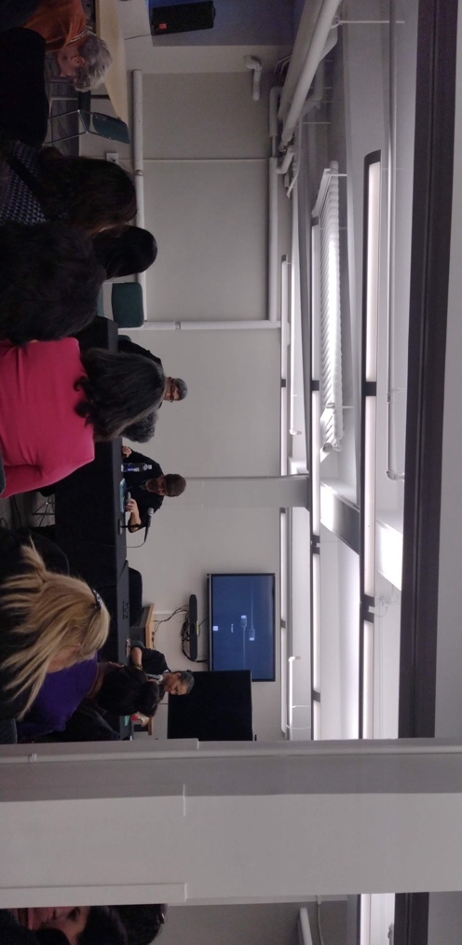

Photo of panellists at event: How Can Technology Enhance the Dignity of Women in Prison?

5. Key meetings with other organisations

During the week, WWDA delegates Margherita and Kelly met with various other organisations and advocates, some of whom had reached out to WWDA, others were known through personal networks or through COSP15. These included:

- Women Enabled International (WEI) and International Disability Alliance (IDA)

Kelly and Margherita attended an organised meeting with Women Enabled International, where various women with disability from around the world attended. Attendees shared our experiences of ableism at the conference, getting disability on the agenda, accessing International Sign language and the treatment of disability organisations by delegations.

- Federation of Women With Disability Nepal

Kelly met Nirmala Dhital, the Chairperson of the Federation of Women With Disability Nepal, and her colleagues post side event. They have kept in contact post CSW.

- Disability Policy Centre UK

Both delegates met with Kirstie Stage from the UK, who is doing PHD research in employment of people with disabilities in the UK and was an avid and passionate advocate for disabilities. She was able to relate to many of the same barriers both delegates faced and talk to her experience advocating with the UK government.

- Reconnecting with various delegates from CoSP15

Both delegates also reconnected with a people from CoSP15, with delegates from the Congo and the Ministry of National Solidarity and Humanitarian Action Burkina Faso in attendance and reconnected with.

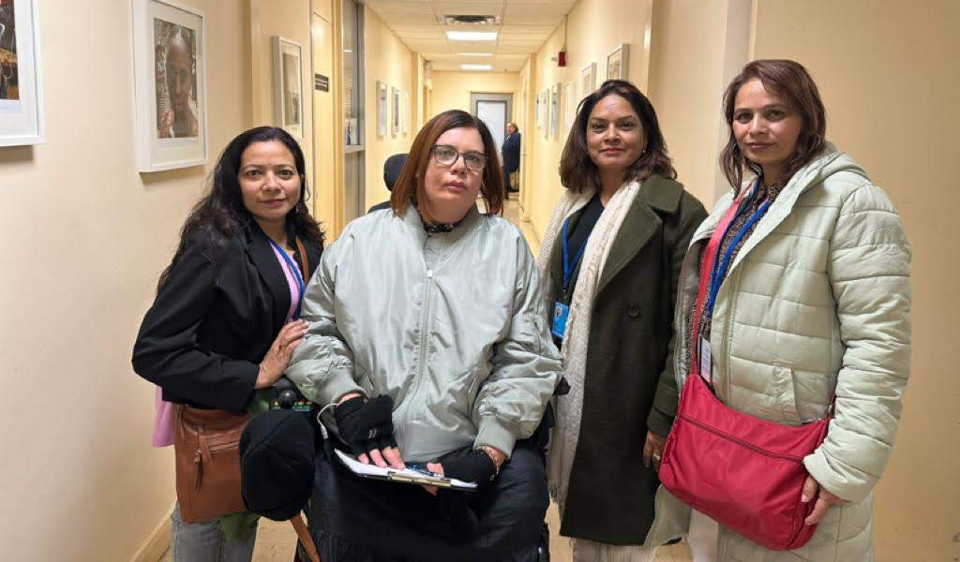

Photo of Kelly with Nirmala Dhital and her colleagues.

6. Communications

Throughout the week, Margherita provided daily updates to members and organisations in Australia on both delegates activities through:

- WWDA Youth Network Instagram, Facebook and Twitter
- WWDA Instagram Stories
- Pre and post updates on the WWDA Website
- Kelly personal Twitter
- Margherita’s personal Instagram.

The communications of the week and pre-CSW were highly organised and catalogued, with WWDA Communications Officer Jacinta Carlton organising and supporting all communications efforts from Australia and making herself available for any delegate concerns regarding communications. Jacinta’s significant efforts updating the WWDA website and following up on our three parallel events to ensure recordings and transcripts were uploaded promptly should be commended.

Conclusion: Key Outcomes and Benefits

CSW67 provided a significant skills and capacity building opportunity for WWDA delegates.

WWDA’s delegates benefited greatly from interacting with others, the wide scale knowledge exchange that occurred through parallel and side events, and the main UN program. They were able to gain an understanding of the main issues internationally and how these can be brought back to Australia to inform the work of WWDA.

The presence of WWDA delegates was particularly important, given the lack of women with disabilities and organisations of people with disabilities in attendance. While delegates faced barriers to include disability in conversations, due to their underrepresentation, they were able to have input into some key topics of discussion.

For WWDA delegates, it was difficult to attend while facing so many barriers from the UN, the NGOCSW administration and other civil society members of the Australian delegation. There was a significant lack of thought, organisation, and planning put into accessibility of the conference. This disorganisation created barriers for both delegates to attend sessions and events, and to participate in conversations. Although there was some conversation on who is ‘left behind’ from the conference due to its location, delegates had to fight to include women with disabilities in this conversation.

In the future, WWDA recommends that women with disability are better supported by the Australian Government and the NGO delegation to attend and be able to meaningfully participate in CSW (in its entirety).

WWDA strongly recommends that the Australian Government recognise and appropriately fund, the reasonable accommodations required for disabled women and girls to attend CSW, and other relevant international events.

WWDA further recommends that the Australian Government, consistent with CRPD Article 8 and CRPD General Comment 2, work to ensure that accessibility measures and reasonable accommodations are put in place for any conversations or events hosted by Australian representatives in the international human rights space.

