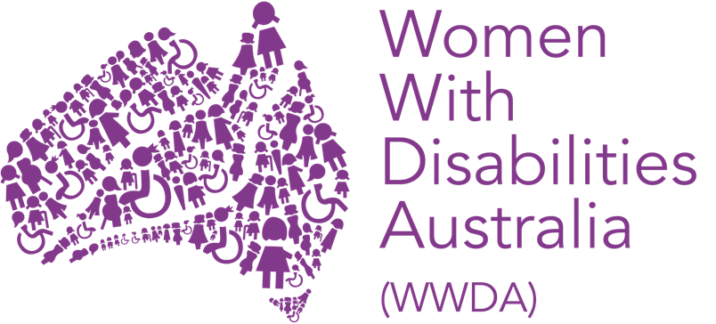

ANNUAL REPORT

JULY 2020 – JUNE 2021

PUBLISHING INFORMATION

Women With Disabilities Australia (WWDA) (2021). ‘Annual Report July 2020 – June 2021.’ Published December 2021. WWDA: Hobart, Tasmania.

Acknowledgments

WWDA acknowledges the traditional owners of the land on which this publication was produced. We acknowledge Aboriginal and Torres Strait Islander people’s deep spiritual connection to this land. We extend our respects to community members and Elders past, present and emerging.

Prepared by Carolyn Frohmader, WWDA Executive Director.

Women With Disabilities Australia (WWDA) receives part of its funding from the Australian Government, Department of Social Services (DSS). WWDA acknowledges with thanks, the support of DSS.

Contact

Women With Disabilities Australia (WWDA)
PO Box 407, Lenah Valley, 7008 Tasmania, Australia
Phone: +61 438 535 123
Email: officeadmin@wwda.org.au
Web: www.wwda.org.au
Facebook: www.facebook.com/WWDA.Australia
Twitter: www.twitter.com/WWDA_AU

Winner, National Human Rights Award 2001
Winner, National Violence Prevention Award 1999
Winner, Tasmanian Women's Safety Award 2008
Certificate of Merit, Australian Crime & Violence Prevention Awards 2008
Nominee, UNESCO Prize for Digital Empowerment of Persons with Disabilities 2021
Nominee, National Disability Awards 2017
Nominee, French Republic's Human Rights Prize 2003
Nominee, UN Millennium Peace Prize for Women 2000

Women With Disabilities Australia (WWDA) has Special Consultative Status with the Economic and Social Council of the United Nations.

Disclaimer

The views and opinions expressed in this publication are those of Women With Disabilities Australia (WWDA) and not necessarily those of our funding bodies. All possible care has been taken in the preparation of the information contained in this document. WWDA disclaims any liability for the accuracy and sufficiency of the information and under no circumstances shall be liable in negligence or otherwise in or arising out of the preparation or supply of any of the information aforesaid.

This work is copyright. Apart from any use as permitted under the Copyright Act 1968, no part may be reproduced without written permission from Women With Disabilities Australia (WWDA).

© 2021 Women With Disabilities Australia (WWDA).

ABN: 23 627 650 121

ABOUT WOMEN WITH DISABILITIES AUSTRALIA (WWDA)

Women With Disabilities Australia (WWDA) is the national Disabled People’s Organisation (DPO) for women, girls, feminine identifying and non-binary people with disability in Australia. As a DPO, WWDA is run by and for women, girls, feminine identifying and non-binary people with disability.

WWDA uses the term ‘women and girls with disability’, on the understanding that this term is inclusive and supportive of, women and girls with disability along with feminine identifying and non-binary people with disability in Australia.

WWDA represents more than 2 million women and girls with disability in Australia, has affiliate organisations and networks of women with disability in most States and Territories, and is recognised nationally and internationally for our leadership in advancing the rights and freedoms of all women and girls with disability. Our organisation operates as a transnational human rights organisation - meaning that our work, and the impact of our work, extends much further than Australia.

Disabled People’s Organisations (DPOs) are recognised around the world, and in international human rights law, as self-determining organisations led by, controlled by, and constituted of, people with disability. DPOs are organisations of people with disability, as opposed to organisations which may represent people with disability. The United Nations Committee on the Rights of Persons with Disabilities has clarified that States should give priority to the views of DPOs when addressing issues related to people with disability. The Committee has further clarified that States should prioritise resources to organisations of people with disability that focus primarily on advocacy for disability rights and, adopt an enabling policy framework favourable to their establishment and sustained operation.

Australia is a signatory to seven international human rights treaties. These are:
- the Convention on the Rights of Persons with Disabilities (CRPD).
- the Convention on the Elimination of All Forms of Discrimination against Women (CEDAW).
- the International Covenant on Civil and Political Rights (ICCPR).
- the International Covenant on Economic, Social and Cultural Rights (CESCR).
- the Convention on the Rights of the Child (CRC).
- the Convention against Torture and Other Cruel, Inhuman or Degrading Treatment or Punishment (CAT).
- the Convention on the Elimination of All Forms of Racial Discrimination (CERD).

In addition to these seven international human rights treaties, in 2009, Australia also formally endorsed the United Nations Declaration on the Rights of Indigenous Peoples - an international human rights instrument that sets a standard for the protection of Indigenous rights. By signing up to these international human rights treaties, Australia has agreed to implement their requirements within Australia. Most of these seven treaties include responsibilities to improve the rights of people with disability, of women, and of other marginalised groups.

All WWDA’s work is grounded in a human rights-based framework that links issues of gender and disabilities to civil, political, economic, social, and cultural rights. This means that WWDA uses the international human rights treaties to which Australia has signed up to, to guide and inform our work. WWDA does this, because our key mission is to advance and promote the human rights and freedoms of all women and girls and disability.

WWDA holds Special Consultative Status with the Economic and Social Council of the United Nations. This means that WWDA is formally recognised by the United Nations for our expertise in gender and disability. It also allows WWDA to be invited to, and formally contribute to, the work of the United Nations.

To find out more about WWDA, including how to join (membership is free) go to:

https://wwda.org.au

CONTENTS

Publishing Information 2

About Women With Disabilities Australia (WWDA)…………………………. 3

About WWDA’s Annual Report…………………………. 6

WWDA Board 2020-2021…………………………. 7

Summary of Key Achievements and Outcomes …………………………. 8

The Disability Royal Commission …………………………. 9

The WWDA LEAD Project …………………………. 12

National Advisory Bodies – WWDA Representation …………………………. 17

WWDA Policy Submissions & Evidence To Inquiries …………………………. 20

The NDIS and the NDIS Quality & Safeguards Commission …………………………. 22

WWDA Presentations …………………………. 24

Communications & Engagement …………………………. 27

Operational Development, Governance & Reporting …………………………. 30

ABOUT WWDA’S ANNUAL REPORT

This Annual Report provides a summary snapshot of just some of WWDA’s key outputs, activities, and achievements for the financial year reporting period 1st July 2020 – 30th June 2021. The Report demonstrates the breadth, scope, and high standard of WWDA’s work, on a wide range of initiatives and programs, across all portfolio areas and across jurisdictions.

Our Annual Report highlights and reflects WWDA’s commitment to promoting and advancing the rights and freedoms of women and girls with disability – both within Australia and around the world. Our Annual Report also reflects the human rights-based approach from which we operate.

It is outside the scope of this Report to do justice to the extensive work of WWDA during the reporting period July 2020 – June 2021.

However, in compiling this Summary Report, we have endeavoured to give our members, supporters, and funders a synopsis of just some of the key activities our organisation has undertaken, and has been engaged in, as part of our efforts to promote the rights of all women and girls with disability.

Further detail of WWDA’s work can be found on our extensive website at www.wwda.org.au and across our other platforms, which can be accessed from our website.

WWDA BOARD 2020-2021

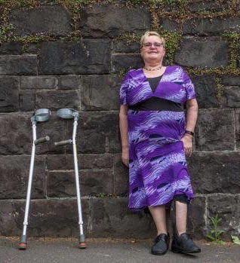  Tricia Malowney  President | 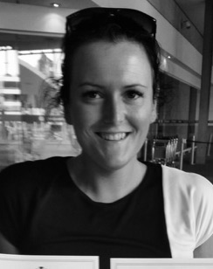  Jess White  Vice President | 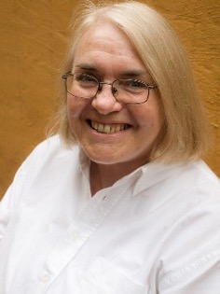  Pamela Menere  Treasurer
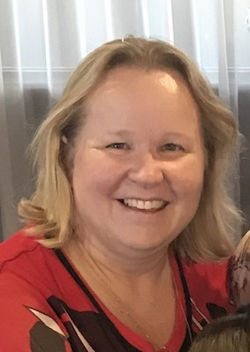  Jody Barney  Committee Member | 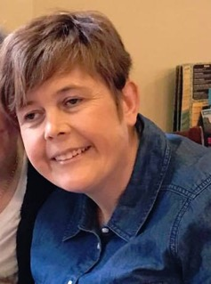  Monique Crowden  Committee Member | 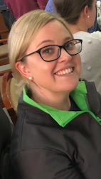  Allira Honner  Committee Member

WWDA staff profiles can be found on the WWDA website at:

https://wwda.org.au/about/board-and-staff/

SUMMARY OF KEY ACHIEVEMENTS AND OUTCOMES

This Annual Report provides a summary snapshot of just some of WWDA’s key outputs, activities and achievements at the national and international level for the financial year reporting period 1st July 2020 – 30th June 2021. The Report demonstrates the breadth, scope and high standard of WWDA’s work, on a wide range of initiatives and programs, across all portfolio areas and across jurisdictions. Our Annual Report highlights and reflects WWDA’s commitment to promoting and advancing the rights and freedoms of women and girls with disability. Our Annual Report also reflects the human rights-based approach from which we operate.

This Annual Report is structured in line with WWDA’s operational funding contract with the Australian Government Department of Social Services (DSS). The Report is also aligned with WWDA’s Strategic Plan 2017-2022 which was published after extensive consultation with our members and constituents. WWDA’s Strategic Plan 2017-2022 contains five main goals. Under each goal are listed key objectives which set out how we intend to achieve our goals. The five goals are to:

- Undertake focused systemic advocacy on priority human rights issues identified by women and girls with disability: freedom from all forms of violence; decision-making and participation; sexual and reproductive rights; economic security, justice.

- Build on and further develop WWDA’s profile and reputation at the national and international levels as the globally recognised leader on advancing the human rights of women and girls with disability.

- Contribute to the development, implementation and monitoring of Australian Government legislation and policies that affect women and girls with disability.

- Enhance WWDA’s capacity to consult, engage and represent young women and girls with disability.

- Develop infrastructure, systems and mechanisms to enable WWDA to effect its purpose, goals and objectives.

It is outside the scope of this Annual Report to do justice to the extensive work of WWDA during the reporting period July 2020 – June 2021. However, in compiling this summary report, we have endeavoured to give our members, supporters, and funders a synopsis of just some of the key activities our organisation has undertaken, and has been engaged in, as part of our efforts to promote the rights of all women and girls with disability.

Further detail of WWDA’s work can be found on our extensive website at www.wwda.org.au and across our other platforms, which can be accessed from our website.

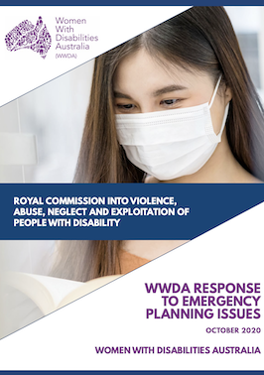
THE DISABILITY ROYAL COMMISSION

During the reporting period, WWDA continued our work on the Royal Commission into Violence, Abuse, Neglect and Exploitation of People with Disability which was formally announced by the Prime Minister on 4th April 2019.

WWDA has researched and written a number of comprehensive evidence-based Submission to the Disability Royal Commission (DRC), including several in response to the ‘Issues Papers’ released by the DRC. WWDA’s formal Submission have included:

- WWDA’s Response to the Education & Learning Issues Paper
- WWDA’s Response to the Employment Issues Paper
- WWDA’s Response to the Emergency Planning & Response Issues Paper
- WWDA’s Response to the Group Homes Issues Paper
- WWDA’s Response to the Promoting Inclusion Issues Paper
- WWDA’s Response to the Rights & Attitudes Issues Paper
- WWDA’s Response to the Violence in the Home Issues Paper
- WWDA Submission on the issue of Restrictive Practices
- WWDA’s Response to the Safeguards & Quality Issues Paper (forthcoming)
- WWDA Submission on the issue of Sexual & Reproductive Rights (forthcoming)

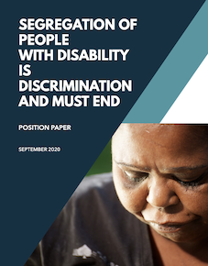
WWDA also took on the role of co-ordinating a Position Paper on Segregation, on behalf of Disabled People’s Organisations (DPOs) and Disability Representative Organisations (DRO’s). This Position Paper entitled ‘Segregation of People With Disability is Discrimination and Must End’, sets out the sectors concerns regarding existing law, policy and practice frameworks that maintain the segregation of people with disability from community life.

The Paper calls on the Disability Royal Commission to explicitly recognise the segregation of people with disability as discrimination, that segregation is an underpinning enabler of violence, abuse, neglect and exploitation, that segregation constitutes systemic neglect and exploitation; and the Disability Royal Commission must hold governments and other stakeholders to account for supporting, maintaining and funding segregated systems. It includes a series of recommended actions to work towards ending segregation of people with disability.

During the reporting period, WWDA has worked closely with the Disability Royal Commission, and our members on a wide range of activities. Just some examples include:

- Participating in fortnightly meetings with DRC staff, including the Office of the Senior Counsel
- Attending quarterly meetings with the Your Story Disability Legal Support service, as a WWDA representative on the Your Story Committee
- Working with the Economic Media Centre (EMC) to develop a media engagement plan around the Public Hearing on ‘The Health and Safety of Women and Girls with Disability’ to be held in October 2021 and March 2022
- Developing a WWDA DRC Engagement Strategy
- Giving a presentation at the Disability Advocacy Network of Australia (DANA) National Forum on the Disability Royal Commission
- Initiating and attending quarterly DPO/DRO meetings with Disability Royal Commission personnel
- Initiating and writing correspondence to the Disability Royal Commission on behalf of the DPO/DRO sector
- Participating in DRC commissioned research studies

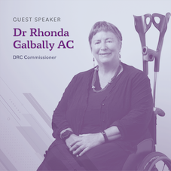

During the reporting period, WWDA has undertaken a significant amount of work for and with our members in order to support them to learn about, and engage in, the work of the Disability Royal Commission. Just some of this work has included:

- Developing, updating and maintaining the WWDA website campaign landing page on the DRC
- Developing and disseminating a wide range of Easy English Fact Sheets
- Developing and disseminating a series of Videos including videos in eleven different languages
- Commencing work to develop Videos in Auslan and 3 Indigenous languages
- Organising and hosting a webinar on Our Disability Royal Commission: A webinar for women with disability on how to get involved.
- Engaging with, and supporting individual WWDA members (and non-members) to discuss how they can tell their stories to the Disability Royal Commission in a safe and supportive way
- Implementing specific, targeted initiatives and activities to build the capacity of young women, feminine identifying and non-binary young people, to engage with the Disability Royal Commission, including for example, a specific WWDA Youth Network social media campaign promoting engagement with DRC

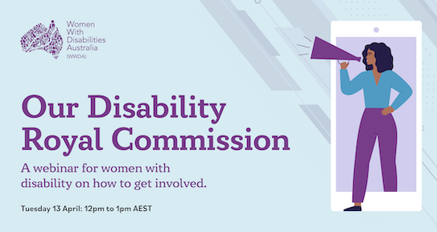

WWDA LEAD PROJECT: ‘Building Capacity of Women and Girls with Disability in Australia’

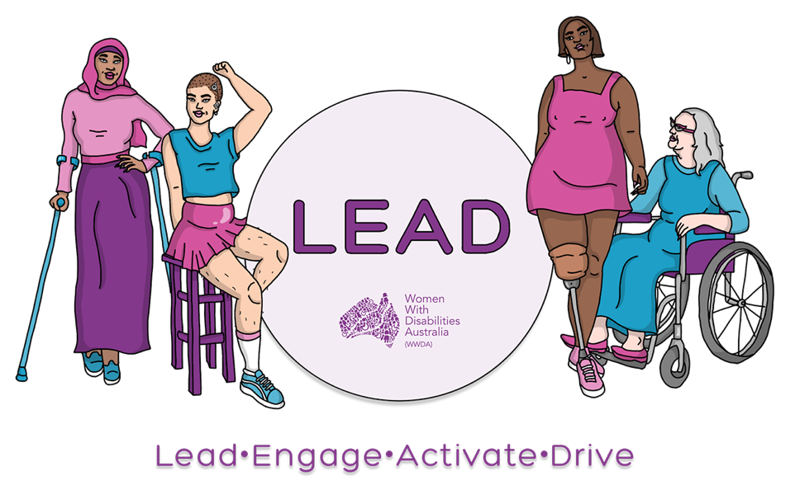

In June 2020, WWDA secured a project grant from the NDIS Linkages and Capacity Building (ILC) program to implement a project over three years aimed at ‘Building Capacity of Women and Girls with Disability in Australia’ - known as WWDA LEAD – Lead, Engage, Activate and Drive.

This ILC Project specifically recognises the need for the adoption of specific measures aimed at the development, advancement and empowerment of women and girls with disability and the promotion of measures to empower them by recognising that they are distinct rights holders, by providing channels to have their voice heard and to exercise agency, by raising their self-confidence and by increasing their power and authority to take decisions in all areas affecting their lives. Women and girls with disability (WGwD) have identified that one of the best ways for them to build their individual capacity is to come together with other WGwD – to share experiences, to gain strength from one another, to learn by doing, to be treated equally, to experience mentorship, and to work together on issues that affect them.
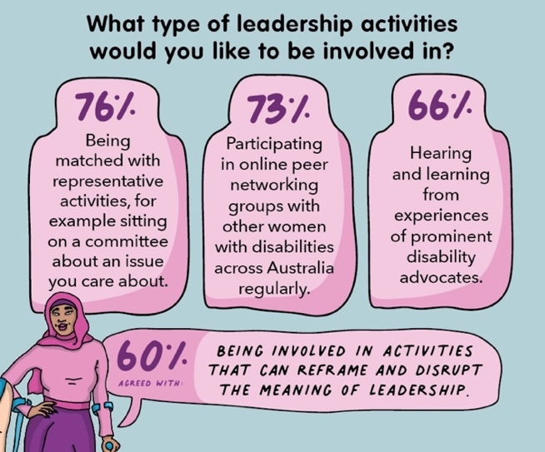
In the last year, the WWDA LEAD project has already made huge inroads to implementation and has seen improvements in the leadership capacity of women and girls with disability both individually and collectively.

True to WWDA’s human rights principles, the WWDA LEAD project has utilised an inclusive co-design methodology right from its inception, with a Project Steering Committee, made up of 7 women with disability and a WWDA Youth Advisory Group, made up of 15 young women and girls with disability advising on and overseeing the delivery of the entirety of the WWDA project, as well as representing WWDA on external committees and consultations.
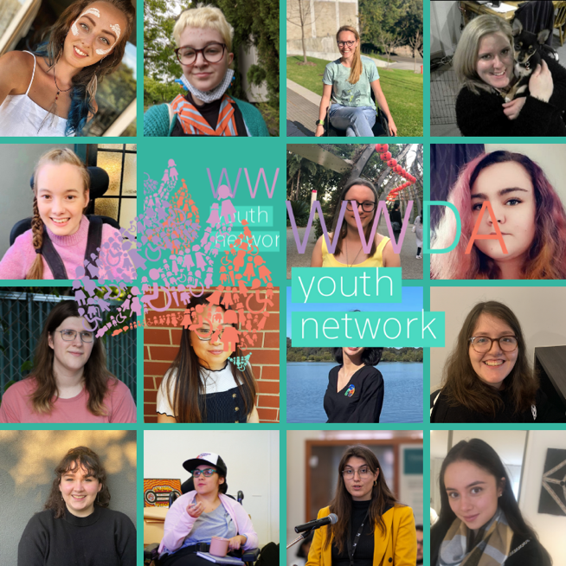
Throughout the project so far, the WWDA team has found that the involvement of these committees has resulted in immeasurable benefits for both the women themselves, and WWDA’s community of women and girls with disability more broadly.

“I love connecting people with the resources they need to live their best life, regardless of who they are and where they live, I’m excited to be working with Women with Disability Australia (WWDA) to grow the potential and opportunities for all Australian women living with disability to develop and expand their leadership skills and influence.” – Raelene Bock, Project Steering Committee member.

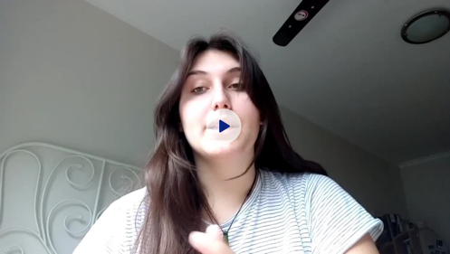
“The WWDA Youth Advisory group has changed my life. Not only have I been able to step into my power as a disabled young woman, but I have been able to make connections with people in the disability justice space that I never thought I would have made. I have been able to make friends, work on meaningful projects and make meaningful change.” – Margherita Dall’Occo, WWDA Youth Advisory Group member

Under the guidance of WWDA’s advisory committees, as well as consultation with WWDA members, the WWDA staff team has already successfully implemented a huge number of project activities and initiatives for WWDA members, including, a leadership survey, leadership position statement, leadership blog, scholarship program, webinar series, podcast series, art prize, mentoring program, online peer-networking sessions, free training courses, virtual movie nights, social media discussions and more; all of which have had a significant number of attendees and great feedback from members.

“Connecting with community, connecting with organisations like WWDA and even just listening to this webinar is self-affirming as it allows us to let go of our shame as people with disability.” – Akii Ngo, WWDA LEAD webinar participant.

“Thank you so much for your help! You empowered me to stand up for myself and stick to what I thought was right.” – Margherita Dall’Occo, WWDA LEAD Scholarship recipient.

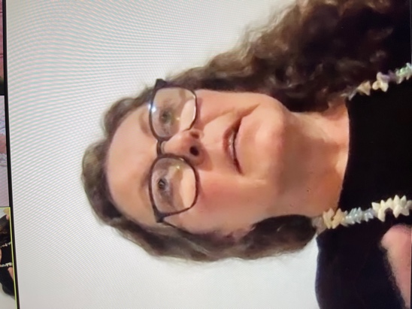
“As I've become older and my practice as an artist has developed, I realised that we have to make it easier for young people to make art and we have to make it easier for young women and young non-binary people to have access to opportunities to make art and to have valuable platforms like this, so I just want to really thank WWDA for really instigating this art award. It's incredibly important and I really hope it continues in the future.” – Fiona Hamilton, WWDA LEAD Art Prize Judge

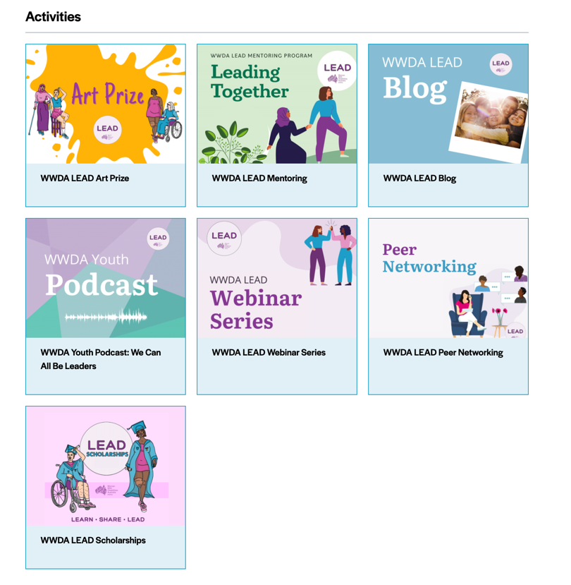

On International Women’s Day on March 8th, 2021, WWDA launched our WWDA LEAD Art Prize. We wanted to encourage our community of women, girls, feminine identifying and non-binary people with disability to submit their artwork on the theme ‘We can all be leaders’ in a variety of accessible and creative formats.

WWDA received an overwhelming response to the WWDA LEAD Art Prize, with 112 entries received from entrants in all states and territories, living in metropolitan/regional/rural and remote communities. Submissions were made across a wide array of mediums, including sculptures, drawings, acrylic paintings, crochet and fashion, photography, video and digital art. All entries continue to be virtually exhibited through WWDA’s Oursite website portal.

An awards ceremony was held on 26 August 2021 with over 70 attendees and can be viewed on WWDA’s webinar channel. Prize categories included an Under 18s and Over 18s category, judged by a panel of women and non-binary artists with disability including Larissa MacFarlane, Fiona Hamilton and Meleika Gesa-Fatafehi. A People’s Choice award category was also established, with voting open to the general public, as well the selection of Highly Commended entries across all categories and the awarding of six WWDA Youth Advisory Group ‘WWDA Youth Picks’.

More details about the WWDA LEAD Art Prize, including the submission process, can be found on WWDA’s website.

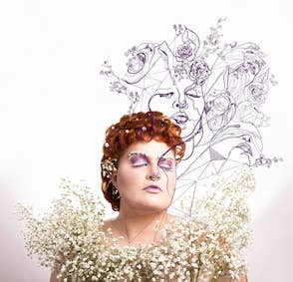

Image Credit: Beyond Invisibility by Marla Bishop and Sam Makin, overall winner of the Over 18’s category.

The WWDA Blog written BY women and non-binary people with disability FOR women and non-binary people with disability continues to be a space to explore what leadership means to us! This year we’ve posted 30 blog posts exploring everything from gender-based violence to leadership in the workplace.

Some brilliant blog posts this reporting year included:

- 'The Chicken or the Egg – Trying to decode Autism/ADHD and mental illness now’ in which Laura Lewis shared her experiences of being diagnosed later in life with autism and ADHD, and how important self-advocacy has been for her. “I don’t ask for accommodations to make anyone feel bad. I ask for accommodations to help me function in society. I’m just trying to be a leader for myself and my family through self-advocacy, and yet I feel punished. How unfair is it for me to be punished for a disability I can’t control?”

- ‘The Waiting Room and Hep C’, in which Tabitha Lean explored the intersections of race, disability, and incarceration. “This is my reality. The reality of a criminalised Blak woman in this colony. A reality that forces women to gather up all of their ashes and make sweet poetry from it through both our activism and resistance.”

- ‘Giving Voice to Autistic Migrant Women’, in which Helen Said shared her story about growing up as a migrant woman with Autism. “Through my activism, I am determined to give voice to Autistics in CALD communities. No one should be invisible. Everybody needs the confidence to speak up and ensure their needs are met.”

Find out more about how to submit to the WWDA Blog here:
https://wwda.org.au/wwda-lead-blog/

The WWDA team is now in the process of establishing a WWDA LEAD Content Co-Design Committee made up of 12-15 women with disability, who will advise on, design, draft and review and number of unique and one-of-a-kind WWDA resources including a new WWDA Leadership and Mentoring toolkit, WWDA documentary, NDIS resources and more.

Internally, WWDA has also benefited greatly from the opportunities that the WWDA LEAD project has given the organisation to grow. In addition to the many outward facing activities, the team has been a number of initiatives aimed at upskilling, training and developing the capacity of existing and future staff, volunteers and committee/board members, including supporting individuals to take part in training courses, revising and developing the broad suite of WWDA policies and procedures, developing guides to assist WWDA members with representation and facilitating strategic planning meetings and discussions with staff and Board members.

In late 2022, the WWDA LEAD project forward facing activities will culminate with a national virtual leadership summit for the broad array of women and girls with disability across Australia who have been involved in all the different aspects of the WWDA LEAD project. The Summit will be the launch site for the Leadership and Mentoring Toolkit and Documentary as well as a celebration of everything that the project has achieved for WWDA and its members.

NATIONAL ADVISORY BODIES – WWDA REPRESENTATION

During the 2020-2021 reporting period, WWDA was represented on more than 37 formal, national Advisory Committees and structures. Many of these Advisory bodies are ongoing, and WWDA has been represented on some of these forums for much longer than the reporting period. Many of these national Advisory Committees meet on at least a monthly basis, and the work involved by being on these forums is often extremely labour intensive and requires a significant amount of work between the formal meetings.

These Advisory bodies are not ‘one off’ meetings or events – they are national Committees where specific, targeted work is undertaken by the members of the Committees on an ongoing basis. Some of the memberships of these Committees are determined by the relevant Government Minister, whereas others are Committees where memberships are determined by the particular Government Department or agency.

WWDA’s representation on many of these formal Committees is critical, given that women and girls with disability can often be overlooked or ‘forgotten’ in national initiatives, including reforms to existing national policies and frameworks, or, in the development of new policies, frameworks and other initiatives. WWDA’s representation on many of these national and formal Advisory structures have led to meaningful outcomes for the inclusion of disabled women and girls in national policy frameworks, regulatory bodies and program and service reforms.

As a result of the COVID pandemic, many of these Committee meetings were held via various online platforms, including Zoom, Microsoft Teams, WebEx, and more. Some of these platforms are more accessible than others, but there remain accessibility issues with some of the platforms used.

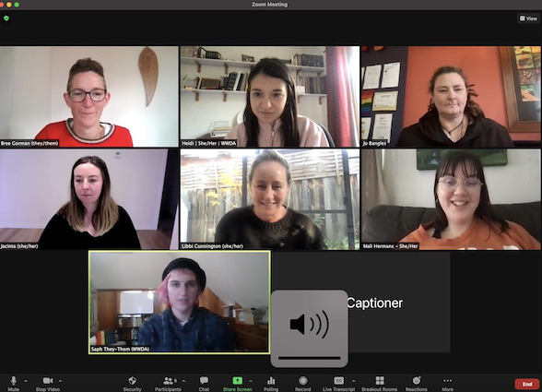
Some of WWDA staff participating in a Zoom meeting.

The formal, national Advisory Committees and structures WWDA was represented on during the 2020-2021 financial year included:

- National Disability Strategy (NDS) National Reform Committee (DSS)

- National Disability Employment Strategy Advisory Committee (DSS)

- National Disability Gateway Reference Group (DSS)

- National NDIS Quality & Safeguards Commission Disability Consultative Committee

- National NDIS Quality & Safeguards Commission Complaints Function Advisory Committee

- National Plan to Reduce Violence Against Women & Children – National Plan Advisory Group

- National Plan to Reduce Violence Against Women & Children – Victim Survivor Expert Advisory Panel

- National Women’s Safety Summit - Advisory Group

- COVID19 National Disability Support Services Committee (DSS/DOH)

- National Disability Insurance Agency - CEO’s Forum

- National Disability Insurance Agency - Stakeholder Engagement Forum

- Australian Human Rights Commission Employment Project - IncludeAbility Ambassador Group

- Royal Commission into Violence, Abuse, Exploitation and Neglect (DRC) DPO/DRO Forum

- National Disability Representative Organisations (DROs) Royal Commission Working Group

- Your Story Disability Legal Support (Disability Royal Commission Legal Service) Advisory Group

- Commonwealth Children and Young People With Disability Network (CCYDN) Executive Committee

- Department of Social Services (DSS) and DPOs and DRO’s – Quarterly Forum

- Australian Human Rights Commission, Disability Discrimination Commissioner DRO/DPO Forum

- National Coordinating Committee for the Universal Periodic Review (UPR) of Australia

- Australian Women Against Violence Alliance (AWAVA) Advisory Group

- Australian Women Against Violence Alliance (AWAVA) Policy Executive Group

- Australian Electoral Commission Disability Advisory Committee

- Our Watch Advisory Group: Prevention of Violence Against Women with Disability

- Our Watch Advisory Group: Media Making Change: National Media Engagement Advisory Group

- DFAT and Attorney General’s National NGO Human Rights Forum

- National Youth Disability Network

- Equality Rights Alliance- Member Advisory Group

- The Shift – Network for the Achievement of Intersectional Gender Equality in Australia

- Blue-Knot Reference Group: Creation of National Trauma-Informed Disability Practice Guidelines

- NDIS Systemic Advocacy Working Group

- Disability Justice Network

- Disability Sector Reference Group - NDIS Reforms

- Department of Social Services - National Advocacy Review Forums

- National Justice Project – LawHack 2021: Disability Justice

- ACON LGBTIQ+ Disability Interagency Group

- ANROWS National seminar series – Advisory Group

- ANROWS Stakeholder Advisory Group – sexual harassment in the workplace

WWDA POLICY SUBMISSIONS & EVIDENCE TO INQUIRIES

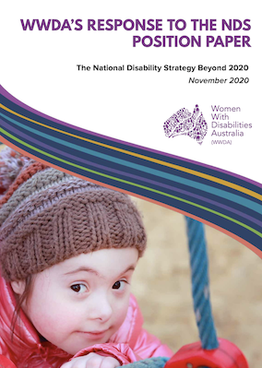
During the reporting period, WWDA developed a wide range of policy submissions to Government and other stakeholders across several issue areas; contributed to international initiatives to improve the status of women and girls with disability globally; contributed to disability reforms being undertaken by the Australian Government; provided evidence as a witness to a number of Senate and Parliamentary inquiries, and much more. It is outside the scope of this Report to provide a narrative on all the policy submission work WWDA has undertaken during the reporting period, however the following information is illustrative of WWDA’s extensive policy submission work program.

- Submission: ‘The National Disability Strategy Beyond 2020: WWDA Response to the NDS Position Paper’

- Submission: House Standing Committee on Social Policy and Legal Affairs’ Inquiry into Family, Domestic and Sexual Violence

- Submissions: Development of the National Disability Gateway

- Submission: Joint Standing Committee on the NDIS: NDIS Quality & Safeguards Commission

- Submission: Hon Robertson Inquiry into the death of Ann-Marie Smith

- Submission: Senate Select Committee on COVID-19

- Submission: Parliament of Australia Joint Standing Committee on the National Disability Insurance Scheme (NDIS)

- Submission: Department of Social Services ‘Stop it at the Start’ campaign

- Submission: NDIS Consultation Paper on Autism

- Submission: National Disability Employment Strategy Consultation Paper

- Submission: NDIS Eight Priority Areas for Access and Planning Improvements

- Submission: NDIS Quality & Safeguards Commission Provider Guidance

- Submission: Draft Framework for the new National Action Plan to Reduce Violence Against Women & their Children

- Submission: Response to the Draft Statement for the National Women’s Safety Summit

- Submission: NDIS Consultation Paper on Supported Decision-Making

- Submission: NDIS Consultation Paper on Life at Home

- Submission: UNSW Consultation Paper on a National Supported Decision-Making Framework

- Witness Evidence: House Standing Committee on Social Policy and Legal Affairs’ Inquiry into Family, Domestic and Sexual Violence

- Witness Evidence: Joint Standing Committee on the NDIS: NDIS Quality & Safeguards Commission

- Witness Evidence: Hon Robertson Inquiry into the death of Ann-Marie Smith

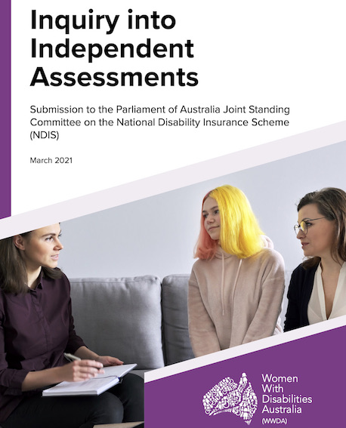

Copies of WWDA Policy Submissions work can be found on our website at www.wwda.org.au

THE NATIONAL DISABILITY INSURANCE SCHEME (NDIS) & THE NDIS QUALITY & SAFEGUARDS COMMISSION

During the reporting period July 2020-June 2021, WWDA has undertaken a significant amount of work related to the NDIS and the NDIS Quality & Safeguards Commission.

WWDA CEO, Carolyn Frohmader represents WWDA as a member of the NDIS CEO’s Forum and also the NDIS Quality & Safeguards Commission National Consultative Committee (Disability Sector).

The primary function of the NDIS Quality & Safeguards Commission National Consultative Committee (Disability Sector) is to provide ongoing high-level advice to the NDIS Commission on national issues, which influence the delivery of quality and safe NDIS supports and services. The Committee meets every three months, as well as undertaking work outside of the meetings.

Over the reporting period, WWDA has been heavily involved in working with the NDIS Quality & Safeguards Commission on a wide range of work, including for example:
- Providing advice and expertise on the Commission’s complaint making processes.
- Providing feedback on Service Provider Draft Guidance materials.
- Providing written Submissions.
- Giving witness evidence to the Parliamentary Inquiry into the operation of the Commission.
- Submitting formal complaints for and on behalf of WWDA members.
- Providing advice and expertise on the Regulation and oversight of Supported Independent Living homes.
- Providing advice and expertise on the Amendments to Practice Standards.
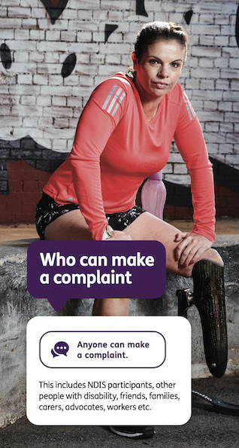
- Advocating for the collection and publication of gender disaggregated data.
- Advocating for ‘restrictive practices’ to be conceptualised as a form of violence and abuse.
- Advocating for the need for the Commission to use methods other than technology to communicate and engage with people who are in closed settings and do not use or have access to technology.
- Working with the Commission’s Community Engagement Team to promote ways for the Commission to expand their outreach to NDIS participants, particularly those in closed settings.

WWDA CEO Carolyn Frohmader also presented a session at the NDIS Commission ‘Virtual Disability Advocacy Forum’, held 21st- and 28th April 2021. Carolyn’s presentation focused on ‘Supporting people with disability to bring their complaint to the NDIS Commission.’

Recordings and information from the NDIS Commission ‘Virtual Disability Advocacy Forum’, can be found on the Commission’s website at:

https://ndis.delegateconnect.co/talks

Over the reporting period, WWDA has also been heavily involved in working with the National Disability Insurance Agency (NDIA) on a wide range of work relating to the NDIS. Just some examples include:

- Attending and participating in meetings of the NDIA CEO’s Forum.
- Researching, writing and publishing a number of WWDA Submissions to NDIA Consultation Papers.
- Attending NDIA Workshops and Forums on specific issues such as ‘co-design’ and ‘independent assessments.’
- Submitting written responses and evidence to relevant parliamentary inquiries, including those conducted by the Joint Standing Committee on the National Disability Insurance Scheme.
- Undertaking consultations with WWDA members on a range of topics related to the NDIS, including independent assessments.
- Participating in Roundtable meetings with the Minister for the NDIS.
- Working collaboratively with the disability representative sector on joint initiatives and activities relating to the NDIS.
- Initiating and hosting a WWDA Webinar on the NDIS to examine why women are not accessing the NDIS at the same rate as men.

WWDA PRESENTATIONS

During the 2020-2021 reporting period, WWDA has undertaken a large number of presentations across a range of sectors and settings, to promote and advance the rights of women and girls with disability. WWDA has also partnered and collaborated with other organisations and agencies in some of these presentations and events. Just some examples of WWDA events and presentations implemented during the reporting period are provided below.

Rural Women With Disability and COVID-19 Webinar – On 14th October 2020, WWDA partnered with the National Rural Women’s Coalition (NRWC) to host The Rural Women with Disability COVID-19 Webinar. The Zoom webinar included a discussion with 3 women with disability living in rural areas during the COVID-19 pandemic, followed by a Q&A with the audience.

We Can All Be Leaders - On the 15th of March, WWDA hosted the first WWDA LEAD webinar ‘We Can All Be Leaders,’ with a great panel of four women and non-binary people with disability.

Scholarships Information Session - On 24 March 2021, the WWDA LEAD team held a webinar information session for people to learn about the WWDA LEAD scholarships before applying.

Disability Royal Commission Webinar – On 13 April, WWDA hosted a webinar about the Disability Royal Commission and how women, girls, feminine identifying and non-binary people with disability can get involved. Speakers included Commissioner Dr Rhonda Galbally AC from the Disability Royal Commission Susannah O’Reilly from the Your Story Disability Legal Support Service, WWDA President Tricia Malowney, and WWDA member Kalena Bos.

NDIS and Gender - On the 27th of May, WWDA hosted a webinar to discuss why women are not accessing the NDIS at the same rate as men. Our expert panel discussed the current barriers and what we can be done, to ensure equal access to the NDIS.

National Youth Commission Australia Youth Futures Summit – WWDA gave two presentations at the National Youth Commission Australia (NYCA) national online summit for young people, which was held following the NYCA national inquiry into the challenges faced by young people preparing for and seeking work now and into the future.

Harmony Alliance – WWDA presented at the Harmony Alliance Webinar presentation on “Unpacking the power of language: Othering of culture as complexity in the context of violence against women.

National Disability Strategy Webinar – WWDA presented a 2-minute vlog about the role of the National Disability Strategy (NDS) in addressing the gender inequalities in disability support. See: https://vimeo.com/460435936/463f0d5a54. The Webinar was also live tweeted by WWDA.

Children & Youth People with Disability Australia (CYDA) National Youth Disability Summit (NYDS) – WWDA provided several presentations at this National online Summit, including on employment; segregation; Gender & the NDIS. WWDA also coordinated a WWDA Youth Virtual Booth at the summit to promote the WWDA Youth Network and encourage young women with disability to get involved.

Senator Jordan Steele-John Live Facebook Forum on the Disability Royal Commission – WWDA presented at this online Forum, which focused specifically on the Disability Royal Commission public hearing on ‘the use of psychotropic medication’ in the disability sector. Over 300 people attended the Forum.

CCYDN ‘Taking Charge of Our Future Event’ – WWDA spoke at and represented WWDA/Australia at a Commonwealth Children and Youth Disability Network (CCYDN) online webinar event ‘Taking Charge of our Future’ to discuss issues impacting young people in Australia post COVID-19.

CCYDN Hospital Communication Passport Launch – WWDA attended and spoke at the launch of a CCYDN Hospital Communication Passport resource – the resource aims to support young people with disability when admitted to hospital. It provides a quick passport to communicate the young person’s disability and support needs.

National Union of Students Disabilities Conference - WWDA gave a presentation at the National Union of Students Disabilities Conference on a panel about disability, unions and activism.

The Australian Women Against Violence Alliance (AWAVA) Webinar on CSW65 (2021) and the Elimination of Violence against Women – WWDA provided a presentation at this Webinar. WWDA’s presentation focused on the impact of violence on women with disability; the need for intersectional data collection and research; and the types of prevention and response needed to tackle violence against women with disability.

YWCA Equality Rights Alliance Webinar on the #BlokeBasedBudget – WWDA gave two presentations at this Webinar on how the Federal Budget impacts young women. WWDA’s presentations covered a range of issues including the lack of funding for social security payments, disabled students, women experiencing violence, the National Disability Strategy and the National Strategy to Prevent Violence Against Women and their Children.

Australian Women Against Violence Alliance (AWAVA) Videos about VAW for 16 days of activism – WWDA took part in short video about violence against women with disability for AWAVA 16 days of Activism campaign.

Commonwealth Children and Youth Disability Network (CCYDN) IDEAS Capacity Building Workshops for Young People With Disability – WWDA spoke and presented at 3 CCYDN workshops for young people with disability covering: disability advocacy; disability rights; and social media campaigning.

Children & Youth People with Disability Australia (CYDA) Leadership Video - WWDA developed short video on Leadership for CYDA Leadership course.

Commission on the Status of Women (CSW) 65 – WWDA was represented at the 65th Session on the Commission on the Status of Women in March 2021. As well as attending a number of NGO side and parallel events; WWDA joined meetings with the International Network of Women With Disabilities which took part each morning at 8am AEDT.

Commission on the Status of Women (CSW) Australia 2021 - Due to the time difference between New York and Australia, a number of women’s organisations in Australia partnered in 2021 to run a two-day parallel CSW Australia event. WWDA took part in a number of sessions and presented on a panel about ‘Intersectionality: Differential Impacts of Violence and What this Means.’

March 4 Justice - WWDA was represented at the March 4 Justice rallies around Australia. WWDA live-tweeted from the rally at Parliament House in Canberra and other locations around the country.

Generation Equality Forum 2021 – WWDA Youth Advisory Group members represented WWDA Youth at the Generation Equality Forum in 2021.

Tasmanian Young Achievers of the Year Awards Night – WWDA staff member Heidi La Paglia was nominated in these Awards in the Services to the Disability Sector category. And she WON!!!

Several of WWDA’s Webinars and presentations can be found on WWDA’s Webinar Channel:

https://www.youtube.com/channel/UCaxOlTjp6E0p-boKYyXlYqg/videos

COMMUNICATIONS & ENGAGEMENT

As a Disabled People’s Organisation (DPO), WWDA consistently seeks out opportunities to build our capacity to meaningfully engage with our members and stakeholders. It is outside the scope of this Report to provide a narrative on all the communications and engagement work WWDA has undertaken during the reporting period, however the following information is illustrative of WWDA’s extensive work in this area.

WWDA Social Media Analytics 1 July 2020 - 30 June 2021

WWDA Facebook
- At July 2020: 9,756
- At 30 June 2021: 11,115
- Increase: 1,359 or 13.9%

WWDA Twitter
- At July 2020: 3,074
- At 30 June 2021: 4,485
- Increase: 1,411 or 45.9%

WWDA Youth Network Facebook
- At July 2020: 1,576
- At 30 June 2021: 1,903
- Increase: 327 or 20.6%

WWDA Youth Network Twitter
- At July 2020: 331
- At 30 June 2021: 631
- Increase: 300 or 90.6%

WWDA Closed Community Facebook Group
- At July 2020: 602
- At 30 June 2021: 1,188
- Increase: 586 or 97.34%

WWDA Newsletters
During the reporting period, WWDA continued to produce our very successful WWDA Newsletter each month, along with our WWDA Youth Newsletter, which is also produced each month. WWDA has worked on improving our website and other platforms so that members can automatically subscribe to the WWDA Newsletters. Each Newsletter provides a range of current information, not only about the work of WWDA, but also provides up-to-date information on key Government and related initiatives, including for example: the National Disability Insurance Scheme (NDIS); COVID19; National Disability Strategy (NDS); NDIS Quality & Safeguards Commission, the Disability Royal Commission, government and related inquiries and consultations and much more.

WWDA Social Media Campaigns
During the 2020-2021 reporting period, WWDA developed and implemented over 25 targeted social media campaigns, using a range of WWDA’s platforms: Facebook, Twitter, Instagram, WWDA Youth Network Facebook, WWDA Youth Twitter and WWDA Youth Instagram. Examples included:

- Rural Women with Disability COVID-19 Webinar
- 16 Days of Activism Against Gender Based Violence
- WWDA LEAD Survey
- WWDA LEAD We Can All Be Leaders Webinar
- New WWDA website
- WWDA LEAD Scholarships
- Disability Royal Commission Webinar
- WWDA LEAD Art Prize and Awards Ceremony
- WWDA LEAD Peer-Networking
- WWDA LEAD NDIS & Gender Webinar
- WWDA LEAD Avenues of Support Webinar
- NDIS Independent Assessments
- Commonwealth Children and Youth Network (CCYDN) COVID-19 Statement and Recommendations
- Introduction of WWDA Youth Advisory Group (WYAG) members
- CCYDN IDEAS Capacity Building Programme
- WWDA Youth Peer-Networking – Meet the Youth Advisory Group
- It’s Not A Compliment
- WWDA Youth Peer Networking: NDIS
- AWAVA / WWDA Youth Young Women’s Survey
- WWDA Youth Network Social media campaign addressing violence against women with disability
- WWDA Youth Sunday Disability Spotlight Posts

WWDA Expos
During the 2020-2021 reporting period, WWDA also took the opportunity to promote the organisation and our work, as well as recruit new members through attending Disability Expos. WWDA attended the very large Disability Expo on the Gold Coast, where our stall was incredibly popular. WWDA recruited over 50 new members over the two-day Expo.

WWDA was also able to use the opportunity of having a stall at the Expo, to promote the Disability Royal Commission, including providing accessible information about how people could tell their story to the DRC.

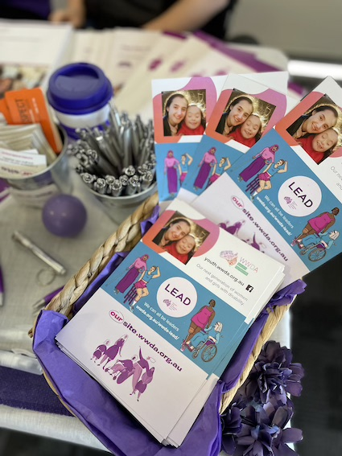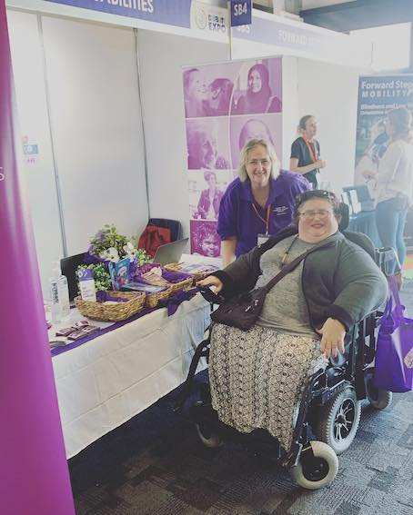
WWDA stall at the Gold Coast Disability Expo.

OPERATIONAL DEVELOPMENT, GOVERNANCE & REPORTING

WWDA has continued to employ high standard governance and financial management practices. During the reporting year, WWDA has met all reporting and accountability requirements as well as those in relation to our funding bodies. In accordance with the constitutional requirements of the organisation, WWDA’s service agreements; the Associations Incorporation Act 1991 (ACT); and the Charities Act 2013 (Cth), WWDA has undertaken a wide range of internal and external reporting and accountability requirements. During the reporting period, WWDA has also undertaken a significant amount of work in relation to governance, including financial management, human resources, and related reporting.

WWDA’s sound governance, financial and organisational management practices are demonstrated through the following processes:

- Undertaking of reporting in accordance with the constitutional requirements of the organisation, WWDA’s funding contract service agreements; the Associations Incorporation Act 1991 (ACT); and the Charities Act 2013 (Cth)
- Preparing and completing Annual Reporting requirements of the Australian Charities and Not-for-profits Commission
- Preparing and submitting WWDA Service Agreement (and relevant Project funding contracts) Progress and Project Reports and financial acquittals
- Writing, publishing and disseminating the WWDA Annual Report
- Provision of financial reports prepared by the WWDA Accountant to the WWDA Board
- Annual Auditing of financial statements by registered audit company in accordance with the Australian Accounting Standards and Australian Auditing Standards
- Conducting bi-monthly meetings of the WWDA Board
- Conducting the WWDA Annual General Meeting
- Weekly meetings between WWDA Executive Director and the President of the WWDA Board
- Conducting of annual staff performance reviews
- Review and renewal of WWDA Insurance policies
- Annual review of WWDA Strategic Plan, WWDA Management Committee Orientation Kit
- Review and updating of the WWDA Employee Handbook
- Development of a new WWDA Privacy Policy
- Development of COVID19 policies and procedures for the organisation
- Development of WWDA policies for staff working remotely
- Development of a WWDA Style Manual

WWDA’s organisational management practices and ongoing quality improvement are further supported by the services of Employsure who are available to assist WWDA to ensure our organisation maintains compliance with all employment legislation and work health and safety matters.

