Women With Disabilities Australia
wwda.org.au

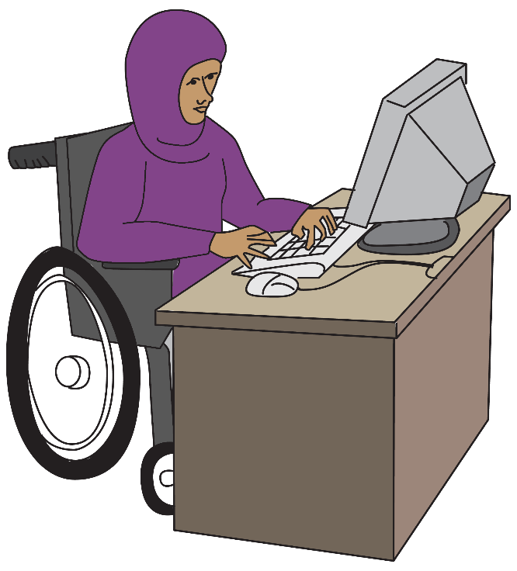
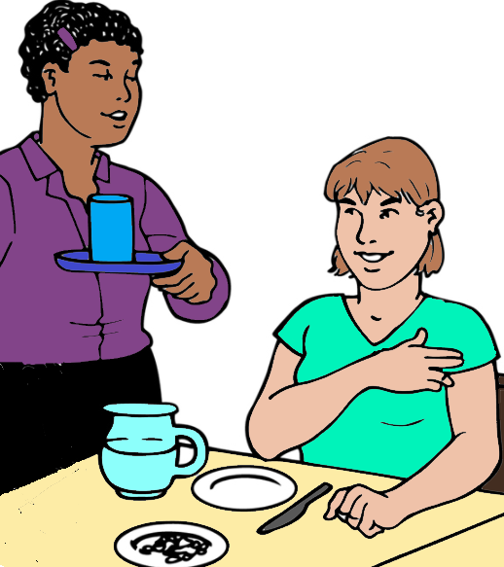

Our report to the DRC.
About work.
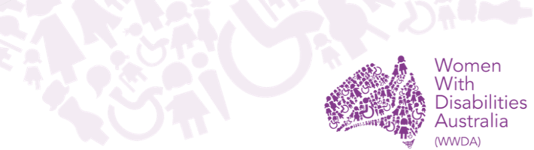

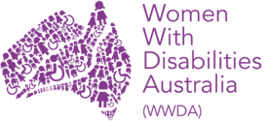
We are Women with Disabilities Australia.
We write WWDA when we talk about us.


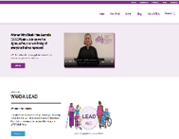
You want to know more about WWDA.
Go to www.wwda.org.au
Click the About us button.

Now.
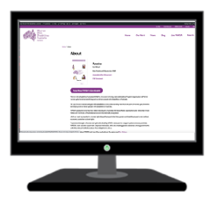

Open the About WWDA button.

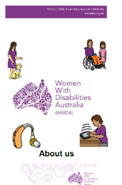

Read About us. It is in Easy English.
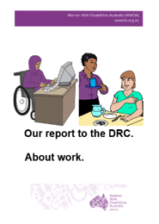
This is 1 of our reports to the
Disability Royal Commission.
We write DRC when we talk about the
Disability Royal Commission.

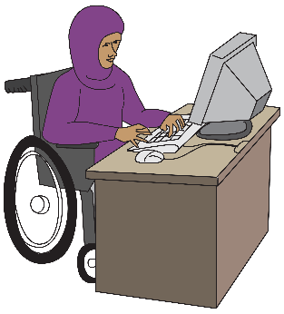

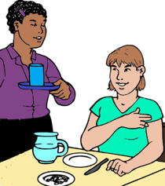
This is our report about work.

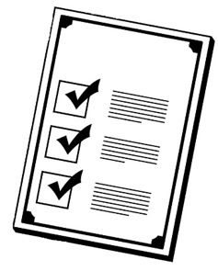
Rules

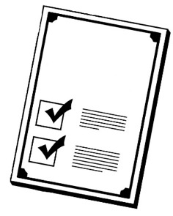
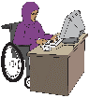
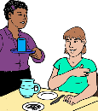

There are laws about how we work.

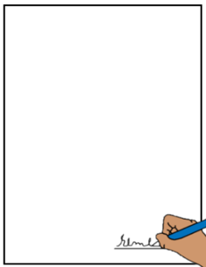



Like The United Nations Convention on the Rights of Persons with Disabilities.
We write CRPD to talk about it.

The CRPD are rules for every person in
every country. It tells us about the rights of
all people with disability.


The Australian Government signed the CRPD.
They agree to follow these rules.

Australia agrees people with disability have the right to work.

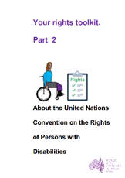

Learn more about the CRPD. Go to page 23.

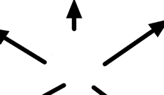
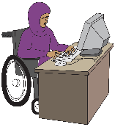
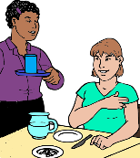
Where people work

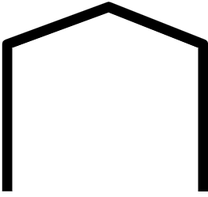
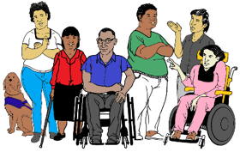
People with disability can work in lots
of places. You may work where
- all workers have a disability.

or
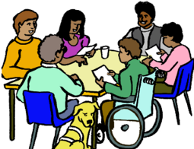

- any person can work.


Your job may pay you
- some money

or

- no money. You work for free

or


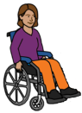

- the same money as other people.
You do the same job. You get the same pay.

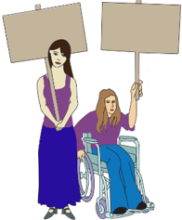

Your Rights

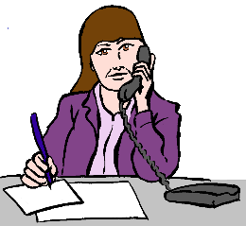


Women and girls with disabilities have the right to
- choose the sort of work they do

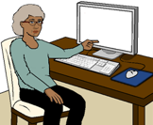
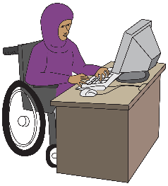

- have the same work choices as other people.

You have the right to
- get paid the same as others
and
- you can pay for your every day needs.
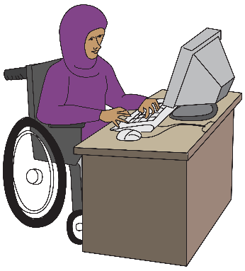
You have the help you need to do your job.
You have
- the right things for your computer
- a desk that fits your wheelchair




- information in a way you understand.

And

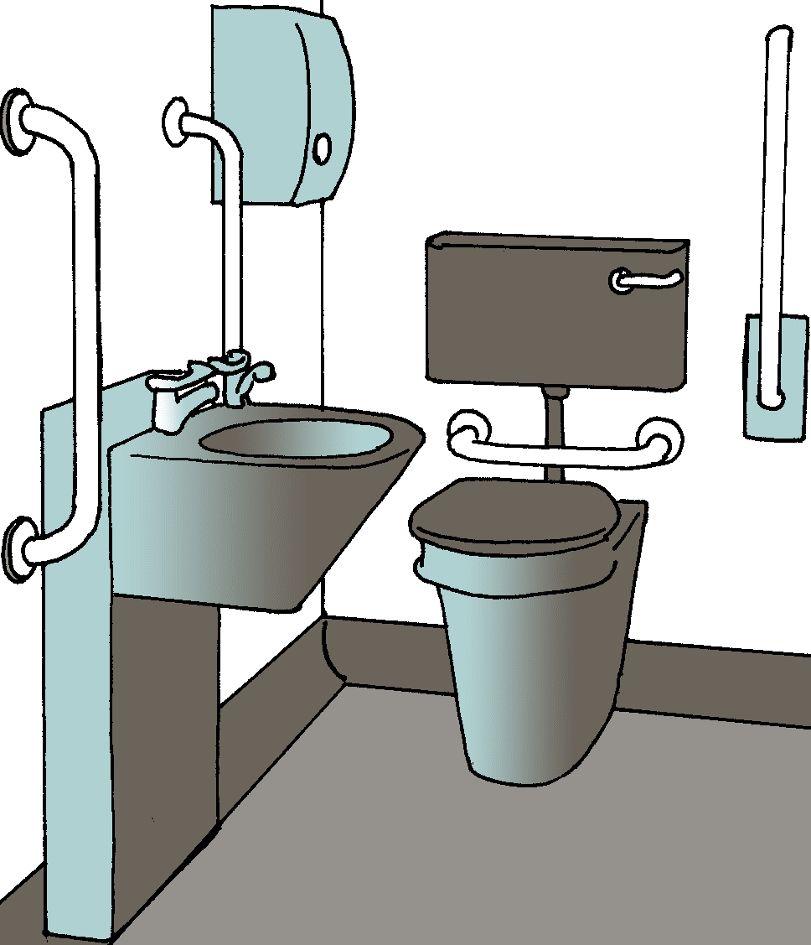
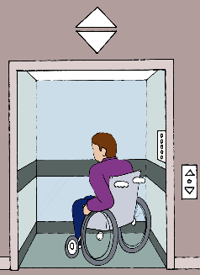
It must be easy to move at work.
Like you can
- use the toilet
- get in to the building

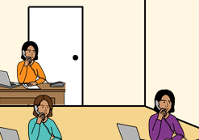
- there is the right space around your desk.
You can move about in a safe way.
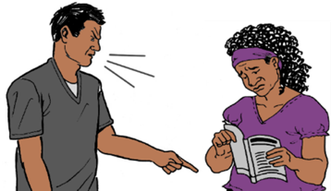
You have the right to be safe at work.
People must treat you well at work.
You do not get hurt.

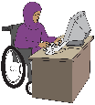

The government must have rules.

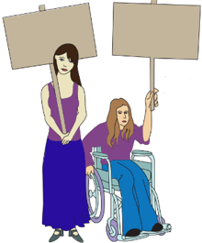
The rules are to make sure women and girls
with disabilities
- have all their rights at work
and
- are safe at work

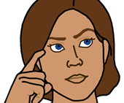
Some problems

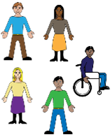
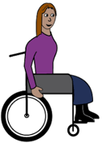

You do not work in the community

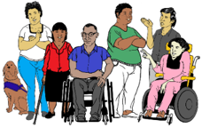
Lots of people with disabilities only work with other people with a disability.

You get less pay.

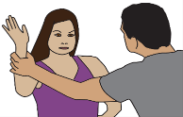
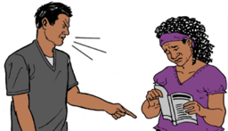
There can be more violence.

Lots of the workers are men. This can mean more violence for women and girls with disabilities.

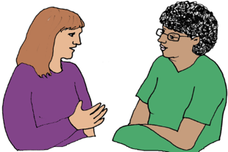
You only see staff.
or
You only see other people with disability.
You do not see other people in the community.

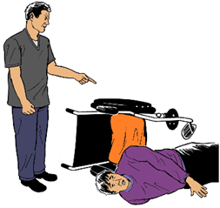
You may be hurt. It is all the time.
You do not feel safe.
There is no one you can tell.

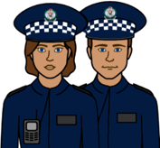
You get hurt at work. Some times you
can not talk to
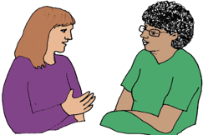
- the police
- a therapist.

Only some people with disabilities move to
a new job.

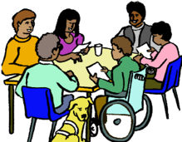

Only some people get a job in the community.

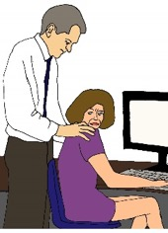
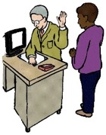
Violence and abuse at work
This can be in any work place.

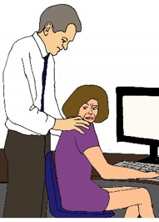
It can be you do not feel safe with the
people you work with.

or

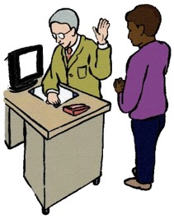
You are not treated the same as other workers.
Like your boss is rude to you.

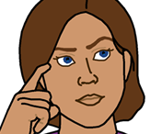
More problems

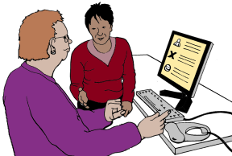
Lots of women and girls with disability say
they do not get help. Like
- help to learn your job


- information in a way you can understand.
or
- you do not understand what they say.

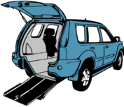
You can not get to work. Like
- cars may not fit your wheel chair.
- you can not get into your work place.

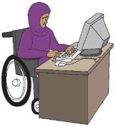
Lots of women and girls with disabilities say they
- do not get the same choice of work

or



- do not get the same pay as others.


The NDIS can help you get a job.

But

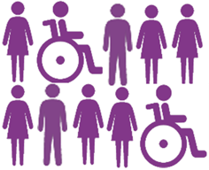
You want a job you can choose.
Only some people with disability say the NDIS help them get a job.



Some women and girls with disabilities
- do not have a home
- do not have money for a home
- can not get help.

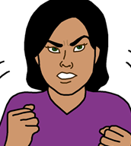

We know this makes it hard to get a job.
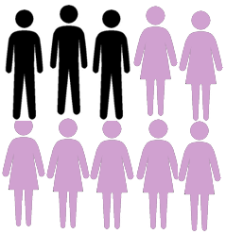
We know women and girls have this problem more than other people.

But


It is more for women and girls with disability.


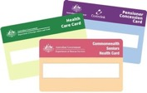
Lots of women and girls with disability
- do not have paid work
- only get the Centrelink pension.


We know lots of women do not have the money they need to live.


Ideas for change

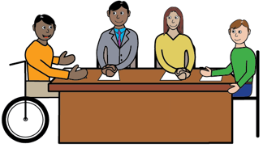
- Woman and girls with disabilities want the DRC to think about how you work.

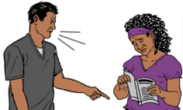
We want the DRC to talk about
- violence and abuse at work

- your work is only for people with disabilities.


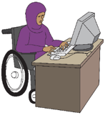
There need to be new ideas so
- you can have the same jobs as other people
- you get the same pay for the same job.

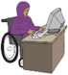
- Australia needs to make new rules about work.
There may be laws that need to change.

- Women and girls with disabilities want
the NDIS to think about
- how to help you get work
- how to stop violence.

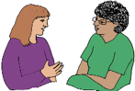
- The government needs new ways
- to keep you safe
and
- to help you when you do get hurt.




- Centrelink must give you more money.

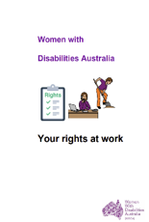
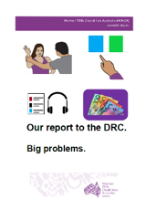
Some other fact sheets
They are in Easy English.

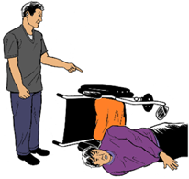
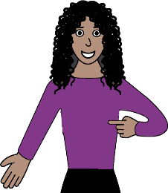
Problems in all parts of our lives. Like
- violence
- how you see yourself.

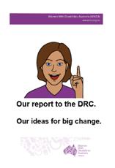
Front cover
Front cover
Our reports to the DRC.
- Big problems.
- Our ideas for change.

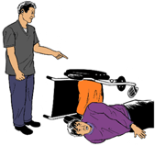
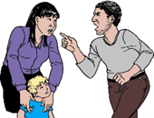
Learn more about
- violence
- abuse.

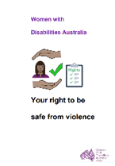
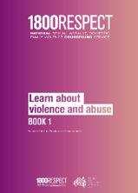
There is lots of information here. Like
- Your right to be safe from violence
- 1800 Respect. Book 1

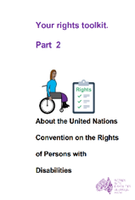
Rights
        - Your rights at work.
        - About the CRPD.

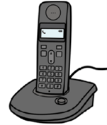

Call 0438 535 123.
We can send you the fact sheets.

Or

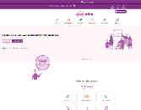
Go to www.oursitewwda.org.au
Click on Easy English at the top.

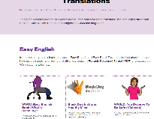
There are different topics. There are
- Your Rights
- Learn and take part
- Life choices
- Sex and your body
- Safety and violence.

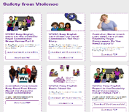
All our Disability Royal Commission reports are in the last part. It is Safety from Violence

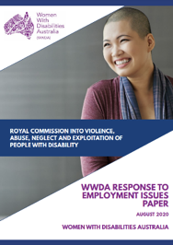
This fact sheet is based on the Disability Royal Commission WWDA Response to employment issues paper. August 2020.

Images
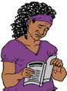



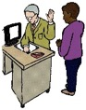



We can use these images. They are from
- ChangePeople
- ClipArt
- EasyontheI
- InspiredServices
- Picto-Selector
- Pinterest
- Spectronics
- TheNounProject
- Tobii-Dynavox
- Google Map photos.

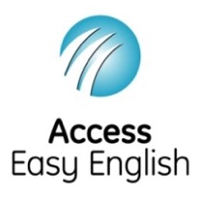
Access Easy English wrote the Easy English.
October 2021.

