Women With Disabilities Australia
wwda.org.au

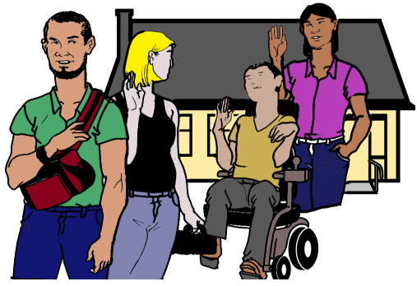

Our report to the DRC.
Group homes. Part 1.
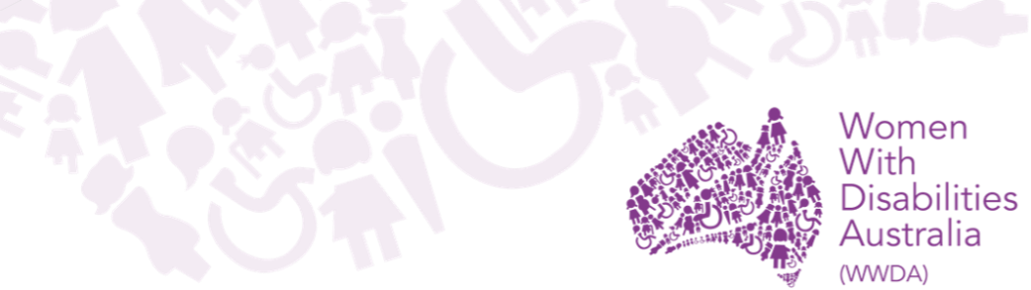

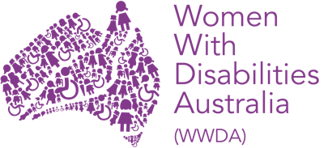
We are Women with Disabilities Australia.
We write WWDA when we talk about us.


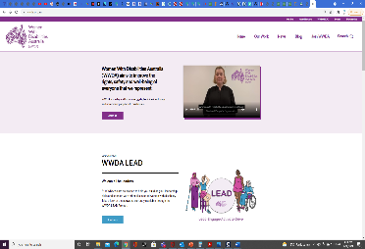
You want to know more about WWDA.
Go to www.wwda.org.au
Click the About us button.

Now.
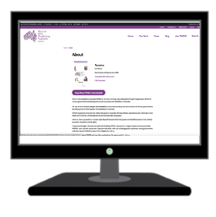

Open the About WWDA button.

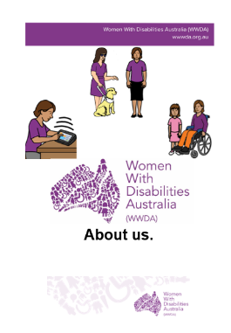

Read About us. It is in Easy English.

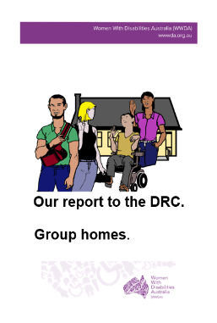
This is 1 of our reports to the
Disability Royal Commission.
We write DRC when we talk about the
Disability Royal Commission.

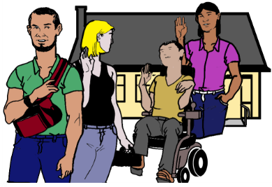
This is our report about problems with
group homes.


Rules


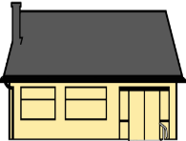

There are laws about how we live.





Like The United Nations Convention on the Rights of Persons with Disabilities.
We write CRPD to talk about it.

The CRPD are rules for every person from
every country. It tells us about the rights of
all people with disability.


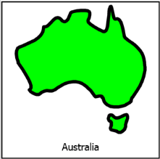

The Australian Government signed the CRPD.
They agree to follow these rules.

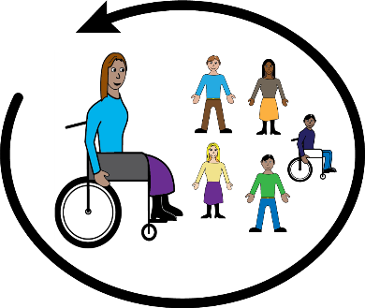
Australia agrees people with disability must be part of their community.

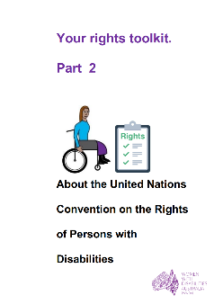

Learn more about the CRPD. Go to page 25.

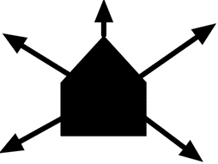
Where people live

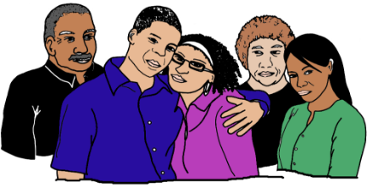
People with disability can live in lots of
different homes. You may live with
- family
- friends
- with your partner
- with your children.

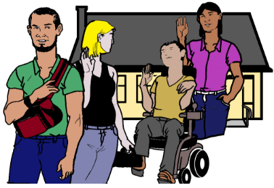
You may live with
- other people with disability

or
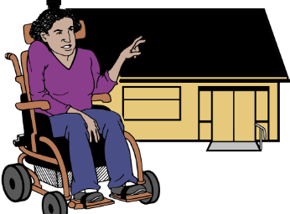
- by your self.
Group Homes

You live with other people who have a disability.
You have help from staff.
It is called a group home.

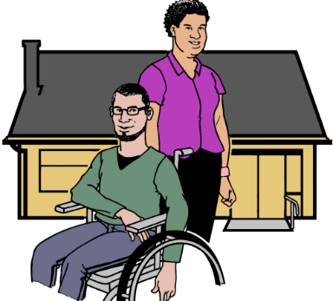
You may live with
- 1 other person

or

- 3 other people
or
- many other people.
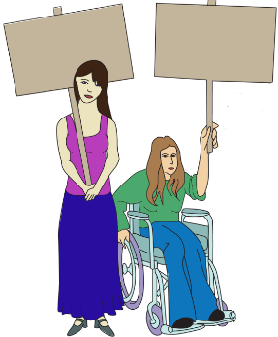

Your Rights

Women and girls with disability have the right to
- live in the community

and


- take part in community life
- have the same choices as other people.

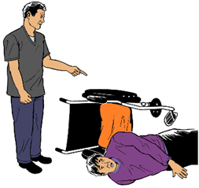
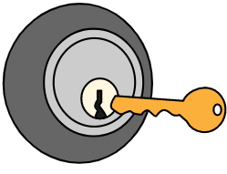
You have the right to be safe at home. Like
- you have your own key to your room
- you are safe at home. You do not get hurt.
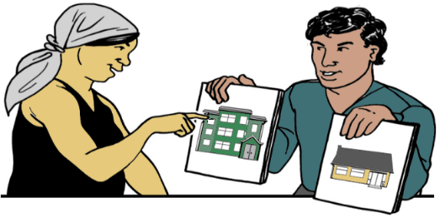
You have the right to
- choose where you live

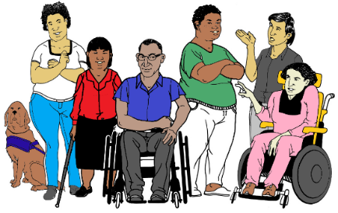

- choose who you live with

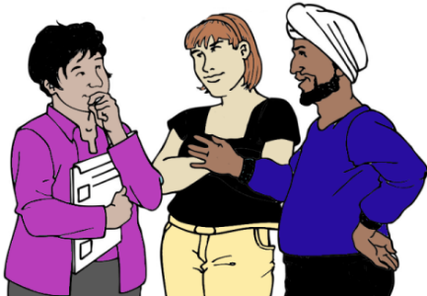

- choose your own staff.

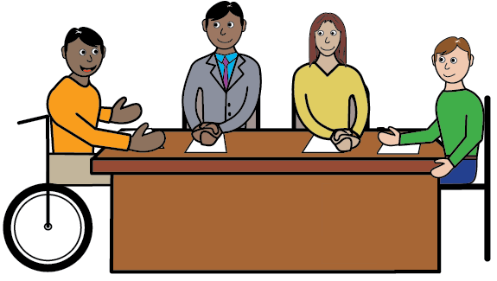
What does the DRC say?

The DRC says some people with disability
get hurt. It is in their home.



This is not OK.

We agree. You may not be safe where you live.

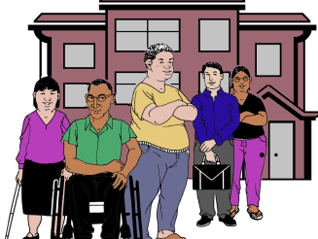
The DRC talks about
- the type of home
and
- the number of people who can live there.

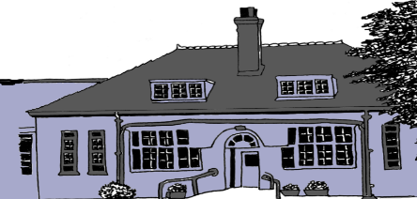
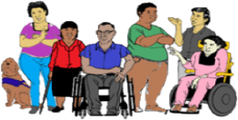
The DRC says there can be some changes
to group homes.
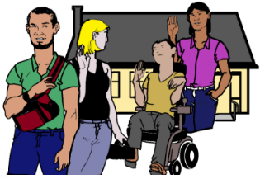
Like you can live with only a few people now. They say it will give you more choice.

But

Women and girls with disabilities say
you need the same choices as other people.

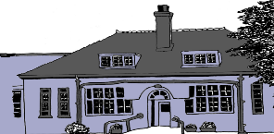
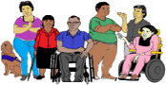
Women and girls with disability want the DRC to think about other places you live. Like
- in large group homes. Lots of people live there

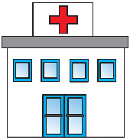

- in a hospital

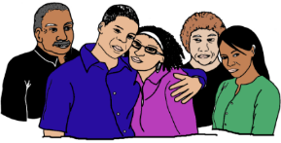
- with your family
- with your partner.

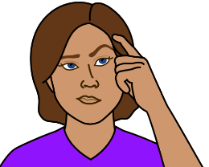
Some problems

You may live in a home with staff.
You have all the things you need.

But


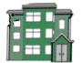
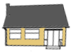
You did not have a choice.
There may only be 1 house you can
- get the help you need
or
- have the things you need. Like a ramp

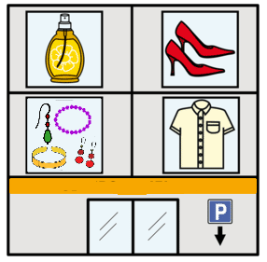
You can not do the things you want.
Like you can not go to
- shops
- work
- meet your friends.

Or

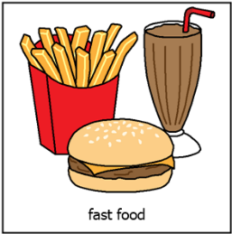
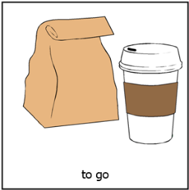
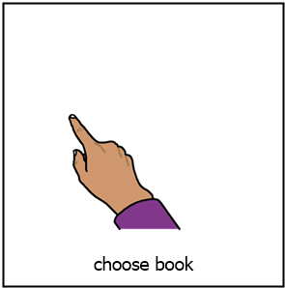
You can not choose
- the food you want
- what time you go to bed.

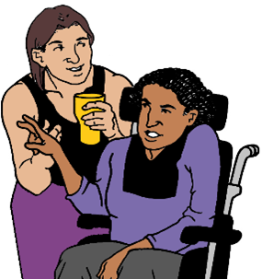
Some times there is a problem with the
help you get. You may
- want more help from staff

or

- you do not feel safe with staff

or

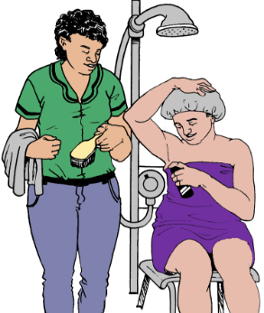

- staff help you to shower. A man helps you. You want a woman to help you.

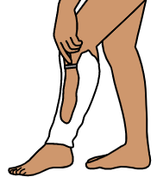
Some times the service rules stop you. Like
- you choose to shave your legs. The service says you can not. They say it is not safe.

or

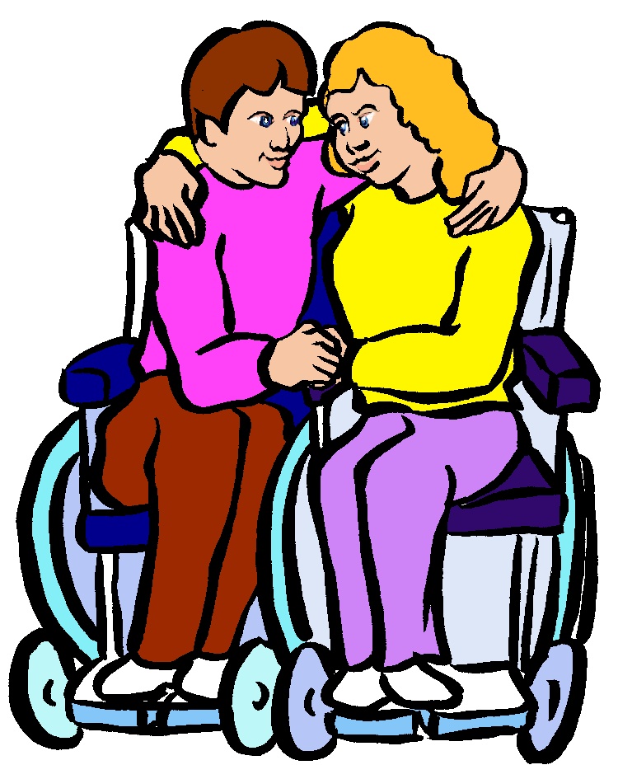
- the service says you can not have a special person in your life. Like a boy friend.

or

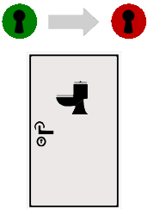
- you do not have private space.
Like you can not lock the toilet door.

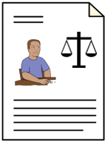
Some people with disability do not get a choice. Like you have a Legal Order.
It says a different person chooses for you.


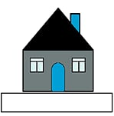
Some women and girls with disability
- do not have a home
- do not have money for a home
- can not get help.

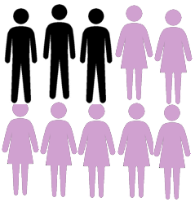
We know women and girls have this problem more than other people.

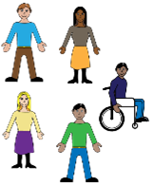
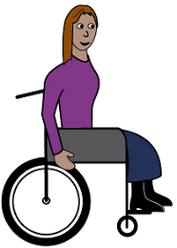
You are not part of
your community

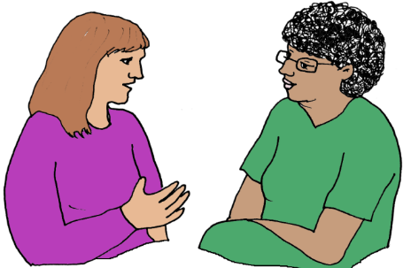
You only see staff.
Or
You only see other people with disability.
You do not see other people in the community.

You may be hurt. It is all the time.
You do not feel safe.
There is no one you can tell.

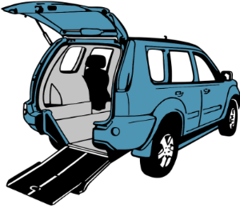
Some times you can not go in to the community.
Cars may not fit your wheel chair.

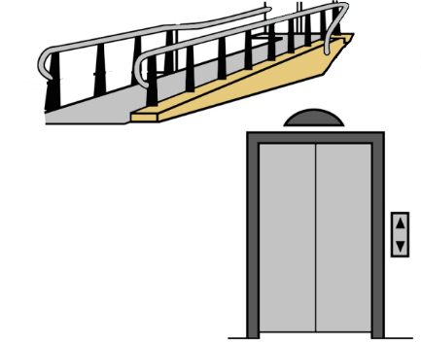
Or

You can not get into buildings.

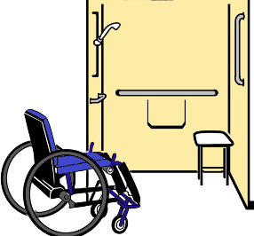
Lots of homes are not made for you.

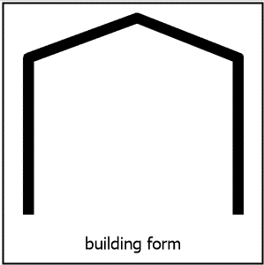
Violence in group homes

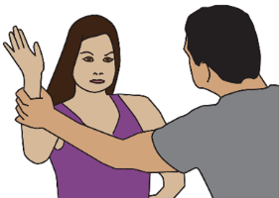
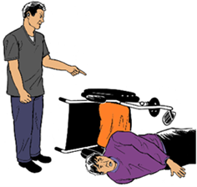
There are lots of other ways women and girls may be hurt in group homes. We told the DRC.

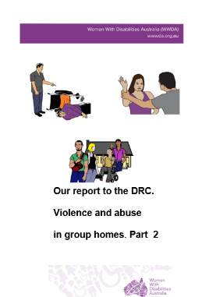
Read Our report to the DRC.
Violence and abuse in group homes. Part 2.
It is in Easy English.

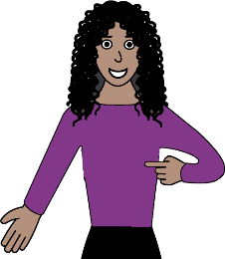
Problems in all parts
of your life.


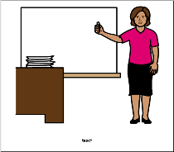
Some problems happen in all parts of your life.
It does not matter where you are. Like at
- school

- work
- home.

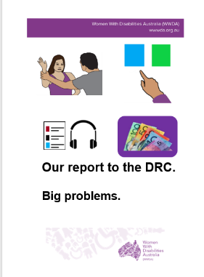
Read
Our report to the DRC. Big problems.
It is in Easy English. Go to page 26.

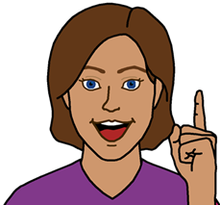
Ideas for change

- Woman and girls with disabilities want the DRC to think about how you live.

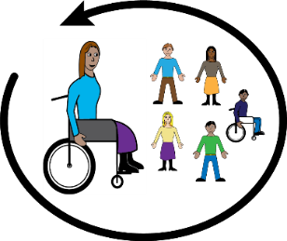
We want the DRC to talk about how
- you can live in your community


- you can have real choice.
There may be laws to change.

- Women and girls with disabilities want Australia to change its plan about choice.
You want help to make choices. You do
not want other people to choose for you

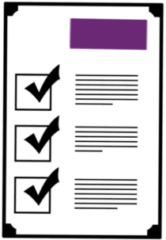

- The NDIS have rules about where you can live. Women and girls with disabilities want the NDIS to change this rule.

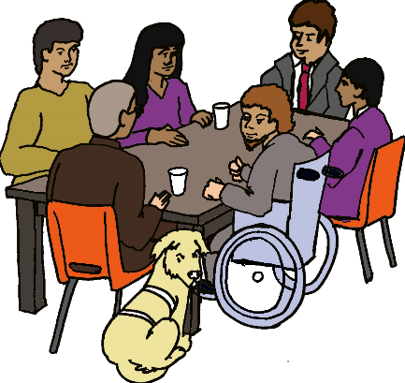
- Women and girls with disabilities want to be in planning meetings about homes.


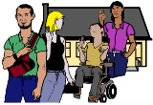
- Australia has a plan.
It is about less violence to women.
The plan must talk about group homes.

Learn more about the CRPD
It is in Easy English.

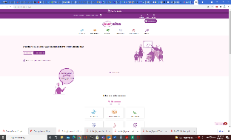
Go to www.oursitewwda.org.au
Click on Easy English at the top.

Now.

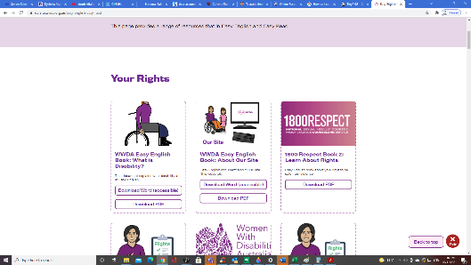
Go to the Your Rights part.
Open the Your Rights Toolkit button.
Find part 2.

Here is our CRPD fact sheet.
Problems in all parts of
our lives.

Read
Our report to the DRC. Big problems.
It is in Easy English.

Go to www.oursitewwda.org.au
Click on Easy English at the top.

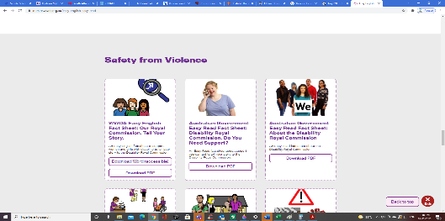
Look for the
Safety from Violence part.
Here is all our Easy English about the DRC.
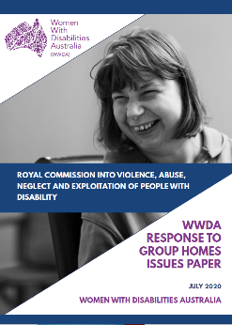
This fact sheet is based on the
Women With Disabilities Australia Disability Royal Commission report Response to group homes issues paper. July 2020.

Images
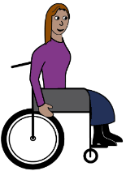
We can use these images. They are from
- ChangePeople
- EasyontheI
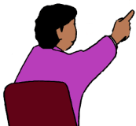
- InspiredServices
- Picto-Selector

- Spectronics
- Tobii-Dynavox.


Access Easy English wrote the Easy English.
September 2021.

