Women With Disabilities Australia
wwda.org.au

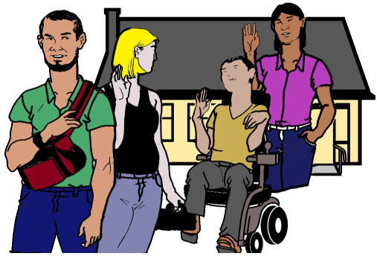
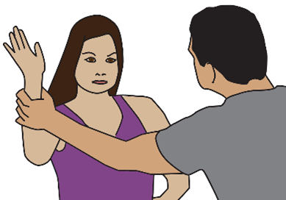
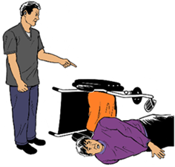

Our report to the DRC.
Violence and abuse
in group homes. Part 2.
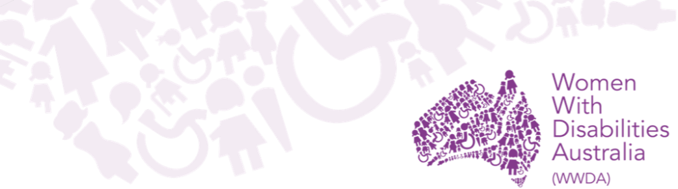

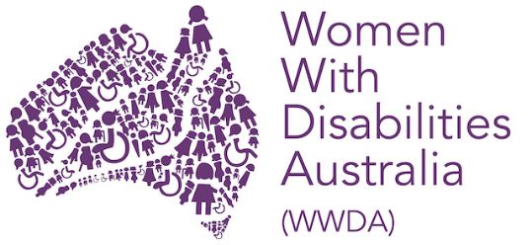
We are Women with Disabilities Australia.
We write WWDA when we talk about us.


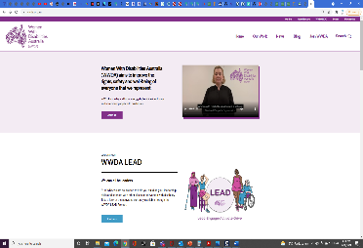
You want to know more about WWDA.
Go to www.wwda.org.au
Click the About us button.

Now.
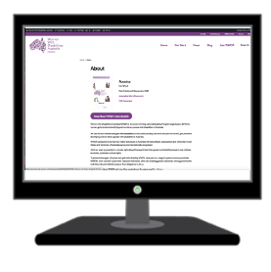

Open the About WWDA button.

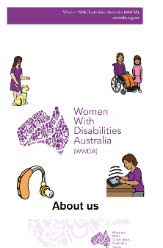

Read About us. It is in Easy English.

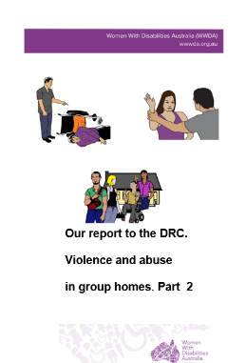
This is 1 of our reports to the
Disability Royal Commission.
We write DRC when we talk about the
Disability Royal Commission.

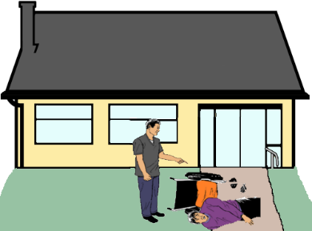
This report is about violence and abuse in
group homes.

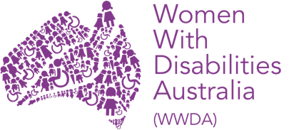
WWDA know lots of women and girls with disability get hurt.




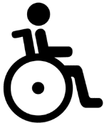
Violence happens to many people with disability.

But

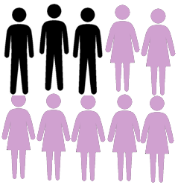
It happens more to women and girls
with disability.

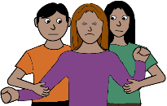
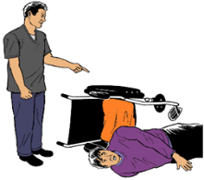
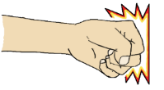
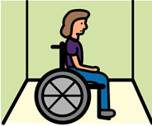
There are lots of ways women and girls get hurt in group homes.

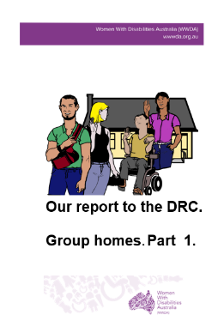
Also read
Our report to the DRC.
Group homes. Part 1.
Violence and abuse
in group homes.

There may be more types of violence and abuse.


It may be by
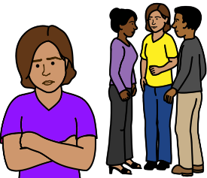
- staff
- other people you live with.

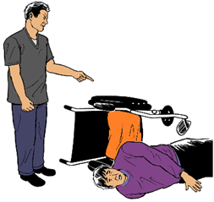
You may be hurt. It is all the time.

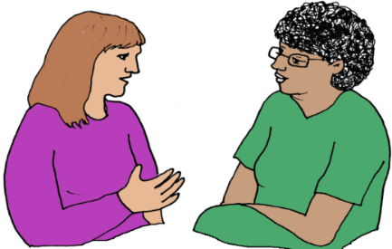
You do not feel safe.
There is no one you can tell.

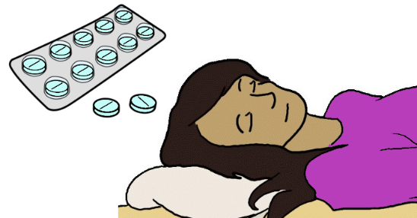
Staff may do things. It changes you. Like
- staff give you pills.
The pills make you sleep all the time

- staff make you stay in a room by your self.
It is for a long time. You do not know how long you will be there.

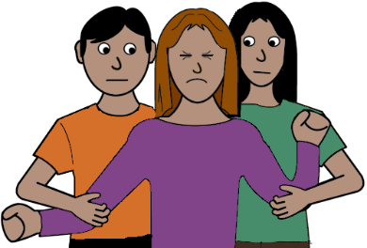
- staff hold you. You can not move.
It hurts where they hold you.

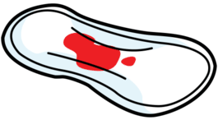
Other people make choices about your health.
It is about your body. Like
- staff give you pills. It stops your period.

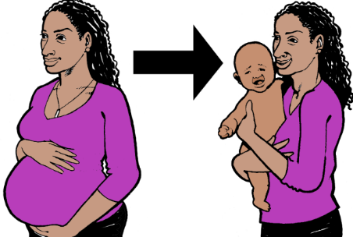
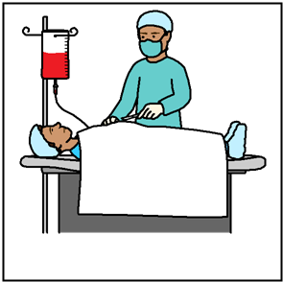
- you had an operation. No one asked you.
Now.
You can not have a baby.

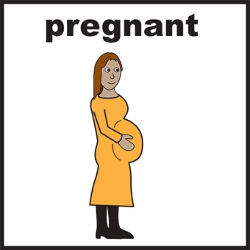
- you are having a baby.
You are told to stop the baby.
This is called an abortion.
You did not choose this.

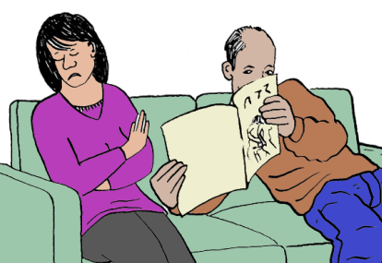
There may be sex violence. Like
- a person makes you look at rude pictures.
You do not want to do this.

or
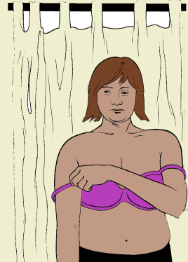

- a person looks at you. You are not dressed.

or

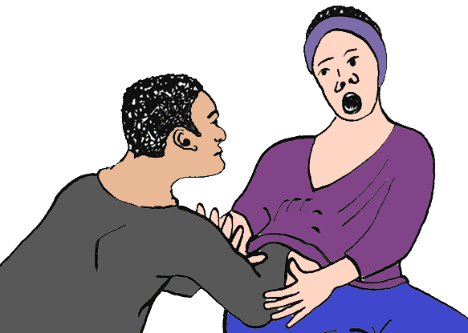
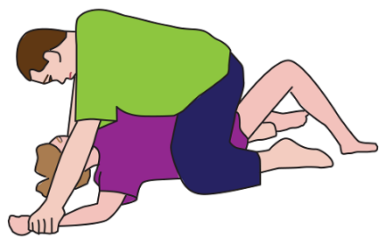
- a person makes you have sex
You do not want this.

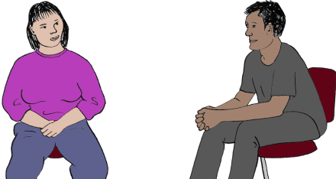
You get hurt. It is sex violence. You tell staff.

But


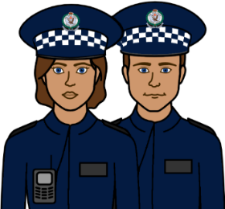
You do not get help from
- police
- doctor.

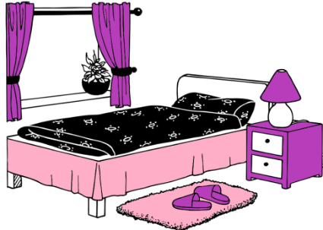

You still sleep in the room where you got hurt.

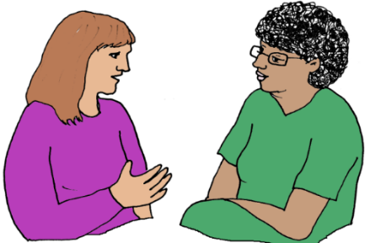
You do not get a person to talk to.
Like a social worker.

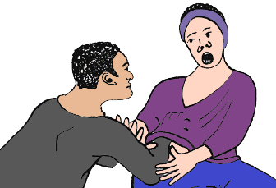
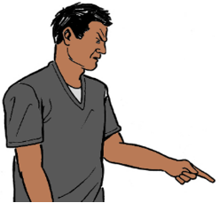

A person you live with makes you have sex.
Staff say it is OK .

But
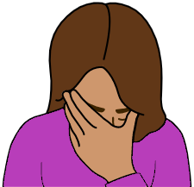
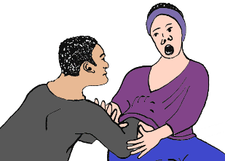
You do not want this. This is not OK.

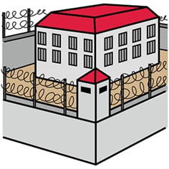
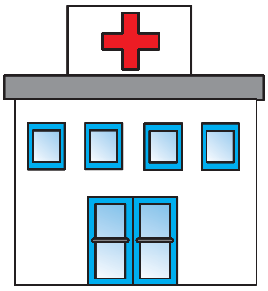
You may live in a place you can not leave. Like
- a jail
- a hospital.

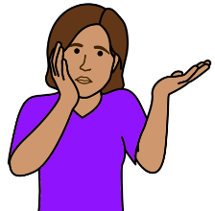
You do not understand why you are there.
You do not feel safe.
You do not know what to do to leave.

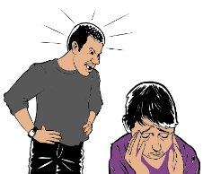
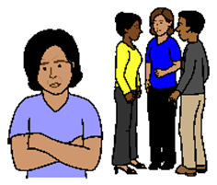
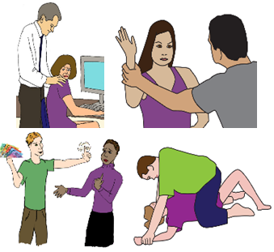
All violence and abuse is wrong.
The law says it is not OK.

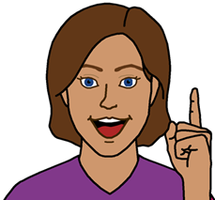
Ideas for change

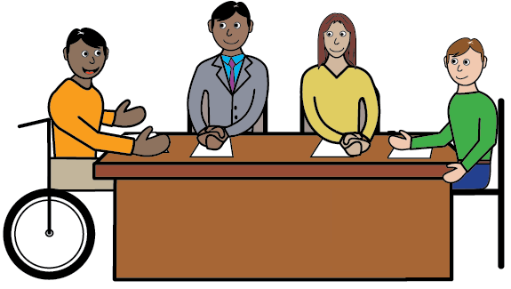
- Women and girls with disabilities want
the DRC to think about
- all types of violence and abuse.
- what things make violence happen to
women and girls.

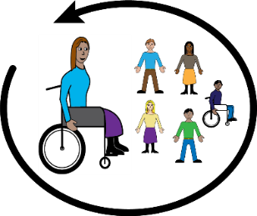
- Women and girls with disabilities want the DRC to know more violence can happen to you.
It is because of where you live. You may
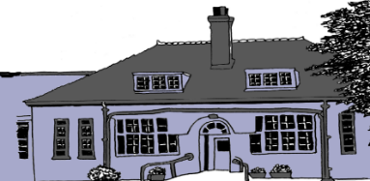
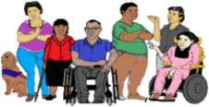
- not live in your community
- live with lots of other people
- live in a group home.
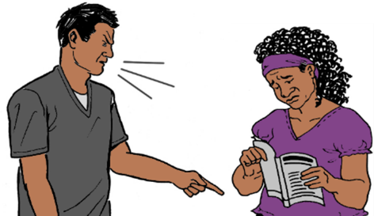
- We want the DRC to know the things that make violence happen. Like
other people do not treat you with respect.

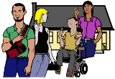
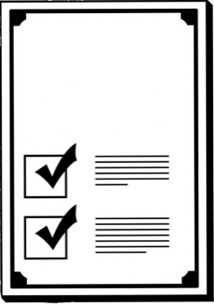
- Australia has a plan for less violence
for all women.
The plan must talk about group homes.

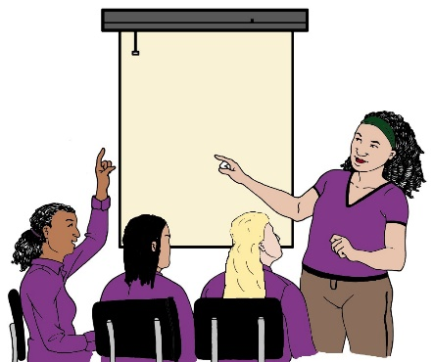
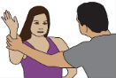
- The government must have a group to look at
- violence to women and girls with disability
and
- how to stop the violence.
We need to be part of this group.

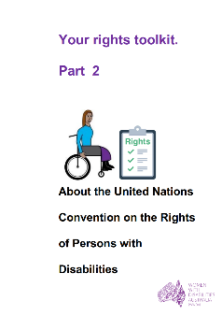
Learn more about the CRPD
It is in Easy English.

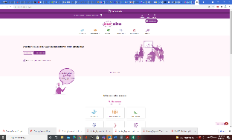
Go to www.oursitewwda.org.au
Click on Easy English at the top.

Now.

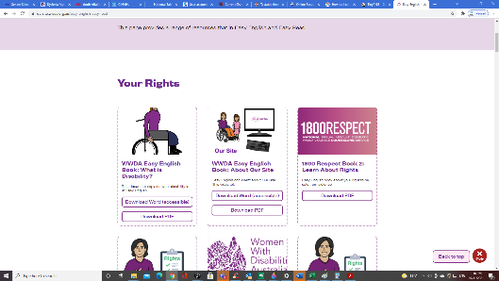
Go to the Your Rights part.
Open the Your Rights Toolkit button.
Go to part 2.

Here is our CRPD fact sheet.
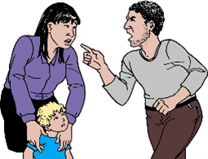
Learn more about
- violence
- abuse.

Go to www.oursitewwda.org.au
Click on Easy English at the top

Now.
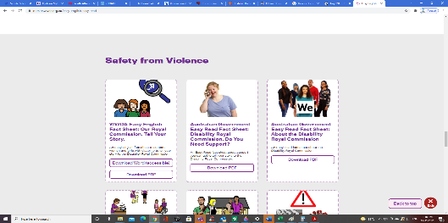

Go to the Safety from Violence part.

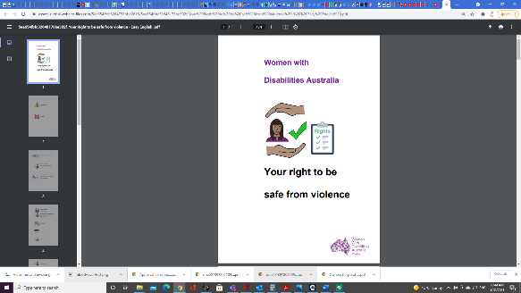
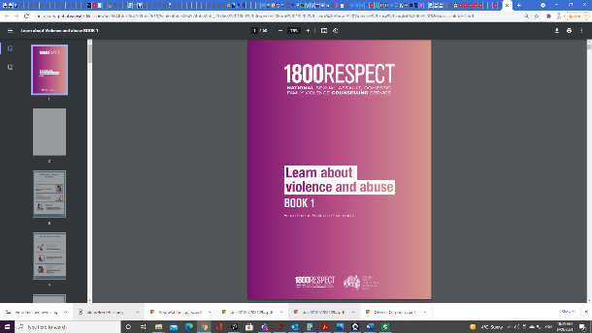
There is lots of information here. Like
- Your right to be safe from violence
- 1800 Respect. Book 1. Learn about violence.
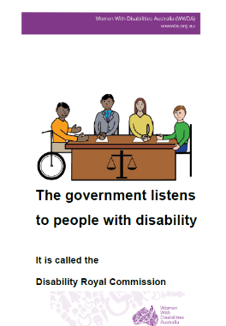
Our other reports to the DRC

They are in Easy English.

Our report to the DRC.

Group homes. Part 1.

or

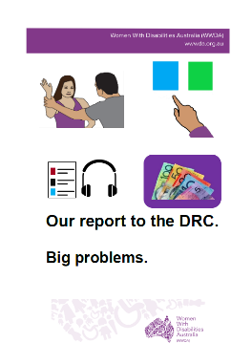

Our report to the DRC. Big problems

Go to www.oursitewwda.org.au
Click on Easy English at the top.

Now.

Look for the
Safety from Violence part.
Here is all our Easy English information about the Disability Royal Commission.

Or

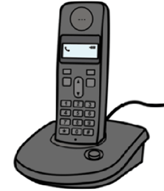

Call us 0438 535 123.
We can send you the reports.

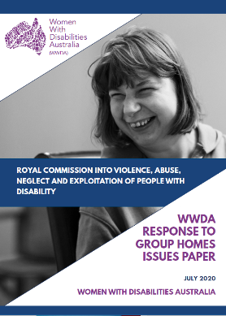
This fact sheet is based on the Women With Disabilities Australia Disability Royal Commission report WWDA Response to group homes issues paper. July 2020.

Images
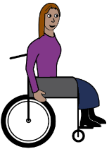

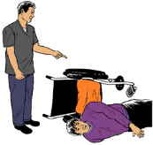
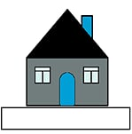
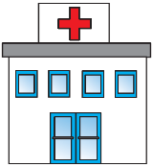
We can use these images. They are from
- ChangePeople
- EasyontheI
- InspiredServices
- Picto-Selector
- Tobii-Dynavox.

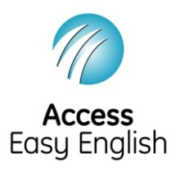
Access Easy English wrote the Easy English.
September 2021.

