Women With Disabilities Australia
wwda.org.au

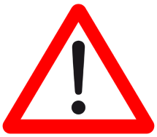
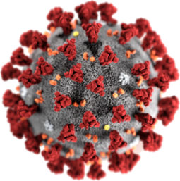
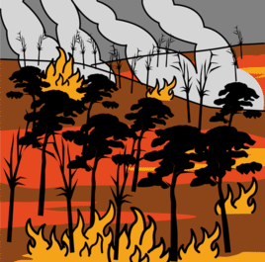

Our report to the DRC.
Help in an emergency.
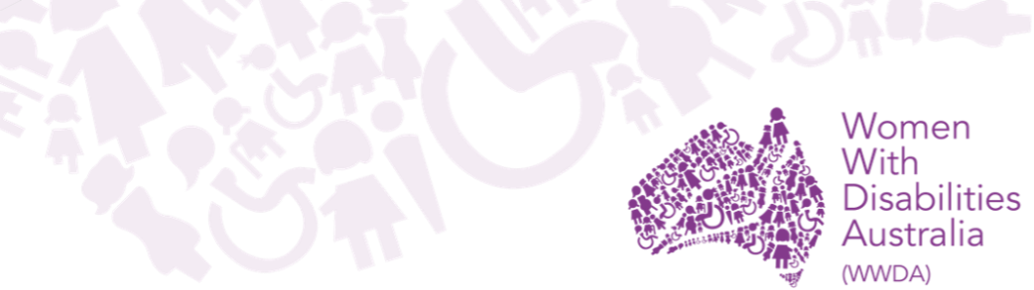

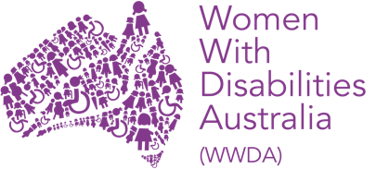
We are Women with Disabilities Australia.
We write WWDA when we talk about us.


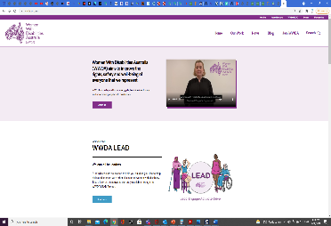
You want to know more about WWDA.
Go to www.wwda.org.au
Click the About us button.

Now.
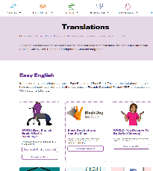

Open the About WWDA button.

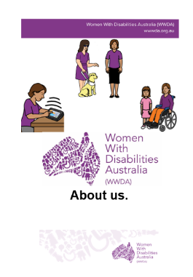

Read About us. It is in Easy English.

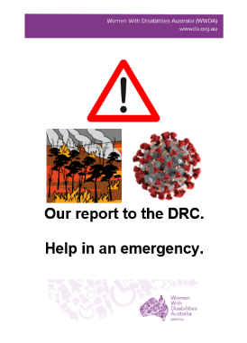
This report is 1 of our reports to the
Disablity Royal Commission.
We write DRC when we talk about the
Disability Royal Commission.

It is about problems in emergencies. Like
- bush fires

- COVID 19.

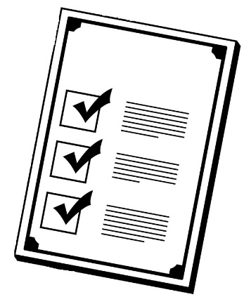
Rules

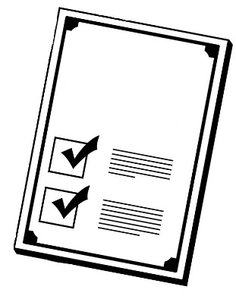
There are laws about emergencies.
000
They say we have the right to be safe.

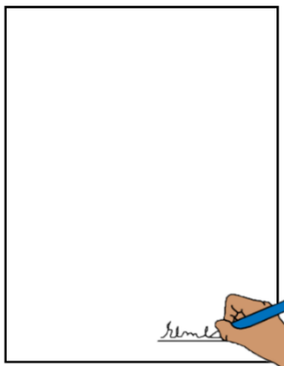
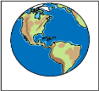

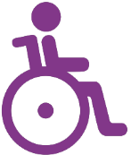
Like The United Nations Convention on the Rights of Persons with Disabilities.
We write CRPD to talk about it.

The CRPD are rules for the whole world.
It tells us about the rights of
all people with disability.
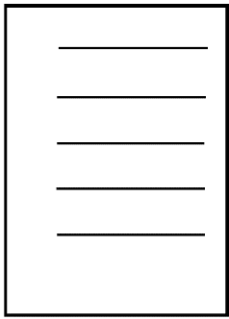
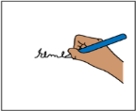
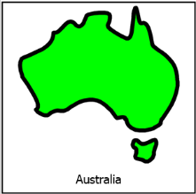

The Australian Government signed the CRPD.
They agree to follow these rules.

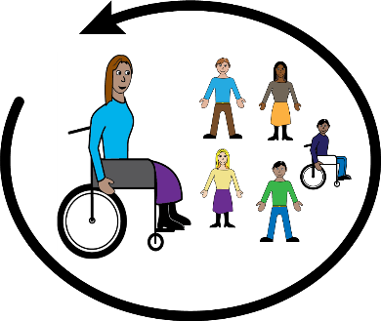
Australia agrees people with disability must be part of their community.

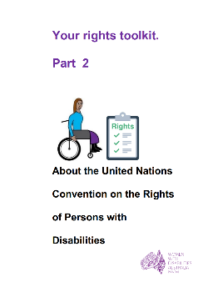

Learn more about the CRPD. Go to page 22.

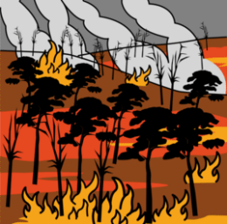
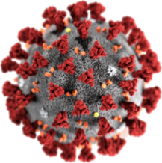
Big emergencies

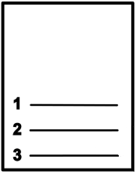

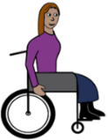
The CRPD says all emergency plans must plan for people with disability. Like
- where people with disability can go
- gives the right help to people with disability
- has help for different sorts of disabilities.

There are big emergencies. Like
- bush fires

- COVID 19.

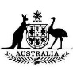
The government has a plan.
It is to help people in a big emergency. Like
- to keep people safe
- to give people the help they need.
It is a plan to tell people
- what people need to do
- where people need to go.

But



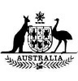
The plan does not talk about
- people with disability
- the right help for people with disability
- what people with disability can do
- where people with disdablity can go.

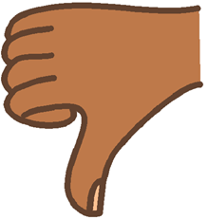
This is not ok.
There have been big emergencies in Australia.
We all had to know about them. Like
- the Black Summer bush fires in
- 2019
- 2020
- COVID 19.

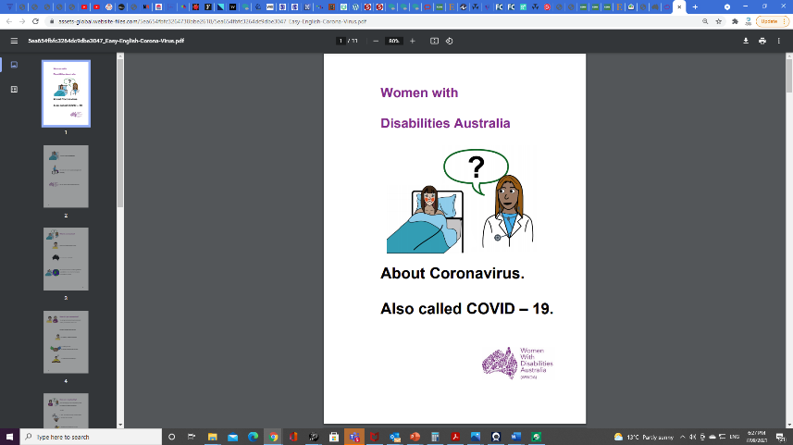

Learn about COVID 19. Go to page 24.

The emergency plans for us

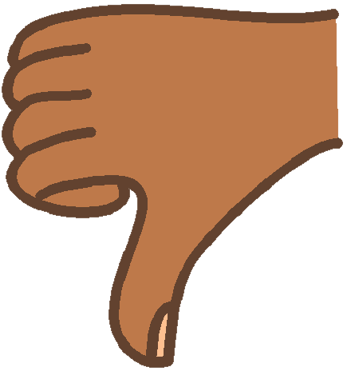
Lots of women and girls with disability said they
- did not get help
or
- did not have the right help for their disability.

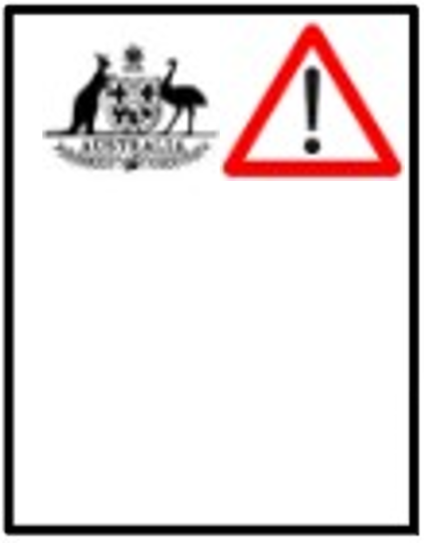

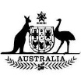
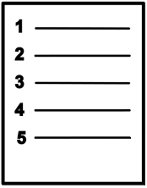
The government emergency plan has
lots of steps.

The plan says what to do
- before there is an emergency
- when there is an emergency
- right after an emergency.

But

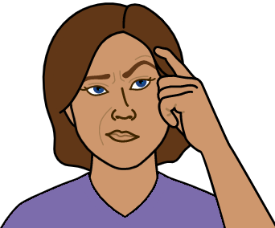
There are a lot of problems. The plan does
not talk about women and girls with a disability.

The plan must plan for people with disability in
all the steps. The plan must say
- what people with different disabilities need
- how to help people with different disabilities.

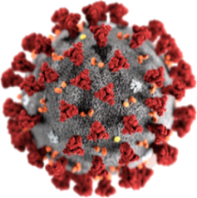
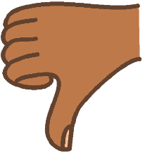
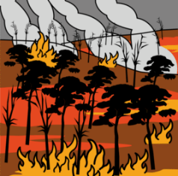
Lots of women and girls with disability say there were lots of bad things in the plans for
- The Black Summer bush fires
- COVID 19.

There were many things not in the plan.


Like
- How you see the people who help look after your health. You must see them to stay well. Like
- go to your doctor
- go to your therapist.

The government said you can see them
on a computer.

But

You do not have a computer.
You can not get the care you need.

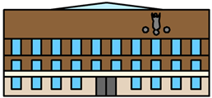
- The bush fire may be near you.
The news says we need to go to a safe place. Like the hall in the middle of town.

But

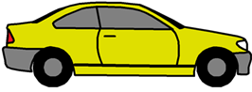
You do not have a car. You can not get there.
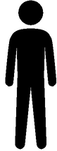
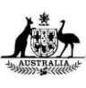

- Other people got some more money.

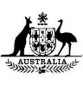

You did not get more money.
Your carers did not get more money.

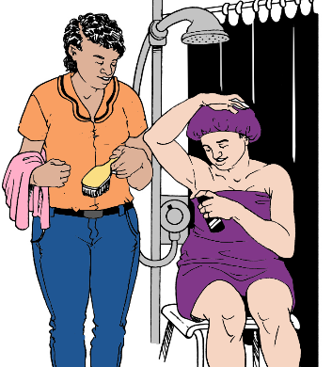
- You can not go to other houses.
Other people can not come to your home.
But
You need help at home. Like
- help to shower
- staff in your home.
You can not have the staff at home.


- There was new information all the time.
The information told people about
- the emergency
- what you need to do to stay safe
- where to get help.


You can not understand the information.
You do not know the new rules.
You do not know what to do.


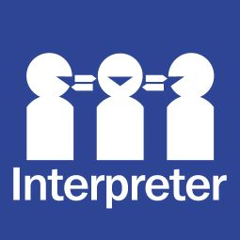
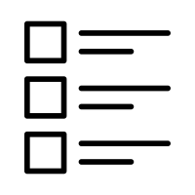
There was no information
- in Easy English
- you can listen to
- in Large Print
- in a different language.
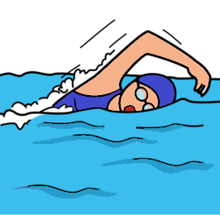
- You have to stay home. You feel cut off. You
- do not understand why
- can not see friends
- can not do the things you do.
Like go for your swim.

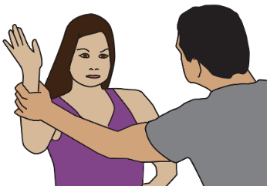
- A person is violent to you. Like
- they grab you all the time. It hurts you
- they say bad things to you.
They do it all the time.


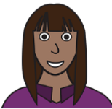

You do not have a safe place to go.
It is because of your disability.

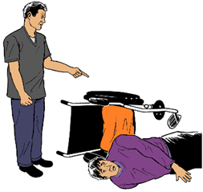
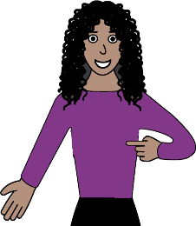
Problems in all parts
of your life.
We told the DRC about this.

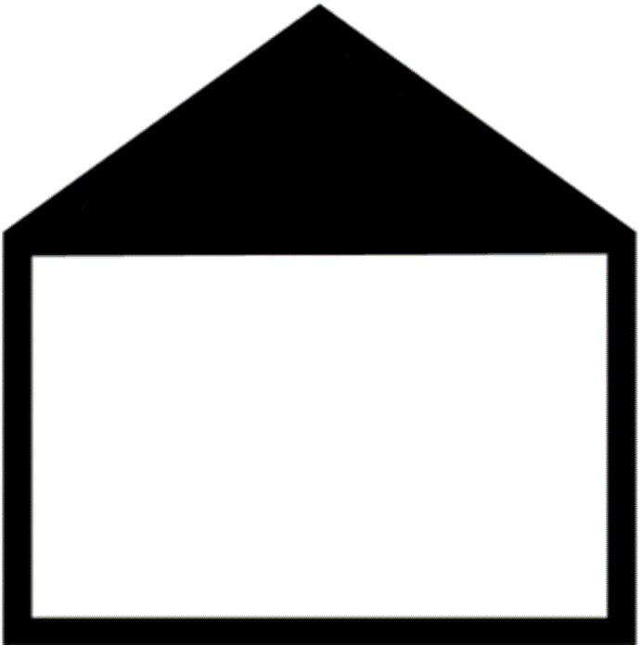
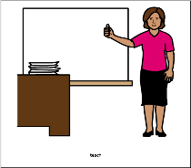
Some problems happen in all parts of your life.
It does not matter where you are. Like at
- school
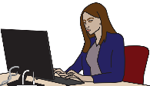
- work
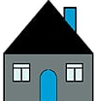
- home.

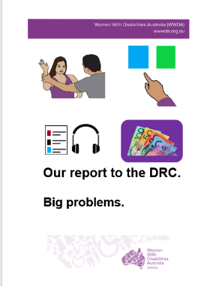
You can read more in
Our report to the DRC. Big problems.
Go to page 23.
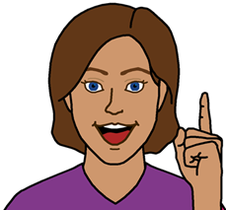
Ideas for change

1. We want a plan for all Australia. It will help all
people with disability in emergencies.
Like
- bush fires
- floods.

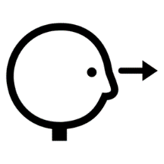
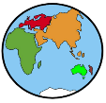
2. Some other countries have good
emergency plans for people with disability.
The government needs to look at
these plans.

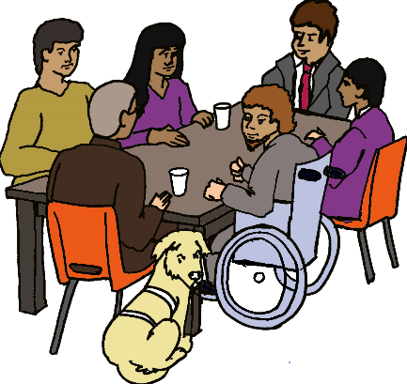
3. We want women and girls with disability to be in meetings about emergency plans

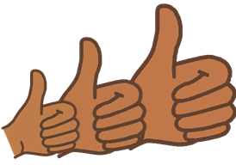

We can talk about how to make things better.

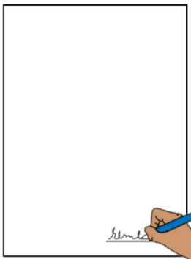
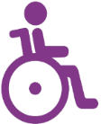
We can talk about
- emergency plans
and
- the CRPD.

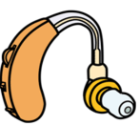
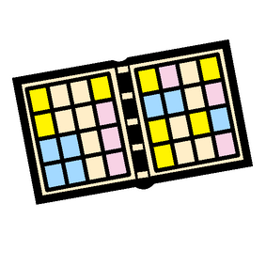
4. The government listens to us about what
we need. Like
- a quiet place to talk
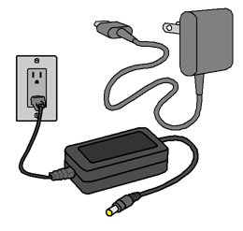

- chargers for the things we need

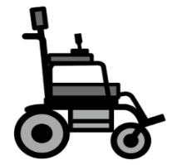
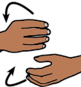
- how to help all kinds of people
with disabilities.

6. You get information in a way you understand.
Like you get information
- in Easy English
- you can listen to
- In Auslan
- in Large Print
- in a different language.

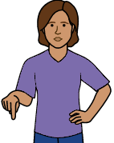
- You get information about the emergency
- from the government
- at the same time as every one else.

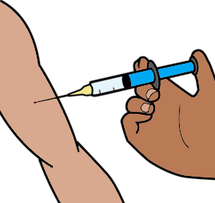
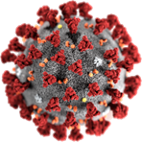
6. The government has the same rules
for every one. Like when staff get their
COVID 19 needle.

Learn more about the CRPD
It is in Easy English.

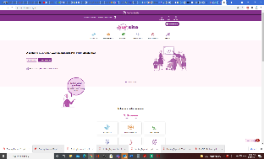
Go to www.oursitewwda.org.au
Click on Easy English at the top.

Now.

Go to the Your Rights part.
Open the Your Rights Toolkit button.

Go to page 13
Here is our CRPD fact sheet.
Problems in all parts of
our lives.

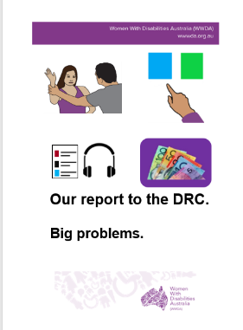
Read
Our report to the DRC. Big problems.
It is in Easy English.

Go to www.oursitewwda.org.au
Click on Easy English at the top.

Look for the
Safety from Violence button.
Here is all our Easy English about the DRC.
Learn about COVID 19
It is in Easy Read.

Go to www.oursitewwda.org.au
Click on Easy English at the top.

Now
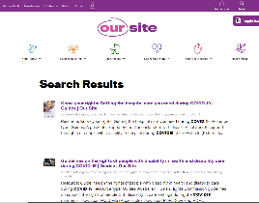

Go to Life Choices.

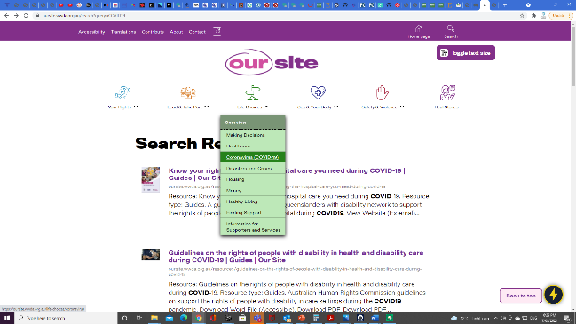

Click on the About Coronavirus button.

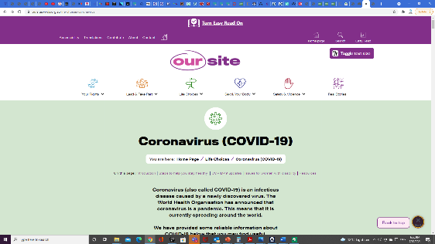
This is our COVID 19 web page.
Click on resources.

It will go to the bottom of the web page.
Here is our Easy Read. What is COVID 19?

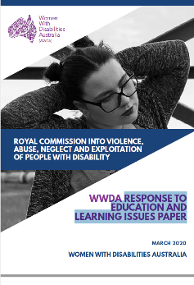
This report is based on the Women
With Disabilities Australia Disability Royal Commission report. Response to emergency planning issues. March 2020.

Images
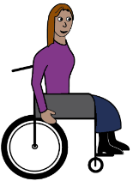
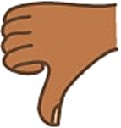
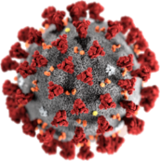
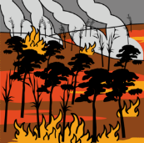
We can use these images. They are from
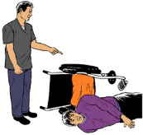
- ChangePeople
- EasyontheI
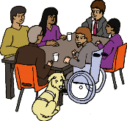
- Freepikpsd
- InspiredServices
- Picto-Selector
- TheNounProject
- Spectronics
- Tobii-Dynavox.

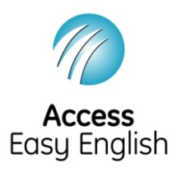
Access Easy English wrote the Easy English.
August 2021.

