Women With Disabilities Australia
wwda.org.au


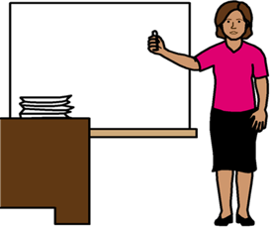

Our report to the DRC. About where we learn.
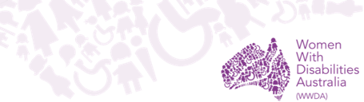

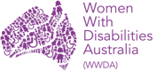
We are Women with Disabilities Australia.
We write WWDA when we talk about us.


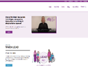
You want to know more about WWDA.
Go to www.wwda.org.au
Click the About us button.

Now.
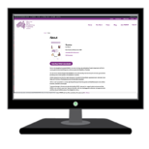

Open the About WWDA button.

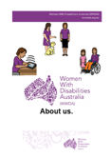

Read About us. It is in Easy English.

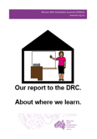
This report is 1 of our reports to the
Disablity Royal Commission.
We write DRC when we talk about the
Disability Royal Commission.


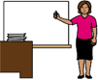
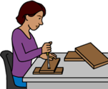
It is about problems with places we learn. Like
- schools

- TAFE

- other places we learn.

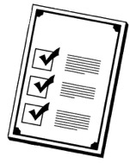
Rules

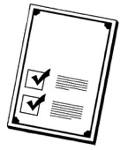

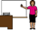
There are laws about places we learn.
They say we have the right to learn.

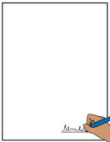


Like The United Nations Convention on the Rights of Persons with Disabilities.
We write CRPD to talk about it.

The CRPD are rules for the whole world.
It tells us about the rights of
all people with disability.

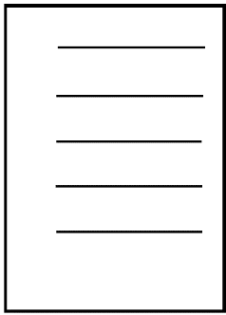



The Australian Government signed the CRPD.
They agree to follow these rules.

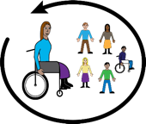
Australia agrees people with disability must be part of their community.

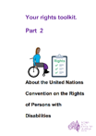

Learn more about the CRPD. Go to page 16.


Places we learn


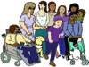
Women and girls with disability have a right
- to learn


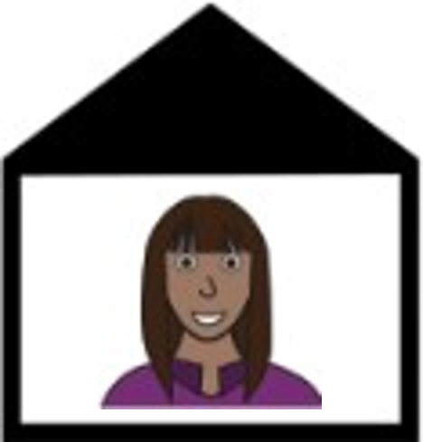
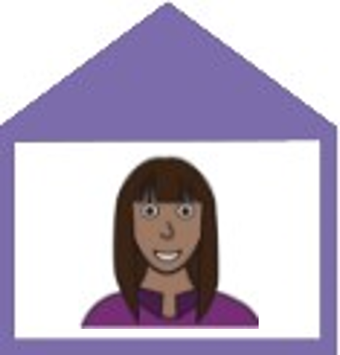

- to choose where you go to learn





- to be safe at school.

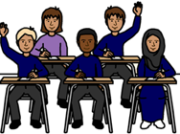
We have the right to be in a class
- with students with no disability
- with students your age.

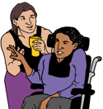
We have the right
- to the right help at school. Like you get
- an aide to help you drink


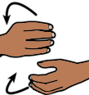

- your work in a way you can do
- a teacher who signs.

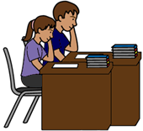
You have the right to learn lots of things.
Like you learn about the same things as other students in your class.

Some times women and girls with disability
  - can not choose where they go to school
  - do not get help to go to school.

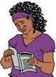
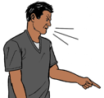
Like people say we can not do the work.
But.
We do not get the chance to try.

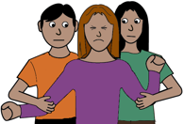
Some staff may hurt students.
They stop you from
- being able to move
- doing what you want.

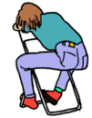

Like
- you need to move about
- talk.
It is because of your disability.

But
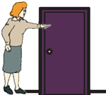

The teacher makes you leave the room.

Schools say this is to help you.

But
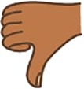

This does not help.
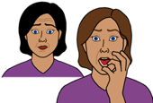
It makes you feel scared.

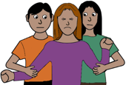

It is wrong.

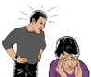
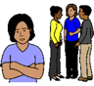
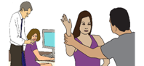
All violence against women and girls with disability is wrong.

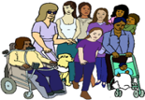
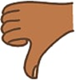
Lots of women and girls with disability say there are lots of bad things at school.

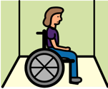
Like
- you are put in a room. It has no windows.
You do not know how long you will be there.
You can not get out. You are scared

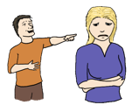

- people say bad things about you

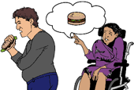

- you do not get the help you need.

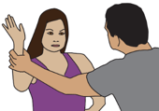
A person is violent to you. Like
- they grab you all the time. It hurts you
- they say bad thing to you.
They do it all the time.




You do not have a safe place to go.
It is because of your disability.




Women and girls with disability have the right to be safe at school.

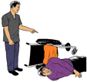
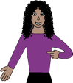
Problems in all parts
of your life.


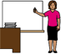
Some problems happen in all parts of your life.
It does not matter where you are. Like at
- school

- work
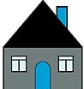
- home.

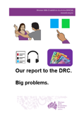
Read
Our report to the DRC. Big problems.
It is in Easy English. Go to page 17.

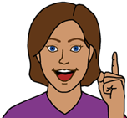
Ideas for change

- We want a plan for all of Australia to
- help more women and girls with disability to go to the school they want


- give money to those schools

- make sure women and girls with disability
do not get hurt in schools.

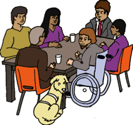
- We want women and girls with disability to be in planning meetings about schools.
We can talk about what we need.

And

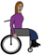


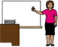
We can talk about how schools must do the things in the CRPD.

Learn more about the CRPD
It is in Easy English.

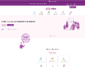
Go to www.oursitewwda.org.au
Click on Easy English at the top.

Now.

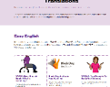
Go to the Your Rights part.
Open the Your Rights Toolkit button.

Go to Page 13
Here is our CRPD fact sheet.
Problems in all parts of
our lives.

Read
Our report to the DRC. Big problems.
It is in Easy English.

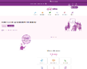
Go to www.oursitewwda.org.au
Click on Easy English at the top.

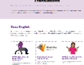
Look for the
Safety from Violence button.
Here is all our Easy English about the DRC.
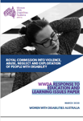
This report is based on the Women With Disabilities Australia Disability Royal Commission report Response to education and learning issues paper. March 2020.

Images
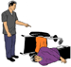
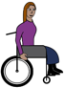
We can use these images. They are from
- ChangePeople

- EasyontheI
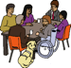
- InspiredServices

- Picto-Selector

- Spectronics

- TheNounProject
- Tobii-Dynavox.

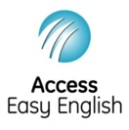
Access Easy English wrote the Easy English.
August 2021.

