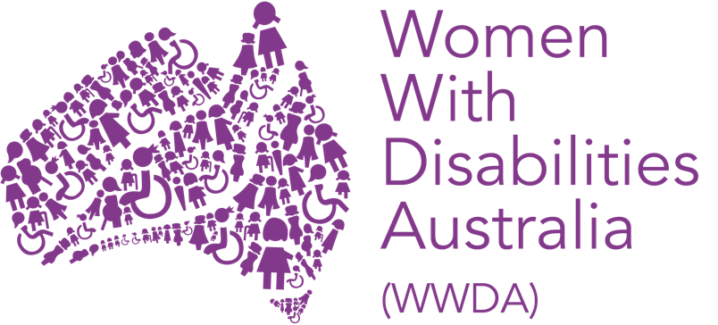

ANNUAL REPORT

2019 – 2020

PUBLISHING INFORMATION

Women with Disabilities Australia (WWDA) (2020), ‘Annual Report for the Period July 2019 – June 2020’, WWDA: Hobart. December 2020. Prepared by Carolyn Frohmader.

Acknowledgments

Women With Disabilities Australia (WWDA) receives its operational funding from the Australian Government, Department of Social Services (DSS). WWDA acknowledges and thanks DSS for its support.

WWDA acknowledges the traditional owners of the lands on which this publication was produced. We acknowledge Aboriginal and Torres Strait Islander people’s deep spiritual connection to this land. We extend our respects to community members and Elders past, present and becoming.

Disclaimer

The views and opinions expressed in this publication are those of Women With Disabilities Australia (WWDA) and not necessarily those of the funding body. All possible care has been taken in the preparation of the information contained in this document. WWDA disclaims any liability for the accuracy and sufficiency of the information and under no circumstances shall be liable in negligence or otherwise in or arising out of the preparation or supply of any of the information aforesaid.

This work is copyright. Apart from any use as permitted under the Copyright Act 1968, no part may be reproduced without written permission from Women With Disabilities Australia (WWDA).

© 2020 Women With Disabilities Australia (WWDA).

ABOUT

Women With Disabilities Australia (WWDA) is the national Disabled People’s Organisation (DPO) for women, girls, feminine identifying and non-binary people with disabilities in Australia. DPOs are recognised around the world, and in international human rights law, as self-determining organisations led by, controlled by, and constituted of, people with disability. DPO’s are organisations of people with disability, as opposed to organisations who may represent people with disability. WWDA uses the term ‘women and girls with disability’, on the understanding that this term is inclusive and supportive of, women and girls with disability along with feminine identifying and non-binary people with disability in Australia.

As a DPO, WWDA is run by and for women, girls, feminine identifying and non-binary people with disabilities. WWDA represents more than 2 million women and girls with disability in Australia, has affiliate organisations and networks of women with disability in most States and Territories, and is recognised nationally and internationally for its leadership in advancing the rights and freedoms of all women and girls with disability. Our organisation operates as a transnational human rights organisation - meaning that our work, and the impact of our work, extends much further than Australia. WWDA’s work is grounded in a human-rights based framework which links gender and disability issues to a full range of civil, political, economic, social and cultural rights.

WWDA is a founding member of Disabled People’s Organisations Australia (DPO Australia), an alliance of four national, population specific and cross-disability DPO’s in Australia. DPO Australia was founded by, and is comprised of: Women With Disabilities Australia (WWDA); First Peoples Disability Network Australia (FPDN); People with Disability Australia (PWDA); and, National Ethnic Disability Alliance (NEDA). The key purpose of DPO Australia is to promote, protect and advance the human rights and freedoms of people with disability in Australia by working collaboratively on areas of shared interests, purposes and strategic priorities and opportunities.

Contact

Women With Disabilities Australia (WWDA)
PO Box 407, Lenah Valley TASMANIA 7018
Mobile: +61 438 535 123
Email: officeadmin@wwda.org.au
Web: www.wwda.org.au
Facebook: www.facebook.com/WWDA.Australia
Twitter: https://twitter.com/WWDA_AU
ABN: 23 627 650 121
Contact: Carolyn Frohmader (Executive Director)

Winner, National Human Rights Award 2001
Winner, National Violence Prevention Award 1999
Winner, Tasmanian Women's Safety Award 2008
Certificate of Merit, Australian Crime & Violence Prevention Awards 2008
Nominee, National Disability Awards 2017
Nominee, French Republic's Human Rights Prize 2003
Nominee, UN Millennium Peace Prize for Women 2000
Nominee, UNESCO Prize for Digital Empowerment of Persons with Disabilities 2020

CONTENTS

ABOUT WWDA’S ANNUAL REPORT 5
WWDA BOARD 2019-2020 6
WWDA STAFF 2019-2020 7
WWDA PRESIDENTS REPORT – Tricia Malowney 8
WWDA EXECUTIVE DIRECTOR REPORT – 10
Carolyn Frohmader 10
SUMMARY OF KEY ACHIEVEMENTS AND OUTCOMES 12
The development of ‘Our Site’ 12
THE COVID19 PANDEMIC 14
Australia’s Review under the Convention on the Rights of Persons with Disabilities 16
Royal Commission into Violence, Abuse, Neglect and Exploitation of People with Disability 17
National Women’s Alliances and DPOs Workshop 19
Re-development of the WWDA Website 21
Policy Submissions and Representation 23
Communications & Engagement 25
Operational Development & Reporting 26
FINANCIAL REPORT 27
Board Report - 30 June 2020 1
Statement by Members of the Board 2
Statement of Comprehensive 3
Statement of Financial Position 4
Statement of Changes in Equity 5
Statement of Cash Flows 6
Notes to the Financial Statements 7
INDEPENDENT AUDITOR’S REPORT 11

ABOUT WWDA’S ANNUAL REPORT

This Annual Report provides a summary snapshot of just some of WWDA’s key outputs, activities and achievements at the national and international level for the financial year reporting period 1st July 2019 – 30th June 2020. The Report demonstrates the breadth, scope and high standard of WWDA’s work, on a wide range of initiatives and programs, across all portfolio areas and across jurisdictions. Our Annual Report highlights and reflects WWDA’s commitment to promoting and advancing the rights and freedoms of women and girls with disability – both within Australia and around the world. Our Annual Report also reflects the human rights-based approach from which we operate.

This Annual Report is structured in line with WWDA’s Strategic Plan 2017-2021, which was published in 2017 after extensive consultation with our members and constituents. WWDA’s Strategic Plan 2017-2021 contains five main goals. Under each goal are listed key objectives which set out how we intend to achieve our goals. The five goals are to:

- Undertake focused systemic advocacy on priority human rights issues identified by women and girls with disability: freedom from all forms of violence; decision-making and participation; sexual and reproductive rights; economic security, justice.

- Build on and further develop WWDA’s profile and reputation at the national and international levels as the globally recognised leader on advancing the human rights of women and girls with disability.

- Contribute to the development, implementation and monitoring of Australian Government legislation and policies that affect women and girls with disability.

- Enhance WWDA’s capacity to consult, engage and represent young women and girls with disability.

- Develop infrastructure, systems and mechanisms to enable WWDA to effect its purpose, goals and objectives.

It is outside the scope of this Report to do justice to the extensive work of WWDA during the reporting period July 2019 – June 2020. However, in compiling this summary report, we have endeavoured to give our members, supporters and funders a synopsis of just some of the key activities our organisation has undertaken, and has been engaged in, as part of our efforts to promote the rights of all women and girls with disability.

Further detail of WWDA’s work can be found on our extensive website at www.wwda.org.au and across our other platforms, which can be accessed from our website.

WWDA BOARD 2019-2020

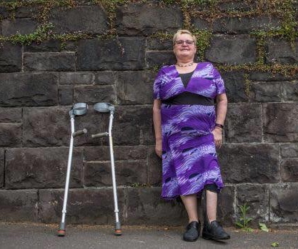  Tricia Malowney  President | 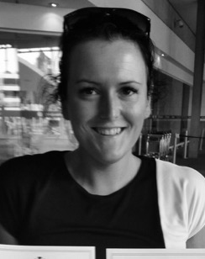  Jess White  Vice President | 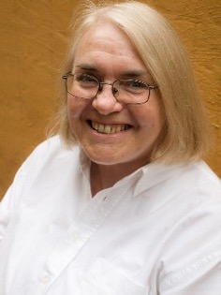  Pamela Menere  Treasurer
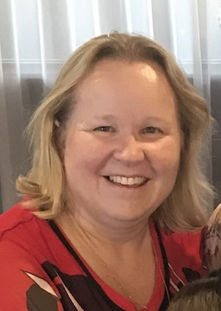  Jody Barney  Committee Member | 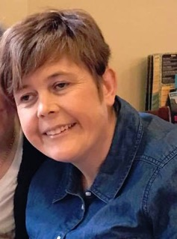  Monique Crowden  Committee Member | 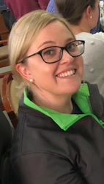  Allira Honner  Committee Member
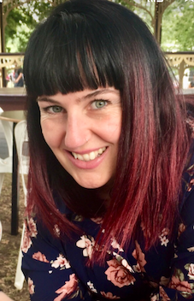

Jen Lowe
Committee Member

WWDA STAFF 2019-2020

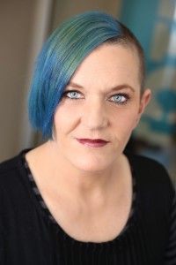  Carolyn Frohmader  Executive Director  (Full Time) | 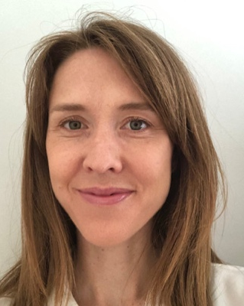  Naomi Thomson  Project Manager, Virtual Centre  (Full Time, Contract Position, ends July 2020) | 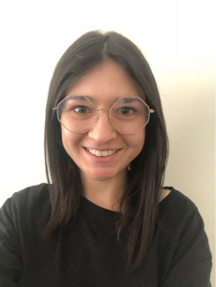  Heidi La Paglia  Senior Content Writer, Virtual Centre  (Full Time)
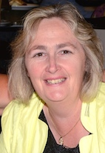  Sharon Williams  Office Manager  (Part Time) | 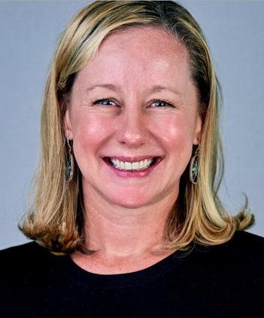  Libbi Cunnington  Senior Project Officer  (Part Time) |   Vanamali (Mali) Hermans  Project Officer  (Part Time)
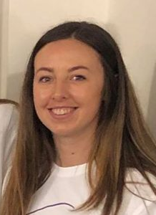

Jacinta Carlton
Media and Communications Officer
(Part Time)

WWDA PRESIDENTS REPORT

Tricia Malowney

Tricia Malowney
President

I am extremely proud to be President of Women with Disabilities Australia and to work alongside our Board to support the excellent work of our Executive Director Carolyn Frohmader and her staff.

Despite a challenging year with an extremely busy year complicated by COVID 19, WWDA has worked extremely hard during the reporting period (July 2019 – June 2020). We have achieved great outcomes despite the challenges to the organisation due to limited capacity, the significant number of major disability reforms being undertaken by governments and other agencies and of course the impact of COVID19 on our organisation and our members.

WWDA has managed to undertake work that is ground-breaking, cutting edge and critically acclaimed by Government and non-Government agencies. As WWDA President, I am often complimented on the work that we do, and I am extremely proud of our staff and what we are able to achieve on such limited resources.

This Report highlights just some of the key outputs and achievements during the reporting period, so I won’t duplicate them hers. The work program is extensive and yet is so productive, so it is almost impossible to give details on all our work in a Report such as this. WWDA’s Executive Director has provided a synopsis of some our key achievements and outcomes in her Report.

Rather, as WWDA President I would like to take this opportunity to make some particular acknowledgments of thanks to those who have contributed to and supported the work of WWDA over the reporting period.

On behalf of the WWDA Board and WWDA’s members and allies, I would like to thank our Executive Director, Carolyn Frohmader, for her ongoing dedication and commitment to our organisation. Carolyn has done an amazing job in representing our organisation on national Committees during this reporting period, including National Committees established to deal with the impact of COVID19 on people with disability, and has done so with dignity and has shown WWDA to be a quality organisation.

Our Executive Director has worked hard to secure funding through the NDIS ILC Program enabled us to recruit new staff. We will continue to work with Governments and other potential funding sources to ensure that our staff can be retained after the end of the ILC project grants. WWDA’s core operational funding of $300,000 per year, is only guaranteed until the end of June 2022, and we have been trying to operate on this same amount of core funding since 2014. We do not receive any indexation to our core funding, which means in practice, that each year we are doing more and more work with no increase in funding to pay for increasing operational costs.

I would like to formally recognise and acknowledge the WWDA Board members for their ongoing commitment and efforts over the past year. I would also like to thank the work of our Vice President Jess White and our Treasurer Pamela Menere in giving up their valuable time to the governance work of WWDA.

We would like to acknowledge, Jen Lowe, who stepped down from her role on the WWDA Board. We thank Jen for her significant contribution to our organisation and we wish her all the best in her new endeavours.

I also acknowledge with thanks, the many contributions that our members make to the work and success of WWDA. Whether it is through representing WWDA at national or international conferences and events; on state or national boards or committees; contributing to our discussion lists, Facebook page, website and twitter; or sharing with us your lived experiences of being women with disability, we highly value your contributions. It is, after all, the lived experiences of women and girls with disability that inform and direct the work we do, so thank you for your efforts, support and dedication. Our wonderful and highly successful project ‘Our Site’ is a perfect example of how our work is directed by, co-designed by, and in direct response to, the priority issues identified by women and girls with disability.

I would like to acknowledge, with thanks the Department of Social Services (DSS) for providing operational funding WWDA to end June 2022. Although DSS is undertaking a review and reforms to independent advocacy (including systemic advocacy) we trust that the Australian Government will continue to see WWDA as a valuable organisation, and continue to provide core funding to us post June 2022.

Tricia Malowney
WWDA President

WWDA EXECUTIVE DIRECTOR REPORT

Carolyn Frohmader

Carolyn Frohmader
Executive Director

The 2019-2020 financial year proved an extremely challenging year for WWDA. We, like many others, were significantly impacted by the COVID19 pandemic. Despite this, we were able to undertake a large work program, and are proud of our achievements during what was, and continues to be a difficult and trying year.

Some of WWDA’s key work during the reporting period (1 July 2019 – 30 June 2020) focused on: supporting our members and the Australian Government with the impact of the COVID19 pandemic; key work areas that are a requirement of our funding contract with the Department of Social Services (DSS); implementing major projects; the Disability Royal Commission; representation on national Advisory structures; providing advice to governments; and work relating to Australia’s international human rights obligations as they pertain to people with disability.

Our members have made it clear that there are four key thematic areas that they consider warrant priority from WWDA and from Government. These key areas include:

- The prevention of all forms of violence against women and girls with disability.
- Promoting the sexual and reproductive health and rights of women and girls with disability.
- Promoting decision-making and agency of women and girls with disability; and,
- Promoting leadership and participation opportunities for women and girls with disability.

It is outside the scope of this Report to detail all of WWDA’s comprehensive work during the reporting period. The following section of this report therefore provides a brief summary overview of some of WWDA’s key achievements and outcomes during the 2019-2020 reporting year. Further detail of WWDA’s work can be found on our extensive website and across our other digital platforms, including our new Our Site website.

I would like to thank Tricia Malowney (WWDA President) for your significant support over the past year, in what has been a very challenging and difficult year for WWDA. I would also like to thank the members of the WWDA Board who have governed our organisation so diligently during the reporting period. Thanks too, to Jen Lowe and Jessica White who stepped down from the WWDA Board during the year. Thank you for your contributions to WWDA and I wish you both well in your future endeavours.

I would like to acknowledge and thank those WWDA members who have undertaken representative work on behalf of our organisation during the reporting period, and also to our members and supporters for their continued faith in WWDA and our work.

I would not be able to perform my role as Executive Director without the fantastic support from WWDA staff: Sharon Williams (Office Manager); Heidi La Paglia (Policy and Project Officer); Jacinta Carlton (Communications Officer); Libbi Cunnington (Senior Project Officer); Vanamali Hermans (Project Officer); and Naomi Thomson (Project Manager). Most of WWDA’s staff work on a part-time basis. Naomi Thomson completed her contract with WWDA in mid 2020, and moved to a new position with another organisation. We thank Naomi for her service to WWDA and wish her well in her new job.

I would also like to thank our accountant, Cody Burdon for his exceptional service over the past year. Cody is a wonderful asset to WWDA, and we are very fortunate to have his high-level financial knowledge and skills to support the work of WWDA.

I acknowledge as always, the Department of Social Services (DSS) for providing WWDA’s operational funding, and also the National Disability Insurance Scheme (NDIS) for the provision of project grants to WWDA under the Information, Linkages and Capacity (ILC) Program.

Lastly, but certainly by no means least, I would like to pay particular thanks to my daughter Lottie – for her patience and her “behind the scenes” support of, and contribution to WWDA.

Carolyn Frohmader
Executive Director

SUMMARY OF KEY ACHIEVEMENTS AND OUTCOMES

The development of ‘Our Site’

In late 2018 Women with Disabilities Australia (WWDA) received funding through the National Disability Insurance Scheme’s Information, Linkages and Capacity Building (ILC) Program to create a new ‘virtual centre’ website for women and girls with disability. The ‘virtual centre’ was created by and for women with disability through a national two-year project led by WWDA. The project delivered on a vision that had been conceived by the WWDA community many years earlier, for an accessible website that provided information about the rights of women and girls with disability in four key areas: leadership and participation, decision-making and agency, sexual and reproductive health and safety from violence.

The ‘virtual centre’ was developed and built during 2019, with the input of over 100 women with disability across Australia, and was named ‘Our Site’ by those involved.

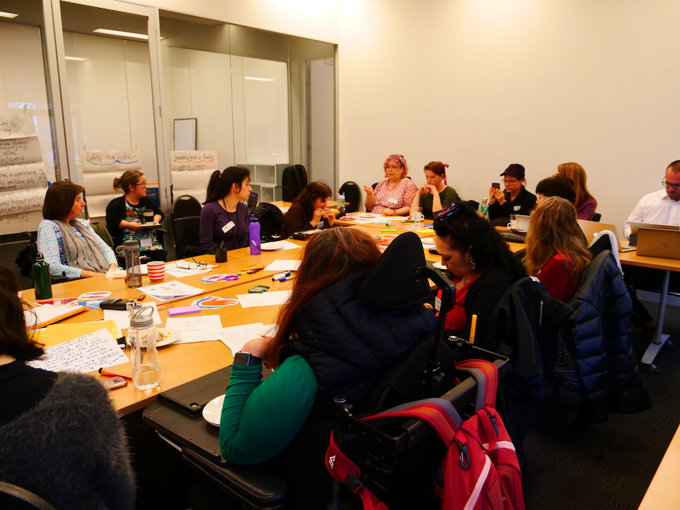

Participants at the Our Site Melbourne workshop.

WWDA delivered the website using an inclusive co-design methodology. This means that the project consistently prioritised the genuine, meaningful involvement and active participation of women with disability in every aspect of the website’s creation. This resulted in multiple benefits for the women involved and a website that is grounded in the diverse experiences of women and girls with disability. Throughout the project, women with disability across Australia participated in a variety in ways, including as part of a Project Steering Committee, Expert Advisory Panel, workshops, user testing story contributions.

‘Our Site’ was launched in March 2020 at an event at the Australian Human Rights Commission in Sydney. Our Site was launched by the Minister for Women, the Hon Marise Payne, and the launch was live streamed on Facebook.

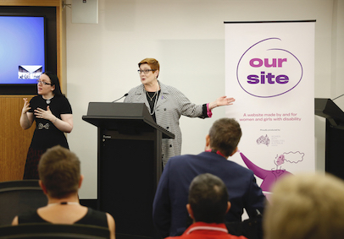

Hon Minister Payne launches the Our Site Project.

While it is continually evolving and growing, Our Site primarily provides practical resources and information across five thematic areas:
- Human rights
- Leadership and participation
- Decision making and choices
- Sexual and reproductive health and rights
- Safety from all forms of violence.

It also showcases real stories in a variety of formats from over 40 women with disability across Australia.

A stand-alone Easy Read version of the Our Site website was launched in July 2020. Since the launch, WWDA has received a fantastic response from those who work in the industry and, most importantly, from women and girls with disability who have been using the site.

The ‘Our Site’ Project has been detailed in a comprehensive report, and an Easy Read of the Report has also been published. The Our Site Reports can be found on WWDA’s website.

The COVID19 Pandemic

The COVID19 pandemic had a major impact on WWDA in many ways. Like many others, our staff were all re-located to work remotely from home, and we needed to purchase equipment and supplies to ensure our staff were properly set up to be able to work remotely. It was extremely unfortunate that WWDA, like most of the Disabled People’s Organisations and Disability Representative Organisations, were provided no additional funding or resourcing to deal with all aspects of the impact of COVID19.

WWDA worked tirelessly to develop and provide accessible information resources to our members and other people with disability. We established a COVID19 portal on our website, and developed a large number of resource materials in a range of accessible formats, including Easy Read. WWDA also provided a national leadership role for the Disabled People’s Organisations and Disability Representative Organisations during the COVID19 pandemic. When it became clear in the early stages of the pandemic, that people with disability had essentially been ‘forgotten’ in government responses, WWDA initiated and authored an ‘Open Letter to the National Cabinet: Immediate Actions Required for Australians with Disability in Response to Coronavirus (COVID19)’.

WWDA also co-ordinated endorsements to the Open Letter, which resulted in over 70 organisations from around the country signing on to the Open Letter. WWDA sent the Open Letter formally to all members of the National Cabinet, plus to all Federal and State/Territory Disability Ministers, Health Ministers, advisers to Ministers, media contacts and a wide range of other key stakeholders. WWDA also undertook to develop the published version of the Open Letter, plus the accessible formats, including Plain English, Easy Read, and text only.

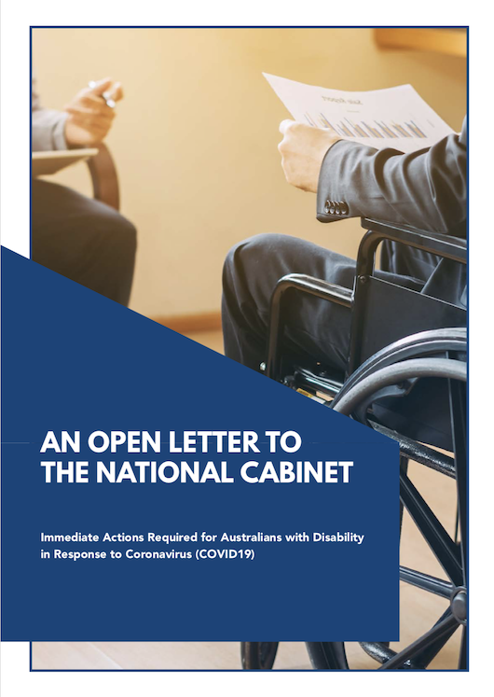

A photo of the front page of the Open Letter to the National Cabinet: Immediate Actions Required for Australians with Disability in Response to Coronavirus (COVID19).

As a result of the Open Letter to the National Cabinet, the Australian Government established a National COVID Disability Support Advisory Committee, which included membership of the DPOs and DROs. WWDA continues to be a member of this National Advisory Group.

WWDA also supported the development of a National Statement of Concern – COVID-19: Human rights, disability and ethical decision-making. This Statement was made by internationally recognised independent experts in the area of human rights, bioethics and disability who came together to emphasise key human rights principles and standards that need to underpin ethical decision-making in the context of disability and the COVID-19 pandemic. WWDA’s Communication Officer undertook the graphic design and publishing of this Statement, and WWDA undertook the coordination of endorsements to the Statement.

Australia’s Review under the Convention on the Rights of Persons with Disabilities

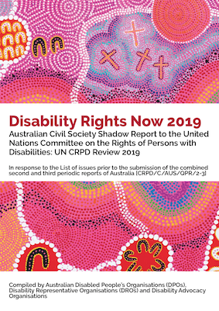

The Committee on the Rights of Persons with Disabilities undertook the Review of Australia’s compliance with the CRPD during the week of 7th-13th September 2019. The Review took place in Geneva at the Palais de Nations.

The WWDA Executive Director researched and wrote the Australian Civil Society Shadow Report on behalf of the National CRPD Civil Society Working Group, and on behalf of people with disability in Australia. The Shadow Report had to follow strict guidelines, including a Word limit of 10,700 words, including Recommendations. The Report was translated into French and Spanish, which along with English, are the key working languages of the United Nations. An Auslan video was also made of the Reports Executive Summary and key issues. A Plain English version was also produced. A non-government delegation also travelled to Geneva in September for Australia’s review under the CRPD.

The WWDA Executive Director also researched and authored a series of eleven ‘Fact Sheets’ which were used by the delegation as lobbying material with the CRPD Committee. The Fact Sheets focused on priority themes, such as Violence; Forced Treatments; Denial of Legal Capacity; Inclusive Education; Forced Sterilisation; Employment and more. These Fact Sheets formed a very important part of the lobbying process with the CRPD Committee, and were published in accessible formats.

Once the CRPD Review of Australia was completed, the CRPD Committee issued their recommendations to the Australian Government, on what the Government needs to do to improve the human rights of people with disability in Australia. These recommendations are known as ‘Concluding Observations’. Many of the recommendations provided by the CRPD Committee reflected the suggested recommendations made in the Australian Civil Society Shadow Report and the Fact Sheets.

Royal Commission into Violence, Abuse, Neglect and Exploitation of People with Disability

During the reporting period, WWDA continued our work on the Royal Commission into Violence, Abuse, Neglect and Exploitation of People with Disability which was formally announced by the Prime Minister on 4th April 2019. WWDA, along with other DPOs and DROs was fortunate to be allocated funding from the Department of Social Services (DSS) to assist us in this critical work. It is outside the scope of this Report to detail all the work WWDA has undertaken during the reporting period in relation to the Royal Commission (RC). However, just some examples include:

- WWDA delegates, staff and members have attended and contributed to the RC Community Forum Information Sessions.
- Due to the Covid-19 restrictions, in March 2020 the RC decided to suspend all community forums until further notice. Since then, WWDA members and staff have been engaging with the RC using online technologies.
- WWDA assisted the RC with arrangements for the Hobart Community Forum, including supporting WWDA members to register and provide their stories.
- WWDA attended and contributed to the RC Advocacy Workshop to assist the RC to develop the Life Domains Framework for the operation of the RC.
- WWDA CEO and WWDA President have attended several meetings with the Commissioners and RC staff to discuss mechanisms for RC engagement with women and girls with disability.
- WWDA Board member Jody Barney has been appointed to the RC First Nations Advisory Committee.
- WWDA has undertaken extensive communications, engagement and outreach to WWDA members and constituents across multiple digital platforms.
- WWDA Newsletter is produced each fortnight and each issue has contained information about the RC and support mechanisms.
- WWDA has contributed to the development of the RC Accessibility Strategy and provided a detailed Submission re same.
- During the reporting period, WWDA has provided detailed, high quality evidence-based Submissions in response to the following RC Issues Papers: Education & Learning; Group Homes; Employment.
- WWDA has taken a leading role with the DPO/DRO sector to engage with the RC. WWDA has written and coordinated correspondence to the RC Chair for and on behalf of DPOs and DROs. WWDA has initiated the establishment of quarterly meetings between the DRO/DPO sector and the RC Commissioners and staff.
- WWDA has attended and contributed to fortnightly meetings of DROs and DPOs to collaborate on RC work.
- WWDA has developed a stand-alone Information portal on WWDA’s ‘Our Site’ website. The Our Site website is also available in Easy Read format. The Information Portal contains a number of downloadable resources, including in Easy Read format, on key concepts and information relating to the RC.
- WWDA has assisted the RC in the organising of Public Hearings and has provided the RC with WWDA members who have agreed to give evidence at the Hearings.
- WWDA has developed and disseminated accessible resources, including Easy English materials targeted to WGwD on all forms of violence, abuse, neglect and exploitation. See: https://oursite.wwda.org.au/safety-violence
- WWDA staff have met individually with some women with disability living in group homes to provide information about the RC.

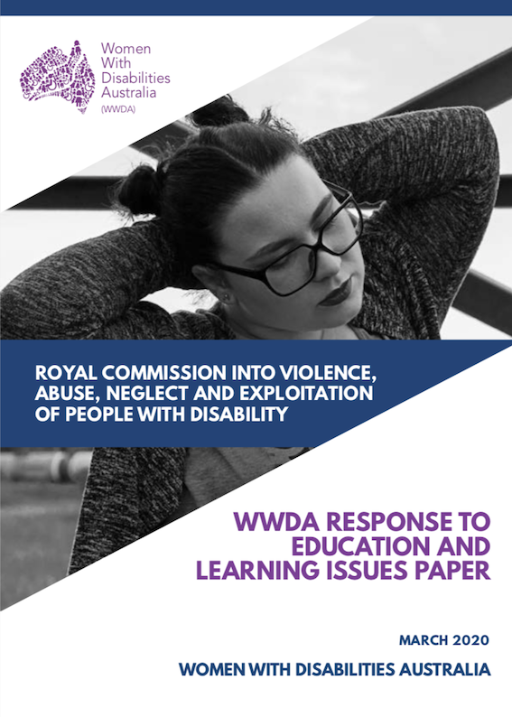

Cover Page of one of WWDA’s Submission to the Royal Commission

National Women’s Alliances and DPOs Workshop

In mid 2019, the Australian Government Department of Prime Minister and Cabinet, Office for Women, provided a small amount of project funding to WWDA to organise and host a two-day national workshop between the six National Women’s Alliances and the four member organisations of Disabled People’s Organisations Australia. The purpose of the workshop was to explore how the organisations could collaborate to strengthen representation and engagement of women with disability across the women’s sector.

A further purpose of the Workshop was to use the proceedings to inform the development of a Position Paper to the Commission on the Status of Women (CSW) Twenty-Fifth Anniversary of The Fourth World Conference on Women and the Beijing Declaration and Platform for Action (BPFA).

The workshop was held in Melbourne in late October 2019 over two days and was facilitated by Caroline Lambert. Medibank kindly donated a floor of their building in Docklands for the Workshop. The DPO Australia members and the six National Women’s Alliances were represented by their Chairpersons and CEOs, or other senior representatives as necessary. The Workshop was a resounding success, and a number of strategies and initiatives were developed to further collaborative work between the national women’s sector and the national DPOs and DROs.

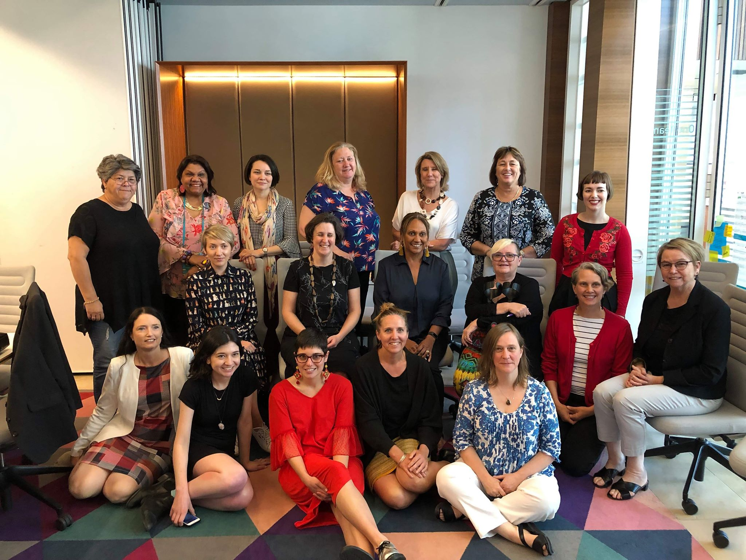

Some of the Workshop participants.

As an outcome of the Workshop and including the Workshop proceedings, WWDA Executive Director Carolyn Frohmader, researched and wrote the Position Paper to the Commission on the Status of Women (CSW) Twenty-Fifth Anniversary of The Fourth World Conference on Women and the Beijing Declaration and Platform for Action (BPFA). This Position Paper was developed in line with the 12 thematic areas of the Beijing Platform for Action. The Position Paper is titled: “The Status of Women and Girls with Disability in Australia” and provides information on the status of women and girls with disability in Australia under each of the 12 thematic areas.

This Position Paper contributed to the Australian NGO Parallel Report to the Commission on the Status of Women Review 2020, and the Position Paper was provided formally to relevant government Ministers and relevant agencies.

One of the most telling issues from the development of the Position Paper “The Status of Women and Girls with Disability in Australia” is the fact that although reviews of the Beijing Platform for Action have called on Governments to improve the collection of disaggregated data, including by disability, there remains an acute lack of available, current gender and disability specific data in Australia - at all levels of Government and for any issue. There is also a lack of Australian research on gender and disability issues, despite the multiple discriminations and human rights violations experienced by women and girls with disability in Australia. This neglect in research of women and girls with disability in Australia has been highlighted by several of the international human rights treaty bodies which monitor implementation of the international human rights treaties to which Australia is a party – yet there has been no initiatives or progress from the Australian governments to address this dearth of data and information.

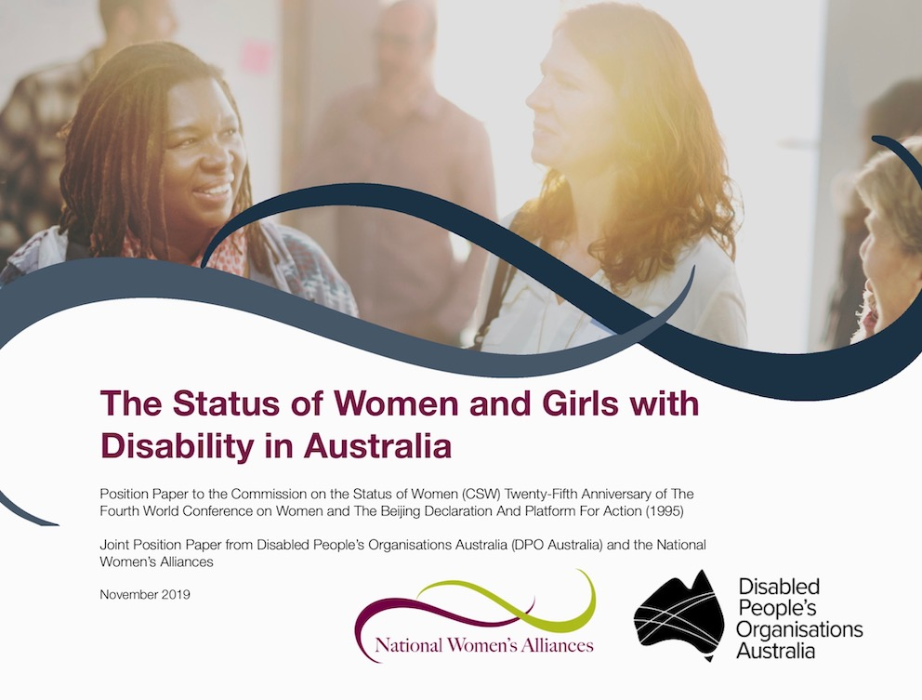

Re-development of the WWDA Website

During the reporting period, WWDA undertook a major project to re-design, re-build and re-develop our 20-year-old website. WWDA was able to undertake this project through a small funding grant provided by the NDIS ILC Program. WWDA’s website consisted of thousands of documents and materials, and was heavily text based and did not meet web accessibility standards. WWDA’s Communications Officer, Jacinta Carlton, and Project Officer, Heidi La Paglia took on the management of the major task of building a new and contemporary website that was fully accessible and engaging for users. WWDA engaged Ionata Digital to assist with the design and structure of the new website. The new website now has automatic functions for people to donate to WWDA, and an online membership form process (along with downloadable versions of the WWDA Membership Form). The new WWDA website also contains a Blog, where women and girls with disability are provided with a paid opportunity to contribute to the WWDA Blog.

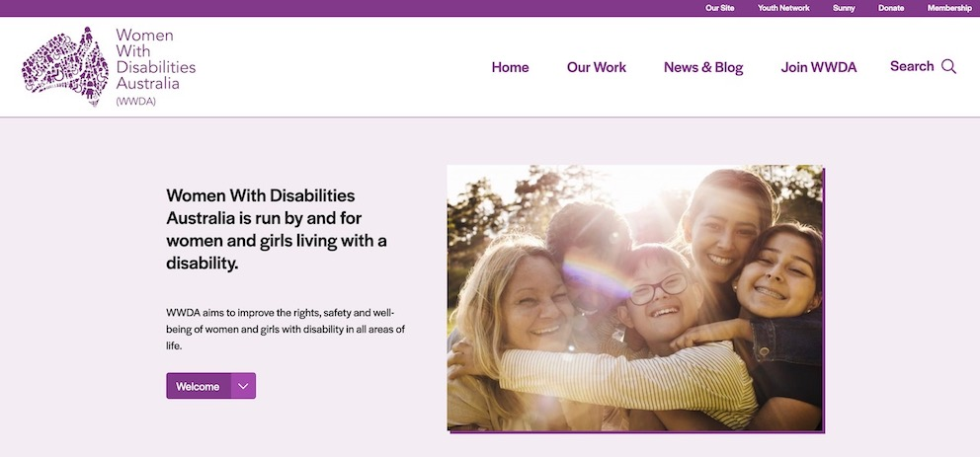

A section of the WWDA Website Home Page

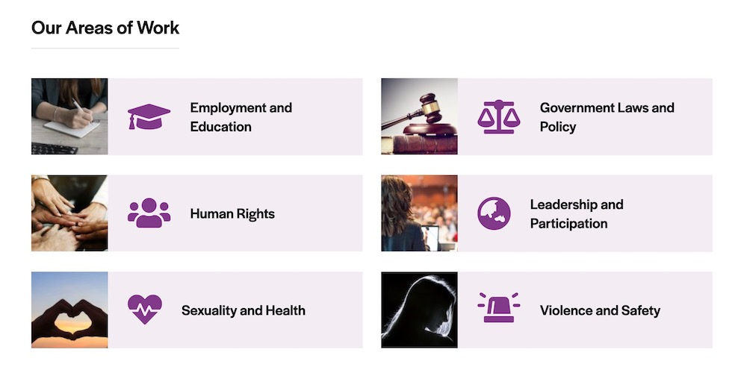

A section of the WWDA Website Home Page

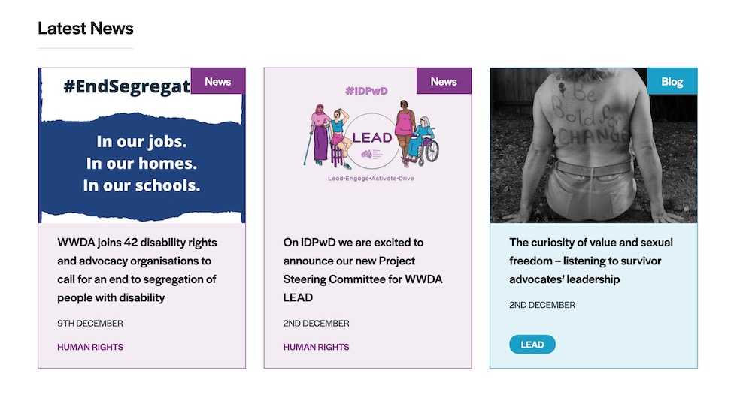

A section of the WWDA Website Home Page

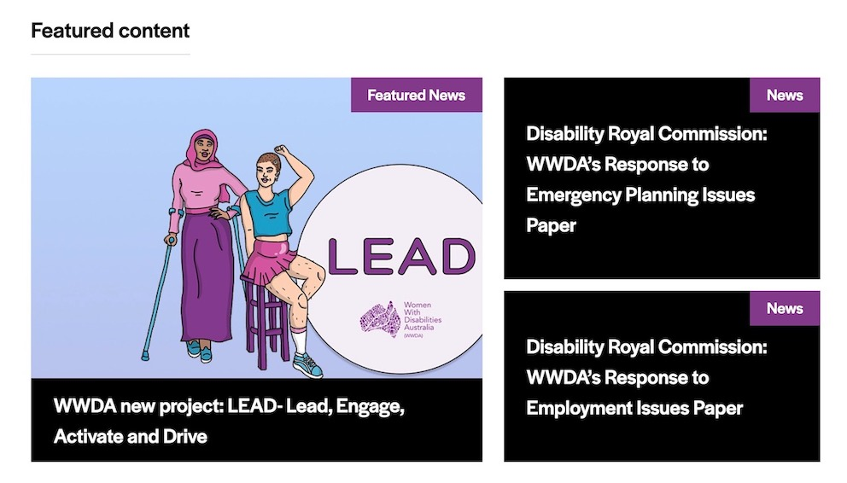

A section of the WWDA Website Home Page

Policy Submissions and Representation

During the reporting period, WWDA developed a range of policy submissions to Government and other stakeholders across several issue areas; contributed to international initiatives to improve the status of women and girls with disability globally; contributed to disability reforms being undertaken by the Australian Government; undertook extensive representation work; was (and remains) represented on an extensive number of national Government Advisory Committees; contributed to a number of national and state/territory research and reform initiatives of interest to women and girls with disability; engaged in collaborative research with academic institutions; provided evidence as a witness to a number of Senate and Parliamentary inquiries, and much more. It is outside the scope of this Report to provide a narrative on all the representative work WWDA has undertaken during the reporting period, however the following information is illustrative of WWDA’s extensive work program.

Just some examples of WWDA’s Representation and Policy work during the reporting year included membership of and policy advice given to:

- COVID19 National Disability Support Services Committee;
- COVID19 National Committee on the Management & Operational Plan for People with Disability;
- National Disability Strategy (NDS) National Reform Committee;
- National NDIS Quality & Safeguards Commission Disability Consultative Committee;
- National Disability Gateway Reference Group;
- Department of Social Services (DSS) National Disability Employment Committee;
- National Disability Insurance Scheme (NDIS) CEO’s Forum;
- Department of Social Services (DSS) and DPOs and DRO’s Quarterly Forum;
- Department of Social Services (DSS) Engagement Project on Advocacy;
- Royal Commission into Violence, Abuse, Exploitation and Neglect (DRC) Quarterly Meetings;
- Royal Commission into Violence, Abuse, Exploitation and Neglect (DRC) Research Advisory Group;
- National Disability Representative Organisations (DROs) Royal Commission Working Group;
- Disability Discrimination Commissioner (Australian Human Rights Commission), DPOs and DROs Quarterly Meetings;
- National Coordinating Committee for the Universal Periodic Review (UPR) of Australia;
- National Disability Insurance Scheme (NDIS) Stakeholder Engagement Group Meetings;
- Australian Women Against Violence Alliance (AWAVA) Advisory Group;
- Australian Women Against Violence Alliance (AWAVA) Policy Executive Group;
- Our Watch Advisory Group: Prevention of Violence Against Women with Disability;
- Our Watch Advisory Group: Media Making Change: National Media Engagement Advisory Group;
- Your Story Disability Legal Support (Disability Royal Commission Legal Service) Advisory Group;
- Commonwealth Children and Young People With Disability Network (CCYDN) Executive Committee;
- Children and Young People with Disability Australia (CYDA) Collaboration Meetings;
- National Youth Disability Forum;
- National Youth Commission Australia Youth Futures Summit;
- Equality Rights Alliance- Advisory Group;
- The Shift – Network for the Achievement of Intersectional Gender Equality in Australia;
- QLD Government- Communication and Engagement Strategy regarding domestic and family violence against people with disability;
- Our Watch National Primary Prevention Hub Stakeholder Reference Group;
- National Disability Research Agenda Development;
- National Foundation for Australian Women - Social Policy Committee;
- National Association of Sexual Assault Services and DSS- Expert Advisory Group;
- Blue-Knot Reference Group on creation of National Trauma-Informed Disability Practice Guidelines;
- UNSW Social Policy Research Centre Meetings;
- Disabled Peoples Organisations Australia (DPO Australia) monthly meetings;
- DFAT and Attorney General’s National NGO Human Rights Forum;
- Australian Electoral Commission Disability Advisory Committee;
- National Youth Commission Australia Youth Futures Summit;
- Our Watch - Connected Communities: Leading approaches to prevention;
- Minister for Women Roundtable - Women’s economic empowerment forum;
- UNSW and Centre of Research Excellence in Disability and Health (CRE-DH) - Improving evidence-based policy in disability and health through the use of an expert policy lab;
- Disability Housing Outcomes Framework -Social Ventures Australia;
- Personal Care in Schools Policy – DSS;
- Australian Government Dept of health- workshop on the development of national guidelines to improve coordination of treatment and supports for people with severe and complex mental illness;
- National Union of Students Disabilities Conference;
- AWAVA Webinar on CSW65 (2021) and the Elimination of Violence against Women;
- Commonwealth Children and Young People With Disability Network (CCYDN) ‘Taking Charge of Our Future Event’;
- Commonwealth Children and Young People With Disability Network (CCYDN) Hospital Communication Passport Launch;

Communications & Engagement

As a Disabled People’s Organisation (DPO), WWDA consistently seeks out opportunities to build our capacity to meaningfully engage with our members and stakeholders. WWDA was fortunate to recruit a part-time Communications Officer, Jacinta Carlton in late December 2019. Jacinta has been a fantastic addition to the WWDA team, and her communication and engagement skills, along with her graphic design skills, have seen WWDA expand and grow our public profile and build on and strengthen our online presence. It is outside the scope of this Report to provide a narrative on all the communications and engagement work WWDA has undertaken during the reporting period, however the following information is illustrative of WWDA’s extensive work in this area.

- Designed and implemented a number of social media campaigns.
- Designed and implemented social media campaigns to promote key Government and related initiatives, including for example: the National Disability Insurance Scheme (NDIS); COVID19; National Disability Strategy (NDS); NDIS Quality & Safeguards Commission.
- Authored, published and disseminated fortnightly WWDA Bulletin, including a number of feature editions.
- Expanded online reach and engagement mechanisms through its digital platforms including Twitter, the WWDA Facebook Page; the WWDA Website; and the WWDA website ‘Our Site’ including an Easy Read version of the whole site;
- Establishment of the WWDA YouTube channel.
- Establishment of a WWDA Youth Twitter account.
- Establishment of a WWDA Youth Instagram account.
- Establishment of a closed Facebook Group for women and girls with disability.
- WWDA has undertaken an extensive series of promotional activities during the reporting period across all its digital platforms.
- WWDA Facebook subscribers increased from 8,823 followers in January 2020 to 11,229 followers at end June 2020.
- WWDA Newsletter is disseminated via email to over 15,000 subscribers, nationally and internationally.
- WWDA Twitter subscribers increased from 2,541 followers in January 2020 to 3,368 followers at end June 2020.
- WWDA Youth Network Facebook has increased from 1,630 followers in January 2020 to 1,736 followers at end June 2020. NB: WWDA Youth Network Facebook is not funded and is coordinated by a volunteer.
- Establishment of a WWDA Instagram page.

Operational Development & Reporting

WWDA has continued to employ high standard governance and financial management practices. During the reporting year, WWDA has met all reporting and accountability requirements as well as those in relation to our funding bodies. In accordance with the constitutional requirements of the organisation, WWDA’s service agreements; the Associations Incorporation Act 1991 (ACT); and the Charities Act 2013 (Cth), WWDA has undertaken a wide range of internal and external reporting and accountability requirements. During the reporting period, WWDA has also undertaken a significant amount of work in relation to governance, including financial management, human resources, and related reporting.

WWDA’s sound governance, financial and organisational management practices are demonstrated through the following processes:

- Undertaking of reporting in accordance with the constitutional requirements of the organisation, WWDA’s service agreements; the Associations Incorporation Act 1991 (ACT); and the Charities Act 2013 (Cth)
- Preparing and completing Annual Reporting requirements of the Australian Charities and Not-for-profits Commission
- Preparing and submitting WWDA Service Agreement (and relevant Project funding contracts) Progress and Project Reports and financial acquittals
- Writing, publishing and disseminating the WWDA Annual Report
- Provision of financial reports prepared by the WWDA Accountant to the WWDA Management Committee
- Annual Auditing of financial statements by registered audit company in accordance with the Australian Accounting Standards and Australian Auditing Standards
- Conducting bi-monthly meetings of the WWDA Board
- Conducting the WWDA Annual General Meeting
- Weekly meetings between WWDA Executive Director and the President of the WWDA Board
- Conducting of annual staff performance reviews
- Review and renewal of WWDA Insurance policies
- Annual review of WWDA Strategic Plan, WWDA Management Committee Orientation Kit
- Review and updating of the WWDA Employee Handbook
- Development of a new WWDA Privacy Policy
- Development of COVID19 policies and procedures for the organisation
- Development of WWDA policies for staff working remotely

WWDA’s organisational management practices and ongoing quality improvement are further supported by the services of Employsure who are available assist WWDA to ensure our organisation maintains compliance with all employment legislation and work health and safety matters.

FINANCIAL REPORT

2019 – 2020

CONTENTS
Page

Financial Report

Board Report 1
Statement by Members of the Board 2
Statement of Comprehensive Income 3
Statement of Financial Position 4
Statement of Changes in Equity 5
Statement of Cash Flow 6
Notes to the Financial Statements 7
Independent Audit Report 11

Women With Disabilities Australia Inc

Board Report - 30 June 2020

Your Board members submit the financial report of the Association for the financial year ended 30 June 2020.

- General information

Principal Activities
The principal activities of association during the financial year were:

  - To promote and protect the rights of women with disabilities nationally and internationally.

  - To undertake systemic advocacy in specific areas of concern to women with disabilities.

  - To continue to build on Women With Disabilities Australia's key role in the consolidation, production and dissemination of high quality information, publications and research on issues relevant to women with disabilities.

  - To further develop the internal and external operations of the organisation in order to achieve its vision, goals and objectives.

  - To contribute to the development and implementation of Australian Government policies affecting women with disabilities.

Significant Changes

No significant change in the nature of these activities occurred during the year.

- Operating Results and Review of Operations for the Year
Operating result

The surplus/(deficit) of the Association for the financial year amounted to $107,262 (2019: $52,786).
Signed in accordance with a resolution of the Members of the Board:

Board Member .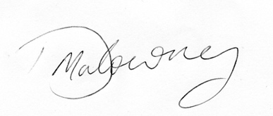........................................................................

Board Member ......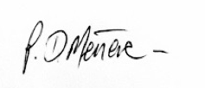...................................................................

Dated this .20th ............................ day of .November.............. 2020

Women With Disabilities Australia Inc

Statement by Members of the Board

The Board has determined that the Association is not a reporting entity and that this special purpose financial report should be prepared in accordance with the accounting policies outlined in Note 1 to the financial statements.

The Board of the Association declare that:

- The financial statements and notes, as set out on pages 3–10, are in accordance with the Australian Charities and Not-for-profits Commission Act 2012 and:

  - Comply with Australian Accounting Standards to the extent outlined in Note 1 to the financial statements; and
  - Give a true and fair view of the financial position as at 30 June 2020 and of the performance for the year ended on that date in accordance with the accounting policies described in Note 1 of the financial statements.

- In the Boards’ opinion, there are reasonable grounds to believe the Association will be able to pay its debts as and when they become due and payable.

This declaration is made in accordance with a resolution of the Board.

Board Member. ...........................................................................

Board Member .. .........................................................................

Dated this .20th............................. day of November............................. 2020

Women With Disabilities Australia Inc
Statement of Comprehensive Income For the Year Ended 30 June 2020
 | 2020 | 2019
 | $ | $
Income  Grants Received | 1,362,071 | 679,636
Donations | - | 175
Consultancy | 6,273 | 54,326
Interest | 1,745 | 5,947
Other income | 455 | 6,207
Profit/(Loss) on disposal of assets | - | 1,975
Total income | 1,370,544 | 748,266
Expenses  Accountancy and audit fees | 2,109 | 1,959
Administration | 16,875 | 1,224
Consultancy | 476,892 | 83,163
Depreciation | 497 | 726
Employee costs | 555,470 | 444,866
Information technology | 29,920 | 5,589
Insurance | 10,082 | 3,918
Office supplies and equipment | 48,031 | 37,005
Postage and freight | 2,968 | 1,391
Rent | 39,493 | 23,275
Subscriptions and publications | 2,837 | 5,117
Telephone, teleconferences and internet | 10,458 | 9,323
Travel | 67,650 | 77,924
Total Expenses | 1,263,282 | 695,480
Net surplus/(deficit) | 107,262 | 52,786
Other comprehensive income | - | -
Total comprehensive income | 107,262 | 52,786
The accompanying notes form part of these financial statements.
Women With Disabilities Australia Inc

Statement of Financial Position
As At 30 June 2020
ASSETS | Note | 2020  $ | 2019  $
CURRENT ASSETS  Cash and cash equivalents |  | 1,784,396 | 1,470,075
Trade and other receivables |  | - | 5,141
GST receivable |  | 19,117 | -
Security deposit |  | 5,833 | -
TOTAL CURRENT ASSETS |  | 1,809,346 | 1,475,216
NON-CURRENT ASSETS  Property, plant and equipment | 2 | 8,428 | -
Security deposit |  | - | 5,833
TOTAL NON-CURRENT ASSETS |  | 8,428 | 5,833
TOTAL ASSETS |  | 1,817,774 | 1,481,049
LIABILITIES
CURRENT LIABILITIES  Trade payables | 3 | 11,320 | 13,829
GST payable |  | - | 14,821
Employee provisions | 4 | 165,954 | 125,541
Unspent grant funds |  | 1,248,088 | 1,041,708
TOTAL CURRENT LIABILITIES |  | 1,425,362 | 1,195,899
NET ASSETS |  | 392,412 | 285,150

EQUITY  Accumulated surpluses | 392,412 | 285,150
TOTAL EQUITY | 392,412 | 285,150

The accompanying notes form part of these financial statements.

Women With Disabilities Australia Inc

Statement of Changes in Equity
For the Year Ended 30 June 2020

2020 | Accumulated Surpluses | Total
 | $ | $
Balance at 1 July 2019 | 285,150 | 285,150
Net surplus/(deficit) for the year | 107,262 | 107,262
Balance at 30 June 2020 | 392,412 | 392,412

2019 | Accumulated Surpluses | Total
 | $ | $
Balance at 1 July 2018 | 232,364 | 232,364
Net surplus/(deficit) for the year | 52,786 | 52,786
Balance at 30 June 2019 | 285,150 | 285,150
The accompanying notes form part of these financial statements.
Women With Disabilities Australia Inc

Statement of Cash Flows
For the Year Ended 30 June 2020

 | Note | 2020  $ | 2019  $
CASH FLOWS FROM OPERATING ACTIVITIES:
Receipts from government and customers |  | 1,733,367 | 920,177
Interest received |  | 1,745 | 5,947
Payments to suppliers and employees |  | (1,411,866) | (837,775)
Net cash provided by (used in) operating activities | 5 | 323,246 | 88,349
CASH FLOWS FROM INVESTING ACTIVITIES:
Purchase of property, plant & equipment |  | (8,925) | -
Proceeds from sale of property, plant & equipment |  | - | 1,975
Net cash provided by (used in) investing activities |  | (8,925) | 1,975
CASH FLOWS FROM FINANCING ACTIVITIES:
Proceeds from loans |  | - | -
Repayment of loans |  | - | -
Net cash provided by (used in) financing activities |  | - | -
Net increase (decrease) in cash and cash equivalents held |  | 314,321 | 90,324
Cash and cash equivalents at beginning of year |  | 1,470,075 | 1,379,751
Cash and cash equivalents at end of financial year |  | 1,784,396 | 1,470,075

Women With Disabilities Australia Inc

Notes to the Financial Statements
For the Year Ended 30 June 2020

1 Summary of Significant Accounting Policies

- Basis of Preparation

The Board has prepared the financial report on the basis that the not-for-profit Association is a non-reporting entity because there are no users dependent on a general purpose financial report. This financial report is therefore a special purpose financial report that has been prepared in order to meet the requirements of the Australian Charities and Not-for-profits Commission Act 2012. The Association is a not-for-profit entity for financial reporting purposes under Australian Accounting Standards.
The financial statements have been prepared in accordance with the minimum requirements of the Australian Charities and Not-for-profits Commission Act 2012 and therefore comply with the following Australian Accounting Standards as issued by the Australian Accounting Standards Board:
- AASB 101 Presentation of Financial Statements;
- AASB 107 Statement of Cash Flows;
- AASB 108 Accounting Policies, Changes in Accounting Estimates and Errors;
- AASB 1048 Interpretation of Standards; and
- AASB 1054 Australian Additional Disclosures.
Material accounting policies adopted in the preparation of the financial statements are presented below and have been consistently applied unless otherwise stated.
The financial statements, except for the cash flow information, have been prepared on an accruals basis and are based on historical costs unless otherwise stated in the notes. The amounts presented within the financial statements have been rounded to the nearest dollar.

Comparative Figures

Where appropriate, comparative figures have been adjusted to conform to changes in presentation for the current financial year.

Cash and Cash Equivalents

Cash and cash equivalents include cash on hand, deposits held at call with banks, and other short- term highly liquid investments.

Property, Plant and Equipment

Office equipment is carried at cost less, where applicable, any accumulated depreciation. The depreciable amount of all equipment is depreciated over the useful lives of the assets to the Association commencing from the time the asset is held ready for use.

The depreciation rates used for each class of depreciable assets are:

 | Furniture & Equipment | 10-33%

Notes to the Financial Statements
Women With Disabilities Australia Inc

For the Year Ended 30 June 2020

1 Summary of Significant Accounting Policies - continued

(e) Trade and other payables

Trade and other payables represent the liability outstanding at the end of the reporting period for goods and services received by the Association during the reporting period which remain unpaid. The balance is recognised as a current liability.

(f) Employee Benefits

Provision is made for the Association's liability for employee benefits arising from services rendered by employees to the end of the reporting period. Employee benefits have been measured at the amounts expected to be paid when the liability is settled.

Contribution made by the Association to an employee superannuation fund is charged as an expense when incurred.

Income Tax

No provision for income tax has been raised as the Association is exempt from income tax under Division 50 of the Income Tax Assessment Act 1997.

Goods and Services Tax (GST)

Revenues, expenses and assets are recognised net of the amount of GST, except where the amount of GST incurred is not recoverable from the Tax Office. In these circumstances the GST is recognised as part of the cost of acquisition of the asset or as part of an item of the expense. Receivables and payables in the statement of financial position are shown inclusive of GST.

Unexpended Grants

It is the policy of the Association to treat grant monies as unexpended grant liabilities in the statement of financial position where the Association is contractually obliged to provide the services in a subsequent financial period to when the grant is received or in the case of specific project grants where the project has not been completed.

Revenue and Other Income

Interest revenue is recognised over the period for which the funds are invested. Membership income is recognised over the period to which the membership relates.
Grant income is recognised when expensed in accordance with the terms of the funding agreement.

Donation income is recognised when the Association obtains control over the funds which is generally at the time of receipt.

All revenue is stated net of the amount of goods and services tax (GST).

Notes to the Financial Statements
Women With Disabilities Australia Inc

For the Year Ended 30 June 2020
2 | Property, Plant and Equipment | 2020 | 2019
 |  | $ | $
 | PLANT AND EQUIPMENT
 | Furniture & equipment At cost | 20,005 | 11,080
 | Accumulated depreciation | (11,577) | (11,080)
 |  | 8,428 | -
3 | Trade and Other Payables | 2020 | 2019
 |  | $ | $
 | Trade payables | 2,712 | 406
 | Employee expenses payable | 8,608 | 13,423
 |  | 11,320 | 13,829
4 | Provisions | 2020 | 2019
 |  | $ | $
 | CURRENT  Annual leave | 131,902 | 97,049
 | Long service leave | 34,052 | 28,492
 |  | 165,954 | 125,541
5 | Cash Flow Information
 | Reconciliation of net surplus/(deficit) to cash flows from operating activities. | 2020 | 2019
 |  | $ | $
 | Surplus/(deficit) for the year | 107,262 | 52,786
 | Cash flows excluded from surplus/(deficit) attributable to operating activities
 | Non-cash flows in surplus/(deficit):
 | - Depreciation | 497 | 726
 | - Profit/(loss) on disposal of assets | - | (1,975)
 | Changes in assets and liabilities:
 | - (increase)/decrease in trade and other receivables | (13,976) | 4,759
 | - (increase)/decrease in other assets | - | (5,833)
 | - Increase/(decrease) in trade and other payables | (17,330) | (75,853)
 | - Increase/(decrease) in employee provisions | 40,413 | 25,173
 | - Increase/(decrease) in other liabilities | 206,380 | 88,566
 | Cash flows from operations | 323,246 | 88,349

Notes to the Financial Statements
Women With Disabilities Australia Inc

For the Year Ended 30 June 2020
6 | Auditors Remuneration | 2020  $ | 2019  $
 | Remuneration of the Auditor of the Association, Accru Hobart for:
 | Auditing the financial report | 1,500 | 1,386
7 | Capital and Leasing Commitments
There are no capital or leasing commitments as at reporting date to be disclosed.
8 | Contingent Liabilities and Contingent Assets
There are no contingent liabilities or contingent assets as at reporting date to be disclosed.
9 | Events After the End of the Reporting Period
There are no events after the statement of financial position date affecting these financial statements to be disclosed.
10 | Economic Dependency
Although there is no reason to believe that grant funding will cease, the ongoing viability of the Association as a going concern is dependent on funding from its funding providers.
11 | COVID-19
Within Australia and globally, unprecedented measures have been introduced to control the spread of the COVID-19 outbreak, including travel and trade restrictions, restrictions on public gatherings and temporary business closures. These significant measures have had a sudden and substantial negative impact on global economic activity, with certain industry sectors experiencing unforeseen financial difficulties. Consequently, the functioning of global capital markets has been impaired by increased volatility and negative investor sentiment.

The expected duration and magnitude of the COVID-19 global pandemic and its potential implications on the global economy and financial markets remains unclear. Should these circumstances become severe or prolonged, it is expected to have a material adverse impact on the global and Australian economies, which in turn may have a material adverse impact on the entity’s financial performance and position if government contracts were not renewed as a result of the pandemic.



INDEPENDENT AUDITOR’S REPORT

To the members of Women With Disabilities Australia Inc

Opinion
We have audited the financial report of Women With Disabilities Australia Inc (the Entity), which comprises the statement of financial position as at 30 June 2020, the statement of comprehensive income, statement of changes in equity and statement of cash flows for the year then ended, and notes to the financial statements, including a summary of significant accounting policies and other explanatory information, and the statement by members of the board.

In our opinion, the accompanying financial report presents fairly, in all material respects, the financial position of the Entity as at 30 June 2020 and of its financial performance and its cash flows for the year then ended in accordance with Australian Charities and Not-for-profits Commission Act 2012.

Basis for Opinion
We conducted our audit in accordance with Australian Auditing Standards. Our responsibilities under those standards are further described in the Auditor’s Responsibilities for the Audit of the Financial Report section of our report. We are independent of the Entity in accordance with the ethical requirements of the Accounting Professional and Ethical Standard Board’s APES 110 Code of Ethics for Professional Accountants (the Code) that are relevant to our audit of the financial report in Australia. We have also fulfilled our other ethical responsibilities in accordance with the Code. We believe that the audit evidence we have obtained is sufficient and appropriate to provide a basis for our opinion.

Emphasis of Matter – Basis of Accounting
We draw attention to Note 1 to the financial report, which describes the basis of accounting. The financial report has been prepared to assist Women With Disabilities Australia Inc to meet the requirements of the Australian Charities and Not-for-profits Commission Act 2012. As a result, the financial report may not be suitable for another purpose.

Responsibilities of the Board for the Financial Report
The Board is responsible for the preparation of the financial report in accordance with the Australian Charities and Not-for-profits Commission Act 2012, and for such internal control as the Board determines is necessary to enable the preparation of the financial report that is free from material misstatement, whether due to fraud or error.

In preparing the financial report, the Board is responsible for assessing the Entity’s ability to continue as a going concern, disclosing, as applicable, matters related to going concern and using the going concern basis of accounting unless the Board either intends to liquidate the Entity or to cease operations, or has no realistic alternative but to do so.

The Board is responsible for overseeing the Entity’s financial reporting process.
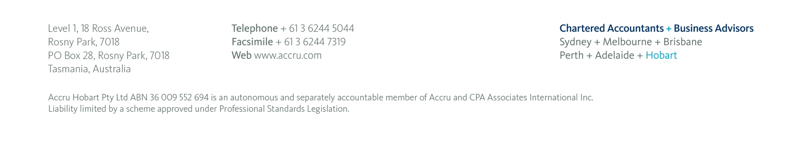

Auditor’s Responsibility for the Audit of the Financial Report
Our objectives are to obtain reasonable assurance about whether the financial report as a whole is free from material misstatement, whether due to fraud or error, and to issue an auditor’s report that includes our opinion. Reasonable assurance is a high level of assurance, but is not a guarantee that an audit conducted in accordance with Australian Auditing Standards will always detect a material misstatement when it exists.

Misstatements can arise from fraud or error and are considered material if, individually or in the aggregate, they could reasonably be expected to influence the economic decisions of users taken on the basis of the financial report.

A further description of our responsibilities for the audit of the financial report is located at the Auditing and Assurance Standards Board website at: http://www.auasb.gov.au/Home.aspx. This description forms part of our auditor’s report.
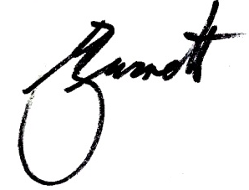

…………………………………………
Michael Burnett B.Com.F.C.A.
Registered Company Auditor: 281
Partner
Level 1/18 Ross Avenue, Rosny Park TAS 7018

Dated …19………… / November…………… / 2020……………

