Women With Disabilities Australia
WWDA Youth Network
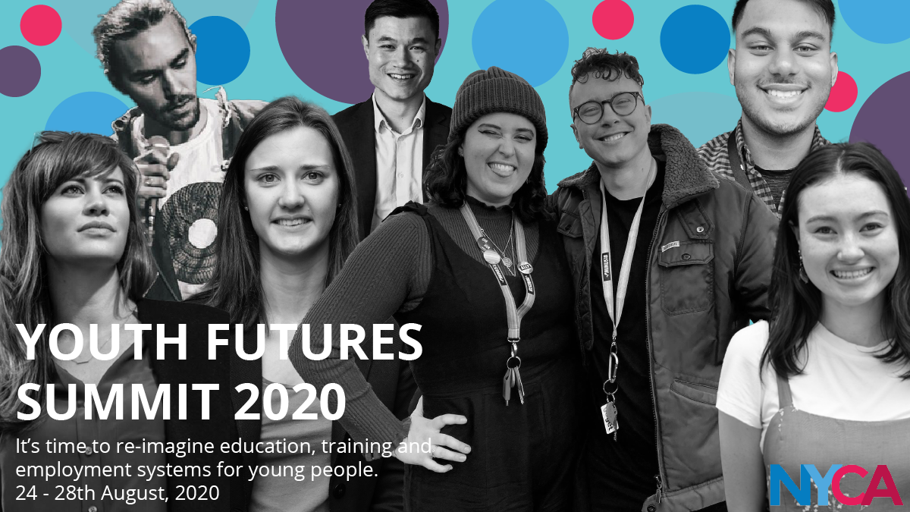

Report from the National Youth Commission Online Youth Futures Summit, 24-28 August 2020.
Prepared by Heidi La Paglia, WWDA Project and Policy Officer and WWDA Youth Network Coordinator.
Report from the Report from the National Youth Commission Online Youth Futures Summit, 24-28 August 2020.
By Heidi La Paglia for Women With Disabilities Australia (WWDA) © Women With Disabilities Australia (WWDA) September 2020.

Disclaimer
This post-event report is prepared by Heidi La Paglia for members of WWDA and other interested stakeholders. This report does not reflect the views of the Australian Government, the National Youth Commission Australia or any other organisation.

Introduction and Background
In 2019, the National Youth Commission Australia (NYCA) was launched to conduct a national inquiry into the challenges faced by young people preparing for and seeking work now and into the future. Since its conception, the National Youth Commission has held a range of public hearings, in-person workshops and online consultations to hear directly from a diverse range of young people about their experiences.
An Interim Findings Report from these consultations was released in the last week of August 2020, which detailed evidence from over 1200 young people that four key things are needed to support our future:
- Direct and meaningful engagement with young people in the consultation on and development of policies and programs that impact us
- consideration of the diversity of young people – including diversity across different geographical locations, ethnicities, genders, sexualities and economic statuses
- recognition of the diverse variety of people, organisations and sectors that are willing to come together to support the needs of young people
- Accessibility, support and stability in the areas of education, work experience and advice, employment, housing, social security, mental health services, transport and practices that support environmental sustainability.

In the same week as the launch of this report, the NYCA held a national online summit for young people to come together from across Australia to discuss ideas for the future and to launch a campaign for a Youth Futures Guarantee - a framework of reforms and initiatives that will support young people meet the great challenges of the future. The summit was a week-long event that included over 1000 attendees, 160 Australian and global speakers and presenters and more than 60 sessions co-hosted by young people in collaboration with professionals across multiple sectors and communities.

To connect with the youth sector and to represent the views young women with disability at the summit, WWDA’s Project and Policy Officer, Heidi La Paglia, attended and spoke at the summit as a representative of the WWDA Youth Network. While not representing WWDA specifically, WWDA’s (at the time, incoming) Project Officer Vanamali Hermans also attended and presented at the summit.
In this report, Heidi provides a brief overview of the highlights from each day of the conference. Throughout the conference week, Heidi also posted highlights and updates about the summit to the WWDA Youth Network Facebook, Instagram and Twitter accounts.

Day 1 – A Seat at the Table
On day 1, the summit started with four keynote speakers who spoke about various issues facing young people in 2020, including climate change, homelessness, economic insecurity and rising unemployment in the wake of the COVID-19 pandemic. Two of the speakers that particularly stuck with me were Sophie Johnston, who is the National Youth Commissioner, and Hayden Moon from the NSW activist group ‘Trans Action Warrang.’

As a young woman with disability, it was particularly refreshing to hear Hayden speak and tell their story as a young transgender, Indigenous person with disability. Hayden explained that throughout their life they had experienced homelessness and discrimination and discussed the way that gender, disability and indigeneity intersect to create multiple layers of disadvantage.
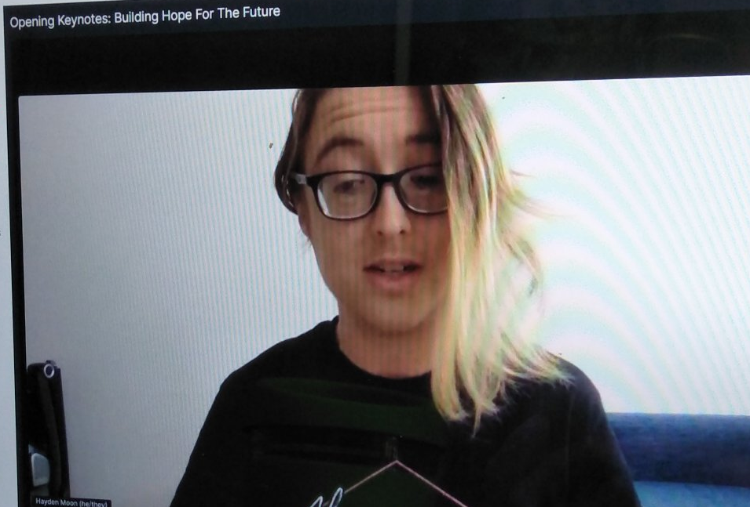
While WWDA is aware of and tries to incorporate these intersections in all of its work; it is rare to see them spoken about in the introductory session of a conference that is not specifically aimed at the disability community. Right from the get-go, this suggested to me that the conference organisers had made an effort to ensure that the summit honoured intersectional experiences and represented its calls for youth inclusion. While not as personable, Sophie’s speech spoke to the need for young people to be included in the planning and development of government responses to cope with and recover from COVID-19.
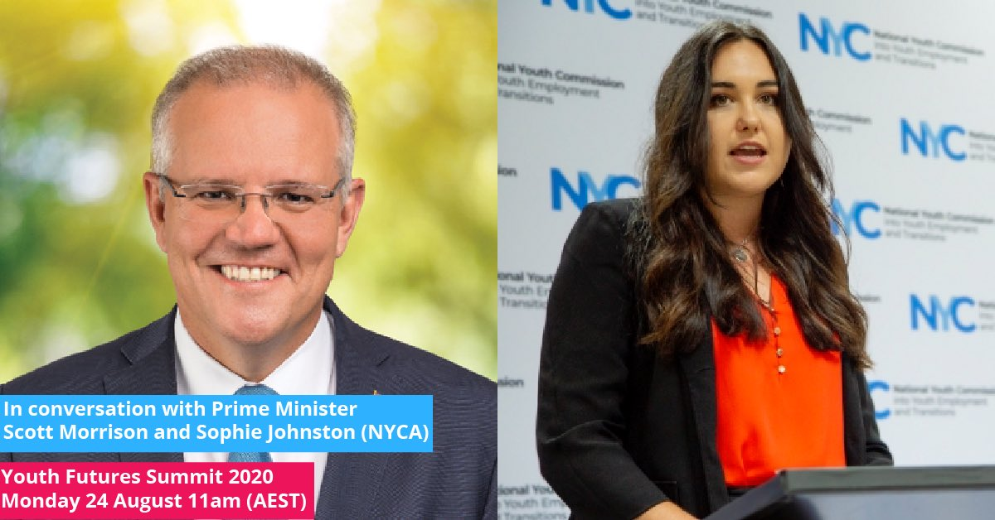

Following this keynote, Sophie Johnston appropriately hosted a Q&A session with Prime Minister Scott Morrison about the Federal Government’s plans for young people. In this session Sophie asked a number of questions including whether the Government would be implementing a National Youth Strategy and how it would be supporting young people into employment post coronavirus. It was unfortunate but unsurprising that this session ended long before it was close to a commitment from the Prime Minister. Furthermore, Scott Morrison avoided the questions by saying that it is up to the market to create jobs for young people and talking about his own experiences as a young person at university. For me, it was disappointing to see the Prime Minister refuse to recognise how Government policies play a role in supporting education and employment for young people, nor how young people from disadvantaged cohorts face an array of barriers to participation. However, attendees were overall thankful that Scott Morrison MP took the time to attend. As stated throughout the conference, conversing with us is essential. This need to include young people in policy design and development continued throughout the day and for the rest of the summit.

Day 2 – Education
On day 2 of the summit, there was a clear theme of education that lead the discussion throughout. Again, this started with keynote speakers, including Professor. Pasi Sahlberg, from the Gonski Institute at the University of New South Wales (UNSW) and Hayley McQuire from the National Indigenous Youth Education Coalition (NIYEC) who both spoke about the education system privileges some groups of young people over others. In particular, it was emphasised that young people from higher income families, inner-city postcodes and colonised cultural backgrounds are particularly disadvantaged in the mainstream education system in Australia. As a young aboriginal woman for example, Hayley McGuire explained how what she learned at school was based around a colonised history, and how this made her feel othered as an aboriginal student.
“Being told that we were founded as a country of convicts, I didn’t know where I fit in”- Hayley McGuire.

Later in the morning, panellists workshopped ideas for how to combat educational disadvantage in a session which asked, ‘what does a new vision for education in Australia look like?’ While the panellists made some good points in the session about the importance of including students in the design and development of educational programs; panellists also argued that it was important to maintain standardised testing and evaluation of students based on ATARS; which overlooked the needs and experiences of disadvantaged groups such as students with disability and Aboriginal and Torres Strait Islander students.

In response to this discussion, it was, however, good to see young people with disability commenting on its limitations. For example, Issy Hay, who is a young person with disability that works at the Youth Disability Advocacy Service in Victoria posted on Twitter:

“Something that was missed around this conversation is that ‘testing’ in its current form is completely inaccessible for so many students for various reasons including disability, language, etc. That’s an issue!” – Issy Hay, YDAS.
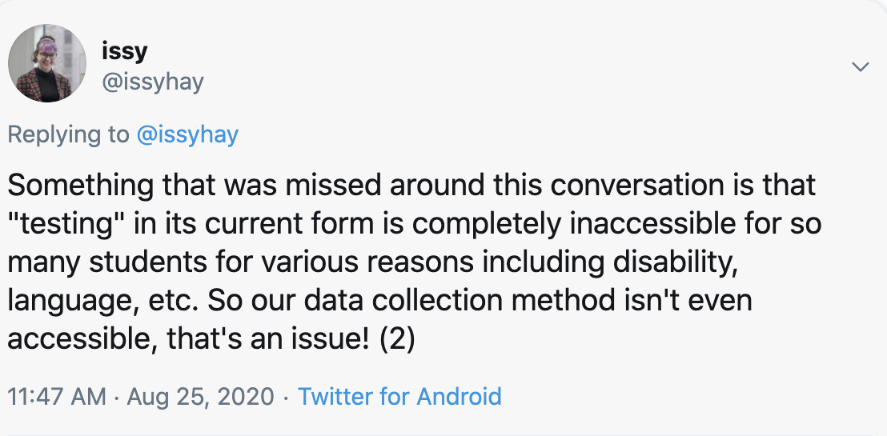
Later on, in the day, some of the challenges that face students with disability were more formally recognised in a break-out session on the benefits and limitations of online learning. While there were a range of sessions available, I chose to attend this specific panel because it included a range of speakers with different expertise, including Corenna Haythorpe from the Australian Education Union (AEU) and Tasha from Children and Young People With Disability Australia (CYDA). It also appealed to me that the session was being hosted by a student called Shrishti who, as the current Disabilities Officer at the University of Melbourne Student Union (UMSU), honed in on some of the particular challenges that the move to online learning during COVID-19 has created for students with disabilities.

“There has been a lot of talk about how COVID19 has been an equalizer. It has affected everyone. But actually, students with disabilities has exacerbated inequalities for many people, including students with disabilities” – Shrishti, UMSU.
During the discussion there were a number of barriers raised. For example, Corenna Haythorpe talked about how students at private schools have had more support compared to public schools due to the difference in resources; and Tasha from CYDA spoke in detail about the experiences of students with disabilities. Referring to CYDA’s recent surveys of children with disability and their families, Tasha explained, there was a clear indication from respondents that children with disability felt excluded from online educational activities and didn’t have the support they need to take part in online learning. As a result, many students felt socially isolated and had increased experiences of stress and anxiety.
“For some people, online learning has been great. But there has been a lack of consideration of the specific needs of individual students” – Tasha, CYDA.

The end of the day finished with another break out session, in which I chose to attend a session about the Global Impact of Sexual Violence on students in education. The session was hosted by a young person and involved an in-depth discussion about sexual violence in higher education with Sharna Bremner from End Rape on Campus (EROC) and Andrea L. Pino-Silva who starred in United Sates (US) documentary, The Hunting Ground. As I have past experience working with survivors of sexual violence in higher education, I found this session of particular interest. However, it did strike me around half way through the session that the discussion, again, didn’t give much consideration to the impact of sexual violence on women students with disability. So, I decided to ask a question based on my experiences:
“I went from working with women studying at university to working with women with disability; who both face similar issues in terms of experiencing high rates of sexual violence. Do you have insight into the intersection of these experiences?” – Heidi La Paglia, WWDA.

In response, both panellists confirmed my suspicion that sexual violence has an even greater detrimental effect on young women with disability who experience it while studying at university. Sharna for example explained that from her work she is aware that many students who experience sexual violence develop psychosocial disabilities such as PTSD, Depression and Anxiety; so, for students with existing disabilities, this can be debilitating. Sharna added that students who decide to report their experiences are also often pressured to provide ‘proof’ the incident. She explained that this can place an extra burden on students with disability who are often already being asked to prove their disability or support needs.
“It can be hugely consuming” – Sharna Bremner, EROC.
Unfortunately, however, both panellists explained that there is a severe lack of data on the experiences of sexual assault among students with disability. While the Australian Human Rights Commission conducted the first comprehensive nation-wide survey into sexual assault at university in 2016; it did a very bad job at collecting information on the experiences of disadvantaged cohorts of students, including students with disability. Andrea also explained that even when this data is collected, there is a broad lack of recognition of PTSD, Anxiety and Depression as disabilities. Overall, I found this discussion fascinating; but also, another example of mainstream services and research projects failing to adequately investigate the experiences of women with disability.

Day 3 – Income and Employment
On the Wednesday of the Youth Futures Summit, I started off the day by presenting on a panel discussion about wage gaps and inequality with four other panellists, including Katie Biddleston from the SDA, Jacob Thomas from Monash University, Grace Mugabe from Financially Empowered, Swathi Shanmukhasundaram from the Migrant Youth Advocacy Network (MYAN) and host, Mariam Mohammed from MoneyGirl.
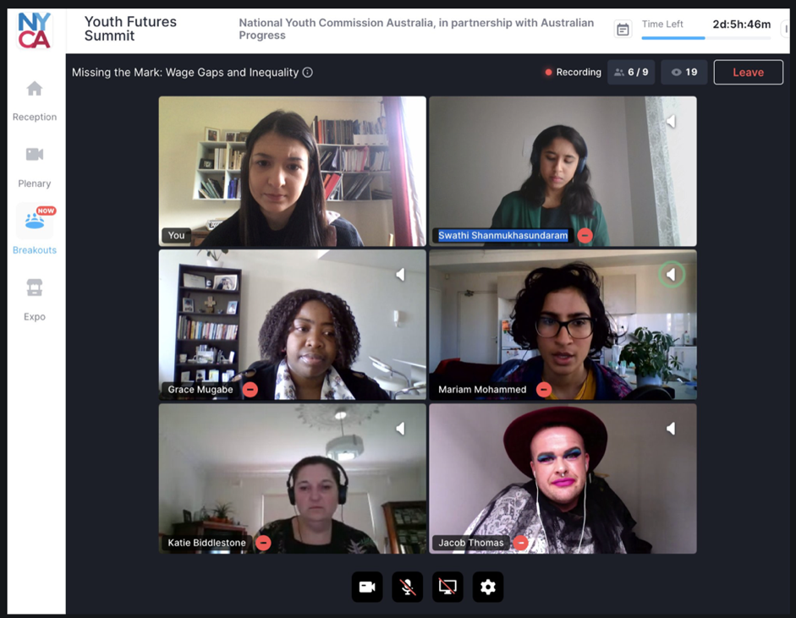

The event included some great discussion about the intersectional disadvantage experienced by young women, young people with disabilities and young people from migrant backgrounds in the workforce. While each panellist spoke from different experience, there was an overall consensus that young women, femme identifying, and gender diverse people are predominantly in work that Is less secure and lower paid than older men. There was also a strong focus on difficulties experienced by young people with psychosocial disabilities in securing and maintaining employment. Through various examples and scenarios, each panellist illustrated that young people who are experiencing psychosocial disabilities such as anxiety, depression are often not accommodated for in workplaces.

A strong take away from all panellists was the importance of knowing your rights in employment; and at the end I was able to give a shout out to WWDA’s Our Site website as a hub of information about rights that, while aimed at women with disability, is relevant to all people of all ages.
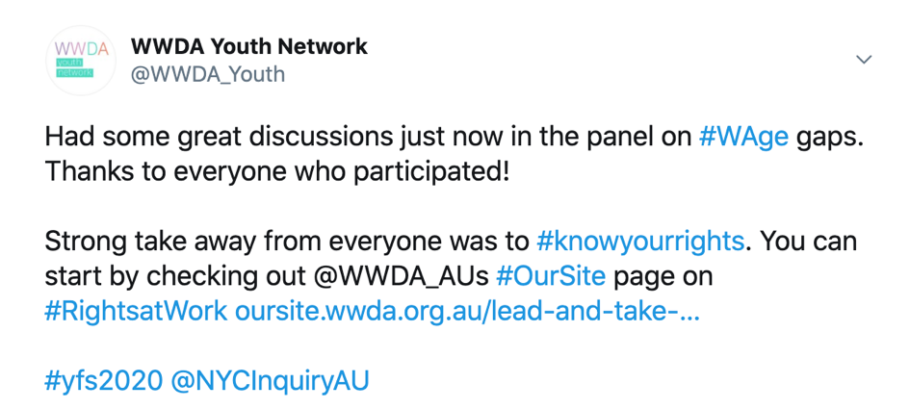
Later in the afternoon, I was able to join a session with WWDA’s incoming staff member, Mali Hermans, who hosted a discussion with the four winners of the Youth Futures Summit Creative Competition. In the same theme as the morning session, the theme of the competition and the session was on barriers young people face in employment. The discussion included some great points about issues young people face in employment in a post COVID-19 context, including limited access to jobs, a decreasing value for creativity and an expectation to do unpaid internships. However, I think my favourite part of the session occurred towards the end when Mali asked what they would like to see in an inclusive 2030 workforce. Ideas pitched were progressive and innovative and included things like free education, the stigmatisation of trades, paid internships, universal basic incomes and the normalisation of flexible work arrangements.

Day 4 – Improving Inclusion
While I wasn’t able to attend all of day 4, the sessions I did attend had a strong theme of improving the inclusion of young people in employment into the future. The early afternoon plenary for example was based on the question ‘How Do We Transition All Young People Into Meaningful Employment?’ While there were five panellists in the plenary, the panellist that particularly stood out for me was Issy Hay from the Victorian Youth Disability Advocacy Service (YDAS). As a young person with disability, Issy made some great points about the issues that young people with disability face in employment and offered suggestions for how workplaces can better include young people with disability in the future.
One key point that Issy made was about the importance of co-designing policies and programs with young people with disability. The other point which I thought was particularly important was about ensuring workplaces are accessible. Issy offered some suggestions, including flexible working formats, like the option to work from home.

“Treat us as equals but don’t erase our support needs - COVID-19 has proven that meaningful adjustments CAN be made over night” – Issy Hay
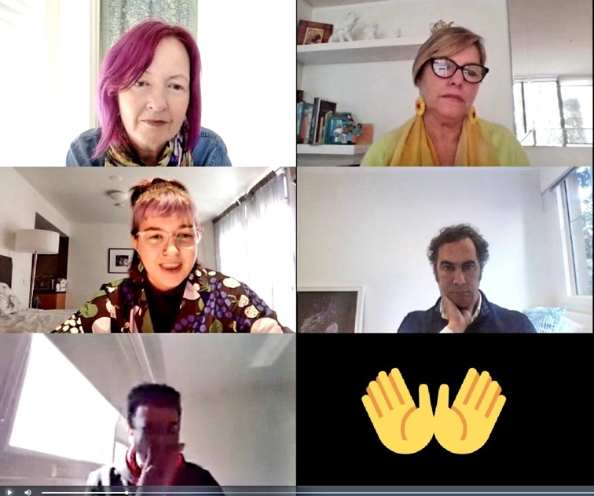
Later on, in the day, the importance of supporting young people in the future was continued in a discussion about the NYCA Interim Findings Report and National Plan. Building on the discussions from day 1, the session brought young people together to discuss challenges for young people in a COVID-19 era and the need for the Federal Government to commit to a youth post COVID-19.

Day 5 – The Future
On day five of the youth futures summit, I started the morning by joining the break-out session on the question, ‘Do we need a universal basic income (UBI)?’ which was hosted by Andrew Tangas in discussion with panellists: Emma Dawson, from Per Capita, Dr Elise Klein from the Australian National University (ANU), Professor Greg Marston from the University of Queensland and Professor Gini Foster from the University of New South Wales (UNSW).

While I expected the session to be interesting, what I did not expect was the heated debate that it facilitated. I was particularly surprised that some of the panellists were adamantly against the idea of a UBI because of the value of employment and working for income. While these arguments held some weight, I thought they lacked consideration of diverse experiences and overlooked the barriers people face to employment because of things like gender, disability, migrant status and caring responsibilities.
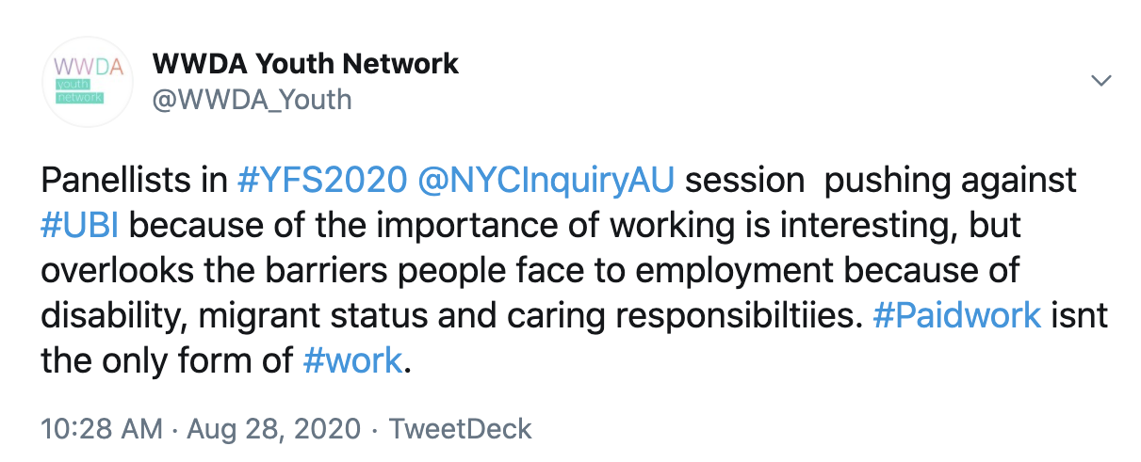

I was grateful however, that in response to the arguments against the UBI, Dr Elise Klein explained how placing such value on paid work is a symptom of a broader patriarchal system which does not support the unpaid labour often done by women.
While the session did not really come to any consensus on the issue, it certainly only reinforced my personal view that a Universal Basic Income (UBI) would help to breakdown inequalities between different classes, social statuses and identities of people. For this reason, I was pleased to be a session later on in the day on ‘working with and leading young people,’ which specifically explored how to support diverse groups of individuals. Specifically, the presenters talked about being considerate of working with young people who come from a culturally or linguistically diverse background (CALD), are LGBTIQA+, Indigenous or disabled. As a young organiser working with women with disability, I took this opportunity to ask the panellists about tips for being as accessible as possible.

While the answers to my question were not things I have not heard before, it was great to have what I already know reinforced. This included things like offering information in accessible formats such as accessible word documents and PDF’s. and paying participants for consultations.

