Women with Disabilities Australia

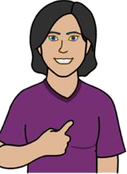
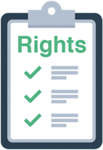
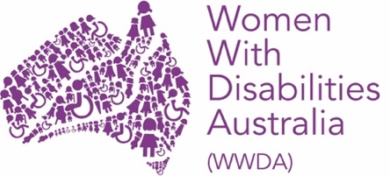
Your rights toolkit

Your rights toolkit. Part 1

What are rights

2

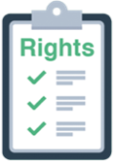Your rights toolkit. Part 1

This set of books are about your rights. There is a lot of information about your rights. We have put the information in 4 books.

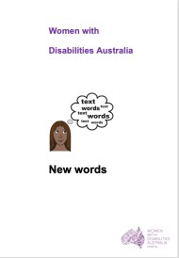
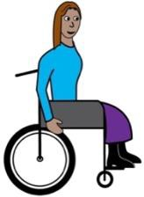
We wrote this book for women and girls with disability. Read more about disability in our book New Words.

We are Women with Disabilities Australia.

3



What is in this set of books?

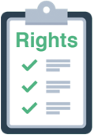
This book is Part 1 Part 1
?
What are rights?

and

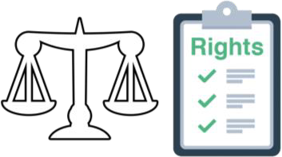
The law and your rights.

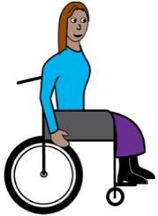Part 2

About the United Nations Convention on the Rights of Persons with Disabilities.

4

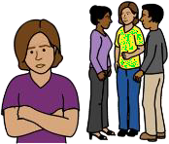
Part 3

About the United Nations Convention on the Elimination of all Forms of Discrimination against Women.

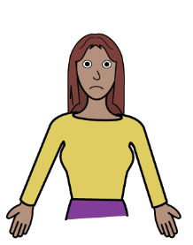Part 4

How to make a complaint about your rights.

5

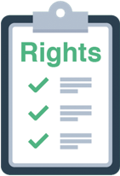
What are rights?
?

Everyone has rights.

Rights are things you can

- be. Like you want to be a nurse

- do. Like you want to go on a holiday

- have. Like you want to have children.


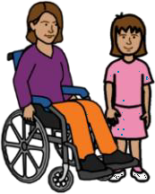
Women and girls with disability have the same rights as every one else.

No one can take away your rights.

6

The law and your rights

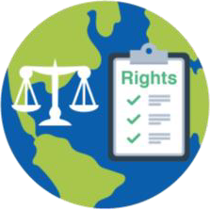
There is a group called the United Nations. They are also called The UN. Most countries in the world are part of The UN.

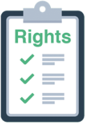The UN write conventions. UN Conventions are like laws. Laws are the rules we must all follow. They are for every one in the world.
The rules tell every one about our rights.

7

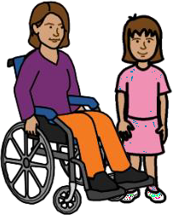
Rights of women and girls with disability

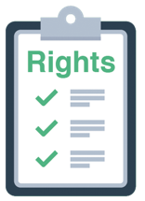Read part 2 for information on the

The United Nations Convention on the Rights of Persons with Disabilities.

Read part 3 for information on the The United Nations Convention on the
Elimination of all forms of Discrimination against Women.

8

Other UN Conventions you may want to know more about are
  - The Convention on the Rights of the Child

  - The Convention on the Elimination of all forms of Racial Discrimination
  - The Convention against Torture and other inhumane treatment or punishment
  - Declaration on the Rights of Indigenous Peoples

and

  - The International Covenant on Civil and Political Rights
  - The International Covenant on Economic Social and Cultural Rights.

9

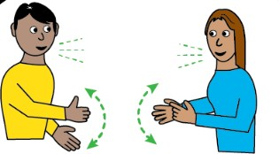
You can ask for these UN laws in a way you can understand and use. Like
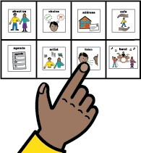
  - to listen to

  - in a different language'

  - using every day words and pictures.

10

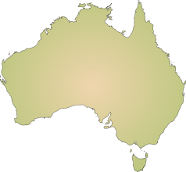
In Australia

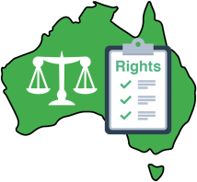
Australia has laws about your rights too. Like

  - The Disability Discrimination Act

  - The Sex discrimination Act

  - The Racial Discrimination Act

and

  - The Age Discrimination Act.

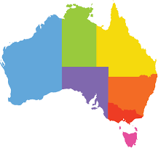
There are also laws in every state of Australia. They help you with your rights.

11

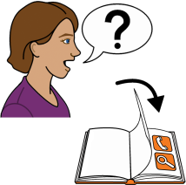
You can ask for help when some one breaks any of these laws,.
Read part 4 of Your rights for where to get help.

12

Your rights toolkit. Part 2

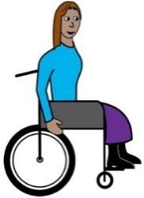

About the United Nations Convention on the Rights of Persons with Disabilities

Your Rights. Part 2

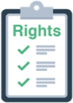
This set of books are about your rights. There is a lot of information about your rights. We have put the information in to 4 books.

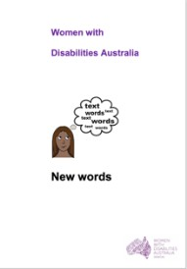
We wrote this book for women and girls with disability. Read more about disability in our book New Words.

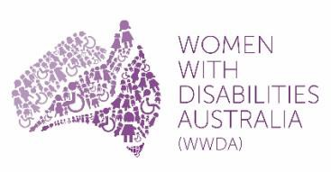We are Women with Disabilities Australia .

14

What is in this set of Books?

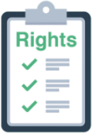
Part 1
?

What are Rights?

and

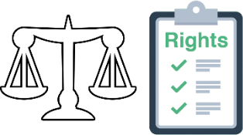
The law and your rights.

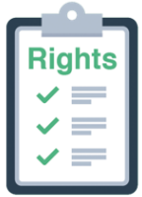This book is part 2. Part 2
About the United Nations Convention on the Rights of Persons with Disabilities.
15

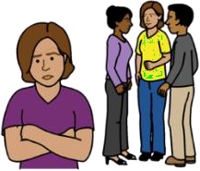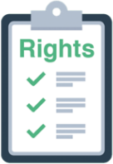Part 3

About the United Nations Convention on the Elimination of all Forms of Discrimination against Women.

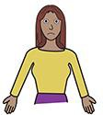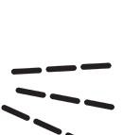Part 4

How to make a complaint about your rights.

16

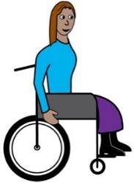The United Nations Convention on the Rights of Persons with Disabilities.
It is a long name. It is also called the

UNCRPD or
    - CRPD.

We will write UNCRPD when we talk about it.

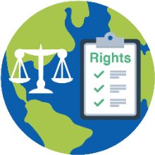
The UNCRPD is a law for the whole world. It helps everyone know about the rights of people with disability.

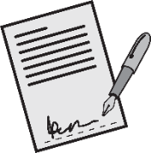
Australia signed the UNCRPD in 2008.

Some countries have not signed the UNCRPD.

17

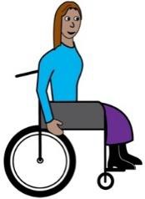The UNCRPD has 50 parts. The parts are called articles.

!!!

Each part of the UNCRPD is different. All the parts are important.

Each article of the UNCRPD talks about the rights of people with disability. We will write PWD when we talk about people with disability,

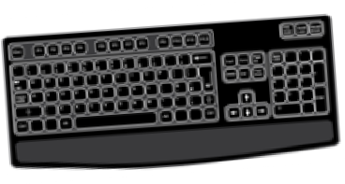You can find the hard to read UNCRPD at www.un.org/disabilities

18

The articles of the UNCRPD

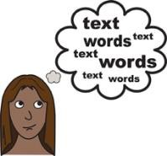Article 1 and 2. The agreement

These parts tell us who the UNCRPD is for. It tells us what some of the big words mean.

Article 3. Basic ideas

The UNCRPD is based on rights. Like people with disability
    - are free to make their own choices

    - have the same rights as every one else

    - must be treated with respect

    - are able to take part.

19

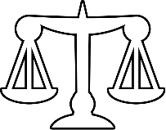
Article 4. What each country must do

Each country that has signed the UNCRPD must

    - have laws about our rights. Laws are the rules every one must follow. We will write rules to talk about the law.

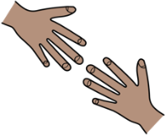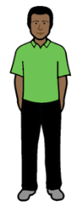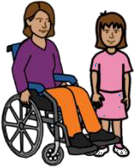Articles 5 and 6. Being Equal

Women and girls with disability need more help to get treated in an equal way. Like
-government policies that say we must be treated fairly

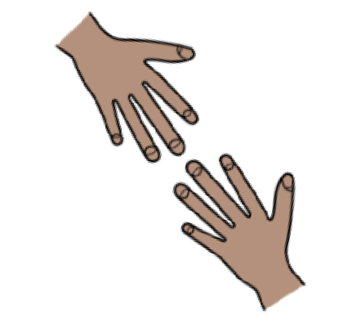Article 7. Children with disabilities must be treated equal
Children with disability need more help to get treated in an equal way.
Like to go to school each day.

20

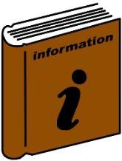Article 8. Information about disability

Countries must give information to people about disability that they can understand and use.

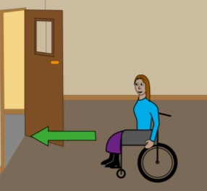
Article 9. Access

Countries must make sure PWD can get in to different places. Like

    - 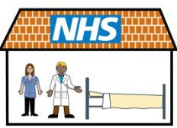hospitals

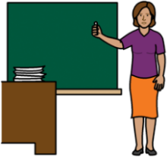
    - schools.

21

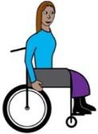
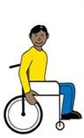
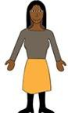Article 10. Right to life

All PWD have a right to life. A PWD is

not killed just because they have a disability.

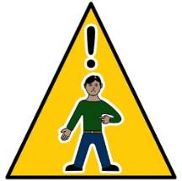
Article 11. Emergencies

PWD have a right to help when there is danger. Like when

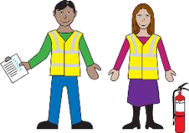
    - there is a fire

    - 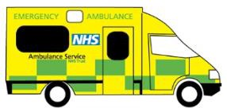they need an ambulance

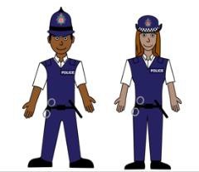
    - they need the police.
22

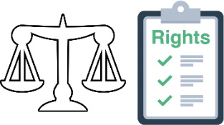
Article 12. The law and your Rights

PWD have the same legal rights as every one. Like PWD have a right to

    - 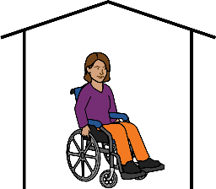have a bank account

    - live in a house

    - 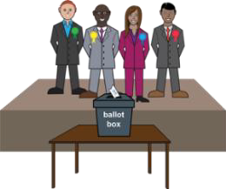to vote in elections.

23

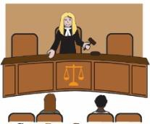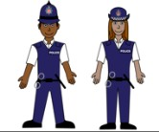Article 13. Help from the police. Help from Courts

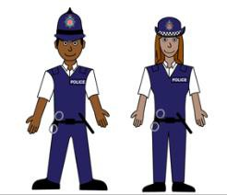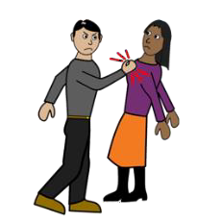PWD have a right to go to the police. Like when a PWD
    - is hurt by their partner

    - has their bag stolen.

and

PWD have a right to go to court. Like

    - to get a divorce

    - to sue someone for treating them badly.

24

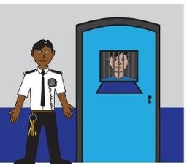Article 14. Right to be free

PWD must have done something wrong to be locked up. Like broke into a bank.
PWD must not be locked up just because they have a disability.

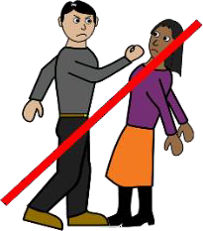Article 15. People are not cruel to PWD

PWD have the right to be free of people who

    - are nasty to you

    - hurt you

    - do things that make you feel bad

or

    - 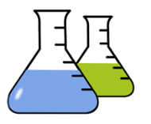give PWD new pills that are not tested yet.

25

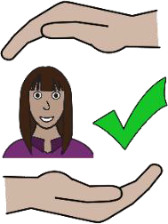Article 16. Right to be safe

PWD have a right to be safe from violence and abuse. Read more about Violence in our book New Words.

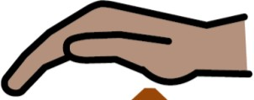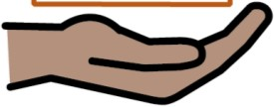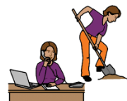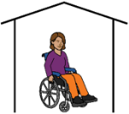PWD have the right to be safe

    - at home

    - at work

    - at school

    - any where else a PWD goes.

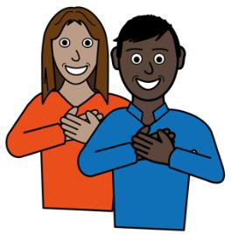
Article 17. Right to be treated with respect PWD have the right to respect for their own body. PWD choose who can touch their body.

PWD have the right to respect for their mind.

PWD can tell others what they think.
26

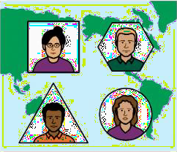
Article 18. Right to move to a different country
PWD can


    - get a passport

    - move to a new country

    - become a person of that new country.

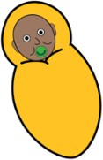
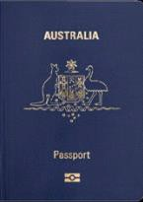
All children with disability born in Australia

    - are an Australian

    - get a birth certificate

    - can get a passport.

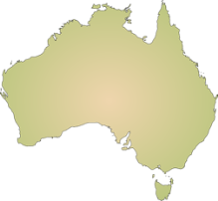Every Australian PWD

and

every Australian with a disability can
    - go to another country

    - come back to Australia.

27

Article 19. The Right to choose how to live

PWD have a right to choose where to live.

and

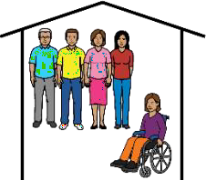
PWD have a right to choose who to live with.

Article 20. The right to move about PWD have a right to get aids they need to move about. Like
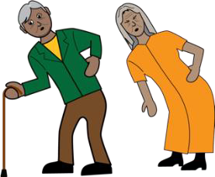
    - walker

    - wheelchair

    - scooter.

PWD have a right to learn how to use their aids.

28

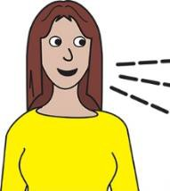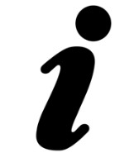Article 21. The right to information. The right to speak up.
PWD have a right to say what they think.

PWD have a right to information in a way they can understand. Like

    - 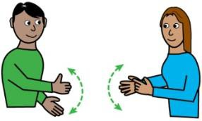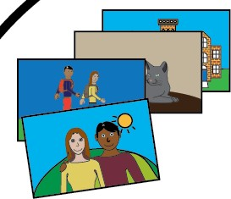sign language

    - large print

    - Braille

    - so they can hear it

    - easy words and pictures

    - information in a different language.

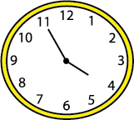
PWD must get the information at the same time as other people.

29

PWD have the right to use other ways to talk. Like
    - have a communication board

    - use sign language

    - use a device to speak.

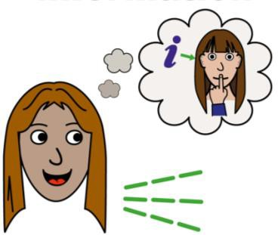
Article 22. Keep things private

PWD have a right to a private life.

You do not have to share things about you with every one. PWD have a right to
    - information about them to be in a private place

    - have a private meeting with doctors or nurses.

30

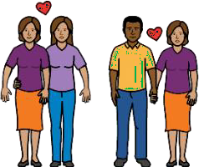
Article 23. Family and relationships

PWD have a right to


    - be in a relationship

    - get married

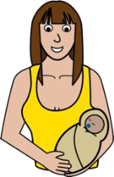
    - have a child

    - choose how many children to have.

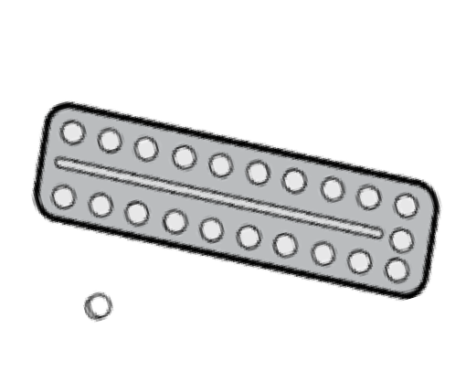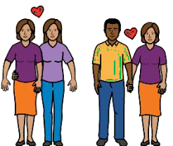Women with disability have a right to

    - learn about how to plan a family

    - use things to stop getting pregnant.

Like take the pill.

31

Women with disability also have a right to

    - say yes or no to an operation to

      - 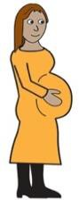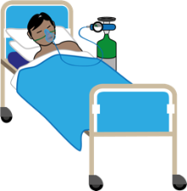stop you getting pregnant. This is called sterilisation

      - stop you being pregnant.

This is called an abortion.

32

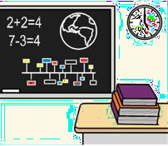
Article 24. Right to learn

PWD have a right to learn Like

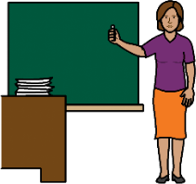
    - go to kinder

    - go to primary school

    - go to high school

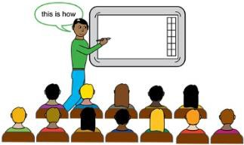
    - go to university

    - go to college

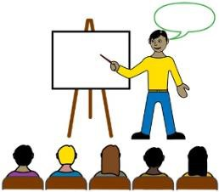
    - go to TAFE

    - get work training.

33

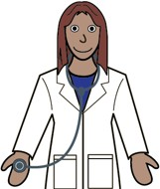
Article 25. Health

PWD have a right to

    - go to their own doctor

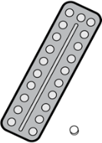
    - have the best pills for them

    - go to a special doctor. Like an asthma doctor

    - have tests to check things like other people.

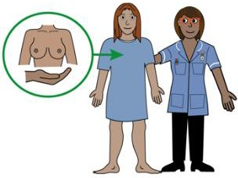
Like

      - a check of your breasts

      - a heart check.

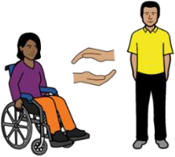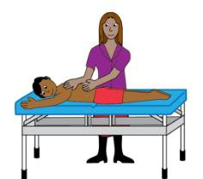Article 26. Get better

PWD have a right to be able to get service. Like

    - a therapist to teach you to move better

    - a therapist to rub your sore back

    - a support person to help you get the bus.

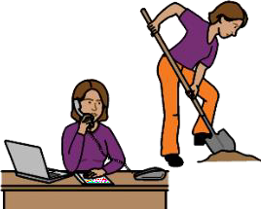
Article 27. Work

PWD have a right to work.

34

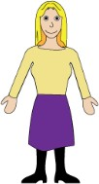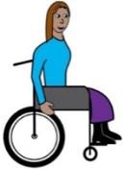PWD have a right to

    - get pay for their work

    - get the same pay for the same work as other people.

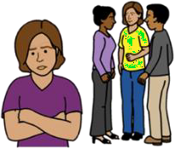PWD must be treated in a fair way at work.

When you are not treated in a fair way it is

called discrimination. Read more about this in our book New Words.

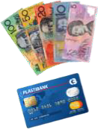PWD must not be made to do work for no money


PWD have a right to join a union.
35

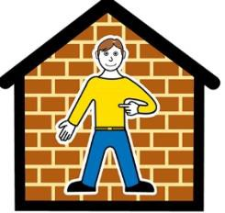
Article 28. A good life

PWD have a right to live well.

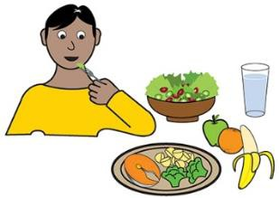
All PWD must have

    - enough food to eat

    - enough water to drink

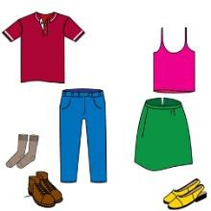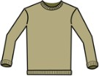the right clothes to wear. Like warm clothes in winter.
•

    - a house to live in.

36


Article 29. Politics

PWD have a right to take part in politics. Like PWD can

    - 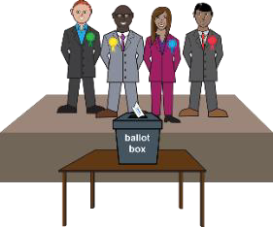vote in elections

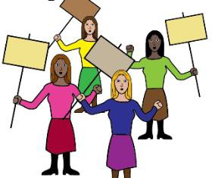
    - go to protests.

37

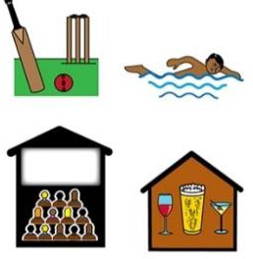
Article 30. Be part of your community

PWD have a right to do different things. Like


    - go to bars

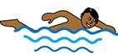
    - swim at the pool

38

Article 31 to part 40. What countries must do
Countries must use this information to get the rights of PWD better.

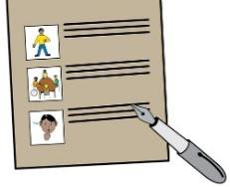
Countries must write a report

    - every 4 years

    - on what they have done about the UNCRPD.

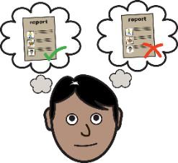
Part 41 to part 50. Report back

The UN will tell each country

    - what they do that is good

    - what more that country needs to do.

39

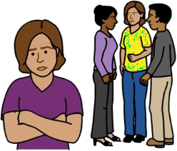
Your rights toolkit. Part 3

About the United Nations Convention on the Elimination of all Forms of Discrimination
against Women.

Your rights toolkit. Part 3

This set of books are about your rights. There is a lot of information about your rights. We have put the information in to 4 books.

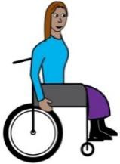
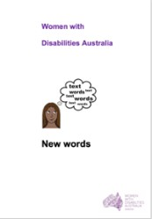
We wrote this book for women and girls with disability. Read more about disability in our book New Words.

We are Women with Disabilities Australia .

41

What is in this set of Books?

Part 1
?

What are Rights?

and

The law and your rights.

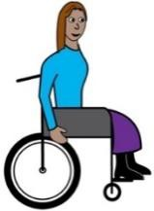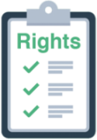Part 2

About the United Nations Convention on the Rights of Persons with Disabilities.

42

This book is part 3 Part 3
About the United Nations Convention on the Elimination of all Forms of Discrimination against Women.

Part 4

How to make a complaint about your rights.

43

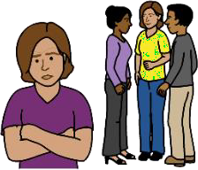
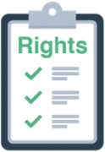
About the United Nations Convention on the Elimination of all forms of Discrimination Against Women.

It is a long name. It is also called the CEDAW.

We will write CEDAW when we talk about it.

The CEDAW is a law for the whole world. It helps every one know about the rights of all women.

Australia signed the CEDAW in 1980.

44


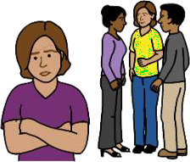
The CEDAW has 30 parts. The parts are called articles.

!!!

Each article of the CEDAW is different. All the articles are important.

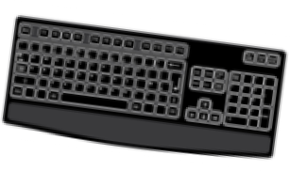You can find the hard to read CEDAW at www.un.org/womenwatch

45

The articles of the CEDAW

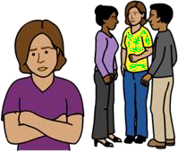Article 1. Women are treated in an unfair way The CEDAW says lots of women are treated in an unfair way. Like
    - they can not own their own home

    - they do not have their own money

    - they get less pay than men for the same job.


The CEDAW says this is wrong.

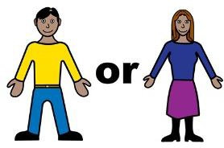Women are treated like this because they are women.

46

This is all called discrimination. Read more about discrimination in our book New Words.

Articles 2 and 3. Laws

Laws are like rules. We will write the word rules when we talk about the law. We must all follow these rules.


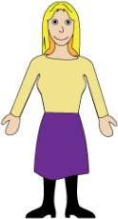Each country that has signed the CEDAW must

    - make rules that treat women in a fair way

    - do not make rules that treat women in an un fair way
    - make rules that help women be part of all areas of life.

47

Article 4. More help for women Countries must give more help to women. It will help them do the same as men. Like

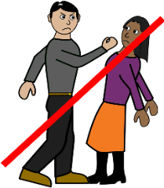
    - give money to services that help women who live with violence

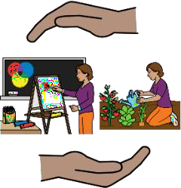
    - give help to women with disability at home

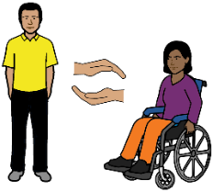
    - give women with disability support staff when they need them.

48

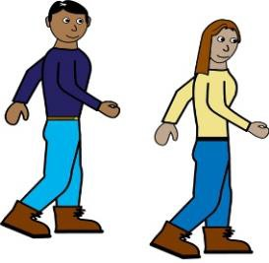Article 5. Information to tell us

women and men can do the same things

Countries that signed the CEDAW must tell every one

    - women can do the same things as men

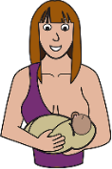
    - women must not be told they can only do some things. Like

      - women can only look after children

- women can only clean the house.

49

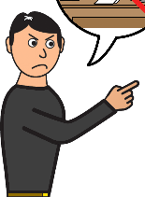Article 6.

Made to work. Made to have sex Countries must stop women and girls from being

    - sent to a different place

and

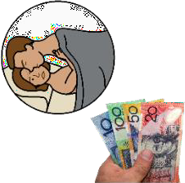
    - made to have sex for money.

This is called trafficking.

50

Article 7. Politics

All women have a right to take part in all politics. Like women can

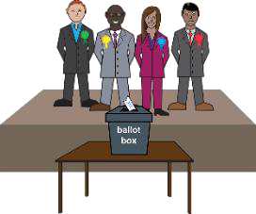
    - vote in elections

    - go to protests.

51

Article 8. Talk to women around the world Women have a right to take part in politics around the world. Like

    - 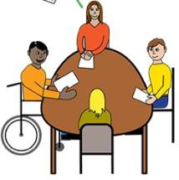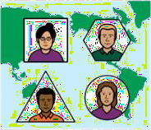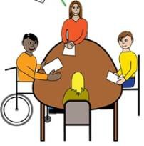meetings with women from other countries

    - meetings with the UN.

52

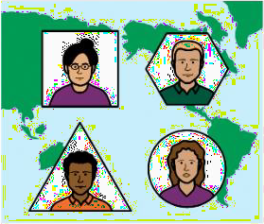
Article 9. Belong to a country

All women have a right to be part of a country. This is your nationality.

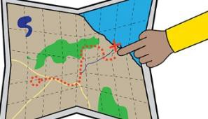
All women have a right to change the country they are a part of.

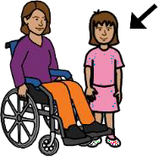Women have a right to pass their nationality to their children.

53

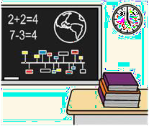
Article 10 – Right to learn

Women and girls have a right to learn Like

    - go to kinder

    - go to primary school

    - go to high school

    - go to university

    - go to college

    - go to TAFE

    - get work training.

54

Article 11. Work

All women have a right to work.

Women have a right to

    - get pay for their work

    - get the same pay for the same work as men.

55

Article 12. Health

Women have a right to

    - go to their own doctor

    - have the best pills for them

    - go to a special doctor. Like an asthma doctor

    - have tests to check things like other people.

Like

      - a check of your breasts

      - a heart check.

56

Article 13. Be part of your community

Women have a right to do different things. Like

    - go to bars

    - swim at the pool

57

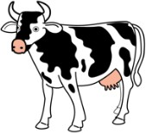Part 14. Women who live in the country

Like

    - live on a farm

    - live in a small town.

They do not live in a city.

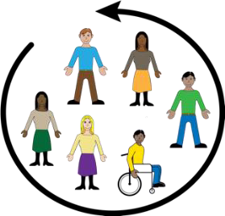
These women and girls must be able to take part in all areas of life. Like

    - work

    - school.

58

Article 15. The law and your rights

All women must have the same legal rights as men to do things. Like

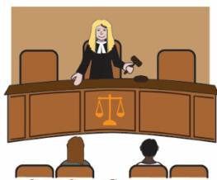
    - take part in court

    - 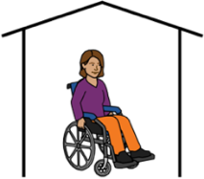own a home


    - have money.

59

Article 16. Family and Relationships

All women have the same family rights as men.

Like women have a right

• to be in a relationship
    - to marry

    - have a child

    - choose how many children to have.

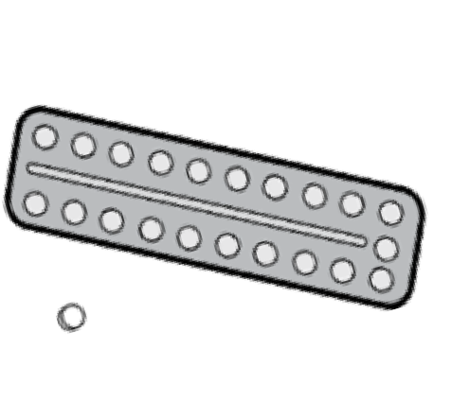Women have a right to

    - learn about how to plan a family

    - use things to stop getting pregnant.

Like take the pill.

60

Women also have a right to

    - say yes or no to an operation to

      - stop you getting pregnant. This is called sterilisation

      - stop you being pregnant.

This is called an abortion.

61

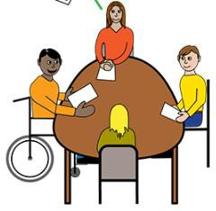
Article 17 to part 22. The CEDAW Committee
The United Nations checks countries follow the CEDAW.

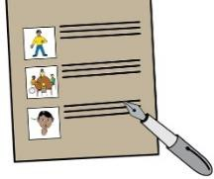
Countries must write a report

    - every 4 years

    - on what they have done about the CEDAW.

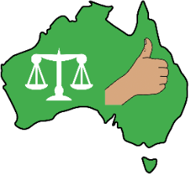
Article 23 to part 30. Using the CEDAW.
Australia has signed the CEDAW.

Australia must do the things in the CEDAW.

62

Your rights toolkit Part 4

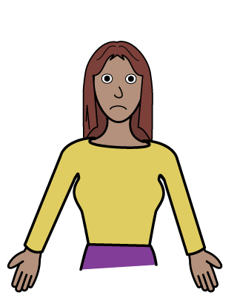
How to make a complaint about your rights.

Your rights toolkit. Part 4

This set of books are about your rights. There is a lot of information about your rights. We have put the information in to 4 books.

We wrote this book for women and girls with disability. Read more about disability in our book New Words.

We are Women with Disabilities Australia .

64

What is in this set of Books?

Part 1
?

What are Rights?

and

The law and your rights.

Part 2

About the United Nations Convention on the Rights of Persons with Disabilities.

65

Part 3

About the United Nations Convention on the Elimination of all Forms of Discrimination against Women.

This is part 4 Part 4
How to make a complaint about your rights.

66

What is a complaint?

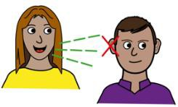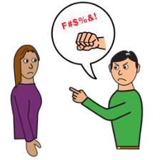Some times things are not right. Like

    - someone hurts you

    - someone is rude about your disability

    - the support staff do not listen to you.

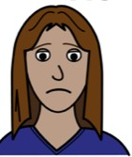
It is a problem.

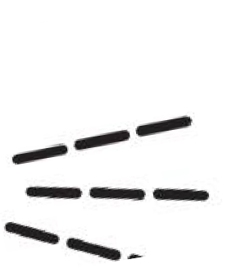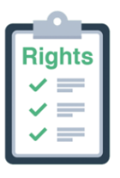You have a right to tell someone about your problem. This is called a complaint.

67

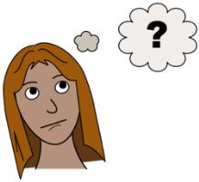You have a complaint. What do you do?


You have a right to make a complaint. This is OK.
You will not get into trouble.

There are different places to make a complaint

    - in your state or territory

to the Australian Human Rights Commission

- to the boss

  - at work

  - at your group home.

68

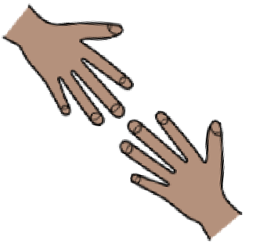
Someone can help you make a complaint. Like

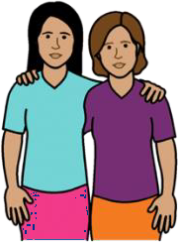
    - a friend

    - a family member

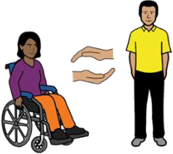
    - a support worker

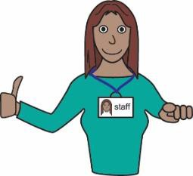
    - a staff member.

69

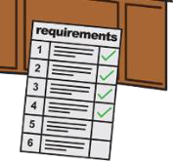What do you need to say in your complaint.

You will need to say

- Who you are. Like

  - your name

  - address

  - phone number.

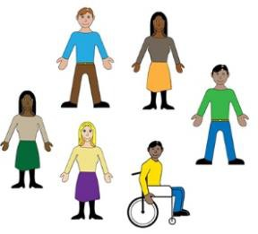
- Other things about you. Like

  - are you

    - a man

    - women

    - do not want to say

  - your disability

  - your age.

70

- What is the problem?

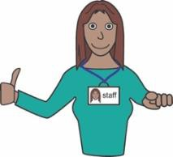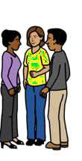Who treated you in a bad way? Was it
A.

  - a staff person

  - another worker

  - someone at a shop

  - a group of people.

- 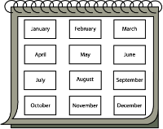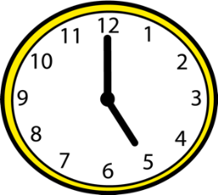When did they do it? Was it

  - every day this week

  - on Monday

  - at night

  - a different time.

71

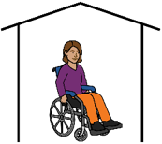Where did they do it? Was it
C.

  - at work?

  - at home?

  - in the car?

  - somewhere else?

- 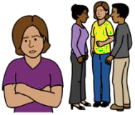What did they do? Did they

  - Hit you

  - yell at you

  - would not let you join in

  - something else.

72

Australian Human Rights Commission

We will write AHRC to mean the

Australian Human Rights Commission.

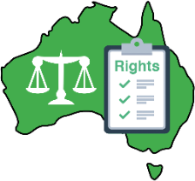
The AHRC takes complaints about human rights. You can be from anywhere in Australia.


Call ……. 1300 656 419

or

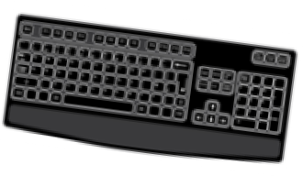
Go to www.humanrights.gov.au/complaints/make- complaint

73

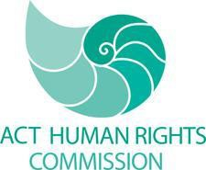
ACT Human Rights Commission


For people who live in Canberra

or

anywhere in the Australian Capital Territory.


Call……. 02 6205 2222

Email … human.rights@act.gov.au

or

Go to www.hrc.act.gov.au/discrimination

74


Queensland Human Rights Commission

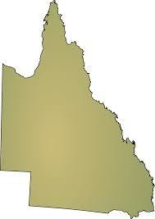
For people who live in Queensland.

Call ……. 1300 130 670

Email … info@adcq.qld.gov.au

or

Go to
www.adcq.qld.gov.au/complaints/making-a- complaint
Type in the search window Complaints Form
75

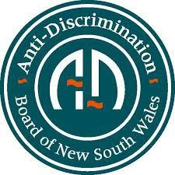
Anti-Discrimination Board of NSW.

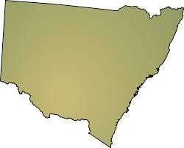
For people who live in

New South Wales. It is also calledNSW.

Call ……. 1800 670 812

Email… adbcontact@agd.nsw.gov.au

or

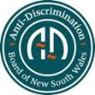Go to www.antidiscrimination.justice.nsw.gov.au Type in the search window Complaints Form

76

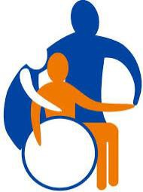
Northern Territory

Anti-Discrimination Commission

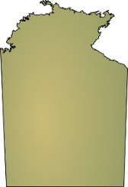
For people who live in the Northern Territory.

Call ……. 1800 813 846

Email … antidiscrimination@nt.gov.au

or

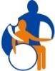Go to www.adc.nt.gov.au/complaints/complaint_form.ht ml
77

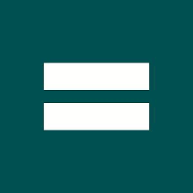
Equal Opportunity Tasmania

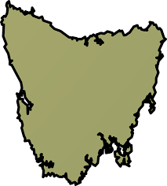
For people who live in Tasmania.

Call ……. 1300 305 062

Email … office@equalopportunity.tas.gov.au

or

Go to

www.equalopportunity.tas.gov.au/complaints

78


The South Australian Equal Opportunity Commission

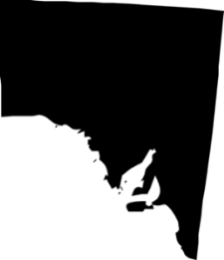
For people who live in South Australia.

Call ……. 08 8207 1977

Email … eoc@agd.sa.gov.au

or

Go to

www.eoc.sa.gov.au/what-discrimination/making- complaint

79


Victorian Equal Opportunity and Human Rights Commission

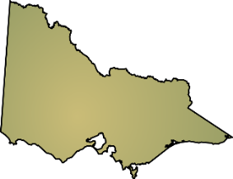
For people who live in .

Call ……. 1300 292 131

Email … enquiries@veohrc.vic.gov.au

or

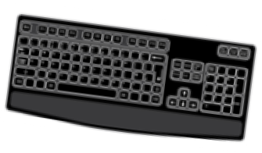Go to www.humanrightscommission.vic.gov.au Type in the search window Complaints Form

80


WA Equal Opportunity Commission

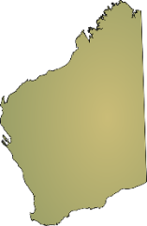
For people who live in Western Australia.

Call ……. 08 9216 3900

Email … eoc@eoc.wa.gov.au

or

Go to www.eoc.wa.gov.au/complaints- inquiries/complaint-form

81

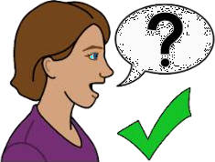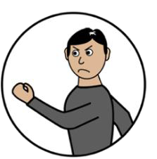You can talk to someone about violence

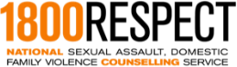 1800 Respect


Call ……. 1800 737 732

or

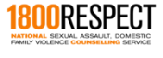Talk online at … www.1800respect.org.au

82

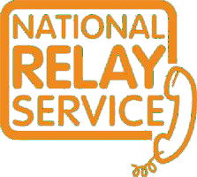
Use the National Relay service

Call ……… 1800 | 555 | 677
TTY 133 | 677

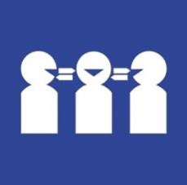
Need a translator Call ……… 131 450

83


Thank you

Who wrote this book?

Women with Disabilities Australia wrote this book in 2019-2020. This book is for general education and information only.

Copyright

© Copyright

Women with Disabilities Australia (WWDA) Inc. 2020.

All intellectual property rights, including copyright and patents, in this book is owned and licensed by Women with Disabilities Australia Inc.

Thank you for the money to write this book.

The National Disability Insurance Scheme gave Women with Disabilities Australia some money to help build this website.

The images used in this fact sheet

Easy on the I Images © 2019 Leeds and York Partnership NHS Foundation Trust. Used with permission. www.easyonthei.nhs.uk

The Picture Communication Symbols © 2019 by Mayer Johnson LLC a Tobii Dynavox company. Used with permission. www.tobiidynavox.com

Logos. Used with permission.

84

