Women with

Disabilities Australia

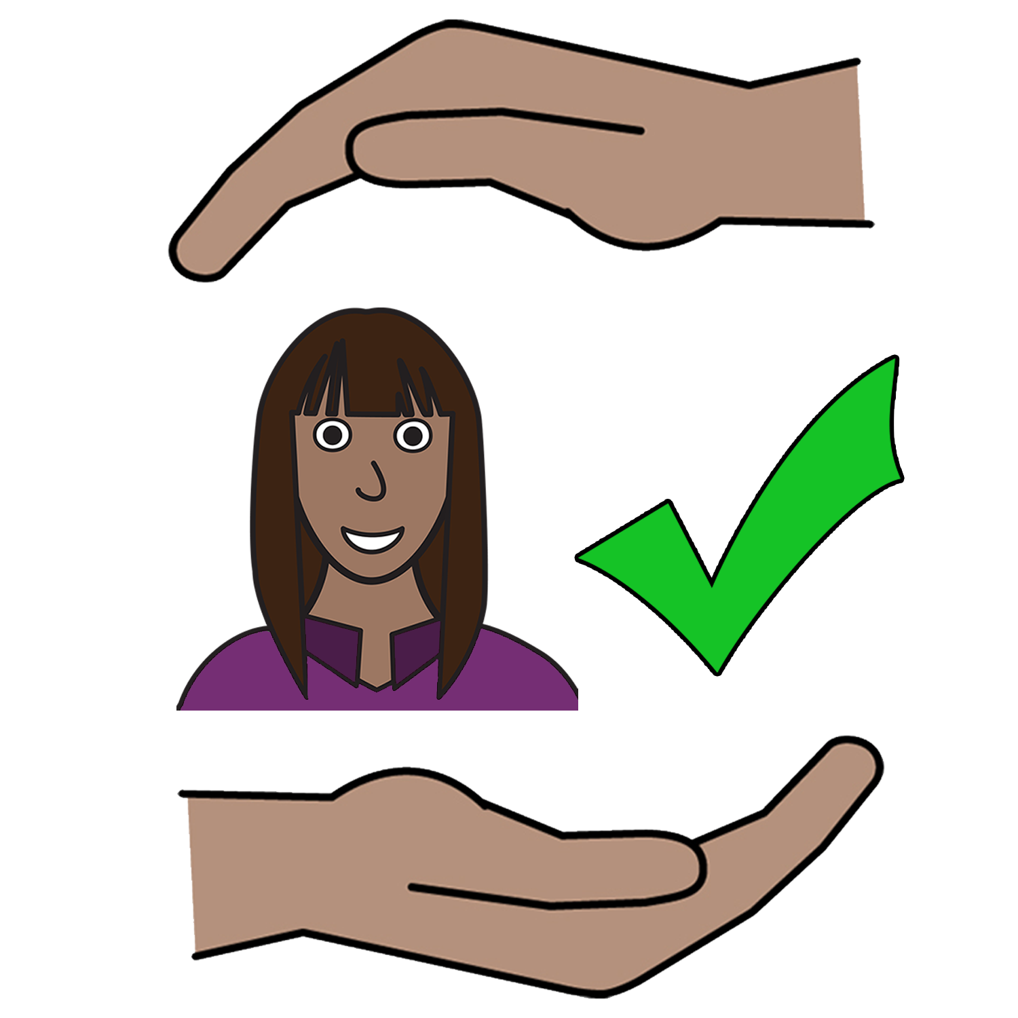
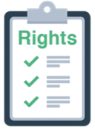

Your right to be safe from violence

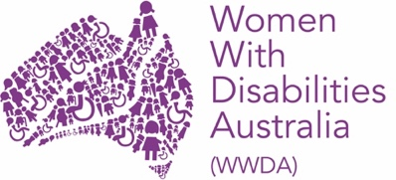

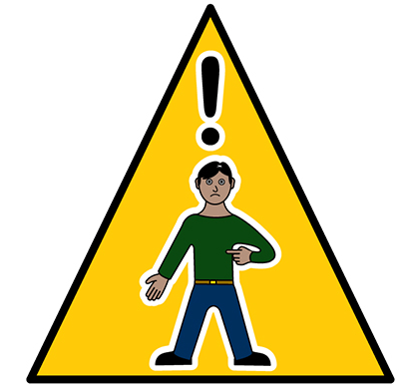
In danger now

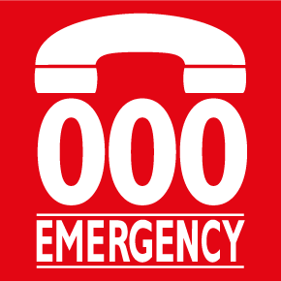
Call 000
We are Women with Disabilities Australia. We will write WWDA when we talk about us.

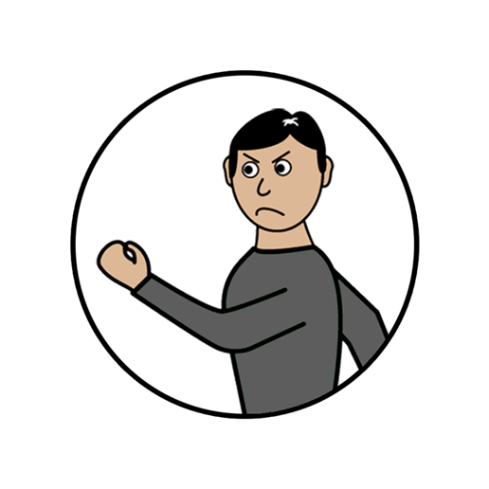
This book is about violence.
Read about what is violence in the book New words.

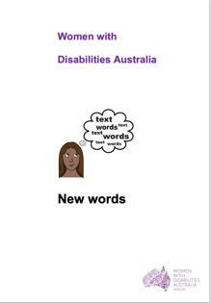
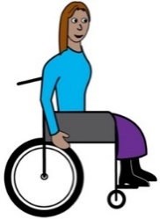
We wrote this book for women and girls
with disability. Read more about disability
in our book New Words.

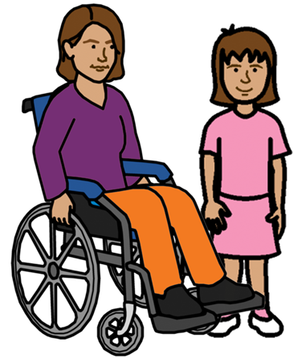
Women and girls

with disability
Many women and girls with disability live with violence in their own life. It occurs in many different places. Like

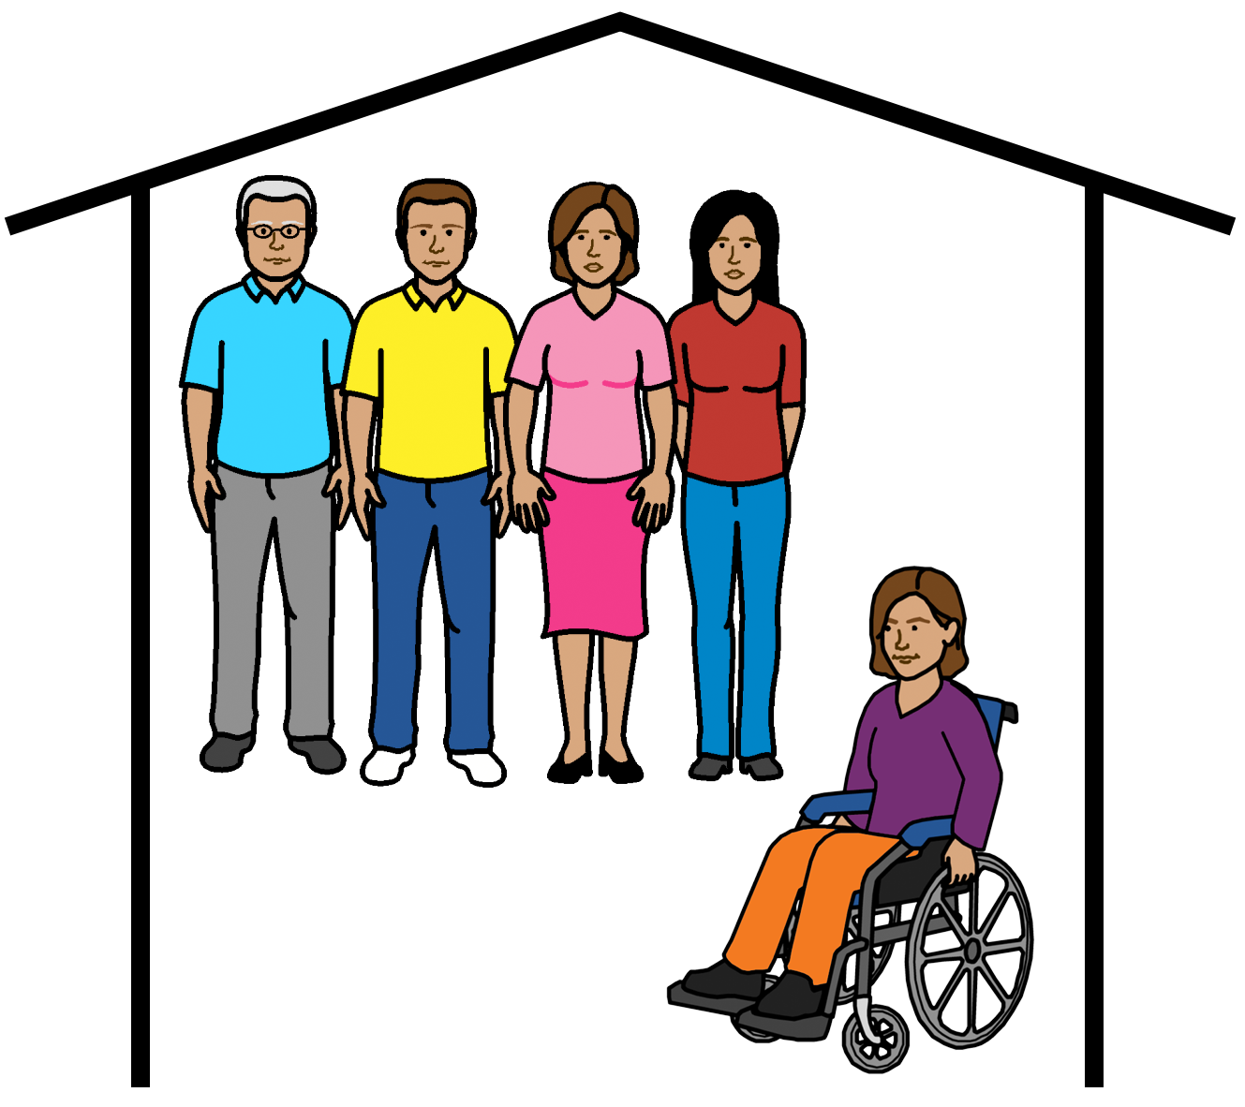

      - group homes

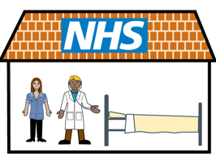

      - hospitals

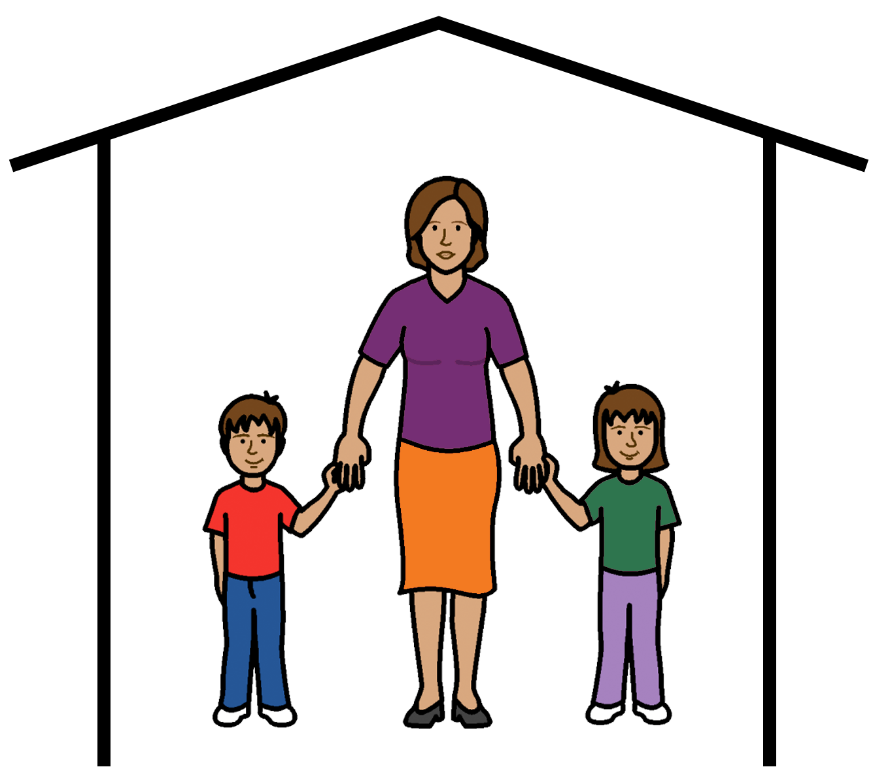

      - the family home.

Violence can also occur

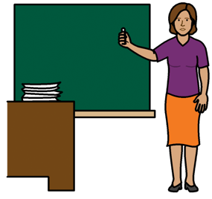
      - in schools

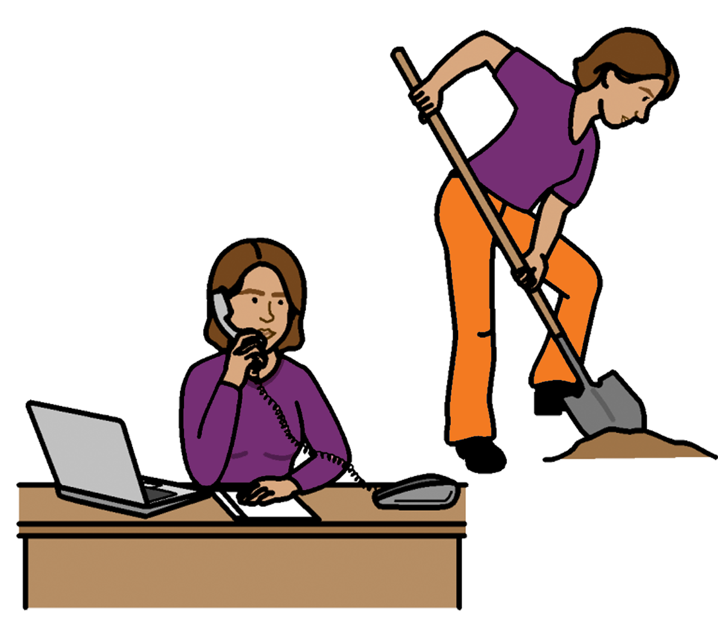
      - in workplaces

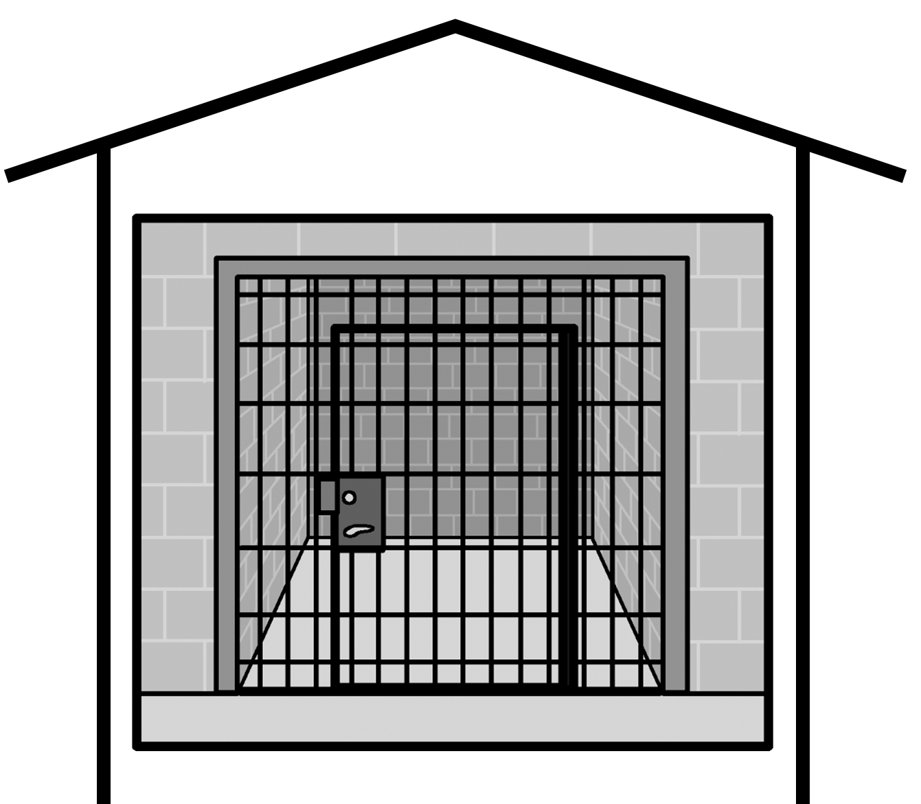

      - in prisons.

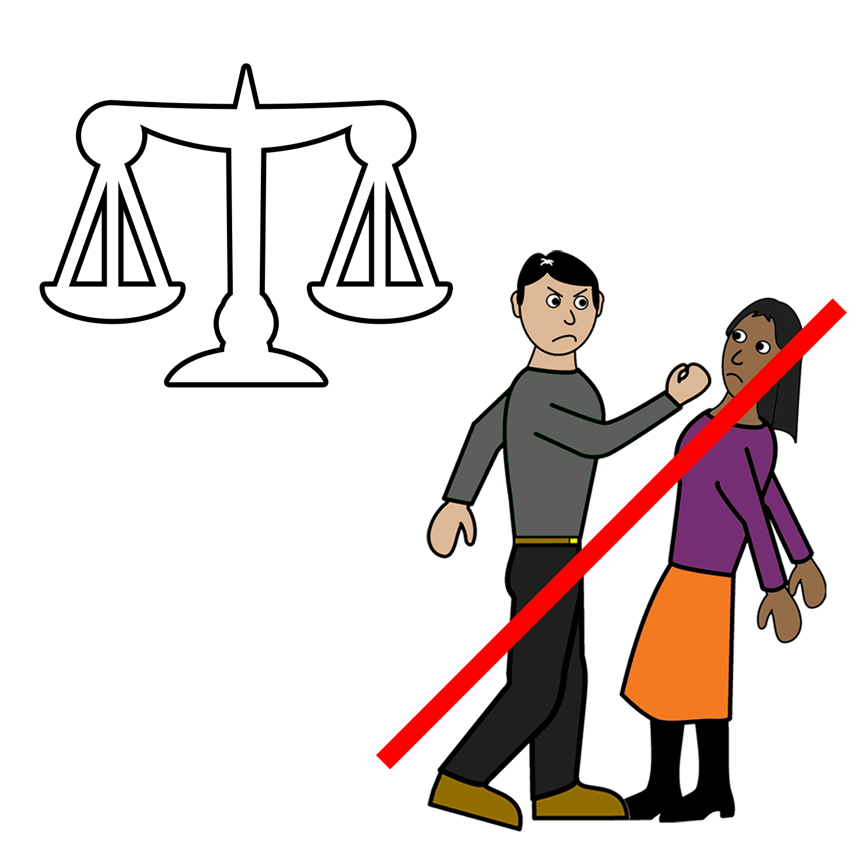

All violence against women and girls with disability is bad.

All women and girls with disability have a right to be safe from violence.

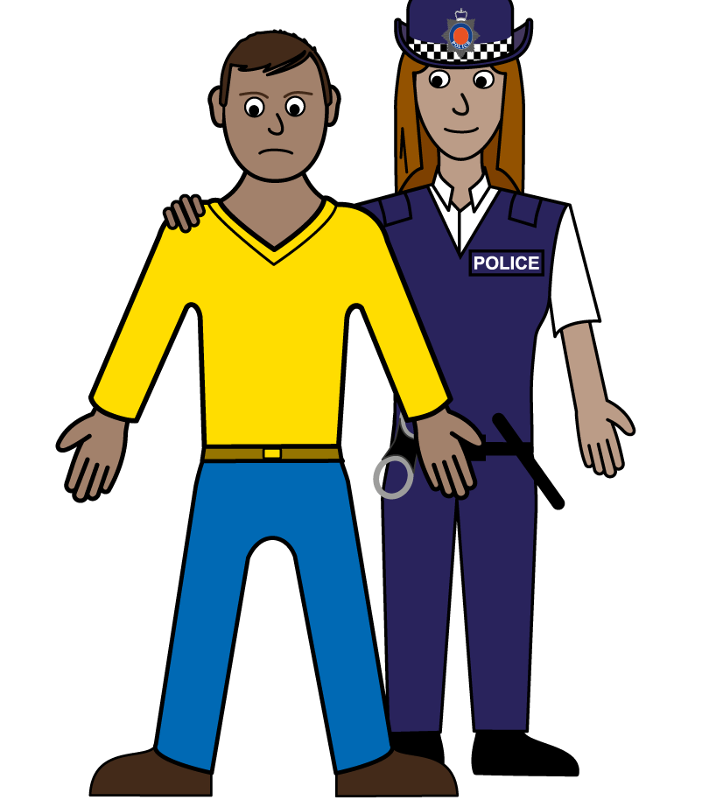

All violence is against the law.

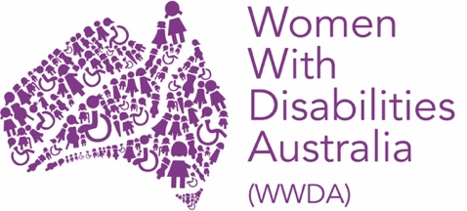
WWDA stand up for women and girls with disability who live with violence.

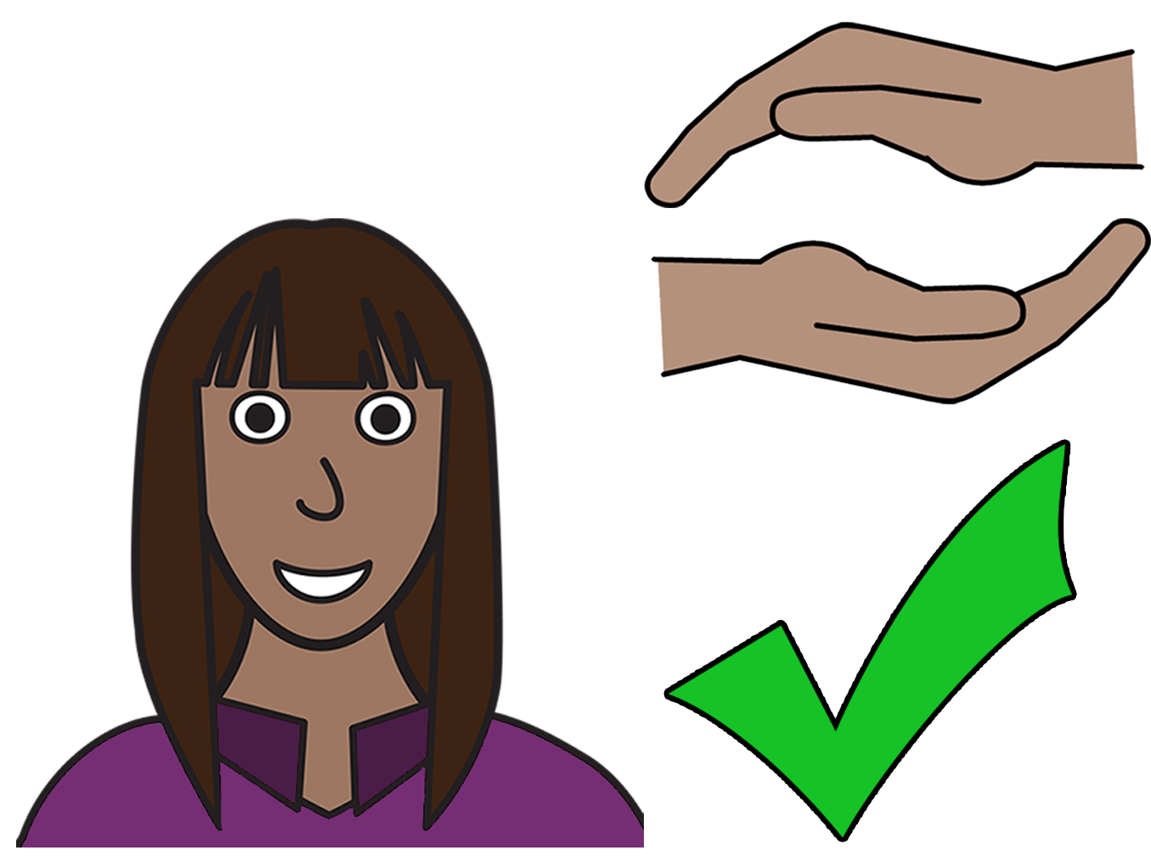

Your rights
You have the right to be safe from violence.

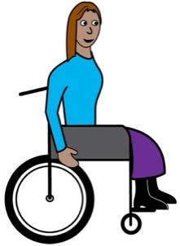
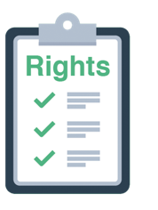
There are laws to help you.
There is the United Nations Convention on the Rights of Persons with Disabilities.
We will write UNCRPD when we talk about it.

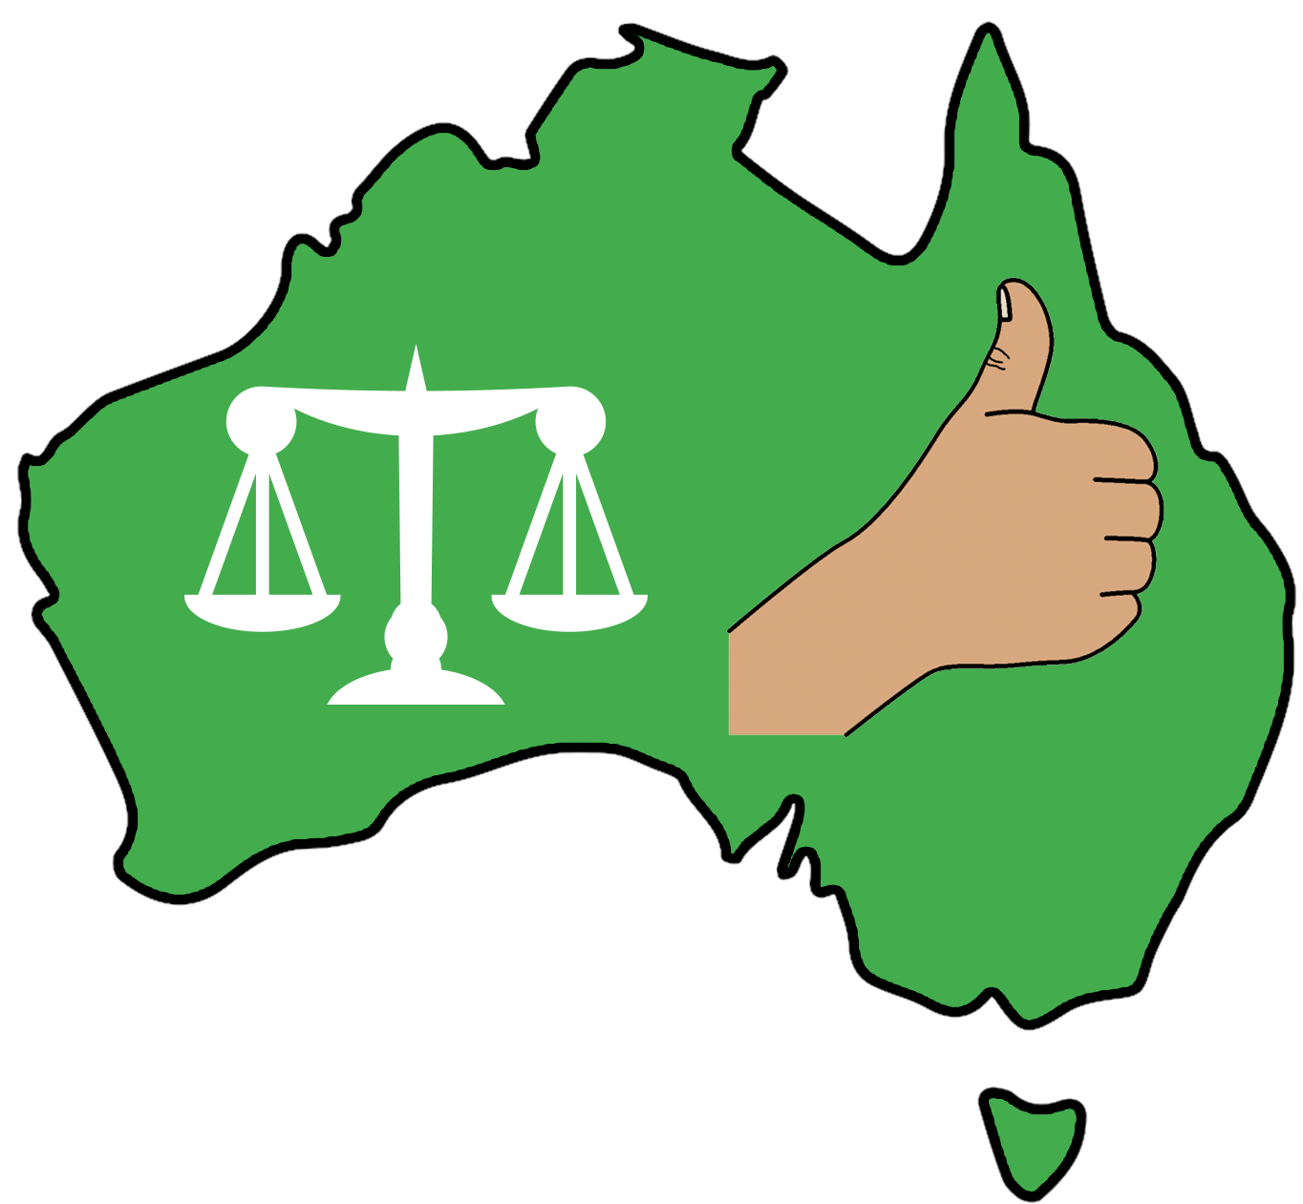

Australia must follow the UNCRPD.

Australia must do all it can to stop violence against women and girls with disability.


Remember!

You have a right to be safe from violence.

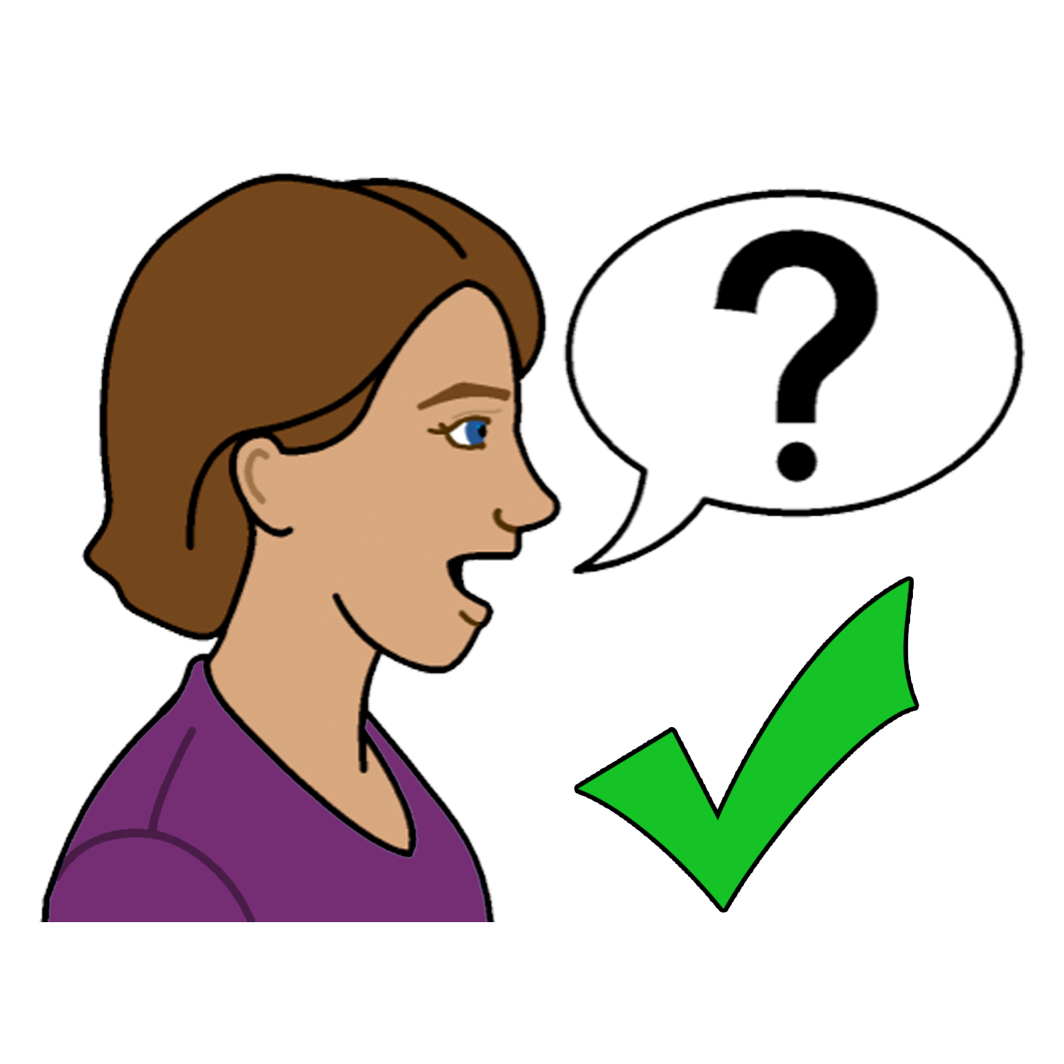
You can talk to someone
about violence

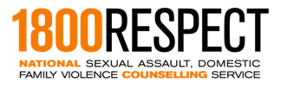
1800 Respect


Call 1800 737 732

or


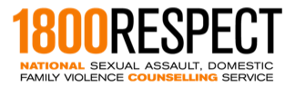

Talk online at www.1800respect.org.au

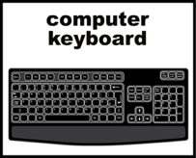

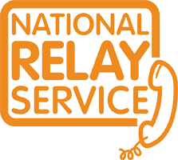
You can use the National Relay service
with 1800Respect
Call 1800 555 677
TTY 133 677
Ask for 1800 737 732

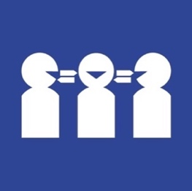
Need a translator
Call 131 450
Ask for 1800 737 732.

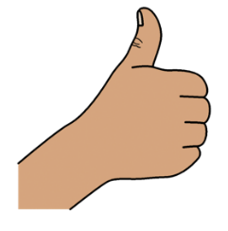
Thank you
Who wrote this book?
Women with Disabilities Australia wrote this book in 2019-2020.
This book is for general education and information only.

Copyright
© Copyright
Women with Disabilities Australia (WWDA) Inc. 2020.

All intellectual property rights, including copyright and patents, in this book is owned and licensed by Women with Disabilities Australia Inc.

Thank you for the money to write this book.
The National Disability Insurance Scheme gave Women with Disabilities Australia some money to help build this website.

The images used in this fact sheet
Easy on the I Images © 2019 Leeds and York Partnership NHS Foundation Trust. Used with permission. www.easyonthei.nhs.uk
The Picture Communication Symbols © 2019 by Mayer Johnson LLC a Tobii Dynavox company. Used with permission. www.tobiidynavox.com

Logos. Used with permission.

