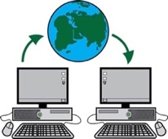

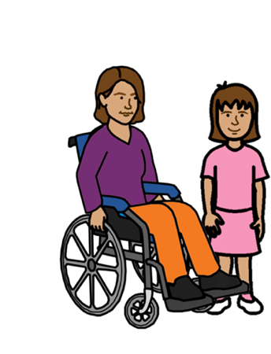
The Virtual Centre for
Women and Girls with Disability

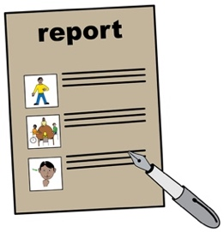
Workshop Report
Easy Read


Need a translator
- Call 131 450
- Ask for 1800 737 732

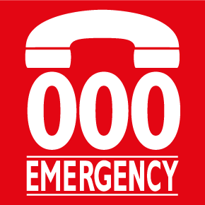
In danger now?
Call 000

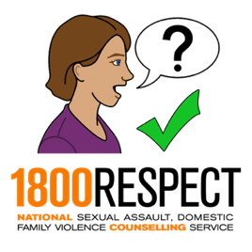
To talk to some one about violence.
- Call 1800 RESPECT on 1800 737 732
or
- Chat online at www.1800respect.org.au

WWDA means
Women with Disabilities Australia.

WWDA is developing a Virtual Centre (website) for women and girls with disability

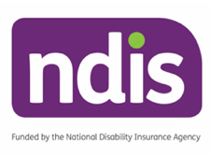
The Virtual Centre website is being funded by the NDIS

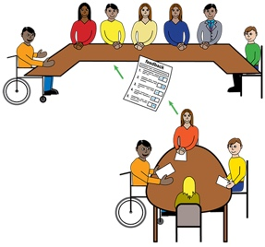

In July 2019 WWDA ran workshops around Australia to find out what women with disability wanted on the website.

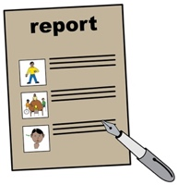
This document is a summary of the workshop report in Easy Read.
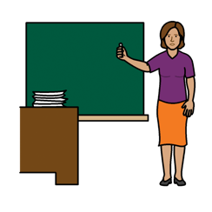
Each workshop was organised and run by WWDA, workshop facilitator, Dr Julia Wolfson and a local organisation.

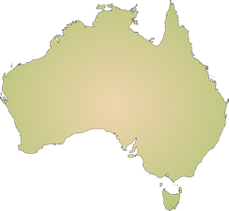
The workshops were held in 6 places around Australia with 6 different local organisations. They were:

- Hobart, Tasmania with Speak Out Association of Tasmania.

- Canberra, ACT with Women With Disabilities ACT (WWDACT)

- Melbourne, Victoria with Women With Disabilities VIC (WDV)

- Brisbane, Queensland with Women With Intellectual Disabilities (WWILD)

- Tennant Creek, Northern Territory with First People’s Disability Network (FPDN).

- Perth, Western Australia with Women With Disabilities WA (WWDWA).
Workshops were attended by:
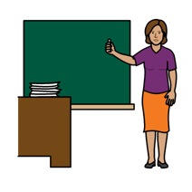
- Dr Julia Wolfson.

- WWDA staff:
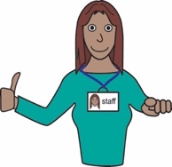
- The Virtual Centre Project Manager.
- The Virtual Centre Senior Content Officer.
- The WWDA Communications Officer.

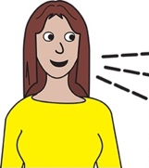
- A host from each local organisation.
- A group of local women with disability.

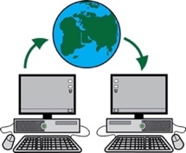
3 of the 6 workshops were also attended by David Shering from Handbuilt Creative. Handbuilt Creative is the organisation that is designing the website.
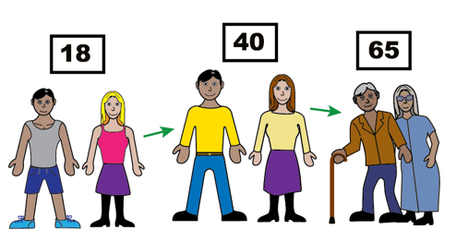

All together 45 women between ages of 18 and 65 took part in the workshops.
The workshop was split into 2 parts.
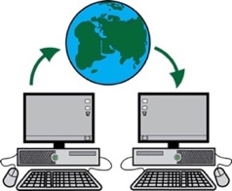
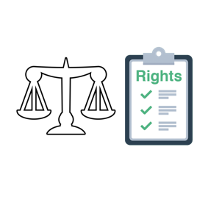
In Part 1 women with disability were asked about what they wanted to see on the Virtual Centre website in five different areas. These 5 areas were:

- Your Rights.
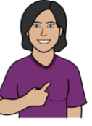
- Leadership and taking part.
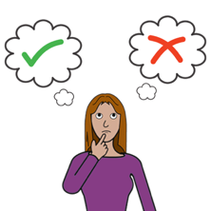

- Making decisions and choices.

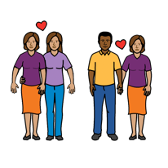
- Sex, women’s health and families.

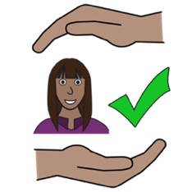
- Safety from violence.

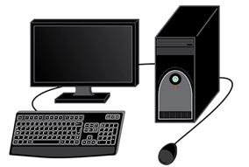
In Part 2 of the workshop the women were asked to do an activity on a computer to help WWDA understand how they use websites.

There were 8 important things that WWDA learned from the women at the workshops. They were:

- Women with disability want the website.
All the women who came to the workshops said the Virtual Centre was a good idea and was something that they would use.

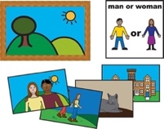
- The website should have lots of different stories.

All of the women at the workshops asked for stories and videos on the website. Women with disability want to see, hear and read stories from other women like them.


- The website should have guides and checklists
Many of the women at the workshops wanted guides and checklists that they could use to help with things like: applying for a job and employing a support worker.

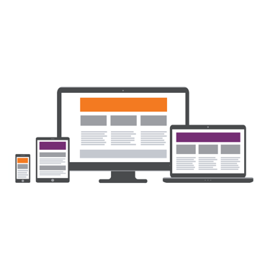
- The website should be easy to use.
All of the women at the workshops wanted the website to be easy to use for people with different types of disability. They also said it was important that they could use the website on tablets and smart phones.

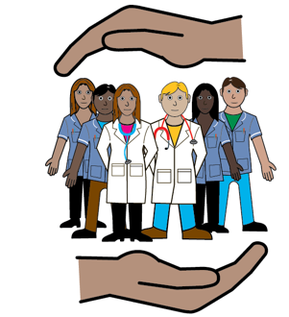
- Women need information on services and supports.
Many women said that they needed information about services and who to go to for help. The website could help women work out how to find this information.

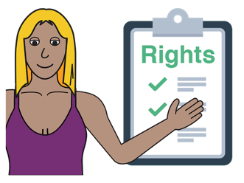
- The website should help women stand up for themselves.
The workshops showed that the rights of women with disability are often not supported. Having information on the website that will help women with disability to stand up for themselves is important.

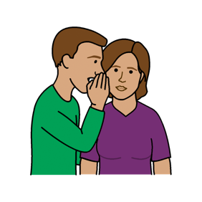
- The website should have information on private and sensitive topics.
Women at the workshops wanted information on the website about private and sensitive topics like sex, relationships, violence and bodies.
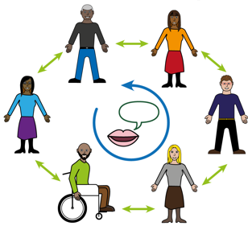
- The website should help women with disability to connect with other women like them.
All groups asked for the website to have ways to connect with other women with disability online for friendship and mentoring.



Acknowledgements

Authorship
Women with Disabilities Australia (WWDA) wrote the content for this booklet.

Copyright
© Copyright Women with Disabilities Australia (WWDA) Inc. 2019
The information in this booklet is for general education and information purposes only.

All intellectual property rights, including copyright and patents, in these booklets are owned and licensed by Women with Disabilities Australia Inc.

Funding Acknowledgement
The Virtual Centre project is funded by the National Disability Insurance Scheme (NDIS) in collaboration with Women with Disabilities Australia (WWDA).

Image Licensing
Easy on the I Images © 2018 Leeds and York Partnership NHS Foundation Trust. Used with permission. www.easyonthei.nhs.uk.

