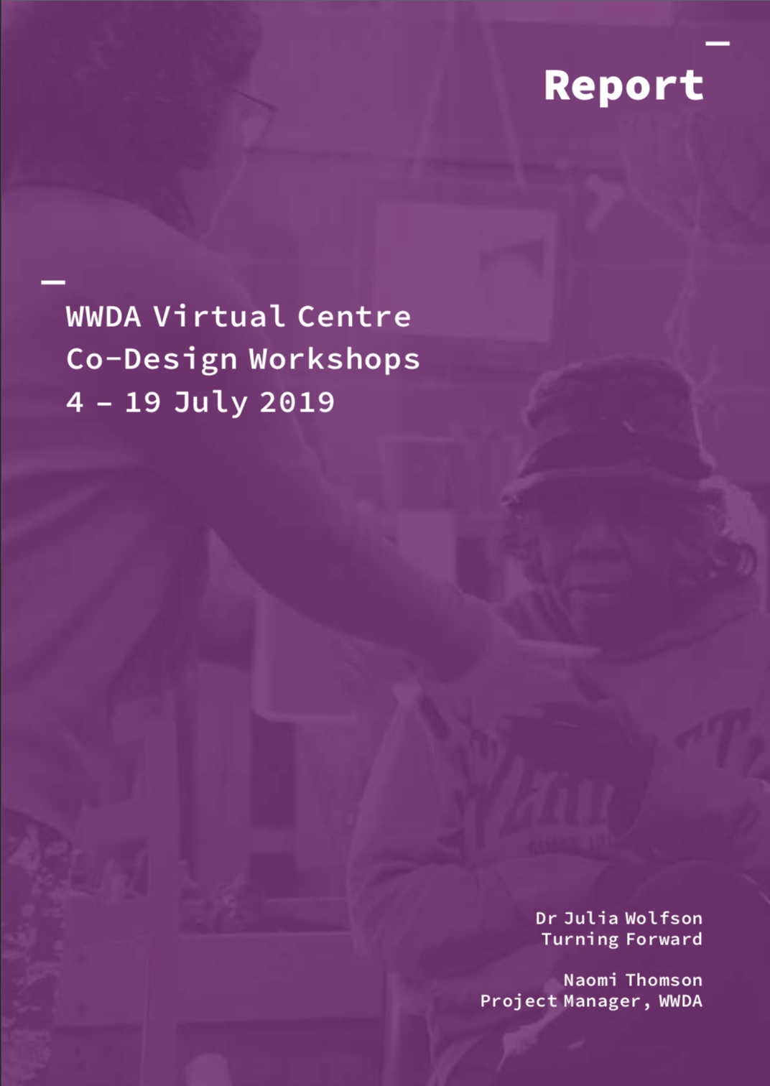

Report

WWDA Virtual Centre

Co-Design Workshops

4 – 19 July 2019

Dr Julia Wolfson, Turning Forward

Naomi Thomson, Project Manager, WWDA

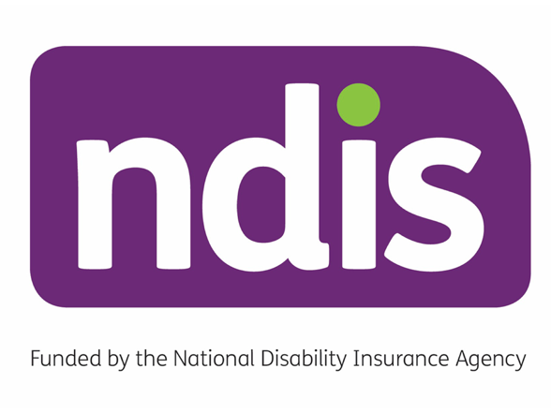

Contents
Executive Summary 4
Part 1: Context 7
1.1 Background 7
1.3 The workshops 8
1.4 Report scope 9
1.5 Needs and wants that emerged: Summary 9
1.6 Workshop locations and participants 10
1.7 Workshop approach 11
1.8 Ensuring accessibility 12
1.9 Emotional well-being and safety 12
1.10 Website technical design 13
Part 2: Needs and wants: what we learned 14
2.1 Distinct themes across the six workshops 15
2.2 Feedback on Overall structure 16
2.3 Your Rights: Overview page 16
2.4 Leadership and Opportunities 21
2.5 Choices and Decisions 24
2.6 Sexuality, women’s health and family 27
2.7 Safety from violence 30
2.8 Navigating the NDIS 33
2.9 Website design and usability 34
2.10 Workshop Evaluation 36
Part 3: Reflections, outcomes and suggestions 38
Conclusion: Unity in diversity 41
Acknowledgement and thank you 41
Appendix 1: Workshop attendance summary 42
Appendix 2: Consent form (Plain English) 43
Appendix 3: Consent form (Easy English) 47
Appendix 4: Workshop Agenda – example 62
Appendix 5: Wireframe Prototype Activity Response Form 63

Executive Summary
WWDA undertook a series of workshops around Australia with diverse groups of women, to find out what they needed and wanted from the Virtual Centre, a web-based information source to address five priority areas of need: rights, leadership, decision-making, safety from violence and sexual and reproductive health.
The workshops involved smart, wise, humble, proud, tenacious and energising women of all ages. The purpose of the workshops was to ensure that the Virtual Centre is both responsive and reflects the diversity of women with disability around Australia. The project brief stated:
The facilitation of the co-design workshops will be collaborative, adaptable to each workshop’s context and will harness the unique expertise, insight and skills of local women with disability.
Dr Julia Wolfson was hired to design and facilitate the workshops. The co-design format allowed the WWDA team and facilitator to be learners, and the participants to educate, inform and make visible what was on their minds and what they felt would be useful on the Virtual Centre. The workshops were iterative and adaptive in that each workshop benefitted from the experiences and insights of prior workshops in refinement of structure, team roles, facilitation style and content focus.
The WWDA project manager led the project and attended all workshops, accompanied in some locations by the WWDA Senior Content Officer and WWDA Communications Officer. A local co-facilitator – a women with a disability – was recruited in each location on the advice of the local host organisation to provide insight into the local context and to ensure that each workshop was truly for and by women with disability.
The website design agency Handbuilt Creative was contracted to undertake the design and development of the Virtual Centre. Handbuilt staff attended three of the six workshops to gain first-hand insight and experience.
The workshops were structured in two parts. Part one was a highly interactive and frank discussion across the five priority areas. Part two gave individuals the opportunity to take part in an initial prototype testing activity to inform the development of the Virtual Centre layout.
Workshops were held in six locations: Hobart, Canberra, Melbourne, Brisbane, Tennant Creek and Perth. In total 45 women between ages of 18 and 65 participated.

Summary of key learnings from the workshops
- Overwhelming support for the creation of the Virtual Centre and appreciation for non-tokenistic involvement of women with disability. The participants valued being part of the website development so early on, and the opportunity to contribute meaningfully through the workshops.
- Stories, stories, stories. There was unanimous request for stories and videos to be a feature of the website. Women want to see themselves, their strengths and diversity reflected in the website. They want to see, hear and read stories from their peers as this can create a sense of “I am not alone”.
- Practical guides, checklists and resources for navigating specific situations should be provided on the website. This could include situations such as going for a job interview, when and how to talk about your disability, how to tell your carer to stop being controlling.
- The layout and design of the website should make it easy to use, including for those who require a support person to assist them.
- The Virtual Centre has an important role as a self-advocacy tool because it is equipping and resourcing women to be self-advocates, and to advocate for others.
- There was widespread appreciation that the Virtual Centre is offering information on sensitive and often taboo topics such as violence, gender and sex.
- There was a widespread desire for the website to provide a virtual forum for mentoring, connectivity and interaction on topics that matter to women with disability.

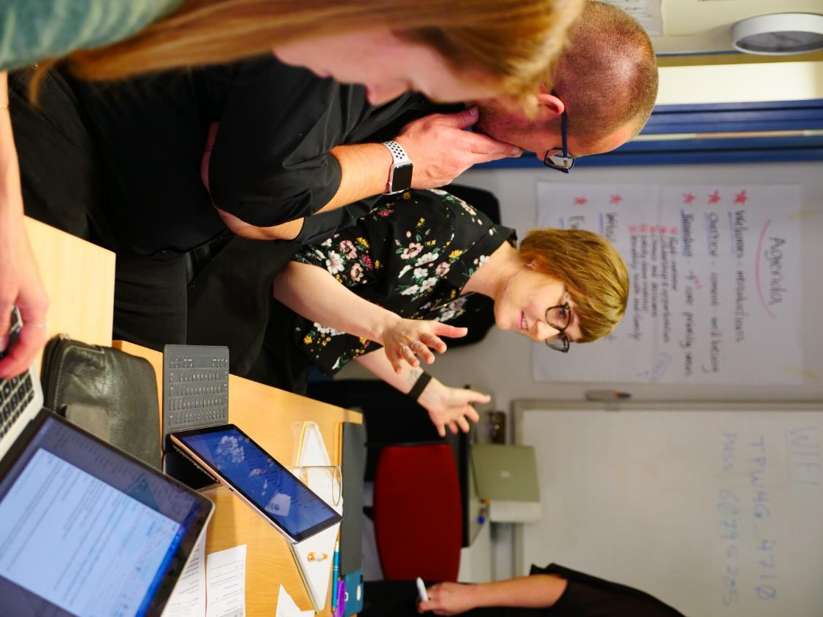
Participants in discussion at the Canberra workshop

Part 1: Context

1.1 Background
The Virtual Centre for women and girls with disability (‘the Virtual Centre’) is a new website that will provide accessible, inclusive and practical resources and information for women and girls with disability. The Virtual Centre is being created by Women with Disabilities Australia (WWDA) using funding provided by the National Disability Insurance Scheme (NDIS) Information Linkages and Capacity Building (ILC) program. Project Planning commenced in late 2018 and the Virtual Centre is due to launch in early 2020.
The goal of the Virtual Centre project is:
“To develop a centralised and sustainable Virtual Centre for Women and Girls with Disability that provides accessible and quality information on their rights to: decision-making and agency; leadership and participation; sexual and reproductive health; and safety from all forms of violence.”
The Virtual Centre will publish information and resources on the priority areas listed in the project goal. These priorities have been selected by women with disability in Australia through multiple structured consultation processes, including the WWDA National Forum (2017) and the National Symposium on Violence Against Women (2013). WWDA has published position statements that provide more information on each of these priority areas, which are available here: http://wwda.org.au/papers/toolkit/position-statements/.
The primary target audience for the Virtual Centre is women and girls (aged 15 years+) with disability in Australia. WWDA recognises that the unique experiences of young women and girls with disability under the age of 15 years may require different considerations, which are beyond the scope of this project.
In early May 2019 a competitive tendering process was undertaken to recruit a website design agency. Handbuilt Creative, based in Richmond Tasmania, was the successful tenderer, largely due to their experience in designing user-driven, accessible websites.

1.2 Participation and co-design
WWDA recognises that the meaningful participation of women and girls with disability in the design, implementation, monitoring and evaluation of targeted measures to advance their rights, is critical if they are to realise those rights.
The Virtual Centre project is utilising a co-design approach to ensure that the project is led and influenced by women and girls with disability at every stage.
Co-design is a collaborative, participatory approach to design which actively engages and places decision-making capacity in the hands of end users. Co-design goes beyond simply involving stakeholders in the beginning stages of design. Participants engage in problem-solving, decision-making and feedback processes throughout the project cycle, allowing for genuine and meaningful contribution,. Co-design principles are widely recognised as best-practice in the disability sector and utilised by the National Disability Insurance Agency (NDIA) and National Disability Services (NDS) to ensure service-user inclusion and satisfaction.
The Virtual Centre project’s co-design approach includes ensuring the meaningful participation of women with disability in governance and decision-making bodies. The Virtual Centre Project Steering Committee (PSC) oversees the governance and strategic direction of the Virtual Centre. It comprises seven women who are experts in their areas and have deep networks throughout the women’s and disability sectors. Four of these women identify as women with disability.
The Virtual Centre Expert Advisory Panel (EAP) is comprised of over 40 women with disability. This diverse group is consulted with regularly to review and provide feedback and input on Virtual Centre content and design. The EAP help to ensure the website is accessible, inclusive and relevant, and importantly, guarantee that the Virtual Centre is developed by women and girls with disability for women and girls with disability.

1.3 The workshops
As part of the co-design approach, participatory workshops were held around Australia in the mid stages of the Virtual Centre development. The purpose of these workshops was to seek feedback and input from a range of women with disability on the design, structure and content of the Virtual Centre. The workshops were to be engaging, inclusive and positive events that provided a safe and enjoyable space for women with disability to contribute to the design and development of the Virtual Centre. The workshops were intended also for the project team to capture input and feedback from women and girls with disability who may be harder to reach and/or who prefer to be engaged with in person, in order to have the opportunity to contribute meaningfully.
Collating the feedback from the co-design workshops in this report and acting on it will ensure that the Virtual Centre is relevant, accessible, collaborative and usable for a wide range of women and girls with disability.
WWDA’s commitment to genuine co-design led to hiring a workshop facilitator highly experienced in co-design in the disability space as well as across diverse sectors, in Australia and internationally.

1.4 Report scope
Part 1 of this report presents the context of the co-design workshops. Part 2 covers the information and feedback gathered from participants at all six workshops. Part 3 offers some reflections and suggestions for the website, with possible directions for the Virtual Centre. To assist the reader to get an immediate overview of needs and wants that emerged, a summary of highlights is presented in the next section.
The report focuses on the content aspect of the Virtual Centre website, in five core focus areas, with some additional topic areas that emerged during the workshops. As the Virtual Centre is for and by women and girls with disability, decisions about prioritisation of the material will be made by the project team in consultation with the EAP and PSC and are beyond the brief of this report.

1.5 Needs and wants that emerged: Summary

Overall learnings from the workshops
There was overwhelming support for the creation of the Virtual Centre, and non-tokenistic involvement. The women valued being part of its development so early on, and to contribute through the workshops.
Stories, stories, stories. There was unanimous request for stories, videos and showing things rather than just explaining them in text. Women want to see themselves, their strengths and diversity reflected in the website.
Practical guides, checklists and resources are needed for navigating specific situations such as: going for a job interview, when and how to talk about your disability and how to tell your carer to stop being controlling or patronising.
The Virtual Centre has an important role as a self-advocacy tool because it is equipping and resourcing women to be self-advocates, and advocate for others.
There is widespread appreciation that the Virtual Centre is offering information on sensitive and often taboo topics such as violence, gender relations and sex.
There is a widespread desire for the website to provide a virtual forum for mentoring, connectivity and interaction on topics that matter to women with disability.

Website design
It was clear from the feedback that there is a tension between accessibility and complex functionality built into design decisions. It became evident that the Virtual Centre website may need to trade some functionality aspects to extend the accessibility of the site to anyone who can use a computer (even with help).
This means cleaner design, clearer fonts, icons with thicker strokes, contrasting colours. It became clear that a well-designed, accessible website was far more preferred to a powerful online resource, and Handbuilt Creative is already taking steps to reflect this in their approach.

1.6 Workshop locations and participants
The local workshops offered a unique opportunity to engage with women who can most meaningfully contribute in a face-to-face environment. The workshops also welcomed and encouraged a diverse group of women to attend. The range of disabilities represented included physical, intellectual, learning and psychosocial. Workshop participant numbers ranged from four to 12 across the workshops. In total 45 women participated in the events, with ages ranging from 18 to 65. Further details on workshop participation is available in Appendix 1.
The workshops were held in partnership with a local advocacy or service organisation. The six locations and partners were:
- Hobart, Tasmania (in partnership with Speak Out Association of Tasmania)
- Canberra, ACT (in partnership with Women with Disabilities ACT)
- Melbourne, Victoria (in partnership with Women with Disabilities Victoria)
- Brisbane, Queensland (in partnership with WWILD)
- Tennant Creek, Northern Territory (in partnership with First Peoples Disability Network)
- Perth, Western Australia (in partnership with Women with Disabilities WA).

1.7 Workshop approach

Guiding principles and outcomes
A key principle of the Virtual Centre is that it is for and by women and girls with disability. The principles that guide the Virtual Centre also guided the workshops:
- Women and girls with disability actively contribute to leading, shaping and influencing their community
- Women and girls with disability are connected and have the information they need to make decisions and choices
The workshops used a co-design approach (see section 1.2).
The purpose of the workshops was to augment the feedback and recommendations gathered thus far from the PSC and EAP members, with direct feedback in-person from women in diverse settings and with diverse requirements.
The focus of the co-design workshops was for the WWDA project team to learn how to make the Virtual Centre content and functionality most relevant, usable and accessible.

Facilitation team
Dr. Julia Wolfson of Turning Forward (see www.turningforward.org) was hired to facilitate the workshops, report on the learnings and make recommendations. The WWDA Project Manager attended all workshops, and the WWDA Senior Content Officer and WWDA Communications and Marketing Officer attended most workshops.
Every workshop was co-facilitated by a woman with disability. Before the start of each workshop, the travelling WWDA team met with local facilitators to learn about the local context and to go through the workshop program.
The local facilitator welcomed participants, acknowledged country and elders, and took ownership for creating a welcoming ambience to encourage participation.
There was no lengthy lecture of content provided. The topic for discussion was given by the facilitators, the participants provided content and responded to open questions.
The flexible style of facilitation and the use of visual posters stuck up on the walls around the room enabled spontaneous contributions to come out across themes and be immediately captured. This also made it easy to pick up where the discussions left off if the discussion shifted to a deeper level of emerging feelings and concerns.
The WWDA facilitation team viewed themselves as listeners and the participants as teachers.
An example of a workshop agenda is provided in Appendix 4.

Feedback
Participants were invited to provide feedback at the end of the workshop about the extent to which they felt free to participate and express their views. They were also invited to give advice to the facilitators on how to make future workshop more inclusive and participative.
The WWDA Project Manager undertook to stay in touch with participants about ongoing progress of the website moving forward. This included future opportunities for user testing of the website in their own time, from their own devices.
All workshop participants were also given the opportunity to review and provide comments on this workshop report prior to its finalisation. An Easy Read version of the Executive Summary will also be made available.

1.8 Ensuring accessibility
All workshops were held in accessible venues. Local partner organisations in each location assisted the travelling WWDA team by providing information on each participant’s interests, communication style and accessibility requirements prior to each workshop. If relevant, the local team ensured that participants had a support person or assistant present to enable their full participation.
All workshop materials were provided in alternative formats where required – this included the development of Easy English summaries and consent forms (see Appendix 3). The flexible facilitation style and the use of both verbal and visual communication methods also helped to ensure inclusion of all participants.

1.9 Emotional well-being and safety
The workshops had an advocacy focus and were not primarily intended as a space for sharing personal experiences. Even so, difficult experiences from the past and present naturally surfaced. The facilitation approach was open to emotional experiences and gave them space, appreciating personal strengths and resilience that shone through.
Various visual cards were strewn around the tables that could be used by participants to indicate if they needed to stop, pause, take a break, or speak with someone privately.
The local teams and facilitators had a vital role in creating a welcoming, energised and culturally safe environment that encouraged participation. In some localities (such as ACT and QLD), local team members were certified in mental health first aid and/or violence response and were available to respond in the event of a disclosure or need for support.
Local teams were asked to prepare a referral list of counsellors, therapists and other specialist providers in their area, and have access to a local counsellor if not already available within their organisation. The WWDA project team brought along and distributed 1800RESPECT flyers.
When hot topics arose, the facilitator took time to pause and check whether the group wanted to keep going. Asking permission any time the atmosphere shifted and deepened, or when someone began to tell a painful story, helped to create safety in the group.
Another safety practice was to frame the more painful topics as an advocacy discussion. The facilitator began such conversations by thanking everyone for being present and appreciating the survival abilities and strengths in every person to go through the ups and downs of life, and to endure things that no human being should have to go through. Questions were posed: ‘What got you through?’ ‘What might the Virtual Centre show or do, to make this different for others coming after you?’ ‘What would you say to someone who went through what you went through, and didn't know what to do?’ ‘Has anyone else here experienced that? Ah! You are not alone!’. This made it easier to stay with the more generalised advocacy purpose.
All participants signed a consent form prior to the workshop commencing (see Appendix 2 and 3). This ensured that they were all comfortable with the workshops being recorded, allowed them to decide whether they were included in photos and explained how and where their feedback would be used.

1.10 Website technical design
The functionality, design and accessibility of the website was also discussed in the workshops. Handbuilt Creative CEO, David Shering was present at the co-design workshops in Hobart, Melbourne and Canberra. The workshops sought to learn how diverse users will most easily interact with the site, and understand accessibility needs and considerations. In particular, Handbuilt Creative wanted to learn who was going to use the website, and what functions the users might typically perform when using a website. Handbuilt Creative and the WWDA project team were working from the assumption that users are able to access the internet and navigate a website (either on their own or with assistance).
At each workshop participants were invited to try out three prototype wireframes in a personal interview with a WWDA/Handbuilt team member and provide feedback on their unique accessibility and user preferences. In total, 32 women completed the activity. The response form is attached at Appendix 5.
It was clear [from workshop discussions] that a well-designed, accessible website was far more preferred to a powerful online resource, and we have taken steps to reflect this in our approach. This means cleaner design, clearer fonts, icons with thicker strokes, more contrasting colours and a range of other techniques.
David Shering, Handbuilt Creative
A ‘user profile’ spreadsheet was completed after each workshop which detailed each participant’s responses to the prototype wireframe testing activity and captured any additional feedback and insight they provided.

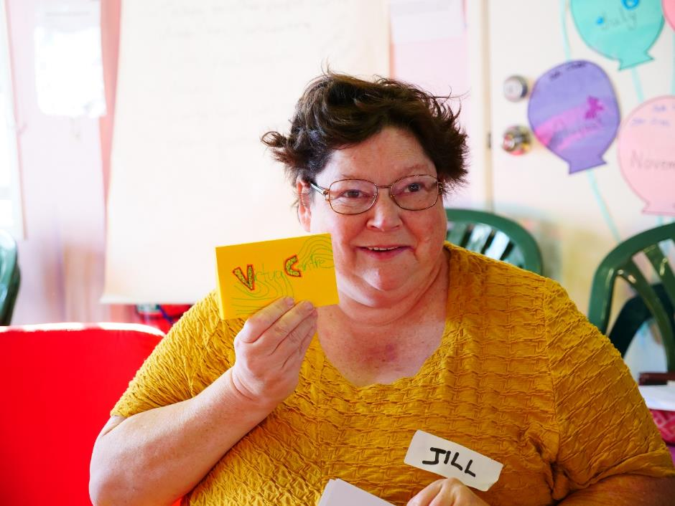
A participant at the Brisbane workshop holds up her design of the Virtual Centre logo

Part 2: Needs and wants: what we learned
This section provides a synthesis of the content learning from the workshops under the five topic headings. The WWDA project team and Expert Advisory Panel can use this information to prioritise feedback and requests.
The order of presentation here is not intended to convey a hierarchy of importance. Direct quotes from the workshops are provided in italics. Where relevant to the content, the specific location is identified. In some instances, a participant asked for their name to be attached to the quote. [Words in brackets] indicates they were added by the authors.

2.1 Distinct themes across the six workshops
There were themes common to all six workshops (as outlined in the executive summary and section 1.3). Each workshop also had its own unique flavour.
A variety of hot topics popped up and were given space to be processed in each session. When someone had something to say, however seemingly off topic, the group listened. Invariably the person was carrying something urgent and meaningful to the whole group that was relevant.
In Hobart, women living in residential settings spoke of the everyday restrictions on their environment, freedom of movement, and choices and decisions made for them by staff.
In Canberra, the women emphasised accessibility and adaptive communication to enable women with a myriad of communication styles to express themselves. Hidden disabilities folded under mental health stigma was also a topic – women expressed that they are not seen or believed, and their situation is dismissed. Women expressed a lot of anger at unwanted touch by people trying to be helpful but actually “clutching your arm, holding your cane, or touching your wheelchair”.
In Melbourne many women expressed immense frustrations with NDIS planning and responsiveness. Some expressed the painful experience of being seen as less-than within the disability community. One’s worth – we were told – varies depending on whether you were born with your situation or acquired it later in life.
In Brisbane, women living in the aftermath of violence spoke of the difficulties getting support to get back on their feet.
In Tennant Creek the women strongly advocated for the content and presentation of the Virtual Centre to be culturally relevant and mirror the lives of indigenous women and girls. In addition, the women spoke of the cycle of violence: who and what creates it, and what might help to break it.
In Perth the women emphasised the vexed topic of power and misuse of power by support workers. We learned of the agony of put downs, basic disrespect and restrictions on basic life choices. As one participant said: “It starts out all right, then they take over. I’m not your client, I’m your boss”. Another strong theme was the power of individual agency in influencing practical improvements to a more inclusive and accessible public environment.

2.2 Feedback on overall structure
This section covers the feedback in each topic area from all six workshops, comments on design and accessibility, as well as additional topic areas that emerged across the workshops, such as the National Disability Insurance Scheme (NDIS).

2.2.1 Sections to add:
What is disability? “Your disability may be invisible on the outside, but its real!”
United Nations (UN) definitions
Relevant statistics: e.g. % of population have a disability, what kinds of disabilities.

2.2.2 Ideas for each of the five focus area sections:
Provide a brief summary of the topic, a definition of the topic area, Frequently Asked Questions (FAQ) and reliable and verified links to more information.
On each page include contact information to make it easy to find without going back.
Provide legal frameworks – national and state-by-state pulled together in one spot
Statistics: Include summary statistics in every section relevant to that section

2.2.3 General requests:
Definitions of all key terms used
Examples and case studies
A suggestion box and ability for users to submit content.
Ensure the site is constantly updated.

2.3 Your Rights: Overview page
While every topic on the Virtual Centre covers rights, the Your Rights sections will give an overview. Some suggestions from participants:

2.3.1 Summary – key messages
The Australian rights framework
UN rights framework
Legal rights – being a decision maker
Information on consent
Information on discrimination
Rights are equitable and universal
Intersectionality – rights cut across various areas of life.

2.3.2 Statistics
Incarceration rates of people with disabilities
Gender inequities.

2.3.3 Frameworks
The Australian rights framework
UN Conventions (include Easy English/Read versions)
Your legal rights as a decision maker
About consent
Advocacy information.

2.3.4 About rights: what are your rights?
Clarify in practical ways what exercising rights might mean to different people. This could be in a story, talking book or some other lively way.
Respect, equity and opportunity: The right to be happy. The right to enjoy an everyday life with the same opportunities that people in your community and in Australia expect and enjoy. The right to non-discrimination. The right to be seen, heard and respected.
“The right to respect: to be listened to, not to be told ‘you are stupid because you have a disability’. The right to get help when you don't understand”.
Safety: The right to be and feel safe.
Home: The right to move house if you want to. The right to have access to country and be on country for end of life.
“Government housing has no insulation. It’s freezing. Great rate of deaths from the flu here. People are freezing in their homes” and “People over 50 are facing homelessness and women with disabilities are in violent situations”.
Fair treatment: The right to complain about rights violations, restrictive practices and unfair treatment, and get redress.
Relationships: The right to an intimate relationship, where intimacy is defined by you. The right to sexual relationships and respectful relationships.
Care: The right to good care and support that respects your rights. The right to be supported by a person of your preferred gender.
“I want to say to my support worker, I am not your client, I’m your boss! One lady berated me for being a control freak. I’m allowed to be! It’s my life! They infantilise you. It starts out alright, after a while they take over”.
Family: The right to have a child and raise your child and show what a great parent you can be – not have your child taken away.
Self-advocacy: The right to make your own decisions. Your right to be included in decisions about things that affect you and are important to you. Right to use bush tucker.
Participation: Your right to be included and participate in a group you are part of: “Don't just assume I can’t do it”. The right to a case-worker to help you get out of the house and find low-cost or free opportunities in your local community. To participate, learn, develop interests such as find an exercise group or an art group, contribute, meet people.
Information: Your right to information about things that are important to you, in an accessible format.
Education: Your right to be informed about how society works. Your right to education. The right of students in special schools to be provided with equitable education.
Privacy: Your right to privacy regarding your records and personal information. When there is a third party involved, how to assert yourself to get accurate information and assert your right to give permission to have your information passed on. Your right to non-disclosure and privacy about your disability.
Consent to touch: Your rights with your body. Your right to not be touched without consent. “Ask me if you can touch me, even if you are helping me get upstairs”.
Employment: Your rights at work. Your right to equity in employment. Your right to gender equity in the workplace, and an equitable wage in the workplace. The right to progress on a career path. Your right to choose your work.
“My right to job support to learn the job and not get fired for making a mistake”.
Advocate: Your right to an external advocate/supporter.

2.3.5 Videos, stories moving books
Stories of survival. Role models living ordinary lives. Messages of encouragement to keep going through the tough times. “How to” stories
Stories to encourage you to reinforce what you are good at and keep moving forward
Stories that show what to do if people are mean to you
Message to parents: “Let me do my own thing”.

2.3.6 Tips, tools and checklists
How to make a complaint
Hiring your own staff to get the support person you like and the support you want and need
What to do if…. with examples: “My support worker texts while driving. It’s dangerous!” “The tap in my shower is broken, I have asked and asked to get it fixed I’m scared to get in the shower in case I get burned”
Go to someone you trust
What accommodations do you have the right to ask for in different areas of life (e.g. work), and how to go about it?
Some tips as to how to enter a space with any professional – and have adequate time and space to tell what is going on
“A checklist to help me understand my own access requirements”
What you can expect when you go to a service for assistance?
How to strengthen your self-esteem.

2.3.7 Links to quality information
Your rights in the criminal justice system – for instance, if you are arrested.
Finding an advocate. Some girls and women are good at advocating for themselves. For some the barriers are too great to advocate and negotiate on their own. Find an advocate if you need it. Sometimes this is someone beyond your paid support and natural support network whose sole function is to support you to advocate for your rights
Your rights to have the carer you want, and what to do about a carer who overpowers you
Link to UN conventions, including Easy Read
Links to UN Declaration on the Rights of Indigenous Peoples
Links to Facebook groups for peer exchange, information and support to know and exercise your rights
Link to information about carer boundaries and limits – what you can expect
Link to Human Right Commission
Link to health rights – a document on People with Disabilities (PWD) website
Links to advocacy information and organisations (e.g. Persons with Disabilities Australia)
Link to heath consumers councils
Link to AdvoCare – for women on the aged pension
Link to culturally and linguistically diverse (CALD) websites with information about rights
Links to Aboriginal and Torres Strait Islander (ATSI) websites with information about rights
Links to vision impaired and deaf community websites
Where to get practical assistance to navigate services, including how to fill out forms etc (e.g. Anglicare’s Alina in Brisbane).

2.3.8 Myths and facts
To educate and raise awareness among carers, family members, service providers, the broader community, civic institutions and civil society.
“Don't compare me with others. I am an individual with unique gifts”
Women with disability are often seen as inadequate mothers because of their disability. Include a mother’s story.

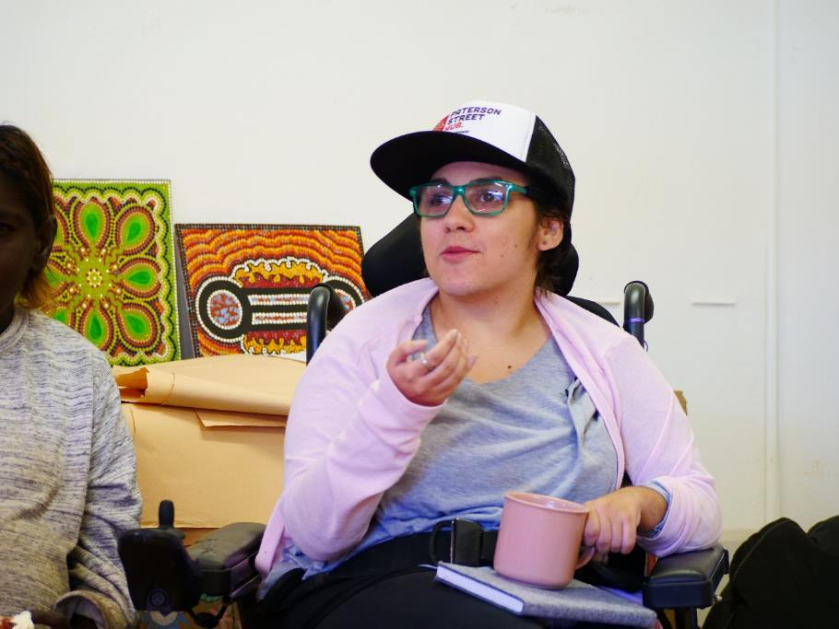
A participant contributes to the discussion at the Tennant Creek workshop

2.4 Leadership and Opportunities

2.4.1 About leadership
“Be a leader by leading others to become leaders”

What is leadership?
What it is and isn’t - what does good leadership look like?
What is leadership mentoring? The value of finding a leadership mentor and being a mentor. The boundaries of mentoring
Tokenism – and what to do about it
Getting a job for some is an act of leadership, and provides leadership opportunities
What is advocacy? The right to advocacy
Encourage younger women to progress on a career path
What is involved in being a leader and what are some benefits?
Write letters to government
Support others to speak up
Join an executive committee
Be a role model for other self-advocates
Find a self-advocate mentor
Learn how to take responsibility and get organised
Be a representative – think broader than just your own needs
Experience diversity.
“Role models and mentors are very important to help you build confidence by showing others how. I went to the United Nations in the USA. Presenting on stage is scary, but you can just do it, and get courage by seeing others do it”.
“Mentors are like a best friend – there for you no matter what”
“Carer pressure can be limiting, for example, the carer’s mindset and values can limit your sexuality. If you come up against barriers, NO, keep at it, don't give up. Seek support/mentoring/assistance to pursue your path”.

2.4.2 Stories, talking books, videos, resources
“There are opportunities everywhere. Be open. They present themselves when you least expect it” Liz, Perth
“You can grow up to be anything you want to be” Jackie, Perth
“Don't dream your life away, believe in yourself” Elizabeth, Perth
[What helps you find your personal power when the situation is agony? Finding a role model. Easing the path for others by sharing your story and what got you through. You have important lessons to teach about surviving, bouncing back from hard situations and using your experience to help others].
Get courage to overcome shyness: “People used to walk all over me”.
Videos and quotes in the words of indigenous elders
Leadership books – inspiring autobiographies and picture books are uplifting
Music – songwriters who create their stories in song
Guidance for starting a project (e.g. a business, a group etc)
How to talk about your disability at an initial job interview
Include inspirational quotes – see Brain Injury Matters
Examples of people who have gone through various leadership courses
Crystal – Sistergirl Australian of the Year Awards NT
Purple house – dialysis on country – Sarah Brown
Elizabeth’s story: Elizabeth went through the public toilets and recorded exactly what was needed to make them accessible, wrote to the council, and got action.
“Snap, send, solve” App – you can use this to take a photo of something that isn’t accessible (e.g. footpath) and it will be sent to the council to action.

2.4.3 Opportunities: Things you can do to get involved and make a difference
Get asked to join a group
Join a youth group
Join health, fitness and good eating groups
Join a special interest group: “I went on the cat walk!”
Link up with international groups
Start a self-advocacy group, join a self-advocacy group and learn self-advocacy skills
Go to leadership camps – where you can make new friends, meet people and learn to trust
Meet people
Sign up for newsletters which often have information about events and groups
Join a mother’s group
Join activity groups and interest groups in your region/state to meet people, pursue interests, and develop a sense of belonging and expand your network
Join leadership trainings, camps and workshops. Learn to develop yourself and help others
Volunteer in your local community
Make a difference in your local council’s Disability and Inclusion Plan
Join advisory groups at your local hospital/council

2.4.4 Checklists, tips and tools
How to do publicity and media
How to plan for accessibility in getting around safely when travelling
How to prepare and dress for an interview. How to talk about disability in a job interview. Where to access interview coaching
Writing a CV and including your leadership role. Provide an example of a good CV
How to fill in an expression of Interest form – provide an example
Things you can do to facilitate end of life on country
Where to go and how to go about finding a mentor
Links

2.4.5 Information about governance opportunities and development

Leadership events and links
Redefining Leadership Exhibition in ACT
Stories on social media
Self-advocacy groups – national and state by state. Who you can contact in advocacy organisations?
Organisations offering mentoring opportunities
Organisations willing to be contacted if you want to offer yourself as a mentor
A.N.D employment link
Leadership events and training opportunities, where to learn self-advocacy skills (state-by-state links)
Applying for leadership scholarships
Disability Leadership Institute Australia resources
ATchat Facebook page – Peer support for getting a mentoring program up and running
Links to forums such as PWD – where you can learn, build up networks and ask questions.

Forums
Have an online forum for exchange of information. A space to grow naturally into mentorship roles for younger and older women.
Link to Disability Leadership Institute’s closed Facebook page. This page is reported to be well moderated and an opportunity to exchange, learn, network and mentor.

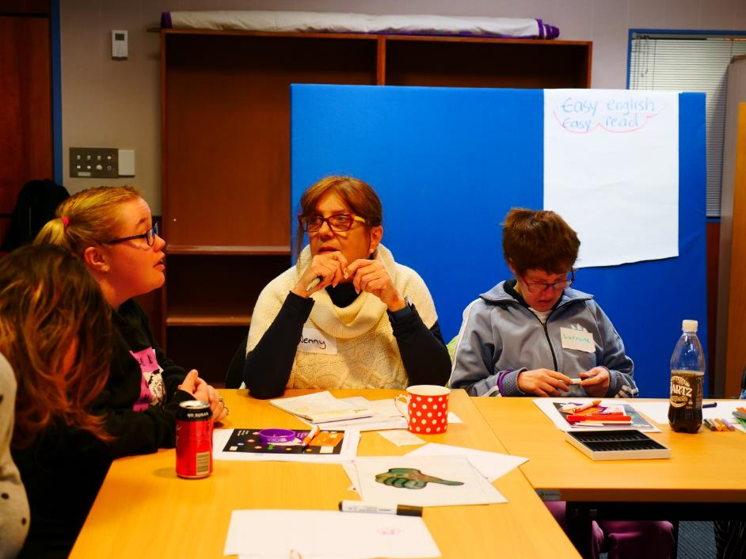
Participants in discussion at the Hobart Workshop

2.5 Choices and Decisions
“You are the only one who knows you! You know!”
“I have the right to make choices”

2.5.1 Definitions
Informed decision making
Supported decision making
Assisted decision making
Assumed capacity
Consent
Autonomy
Supported decision making
Guardianship and the role of guardianship boards. [The purpose of guardianship is to expand your exercise of rights, not lessen it].

2.5.2 Information
To make informed decisions, you need to have information on the scope of what is available
Gendered impact on access to choice and decision making for women
Decision making can take time
The importance of being believed and listened to
An advocate is someone who can help you speak up and speak for you
Who can step in and when.

2.5.3 Everyday life choices and decisions
Work you want, where you want
Where you live and who you live with
What activities you do and get involved in
Learn things, and attend courses
Choose what to cook, eat and when to eat
The right to self-expression – access to communication devices and communication support
The right to respect – to be treated like an adult and to be asked – not talked over
The right to direct communication with health professionals
The right to privacy – for a person with a psycho-social disability to refuse unwanted risk assessment that you feel corrodes your right to privacy
The right to assert your right to say no and state your needs
The right to choose your support
The right to go to your country, to eat bush tucker. Access to traditional ways. Access to going bush.
Residential settings – the right to have a friend over to visit, to stay the night. The right to have a pet.
“I made a decision to go to Hobart [for this workshop]”
“It’s your choice to make, not anyone to make it”

2.5.3 Stories, videos, talking books
Share your story with other women and girls and show: “You are not alone” “I look after myself”
Show women with disability leading ordinary everyday lives in pictures. Washing, cooking, looking after each other
“We don't leave people with disabilities on their own. Caring and sharing. Family help me around the house. That's our culture” Marjorie (Tennant Creek).

2.5.4 Tips and tools
Using your inner power: Taking control of your lifestyle choices. What to do about people who stop you from doing things? How to respond when people take over? How to be assertive, speak up and stand up for your rights? What language you can use when you feel shut down, infantilised. Some easy ways to say “No, this is what I need”.
Managing your support worker: How to get action when there is non-action by support workers e.g. getting something fixed. How to dismiss/change a support worker when it’s not a good match.
Safe environment: How to be safe in your home – appliances work, things in good order, the environment is physically safe.

2.5.5 Links
UN framework
Legal framework for consent and guardianship state by state
Advocacy organisations
Peak bodies
Public Advocate state by state
Guardianship frameworks, boards, tribunals state by state
Multi-Cap – whole of life disability support
Links to learn who can help you make decisions, and how to make them
Links to independent living centre
Create a noticeboard for individuals and advocates to learn about funding sources
Environmental design and adaptations for people with disabilities.

2.5.6 Resources
A user guide for guardians, supporters and various stakeholders in how to support decision making in order to enable exercising of rights
Decision making tools
How to support another person to make a decision
Where to find out about local activities? Join a choir, a theatre group, an art group, participate in community events etc.

2.6 Sexuality, women’s health and family
“You should always get consent and don't let them force you to do it or anything you don't want to do. Use a condom.”

2.6.1 Definitions
Sexuality as distinct from sex. What is sexuality?
Sexual orientation, gender diversity, LGBTQIA+ etc. also in Easy English
Consent: Enthusiastic, informed, participatory consent. “She didn't say no” is not consent. Often you might freeze of be unable to verbalise on the spot.
Sexual abuse
Information on basic terms in sex education in Easy English. Safe sex. Terms and body parts
Contraception
Sterilisation
Spectrum of normal
Terminology – e.g. Sistergirl is an indigenous term for transgender woman.

2.6.2 Myths and facts
Myth: “Women with disability are inadequate mothers because of their disability”. Show a video of a mother’s story. The agony of having your baby removed.
Myth: “Don't breastfeed, your boobs will go saggy”.

2.6.3 Provide accurate, relevant and accessible information on:
Consent and health providers: Your rights when seeing a heath/medical practitioner. The right to say no to getting undressed, to request and get personal space. Asking for more time in an appointment. Dealing with having to pay double because you needed more time.
Sex: You have the right to have and to enjoy sex, and not be hurt. The right to consent to sex – in Plain English. Positive messages about sex and sexuality. Accessibility barriers in being sexually active – advice and tips. Show safe sex visually with objects. No means No!
Family: The right to access fertility treatments (e.g. IVF). The right to have a baby and to be informed about what is involved in taking care of a baby, such as hygiene, food, bottles. Information about how to be healthy during pregnancy– links to good videos. Information about miscarriage and grief. Advice and information about family health state by state.
Guardianship: Guardianship and marriage.
“I’m 50 and my parents have guardianship over me and won’t allow me to get married”
Sexuality, sex, sexual health and education: Your right to accurate, accessible, relevant, situational sex education that is easy to understand. The right to information about women’s health. The right to have sex with a consenting person/partner. The right to education to understand consent and safe sex. The right to wear what you like as a way to express your unique self.
  - Your rights regarding your sexual health and freedoms and how to protect them
  - Consent – resources and awareness
  - Setting boundaries
  - Safe sex, sexually transmitted infections (STIs)
  - What are your options if you are pregnant?
  - Pregnancy stigma and how to prevent it
  - State by state options regarding abortion
  - How and where to get help
  - Contraception, sterilisation
  - Assistive technology – to explore your own sexuality.
Health: “If you know/feel there something wrong, keep at it, don't take NO – keep doing your research, seek second and third opinions. It can be life threatening”. Jo in Brisbane.
  - Importance of breast screening and pap smears
  - Range of complementary heath care options available
  - Consent around youth and sterilisation
  - Menopause
  - Include a list of some of the common challenges, obstacles, experiences, structural barriers and inequalities women with disability have encountered when trying to navigate/access healthcare (e.g. substitute decision making, ‘carers’ talking on behalf to health practitioners, medical procedures or conditions not being properly explained to women, reproductive health, mother with disability).

2.6.4 Links
Getting information/help with STIs
Getting information/help with unplanned pregnancy
Where to get the morning after pill
Consentability Facebook page
Contraception and consent (WWDA report)
Gender identity (WWDA report)
Intimately Disabled Facebook page
Links to websites on how to enjoy sex and intimacy and not be hurt
State by state links to health services
Accessing genetic counselling regarding having children
Queer community websites
Living safe and sexual lives – for people with intellectual disability
Parenting podcast on ABC Life Matters: “We’ve got this”
Breast screening and pap smears
Links to health professional recommended allies
iTalk studios for animated education and stories
Kulila! Indigenous language app (by NPY)
Mental health – who to talk to
Where to get help on the journey to passing – end of life conversations
Link to home heating subsidies for women with thermo regulatory disfunction.

2.6.5 Stories and quotes – graffiti wall
Experience of using sex to feel self-worth
Ageism about being sexually active
Expectations of health practitioners.

2.6.6 Forums
Forum for parents with an intellectual disability. Parenting boys and adolescents e.g. refer to closed Facebook group for parents of children with ADHD
Parenting support links state-by-state (e.g. Anglicare’s Alina Services in Brisbane).

2.6.7 Tips and tools, checklists
How to get healthy, how to stay healthy. Exercise, aqua aerobics, lifting bars, dancing, go for a walk along the river, join a Zumba class, Tai Chi …
Respect, safety and consent in relationships
Tips for making appointments with health providers: How to be confident in a phone call to ask, open up and get what you need. Getting the best out of a service when you call them – know what the service is for, so you are going to the right place for what you want.
Dispel tension and get your needs understood. “I’m your problem patient today” in a friendly tone, can sometimes allow the person on the phone to want to help you!
Check the physical access in detail. How close is the clinic/hospital to public transport?

2.6.8 Content

Messages – maybe in stories
Everyone is a sexual being and has a right to sex and to explore sexuality – that's inclusion
Love yourself, think for yourself
Do things you love
What is a good relationship? Loving each other, holding hands, sharing interests and ideas
Eat healthy, be heathy, care for your body
Help your children be healthy
Talk to someone you trust
Build strong networks – talk about taboo topics.

2.7 Safety from violence

2.7.1 Summary
Some core messages:
Family violence affects everyone in the family. Violence is nuanced. It may be invisible, but its real!! Find someone you trust and respect. Talk about sexual violence. Important that every person has a network and feels they are valued and they belong.

2.7.2 Definitions
Provide pictures, words, moving pictures to help women to understand what violence is, in all its forms.
Provide UN definitions
Define all forms of violence and abuse [mistreatment and neglect]:
  - What is violence? Types of violence and what they look like. Includes hitting, being pushed off the bus…. What is safety from violence?
  - What is sexual assault versus sexual abuse, and what it is not
  - What is abuse? Include financial abuse, social abuse and how they may specifically impact people with a disability.
Institutionalised and systemic violence. Exclusionary policies, restrictive practices
Intersectionality and violence against ATSI women and LGBTQI+ women with disability.
“Financial abuse is when people make you buy things for them”
Mandatory reporting.

2.7.2 Statistics
Statistics on violence, gender and disabilities, women with disability
Prevalence, who it happens to, ages, who perpetrates.

2.7.3 Information
What is the role of police?
Your rights regarding records
The fear of not being believed
Being safe in all environments – work, home, leisure
Knowledge is power – get yourself informed.

2.7.4 What to do and getting help
“Go to someone you trust and get help. Don’t stay with the person. Go to the cops and get help. Stay: STOP! I don't like it!”
This section should provide a clear pathway if this happens to you and advice on what to do. You should not have to wade through information.
You can call 1800 RESPECT, Download Sunny App, go to someone you trust
Discreet instructions for incognito browsing and quick ‘get out’ link
What actions to take if you are in an unsafe situation and need immediate and urgent help
Who you can talk to for support
Mandatory reporting rules.

2.7.5 Tips, tools and checklists
Provide different scenarios and checklists for teenagers, parents and carers
“I want to say to my carer: Stop telling me what to do!”
Downloadable fact sheets
Guidelines to support women with disability to become free from violence – messages of hope (WWD Victoria)
Make a poster for your wall at home with things that help you feel safe and strong
Make reminders for yourself and put them around you
Staying calm – tips
Try journaling. Sometimes you can’t talk about it, but you can write or draw it and show people that way
Join a support group. Check it out first to be sure it’s right for you and that you like the people. Does it feel safe and good to be there?
Things you can do to be aware of your safety
Self-respect checklist – things you can say/do about unwanted touch of any kind. Say No! if you don't like it or want it
Taxis: once you find a good one, stick with it! Book direct, not through central switchboard
The importance of valuing your personal space – be aware of it in different situations and how to hold on to it. Trust your instincts.

2.7.6 Reclaiming power – information, stories
Protective behaviours to strengthen women’s awareness to take back power
Bullying, and verbal abuse – learn to get in touch with your personal power to push back/get help
How to stay in control through the process of getting help. For instance: You can disclose to police and request it not be taken further at this stage
Finding and using your personal power to push back and get help
Saying no to unwanted touch.

2.7.7 Stories, videos, case studies
Confidentiality and support for those sharing stories. For instance, someone else can tell your story on your behalf so you are not identified
Content alert: Give a warning at what point in the recording or video there is content some may find disturbing
It’s OK to say NO! Stop! and be assertive
Messages of hope. We can stop it from happening
Stories of people who have gone through it and come out strong
What causes violence? e.g. jealousy
What does a non-violent relationship look like? What does a good relationship look like?
Stories of success.

2.7.8 Links
Resources for all ages. Online, national, state and local services
Response services
Prevention peak bodies
1800 RESPECT
SUNNY App
Domestic Violence Resource Centre Victoria (DVRCV)
Salvation Army – DV and financial support (Brisbane)
DV services – (Leona, Brisbane)
Self-care cards for people with low energy – full of ideas that don't require a lot of physical activity or movement
Positive action cards
Counselling services
Where to find professionals to talk to
Clutterbugs WA – will take your clutter/household goods to a women’s refuge
CrisCare – beds in refuges
Self-defence training
Links to good information
SECCA – including people with intellectual disability

2.8 Navigating the National Disability Insurance Scheme (NDIS)
“The NDIS will help [the problem of overpowering support workers] because it’s about self-managing” Elizabeth, Perth.
The NDIS came up repeatedly within so many of the discussions, therefore it has its own section here.
Right to apply for support though the NDIS to pursue your goals. Having access to ordinary everyday life opportunities that are available to people without a disability. Such as: work I love, being paid, a home I am happy in, pursuing my interests and goals, access to a good therapist
How to apply for the NDIS and develop a Plan. How to get your NDIS person to help you get what you need and help you to be able to pursue your goals
How to get NDIS funding for sexual rights
Need support to navigate the NDIS and all the admin involved. Things you can say to get more information in order to make better decisions.
[One participant wrote an entire submission within the workshop about the NDIS and it is presented here:]
“Choice and decisions – NDIS marketed giving disabled people more choices but there are many instances (often hard to detect) where choice is being manufactured.
Private NDIS providers to keep funding going into their own pockets will often limit clients to the services they provide, even when a service offered outside their business is more appropriate. Clients have to ask specifically for their NDIS worker to research services of other providers.
Private NDIS providers can be very insistent and pushy when it comes to clients signing new service agreements. Simple English, braille or audio versions of service agreements are often not provided.
A guide, or set of questions, criteria for people with disabilities to draw on to better assist them or a person close to them to choose an NDIS support worker that will best meet the individual needs. I.e. how many years of experience have you had working with people with disabilities (or more specifically what is your experience/knowledge of my disability, what have you studied? How long have you been in the disability sector?
Often a private NDIS provider will assign a random support worker to a client without much consideration as to whether they’re an adequate fit. Often people with disability have been waiting for services or for someone to contact them from the NDIS for such a long time that the moment a support worker is assigned to them they immediately ‘just go with it’ because of the urgency of needing to get support.
It needs to be more explicitly stated to people with disability that the worker assigned to them is not the one they have to work with.
I have mentioned the phrase ‘private NDIS provider’ a few times now and it occurred to me that perhaps some disabled people who are contacted by a ‘private NDIS provider’ might think they’re being contacted by the NDIA directly – and as a consequence of not comprehending this distinction they aren’t able to recognise how ultimately these providers are businesses (many businesses started under the NDIS have been started by people with no previous background in the disability sector”.
The Tennant Creek Barkly region was a first site for the NDIS. Equipment needs were the first priority. But wheel chairs were often not accessible in sand on country. We learned that there is no word for disability in the local language/s. The term ‘mad’ is used for both mental health and intellectual disabilities. Many don't think of themselves as living with a disability.

2.9 Website design and usability

Needs, suggestions and requests
“Easy English and Easy Read. Should have it on everything so people with disabilities can read it and understand it and read it properly. Loud and big!”
Easy read and plain English. No big words
Conversion button for easy read
Large font, well-spaced out
Not too much stuff!
Colour contrast between background and print e.g.: white and pink don't work!
Make it interesting and colourful
Use boxes, bold, clear, colour
Videos. Moving stories. Short. Clear message. Music. Acting. Colour
Stories in language. Use subtitles
Visual information. Buttons with icons.
“We want viewers to see diversity, see country, see social life. Indigenous women want to see our own age, our own situation in the videos” Tennant Creek.
Suggestion:
Summary section at the top (Easy English)
Plain English version under that with more detail
Links for more in-depth information for those who seek that
Screen reader compatible.
From a woman with autism:
Have a uniform pattern throughout so you don't get anxiety about what’s coming next
A pattern to the colours
Make it simple, “if it’s too overwhelming, I shut down”.
Have a section: What is this website and how do I use it?
Have audio format for those that don't read.

Layout
Under each category, after a ‘look out for these things’ sort of list, perhaps a recommendation of further resources/supports? Such as YouTube videos about the issue.

Networking
Create a forum to talk with other women and girls with disabilities
Facebook link to website moderated by WWDA for exchange about topics on the Virtual Centre.

Commonly used devices
Phone and tablet. Many without traditional computer literacy have workaround shortcuts to use computer – keyboard shortcuts by counting keys – shortcuts to various websites.

Access to internet in Tennant Creek
The local park will soon have a space to sit with free Wi-Fi. Michelle, hub manager, hopes to acquire computers for the Paterson St Hub.

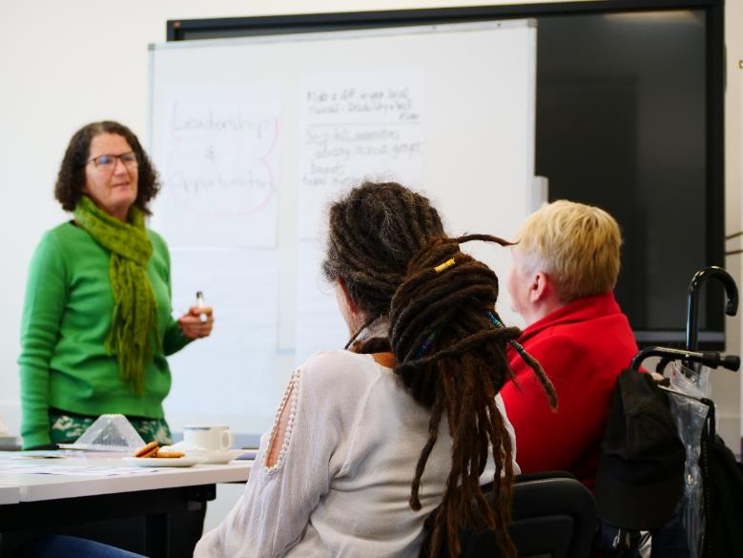
Workshop facilitator, Julia, listens to participants feedback at the Perth Workshop

2.10 Workshop Evaluation
In most workshops an evaluation was conducted. In one setting the evaluation was not logistically possible because of time constraints, comings and goings (Tennant Creek, Northern Territory). The evaluation happened in two parts:
Participants were asked to place dots on a large poster with a line from left to right that represented a continuum - starting at ‘I was not able to contribute as much as I would like. I have more to say’ to ‘I got say what I wanted’. A green dot indicated ‘I got to say what I wanted. Easy to have my voice heard’. A red dot indicated ‘I had more to say that didn't come out’. For those who could not perform the task physically, a local co-ordinator assisted. In five of the six workshops one red dot was used, the rest were green.
In addition, team members and local co-ordinators (not the facilitators) discreetly went to each person privately to ask what they felt had worked well, and what suggestions they may have had for improvement. The responses were as follows:

Suggestions for improvement:
More time
More meetings like this
More of these workshops
The last few topics were a little rushed
It was a little long, I got tired
I got a bit distracted with personal things
More pictures to explain what we were talking about
More money on the gift cards
I would like to talk about more subjects
More groups like this.

What worked well:
Talking, sharing, doing pictures, drawing, writing
I like the people moving [around] where you search [for information on the posters]
All!
Good to talk about complaints, to make sure we don't have complaints
I loved the leadership from people, and people sharing their stories. Feel privileged to be learning here
Get to see changes before they will happen, to make a difference for those who don't have a voice
Life experiences
Very interactive. Excited to see what comes out!
Grateful for the experience
Liked the sense of safety in discussion around sex and violence
Deep work
Time flies!
Feeling comfortable enough to speak about my/our experience
Atmosphere was calm and laid back
Well prepared and executed. Great work.

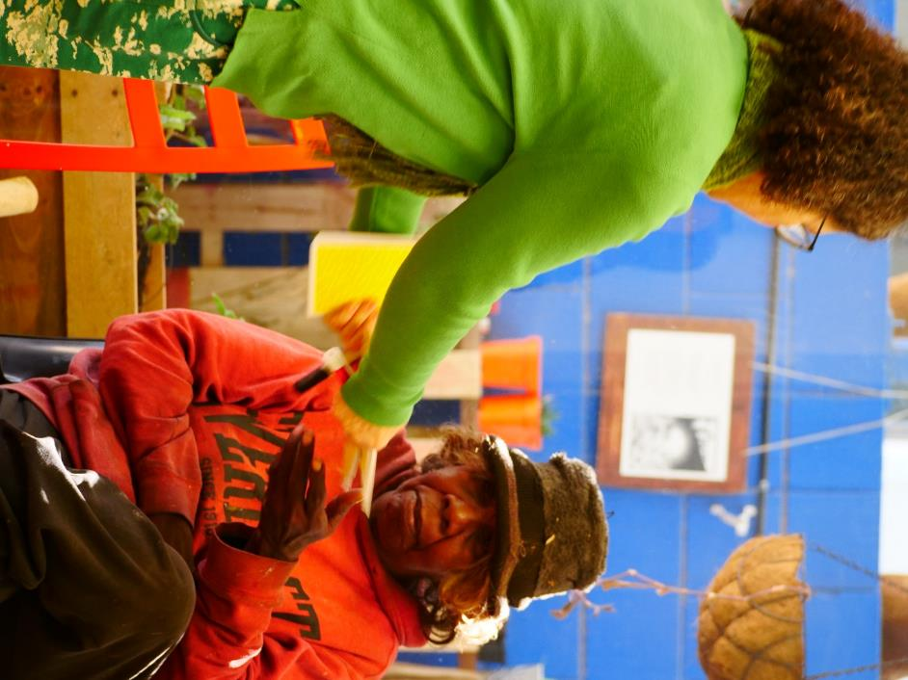
Facilitator, Julia, hands a participant a card at the Tennant Creek Workshop

Part 3: Reflections, outcomes and suggestions

Women want the website
The fact of doing these workshops in itself was important. Participants felt engaged. They appreciated being so involved, having their voices heard and influencing the outcome early on. Women across the board overwhelmingly expressed that the Virtual Centre is needed.

Stories, stories, stories
Across the board women requested stories and in particular, video stories. Women expressed over and over the need for role models that mirror their own lives.
Participants wanted to see and hear women with disability of all ages speak of their experience, how to live with pride, how to navigate the reality of everyday lives, to dream, and to show what is possible.
In response to the significance placed on this need, the project manager has now hired a professional film maker.

Practical guides for specific situations
It is not so easy to do things differently if you have never seen it done. Across the board, women indicated it would be a great help to have practical checklists and resources for specific situations, such as going for a job interview, stopping your carer from taking over and limiting you, talking about your disability at work, and many others.

Navigating services
The hunger for information about local services and clear and easy referral pathways is clearly a need for women with disability. In every location, the facilitators needed to explain that that the Virtual Centre is not a service directory. The Virtual Centre can, however, provide information that will help women to navigate services and referral pathways and help them to work out who to talk to that can assist them with this locally.

Self-advocacy tool
It became evident through the workshop experience that the Virtual Centre is providing a self-advocacy tool. It is equipping and resourcing women with information, role models, examples and the confidence to be able to advocate for themselves, as well as for and with other women with disability. Many women commented, “I know my rights, but how do I speak up about them? Particularly in situations where I feel less powerful – such as with my support worker”.
Some of the women who attended the workshops are already well aware of their rights, and many are already in advocacy roles. They were able to speak about what women need more broadly, and advocate for women in similar situations who many not know their rights and the potential impact the Virtual Centre could have in their lives.

Taboo topics
Many participants expressed appreciation that the Virtual Centre is providing information on more sensitive and often taboo topics in some settings –such as violence, gender relations and sex. It was stated multiple times that an online resource is a great way for women to research these areas themselves and learn about things they may not feel comfortable asking others about for information.

Connectivity and interaction
It was recognised that the online environment opens up all kinds of opportunities for women with disability to connect with other women all around the country and the world. Women wanted the website to provide some form of connectivity to be able to interact with each other on topics that matter to them. For example: a face book page, a virtual forum, on-line mentoring and networking opportunities. This request should be included in the overall Victual Centre strategy.

The Alice Springs experience
In Alice Springs it was not possible to organise a workshop with women with disability for local logistical reasons. The team did however, meet with various agencies providing services to women with disabilities to seek their direct input and feedback on the Virtual Centre plan. These meetings have the potential to strengthen the WWDA network. These organisations included:
The Purple House – an indigenous led and managed project for mobile dialysis on country. The team visited Purple House’s clinic, community centre and social enterprise hub in the centre of town.
National Disability Services (NDS), Alice Springs – the team met with the leadership team of NDS providing accommodation, employment and services to people with disability in the area.

The Tennant Creek experience
In Tennant creek the team witnessed the strengths of community networks, of resilient women with inner power, and the power of influence. They met women with the savvy and humour to use the material resources they have access to, for practical solutions.
The workshop team also experienced first-hand the impact of economic and social barriers of systemic racism that are often invisible to many Australians. It was clear that material resources for simple solutions are scarce. Tennant Creek was a trial site for the NDIS, but women reported how difficult it has been to source adaptable equipment suited to local terrain. Money for service providers was allocated, but in the region there is a lack of therapists and suitable service providers to respond to the demand and need.
Like many ‘helpers’, the team flew in and out. It is recognized that for future projects there should be more effort made to make time to just be with people, and to get to know their lives and situation on their terms.

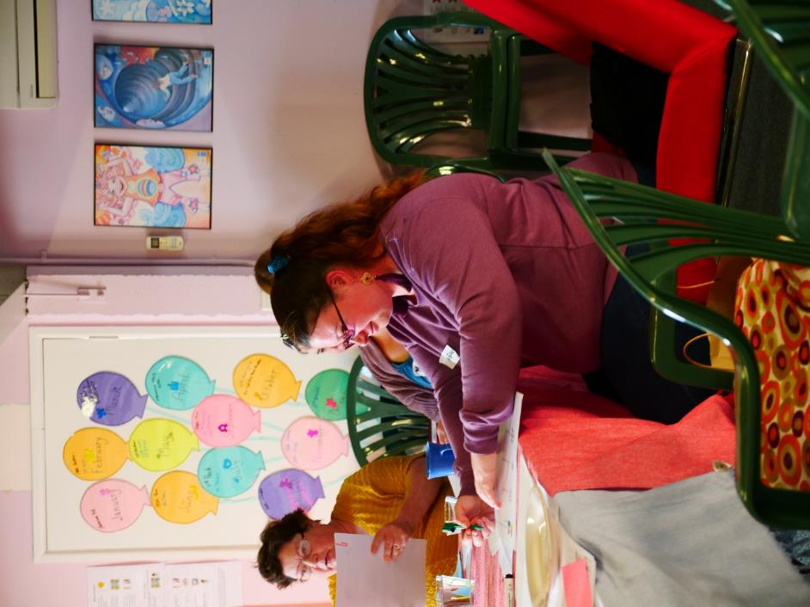
A participant makes notes at the Brisbane workshop

Conclusion: Unity in diversity
A guiding principle for the Virtual Centre is that women with disability see themselves reflected in it. A website that equips and resources women with disability, empowers them to realise their human rights and reflects and celebrates their diverse stories is an important and achievable goal.
The Virtual Centre is an opportunity to contribute to the vision of an equitable and inclusive Australia, and to reflect the diversity of communication styles, language, faces and perspectives of women with disability across Australia.

Acknowledgement and thank you
The WWDA facilitation team owes our gratitude to all the women who participated in the workshops. We met incredible, smart, wise, humble, tenacious women of all ages, cultures and backgrounds. We learned so much from each and every one of you.
We thank our partner organsiations in every location who welcomed us, hosted the event, and provided invaluable assistance and local knowledge. Thank you for making us feel at home with you!

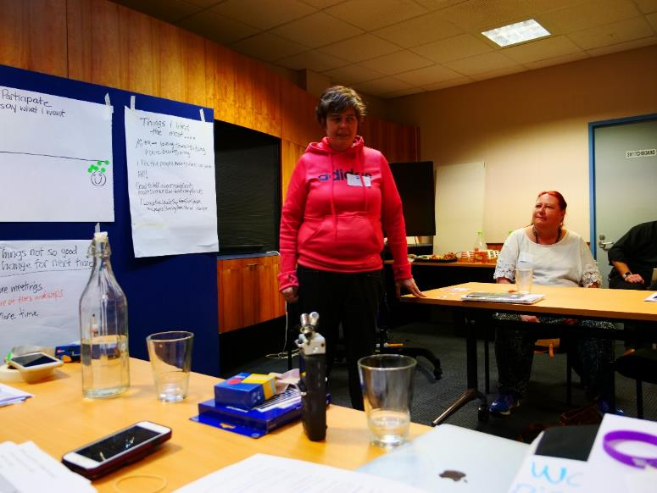
The co-facilitator Monique at the Hobart workshop

Appendix 1: Workshop attendance summary

Table 2. Breakdown of the workshop sessions and attendee details
Location | Participants | Age range
Hobart | 7 | 18 – 60
Canberra | 6 | 20 – 60
Melbourne | 10 | 21 – 60
Brisbane | 8 | 18 – 55
Tennant Creek | 10 | 22 – 55
Perth | 4 | 40 – 65

Appendix 2: Consent form (Plain English)
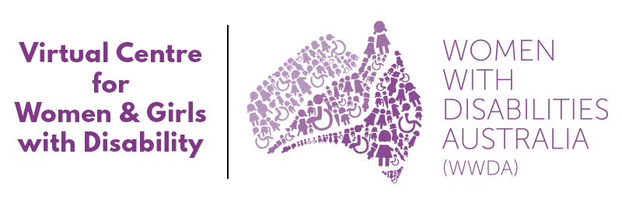

Workshop Information Sheet
Thank you for coming to the Women With Disabilities Australia (WWDA) Virtual Centre Co-Design Workshop in …… (place) at ….. (venue) On ….. (date, time)
WWDA is making a Virtual Centre website for women and girls with disability around Australia.
We will use the feedback and ideas that you give us in this workshop to help to make sure that the Virtual Centre website has information that is useful and easy for you to use.
We will be taking notes at the workshop. We will also take photos and will record what you say using an audio recording device. The notes and audio recording will only be used by us to help us remember what you say and to make sure we record all of your feedback and ideas.
We may also take photos and short videos at the workshop. These may be used for promotional purposes – including things like social media and WWDA newsletters. You can tell us if you do not want us to use your photo or video.
We will write a report about this workshop. This report will summarise all of the feedback and ideas that you and other workshop participants give us about the Virtual Centre. This will be used by WWDA and the website design organisation (Handbuilt Creative) to help us create the Virtual Centre. We will provide this report to the government department that has given us funds to create the Virtual Centre.
The report will not include your personal name, except in the list of participants (if you agree). The report might have ideas for a particular state or location. The report might include photos taken at the workshops.
The report will be kept on a password-protected computer at WWDA for at least 5 years. We will send you a copy of the report so you can read it.
The report may also be made public on the WWDA website.
WWDA may use parts of the report for things in the future like:
Statements to the media and the public
WWDA Newsletters.
We really appreciate your participation and the workshop and will provide you with a $50 gift voucher to thank you for your time at the end.
If you have any questions you contact the Project Manager, Naomi Thomson at pm@wwda.org.au.

Thank you for participating.

The WWDA project team
Naomi Thomson (Project Manager)
Julia Wolfson (Workshop Facilitator)
Heidi La Paglia (Senior Content Officer)
Dana Endelmanis (Communications and Media)

Workshop Consent Form

I agree to take part in the Virtual Centre workshop.

I agree to allow WWDA to audio record the workshop.

I agree that WWDA can include my comments and suggestions in the workshop report.

I understand my name will not be next to my comments in the workshop report.

I agree that WWDA can write my name in the list of participants in the workshop report.

I agree that WWDA can use the information in the report for public statements in the future.

I agree that WWDA can take photos of me at the workshop

I agree that WWDA can take videos of me at the workshop

I agree that WWDA can use photos and video footage of me for promotional purposes. I know I can change my mind about this at any time by contacting WWDA.

I would like to get information and continue to be involved in the development of the Virtual Centre after the workshop.

I understand that WWDA will not give my personal information to anyone else.

Name

Address

Telephone

Email

Contact person (name and telephone) (optional)

Signature Date

Appendix 3: Consent form (Easy English)

Women with Disabilities Australia (WWDA)


Consent Form

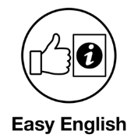

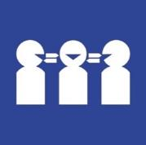
Need a translator
Call 131 450
Ask for 1800 737 732

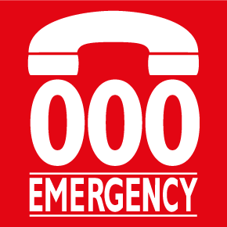
In danger now
Call 000

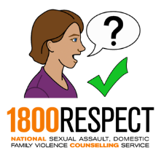
To talk to some one about violence.
Call 1800 RESPECT on 1800 737 732.
or
Chat online at www.1800respect.org.au

WWDA means
Women with Disabilities Australia.


WWDA is developing a Virtual Centre website for women and girls with disability


The Virtual Centre website is being funded by the NDIS


We are doing this workshop to find out what you want on the website

We will tell you about the website in the workshop

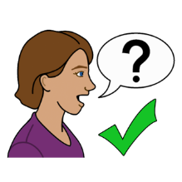
We will ask you questions about the website in the workshop


We will take notes in the workshop about what you say



We will audio record the workshop

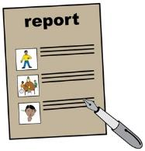
- We will use the Information you give us to write reports for people. Like

WWDA



The people who make the website

The NDIS

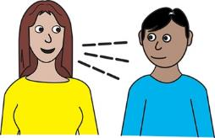
We may also use the things you say in other things like



- News articles

- Reports about WWDA.

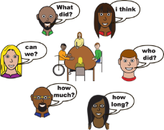
- Other workshops


We would like to know if you are happy for us to use the things you tell us in these ways

We would also like to know if we can take your

- Photo


You can tell us on this form

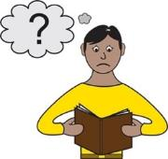
- Read the form


- Tick the boxes next to the things you would like your photo to be used for

- Sign this form

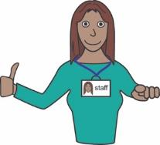
You can ask someone to help you fill out this form.

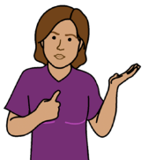
About you


My name is

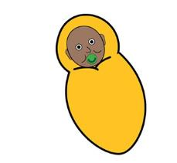
I was born on
Write the day / month / year

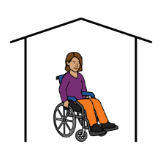
I live at


My phone number is


My email is


I am happy to take part in the

workshop about the
Virtual Centre website

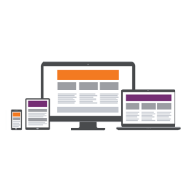
I am happy for WWDA to use

the things I tell them to make
sure the website is easy to use

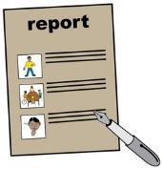

I am happy for WWDA to use
the things I tell them in reports



I am happy for WWDA to record
the Workshop by audio


I am happy for WWDA to

take photos of me at the workshop

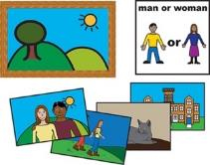
WWDA can use my photo

- On the WWDA website

- wwda.org.au



- On the Virtual Centre

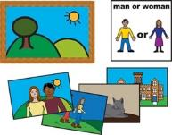
WWDA can also use my photo

On Social Media sites like


- Facebook



- Twitter



- Instagram



- In an email newsletter

My signature:


Thank you for your time!

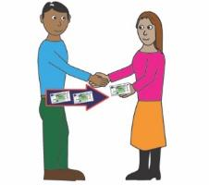
We will give you a $50 Coles Voucher at the end of the workshop as a payment.

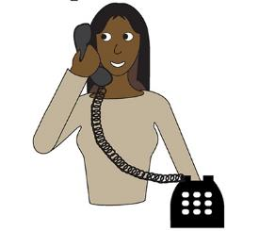
If you have any questions about the workshop you can contact our Project Manager Naomi:
- email pm@wwda.org.au
- call 0448 417 875


Acknowledgements

Authorship
Women with Disabilities Australia (WWDA) wrote the content for this booklet.
Copyright
© Copyright Women with Disabilities Australia (WWDA) Inc. 2019
The information in this booklet is for general education and information purposes only.
All intellectual property rights, including copyright and patents, in these booklets are owned and licensed by Women with Disabilities Australia Inc.
Funding Acknowledgement
The Virtual Centre project is funded by the National Disability Insurance Scheme (NDIS) in collaboration with Women with Disabilities Australia (WWDA).
Image Licensing
Easy on the I Images © 2018 Leeds and York Partnership NHS Foundation Trust. Used with permission. www.easyonthei.nhs.uk.

Appendix 4: Workshop Agenda – example

WWDA Virtual Centre Co-design Workshop
Location: Perth, WA
Date: Friday 16 July 2019
Time: 11am-2:30pm

Time | Topic | Speaker
11:00am | Welcome and Introductions  Consent and wellbeing  Agenda – what will happen today? | Local facilitator and  Julia Wolfson
11:20am | Introduction to the Virtual Centre  What is it? Why are we meeting today? | Naomi Thomson
11:30am | Questions and Discussion  What do you want to see on the Virtual Centre? | All
12:30pm | Break
1:00pm | Questions and Discussion  What do you want to see on the Virtual Centre? | All
1.45pm | Break
2:00pm | The Virtual Centre website layout  Trying it out on computers | All
2:15pm | What did you think of the workshop?  Summary of what we talked about | Local Facilitator & Julia
2:25pm | Thank you for coming and what we will do next | Julia & Naomi
2:30pm | Finish

Appendix 5: Wireframe Prototype Activity Response Form

Wireframe Prototype Activity Response Form
Form to be completed by interviewer
Location:
Name:
Support requirements:
Requires a support person to view websites? (Yes/No)
Preferred device for using websites? (eg ipad, smartphone, laptop):
Uses assistive technology to view websites? (if yes, please detail):

Remind them – this is not a test!

We will show you 3 different possible homepage designs (which are very simple, barebone ‘shells’ of website layout). They don’t contain images or correct content, and they are not functioning websites. We will give you a simple task to do for each design. Watching what you do will give us very helpful information and help us to choose which layout we use.

Please talk out loud and tell us what you are thinking and doing as you do it.

Wireframe 1 – https://wwdavc-beta01.webflow.io/

- Ask: Can you find information about Health?
Comments/reactions:

- Ask: Did you know you could scroll?

Wireframe 2 – https://wwdavc-beta02.webflow.io/

- Ask: Can you find information about being Safe?

Comments/reactions:

- Ask: Did you see the ‘Tips’? Were they helpful?

Wireframe 3 – https://wwdavc-beta03.webflow.io/
- Ask: Can you find information about Events?

Comments/reactions:

- Ask: Did you notice the video? Do you like it?

Any other comments/ notes

NSW Council of Social Service (2017). Principles of Co-design. [online] NSW: NCOSS, pp.1-3. Available at:¹https://www.ncoss.org.au/sites/default/files/public/resources/Codesign%20principles.pdf [Accessed 5 Aug. 2019].
Vichealth.vic.gov.au (2019). How co-design delivers agency, advocacy and real-world impact. [online] Available at: https://www.vichealth.vic.gov.au/letter/articles/vh-letter-45-co-design [Accessed 13 Aug. 2019].
NSW Council of Social Service (2017). Principles of Co-design. [online] NSW: NCOSS, pp.1-3. Available at: https://www.ncoss.org.au/sites/default/files/public/resources/Codesign%20principles.pdf [Accessed 5 Aug. 2019].
Sutton-Long, C., Skov Aagaard, K., Howard, Z. and Tassone, V. (2016). Co-Design for Community Inclusion. [online] National Disability Services (NDS). Available at: https://www.nds.org.au/images/events/files/huddle_report.pdf [Accessed 13 Aug. 2019].
See Julia Wolfson’s website Turning Forward. Julia is also a faculty member of the global Deep Democracy Institute.

