

Women With Disabilities Australia (WWDA)

Report from the United Nations Committee on the Rights of Persons with Disabilities (CRPD)
10th Session - Review of Australia

Geneva, 2-13 September 2013

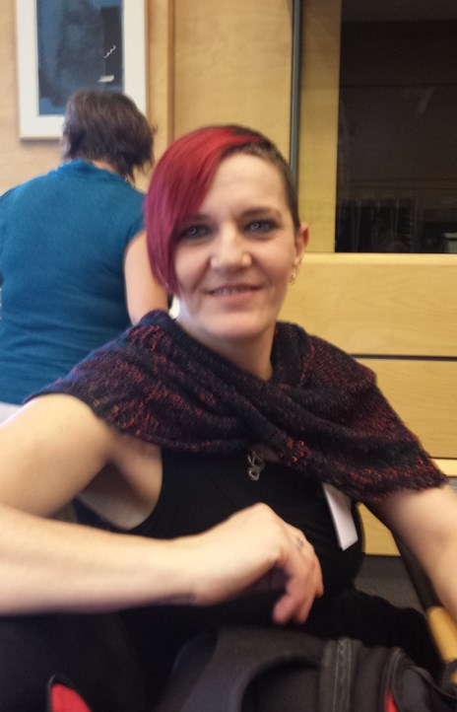

Report prepared by: Carolyn Frohmader, WWDA Executive Director and Member of the Australian NGO Delegation to the
CRPD 10th Session – Review of Australia

Report from the United Nations Committee on the Rights of Persons with Disabilities (CRPD)
10th Session - Review of Australia, Geneva, 2-13 September 2013

By Carolyn Frohmader for Women With Disabilities Australia (WWDA)

© Women With Disabilities Australia (WWDA) October 2013

About Women With Disabilities Australia (WWDA)

Women With Disabilities Australia (WWDA) is the peak non-government organisation (NGO) for women with all types of disabilities in Australia. WWDA is run by women with disabilities, for women with disabilities, and represents more than 2 million disabled women in Australia. WWDA’s work is grounded in a rights based framework which links gender and disability issues to a full range of civil, political, economic, social and cultural rights. Promoting the reproductive rights of women and girls with disabilities, along with promoting their rights to freedom from violence and exploitation, and to freedom from torture or cruel, inhuman or degrading treatment are key policy priorities of WWDA.

Contact Details

Women With Disabilities Australia (WWDA)
PO Box 605, Rosny Park 7018 TASMANIA, AUSTRALIA
Ph: +61 3 62448288 Fax: +61 3 62448255
Email: wwda@wwda.org.au
Web: www.wwda.org.au
Facebook: www.facebook.com/WWDA.Australia
Contact: Carolyn Frohmader, Executive Director

Winner, National Human Rights Award 2001
Winner, National Violence Prevention Award 1999
Winner, Tasmanian Women's Safety Award 2008
Certificate of Merit, Australian Crime & Violence Prevention Awards 2008
Nominee, French Republic's Human Rights Prize 2003
Nominee, UN Millennium Peace Prize for Women 2000

Disclaimer
This post-event report is prepared by Carolyn Frohmader for members of WWDA and other interested stakeholders. Apart from where specifically stated otherwise, this report does not reflect the views of the Australian Human Rights Commission nor the Australian Government.

Contents

Acknowledgment 4

Introduction 5

Background 6

Delegation Preparation Meeting in Sydney 9

Day One: Getting to Geneva 10

Day Two: Preparation and Delegation Meetings 12

Day Three: The CRPD Opening Session 13

Day Four: Australian Civil Society Delegation Side Event 17

Day Five: Delegation Forums and Meetings 25

Day Six: International Disability Alliance (IDA) 28

Release of CRPD Concluding Observations 29

Where to from here 30

Appendix 1: Civil Society Delegation Formal Opening Statement 31

Appendix 2: Civil Society Delegation Side Event Presentations 34

Appendix 3: Australian Government Delegation Opening Statement 39

Appendix 4: Disability Discrimination Commissioner Opening Statement 44

Appendix 5: Disability Discrimination Commissioner Closing Statement 46

Appendix 6: Australian Government Delegation Closing Statement 49

Appendix 7: CRPD Concluding Observations – Australia CRPD/C/AUS/CO/1 50

Acknowledgment

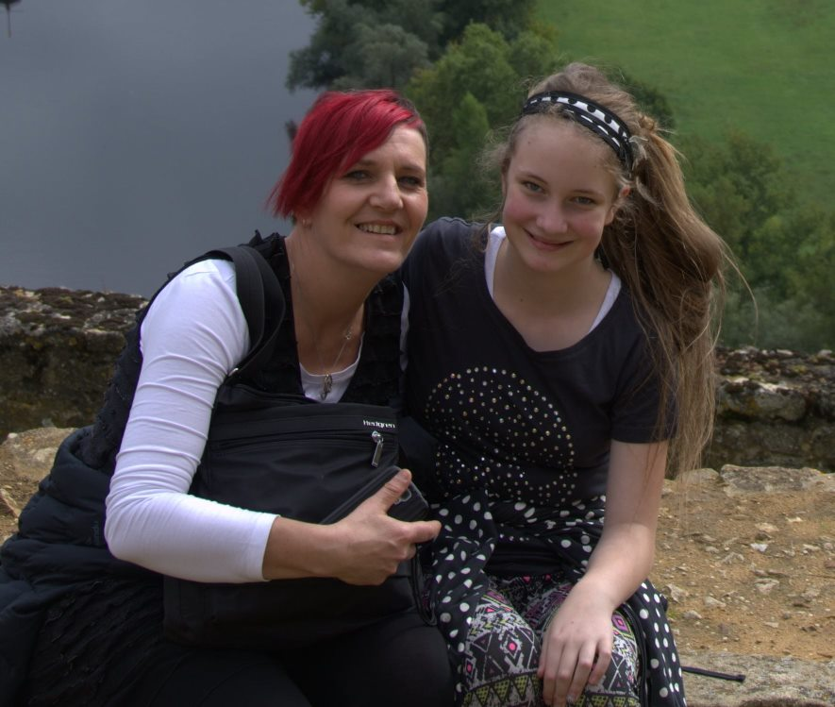

Carolyn & Lottie Frohmader

It was a profound honour to be given the opportunity to represent Australians with disabilities at the 10th Session of the United Nations Committee on the Rights of Persons with Disabilities (CRPD), held in Geneva, 2-13 September 2013. I would like to acknowledge, with sincere thanks, those who helped make it possible for me to attend, including those who supported me behind the scenes, and all those who made it such an unforgettable and life-changing experience:

- Australian Civil Society Delegation Members and support persons (Therese, Rosemary, Judy, Brett, David, Damian, Stephen, Paul, Raja, Michelle, Dominique, Annette, Peter, Sara) – thanks for the fantastic work, the camaraderie, and the lasting friendships;

- Board and members of Women With Disabilities Australia (WWDA) – for your unwavering support, trust and respect;

- Dr Paul Levett – for your support, encouragement and friendship;

- Australian Human Rights Commission and the Department of Social Services, for funding the Australian Civil Society Parallel Report Group Delegation;

- Victoria Lee (International Disability Alliance) – for your work behind the scenes supporting our delegation, your warmth and friendship;

- CRPD Committee Members – for your commitment to engaging with our Civil Society Delegation to learn more about the situation of people with disabilities in Australia;

- My wonderful friends – for rallying around and doing everything to make sure I could get to Geneva

- And Lottie – for your understanding, patience, support, and for always inspiring me to be the best I can be.

Introduction
In August 2013, WWDA Executive Director Carolyn Frohmader, was selected as a member of the six person ‘Australian Civil Society Parallel Report Group Delegation’ to represent the views of people with disabilities in Australia to the Committee on the Rights of Persons with Disabilities during its formal review of Australia’s compliance with the United Nations Convention on the Rights of Persons with Disabilities (CRPD). The Review took place during the CRPD Committee’s 10th Session in Geneva, 2-13 September 2013.

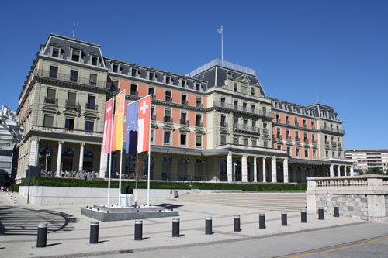

The United Nations Palais Wilson building in Geneva, where the CRPD Committee met for the 10th session

Carolyn spent a week at the United Nations in Geneva, working with the CRPD Committee as a member of the Civil Society Parallel Report Group, as well as participating in a number of other events during the week. During her time in Geneva, Carolyn was also able to take up a range of opportunities to meet with several key stakeholders to specifically focus on WWDA’s work and also to provide advice and expertise on issues concerning women and girls with disabilities.

This Report has been prepared by Carolyn to highlight her work and experiences during her time in Geneva.

Background
The Convention on the Rights of Persons with Disabilities (CRPD) was ratified by Australia on 17 July 2008, and it entered into force for Australia on 16 August 2008. The CRPD offers the most comprehensive and authoritative set of standards on the rights of people with disabilities. Its fundamental purpose is to promote, protect and ensure the full and equal enjoyment of all human rights and fundamental freedoms by all persons with disabilities, and to promote respect for their inherent dignity.

The Committee on the Rights of Persons with Disabilities (CRPD) is the body of independent experts which monitors implementation of the Convention by the States Parties, including Australia. All States parties are required to submit regular reports to the Committee on how the rights are being implemented. States must report initially within two years of accepting the Convention and thereafter every four years. The Committee examines each report, and has a formal dialogue with a delegation of the State Party under review. The Committee also accepts reports from civil society organisations (CSO’s), and/or non-government organisations (NGO’s) as part of the review of a particular State Party. CSO’s and NGO’s are a critical part of the review process, and there are a range of mechanisms available for civil society involvement, including through official CSO Reports (often referred to as ‘Shadow Reports’, or ‘Parallel Reports’) and through interactive dialogue between the Committee and NGO delegations from the State Party under review. At the completion of the Review process, the Committee makes suggestions and general recommendations as to how the State Party can improve and/or accelerate its implementation of the CRPD.

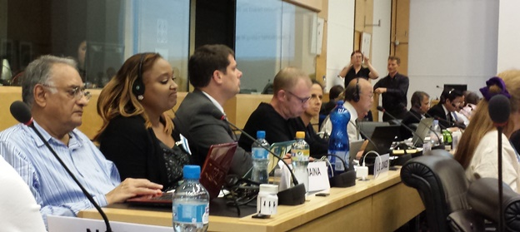

Some of the Members of the CRPD Committee preparing for the 10th session

The Australian Government submitted its initial report to the CRPD Committee in December 2010. The CRPD Committee began its review of Australia at its 9th Session in April 2013. At this session the Committee developed a List of Issues for Australia emerging from Australia’s baseline report. The List of Issues contained 50 specific questions (under articles from the CRPD), where the Committee felt more detailed information and responses were needed. The Australian Government was then required to formally respond to the 50 questions posed by the Committee.

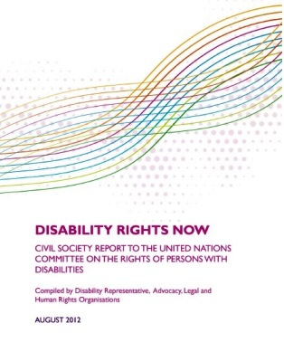
In August 2012, the Australian Civil Society ‘Shadow’ or ‘Parallel’ Report on the CRPD was launched by Australian Disabled Peoples Organisations (DPOs), disability advocacy and human rights organisations. The Report, entitled Disability Rights Now contains over 130 recommendations and was endorsed by over 80 organisations. Disability Rights Now was sent to the CRPD Committee for its review of Australia’s compliance with the CRPD.

The CRPD Committee also tabled WWDA’s Submission to the Senate Inquiry into Involuntary Sterilisation of People with Disabilities in Australia as a formal Shadow Report to inform the Committee’s review of Australia.

Earlier this year, a competitive Expression of Interest (EOI) process was undertaken to select four NGO delegates to join delegation coordinators, Therese Sands (People with Disability Australia) and Rosemary Kayess (Australian Centre for Disability Law), as the formal Australian Civil Society Parallel Report Group Delegation.

The six person delegation was funded by the Australian Human Rights Commission and the then Department of Families, Housing, Community Services and Indigenous Affairs (FaHCSIA) (now known as the Department of Social Services). The six official members of the Australian Civil Society Parallel Report Group Delegation were:

  Carolyn Frohmader  Women with Disabilities Australia (WWDA) |   Judy Huett  Speak Out Advocacy Tasmania & Our Voice, National Council on Intellectual Disability (NCID) | 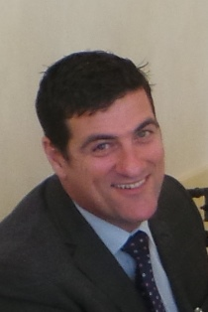  Brett Casey  Queenslanders with Disability Network (QDN) & Deaf Services QLD

  David Heckendorf  People with Disabilities ACT (PWD ACT) | 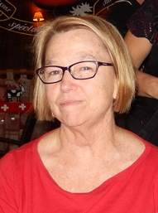  Therese Sands  People with Disability Australia (PWDA) | 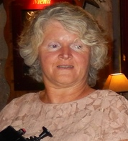  Rosemary Kayess  Australian Centre for Disability Law

An additional four members of the Australian Civil Society Parallel Report Group Delegation were funded through their organisations or other funding sources, and their role on the delegation was to provide additional expertise, support and assistance. The four additional members were:

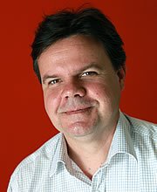  Damian Griffis  First Peoples Disability Network (FPDN) |   Stephen Gianni  Australian Federation of Disability Organisations (AFDO) |   Paul Cain  National Council on Intellectual Disability (NCID) | 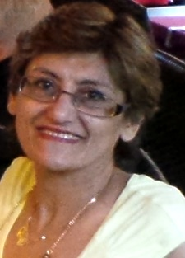  Raja Relf  Physical Disability Council Australia (PDA)

We were also given wonderful support by our various support workers who were an integral part of our delegation

  Michelle Stark |   Annette Colling |   Peter Kayess |   Dominique Vittori

  Paul Levett |   Sara Irvine

Delegation Preparation Meeting: Sydney 23rd August
The ten members of the Australian Civil Society Parallel Report Group Delegation met in Sydney on 23rd August for a day long meeting to finalise all materials and preparations for the week long event in Geneva. This meeting was crucial, as for many of the delegation, it was the first time we had met face to face. It was important to ascertain roles and areas of expertise on specific issue areas, which would be critical when the CRPD sought specific information from delegation members as part of Australia’s Review. It was also very important to ensure that, as members of the delegation, we were clear about our roles as delegates, our individual roles and also the imperative of ensuring we presented on the international stage, as a unified, well-organised, and professional NGO delegation.

At the Preparation Meeting, we finalized our Delegation responses to the List of Issues, updated our priority fact sheets where required, and finalized the wording of our proposed recommendations under each of the articles in the CRPD. We were also fortunate to have a teleconference with Ben Schokman from the Australian Human Rights Law Centre (HRLC), as Ben had participated in several NGO delegations to the UN, and he was able to give us extremely useful practical advice and tips to ensure our time at the UN was used productively.

Day One - Getting to Geneva
I left for Geneva on Friday 30 August. I was accompanied by my support worker Dr. Paul Levett, and was also fortunate to be able to take my ten year old daughter Lottie. As a single mother with no family, I was not prepared to leave my daughter in care for 2 weeks whilst I was away overseas. So with support from WWDA and my daughter’s school, I was able to have her accompany me. Whilst I worked at the UN, my daughter was cared for by my support worker with assistance from one of the other NGO delegate’s family, who had also taken their children to Geneva with them. Being able to take my daughter with me was critical, as it meant that I was able to fully concentrate and focus on the job at hand, without being distracted and worried about her being back in Australia without her mum. I was very grateful to WWDA and also the Australian Civil Society delegation for recognising, understanding and accommodating my needs as a single mother with no family.



At Hobart Airport preparing to leave for the long haul to Geneva

To get to Geneva from Hobart Tasmania is a mammoth task in itself. I confess that I had no real appreciation of how far away Tasmania is from Europe! We flew from Hobart to Melbourne, waited at the airport for five hours, then flew for another 14 hours to Dubai, waited at the Dubai airport for 8 hours, before boarding our plane for another 7 hour flight to Geneva! On a personal level, I found the flight from Melbourne to Dubai extremely difficult. Because I have a psychosocial disability and experience severe claustrophobia and agoraphobia, being stuck on an airplane in a very confined space in the dark for 14 hours was the ultimate challenge. I experienced very debilitating panic attacks and was unable to sleep at all, but somehow, with the assistance of medication, breathing exercises, encouragement from my daughter and support worker, I managed to get by. When we eventually arrived in Geneva in the late afternoon, I was completely mentally and physically drained, but I had to start work the following morning. On reflection, I now realize that I should have allowed myself a day to recover from the travelling. I would also advise anyone travelling those distances to ensure they factor in a day to recover and adjust to the different time zones.

Although in a rather ‘’zombie” like state when we arrived in Geneva, we found our hotel (The Hotel Jade) and were welcomed by the wonderful staff. After settling in, we headed off to find a supermarket to grab a few essential items. We managed to find one just as it was preparing to close. I raced in and grabbed a few items, including some fresh fruit, and took my place at the checkout. When it got to my turn, the woman at the checkout became quite stressed, throwing her arms into their air and mumbling something to me in French which I didn’t understand. Luckily, a kind man came to the rescue. It transpired that I was supposed to have weighed and priced my own fruit (which I hadn’t done) and I had also committed a big no-no – I had taken two bananas from a whole bunch of bananas, which is just not allowed in Geneva! I was meant to buy the whole bunch. Needless to say, the supermarket was a little late in closing that night, as my good Samaritan ran around weighing and pricing my fruit, and the cashier tried to decide what two bananas might be worth!

Although slightly confused by the fruit and veg procedure in the supermarket, I was very impressed by the public transport set up in Geneva. On arrival at our hotel we were issued with free public transport cards, which meant that we were able to travel on any form of public transport for free during our time in Geneva. The public transport system was easy to understand and use, and I was amazed to see fully accessible buses and trams everywhere. It was a very impressive system that seemed to work extremely well. Although I am well known for having absolutely no sense of direction, I was eventually able to find my way around with relatively ease.



Example of the free Transport card for visitors to Geneva

Day Two – Preparation & Delegation Meetings
My first day of official business in Geneva was a day long meeting of the Civil Society Parallel Report Group Delegation, the International Disability Alliance (IDA), and the Australian Human Rights Commission (AHRC). The International Disability Alliance (IDA) is a network of global and regional disabled people’s organizations (DPOs). Victoria Lee, from IDA’s office in Geneva, worked with us during the day to help us be fully prepared for the CRPD Review of Australia. Victoria has extensive experience in working with DPO delegations to promote implementation of the CRPD. She was able to provide us with biographical information for each of the CRPD Committee members, including their specific areas of expertise and interest. She was also able to provide us with information about previous country reviews undertaken by the CRPD Committee, as well as give us practical information about what to expect and how the process would be conducted. IDA was extremely supportive of our Delegation, helping out with last minute things like printing, photocopying and so on. It was wonderful to have on-site support from IDA and during the week we were there, Victoria Lee worked above and beyond the call of duty in assisting us.

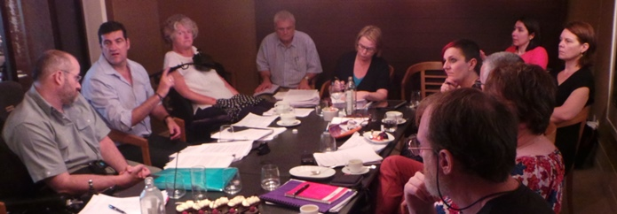

Civil Society Delegation Planning Meeting

During the day, we also had a meeting with the Australian Human Rights Commission delegation to the CRPD 10th session. Disability Discrimination Commissioner Graeme Innes, his support person Rachel Innes, and Helen Potts from the AHRC Disability Rights Unit, were representing the AHRC in Geneva. Graeme outlined what his role would be during the CRPD Review of Australia, and explained that the AHRC was independent of Government, and therefore would be making formal statements to the CRPD Committee from an independent position. It was really useful to be able to meet with the AHRC prior to the formal sessions of the Committee, and as a delegation, we felt very supported by our Human Rights Commission. After a very, very long day, my head full of information, I made my way back to my hotel on the tram and spent the rest of the evening going over material in readiness for the opening session of the CRPD 10th session the following day.

Day Three – The CRPD Opening Session
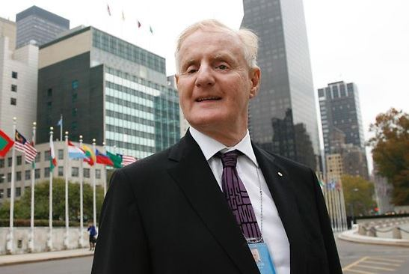

Professor Ronald McCallum

I woke early, very nervous but excited about the day ahead. I was privileged to share some time at breakfast with Professor Ron McCallum (member and past Chair of the CRPD Committee), who was staying at the same hotel as I. As Professor McCallum is Australian, he explained that he would not be able to participate in the formal review of Australia, as it would be considered a ‘conflict of interest’. Instead, Professor McCallum explained that he would be heading the CRPD Review of Austria, which was also being reviewed during the 10th session of the CRPD. Professor McCallum made a point of thanking me on behalf of the CRPD Committee for all the “valuable work” that WWDA does. He said that the Committee very much appreciated the materials and information they regularly received from WWDA.

After breakfast, Therese Sands and I walked to the Palais Wilson building, where the 10th session of the CRPD was to take place. On arrival, we had to present our official passes to the security personnel, show our passports, go through electronic screening, put any bags through separate electronic screening – and only then we were permitted to enter the building! This was to be the daily ritual. I’m not sure what it is about security checks, but I always feel as though I have done something wrong, and struggle to control my anxiety. I realize they are a very necessary measure, but I don’t think I will ever get used to them!

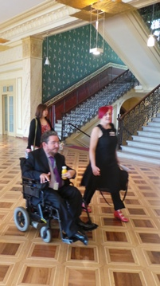

CRPD Committee Member, Mr. Carlos Ríos Espinosa and Carolyn Frohmader

I felt quite nervous walking into the room where the CRPD Opening Session was to take place. It was a hive of activity, with people bustling to find their seats; language and sign interpreters getting organized; captioning equipment being tested, and people everywhere! Our delegation took our place at the front of the main seating area. We each had to put on our headsets and find the right ‘channel’ on the audio equipment so that we could listen to the proceedings in English. I was amazed that so many languages are made available in ‘real time’, meaning that if someone is speaking publicly in Spanish, you can listen to their presentation at exactly the same time in English, or the language of your choosing.

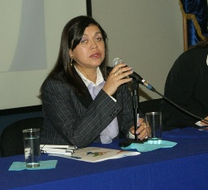

Maria Soledad Cisternas Reyes

The CRPD 10th session formally opened with the Chairperson, Ms. Maria Cisternas Reyes from Chile, welcoming everybody and giving an overview of the activities of the Committee since its last session. She highlighted some of the key priorities of the Committee, which included a stronger emphasis and focus on the rights of women with disabilities, children with disabilities, and indigenous persons with disabilities. The Opening session also included a number of presentations from UN agencies (such as the Office of the High Commissioner for Human Rights; UNICEF; WHO), each of which gave an overview of their work in relation to the rights of people with disabilities. The World Intellectual Property Organisation (WIPO) gave a presentation on the adoption of the new international Marrakesh Treaty to Facilitate Access to Published Works for Persons who are Blind, Visually Impaired, or otherwise Print Disabled.

Following presentations from some of the key United Nations agencies, the CRPD Committee then handed over the floor to international non-government organisations (NGO’s) to make formal statements to the Committee on key issues. Examples of NGO’s delivering statements included: Human Rights Watch, Disability Council International, the International Disability Alliance, the World Network of Users and Survivors of Psychiatry, and more.

The CRPD Committee then began its private sessions with the NGO delegations from the countries being reviewed during the 10th session: Australia, El Salvador, and Austria. This session allowed the NGO delegations to give a brief, formal statement to the Committee about the situation of people with disabilities in the respective countries. The private nature of the sessions is very important, as it enables the NGO delegations to be frank and honest in their statements to the Committee, without fear of reprisal from their Governments.

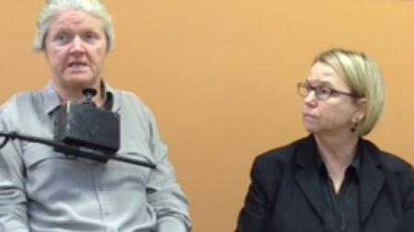

Rosemary Kayess and Therese Sands

As Coordinators of the Australian Civil Society Parallel Report Group Delegation, Rosemary Kayess and Therese Sands delivered the formal statement to the Committee on behalf of our delegation. This Statement is included in full in Appendix 1 of this report. Some of the key points made in our formal opening statement to the Committee included:

- Australia should be held to the highest possible standards with regard to its CRPD obligations, as it is a wealthy country and is better placed than many other Member States to address the human rights of people with disabilities;
- Australia is ranked the worst of OECD countries in terms of poverty and disability; and is ranked 21 out of 29 OECD nations for employment participation;
- Extreme poverty and disadvantage is experienced by Aboriginal and Torres Strait Island communities where rates of disability are twice that of the general population;
- Although Australia has implemented a number of key reforms, including the introduction of the National Disability Insurance Scheme (NDIS), people with disabilities continue to experience a multitude of serious human rights violations, including laws and policies that deny legal capacity; unregulated restrictive practices; forced and coerced sterilisation; indefinite detention in prisons without conviction; the continuation of institutional living arrangements; and the use of the discriminatory wage assessment tool in Australian Disability Enterprises.

After the private session with the CRPD Committee, some members of the delegation were able to meet with members of the CRPD Committee, whilst the remainder of the delegation attended the official launch of the First People’s Disability Network (FPDN) photographic exhibition entitled “Unfinished Business”. The exhibition was launched by Mr. Peter Woolcott, Australian Ambassador to the Permanent Mission to the UN. The exhibition consisted of 30 portrait photographs of Aboriginal people with disabilities from around Australia. The photographs were taken by well know Australian photographer Belinda Mason, who was present at the launch.

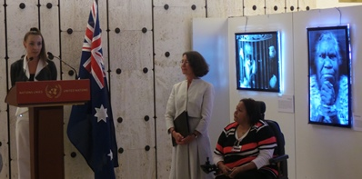
Photographer Belinda Mason at the launch of ‘Unfinished Business’

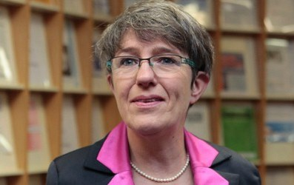

Professor Theresia Degener

At lunchtime, I was fortunate to be able to have a meeting with Professor Theresia Degener, Vice Chairperson of the CRPD Committee. Professor Degener has a particular interest in issues facing women and girls with disabilities, and also an interest in intersectionality, where several forms of discrimination based on various layers of identity may intersect and produce new forms of discrimination. I spoke with Professor Degener regarding issues facing women and girls with disabilities in Australia. Professor Degener was particularly interested in hearing about the outcomes of the Senate Inquiry into Involuntary Sterilisation of People With Disabilities in Australia. I was able to brief her on the Senate Inquiry, WWDA’s Submission to the Inquiry, and input to the Inquiry from WWDA and other stakeholders. We also discussed a range of other issues, including the right to parent; the removal of babies and children from parents with disabilities; violence against women and girls with disabilities, including sexual violence and the difficulty women with disabilities experience in accessing the justice system. I felt very humbled when Professor Degener stated that she, and other members of the CRPD Committee were of the view that WWDA was the “best disability organisation in the world”. She thanked me for WWDA’s contribution to the Committee, and spoke of how WWDA’s work had, and continues to have, significant impact internationally.

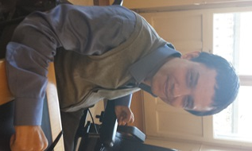

Mr. Facundo Chávez Penillas

In the evening, I attended the formal reception at the Australian Permanent Mission. This reception was hosted by Mr. Peter Woolcott (Australian Ambassador, Permanent Mission to the UN) and Graeme Innes (Disability Discrimination Commissioner, Australian Human Rights Commission). The reception included a screening of Twenty Years, Twenty Stories in recognition of the 20 years of the Australian Disability Discrimination Act (DDA). Several dignitaries attended the event, including members of the CRPD Committee, along with representatives from UN agencies. At the end of the reception, I was approached by Mr. Facundo Chávez Penillas, Advisor on Human Rights and Disability, Office of the High Commissioner on Human Rights (OHCHR). Mr. Chávez Penillas requested a formal meeting with me whilst I was in Geneva, specifically to discuss how his Department could strengthen its advocacy work on women and girls with disabilities, particularly in relation to other international human rights treaties such as CEDAW. Mr. Chávez Penillas also expressed a high regard for WWDA’s work. We arranged to meet later in the week.

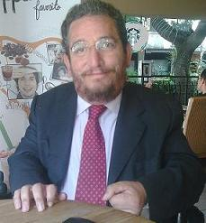

Mr. Carlos Ríos Espinosa

I was fortunate to share a bus ride back to the hotel with Mr. Carlos Ríos Espinosa, a member of the CRPD Committee from Mexico, who has a special interest in issues for indigenous persons with disabilities. I took full advantage of the situation, talking with Mr. Ríos Espinosa about the situation facing people with disabilities in Australia, particularly indigenous persons with disabilities. Mr. Ríos Espinosa was very friendly and extremely interested in learning more about the situation for people with disabilities in Australia. I literally fell into bed at a very late hour, but felt extremely proud of our efforts during the day and evening.

Day Four – Our NGO Delegation Side Event
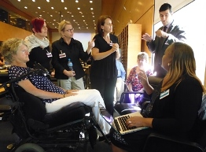

Delegation meeting with Ms. Edah Maina

In the morning, our delegation had a meeting with the CRPD Committee’s Country Rapporteur for Australia’s Review, Ms. Edah Maina from Kenya. The Country Rapporteur’s role is essentially a chairing role – to run the CRPD Committee’s Review of Australia. Our meeting with Ms. Maina was extremely productive. We had the opportunity to highlight a number of key issues prior to the Australian Government’s appearance before the Committee. Ms. Maina also sought more information and clarification on a number of issues, including around legal capacity of people with disabilities, and guardianship laws in Australia. She was also very interested in learning more about how people with disabilities are engaged in decision-making around development of legislation, policy and programs, particularly those persons with disabilities who are deemed not to have ‘legal capacity’.

Our next event for the day was to meet with the Australian Government delegation, which was due to appear before the CRPD Committee later in the day. This was a useful process, as it enabled us to have an open and transparent discussion with the Australian Government delegation about the key issues we were raising with the Committee. Each member of our delegation spoke in turn about the priority issues we were highlighting with the Committee.

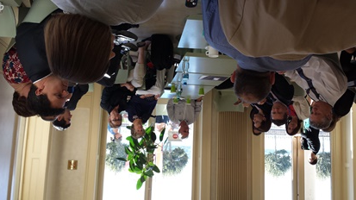

NGO Delegation meeting with the Australian Government Delegation

I spoke with the Australian Government delegation specifically about violence against women and girls with disabilities; including the shortcomings of the National Plan to Reduce Violence Against Women and their Children as a response to address the multiple forms of violence experienced by women and girls with disabilities. I spoke about the urgency of addressing violence against women and girls in institutions, particularly in light of the fact that in 2010 the CEDAW Committee had recommended the Australian Government to address this issue as a matter of urgency, yet there has been no action by Government on this issue since. I also spoke about the issue of sexual and reproductive rights, including forced and involuntary sterilisation, and how some of the proposed recommendations in the Senate Inquiry Report, were inconsistent with previous UN Treaty body recommendations to Australia on this issue.

In the afternoon, our delegation held a Side Event for the CRPD Committee members, other NGO’s, and interested stakeholders. Our Side Event was a private event, meaning that no Government representatives were able to attend. The purpose of the Side Event was to be able to have a more in-depth discussion with the Committee about key issues we believed needed to be given particular attention during the CRPD Committee’s dialogue with the Australian Government delegation. Our Side Event also enabled the Committee members to ask particular questions of our delegation and for us to provide more detailed information and/or clarification on any question posed by the Committee.

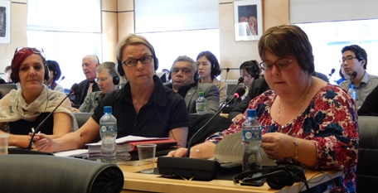

NGO Delegation member Judy Huett delivers her presentation to the CRPD Committee

Our Side Event was chaired by Mr. Colin Allen, President of the World Federation of the Deaf and the second Vice Chair of the International Disability Alliance. Our event commenced with a welcome from the Chair and an introductory statement from Therese Sands. Delegation representatives then each gave a three minute presentation to the Committee. The transcript of the statements presented are provided in Appendix 2. They included:

- Discrimination and extreme disadvantage experienced by Aboriginal people living with disability – Presented by Damian Griffis (First People’s Disability Network);
- Access to justice for people with disabilities; indefinite detention ad incarceration - Presented by Brett Casey (Queenslanders with Disability Network & Deaf Services QLD);
- Violence against women with disabilities; Forced sterilisation of women and girls with disabilities - Presented by Carolyn Frohmader (Women With Disabilities Australia);
- People with disabilities in institutions; Employment - Presented by Judy Huett (Speak Out Advocacy Tasmania);
- Government engagement with people with disabilities - Presented by David Heckendorf (People with Disabilities ACT).

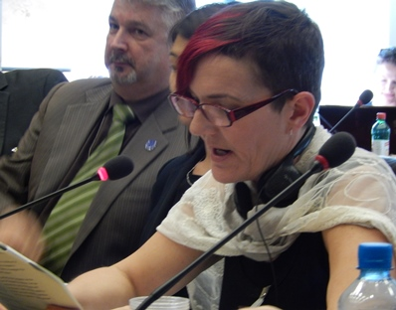

Carolyn Frohmader delivers her presentation to the CRPD Committee

I was extremely nervous about presenting my statement to the Committee, as I do not cope at all well with public speaking situations and/or being in a confined environment. I experienced those awful panic attacks and was honestly terrified, but I was absolutely determined to speak our truth and do justice to many, many women with disabilities who have been denied their human rights. I was fortunate in that the delegation members supported and encouraged me – Therese Sands clenched my hand under the table and I was fed copious amounts of water. When it came to my turn to present, I decided to just focus on my written prepared statement and try to at least sound calm and professional. I think I managed to pull it off – everyone later told me that I sounded most impressive, which was a huge relief!

Following our presentations, the Committee members asked our delegation a series of questions. I was specifically asked about mothers with disabilities, including how women with disabilities fared in divorce proceedings in relation to child custody matters. I was also asked about women with disabilities in the prison system, as well as questions around the existence of participatory mechanisms and processes to enable women with disabilities to participate equally in the development of Government legislation, policies, programs and services. Our Side Event was a great success with the Committee thanking us for our hard work and contributions, including the high standard of our Civil Society Parallel Report ‘Disability Rights Now’.

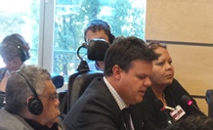  Damien Griffis delivers his presentation to the CRPD Committee | 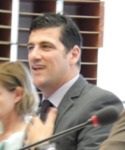  Brett Casey delivers his presentation to the CRPD Committee

It is difficult to put into words how drained I felt after the Side Event – I had expended so much mental energy on just surviving it and trying to do a good job. However, I had no time to recover, as there was just enough time for a quick coffee and toilet stop, and then it was back into it.

After our Side Event, it was time for the Australian Government to begin its official dialogue with the CRPD Committee. The Government dialogue is an open session and we were therefore able to observe the whole process. It was also important for us to be taking notes on what the Government delegation was saying, so that we could follow up with Committee members on any issues that we felt needed clarification. The Australian Government delegation consisted of:
- Mr. Peter Woolcott, Australian Ambassador to the Permanent Mission to the UN;
- Mr. Stephen Bouwhuis, Assistant Secretary, Human Rights Policy Branch, Attorney-General’s Department;
- Ms. Anna Sherburn, Human Rights Policy Branch, Attorney-General’s Department;
- Mr. Evan Lewis, Group Manager of Disability and Carers Group, Department of Families, Housing, Community Services and Indigenous Affairs;
- Mr. David Garner, Counsellor (Labour), Australian Permanent Mission, Geneva, representing the Department of Education, Employment and Workplace Relations.
- Shireen Sandhu, Counsellor (Development), Australian Permanent Mission, Geneva, representing the Australian Agency for International Development (AusAID);
- Kate O’Malley, Minister Counsellor (Migration), Australian Permanent Mission, Geneva representing the Department of Immigration and Citizenship.

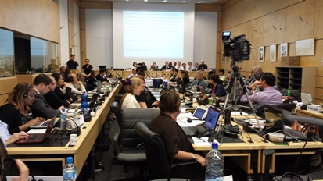

The Australian Government delegation appearing before the CRPD Committee

The Australian Government session opened with Mr. Woolcott giving the Opening Statement for the Australian Government. He spoke of a number of achievements of Australia in relation to people with disabilities, specifically citing the National Disability Strategy; the Disability Discrimination Act; the National Disability Insurance Scheme; Australian Government Disability Employment Services program, and more. He acknowledged that much more needed to be done in enabling people with disabilities to realize their human rights. He specifically spoke about the need for the Australian Government to: meet the challenges faced by Indigenous people with disabilities, improve economic security and social inclusion for people with disabilities, and ensure that Australia’s systems and programs respect a person’s autonomy and choice. The full transcript of the Opening Statement is provided in Appendix 3.

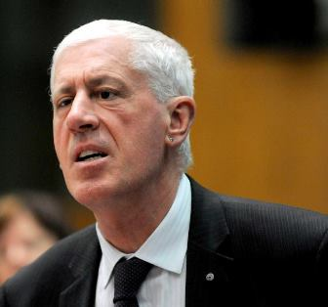

Disability Discrimination Commissioner Graeme Innes

Mr. Graeme Innes, Disability Discrimination Commissioner, then gave his statement to the CRPD on behalf of the Australian Human Rights Commission. Although Graeme shared the stage with the Australian Government delegation, his presentation was given in his independent capacity, in recognition that the AHRC perspective may differ from that of the Australian Government. The transcript of Commissioner Innes’ statement is provided in Appendix 4.

It was then time for the CRPD Committee Country Rapporteur, Ms. Edah Maina, to make the opening statement to the Australian Government delegation on behalf of the CRPD Committee. Ms. Maina acknowledged the reforms implemented by the Australian Government, such as the NDIS, but spoke strongly and unequivocally about concerns held by the CRPD Committee regarding human rights violations of people with disabilities in Australia, including for example: the ongoing use of restrictive practices; forced treatments such as forced psychosurgery and sterilisation; indefinite detention in prisons; the situation of Indigenous people with disabilities; and the medical model approach to disability within the health and rehabilitation systems.

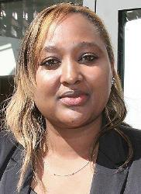

CRPD Committee Country Rapporteur,
Ms Edah Maina

After Ms. Maina’s opening statement, individual Committee members asked specific questions of the Australian Government delegation under Articles 1-10 of the CRPD. The Australian Government delegation was given a 15 minute break to organize its responses to the questions. After the responses were given, the CRPD Committee members asked specific questions under Articles 11-20 of the Convention. The questions posed by the Committee reflected and drew on the issues raised by our delegation, including from the Australian Civil Society Parallel Report ‘Disability Rights Now’, and from our individual and collective advocacy efforts.

A key area of concern, repeated often throughout the course of the review, was the impact of Australia’s Interpretative Declarations to articles 12, 17 and 18 on the implementation of the CRPD.

When Australia ratified the CRPD, it did so with three ‘Interpretative Declarations’, to CRPD Articles 12, 17 and 18. ‘Interpretative Declarations’, are formal statements a country makes to express how it intends to ‘interpret’ or ‘understand’ a particular treaty article. Australia’s ‘Interpretative Declarations’ to the CRPD are as follows:

CRPD Article 12
“Australia recognizes that persons with disability enjoy legal capacity on an equal basis with others in all aspects of life. Australia declares its understanding that the Convention allows for fully supported or substituted decision-making arrangements, which provide for decisions to be made on behalf of a person, only where such arrangements are necessary, as a last resort and subject to safeguards;

CRPD Article 17
Australia recognizes that every person with disability has a right to respect for his or her physical and mental integrity on an equal basis with others. Australia further declares its understanding that the Convention allows for compulsory assistance or treatment of persons, including measures taken for the treatment of mental disability, where such treatment is necessary, as a last resort and subject to safeguards;

CRPD Article 18
Australia recognises the rights of persons with disability to liberty of movement, to freedom to choose their residence and to a nationality, on an equal basis with others. Australia further declares its understanding that the Convention does not create a right for a person to enter or remain in a country of which he or she is not a national, nor impact on Australia’s health requirements for non-nationals seeking to enter or remain in Australia, where these requirements are based on legitimate, objective and reasonable criteria.”

The CRPD Committee stressed to the Australian Government delegation, that these Interpretive Declarations have in fact hindered Australia’s ability to comply with the Convention on the Rights of Persons with Disabilities (CRPD). The Committee repeatedly asked the Government delegation what actions would be taken to repeal these Interpretative Declarations.

The first formal session with the Australian Government delegation then closed for the day at around 6pm, with the Government delegation given overnight to organise its responses to the questions asked during the session in relation to Articles 11-20 of the Convention. Our delegation left the Palais Wilson building for the day, feeling extremely pleased with how the day had unfolded.

During the day, I was contacted by ABC Radio in Australia, which was particularly interested in my presentation on violence against women with disabilities. I conducted a phone interview with ABC radio to speak in more detail about the issue. Some of the transcript of the interview can be found at: http://www.radioaustralia.net.au/international/radio/program/pacific-beat/un-told-australia-is-failing-people-with-disabilities/1184825

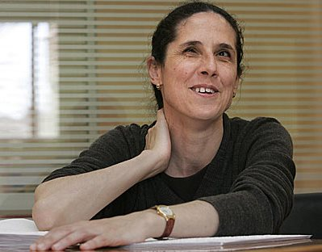

CRPD Committee Member, Ms Ana Peláez Narváez

In the evening, I was fortunate to have a dinner engagement with one of the CRPD Committee members, Ms Ana Peláez Narváez from Spain. WWDA has a long standing relationship with Ms Peláez, having worked with her in her roles as the Commissioner for Gender Affairs of the Spanish Disability Council; and Chairwoman of the European Disability Forum (EDF) Women’s Committee.

In 2012, Ms Peláez invited me as WWDA CEO, to give the keynote address at the International Women With Disabilities Conference ‘’Challenges in the new millennium for women with disabilities”, held in Madrid, Spain. WWDA member Christina Ryan deputised for me at this Conference, and presented on my behalf, a paper on 'Moving Forward and Gaining Ground: The Sterilisation of Women and Girls with Disabilities in Australia'. WWDA also worked with Ms Peláez earlier this year, on the CRPD Half Day General Discussion on Women and Girls with Disabilities. Ms Peláez was the Chair of this discussion, and WWDA member Therese Sands was able to attend the session in Geneva, and present a statement on Sexual and Reproductive Rights, of behalf of WWDA.



CRPD Committee Member, Ms Dianne Mulligan

During the evening, I was also able to meet with CRPD Committee member, Ms Dianne Mulligan from the United Kingdom. Ms Mulligan was a member of the UK’s Equality and Human Rights Commission statutory Disability Committee, and Coordinator of International Advocacy and Alliances for Inclusive Development. She has coordinated international advocacy work on inclusive development to realise the rights of persons with disabilities worldwide. Ms Mulligan was particularly interested in issues for indigenous people with disabilities, including availability of specific data in Australia on their situation.

Day Five –Delegation Forums and Meetings
The day commenced with the Australian Government delegation responding to the extensive number of questions the Committee had asked in the previous day’s session in relation to Articles 11-20 of the Convention. Mr. Peter Woolcott, on behalf of the Government delegation, advised the Committee that due to ‘caretaker mode’ the delegation was unable to provide a response to the issue of the Interpretive Declarations, as this would be a matter for any new incoming federal Government after the election. However, he did state that he was unaware of any intention for the Australian Government to repeal its Interpretive Declarations to the CRPD.

After the Australian Government delegation had provided its responses to the questions relating to CRPD Articles 11-20, it was then time for the Committee to ask specific questions relating to Articles 21-33. These set of questions included many on the issue of violence against women and girls with disabilities; sexual and reproductive rights of women and girls with disabilities, including forced and coerced sterilisation; resourcing of disability people’s organisations in Australia; as well as participation and representation of women with disabilities. The Australian Government delegation responded to a number of the questions posed, but there was insufficient time for all the responses, so it was agreed that the final responses would be provided to the CRPD Committee by 1pm on Friday 6th September (2 days later). Disability Discrimination Commissioner, Mr. Graeme Innes, was then asked to give his closing statement to the Committee. The full transcript of Commissioner Innes closing statement is provided in Appendix 5.

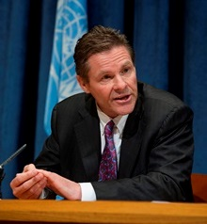

Mr. Peter Woolcott
Mr. Peter Woolcott then gave the closing statement on behalf of the Australian Government delegation. The statement specifically acknowledged that women, children and Indigenous Australians with disabilities face multiple intersecting disadvantage, and clearly stated that the Australian Government “is taking steps to ensure the specific needs of these vulnerable groups are considered during the development and implementation of relevant policies and programs….”. The full transcript of the Australian Government delegation’s closing statement is provided in Appendix 6.



Mr. Jakob Schneider

Following the closing of the formal dialogue between the Australian Government delegation and the CRPD Committee, I was fortunate to have a private meeting with the secretariat for the Committee of the Elimination of Discrimination Against Women. The CEDAW Committee is the body of 23 independent experts on women’s rights from around the world that monitors implementation of the Convention on the Elimination of All Forms of Discrimination against Women (CEDAW). I met with Jakob Schneider from the secretariat to specifically discuss how the CEDAW reviews can be more inclusive of women and girls with disabilities, and also to discuss some of my concerns regarding recent Concluding Recommendations of CEDAW country reviews, which excluded women with disabilities and also used what could be considered ‘offensive’ and/or derogatory language in relation to disabled women and girls. I was also very keen to discuss how WWDA might contribute to the work of the CEDAW Committee, in efforts to ensure that women and girls with disabilities are considered and included as a matter of course in CEDAW Reviews.

My meeting with Jakob Schneider was very successful. Mr Schneider was very appreciative of my expertise and advice. We agreed to look at ways whereby WWDA could be more involved in working collaboratively with the CEDAW secretariat in the future. I also learned more about the process of how the CEDAW Committee conducts its country reviews, and how WWDA’s work might help to inform these processes.

In the afternoon, our delegation met with the South Korean NGO delegation, which had attended the 10th session of the CRPD to assist in preparing for the review of South Korea under the Convention. The members of the South Korean NGO delegation had attended many of the public sessions and had also been present at our Side Event. Our meeting with the NGO delegation was to share experiences of the review process, and to share information and advice as to how the Australian Civil Society delegation prepared for and conducted its report and dialogue with the CRPD Committee. We also discussed lobbying and advocacy strategies and the range of consultation methods and processes used by DPO’s in Australia in relation to the CRPD Review of Australia.



Ms. Heisoo Shin

I was also fortunate to be able to meet with Ms. Heisoo Shin, who was accompanying the South Korean NGO delegation. Ms Shin is a current member of the UN Committee on Economic, Social and Cultural Rights (CESCR), which is the Committee made up of 18 experts that monitors implementation of the International Covenant on Economic, Social and Cultural Rights by its States parties. Ms Shin is also a former member and Vice-Chair of the Committee on the Elimination of Discrimination against Women (CEDAW), and the former Commissioner of the National Human Rights Commission of Korea. We were able to discuss issues for women and girls with disabilities as they relate to the Covenant on Economic, Social and Cultural Rights, and discuss ways that WWDA might make more use of this particular international human rights treaty in the future.

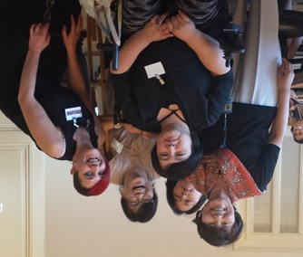

Heisoo Shin (L), MijooKim (C) & Carolyn Frohmader (R) with other members of the Korean delegation

I was also able to meet up with Mijoo Kim, a well-known woman with a disability from Korea who created the first ever Korean women with disabilities self-help organisation and movement. Mijoo and I talked about how we could collaborate more closely in the future to progress the human rights of women and girls with disabilities.

Our final meeting for the day was with Mr. Facundo Chávez Penillas, Advisor on Human Rights and Disability, Office of the High Commissioner on Human Rights (OHCHR). Mr. Chávez Penillas gave an overview of his work and role within the disability focal point of the OHCHR. He discussed a range of priorities for the focal point, particularly work centred on the meaningful inclusion of people with disabilities in the Post 2015 Development Agenda. He also spoke of the need to establish closer linkages with disabled people’s organisations, and encouraged us to collaborate with the focal point, and share knowledge and information.

In the evening, our delegation joined forces with the delegation from First Peoples Disability Network (FPDN) and went out for dinner to celebrate our achievements. To say it was a jovial affair would be an understatement! We all had a fantastic time, and it was a privilege to experience the camaraderie and friendship from such a diverse and wonderful group of people.

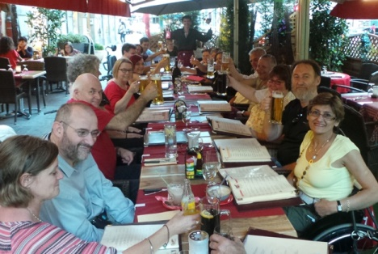

Members of the Civil Society Delegations enjoying the dinner function

Day Six –International Disability Alliance (IDA)
With our formal work at the CRPD Review of Australia at the Palais Wilson completed, we spent the day meeting with Victoria Lee from the International Disability Alliance (IDA). During the meeting we discussed our work during the week, and identified key actions that needed immediate follow up. We spent time drafting some final statements and draft recommendations for the CRPD Committee to consider in its deliberations when writing up its Concluding Observations for Australia. This information was then forwarded to individual members of the CRPD Committee and also provided to IDA for distribution as required.

The meeting with IDA brought to a close our official business in Geneva. It was an exhilarating but exhausting week. I had a few hours to take in the sights of Geneva with my daughter and support worker before we left. Geneva is a beautiful city, particularly the Old Town of Geneva, which sits on the other side of Lake Geneva from where I had been working for the week. We were able to hop on a little boat (free) and it took us only 10 minutes or so to reach the other side of the Lake. We spent a few hours wandering aimlessly around the narrow, cobbled streets of the Old Town, admiring the flower boxes on the old buildings, and listening to the beautiful sounds of street musicians wafting through the streets. It was a lovely way to end my experience in Geneva – an experience I shall cherish.

CRPD Concluding Observations - Australia
On October 7th, the CRPD Concluding Observations of Australia’s review were officially released. They contain very strong recommendations to the Australian Government regarding its international obligations to ensure people with disabilities can realise their human rights. The Concluding Observations are attached in full in Appendix 7.

The Concluding Observations congratulate Australia for the positive reforms that have been implemented, such as:
- The National Disability Strategy;
- The National Disability Insurance Scheme;
- International cooperation programs that support disability inclusive development; and
- The Australian Law Reform Commission Inquiry into equal recognition before the law for people with disability, as well as pilot supported-decision making initiatives.

However, the Concluding Observations outline principal areas of concern and corresponding recommendations, including:
- Legislative reform that incorporates all rights under the CRPD into domestic law;
- Review of interpretative declarations on articles 12, 17 and 18 with a view to withdrawing them;
- Establishment of engagement mechanisms for people with disabilities, through their representative organisations to participate in the development and implementation of legislation and policies;
- Adequate resourcing for Disabled Peoples Organisations (DPOs);
- Strengthening of anti-discrimination laws;
- Inclusion of women with disabilities in public programs and policies on the prevention of gender-based violence;
- Investigate violence, exploitation and abuse experienced by women and girls with disabilities in institutional settings;
- Adopt national, uniform legislation prohibiting the use of sterilisation of boys and girls with disability, and of adults with disability in the absence of their prior, fully informed and free consent;
- Repeal of legislation that authorises medical interventions without the free and informed consent of the person concerned;
- Comprehensive assessment of the situation of women with disabilities and of the situation of children with disabilities.
- Increased effort to promote and protect the rights of children with disabilities, including measures to enable them to express their views;
- Immediate measures to replace substitute decision-making with supported decision-making, which respects the person’s autonomy, will and preferences;
- Training for the justice system to ensure access to justice;
- End the use of prisons for the management of unconvicted persons with disabilities, with a focus on Aboriginal and Torres Strait Islander persons with disabilities;
- Immediate steps to end restrictive practices in environments such as schools, mental health facilities and hospitals; and establish an independent national preventative mechanism;
- Develop and implement a national framework for the closure of residential institutions and allocate the resources necessary for persons with disabilities to live in the community;
- Recognition of Auslan as one of the national languages of Australia;
- Increased effort, research and policies in the area of inclusive education;
- Immediate end to the use of the Business Services Wage Assessment Tool (BSWAT); and,
- Nationally consistent measures for disaggregated data collection by age, gender, type of disability, place of residence and cultural background.

Where to From Here
In many ways, the Concluding Observations from Australia’s review under the CRPD, represent just the beginning of work for people with disabilities and their advocates in Australia. Our job is to actively use the Concluding Observations in our advocacy efforts to lobby for implementation of the recommendations at all levels of government. The Concluding Observations need to be used by people with disabilities, their representative and advocacy organisations. They should also be used by governments throughout Australia to review, plan and implement further actions for progressing the human rights of people with disabilities in Australia. WWDA will be looking at ways to ensure the CRPD Committee’s recommendations concerning women and girls with disabilities, are acted upon by the newly elected Abbott Government as a matter of urgency.

Appendix 1: Civil Society Delegation Formal Opening Statement
On behalf of the Australian Civil Society Parallel Report Group Delegation, we would like to thank the distinguished committee members for this opportunity to present this statement. This morning, my colleague Therese Sands and myself will present this opening statement.

As committee members are aware, Australia is a wealthy country where many of its citizens enjoy their human rights and a high standard of living. Australia is ranked second on the UNDP Human Development rankings.

However, Australians with disability do not enjoy the same high standard of living, or the same respect for human rights. For employment participation of people with disability, Australia is ranked 21 out of the 29 member countries of the OECD. Australia has the highest level of disability poverty in the OECD, with 45% of people with disability in Australia living near or below the poverty line.

These figures do not highlight the extreme poverty and disadvantage experienced by Aboriginal and Torres Strait Island communities where rates of disability are twice that of the general population.

It is for this reason that we argue that Australia should be held to the highest possible standards with regard to its CRPD obligations. We argue that the bar should be set high for Australia because as a nation we are better placed than many other Member States to meet the needs of people with disability and realise their human rights.

We acknowledge the positive reforms that have been initiated by Australia since ratification of the CRPD in 2008. In particular we acknowledge the development and the initial launch of the National Disability Insurance Scheme, known as DisabilityCare Australia. We welcome the focus of this Scheme on providing for people with disability to have control over their own funding so that they can choose the disability supports they need to live more inclusive and participatory lives in the community. There is no doubt that this is one of the most significant social reforms undertaken by Australia in generations.

However, DisabilityCare Australia is only focused on the provision of disability supports. For people with disability to achieve inclusion and full participation in all areas of life, it is essential that there is a parallel commitment to comprehensive, whole of government legislative and policy reform and implementation.

In this regard, it is critical that a commitment is made by Australia to resource its National Disability Strategy and establish transparent reporting and accountability mechanisms.

It is also critical that Australia incorporates all its human rights obligations, including the CRPD into domestic law. Current human rights protections are fragmented. For example the Disability Discrimination Act has significant limitations. It must be strengthened to address intersectional discrimination; and vilification and disability hate crimes. It must take the onus off individuals with disability making complaints and often risking having costs awarded against them. It must address systemic discrimination by allowing representative complaints by DPOs and other interested stakeholders, including the Australian Human Rights Commission.

Without comprehensive, whole of government legislative, policy reform and implementation, human rights violations that are occurring against people with disability in Australia will continue.

We acknowledge that Australia has implemented reform measures to address a number of critical human rights violations; however we hold a number of concerns regarding these measures. In particular, we draw the attention of the Committee to the following:

- Australia must withdraw its Interpretative Declaration in relation to article 12; and as a matter of priority undertake a comprehensive audit of Commonwealth, State and Territory laws, policies and administrative arrangements to address the current denial of legal capacity.
The current review into equal recognition before the law only considers Commonwealth laws and legal frameworks, but does not address the State and Territory financial management, substitute decision-making and mental health laws. It is also not clear if the interpretative declaration will be a limiting factor in this review.
- Australia must establish a nationally consistent legislative and administrative framework that protects people with disability from restrictive practices, including the prohibition of and criminal sanctions for particular behaviour modification practices.
The current proposal for a National Framework focuses on reducing rather than eliminating restrictive practices; and only focuses on disability services, rather than a comprehensive protection mechanism to cover other areas such as mental health facilities, schools and hospitals.
- Australia must end the unwarranted use of prisons for the management of unconvicted people with disability, with a focus on Aboriginal and Torres Strait Islander people with disability, by establishing legislative, administrative and support frameworks that comply with the CRPD.
The current approach by Australia to this issue, is to build Disability Justice Centres and highly restrictive Forensic Disability Services that do not comply with the CRPD.
- Australia must develop and enact national uniform legislation prohibiting, except where there is a serious threat to life or health, the sterilisation of children, regardless of whether they have disability and adults with disability in the absence of their prior, fully informed and free consent.
Key recommendations from the recent Senate Inquiry into this issue, if accepted by Australia would still allow for the forced sterilisation of children and adults with disability.
- Australia must develop and implement a national framework for the closure of all residential institutions accommodating people with disability, including those operated by non-government and private sectors, and allocate and provide the resources necessary for people to move to individualised community based housing and support options.
There are many people with disability still living in institutions in Australia. It is unclear how DisabilityCare Australia will assist people who currently live in institutions to transition into genuine community living arrangements when there is a lack of appropriate, accessible and affordable housing options in the community. There have been a number of institutional redevelopments and initiatives that replicate and continue institutional living arrangements.
- Australia must implement the Supported Wage System as the single national wage assessment tool for people with disability who are unable to work at the productive levels required for workers under industrial agreements. People with disability must receive equitable and fair remuneration for their work, and receive the supports they need to move from segregated to open employment.
Employees with disability in segregated employment are still being paid wages based on a wage assessment tool that the High Court of Australia found discriminatory. The Australian Government is currently planning to seek an exemption under the Disability Discrimination Act to continue to use this wage assessment tool until alternative, unspecified arrangements can be put into place. This effectively means that people with disability in this position will have to waive their right to equal pay for the duration of the exemption.

There is a comprehensive analysis of these and many other human rights issues in our Parallel Report, Disability Rights Now, which has been provided to Committee members. This report is based on extensive consultations with people with disability and their representative and advocacy organisations throughout Australia. It has been endorsed by over 80 organisations.

These issues have also been summarised in our submission and factsheets for the 9th session, and in our response to the List of Issues for Australia for the 10th session. We encourage distinguished committee members to use these documents during this review, and to meet with us to clarify any issues.

As the Committee may be aware Australia is currently in the lead up to a federal election and the government is in caretaker mode. Whilst this places some restrictions on members of the government delegation from committing to future actions or decisions, it does not mean the Government delegation can avoid an open discussion of actions that have already been taken.

Our civil society delegation urges the Committee to make strong recommendations to Australia in its concluding observations so that the incoming government is held to account for the comprehensive legislative, policy reform and implementation required to end human rights violations.

Our delegation welcomes any questions Committee members may have on this material. Thank you very much.

Appendix 2: Civil Society Delegation Side Event - Presentations
3 September 2013

Introduction – By Therese Sands

The Australian Civil Society Parallel Report Group Delegation would like to thank Committee members for attending our side-event today. We welcome other DPOs, NGOs and participants.

We have provided a comprehensive analysis of the situation of people with disability in Australia in our parallel report, Disability Rights Now. We have also provided information and factsheets on key issues for the Committee’s 9th session, as well as a response and suggested recommendations to the List of Issues for this 10th session of the Committee. We ask the Committee to use these materials to inform your concluding observations to Australia. These materials are all available on the bench beside the door to this room.

As highlighted in our formal statement yesterday, Australia must be held to the highest possible standards with regard to its CRPD obligations. In this respect, we urge the Committee to make over-arching recommendations to Australia that it incorporate all its human rights obligations into domestic law; and that it remove all its interpretative declarations in respect of Articles 12, 17 and 18 of the CRPD.

Today’s side-event highlights the lived experience of people with disability in Australia, and puts a human face to the issues we raise within Disability Rights Now.

My colleague, Damian Griffis will now provide his statement.

Damian Griffis

By any measure it is difficult to imagine any more disadvantaged Australians then Aboriginal people living with disability. They often face multiple barriers to their meaningful participation within their own communities and the wider Australian community. The 2011 Census showed that at least 50% of Aboriginal people have some form of disability or long term health condition, yet despite this it is only until very recently that disability in Aboriginal communities has begun to receive adequate focus not only by government but within Aboriginal communities themselves.

For Aboriginal people with disability living in regional and remote Australia disadvantage is particularly acute. Living conditions in remote Australia are akin to those in many developing countries around the world, and there remains very serious issues around lack of access to appropriate infrastructure to support Aboriginal people with disabilities. For the 50% of Aboriginal Australians who live in urban settings they too face multiple barriers to their meaningful participation - whilst they may at least have some choice in terms of access to services they are often not delivered in a culturally safe and appropriate way.

Aboriginal people with disabilities face discrimination across all facets of life, be it access to education which can be virtually non-existent in some parts of remote Australia to very low rates of participation in employment for example. Many Aboriginal people with disabilities and their families complain that they simply lack access to information particularly about potentially beneficial social programs. Much of the language in the disability sector is not well understood or not used in communities. Furthermore there is an urgent need to have greater focus upon early intervention to attempt to address the high rates of disability.

Fundamentally there needs to be ongoing recognition on the part of government that in many ways disability is a new conversation across many Aboriginal communities, therefore change in this area is likely to take very significant time. Therefore the role of government must be to provide greater support to continue to build the social movement of Aboriginal people with disabilities. This must be done in partnership and it is critical that the Australian government stay the course.

There is a very simple methodology that has been applied successfully to date that has Aboriginal people with disabilities themselves visiting Aboriginal communities across Australia to educate and inform other Aboriginal people with disabilities about their rights and entitlements. It is critical that if positive change is to occur that it be led by Aboriginal people with disabilities themselves and that government support this approach in an ongoing way.

My colleague Brett Casey will now continue.

Brett Casey

Australia like many countries around the world is not short on studies of prisons. These studies consistently find that people with a disability especially those with psychosocial and intellectual disability and cognitive impairment are over-represented amongst the prison population. In fact, we have seen an increase of 23% of the prison population in Australia over a 10 year period. These studies have also identified that Indigenous Australians with disability are grossly over represented in prisons.

Whilst we know that prisons are tasked with a number of purposes: punitive, deterrent, protective and rehabilitation these purpose however do not apply for people with disabilities. Why?

We have consistently seen people with disabilities experience indefinite incarceration / detention without conviction. People with disabilities are put into the 'too hard' basket usually due to the fact that the prison system in unable to cope or provide resources to assist these people and there are no support options or appropriate accommodations available for them. Many people with disabilities are deemed unfit to stand trial due to having a psychosocial and intellectual disability or cognitive impaired and as result many will be held in the prison system indefinitely.

Not only are people with disabilities who are in prison indefinitely detained, there are also strong reports and known cases amongst our delegation here today in which we have seen people with a disability in prisons subject to systemic widespread abuse and experience degrading treatment, usually which will be attributed to their disability.

I would like to introduce you to Gabe.

Gabe is deaf and an indigenous person and has been classed as having an intellectual disability as a result of a test done when incarcerated. Gabe was arrested when he was 17 and recently turned 21. Gabe has been in prison now for around 4 years being held indefinitely and has not had a trial.

Gabe does have limited language (in sign language) as during his childhood he moved across a number of foster homes who were not always equipped to communicate with him. Missing out on a real education, Gabe’s knowledge of the world can be seen as being limited and has not received support.

Due to Gabe’s inability to communicate with the general prison population and the prison staff, Gabe has been also subject to cruel and degrading treatment. One can imagine the frustration of not being able to understand the rules of the prison and continually breaching regulations that need to be followed. Gabe has been subject to physical abuse (in the name of behaviour modification) and also subject to restrictive practice by way of chemical induced restraint and time out sessions. Gabe has tried to take his own life a few times.

Has an interpreter been provided to him? No

Has the prison and prison officers tried to communicate in a visual way to help him understand? No

Has he been afford the assistance of a support worker? Until just recently, no.

One questions the legitimacy and purpose of prisons where continued human right abuses take place against people with disabilities who are indefinitely detained.

Let’s look at Gabe in the event that he was provided access to Justice in Australia.

Would the police engage an interpreter (most likely not as this is a cost to the police).

Where Gabe was charged an brought before a court, would he be afforded an interpreter - perhaps so, however this is only at the discretion of a Judge and only after Gabe is bought before the court and the Judge determines that he is deaf and then will order the interpreter. This means a delay in the hearing which can result in further detaining Gabe.

There is no inherent right to an interpreter in a criminal or civil court across all jurisdictions in Australia and it is the discretion of the Judge that determines whether a deaf person can participate in the justice system. For a criminal trial the discretion to provide an interpreter is linked to the right to a fair trial not the right of the deaf person to receive access to the proceedings in their language, that is sign language. With civil trials the courts will not provide an interpreter with the only exception being the Commonwealth Evidence Act in which allows for an interpreter to be present for the deaf witness to a trial.

Providing reasonable accommodation to all people with disabilities in accessing the justice system is a fundamental right for people with disabilities. This is provided for in Article 13 and may include all forms of accommodation from Augmentive Alternative Communication, Braille, courtroom access and support people. Without the provision of reasonable accommodation then People with disabilities will continue to be denied access to the justice system and are unable to participate in the legal system.

The existence of a disability should not be a legitimate basis for denying access to justice or a means to indefinitely detain a person with a disability. Certainly for Gabe having such access and meaningful support would have saved at least 4 years of his life.

My colleague Carolyn Frohmader will continue.

Carolyn Frohmader

Thank you for this opportunity to speak to you today.

We remain deeply concerned at the high rates of all forms of violence perpetrated against women and girls with disabilities in Australia. We are particularly concerned at the widespread and unaddressed problem of violence against indigenous women with disabilities, against women with disabilities from culturally and linguistically diverse backgrounds, and against women with disabilities in all forms of institutional settings.

I’d like to share with you a recent example that puts this into perspective.

In 2011, the South Australian Health Complaints Commissioner reported that there had been five cases of rape against women with disabilities in institutions in the preceding year. In one case, the victim had become pregnant with the suspected rapist’s child but the man had disappeared before any action could be taken against him. None of the five cases resulted in any serious police action. Senior public officials in Australia have openly acknowledged that police are not investigating cases of sexual assault against women and girls with disabilities because police believe the ‘current court system offers no chance of conviction’.

In 2010, the CEDAW Committee recommended that Australia take urgent action to address the violence and abuse experienced by women and girls with disabilities living in institutions, yet these recommendations have not been acted upon.

The primary response to addressing violence against women in Australia is through the Australian Governments 12 year National Plan to Reduce Violence against Women and their Children. The National Plan focuses only on domestic violence and sexual assault, and fails to address other forms of violence that women and girls with disability experience, and excludes women with disabilities in institutional settings.

We remain deeply concerned that women and girls with disabilities in Australia continue to experience widespread denial of their right to make decisions about their own bodies, experience their sexuality, have sexual relationships, and found and maintain families.

We express our extreme disappointment and regret that the recent Senate Inquiry into the involuntary or coerced sterilisation of people with disability in Australia, has chosen to ignore the voices of women with disabilities, as well as clear recommendations from the United Nations calling on the Australian Government to enact national legislation prohibiting, except where there is a serious threat to life or health, the sterilisation of children, regardless of whether they have a disability, and of adult women with disabilities in the absence of their prior, fully informed and free consent.

Instead, the Senate Inquiry Report recommends that national uniform legislation be developed to regulate sterilisation of children and adults with disability, rather than to prohibit the practice. The Report recommends that for an adult with disability who has the ‘capacity’ to consent, sterilisation should be banned unless undertaken with that consent. However, based on Australia’s Interpretative Declaration in respect of Article 12, the Report also recommends that where a person with disability does not have ‘capacity’ for consent, substitute decision-making laws and procedures may permit the sterilisation of persons with disability, including children.

If the Australian Government accepts the recommendations of the Senate Inquiry, it will mean that the Australian Government remains of the view that it is an acceptable practice to sterilise children and adults with disabilities, provided that they ‘lack capacity’ and that the procedure is in their ‘best interest’, as determined by a third party.

The recommendations of the Senate Inquiry highlight the urgency for the removal of Australia’s Interpretative Declaration in respect of Article 12.

Thank you. My colleague Judy Huett will present now.

Judy Huett

I am here to represent people with intellectual disability in Australia. I want to talk about two issues.

Institutions

Too many people live in institutions.

I have friends that live in institutions.

Their rights are taken away,

They cannot choose who they live with,

They do not choose when they go to bed,

They do not choose when they can get up,

They do not choose what they eat,

I sent them letters and they don’t receive them

They can’t go out when they choose to

In my state Tasmania, the government says they do not have institutions, but my friends live in them.

214 people live in large institutions in Tasmania. Over 3900 people live in large institutions in Australia

We need to close institutions and give people choice where they live and who they live with.

Employment

Sheltered workshops are not right.

People with disability who work there don’t get enough money for the job they do.

I know of someone whose wage does not cover the cost of his transport to work. It costs him money to go to work.

His pay is $1.95 per hour. A low paid wage in Australia is $17 per hour. After his transport cost to get to work, he is making only 39 cents per hour.

If he was trained to do different jobs, he would have better skills and have a job in the community with a real wage.

Thank You for listening to me. David Heckendorf will continue.

David Heckendorf

As a well-educated, well-spoken self-advocate, who lives in a small self-governing jurisdiction in Australia, I am frequently invited to serve pro bono on government consultation councils.

I have two concerns with this approach:

- First, when I’m appointed, I am appointed as an individual and not as a representative of a DPO with a broad membership.
- And second, the government departments that invites this form of representation are usually restricted to the 'disability' portfolios.

Australia needs to develop an effective engagement strategy as a means of working in partnership with DPOs to ensure effective implementation and monitoring of this convention across all areas of government. Thank you

Conclusion – Rosemary Kayess

We now invite Committee members to ask questions.

Appendix 3: Australian Government Delegation Opening Statement

Australia's appearance before the Committee on the Rights of Persons with Disabilities
Australia’s Opening Statement
3 September 2013

Chairperson, distinguished members of the Committee.

It is an honour to meet with you today to discuss, for the first time, Australia’s implementation of the Convention on the Rights of Persons with Disabilities.

Australia has worked over many years to remove barriers to people with disabilities’ enjoyment of their rights on an equal basis with others. Much has been accomplished.

We do however, acknowledge there is still more work to be done – especially in meeting the challenges faced by Indigenous people with disabilities, improving economic security and social inclusion for people with disabilities, and ensuring that our systems and programs respect a person’s autonomy and choice.

I would like to acknowledge Professor Ron McCallum, Vice-Chair of the Committee and fellow Australian. He has worked tirelessly to advocate for disability rights and to ensure the smooth functioning of this Committee as a mechanism to promote and protect those rights. I’m sure he will keep us on our toes.

Australia welcomes the opportunity to reflect on our progress so far and consider possible areas for further improvement provided by this constructive dialogue.

Caretaker

As you may be aware, a federal election has been announced and the Australian people will go to the polls on Saturday 7 September 2013. In Australia once an election is announced, the Government assumes a ‘caretaker role.’ This practice recognises that with every general election there is the possibility of a change of government.

Due to these caretaker conventions we are unable to respond to your questions regarding any future Government actions or policy developments. However, we are able to provide you with factual information on key legislative, policy and other measures adopted during our review period.

We are honoured to be amongst the first state parties to be considered by this Committee. Australia places great importance on meeting our obligations under the Convention and we have brought together a broad ranging delegation whose members are experienced and who will do their best to answer your questions.

- Mr Stephen Bouwhuis, Assistant Secretary, Human Rights Policy Branch, Attorney-General’s Department.

- Ms Anna Sherburn, Human Rights Policy Branch, Attorney-General’s Department.

The Attorney-General’s Department is responsible for providing legal and policy advice on human rights in Australia and for issues relating to law and justice.

- Mr Evan Lewis, Group Manager of Disability and Carers Group, Department of Families, Housing, Community Services and Indigenous Affairs.

This department is Australia’s national social policy department, and is responsible for many services and programs for people with disability, women, children and Indigenous Australians.

- Mr David Garner, Counsellor (Labour), Australian Permanent Mission, Geneva, representing the Department of Education, Employment and Workplace Relations. The portfolio responsibilities of this department include education and employment programs.

- Shireen Sandhu, Counsellor (Development), Australian Permanent Mission, Geneva, representing the Australian Agency for International Development (AusAID), which manages Australia's overseas aid program

- Kate O’Malley, Minister Counsellor (Migration), Australian Permanent Mission, Geneva representing the Department of Immigration and Citizenship, which manages Australia’s migration, refugee and humanitarian entrance programs, drives Australia’s multicultural policy and is responsible for migration and community support work.

We are particularly pleased to have as part of our delegation Australia’s Disability Discrimination Commissioner, Mr Graeme Innes. The Commissioner works within Australia’s National Human Rights Institution, the Australian Human Rights Commission. This is an independent statutory body that is responsible for the promotion and protection of human rights in Australia.

Mr Innes is a strong disability rights advocate within Australia and also a trusted source of advice for the Australian Government. However, I note that he will speak with you in his independent capacity. This means that Mr Innes may have a different perspective to the Australian Government. Australia is proud to be the first state party to have, as part of its delegation, a representative from a National Human Rights Institution. This is a clear demonstration of Australia’s commitment to open and robust engagement with our National Human Rights Institution and to improving the protection of human rights for people with disabilities. We trust that Mr Innes’s engagement will be of value to the Committee today.

Federalism

Firstly, I would like put into context Australia’s system of government as this fundamentally affects how the Federal Government interacts with Australian people with disabilities.

Australia has a federal constitutional system in which legislative, executive and judicial powers are shared or distributed between the national government, called the Australian Government, six state governments, and two internal self-governing territories.

In practice, there are nine governments which share responsibility for implementing the Convention.

The Australian Government Attorney-General’s Department and the Department of Families, Housing, Community Services and Indigenous Affairs are designated as Australia’s joint focal points for matters related to Australia’s implementation of the Convention. Australia’s focal points encourage all ministries in the national government to think about people with disabilities when they are designing policies and implementing programmes. They also work with policy offices in every state and territory government.

National Disability Strategy

The foundation of Australia’s work to advance disability rights is the National Disability Strategy, which has been agreed to by all nine governments in Australia.

The Strategy guides public policy across all levels of government and aims to improve design and delivery of mainstream, as well as disability specific, services and programs. The National Disability Strategy is an important mechanism to ensure that the principles underpinning the Convention are incorporated into policies, services and programs affecting people with disabilities, their families and carers.

The National Disability Strategy aims to ensure that people with disabilities have access to the same opportunities as other Australians by working to advance:

- inclusive and accessible communities
- rights protection, justice and legislation
- economic security
- personal and community support
- learning and skills, and
- health and wellbeing.

The Australian Government will provide $19.3 billion over seven years from 2012-13 to roll out DisabilityCare across the country.

Disability Discrimination Act

As the Committee is aware, Australia’s work to improve the realisation of the rights of people with disabilities is longstanding. These rights were enshrined in law by the 1992 Disability Discrimination Act. The Disability Discrimination Act makes it unlawful to discriminate against people with disability in a range of areas of public life, including employment, education and the provision of goods and services.

For twenty years, this Act has served as a significant driver for increasing people with disabilities’ access to a range of areas of public life. I had the pleasure of hosting a cultural event last night which showcased short films collated by the Disability Discrimination Commissioner to celebrate the 20th anniversary of this Act. These films highlight that the Disability Discrimination Act is a law that is actively used in Australia to strive for greater equality.

DisabilityCare Australia

Australia’s work to promote and protect the rights of persons with disabilities is a continuous process.

We recognise that, despite our significant work to date, there are substantial faults in the support system available for people with disabilities – and that these create barriers to people with disabilities participating fully in society.

In response, all Australian governments are building DisabilityCare Australia – a National Disability Insurance Scheme. The Scheme was launched on 1 July this year following two years of development.

DisabilityCare Australia will take an individualised approach to provide supports to people with disabilities to enable them to meet their particular needs and goals. This reform will create opportunities for hundreds of thousands of Australians with disabilities to participate in our communities and in the economy in a way that many take for granted.

The legislation that implements the scheme lists implementation of the Convention on the Rights of Persons with Disabilities as its first object and it aims to:

- support the independence and social and economic participation of people with disabilities
- provide people with disabilities with choice and control in identifying their goals and in the planning and delivery of their supports, and
- promote the provision of high quality and innovative supports that enable people with disabilities to maximise independent lifestyles and full inclusion in the community.

The Scheme will be fully rolled out by July 2016. By then, DisabilityCare Australia will provide support to about 460,000 people who have a significant and permanent disability resulting in a substantially reduced capacity to participate in the activities of daily life.

People with disabilities who are participants in the scheme will be empowered to choose the support they want based on their particular needs and goals, as well as how and by whom they are delivered. This support may include links to existing services and support within the participant’s community, and/or reasonable and necessary funded support.

The scheme is being progressively rolled out to ensure that people with disabilities are supported to transition to the new scheme. This will also enable governments and service providers to learn from early implementation and apply these lessons to the rollout across Australia.

The first stage of DisabilityCare Australia launched in four locations around Australia in July 2013 and will launch in two further locations from July 2014.

Improving Workforce participation for people with disability

Australia is also committed to ensuring people with disabilities receive opportunities to reach their potential by participating in the community and the workforce. Work is essential to an individual's economic security and is important to achieving social inclusion. Employment contributes to physical and mental health, personal wellbeing and a sense of identity.

In Australia, it is unlawful to discriminate against someone on the basis of their disability in relation to employment. The Australian Government provides significant services to assist people with disabilities find and maintain employment, including for people who need substantial ongoing support.

For example, the Australian Government Disability Employment Services program encourages employment of people with disabilities - by not only helping job-seekers with disability to build their skills, but also building the disability awareness of employers and helping employers meet the costs of making adjustments for employees with disabilities.

Engaging with People with Disability and their Representative Organisations

We recognise the fundamental importance of engaging people with disabilities and their representative organisations. That’s why the Australian Government provides funding to 13 national disability peak organisations to contribute to government policies on issues affecting people with disabilities, their families and carers. These national disability organisations are member-based organisations, accountable to the individuals and groups that support them. There are also groups that are specifically focused on promoting the rights and needs of people with disabilities who are also women, children, Indigenous Australians or people from culturally and linguistically diverse backgrounds.

The Australian Government also established the National People with Disabilities and Carer Council, which provides advice on the implementation of the national elements of the National Disability Strategy, National Carer Strategy, DisabilityCare Australia and other key reforms impacting on people with disabilities.

The Council consists of 28 members who represent a diverse range of backgrounds and experience including people with disabilities and their families, carers, industry and union representatives, academics and members representing Indigenous Australians with disabilities. The formation of this Council creates a single advisory body on the inter-related issues of disability and caring relationship.

Indigenous Australians with Disability

With the introduction of DisabilityCare Australia, the Australian Government is developing a new target specifically aimed at increasing access to specialist services and support for Indigenous people with disabilities to ensure that Indigenous Australians with disabilities receive the supports they require. There is bipartisan support for this new target.

The Australian Government is also investing in leadership programs for Indigenous disability advocates – in recognition of the important role that advocates and civil society organisations play in effecting change for people with disabilities.

The Australian Government is proud to support a non-government peak organisation, the First Peoples Disability Network Australia, to ensure Indigenous Australians have a say on issues affecting Aboriginal and Torres Strait Islander people with disabilities, their families and carers in Australia. This is the only formal, nationally-constituted organisation representing Indigenous people with disabilities in the world.

Disability inclusive development

Australia’s work to protect and promote the rights of persons with disabilities does not stop at our borders. Australia’s aid program has provided significant support to improve the lives of people with disabilities in developing countries. Australia was recognised by the Organisation for Economic Cooperation and Development’s Development Assistance Committee this year as an international leader in disability inclusive development. In 2012 an independent review found that Australia’s support for disability-inclusive development has been ‘considerable and impressive’ and has led to significant improvement in the lives of people with disability, including through increased access to education, employment, health services and law and justice.

Australia’s work through the aid program is underpinned by the Convention and has a strong focus on active participation and contributions by people with disabilities. Australia’s aid agency - AusAID - is including people with disabilities in both policy development and program design leading to more effective programs in a range of areas such as education, water and sanitation and disaster risk reduction. AusAID is also providing capacity building support to disabled people’s organisations. This is critical to ensuring that people with disabilities can effectively contribute to more inclusive communities.

Conclusion

Madam Chair, distinguished members of the Committee.

I am pleased to share Australia’s laws, policies and programs that promote and protect the rights of persons with disabilities. We do, however, recognise that more can always be done. We must endeavour to consistently evaluate existing measures, to ensure they are still appropriate and relevant to achieving our goal to advance the rights of persons with disabilities. We see our appearance before the Committee as an integral part of that evaluation.

On behalf of the Australian delegation, I wish to thank you for this opportunity.

Appendix 4: Disability Discrimination Commissioner Opening Statement

Commissioner Innes, Opening Statement 3rd September 2013, Committee on the Rights of Persons with Disabilities, 10th Session

Good afternoon Committee members, and thank you for the opportunity to appear before you.

Australia is a developed country which places importance on human rights issues. Our Government has participated in the development of many United Nations human rights treaties, including the Convention on the Rights of Persons with Disabilities.

In relative terms, Australia does reasonably well at protecting, respecting, and fulfilling human rights. This is to be expected in view of the country’s economic capacity, and the importance placed on human rights. Accordingly, the comments of the Australian Human Rights Commission today and tomorrow will be focused on areas where there could be improvement.

The Commission is the National Human Rights Institution of Australia. We have good working relationships with civil society and government, and share information as a basis for cooperation and progress in protecting, respecting and fulfilling the human rights of people with disability in Australia.

The Commission administers the Disability Discrimination Act 1992 (Cth). This Act makes disability discrimination unlawful in a range of areas of public life, and aims to promote equal rights, opportunity and access for people with disabilities. As Disability Discrimination Commissioner, my role includes education and awareness raising, and advice to government on the application of its laws and policies to people with disability.

Today I am participating in the interactive dialogue as a part of the Australian delegation, but with an independent role and the right to speak independently.

The Commission has provided information to the Committee. This submission was drafted in response to a request for information from the Committee, and after a substantial amount of information was already before the Committee from Government and Civil Society. Accordingly, our submission focused on recent work, and areas where there could be some improvement.

The Commission welcomes the opportunity to appear before the Committee, and thanks the Committee for inviting the Commission to submit information pursuant to Rule 51 of the Rules of Procedure. In view of the importance of the role of organisations operating pursuant to the Paris Principles in the implementation of human rights treaties, the Commission looks forward to future cooperation with the Committee, and is available, subject to capacity to provide input to the Committee’s important work. Given Australia’s geographical location, we encourage the Committee to investigate the use of technology, for example video-conferencing and Skype, as a means of facilitating cooperation with national human rights institutions.

The Australian Government has outlined significant recent areas of achievement. These include our National Disability Insurance Scheme, accessible public transport, access to premises, access to services and facilities. Further, our Parliament has recently inquired into forced or coerced sterilisation of people with disability, and inquiries into capacity and security and restraint have recently been announced.

However, there is less evidence of progress in other areas:
- access to justice for people with disability
- violence against women with disability in institutional settings and also involuntary and coerced sterilisation, and
- employment of people with disability.
The Commission has provided briefing notes on these issues, and I would be happy to comment on them at the appropriate time. I am also available to answer questions of the Committee members on these and other issues, both in session and out of session.

Once again, thank you for this opportunity to appear before the Committee.

Graeme Innes
Disability Discrimination Commissioner

Appendix 5: Disability Discrimination Commissioner Closing Statement

Commissioner Innes, Closing Statement 4th September 2013, Committee on the Rights of Persons with Disabilities, 10th Session

Thank you Madam Chair and Committee Members.

As noted earlier, Australia is a developed country, with a strong economy, and continued commitment to human rights. It is therefore absolutely appropriate that this Expert Committee should have high expectations in regard to Australia’s compliance with the Disability Convention.

Australia has made significant progress towards compliance with its Convention obligations. However, there is much still to do. I will highlight some areas which the Expert Committee may wish to consider.

Here are some overall indicators. The four million Australians with disability are among the most disadvantaged groups in Australian society. Almost half live in or near poverty- 45% according to OECD figures. We are 27th out of 27 on that OECD measure. Median gross weekly income is about half that of people without disability. This marginalisation impacts particularly on Aboriginal and Torres Strait Islander people, and concerted effort is needed to address this.

Labour force participation rates remain significantly lower than for people without disability, around 30 %. Unemployment rates are significantly higher for people with disability. We are 21 out of 29 on the OECD measure.

Also, For many people with disability, the participation costs are much greater.

These issues flow into participation in education and training. Secondary school completion rates for people with disability are about half those for people without disability.

The National Disability Insurance Scheme will have a significant impact when it is fully functioning in 2019. It is a much-needed and excellent reform. But it alone will not solve these problems.

The other part of the problem is jobs. And improvement must start with government. Governments can not continue to try to sell to the private sector the benefits of employing people with disability, and not do it themselves. I have described the drop in the employment levels in the public service in the last fifteen years – from 6.5 per cent to 2.9 per cent – as shameful. I, and civil society I am sure, will be encouraging the Government elected on Saturday to use internal programmes, targets and tax incentives to change this situation.

People with intellectual, cognitive and psychosocial disability are significantly over-represented in our prison systems, and some remain in gaol for long periods of time without being convicted of crimes. This is particularly true of Aboriginal and Torres Strait Islander people. Further, some victims of crime who are people with disability do not receive justice, as their matters do not go to trial. The lack of disability awareness training, and of available special measures, are some of the reasons for these barriers. The Commission is carrying out an investigation in this area, and will propose some principles for best practise in our justice systems by the end of this year.

In Australia, people with disability experience significantly higher levels of violence, exploitation, abuse and neglect. Women with disability face increased risk. Those in institutional settings are at greater risk or fare worse than others. There is no national data on the prevalence and nature of this violence.

The Commission endorses the comments of civil society complimenting government on the commencement of initiatives in this area. The Commission supports the civil society recommendations in this area.

The Australian Human Rights Commission shares the concern of the Committee and civil society regarding Australia’s interpretative declarations on Articles 12 and 17 of the Convention. The Commission is concerned that the presence of these declarations could negatively impact on the full enjoyment of the rights and freedoms contained in the Convention by people with disability. The Commission will encourage the incoming government to remove these declarations.

However, the expectation of the Commission is that human rights set out in these articles may currently be enjoyed.

In this context, it is important for the Committee to recognise that there is progress in promoting supported decision-making, and moving towards the eradication of seclusion and restraint practises. The Australian Law Reform Commission inquiry into legal barriers for people with disability will examine restrictive practices, parenthood and family law, supported and substituted decision-making, disability services and support, giving evidence and medical treatment. The Australian Law Reform Commission is to consider international laws and legal frameworks. As a member of that inquiry I will ensure that it turns its mind to the question of interpretative declarations.

The National Mental Health Commission has recommended that action be taken to reduce the use of involuntary practices, and work to eliminate seclusion and restraint. The National Mental Health Commission has commenced a project on reduction and elimination of restraint and seclusion.

There is also a proposed National Framework for Reducing Restrictive Practices, and a recognition amongst policy makers of the need to move towards the ultimate eradication of restrictive practices.

The Commission supports the civil society recommendation that Australia establishes a nationally consistent legislative and administrative framework for the protection of people with disability from behaviour modification and restrictive practices that cause harm and punishment. The Commission also supports the recommendation to include the prohibition of, and criminal sanctions for, particular behaviour modification practices. Further, that Australia develops an evidence-based national plan that outlines actions for the development of positive behaviour support strategies that acknowledge and respect the physical and mental integrity of the person; and for the elimination of environments and treatment approaches that have been shown to exacerbate behaviour that leads to application of inappropriate levels of restriction and restraint.

The National Disability Strategy incorporates implementation plans. They introduce periodic reporting to monitor the progress of National Disability Strategy. However, the draft trend indicators are the same indicators that were included in the original NDS.

We have aggregated data on people with disability. We do not have disaggregated data, on the basis of sex, gender, age, race, ethnicity, geographical location and so on. The Commission supports civil society recommendations here.

The Australian government can develop Standards for access under the Disability Discrimination Act. It has done so in the areas of public transport, access to premises, and education.

As a result, our public transport system is more accessible than it was a decade ago. 55 % accessibility was required by the end of 2012, and we await the results of whether that has been achieved. But the fact that the Standards must be enforced through people with disability making complaints remains a problem. Civil society recommendations in this area could address that problem. The areas of airline access and accessible taxis have been particularly problematic.

The Premises Standards are only three years old, but linking them to the building code is bringing positive results. As our building stock changes over time, we will get more benefit from these Standards.

The Education Standards have achieved positive change, but much is still left to do.

The development of all three sets of Standards took a long time, and much negotiation. The Disability Discrimination Act would benefit from the capacity to adopt codes – developed by industry in consultation with the disability sector – which set out a basis for broader compliance.

Finally, there needs to be a systemic engagement mechanism with Disabled People’s Organisations, plus adequate funding that recognises the broader scope of DPO and Disability Advocacy Organisations work since the ratification by Australia of the Convention. Australia would also benefit from a more systemic process under Article 33.

Australia has made significant progress towards meeting its obligations under the Disability Convention. I look forward to concluding observations from this committee which will assist the Australian Government to continue on the path towards full enjoyment of rights and freedoms for Australians with disability.

I am particularly pleased – as the representative of Australia’s National Human Rights Institution – to have had the opportunity to present the Commission’s independent views. Continuation of such opportunities for NHRI’s to participate in the committee’s work will also facilitate progress towards compliance in other countries.

Thank you Madam Chair and Committee Members.

Appendix 6: Australian Government Delegation Closing Statement
Australia's appearance before the Committee on the Rights of Persons with Disabilities
Australia’s Closing Statement, 4 September 2013

Madame Chair, distinguished members of the Committee.

I thank you for the opportunity to discuss Australia’s implementation of the Convention.

People with disabilities are highly valued members of Australia’s families, communities, workplaces and institutions. Australia is committed to removing the barriers that are faced by people with disabilities and accommodating their diverse needs, to enable them to enjoy their rights on an equal basis with all other Australians.

Australia is a rich country and the Committee is right to hold us to a high standard in implementing our obligations under the Convention. We believe that we are making significant progress in this regard.

Australia is proud of our record under the National Disability Strategy. Its successes in increasing employment, enhancing social participation and improving health care and personalised programs of individual support are clear.

DisabilityCare Australia is just one of a suite of initiatives that clearly demonstrates our commitment to promoting and protecting the rights of persons with disabilities. Australia’s National Disability Insurance Scheme is an enormous step forward for Australia.

DisabilityCare Australia has the full support of the Commonwealth and state and territory governments and requires significant financial and resource commitments from these governments - $19.3billion Australian Dollars. The DPO and NGO support for this Scheme is well known and irrefutable. The development and implementation of this initiative has been a journey of collaboration over several years. It will mean that every single Australian who has significant and permanent disability will have a tailored personal plan to allow them to participate fully in society. DisabilityCare Australia complements the long-standing medical health arrangements that Australia has for all citizens under its medical health scheme, Medicare.

We recognise that women, children and Indigenous Australians with disabilities may face multiple intersecting disadvantage. The Australian Government is taking steps to ensure the specific needs of these vulnerable groups are considered during the development and implementation of relevant policies and programs, including DisabilityCare Australia.

Under the Disability Discrimination Act, Australia is extremely inclusive and the Act quite rightly sees impairment as a trigger for engagement with persons with disabilities. It is not a requirement that persons with disabilities have a medical condition per se. It is, in fact, the interaction between the impairment and its social manifestation for the individual that triggers assistance, access and support.
As we have demonstrated, the Convention underpins much of Australia’s work to advance disability rights. Our laws – the Disability Discrimination Act and the Disability Services Act, give effect to the Convention. And the Human Rights (Parliamentary Scrutiny) Act 2011 ensures compatibility with the Convention is actively and publicly considered when new laws are introduced into the Australian Parliament.

Australia’s work through the aid program is shaped by the Convention and has a strong focus on active participation and contributions by people with disability. Australia is a world leader in this regard.
We thank the Committee for its time.

Appendix 7: CRPD Concluding Observations

 | United Nations | CRPD/C/AUS/CO/1
 | Convention on the Rights  of Persons with Disabilities |  | Distr.: General  4 October 2013  ADVANCE UNEDITED VERSION  Original: English

Committee on the Rights of Persons with Disabilities
Concluding observations on the initial report of Australia, adopted by the Committee at its tenth session (2–13 September 2013)
I. Introduction
1. The Committee considered the initial report of Australia (CRPD/C/AUS/1) at its 107th and 108th meetings, held on 3 and 4 September 2013, and adopted the following concluding observations at its 118th meeting, held on 12 September 2013.
2. The Committee welcomes the initial report of Australia, and is grateful for the comprehensive written replies (CRPD/C/AUS/Q/1/Add.1) to the list of issues prepared by the Committee (CRPD/C/AUS/Q/1).
3. The Committee commends the State party for its delegation, which included among its members representatives of Government ministries and the Disability Discrimination Commissioner. The Committee expresses its appreciation for the fruitful dialogue held between the delegation and the members of the Committee.
II. Positive aspects
4. The Committee commends the State party for the adoption of the National Disability Strategy 2010-2020 to implement the Convention across all jurisdictions.
5. The Committee commends the State party for its international cooperation programmes supporting disability-inclusive development which increases access to education, employment, health services and law and justice.
6. The Committee commends the State party for introducing DisabilityCare Australia, a national scheme of self-directed disability support including persons in need of intensive of support.
7. The Committee welcomes the State party’s commissioning, in June 2013, the Australian Law Reform Commission to inquire into barriers to equal recognition before the law and legal capacity for persons with disabilities, as well as the New South Wales and South Australia funding of pilot supported decision-making initiatives.
III. Principal areas of concern and recommendations
A. General principles and obligations (arts. 1 and 4)
8. The Committee is concerned that despite the adoption of the National Disability Strategy, the State party has not to the full extent enacted legislation that corresponds to the contents of the Convention. It is further concerned about the existence of interpretative declarations to articles 12, 17 and 18 of the Convention.
9. The Committee recommends the State party to incorporate all rights under the Convention into domestic law and to review the interpretative declarations on art.12, 17 and 18 in order to withdraw them.
10. The Committee regrets that there is a lack of mechanism for consultation and engagement between Government and persons with disabilities and their organisations in all matters of Convention policy development and legislative reform.
11. The Committee recommends that the State party, in partnership with persons with disabilities through their representative organisations, including children with disabilities, establish engagement mechanisms for ensuring meaningful participation in the development and implementation of legislation and policies to implement the Convention.
12. The Committee is concerned that not all the organisations of persons with disabilities, including those of people with psychosocial disabilities and Aboriginal and Torres Strait Islander people, are provided with adequate resources for their operations.
13. The committee recommends the State party to take initiatives to increase the resources available for independent organisations of persons with disabilities, including organisations representing children with disabilities.
B. Specific rights (arts. 5-30)
Equality and non-discrimination (art. 5)
14. The Committee is concerned that the scope of protected rights and grounds of discrimination in the Disability Discrimination Act 1992 is narrower than under the Convention and does not provide the same level of legal protection to all persons with disabilities.
15. The Committee recommends the State party to strengthen anti-discrimination laws to address intersectional discrimination and to guarantee the protection from discrimination on the grounds of disability to explicitly cover all persons with disabilities including children, indigenous people, women and girls, hearing impaired, deaf, and people with psychosocial disabilities.
Women with disabilities (art. 6)
16. The Committee is concerned at reports of high incidence of violence and sexual abuse against women with disabilities.
17. The Committee recommends that the State party includes a more comprehensive consideration of women with disabilities in public programmes and policies on the prevention of gender-based violence, particularly so as to ensure access for women with disabilities to an effective, integrated response system.
Children with disabilities (art. 7)
18. The Committee is concerned that the National Framework for Protecting Australia’s Children is focused on child protection against violence, abuse and neglect, and that there is no comprehensive national policy framework for children, including children with disabilities, that articulates how the rights of children should be implemented, monitored and promoted.
19. The Committee recommends that the State party:
  - Increases efforts to promote and protect the rights of children with disabilities, by incorporating the Convention into legislation, policies, programs, service standards, operational procedures and compliance frameworks that apply to children and young people in general;
  - Establishes policies and programmes that will ensure the right of children with disabilities to express their views on all matters concerning them.
Accessibility (art. 9)
20. The Committee notes that the Disability Standards for Accessible Public Transport 2002 and the Disability (Access to Premises – Buildings) Standards 2010, introduce regulations to address accessibility barriers for persons with disabilities. However, it remains concerned at the level of compliance with accessibility standards and regulations.
21. The Committee recommends that sufficient resources be allocated to ensure monitoring and implementation of the Disability Standards and requirements.
Situations of risk and humanitarian emergencies (art. 11)
22. The Committee notes with concern that despite the adoption of local and state emergency response and mitigation plans, disability needs are often not explicitly factored into disaster response measures and that there are as yet no specific measures in National Plans to address emergency intervention strategies for persons with disabilities.
23. The Committee calls upon the State party in consultation with people with disabilities, to establish nationally consistent emergency management standards, that are implemented across all three levels of government; to ensure inclusivity across diverse disabilities and to cover all phases of emergency management preparation, early warning, evacuation, interim housing and support, recovery and rebuilding. It further recommends inclusion in National Plans of emergency response schemes for persons with disabilities.
Equal recognition before the law (art. 12)
24. The Committee notes that the Australian Law Reform Commission has been recently commissioned to inquire into barriers to equal recognition before the law and legal capacity for persons with disabilities. The Committee is however concerned about the possibility of maintaining the regime of substitute decision-making, and that there is still no detailed and viable framework for supported decision-making in the exercise of legal capacity.
25. The Committee recommends that the State party uses effectively the current inquiry process to take immediate steps to replace substitute decision-making with supported decision-making and provides a wide range of measures which respect the person’s autonomy, will and preferences and is in full conformity with article 12 of the Convention, including with respect to the individual's right, in his/her own capacity, to give and withdraw informed consent for medical treatment, to access justice, to vote, to marry, and to work.
26. The Committee further recommends that the State party provides training, in consultation and cooperation with persons with disabilities and their representative organizations, at the national, regional and local levels for all actors, including civil servants, judges, and social workers, on the recognition of the legal capacity of persons with disabilities and on the primacy of supported decision-making mechanisms in the exercise of legal capacity.
Access to justice (art. 13)
27. The Committee is concerned at the lack of training for judicial officers, legal practitioners and court staff on ensuring access to justice for persons with disabilities, as well as lack of guidance on how to access justice for persons with disabilities. It is further concerned that access to sign language interpreters or use of Augmentative and Alternative Modes of Communication (AAC) is not supported in all of the States and Territories.
28. The Committee recommends that standard and compulsory modules on working with persons with disabilities be incorporated into training programs for police, prison officers, lawyers, judicial officers and court staff. It further recommends that legislation and policy across States and Territories be amended to ensure access to justice for persons with disabilities in line with article 13.
29. The Committee further urges the State party to ensure that persons with psychosocial disabilities are ensured equal substantive and procedural guarantees as others in the context of criminal proceedings and in particular to ensure that no diversion programs are implemented that transfer individuals to mental health commitment regimes or that require the individual to participate in mental health services rather than providing such services on the basis of the individual's free and informed consent.
30. The Committee further recommends the State party to ensure that all persons with disabilities who are accused of crimes and are currently detained in jails and institutions without a trial are promptly allowed to defend themselves against criminal charges and are provided with required support and accommodation to facilitate their effective participation.
Liberty and security of the person (art. 14)
31. The Committee is concerned that persons with disabilities, who are deemed unfit to stand trial due to an intellectual or psychosocial disability can be detained indefinitely in prisons or psychiatric facilities without being convicted of a crime, and for periods that can significantly exceed the maximum period of custodial sentence for the offence. It is equally concerned that persons with disabilities are over-represented in both the prison and juvenile justice systems, in particular women, children and Aboriginal and Torres Strait Islander peoples with disability.
32. The Committee recommends that the State party, as a matter of urgency:
  - Ends the unwarranted use of prisons for the management of un-convicted persons with disabilities, with a focus on Aboriginal and Torres Strait Islander persons with disabilities, by establishing legislative, administrative and support frameworks that comply with the Convention;
  - Establishes mandatory guidelines and practice to ensure that persons with disabilities in the criminal justice system are provided with appropriate supports and accommodation;
  - Reviews its laws that allow for the deprivation of liberty on the basis of disability, including psychosocial or intellectual disabilities, and repeal provisions that authorize involuntary internment linked to an apparent or diagnosed disability.
33. The Committee is further concerned that under Australian law, a person can be subjected to medical interventions against his or her will, if the person is deemed to be incapable of making or communicating a decision about treatment.
34. The Committee recommends that Australia should repeal all legislation that authorises medical interventions without free and informed consent of the persons with disabilities concerned, and legal provisions that authorize commitment of individuals to detention in mental health services, or the imposition of compulsory treatment either in institutions or in the community via Community Treatment Orders (CTOs).
Freedom from torture and cruel, inhuman or degrading treatment or punishment (art. 15)
35. The Committee is concerned that persons with disabilities, particularly those with intellectual impairment or psychosocial disability, are subjected to unregulated behaviour modification or restrictive practices such as chemical, mechanical and physical restraint and seclusion, in environments including schools, mental health facilities and hospitals.
36. The Committee recommends the State party to take immediate steps to end such practices including by establishing an independent national preventative mechanism to monitor places of detention including mental health facilities, special schools, hospitals, disability justice centres and prisons, to ensure that persons with disabilities including those with psychosocial disabilities are not subjected to intrusive medical interventions.
Freedom from Exploitation, violence and abuse (art. 16)
37. The Committee is concerned at reports of high rates of violence perpetrated against women and girls living in institutions and other segregated settings.
38. The Committee recommends that the State party orders investigation, without delay, into situations of violence, exploitation and abuse experienced by women and girls with disabilities in institutional settings, and to take appropriate measures on the findings.
Integrity of the person (art. 17)
39. The Committee is deeply concerned that the Senate Inquiry Report into the Involuntary or Coerced Sterilisation of Persons with Disabilities, released in July 2013, presents recommendations, which would allow this practice to continue. The Committee further regrets the failure of Australia to implement the recommendations from the Committee on the Rights of the Child (CRC/C/15/Add.268; CRC/C/AUS/CO/4), the Human Rights Council (A/HRC/17/10), and the Report of the UN Special Rapporteur on Torture (A/HRC/22/53), which addresses concerns regarding sterilisation of children and adults with disabilities.
40. The Committee urges the State party to adopt national uniform legislation prohibiting the use of sterilisation of boys and girls with disabilities, and of adults with disability in the absence of their prior, fully informed and free consent.
Living independently and being included in the community (art. 19)
41. The Committee is concerned that despite the policy to close large residential centres, new initiatives replicate institutional living arrangements, and many persons with disabilities are still compelled to live in residential institutions in order to receive disability support.
42. The Committee encourages the State party to develop and implement a national framework for the closure of residential institutions and allocate the resources necessary for support services that would enable persons with disabilities to live in their communities. The Committee recommends that the state party takes immediate action to make sure that persons with disabilities are given a free choice of where they want to live and with whom and be able to receive the necessary support regardless of the place of residence. The State party should therefore conduct a mapping of the various forms of living accommodation based on the needs of various kinds of persons with disabilities.
Freedom of expression and opinion, and access to information (art.21)
43. The Committee is concerned by the failure to provide all information in accessible formats and to effectively promote and facilitate the use of Australian sign language (Auslan) as Australia’s official sign language and the use of all other forms of accessible formats of communication (deafblind interpretation, braille, easy and plain English, audio description), in particular when persons with disabilities are in official interactions.
44. The Committee recommends that the State party recognizes Australian Sign Language as one of the national languages of Australia and develops the use of other forms of accessible formats by allocating adequate funding for their development, promotion, and use in accordance with Articles 24(3) and 29 (b) of the Convention.
Education (art. 24)
45. The Committee is concerned that, despite the Disability Standards for Education established to ensure access to education on an equal basis, students with disabilities continue to be placed in special schools and that many of those who are in regular schools are largely confined to special classes or units. It is further concerned that students with disabilities enrolled in regular schools receive a substandard education due to lack of reasonable accommodation. The Committee is also concerned that secondary school completion rates for students with disabilities are about half those for people without disability.
46. The Committee recommends that the State party:
  - Increases its efforts to provide reasonable accommodation of the necessary quality in education;
  - Conducts research into the effectiveness of current education inclusion policies and the extent to which Disability Standards in Education are being implemented in each state and territory;
  - Sets targets to increase participation and completion rates by students with disabilities in all levels of education and training.
Access to Habilitation and Rehabilitation (Art. 26)
47. The Committee regrets the state party’s medical model of habilitation and rehabilitation is not based on the human rights model.
48. The Committee recommends that the State party establishes a framework for the protection of persons with disabilities from imposed habilitation and rehabilitation services without free and informed consent.
Right to work (art. 27)
49. The Committee is concerned that employees with disabilities in Australian Disability enterprises (ADE) are still being paid wages based on the Business Services Wage Assessment Tool (BSWAT).
50. The Committee recommends that the State party:
- Immediately discontinues the use of the BSWAT
- Ensures that the Australians Supported Wage System (SWS) is changed to secure the right assessment of the wages of persons in support employment.
- Adopts initiatives to increase employment participation of women with disabilities by addressing the specific underlying structural barriers to their workforce participation.
Participation in political and public life (art. 29)
51. The Committee is concerned that persons with disabilities, in particular persons with intellectual or psychosocial disabilities, are automatically excluded from the electoral roll. It is further concerned that persons with disabilities face significant barriers in the voting process.
52. The Committee recommends that the State party enacts legislation restoring the presumption of the capacity of persons with disabilities to vote and exercise choice; and to ensure that all aspects of voting in an election are made accessible to all citizens with a disability.
C. Specific obligations (arts. 31-33)
Statistics and data collection (art. 31)
53. The Committee regrets the low level of disaggregated data collected and publically reported on persons with disabilities. It further regrets that there is little data about the specific situation of women and girls with disability, in particular indigenous women and girls with disabilities.
54. The Committee recommends that the State party develops nationally consistent measures for data collection and public reporting of disaggregated data across the full range of obligations contained in the Convention, and that all data be disaggregated by age, gender, type of disability, place of residence and cultural background. It further recommends that the State party commissions and funds a comprehensive assessment of the situation of girls and women with disability, in order to establish a baseline of disaggregated data against which future progress towards the Convention can be measured.
55. The Committee regrets that the situation of children with disabilities is not reflected in the data on the protection of children. It further regrets the paucity of information on children with disabilities, in particular data on indigenous children, alternative care for children with disabilities and children with disabilities living in remote or rural areas.
56. The Committee recommends that the State party systematically collect, analyse and disseminate data, disaggregated by gender, age and disability, on the status of children including any form of abuse and violence against children. It further recommends that the State party commissions and funds a comprehensive assessment of the situation of children with disabilities, in order to establish a baseline of disaggregated data against which future progress is made towards the implementation of the Convention.
National Implementation and Monitoring (art.33)
57. The Committee is concerned that Australia lacks a participatory and responsive structure for the implementation and monitoring of the Convention in line with Article 33.
58. The committee recommends the State party to immediately set up a monitoring system that would be fully in line with the provisions of art.33 of the Convention.
Follow-up and dissemination
59. The Committee requests the State party to implement the recommendations of the Committee as contained in the present concluding observations. The Committee recommends that the State party transmit the concluding observations for consideration and action to members of the Government and Parliament, officials in the relevant Ministries, the judiciary and members of relevant professional groups, such as education, medical and legal professionals, as well as to local authorities, the private sector and the media, using modern social communication strategies.
60. The Committee requests the State party to disseminate the present concluding observations widely, particularly to representative organizations of persons with disabilities, non-governmental organizations, persons with disabilities themselves and members of their families, in accessible formats.
61. The Committee encourages the State party to involve civil society organizations, in particular organizations of people with disabilities, in the preparation of its next periodic report.
Next report
62. The Committee requests the State party to submit its combined second and third periodic reports by no later than 17 July 2018, and to include therein information on the implementation of the present concluding observations.

Convention on the Rights of Persons with Disabilities, Initial reports submitted by States parties under article 35 of the Convention: Australia; 3 December 2010; UN Doc. No: CRPD/C/AUS/1
Convention on the Rights of Persons with Disabilities, List of issues in relation to the initial report of Australia, adopted by the Committee at its ninth session (15-19 April 2013); 13 May 2013; UN Doc. No: CRPD/C/AUS/Q/1
Convention on the Rights of Persons with Disabilities, List of issues in relation to the initial report of Australia adopted by the Committee at its ninth session (15-19 April 2013); Addendum; Replies of Australia to the list of issues; 16 August 2013; UN.Doc. No: CRPD/C/AUS/Q/1/Add.1

