Women With Disabilities Australia (WWDA)

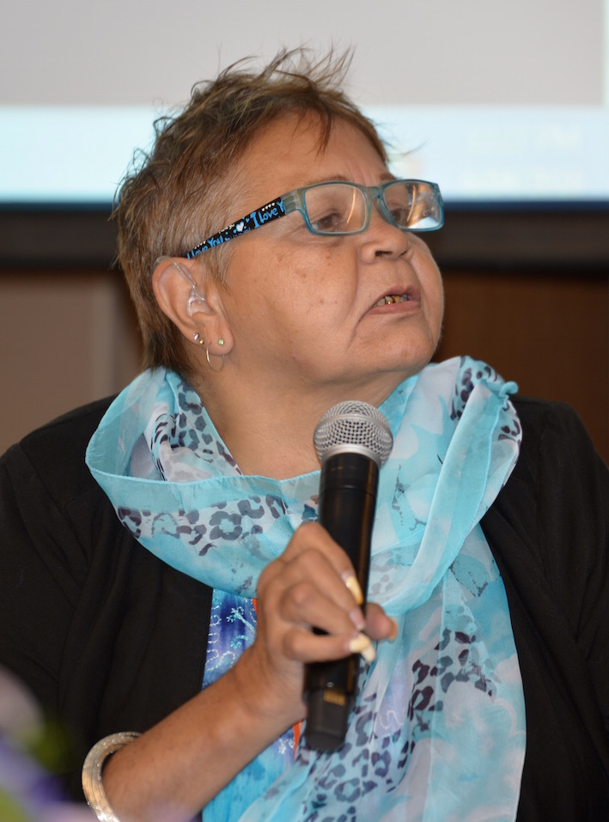

The National Forum for Women & Girls with Disability

Wednesday 6 April 2016, Melbourne

Proceedings and Outcomes Report

Publishing Information

Women With Disabilities Australia (WWDA) The National Forum for Women and Girls with Disability: Proceedings and Outcomes Report. WWDA, Hobart, Tasmania. November 2016. Copyright.
ISBN: 978-0-9775305-4-0

Cover Image
Aboriginal elder Aunty Gayle Rakine at the National Forum for Women and Girls with Disability, Wednesday 6 April 2016, Melbourne.

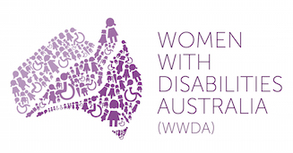

Winner, National Human Rights Award 2001
Winner, National Violence Prevention Award 1999
Winner, Tasmanian Women's Safety Award 2008
Certificate of Merit, Australian Crime & Violence Prevention Awards 2008
Nominee, French Republic's Human Rights Prize 2003
Nominee, UN Millennium Peace Prize for Women 2000

Women With Disabilities Australia (WWDA)
PO Box 407, Lenah Valley Tasmania 7008 AUST
Ph: +61 438 535 123 E: carolyn@wwda.org.au
W: www.wwda.org.au FB: www.facebook.com/WWDA.Australia
Twitter: https://twitter.com/WWDA_AU
Contact: Carolyn Frohmader, Executive Director

Funding Acknowledgment
The National Forum for Women and Girls with Disability was made possible through project funding from the Australian Government (Department of Prime Minister and Cabinet and the Department of Social Services), and generous in-kind support provided by Medibank Health Solutions Pty Ltd.

Disclaimer Statement
Unless otherwise stated, the views and opinions expressed in this publication are those of Women With Disabilities Australia (WWDA) and not necessarily those of the funding body. All possible care has been taken in the preparation of the information contained in this document. WWDA disclaims any liability for the accuracy and sufficiency of the information and under no circumstances shall be liable in negligence or otherwise in or arising out of the preparation or supply of any of the information aforesaid.

This work is copyright. Apart from any use as permitted under the Copyright Act 1968, no part may be reproduced without written permission from Women With Disabilities Australia (WWDA).

© 2016 Women With Disabilities Australia (WWDA).

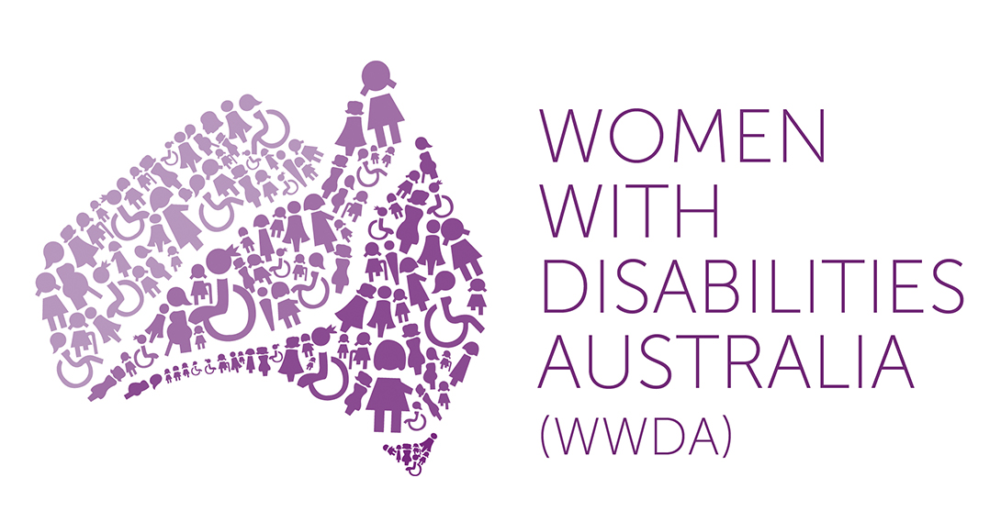 | 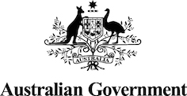 | 

Letter from Senator the Hon Michaelia Cash

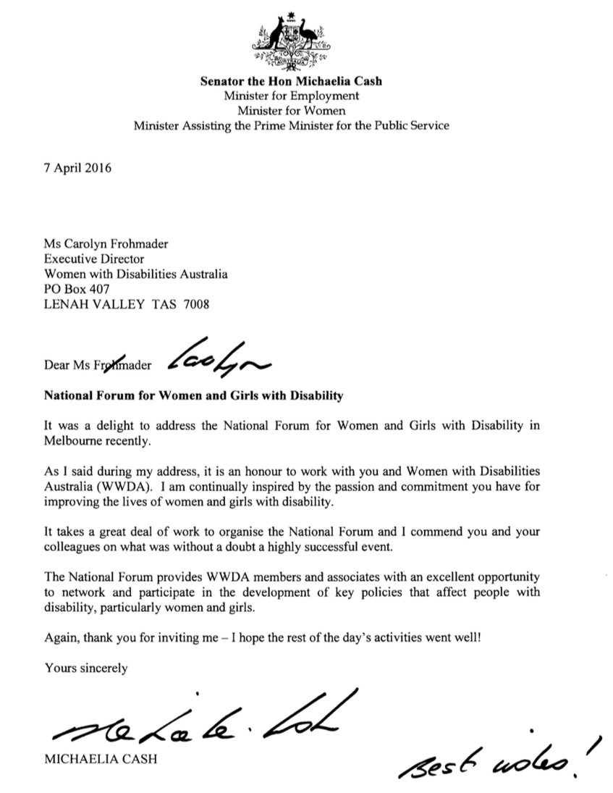

Contents

Publishing Information 2
Letter from Senator the Hon Michaelia Cash 3
Contents 4
About Women With Disabilities Australia (WWDA) 5
Acknowledgments 6
About this Report 7
Section 1: National Forum for Women and Girls with Disability - Overview 9
Section 2: Government priorities and women & girls with disability –Minister for Women 12
Section 3: Presentation of Lifetime WWDA Membership Awards 16
Section 4: An overview of critical issues for women and girls with disability in Australia 18
4.1. Overview of Key Issues - Rayna Lamb 18
4.2. Economic participation and empowerment - Therese Sands 19
4.3. Violence against women and girls with disability - Jen Hargrave 20
4.4. Sexual and reproductive rights - Jax Jacki Brown 22
4.5. Leadership, Participation & Decision-Making - Judy Huett 23
4.7. Aboriginal women and girls with disability - Gayle Rankine 25
Section 5: An Overview of current key policies for women and girls with disability in Australia 27
5.1. Second/Third Action Plan of the National Plan to Reduce Violence against Women and their Children 2010-2022 27
5.2. The National Disability Strategy (NDS) 29
5.3. The National Disability Insurance Scheme (NDIS) 31
5.4. Policies targeting Australian women in relation to economic participation and young women 33
Section 6: Workshop Session: Women with disability and government representatives 34
6.1. Groupwork 1: The National Plan to Reduce Violence Against Women and their Children 34
6.2. Groupwork 2: The National Disability Strategy: Employment 38
6.3. Groupwork 3: The National Disability Insurance Scheme (NDIS) 39
Section 7: What are human rights and why are they important for women with disability? 41
Section 8: An overview of WWDA’s strategic priorities for women and girls with disability 2010-2016 43
Section 9: Developing WWDA’s new strategic priorities 2017-2021 45
9.1. Agreeing on the Top 5 Strategic Priorities for WWDA 2017 - 2021 53
Section 10: Actions for WWDA, government and women with disability in relation to violence, employment, sexual and reproductive rights, leadership and participation 54
10.1. Actions: The right to live free from all types of violence 54
10.2. Actions: Employment of women with disability 55
10.3. Actions: Sexual and reproductive rights of women with disability 56
10.4. Actions: Leadership, Participation and Decision-Making 57
Section 11: The Forum – Preparation and Logistics 59

About Women With Disabilities Australia (WWDA)

Women With Disabilities Australia (WWDA) is the award winning, national Disabled People’s Organisation (DPO) for women and girls with all types of disability in Australia. WWDA was incorporated in 1995 as a very small, independent non-government organisation (NGO) run by women with disability for women with disability. Over the past 20 years, WWDA has grown from a small group of disabled women concerned primarily with building individual confidence and self-esteem, to an internationally acclaimed civil society organisation enabling and representing the collective interests of women and girls with disability and promoting and advancing their rights and freedoms.

WWDA operates as a transnational human rights organisation and is run by women with disability, for women with disability. WWDA’s work is grounded in a human rights based framework which links gender and disability issues to a full range of civil, political, economic, social and cultural rights. WWDA represents more than two million disabled women and girls in Australia, has affiliate organisations and networks of women with disability in most States and Territories, and is internationally recognised for its global leadership in advancing the human rights of women and girls with disability.

WWDA has initiated and conducted ground-breaking and critically acclaimed programs which have addressed a wide range of issues for women and girls with disability. WWDA provides rigorous, informed, and evidence based input into policy development at state/territory, national and international levels. The organisation is widely respected for its high quality, professional, and intellectually rigorous research that continually builds the evidence base in respect of legislation, policies, services, supports and programs for all people with disability. As the Disabled People’s Organisation (DPO) for women and girls with all types of disability in Australia, WWDA is the recognised coordination point between Government/s and other stakeholders, (both nationally and internationally) for expertise, advice, collaboration, consultation and engagement with women and girls with disability in Australia.

The key purpose of WWDA is to promote and advance the human rights and freedoms of women and girls with disability. Its goal is to be a national voice for the rights of women and girls with disability and a national force to improve the lives and life chances of women and girls with disability.

For more information about Women With Disabilities Australia (WWDA)

Visit the WWDA website: http://www.wwda.org.au

Follow WWDA on Facebook: www.facebook.com/WWDA.Australia

Follow WWDA on Twitter: https://twitter.com/WWDA_AU

Acknowledgments

WWDA would like to thank the women and girls with disability who contributed so passionately to the National Forum for Women and Girls with Disability, held in Melbourne on 6 April 2016. The national Forum, and other consultation processes held by WWDA to supplement the Forum, clearly demonstrate that the expertise and experience of women and girls with disability makes them best positioned to identify and determine their own rights, needs, will and preferences and to make decisions concerning their circumstances and conditions.

We thank the Department of Prime Minister and Cabinet (PMC) and the Australian Department of Social Services (DSS), for contributing funding towards the cost of the National Forum for Women and Girls with Disability. We would particularly like to acknowledge with thanks, Medibank and Medibank Health Solutions Telehealth Pty Ltd (MHS), for the extensive in-kind support provided to WWDA to enable us to hold such a successful National Forum.

WWDA would also like to thank:

- Senator the Hon Michaelia Cash, Minister for Women, for taking time out of her busy schedule to attend and address our National Forum;
- Ms Georgie Crozier, Victorian Shadow Minister for Families and Children; Shadow Minister for Prevention of Family Violence; and Shadow Minister for Women, for attending the Forum;
- Aunty Georgina Nicholson, Wurundjeri Tribe Council, for a stirring Welcome to Country address;
- Ms Rayna Lamb, Ms Therese Sands, Ms Jax-Jackie Brown, Ms Judy Huett, Ms Gayle Rankine, Ms Jen Hargrave, Ms Cashelle Dunn – for your presentations on the Panel of Women with Disability;
- Representatives from the Australian Government – Ms Lara Purdy (DSS), Ms Louise McSorley (PMC), Ms Sharon Stuart (DSS) and Ms Vicki Rundle (NDIA) – for attending and working alongside women with disability;
- Representatives from the National Women’s Alliances;
- Susan Matthew and Emma Rodgers from Andrew Jones Travel, for your professionalism and support in organising travel arrangements for Forum delegates;
- AI Media, for your wonderful live captioning service and transcripts;
- The support persons who travelled with delegates and contributed to the event;
- The four Auslan interpreters for your great service throughout the day;
- Ms Jane French, Manger of 1800RESPECT (MHS) for working so respectfully with WWDA to ensure all necessary supports were provided and available;
- Mr Nigel Davis, Organisational Development Partner (Medibank) for co-ordinating the in-kind support provided by Medibank and MHS;
- Medibank and MHS volunteers, photographer, note taker;
- Ms Tarja Malone, 1800RESPECT Counsellor;
- The Board members of WWDA;
- First People’s Disability Network (FPDN), People With Disability Australia (PWDA), and the National Ethnic Disability Alliance (NEDA) for sponsoring women with disability to attend the National Forum.

Planning, organising and hosting the National Forum for Women and Girls with Disability was an enormous task which required months of work. All of the work was done internally by WWDA staff and volunteers. Particular thanks must go to the WWDA National Forum project staff: Ms Cristina Ricci, Ms Cashelle Dunn, and Mr Chris Brophy, who worked above and beyond the call of duty over many months to ensure the Forum’s success. Thanks too, to the family members and friends of WWDA staff, for doing your bit to help out.

Carolyn Frohmader, WWDA Executive Director
On behalf of the Board and members of Women With Disabilities Australia (WWDA)

About this Report

This Report details the proceedings and outcomes of the National Forum for Women and Girls with Disability, held in Melbourne on 6 April 2016. It is presented in 12 main sections, which reflect the sessions conducted during the day of the National Forum.

Section 1 provides a brief overview of the National Forum for Women and Girls with Disability, including the aim, objectives ad anticipated outcomes.

Section 2 provides the transcript of the key address from the Minister for Women, Hon Michaelia Cash, outlining the Australian Government’s priorities and their relationship to women and girls with disability.

Section 3 introduces two WWDA members – Karin Swift and Jules Anderson – who were presented with WWDA Lifetime Membership Awards at the Forum, by the Minister for Women, Hon Michaelia Cash and WWDA Executive Director Carolyn Frohmader.

Section 4 details the presentations given by a panel of women with disability at the National Forum. These presentations included:
- Overview of Key Issues - Rayna Lamb
- Economic participation and empowerment - Therese Sands
- Violence against women and girls with disability - Jen Hargrave
- Sexual and reproductive rights - Jax Jacki Brown
- Leadership, Participation & Decision-Making - Judy Huett
- Young women and girls with disability - Cashelle Dunn
- Aboriginal women and girls with disability - Gayle Rankine

Section 5 provides an overview of current key policies for women and girls with disability in Australia, presented by four representatives of the Australian Government. These presentations included:
- The Third Action Plan of the National Plan to Reduce Violence against Women and their Children 2010-2022, presented by Ms. Lara Purdy, Branch Manager, Family Policy and Programmes, Department of Social Services (DSS).
- The National Disability Strategy (NDS), presented by Ms. Sharon Stuart, Branch Manager, Disability Carers Policy and Access, Department of Social Services (DSS).
- The National Disability Insurance Scheme (NDIS), presented by Ms. Vicki Rundle, General Manager Operations, National Disability Insurance Agency (NDIA).
- Policies targeting Australian women in relation to economic participation and young women, presented by Ms. Louise McSorley, Assistant Secretary, Office for Women, Department of Prime Minister and Cabinet.

Section 6 provides an overview of the workshop session where women with disability and government representatives worked together in small groups to examine particular issues in relation to violence against women and girls with disability; economic empowerment, employment and the National Disability Strategy (NDS), and the National Disability Insurance Scheme (NDIS), particularly in relation to the experiences of women with disability in engaging with the National Disability Insurance Agency (NDIA) and how things could be improved.

Section 7 of the Report gives a brief overview of the Forum session where delegates engaged in a general discussion about human rights and why they thought human rights are important for women and girls with disability.

Section 8 details a brief presentation given at the Forum by Karin Swift (Vice-President of Women With Disabilities Australia (WWDA). Karin gave a brief overview of the strategic priorities the organisation has been working on over the past few years.

Section 9 of the Report details the outcomes of a Workshop session where delegates worked to identify the priority human rights issues for women and girls with disability in Australia. Eight small working groups of delegates worked to identify the most important human rights for themselves as individuals, and for women and girls with disability collectively. Each group then prioritised 5 key human rights issues to direct WWDA’s strategic direction over the next 5 years.

Section 10 details the outcomes of the Workshop session at the Forum whereby groups of delegates identified a series of suggested actions for WWDA, government, and women with disability themselves in relation to some of the key human rights issues prioritised for women and girls with disability in Australia, including: violence, employment, sexual and reproductive rights, leadership and participation.

Section 11 of the Report gives a brief overview of some of the Forum Preparation and Logistics.

Appendices to this Report are provided in a supplementary document, entitled: The National Forum for Women and Girls with Disability, Appendices. This document includes the following information:
- Appendix 1: Attendee list
- Appendix 2: Forum Invitation Letter & Information Flyer [Standard Version]
- Appendix 3: Forum Invitation Letter & Information Flyer [Easy English Version]
- Appendix 4: Participant Information Survey Form
- Appendix 5: Participant Emergency Contact Form
- Appendix 6: Participant Photo/Video Consent & Release Form
- Appendix 7: Participant Information Kit [Standard Version]
- Appendix 8: Participant Information Kit [Easy English Version]
- Appendix 9: Background Reading [Easy English Version]
- Appendix 10: Forum Agenda [Standard Version]
- Appendix 11: Forum Agenda [Easy English Version]
- Appendix 12: Forum Media Release
- Appendix 13: National Forum Run Sheet

Section 1: National Forum for Women and Girls with Disability - Overview

The National Forum for Women and Girls with Disability was held in Melbourne on 6 April 2016, at the Medibank Head Office building in Docklands. The Forum was made possible through one-off Project funding from the Department of Prime Minister and Cabinet and the Australian Department of Social Services, plus extensive in-kind support provided by Medibank and Medibank Health Solutions Telehealth Pty Ltd (MHS).

The National Forum was held to support women and girls with disability from around Australia to identify the issues that affect them, identify solutions, prioritise actions, and engage actively and directly with representatives from the Australian Government on issues relevant to Australian women and girls with disability. Proceedings and outcomes from the Forum also informed the development of WWDA’s five-year Strategic Plan and priorities for 2017 to 2021.

The Forum included a specific focus on the strategic priorities affecting women and girls with disability, including:
- Violence against women and girls with disability;
- Leadership, participation and decision-making;
- Economic empowerment;
- Sexual and reproductive rights;
- Aboriginal and Torres Strait Islander women and girls with disability; and,
- Young women and girls with disability.

The National Forum provided a critical opportunity for women and girls with disability to come together and ensure that their voices and experiences are heard by decision-makers and other key stakeholders. Supports were made available to all attendees to ensure that the Forum was inclusive, meaningful and empowering for all women and girls with disability. Extensive work was undertaken in the planning phase of the Forum to ensure that the Forum event modelled and showcased best practice in accessibility and inclusion.

The National Forum for Women and Girls with Disability was attended by 45 women and girls with disability (and twelve support persons) from each State and Territory of Australia. Other attendees and delegates included:
- Senator the Hon Michaelia Cash, Minister for Women
- Ms Georgie Crozier, Victorian Shadow Minister for Families and Children; Shadow Minister for Prevention of Family Violence; and Shadow Minister for Women;
- Aunty Georgina Nicholson, Wurundjeri Tribe Council;
- Representatives from the Australian Government – Ms Lara Purdy (Department of Social Services), Ms Louise McSorley (Department of Prime Minister and Cabinet), Ms Sharon Stuart (Department of Social Services), and Ms Vicki Rundle (National Disability Insurance Agency);
- Four representatives from the National Women’s Alliances;
- Four Auslan interpreters;
- Ms Tarja Malone, 1800RESPECT Counsellor;
- Attendant Carer (Travellers Aid);
- Four WWDA Project staff;
- Eight staff from Medibank to assist through out day;
- Several additional volunteers.

The key objectives of the National Forum were:

- Build the capacity of women and girls with disability to become better informed about their human rights.

- Build the capacity of women and girls with disability to engage with the Australian Government on policy issues to ensure informed and representative dialogue between women with disability and government.

- Promote and support greater participation of women with disability in all policy-making processes.

- Enhance WWDA’s capacity to contribute to the Australian Government’s work to strengthen the provision of gender analysis, advice and mainstreaming across Government and ensure the voices of women and girls with disability are included.

- Women with disability actively contribute in setting the strategic direction of WWDA for 2017-2021.

The anticipated outcomes of the National Forum included:

- WWDA has increased its capacity to actively engage with the Australian Government, WWDA members, and other key stakeholders on policy issues relevant to women and girls with disability.

- Women and girls with disability are provided with the opportunity to inform, and engage with the Australian Government on priority policy issues relevant to women and girls with disability.

- Women and girls with disability have access to innovative engagement, information, and participation mechanisms to become better informed about their human rights.

- Women and girls with disability from across Australia inform the strategic direction of WWDA for 2017-2021.

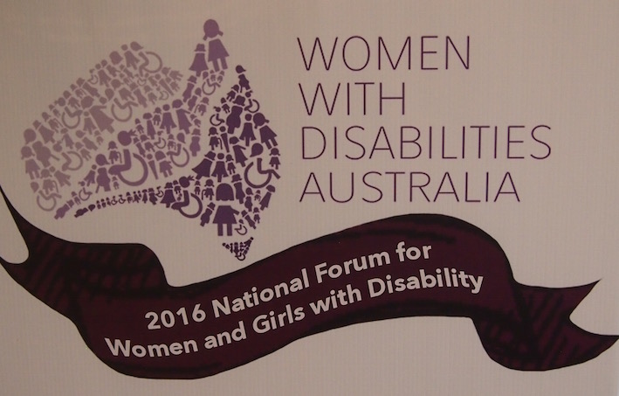

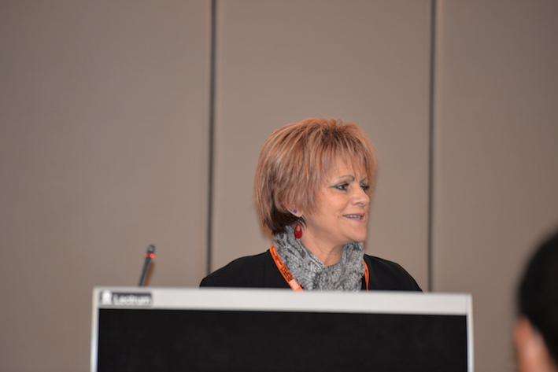  Aunty Georgina Nicholson | 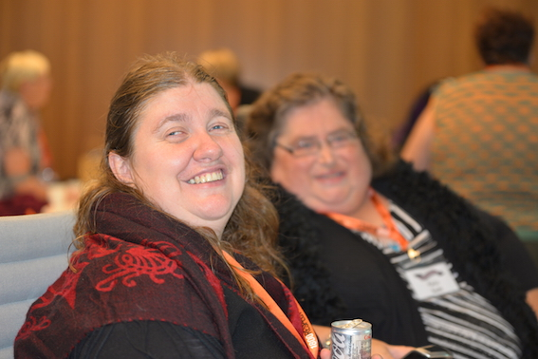  Leah (L) and Karin

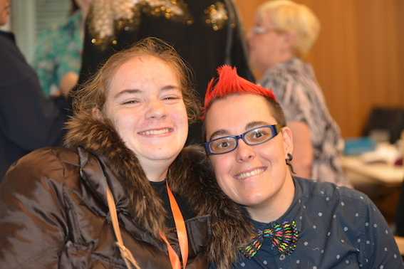  Stella (L) and Jax | 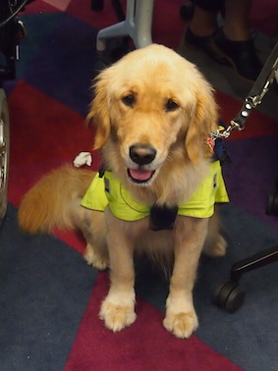

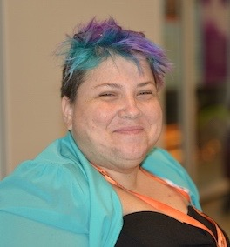  Amy | 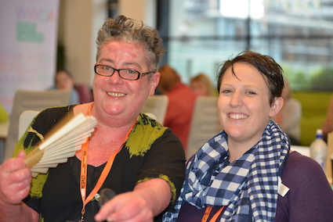  El (L) and Bonnie

Section 2: Government priorities and women and girls with disability – By the Minister for Women, Hon Michaelia Cash

This section provides the transcript of the key address to the National Forum, from the Minister for Women, Hon Michaelia Cash, outlining the Australian Government’s priorities and their relationship to women and girls with disability.

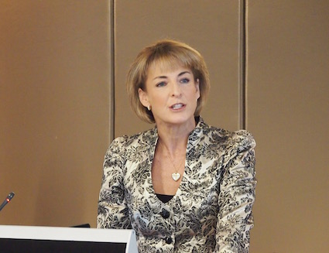

Minister for Women, Hon Michaelia Cash

“As the Minister for Women and the Minister for Employment, we are delighted to assist you with funding for today.

Can I say thank you to Carolyn, this is a woman who, when I was in opposition, inspired in me as a policymaker the will to help this particular organisation.

Why? Because Carolyn, your passion and commitment and the passion you ignite in everybody here says to me that as a minister of the government, we have a group of people here in Australia who already have desire, who already have passion, who already have commitment.

So, what do we need to do as a government? We need to provide you with opportunity. So many times in life, governments can provide opportunity. But often people don't want to take that opportunity. Every time I meet with Carolyn, with Rayna, it confirms to me why we need to work as a partnership.

To each and every one of you here today, thank you so much for everything that you do, that you have done, and I know that going forward you will continue to do, in particular, to hold government to account. In terms of ensuring that we deliver on policy that will make a real and tangible, and probably the best word to use, we are women here, a practical difference. Practicality sometimes is beyond policymakers. But a practical difference in the lives of women with disability.

Ladies and gentlemen, can I also do a very formal introduction here of a very good friend of mine, someone I am so delighted you have an opportunity to meet in her home state, that is one of my colleagues in the Victorian Parliament, Georgie Crozier, can you give everyone a wave? Whilst I work with you from a Federal government perspective, there will be many of you here from Victoria, you have now got that connection with Georgie. In particular, when it comes to assisting me with what you can do to help women in situations of domestic violence, I need to pay tribute to Georgie for all of the policy advice, in particular on a state government level, that she has given to me. I am thrilled you are here today, I wanted to make this formal introduction, now you know who she is, please feel free to put your hand up, if you do need assistance from that State government perspective, Georgie has always been there to help people, she will be there to help you.

As a policymaker, you have to use the time in office to make a positive difference. In terms of making a positive difference for women with disability, there are certain things that as a government I believe we need to focus on.

They are all women and children in Australia, but in particular women who can face particular challenges, culturally diverse women, women with disability, we need to have the appropriate funding in place so you are supported.

I am committed that women and children in Australia are safe at home, safe on the street, and everything we do with technology, that you are safe online. That is why, as you know, we have the National Action Plan to Reduce Violence against Women and their Children. We are about to launch, I am very excited, it will be in June, the third action plan. That is how far we have come so far. We are going into year seven, and I have to pay here special tribute to Carolyn Frohmader again.

Policy makers sometimes look at the one size fits all approach. I am from Western Australia, I know one size does not fit all.

That is why when Carolyn and I sat down all those years ago now, she impressed upon me, “Michaelia, when you are looking at creating the second action plan, you can't have a one size fits all policy, you need to recognise that there will always be certain groups that face challenges mainstream Australia does not face.” There are three groups we talked about, culturally and linguistically diverse women, Indigenous women, but also women with disability.

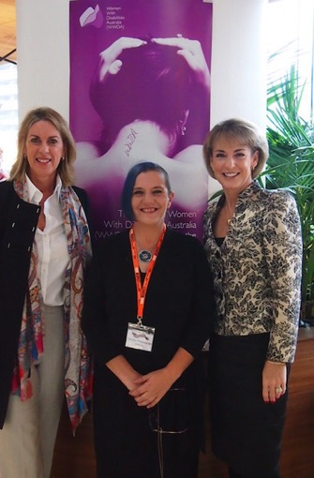

WWDA Executive Director Carolyn Frohmader (C) with Minister for Women, Hon Michaelia Cash (R) and Ms Georgie Crozier, Victorian Shadow Minister for Women

There are unique challenges that you face. So when we look at policy, we need to ensure that it appropriately responds to those challenges. That is why we were so keen that within the second action plan you would be mentioned. We would not have that one size fits all approach, it would be specifically mentioned, there would be actions that were dedicated to you.

Carolyn, thank you, you were instrumental in ensuring that as policymakers we understood that.

We are now working on the third action plan, and again, our relationship with WWDA is integral to ensuring that, again, when we are putting together the third action plan, there are actions in there that directly relate to the challenges you may face.

As a policy maker, but in particular as a woman, I am so immensely committed to ensuring that we live in a country whereby we unlock 100% of our workforce. Everybody, if you can work, you should be able to. Government's role in the first instance is to ensure that the jobs are there. There is no point telling you “you need to work” if we don't put in place policies to create jobs. That is certainly something this government is doing.

Then we need to ensure that we have policies in place that tap into everybody's talent. Life is expensive, as we all know, and I am a believer that people want jobs. Most people put their hand up and say please give me a job. As a government, we need to deliver on that to you.

These are statistics that I personally find quite alarming, I am sure you are absolutely aware of them.

People with disability face additional challenges in entering the workforce that mainstream Australia don't face. Women with disability, these are the statistics, have a considerably lower rate of workforce participation compared to men with disability at 57%. To me, that is unacceptable. Why? Because everybody who wants to work should be afforded the opportunity to do so. So we need to ensure that that is what we are doing.

But as we know, it is the economic benefits, isn't it? I don't know too many people who don't want to be economically independent. We don't want government breathing down our neck, we want to be economically empowered, to make our own choices. Not the choices I have to make because government policy is dictating I make these choices. What is the best way to do that? We offer job opportunities to people.

There are a whole bunch of statistics of why this is good, it does increase our bottom line, but for me it is about personal empowerment. I am so fundamentally committed to personally empowering people.

Just to give you an update on what we are also doing with disability employment services, putting on my hat as the Minister for Employment, but working very closely with Christian Porter in his role delivering the services, we currently provide assistance to more than 174,000 people with disabilities, that includes 77,000 women.

It is good that we can provide the assistance, but one of the things we are finding is despite providing this assistance, we are still not getting quite right the types of jobs that people can get into, or alternatively want to get into.

What we are now doing is reviewing the entire disability employment system. Great that we have a system, that is good, but if a system is not working we need to ask ourselves why, that will obviously involve discussions with this group here. Then we need to replace elements of the system so it delivers better outcomes not just for this group here, but for all Australians. When our systems work, it is good for all, ultimately. We recognise that the system, it is great it is there, it is not achieving the outcomes we want to achieve. We are going to have a really good look at it, see what we can achieve to get you better outcomes.

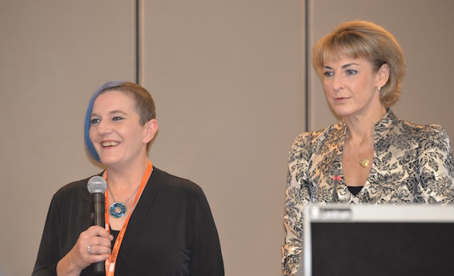

WWDA Executive Director Carolyn Frohmader (L) with Minister for Women, Hon Michaelia Cash

The other issue I would like to discuss with you, an issue I think is now really at the forefront of government and business, that is workplace diversity. I have spoken to a number of you about workplace diversity as it relates to getting more women into the workplace. But I think as a society, and certainly as a government, we have now moved from talking about just getting more women into the workplace, which we are fundamentally committed to, it is now not just about women, it is about really reflecting our population.

We also need to have a specific focus on getting people with disability to be able to better participate in the workforce. I go around and talk with employers, I ask them about their strategies. If you have a strategy to get more women into the workforce, you are well on the way to implementing a strategy that just talks about diversity, and then your workforce will truly represents the Australian population, not be part of the population which is basically just women.

A final note, an update on the National Disability Insurance Scheme I know that obviously Mitch Fifield fundamentally committed to it, Christian Porter has the same commitment ensuring this scheme stays to date. It has formal roll-out for the middle of this year. It is certainly something we are passionately committed to, I do look forward to seeing it rolled out across Australia. This is something we need, to offer opportunity to people, and this is one of those policy levers government can put in place, to assist in offering opportunity.

Again, though, the road to equality, it is a long road, a very windy road, sometimes it is a really bumpy road. But one thing my parents taught me is exemplified in this room today, and everything Carolyn and Rayna are always telling me.

Life puts challenges in front of us all, it is what you do with those challenges, that metaphorical hurdle that is put in front of you, do you pick it up, do you go over it? Do you go under it, do you go around it?

That is the reason we need organisations like this, people like yourself who have that passion and commitment, because we don't want people running into hurdles any more.

There have been too many hurdles in place for women, women with disability, culturally and linguistically diverse women, indigenous women, for too long now.

I agree with you, for too long now.

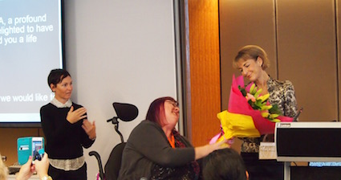

WWDA President Rayna Lamb presents Hon Michaelia Cash with a thank you gift

If we all work together, I do believe we can take further steps down that path towards obliterating those hurdles and getting to the stage that we all want, where we can look at our workforce, look at our society, and say yes, we are achieving diversity in the workplace. Well done, everybody, on everything you have achieved, but I really do wish you all the best with your conference today.

Thank you for giving me the opportunity to address you.”

Section 3: Presentation of Lifetime WWDA Membership Awards

This section introduces two WWDA members – Karin Swift and Jules Anderson – who were presented with WWDA Lifetime Membership Awards at the National Forum, by the Minister for Women, Hon Michaelia Cash and WWDA Executive Director Carolyn Frohmader. Karin and Jules received these Awards in recognition of their outstanding contribution to advancing the human rights of women and girls with disability.

Karin Swift

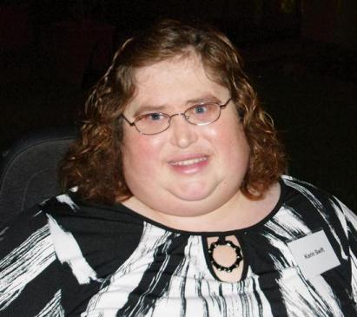

WWDA Vice - President, Karin Swift

Karin has been a member of WWDA for more than two decades. She is a past President of WWDA and is currently serving in the role of Co-Vice President of WWDA, along with El Gibbs.

Karin has represented WWDA on all manner of national advisory committees, reference groups, project management structures and more. Her expertise is widely recognised by Governments and stakeholders across state, territory and national levels.

Karin has presented nationally and internationally on key gender and human rights issues on behalf of WWDA, including co-delivering training to women with disability and other stakeholders in Jakarta, Indonesia in 2012, and representing the Australian Government at the United Nations, New York at the Commission on the Status of Women in 2013.

Karin is currently employed as a Project Worker for the Ready to Go project, the NDIS Participant Readiness Initiative project of Queenslanders with Disability Network (QDN).

Karin is a most worthy recipient of WWDA’s Lifetime Membership Award and we offer her our warmest congratulations.

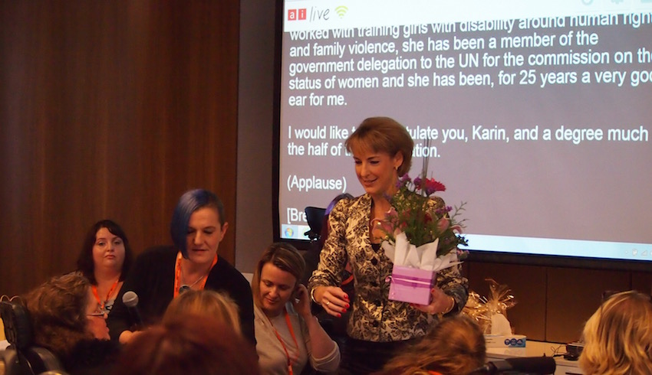  Hon Michaelia Cash preparing to present Karin Swift with her Award | 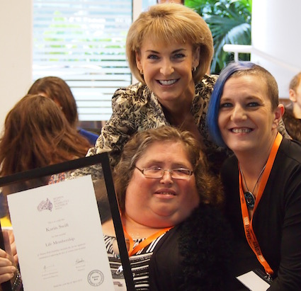  Karin Swift with Hon Michaelia Cash and Carolyn Frohmader

Jules Anderson

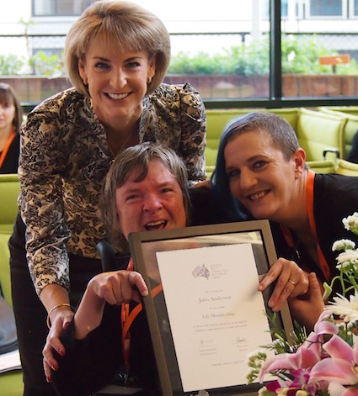

Jules Anderson accepts her Award from Hon Michaelia Cash and Carolyn Frohmader

Jules Anderson is an exceptional advocate for the rights of women and girls with disability. Her dedication and commitment to improving the lives of disabled women and girls – particularly those in institutional settings – knows no bounds.

Jules was instrumental in securing the Senate Inquiry into Violence Against People with Disability in Institutional Settings, which was conducted throughout 2015. Jules led the delegation of people with disability at a Press Conference at Parliament House in Canberra, in February 2015, which resulted in the unanimous motion from the Australian Senate to conduct the National Inquiry. Jules also worked closely with the Senate Committee on various aspects of the Inquiry itself.

Jules currently serves in the role of Secretary for United Voices for People with Disabilities (UVPD), a community based non-government organisation, formed to give people with a disability, their families, friends and supporters, a strong voice to advance and protect their human rights.

We thank Jules for her work for and on behalf of women and girls with disability and are honoured to present Jules with WWDA’s Lifetime Membership Award. Congratulations.

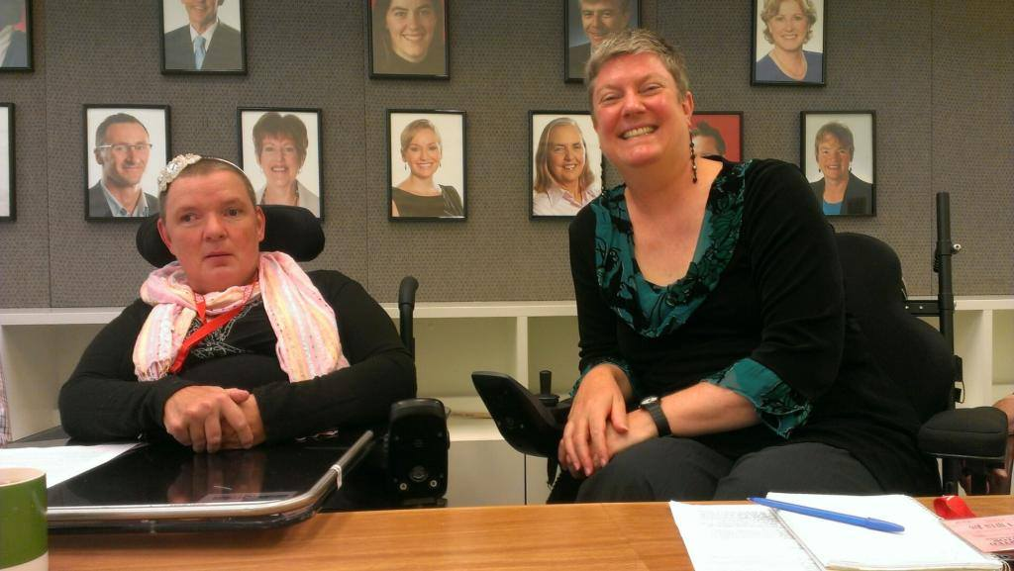  Jules Anderson (L) preparing to front the Press Conference at Parliament House Canberra regarding the Senate Inquiry into Violence Against People with Disability in Institutions. WWDA member Christina Ryan is seated with Jules. | 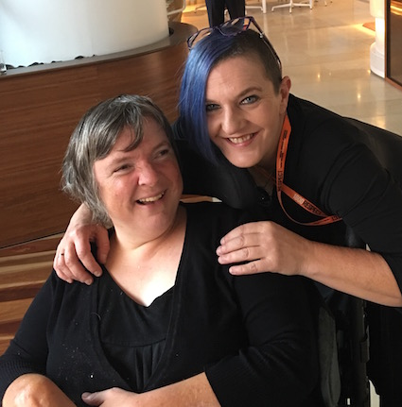  Jules Anderson with WWDA Executive Director, Carolyn Frohmader

Section 4: An overview of critical issues for women and girls with disability in Australia

This section provides transcripts of the presentations given by the Panel of women with disability at the National Forum.

4.1. Overview of Key Issues - Rayna Lamb

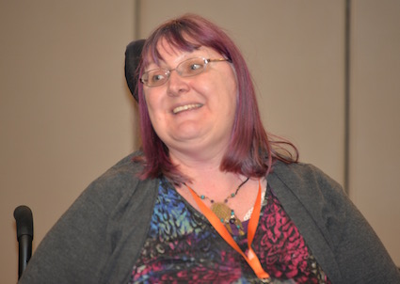

WWDA President, Rayna Lamb

“Each of the women on this panel are well–placed to speak to the key issues that affect women with disability in Australia, drawing on their personal and professional experience. Today, my role is to provide a brief outline of the topics that our panellists will present on. These include:

- Economic participation and empowerment
- Gendered disability violence
- Sexual and reproductive rights
- Leadership and participation
- Young women and girls with disability
- Aboriginal and Torres Strait Islander women and girls with disability.

Systemic discrimination in regard to economic participation remains a key driver of inequality for women with disability. We are more likely to be unemployed or underemployed; we often earn less income for the same work; and, we experience higher levels of workplace discrimination than the broader population. The resulting disempowerment contributes to disadvantage across a range of socioeconomic indicators including access to education, health care, social isolation, housing and social participation. Although recent improvements in legislation and disability policy have and continue to make a difference, the stats suggest we still have a way to go.

Women experience gendered disability violence more frequently and severely than men with disability and the broader population. The forms of violence that women with disability experience are extensive and varied. The impact and effects of violence for women and girls with disability are profound, long-term, wide-ranging and cumulative.

Systemic service gaps continue to facilitate conditions that give rise to ill-treatment of women with disability in Australia and across the world. There remains no comprehensive mechanism in Australia that captures the true prevalence, extent, nature, causes and impact of violence against women and girls with disability in the range of settings in which they reside or receive support.

Sexual and reproductive rights remain key areas where women with disability continue to be disadvantaged and at risk of gross violations of our human rights. Women with disability in Australia continue to experience and be at risk of forced sterilisation, forced contraception, chemical restraint, and denial of freedom to express our sexuality and gender identities in ways that are meaningful to us.

Cultural assumptions continue to place women with disability at a disadvantage in regard to the substantive enjoyment of sexual and reproductive rights, including the freedom to act and be recognised as autonomous and fully capable adults who can make decisions regarding their circumstances and conditions.

Women with disability continue to be systematically denied meaningful opportunities for leadership, social and political participation. For women and girls with disability, participation in social and political life and ensuring an adequate standard of living depends on access to fundamental social structures including education, employment, health care, housing, and enjoyment of human rights including freedom from all forms of violence.

Many women with disability continue to be denied the most fundamental rights and freedoms to enable that would enable their participation in social and political life on an equal basis as others. We are not treated with dignity and respect and remain profoundly more disadvantaged than our male counterparts.

Young women and girls with disability experience higher levels of violence, abuse and harassment than other children and young people, and are often denied opportunities for social participation, meaningful decision making, leadership, expression of their sexuality and gender identity, political participation, and freedom from all forms of violence. Young women and girls with disability continue to be excluded and segregated, and like many adults with disability, continue to be disadvantaged by social and cultural assumptions, expectations, and constructs.

Finally, Aboriginal and Torres Strait Islander women and girls with disability experience many of the same disadvantages and violations of fundamental human rights that other women and girls experience; often in greater proportions due to compounding factors of isolation, violence, racism, the ongoing effects of colonialism and a lack of resourcing for culturally relevant and community-owned supports.

These ‘key issues’ facing us as women and girls with disability are systemic issues that require systemic solutions at local, national and global levels. There are no simple or straightforward solutions, but forums such as this provide an important opportunity for us to come together in our diversity to share our ideas, to share our experiences, and to lead the social, political and cultural change we need.

I will now hand over to my fellow panellists to explore these topics further.”

4.2. Economic participation and empowerment - Therese Sands

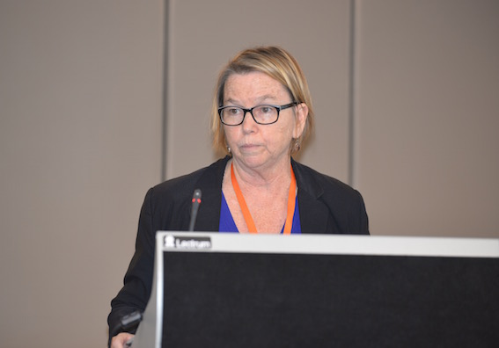

Therese Sands

“It is now well-established that Australia is doing very poorly when it comes to addressing poverty levels and employment rates of people with disability compared to other countries.

Economic security and empowerment should mean that people with disability can get and retain jobs, have careers, be paid equitably (the same as others), plan for career progression and retirement, be financially literate (budget, save and invest), have enough superannuation, make decisions about spending on necessities and luxuries, plan and take holidays etc, In other words, it should lead to having a decent, secure life in the same way as others expect in our community.

However, the employment situation for people with disability, particularly women with disability, has not changed for well over a decade.

The National Disability Strategy is the Australian Government plan to improve the situation for people with disability, to make sure that our human rights are realised. This plan quotes the Australian Bureau of Statistics (ABS) - “women with disability face poorer economic outcomes than men with disability.” Women with disability have lower labour force participation rates, higher unemployment rates than men with disability and non-disabled women, and are more likely to be in low paid, part-time, short-term casual jobs.

However, the National Disability Strategy contains no measures or actions to address this situation. There are no gender-specific actions to target economic security and empowerment for women with disability. Not surprisingly, in 2014, the progress report for the National Disability Strategy stated that the labour force and unemployment situation for women with disability had not changed.

Over the past decade, at least, there have been many inquiries conducted by the Australian Parliament, the Australian Human Rights Commission and governments on the employment situation of people with disability and the employment situation of women – pay equity, work and family balance, increasing employment opportunities and careers, addressing employment barriers. Currently we have the Australian Human Rights Commission’s Willing to Work inquiry and the Department of Social Services review of the Employment Framework.

The poor and unaddressed economic situation has been raised on numerous occasions in submissions to these inquiries – largely by WWDA and PWDA – but there have been few to no recommendations made or implemented that address this situation for women with disability.

In 2013, the United Nations Committee on the Rights of Persons with Disabilities reviewed Australia’s implementation of the Convention on the Rights of Persons with Disabilities (CRPD). Over 70 non-government organisations, including Disabled Peoples Organisations (DPOs), advocacy organisations, women’s organisations, community legal centres and human rights organisations endorsed a civil society report to the UN Committee for this review. The civil society report raised many human rights concerns for people with disability, including the unaddressed, poor employment situation for women with disability.

The UN Committee, in their Concluding Observations following the review recommended that Australia “(a)dopts initiatives to increase employment participation of women with disabilities by addressing the specific underlying structural barriers to their workforce participation.” This has not happened.

Today, I am urging Departmental representatives with us at this national forum to ensure that economic security and empowerment is at the top of your agenda. Gender specific actions must be integral to the second implementation plan for the National Disability Strategy and to the review of the employment framework, including Disability Employment Services (DES); and gender specific plans and strategies to increase women’s labour force participation and employment outcomes must include disability specific measures. Poverty and disadvantage for women with disability will not be alleviated if these actions are not taken.

Thank You.”

4.3. Violence against women and girls with disability - Jen Hargrave

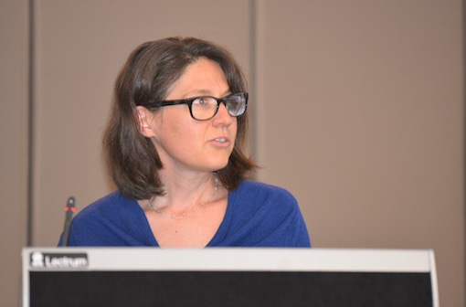

Jen Hargrave

“Women and girls with disabilities experience violence from the same types of people as other Australian women and girls. This is violence from people we know. We experience violence from our partners, our ex-partners, and from our relatives. In fact, evidence shows that we are at higher risk of domestic violence than other Australian women and girls.

But women and girls with disabilities don’t just live in homes on our own, with our families or with our partners. We live in group homes, large residential facilities, boarding houses, and out-of-home-care. We are in institutions like Special Schools, prisons and psychiatric hospitals and detention centres.

And we experience a broader range of violence from a larger group of perpetrators than what is generally considered as domestic violence.

Women and girls with disability, regardless of where we live or receive services, also experience violence from paid and unpaid carers. Some forms of violence we experience are legal in Australia, for example sterilisation of women with disability without their consent.
Evidence tells us that:
- More than 70% of women with disability have been victims of violent sexual encounters at some time in their lives
- 90% of women with an intellectual disability have been subjected to sexual abuse, with more than two-thirds (68%) having been sexually abused before they turn 18 years of age
- The rate of sexual victimisation of women with disability ranges from four to 10 times higher than for other women
- Children with disability are three to four times more likely to experience sexual abuse than their peers, with many not having the language or ability to communicate the abuse.

It would be easy to imagine that government-funded settings would be regulated and safe. But this is commonly not the case. In these settings we experience physical and sexual violence, psychological abuse, restrictive practices, forced treatments, harassment and financial abuse. For example:

Hannah is a teenager who lives in a group home. She has an intellectual disability. One night Hannah was lying in her bed when an older co-resident came into her room. He climbed onto her bed and bit her face and her chest. Afterwards it was easy to see where he had bitten, Hannah had bruises, scratches and black eyes. Despite this, no charges were laid.

But policies and practice are lagging disturbingly far behind our knowledge of what is needed. Things do not need to be like this. We know what actions will improve the situation. These include:
- Making sure there are safe ways for women to report the violence that they experience or witness
- Changing legislation to make sure that all crimes involving violence, wherever they occur, are investigated
- Ensuring that prevention programs are available, especially in disability settings
- Tailoring programs for women and girls at particularly high risk, like culturally safe programs for Aboriginal women, and providing adaptive communication for women with Communication disabilities
- Empowering us by funding programs which reduce our social and economic exclusion
- and through paying serious attention to policy.

The recent Senate Inquiry into ‘Violence, Abuse and Neglect against People with Disability in Institutional and Residential Settings’ pointed to 3 key policies in this space which NEED updating:

1. The ‘National Disability Strategy’ must address gender and violence.
2. The ‘National Plan to Reduce Violence against Women and their Children’ must include institutions and disability services.
3. The ‘National Framework for Protecting Australia's Children’ must address the safety of children with disability.

The Senate Committee’s report said that for change to happen, there has to be increased funding:
- to update these policies,
- to improve data collection,
- and to support women with disabilities to escape domestic violence.

Wherever we live, women and girls with disabilities have a right to safety.”

4.4. Sexual and reproductive rights - Jax Jacki Brown

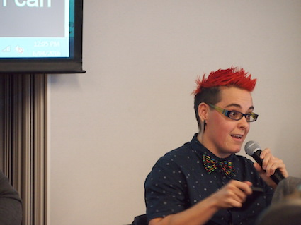

Jax Jacki Brown

“Too often when we talk about reproductive and sexuality rights we forget about Lesbian, Gay, Bisexual, Trans and Intersex and gender diverse people.

So I am here today to put same-sex attracted and gender diverse people with disabilities front and centre of the discussion…for 5mins.

What does ‘sexual and reproductive rights’ mean and how do we, as people with disabilities, demand and enjoy these rights?

Sexual expression is a human right.

The freedom and space to explore our sexuality, with oneself or lovers, provided we give consent, is a human rights issue for people with disability. Our sexuality is often denied or restricted by the people in our lives, either directly or indirectly, through attitudes or structural barriers.

Let me share with you a recent example in my own life. I have been looking into the current adoption laws in Victoria after the same sex adoption legislation was passed. I was excited at first because it was being hailed has having achieved equality but I then realized it didn't mean equality for same-sex attracted people with disability.

The adoption laws continue to discriminate against people with disabilities. They say adoptive parents must be ‘active, fit and healthy’. We are assumed to be inadequate parents from the outset. We are judged and accessed by non-disabled people. For some pregnant women with disability this negative judgment occurs before their child is born.

Parents with an intellectual disability are more likely than any other group of parents to have their children permanently removed by child welfare authorities. In many cases, child removal is ordered without evidence of abuse, neglect and/or parental incapacity, and occurs at the time, or within days of a child’s birth.

Evidence suggests that this remains a current practice in Australia.

Women and girls with disability also face a range of barriers to the enjoyment of their human rights in relation to sexual health, sexuality, gender identity, and reproductive health.

Women and girls with disability in Australia and across the world continue to be denied our basic freedoms to express our sexuality and gender identity. We are also denied the right to bodily integrity, to make decisions about our sexual and reproductive health and how to live our lives.

Women and girls with disability continue to experience forced or coerced sterilization. It remains legal in Australia, despite being recognized as an act of violence, a form of social control and a clear and documented violation of the right to be free from torture.

People with intersex variations - with and without disability – and often infants and children, continue to be sterilised as a result of invasive surgery designed to force their bodies to fit society’s ideas of characteristics of a man or a woman.

Our sexuality, gender identity and expressions are often heavily policed by support workers, family, friends, society.

Sex education for women and girls with disability is wholly inadequate, often focused exclusively on reproductive health and taught from a heterosexual perspective.

Women and girls with disability are often excluded or have difficulty accessing venues and spaces where we can meet people.

Our disability overshadows other aspects of our identities, including our sexualities and gender identities.
So what does access mean when we talk about sexuality and disability? What do rights mean?

- It means creating accessible sex education that incorporates pleasure and strength-based elements: that speaks to what we can and want to do with our bodies.
- It means supporting people with disability to demand respect in relationships and sexual encounters.
- It means creating sex-positive accessible spaces and venues.
- It means proclaiming our bodies as desirable – this is a political act.
- It means rejecting traditional gender roles and ideas about sexuality
- It means making forced and coerced sterilisation illegal.
- It means making forced contraception illegal.

Eli Clare, a disability activist says it means creating ‘…places where we encourage each other to swish and swagger, limp and roll, and learn the language of pride. Places where our bodies become home’’.

For me, the key to enacting sexuality rights as a person with disability is I think, learning to call my body home, to inhabit it fully, just as it is. Too often many of us have been taught to distance ourselves from our bodies, to feel ashamed. It is time to call our bodies home, to feel what it feels like to be in this body, and to do so proudly, boldly and unapologetically.

Its time to get angry and active, to demand our rights and to get political about it, because after all we know, the personal is political and nowhere more so then sexuality and reproductive rights.

Thank you.”

4.5. Leadership, Participation & Decision-Making - Judy Huett

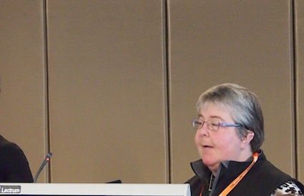

Judy Huett

“Today I want to talk about why women and girls with disabilities, and I mean all of us, must be able to make our own decisions and speak for ourselves.

Other people often make decisions for us and about us. We are not always listened to. We are not always taken seriously.

Our parents can sometimes be too over-protective of us. They want to control our lives.

A lot of people treat us like we are babies or little children.

We are not allowed to take risks.

We are not allowed to do the everyday things that other women and girls do and take for granted.

People sometimes don’t believe us when we tell them things.

Sometimes they don’t believe us when we tell them things about people who have hurt us or that we need help to be safe.

The situation is much worse for women and girls with disabilities who live in institutions. I have got friends who live in institutions:

- Their rights are taken away.
- They cannot choose who they live with.
- They do not choose what time they go to bed or what time they get up.
- They don’t get to choose what time they eat, or even what they eat.
- They are expected to fit in with the routine of the institution
- They don’t get to choose what they wear or what is in their wardrobe.
- They can’t go out when they want to.
- They aren’t allowed to learn about sex or explore their sexuality.
- They aren’t allowed to have a sexual partner.

Many women and girls with disability in institutions have no friends and family and the only people in their lives are the people who work there.

If you live in an institution it is hard to learn how to be part of the community and have choices like everyone else.

For some women and girls with disabilities, it is very hard for them to speak up or make their own decisions, especially if they have never had the chance. They need chances to practice making choices.

Advocacy and mentoring is really important for women and girls with disabilities so that they can learn about their rights and the choices that they can make. This helps to teach them confidence and skills. And then they can teach and help other women and girls with disabilities.

We need more opportunities for women and girls with disabilities to get together so that we can share our stories, experiences and ideas. This will give us confidence and help us learn from each other.

The government should talk to women and girls with disabilities more often. We should be able to tell the government what we need. We know what we need better than anyone else. Don’t talk to the service providers, or the support workers, or to our parents. Talk to us.

And that means women and girls with all types of disabilities. It also means talking to women and girls with disabilities who live in institutions. We all have something to say if you ask us and give us a chance to speak.

Some women and girls with disabilities who can’t speak have never had someone help them to learn to communicate. They don’t even have a way to say yes and no. Can you imagine what that must be like? How can you speak up for yourself and make decisions if you can’t even say yes or no to someone about anything?

There needs to be more help for women and girls with disability who can’t speak to learn to communicate for themselves and make decisions.

Women and girls with disability also need information in a way we can understand. So we can make real decisions and speak for ourselves.

Women and girls with disabilities don’t want other people making choices for us and speaking for us anymore.

Women and girls with disabilities want to have choices like everyone else. We want to speak for ourselves like everyone else. We want this for all women and girls with disabilities. We want this for all women and girls throughout Australia.

4.7. Aboriginal women and girls with disability - Gayle Rankine

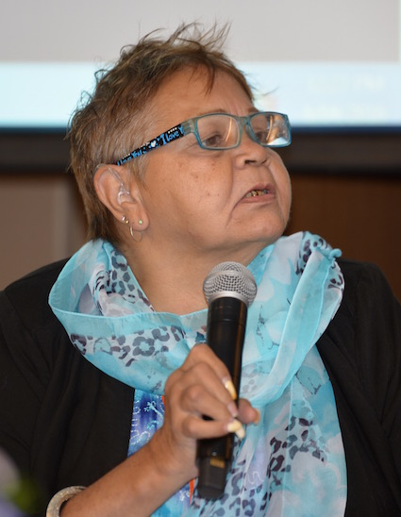

Gayle Rankine

“Thank you to the forum organisers for inviting me to speak to some of the key issues and barriers facing Aboriginal women with disability in Australia.

First of all I would like to acknowledge the land on which we meet and the Elders past and present.

I will particularly focus on those Aboriginal women with disability living in remote areas and will end by highlighting what Aboriginal women with disability themselves see as some possible ways forward.

Aboriginal women with disability living in Australia continue to face a number of barriers to the access and fulfillment of their most fundamental human rights. Just some of these barriers include:
- isolation and remoteness
- violence and abuse
- lack of services;
- lack of community-led and culturally relevant supports;
- poverty;
- and, the ongoing effects of colonisation.

Isolation and remoteness remain significant challenges for Aboriginal women with disability in Australia. Many women live in small communities, often with less than 100 people. Communities may be located many hundreds of kilometres from the nearest regional centre. Accessing even basic health services may require travelling long distances and at great cost.

Aboriginal women with disability can experience isolation within their community. There may not be adequate environmental or social infrastructure, including accessible housing and supports. Often, well-meaning responses from Government and non-government services can be inadequate. As an example, it is not uncommon for Aboriginal women with disability to receive a wheelchair that is virtually unusable because of a lack of footpaths in their community or for it to deteriorate quickly because of dusty desert conditions and rugged landscape.

Lack of services is a major barrier for Aboriginal women with disability. In an increasingly competitive and ‘market-driven’ disability sector, it may be unviable for disability services to provide support to remote areas. Where services are provided, there may be only one provider and as such, little or no meaningful choice for women as to the provider or nature of supports. In addition, external services often lack the skills and knowledge required to work in culturally appropriate ways in Aboriginal communities. This is particularly the case where community members speak traditional language, and where English may be a second or third language. Moreover, strict cultural protocols regarding women and men’s business may determine where and how support can be provided, by whom, and in what capacity.

As a population, we know that women with disability experience significantly higher levels of violence, abuse and neglect than women without disability. For Aboriginal women with disability living in remote communities, the frequency and severity of violence, abuse and neglect is even higher. Experiences of violence can be compounded where there are high levels of alcoholism, poverty, isolation and lack of employment opportunities. In small communities, there may not be safe spaces or adequate supports for women and girls with disability to access in times of need.

Colonisation, mistreatment, dispossession from land and the forced removal of children continue to have negative social, cultural, psychological and economic effects on Aboriginal communities and peoples. Aboriginal people and particularly Aboriginal women with disability frequently experience post traumatic stress disorder where they have experienced violence and abuse. Often these conditions go undiagnosed and unrecognised, made worse by inadequate or non-existent mental health support services in regional and remote areas. On that note, I would like to say that a lot of our women don't bring their children forward for NDIS assessment purely because of the Stolen Generation, they took the children away and never saw them again. Underlying many other factors, poverty remains a significant barrier. There are few employment opportunities in remote Australia and even fewer for Aboriginal women with disability.

While these issues and barriers for Aboriginal women with disability are complex social problems, there are ways forward. Possible solutions that Aboriginal women with disability themselves have identified include:

- Developing a new disability service standard on cultural competence for services working with and for Aboriginal communities

- Increasing Government and non-government support to build the capacity of existing Aboriginal owned and operated disability services organisations

- Increasing Government and non-government support to develop new Aboriginal owned and operated disability services in remote communities

- Resourcing and upskilling remote communities, and in particular Aboriginal people themselves who already have the cultural knowledge required to provide disability support services

- And, perhaps most importantly, we can commit to ensuring that Aboriginal women with disability are afforded their fundamental human right to self-determination and to have meaningful involvement in decision making, development and evaluation of supports and systems that affect them

Human rights is an important one, because Australia does not have a good human rights record and has not really protected the rights of people with disabilities.

I feel empowered by being here in this room with all these women who have disabilities and analysing the issues for all women with disabilities.

Thank you.”

Section 5: An overview of current key policies for women and girls with disability in Australia

This section provides an overview of current key policies for women and girls with disability in Australia, presented by four representatives of the Australian Government.

5.1. Second/Third Action Plan of the National Plan to Reduce Violence against Women and their Children 2010-2022

The overview was presented by Ms. Lara Purdy, Branch Manager, Family Policy and Programmes, Department of Social Services (DSS).

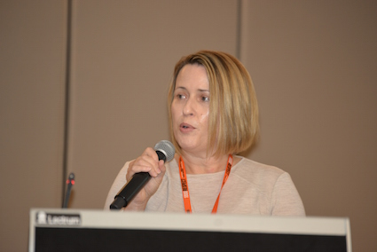

Lara Purdy

“It is a pleasure to be here today, thank you for the invitation.

I am sure that everyone here has heard the shocking statistics relating to the incidence of violence against women and their children. Over the last 12 months, there has been growing awareness about the unacceptable levels of family violence across the country, and the terrible and long-term impact this has on those involved, as well as the flow on effects to the broader community.

I have the privilege of working in Families Group in the Department of Social Services. One of the responsibilities of the Group is to action the Government’s strong commitment to reduce family violence. We work with other government agencies, community sector organisations and researchers, to develop and implement policies and programmes to achieve this goal. This is a responsibility we take very seriously, and we are extremely conscious of the trust placed in us as we progress this work.

A major task we take the lead on is the National Plan to Reduce Violence against Women and their Children 2010-2022 (the National Plan). This is a long-term plan agreed by all Australian governments. The vision of the Plan is that Australian women and their children live free from violence in safe communities.

The Plan has a strong focus on preventing violence from occurring in the first place, changing community attitudes around equality between men and women, and supporting women who have experienced or are at risk of violence and holding perpetrators to account.

The Plan seeks to co-ordinate and drive efforts by all levels of Government to reduce domestic, family and sexual violence. It is being delivered through a series of three- year action plans.

We know that different groups of women have different experiences of violence, and some groups can be more vulnerable.

We know that women with a disability are more likely to experience violence that can be worse and can last longer. We also acknowledge that women with disability can experience diverse forms of violence some of which fall under the definition of domestic and family violence and some that don’t.

It can also be harder for women with a disability to get help and support, and to seek justice.

The action plans under the overarching National Plan, include initiatives to help better identify, support and respond to women with disability experiencing, or at risk of, violence.

Under the First Action Plan, the Australian Government provided funding of $0.5m for Women with Disabilities Australia (WWDA). This was for the delivery of the Stop the Violence Project.

This project collected information about the experience of violence amongst women with a disability. This is used to improve our policies and programmes.

For example, under the Second Action Plan, the Department is now working with WWDA and 1800RESPECT to improve services delivered by 1800RESPECT to women with a disability. This is to ensure that they meet the needs of women with disability who have experienced, or are at risk of, family/domestic violence and/or sexual assault. Specifically, this will include a review of current content of the 1800RESPECT website & Daisy App and the telephone counselling service; and an analysis on increasing awareness of the 1800RESPECT service.

A key focus of the Second Action Plan has been to build the evidence base on family and domestic violence and sexual assault. This is important because a strong evidence base ensures the delivery of a high quality service delivery response.

Particular attention was given to improving and increasing the data collected for diverse groups of women who can be more vulnerable to violence, including women with a disability. This was in recognition that there are key data and evidence gaps in relation to diverse groups.

In July 2015, the Commonwealth provided funding of $160,000 for Australia’s National Research Organisation for Women’s Safety (also called ANROWS) to deliver a data project. This project has reviewed existing knowledge and key gaps in data and information about the diverse experiences of violence of culturally and linguistically diverse women, Indigenous women and women with disability. This project will inform new methods on how improve the data evidence base under the Third Action Plan.

A formal evaluation of the Second Action Plan is currently being undertaken and a report will be provided in the next few months. The findings of the report will be used to inform the development of the Third Action Plan.

The process for developing the Third Action Plan has begun. This will build on the work done so far, and is expected to be in line with the direction of the recommendations set out by the COAG Advisory Panel on Reducing Violence Against Women and their Children, in its final report. The Advisory Panel’s final report was released on 1 April, 2016 and has provided advice regarding the implementation of strategies to reduce violence and assessment of current approaches.

The Advisory Panel has set out two recommendations in relation to women with disability who experience violence. These include improving response and services for women with disability who experience violence; as well as, recommending that governments across Australia support the development of national best practice standards for women with disability.

We are holding a number of consultations around the country between now and mid- May to talk about the priorities for the next three years. These meetings will involve talking with key stakeholder groups

We will of course be inviting WWDA to participate in the consultations. We highly value the knowledge and expertise of WWDA, as the peak organisation for women with all types of disabilities in Australia.

Thank you again for inviting me to be here with you today to talk about this important topic. I am looking forward to the group discussions and learning more from you about the specific needs of, and issues facing, women with a disability in this area.”

5.2. The National Disability Strategy (NDS)

The overview was presented by Ms. Sharon Stuart, Branch Manager, Disability Carers Policy and Access, Department of Social Services (DSS).

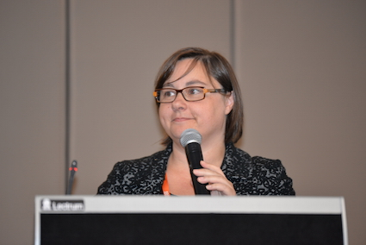

Sharon Stuart

“The first thing I would like to do is get an idea of how many of you are familiar with what the National Disability Strategy is? Most of you? That is great.

If I were standing in a room with a different group of people, I suspect the number of hands raised in the air would be a lot fewer. To be honest, that is one of the key challenges we face.

I’d like to speak about the work we are doing to implement the National Disability Strategy.

The Strategy was agreed by all levels of government in 2011 and is our overarching framework for disability policy reform. It outlines a national approach to support people with disability and to empower them to participate as equal citizens in all areas of community life.

Through the Strategy, we are driving a more inclusive approach to the design of policies, programmes and community infrastructure across a range of important areas, including access to buildings, transport, social events, education, health care services and employment.

This aligns with the principles underpinning the UN Convention on the Rights of Persons with Disabilities and is essential to the success of the National Disability Insurance Scheme (NDIS) — by ensuring that mainstream services and supports are fully accessible.

The Strategy seeks to improve the lives of all Australians with disability, while recognising that not all people with disability are alike.

Everyone has specific needs based on their personal circumstances, including the type and level of support they may need, their gender, age, education, sexuality, and their ethnic or cultural background.

In particular, the Strategy recognises that gender can significantly impact on the experience of disability, and women and girls with disability often face different challenges by reason of their gender.

For example, women with disability experience violence – particularly family violence and violence in institutions – more often than men with disability. They are more vulnerable to being victims of crime – from both strangers and people who are known to them.

A central outcome of the Strategy, therefore, is to ensure that the rights of people with disability are ‘promoted, upheld and protected’. It includes actions that promote awareness and acceptance of those rights; as well as strategies to reduce violence, abuse and neglect of people with disability, and to ensure they have every opportunity to be full and active participants in civic life.

As we heard from Lara a moment ago, under the Strategy, governments have developed the National Plan to Reduce Violence against Women and Children 2010-2022 and also the National Framework for Protecting Australia’s Children as priority actions to improve the safety and wellbeing of women and children, including those with disability.

The Strategy is also an important mechanism for ensuring that the principles underpinning the UN Convention on the Rights of Persons with Disabilities are incorporated into policies and programmes affecting people with disability, their families and carers.

Together with rights protection and freedom from violence, economic security is another important action area under the Strategy.

Women with disability often face greater economic disadvantage. Evidence shows they are less likely to be in paid work than other women, men with disability, or the population as a whole. They are also more likely to be affected by the lack of affordable housing, due to a major gap in overall economic security across the life-cycle, and due to their experience of gender-based violence which often leads to housing vulnerability, including homelessness.

That’s why the National Disability Strategy focuses on improving economic security, including increasing access to employment opportunities and housing options that will provide a secure and affordable place to live.

The first two-yearly progress report on the Strategy was released in December 2015 and is available on the Department of Social Services website. The report was informed by the views of people with disability through their representative organisations, and includes feedback across each level of government on implementation activities.

We are currently developing a second implementation plan for the Strategy, and continuing engagement with people with disability through their representative organisations is an important part of the process. The Plan is due to be finalised around the middle of the year.

It continues our efforts to improve outcomes for people with disability across key policy areas, but also has a particular focus on NDIS transition to full scheme; improving employment outcomes for people with disability; improving outcomes for Aboriginal and Torres Strait Islander people with disability; and communication activities to promote the intent of the Strategy.

An Australian Government plan to improve outcomes for Aboriginal and Torres Strait Islander people with disability is also being developed and will support the second implementation plan.

With the assistance of these and other measures, people with disability, and particularly women with disability, will have greater choice and control over their lives.

Thank You.”

5.3. The National Disability Insurance Scheme (NDIS)

The overview was presented by Ms. Vicki Rundle, General Manager Operations, National Disability Insurance Agency (NDIA).

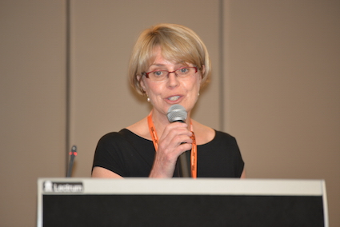

Vicki Rundle

“I would like to acknowledge the wonderful women in this room, having worked in a number of Commonwealth and State departments in the past, I have only been here a few months, but I just know the difference the Scheme will make.

I will just spend a few minutes describing the Scheme to you and the benefits, there are many of you that may know a whole lot more about it than I do.

What is the National Disability Insurance Scheme? It is a new approach for delivering services and supports to people with disability.

It has the support of both governments, they will contribute financially to the scheme. It is being rolled out across the country for the next three years. People will access it differently during that time. When it is fully implemented in three years, there will be around 455,000 participants and new people joining.

One of the questions Cristina asked, how it will be implemented, I am going to talk about the future. It will change the way disability services are implemented across Australia.

State and territory systems across Australia, they have systems for services, sometimes people got a one size fits all solution. It is not anyone's fault, it is the way the system developed.

This will provide individual approaches for every single participant, it is completely individual centred. It is consistent, of course, with the 10 year strategy we have been talking about, and also the United Nations Convention on the Rights of Persons with Disabilities.

You may know there are certain obligations that the Scheme will give effect to, especially respecting the work of people with disabilities, dignity, the right to live a life free of exploitation, and the right to achieve full social and economic participation. That is so important.

What are the benefits for you as a participant? This notion of choice and control, what does it mean?

It means, as a participant, you will be able to set your own goals, once your plans are approved you have complete control if that is what you want.

Who you get to provide your support to you, whether you want to be in control or not. If you want to manage your plan, that will be part of it, there are plenty of ways to receive support to do that.

Other support, such as employment opportunities, are provided, we link up with mainstream services, we really encourage them and hold them accountable for making sure that people with disabilities are able to access the same benefits as everybody else, that they may have had more difficulty with before.

What does it mean for women and girls with disability? In a sense, it is similar to others, in some ways it is quite unique to women and girls with disability.

It means you will be able to exercise your rights and choice. There will be goals you might never have thought about before, and once you get into the Scheme, you start thinking about the other things that might be possible you have not thought about before.

We can look at whether or not there are funded supports and ways we can help you access those things.

It is a journey for life. When you first come into the Scheme, the first play that you have, remembering that we are starting the scheme officially from July this year, until now we have been in trial.

One of the first things that will happen, the first plan will be a quicker process, not so that it excludes the things we do for people, but it enables us to get people smoothly and quickly into the scheme, get their funded supports put in place as soon as we can, check for gaps.

In that first year, people get a chance to get to know the scheme and the people they are working with, then they can get to know what their goals and aspirations might be.

The other thing we will do is it will give you, I am hoping, more options to get involved in local community opportunities, things you may not have been able to think about doing before.

A key feature of the scheme is to build confidence and capability so that people will exercise more choice and control over time.

The last thing I thought I would talk about very briefly is the consultation approaches. I had real difficulty with this, when I thought about all of the formal consultation that the National Disability Insurance Agency does, there are lots of organisations, WWDA is one of them.

We have the Advisory Committee, the Intellectual Disability Reference Group, regional forums, we have so many different ways of trying to connect with people.

I would much rather hear in this session what you think we could do better, other ways we can connect with you.

I will leave you with one thought, the difference between consultation and co-design.

One of the things we are aiming to do more of, not only consult and hear what you have got to say, we need you to help us design how we go forward. We will be learning as we go, there will be some things we may make mistakes about, but it is a chance to hear from you, connect, and redesign.

That is the key message I would like to hear from you today, I hope I get a chance to talk to you later. Thank you so much for hearing from me.”

5.4. Policies targeting Australian women in relation to economic participation and young women

The overview was presented by Ms. Louise McSorley, Assistant Secretary, Office for Women, Department of Prime Minister and Cabinet.

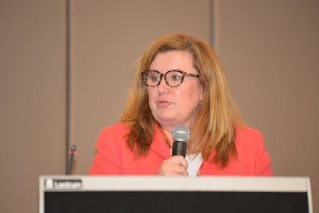

Louise McSorley

“That is what I am supposed to talk about, I have to remember El's tip, speak slowly, I have a lot to say to you all.

I am the head of the Office for Women in the Department of Prime Minister and Cabinet. When new proposals come through to the Prime Minister, the office for women has a look at them and applies a gender lens.

We say, what does this mean for women? More importantly, what does this mean for women in all our glorious diversity? We address those issues of intersectionality.

Being a woman with a disability, being an Indigenous woman, there are multiple ways to consider things. El is not twitching. I am probably speaking slowly enough, please give me a hint if I am not.

That is what we do. You will see the Prime Minister has been talking a lot about ideas, innovation and entrepreneurialism. Part of that includes specific opportunities for women, especially in the new jobs of the future, science, engineering and maths. He has also been talking about infrastructure and cities, we have been in that discussion, applying that gender lens, how can our cities be better for women? How are our transport systems working, our housing systems working?

What we are taking forward at the moment, you will hear from Minister Cash later today. I have two people I work for, the Prime Minister and the Minister for Women. Please don't tell her if she speaks about what I speak about that you have already heard!

Principally because she is also Employment Minister, she is talking about issues of economic participation. That is what I am supposed to talk about. Four key areas she is looking at, how does the tax system, welfare payments, the transport system, operate to either help women into work or be a barrier to work?

For example, sometimes if you work part-time, if you increase your hours, you lose more tax. You might be losing some benefit. So, it is not really worth it to work more, we are looking at those sorts of interactions and what we might do to remove some of those barriers. It's quite complex, I have to say, my brain hurts sometimes talking about it.

How can we make childcare more flexible? We are doing some work around flexibility and diversity in the workplace. How do we make Australian workplaces – both public and private sector – more inclusive? Not just for women, all women, but for all Australian society.

Lastly, we are the jobs of the future and how can we secure them for women? I am really looking forward to the workshop part of today – thanks.”

Section 6: Workshop Session: Women with disability and government representatives

This section provides an overview of the workshop session where women with disability and government representatives worked together in small groups to examine particular issues in relation to violence against women and girls with disability; economic empowerment, employment and the National Disability Strategy (NDS), and the National Disability Insurance Scheme (NDIS), particularly in relation to the experiences of women with disability in engaging with the National Disability Insurance Agency (NDIA) and how things could be improved.

6.1. Groupwork 1: The National Plan to Reduce Violence Against Women and their Children

In this Group, women with disability worked with Government representatives to discuss ways in which the Australian Government could better address, prevent and respond to violence against women and girls with disability. Some of the key components of the discussion are provided here.

Disability support packages are not flexible enough to accommodate crisis situations eg: women with disability fleeing domestic/family violence. This needs to be addressed. The National Disability Insurance Agency (NDIA) staff should be trained about gendered disability violence (ie: all forms of violence against women and girls with disability), and this “lens” should be applied to disability support packages.

Effort needs to be made to drive fundamental cultural change across the community. For example, we now have the Prime Minister saying publicly that it is unacceptable for women to experience domestic/family violence. These kinds of strong statements also need to be made about women with a disability who experience violence, in all its forms.

The ethical, moral and structural issues underpinning violence against women with disability need to be addressed. For example:

- we need women with disability as visible role models in the violence prevention effort. Currently, there are none;

- there needs to be more women with disability as employees and in leadership positions within the National Disability Insurance Agency (NDIA) and government agencies;

- greater general employment of women with disability is needed.

Women with disabilities experiencing violence (including domestic/family violence) can lose access to support services. Example provided of a woman whose partner abused her and her guide dog. Her guide dog was removed.

Women with disability are systematically excluded from policy responses to address and respond to violence against women. For example:

- the current paradigm for discussing and addressing domestic/family violence is very white, hetro-sexual, and based on mainstream needs;

- issues facing women in institutional care and settings are excluded;

- there is consistent ‘othering’ of diverse groups. These are the groups that require the most intensive support and who are the most vulnerable. The model of preventing violence against women should start with addressing the needs of the most marginalised. If we get it right for these groups, you can be confident that everyone’s needs will be met.

There is scope for greater use of technology in the violence prevention effort. However, specific issues facing women with disability need to be recognised. For example:

- women with disability in institutional and closed settings have limited access to technologies and its benefits;

- some women with more ‘severe’ disabilities need specialised equipment (ie: communication aids) but this is not necessarily available or affordable;

- women with disability need something equivalent to the ‘DAISY’ app that provides better access for people who cannot use mainstream options.

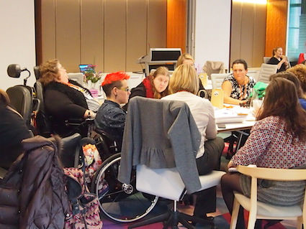

Forum Delegates

Government should mandate, as a contractual obligation, that people who work with women with a disability are trained in gendered disability violence issues. This is something that government has direct control over and would be relatively simple to introduce.

The National Plan to Reduce Violence Against Women and their Children (The Plan) and its 3 year Action Plans must recognise the diverse forms of violence and abuse experienced by women and girls with disability. For example:

- violence perpetrated against women and girls with disability can be from a partner, sex-partners, family members, medical professionals, service providers, support workers and carers;

- it occurs in a wide range of settings: home, hospitals, residential facilities, gaols;

- there is a culture of accepting this violence;

- it includes forced treatments and interventions – including for eg: forced sterilisation, forced contraception, forced psychiatric treatments, restraint, seclusion, indefinite detention;

- 1 in 5 women with disability who access any form of support services experience violence;

- the reality of abuse by “caring professionals” must be recognised and addressed. There is a real power imbalance in these relationships, and it is often hard for women with a disability, who are dependent on the support/assistance provided by these people, to speak out.

- ‘medical violence’ is a reality for many women with disability;

- supervision of professionals and service providers is required even at highest levels;

- women who receive “compulsory treatment disorders” are “stuck” in relationships with medical professionals, even where abuse occurs;

- people in positions of power and authority (eg medical specialists) should be required to be assessed for ethics/decency/morality;

- perpetrators of violence against women and girls with disability may also have disability – within a family or within an institution. The situation is particularly complex when it involves family members.

Some women with a disability have had such negative experiences with the service system that they do not want any engagement with mainstream services despite dealing with serious issues. This disengagement is in fact about self-preservation.

At present, there is a disconnect between domestic/family violence and sexual assault services. Linkages must be stronger. Issues are complex and an integrated response is required.

Need to recognise that for some people with a disability, their vulnerability and disadvantage is compounded by other issues. For example:

- lesbian, gay, bisexual, transgender, and intersex people with disability – compounding issues lead to further vulnerability and isolation. The combination of issues needs to be discussed more openly. The history of oppression needs to be overcome and greater commitment is required to reduce their experience of gendered disability violence, including domestic/family violence.

- women and girls with a disability from culturally and linguistically diverse backgrounds face particularly complex issues. They are unlikely to participate in formal consultations. ‘Soft’ options for engagement need to be explored and utilised eg: informal discussions at schools.

- young people with disability are often unable to access services including youth refuges. They need support at a much earlier point to enable them to remain safe at home – early intervention/prevention lens. Young people from culturally and linguistically diverse backgrounds are sometimes unsafe at home but are sent home by refuges who don’t understand the complexity of problems due to cultural issues.

There is a strong need for the role of police to be improved in relation to preventing, addressing and responding to all forms of violence against women and girls with disability. For example:

- training and up-skilling of police needs to occur and this training must be done by women with disability and their representative organisations;

- women with disability must have the right to take the support person of their choice with them in dealings with police. This is often prevented at present.

There is an urgent need to develop and implement better pathways to safety for women and girls with disability who experience and are at risk of violence in all its forms. There is a great urgency to develop these pathways for women and girls with disability who are particularly marginalised and excluded – including for example: those in institutional, service and closed settings; those with communication impairments; aboriginal women and girls with disability, CALD women and girls with disability, those in remote geographical locations; LGBTIQA+ women and girls with disability.

Other important changes required include:

- The establishment of safe ways to report violence in disability services;

- Mechanisms to enable women with disability the right to choose the gender of their support workers;

- The establishment of safe places, spaces and mechanisms to enable women with disability to share experiences, work together, and build agency and self-esteem;

- All prevention programs to address, prevent and respond to violence against women must be inclusive and accessible;

- All violence prevention policies and programs (including the National Plan) need to be tailored to ‘high risk’ groups;

- There is an urgent need for law reform (universal across all jurisdictions) to enable women with disability who experience violence (in all its forms) the right to access and pursue justice – particularly those women with disability who experience violence in ‘care’ settings and environments;

- NDIS packages must consider gender and include a mandatory assessment of experience/risk of violence (in all its forms);

- The Third Action Plan (under the National Plan) and any subsequent Action Plans, must include dedicated actions specifically for women and children with disability, and these must be matched with adequate resourcing;

- In the development of Action Plans under the National Plan, and any future National Plan, Government must engage directly with women with disability and organisations OF women and girls with disability (not only their carers, or representatives from peak organisations or service providers). Women and girls with disability in institutional settings must be included in all consultation and engagement processes.

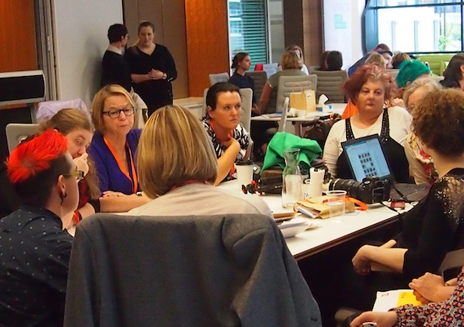

Forum Delegates

In relation to consultation and engagement with women and girls with disability, and their organisations and networks, it is critical for governments to recognise that:

- A ‘single’ national roundtable or equivalent is not sufficient, there needs to be a range of engagement and consultation mechanisms and processes developed and implemented;

- Women and girls with disability must be involved with government in co-design of consultation and engagement mechanisms and this needs to occur at the planning stages;

- Governments must provide sufficient lead time and notice to enable genuine and meaningful participation of women and girls with disability in consultation processes;

- Any government consultation and engagement process must include and provide the supports required to enable women and girls with disability to participate.

6.2. Groupwork 2: The National Disability Strategy: Employment

In this Group, women with disability worked with Government representatives to discuss employment issues for women with disability. Some of the key points of the discussion are provided here.

The ‘Jobaccess’ service needs to be promoted more widely, as it’s not well-known.

Women with disability who have communication impairments have been told outright by Disability employment Services (DES) and other services, that they are “unemployable” because they have a communication impairment.

The current system (employment) is not person-centred; there are assumptions made about what people with disability can do/want to do. For example, if you are a wheelchair user, there are underlying assumptions made about what you are able to do, and job agencies will only put you forward for jobs like data-entry.

Some service providers deliberately leave people with disability unemployed for longer before placing them in a job, so they get more funding for them; a suggestion was made to reverse the payment incentives so that there is a premium on placing the short-term unemployed in jobs; but there would need to be consideration given to consider how to make sure this does not provide a disincentive to place long-term unemployed people (who are more disadvantaged) in work.

How can Government address the “parking” of the short-term unemployed?

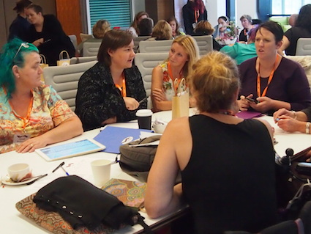

Forum Delegates

Governments and departments take short-term views, which is a fundamental blocker to designing good, enduring employment policy for people with disability.

There is a need for the establishment of programs (and commitment from Government) to supporting young women with disability to build their skills to be role models/ mentors. Mentoring is critically important for young women and girls with disability.

There needs to be the establishment and long-term funding of mechanisms that join women with disability up across the country so that they can provide mentoring and peer support to each other.

Disability Employment Services (DES) should be required to employ people with disabilities within DES agencies, to model behaviour and also provide support/mentoring to clients of DES. This could be gendered through some sort of quota system to ensure that women with disability are recruited and employed in DES services.

Pilots and trials are too often run and then abandoned without being incorporated into ongoing policy; there needs to be something after the pilot/trial has concluded and has been evaluated. What works should stay in place.

The Government must act to abolish special schools and segregated employment (Australian Disability Enterprises (ADE’s), also referred to as “sheltered workshops”).

The Australian Government should invest in some updated national research in relation to the cost of disability to go to work. This is a major issue for women with disability and will not be addressed through the NDIS.

The National Disability Strategy (NDS) needs to be “joined up” to the National Action Plan for Reducing Violence against Women and their Children; should include women’s health issues; clear outcomes, including how progress is monitored. These two national policy frameworks are critical in addressing the underlying structural issues that are barriers to employment participation of women with disability, yet they “siloed”.

There should be clear service specifications for Government programmes and policies – incorporating universal design for all groups.

The Australian Government, and State/Territory Governments need to do more to actively educate small business about employment for people with disability.

6.3. Groupwork 3: The National Disability Insurance Scheme (NDIS)

In this Group, women with disability worked with Government representatives to discuss their experiences of engaging with the National Disability Insurance Agency (NDIA) and how things could be improved. Some of the key points of the discussion are provided here.

There is concern that NDIA staff do not have the requisite experience and expertise around gendered disability violence, including for example how to work with women with disability escaping violence (including domestic/family violence).

There remains a lack of clarity about whether escaping violence could be funded as part of an NDIS participants’ plan, including the supported accommodation component.

There appears to be a gap in knowledge of NDIA staff about what is “out there in the service system” for NDIS participants.

NDIA staff need to be prepared and adequately trained for when people disclose violence in a planning or information gathering session and NDIA staff should have the knowledge and feel confident about responding to such disclosures.

The NDIA needs to articulate how it is responding to the relevant recommendations from the Victorian royal Commission into Family Violence, including those that specifically relate to the NDIA/NDIS (including for eg: training of workers).

There appears to be a lack of understanding on the part of the NDIA that some Aboriginal women won’t want to bring their children forward for access to the NDIS because of the past Stolen Generation and a fear that their children will be taken away.

There is a critical need for the NDIA to ensure that when NDIA staff or partners go to Indigenous communities they take the time to prepare and connect with the community elders and that they understand the community so that the interaction with the community is appropriate. There are obvious language barriers, especially in the Northern Territory and it is not clear how the NDIA will overcome that in working with NDIS participants.

The NDIA has an Aboriginal and Torres Strait Strategy that sets expectations and provides guidance, although it is not clear how well this is known.

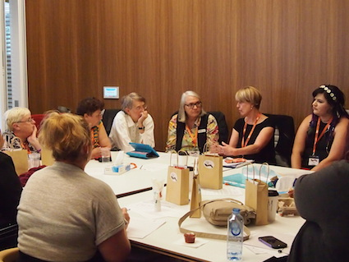

Forum Delegates

There is a need for NDIA/NDIS language and communications to be in simple, easy to understand terms. All information coming from the NDIA or about the NDIS should be made available in the full range of accessible formats.

The NDIA is going to be releasing a ‘Participant Pathway Booklet’ and this booklet must be made available in the full range of accessible formats and distributed widely. There should also be a range of ways to communicate NDIS information (and the ‘Participant Pathway Booklet’) because not everyone has access to the internet, or has literacy. Need to use mechanisms to actually get to people.

There is still a lack of understanding amongst people with disability about what the NDIS actually is, and what it means for individuals. More work needs to be done by the NDIA to communicate the messages and information in ways that people with disability can relate to, including to their own situation and circumstances, and those of their families.

There remains a lack of understanding about Tier 2 (Information, Linkages and Capacity Building (ILC)) of the NDIS. Does it fund advocacy? Who can apply for the funding? How will people with disability benefit from the ILC?

The NDIA needs to engage directly with people with disability. Too often other parts of the sector speak for and on behalf of people with disability (like for example: Carers Australia, National Disability Services). The NDIA must engage with organisations of and for people with disability (Disabled People’s Organisations).

There should be more emphasis on young women with disability in the NDIS. The current education system is not designed to support and provide opportunities for young people with disability, particularly young girls with disability. There should be an end to segregation of children with disability from mainstream classes in schools, and the issue of bullying and violence of children with disability in education settings must be addressed. There is a need for the establishment, funding and support of leadership and mentoring programs for young girls and women with disability.

Section 7: What are human rights and why are they important for women with disability?

In this session of the Forum, women and girls with disability engaged in a general discussion about human rights and why they thought human rights are important for women and girls with disability.

Participants were asked what the words “human rights” means to them. Just some of the responses included:

Safety
Freedom
Dignity
Quality of life
To speak for ourselves
Freedom from harm
Expressionism
Equality
To make our own decisions
Identity
To make up our own minds
To have pride in ourselves
To be treated equally
Respect
To be whatever we want to be
To have an education and a job
To have safe and affordable housing
To be as free as a bird

The Forum participants discussed the importance of women and girls with disability being able to use the language of human rights and being educated and informed about their human rights. Having knowledge of human rights and how to claim them, means that women and girls it disability can be armed with the means and the tools to act individually and collectively to fight against things like discrimination, violence, poverty, denial of the right to make our own decisions, forced treatments, injustice and so on.

When human rights are not well known by people – including women and girls with disability – abuse, violations, and oppression continues to occur unchallenged. The Forum participants talked about the importance of the Convention on the Rights of Persons with Disabilities (CRPD) and how we need to work to ensure that the CRPD is known and understood by all women with disability in Australia.

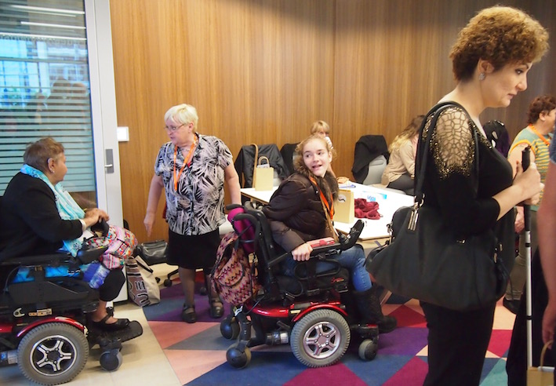  Forum Delegates | 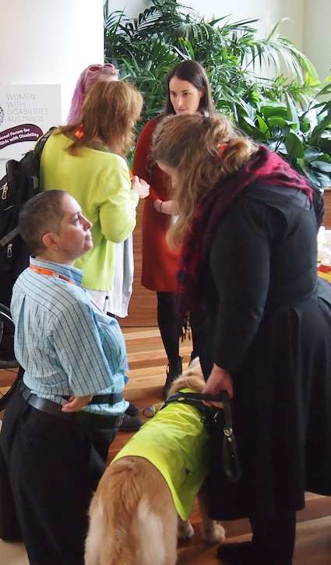  Forum Delegates

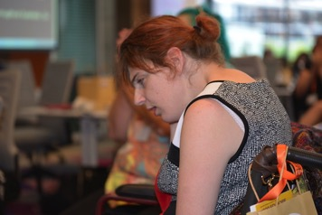  Terri | 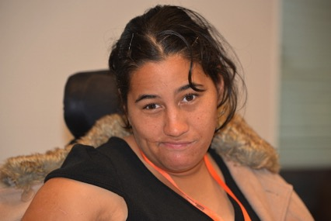  Marlena

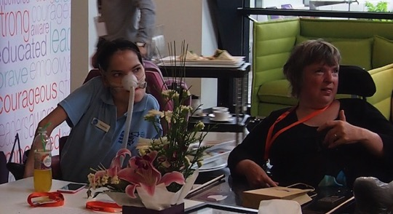  Rebecca (L) and Jules | 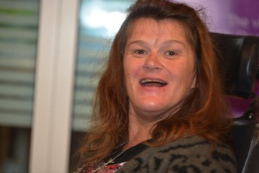  Margie

Section 8: An overview of WWDA’s strategic priorities for women and girls with disability 2010-2016

In this session of the Forum, Karin Swift (Vice-President of Women With Disabilities Australia (WWDA) gave a brief overview of the strategic priorities the organisation has been working on over the past few years. These strategic priorities had been identified by WWDA members in national consultations to inform the development of WWDA’s Strategic Plan for 2010-2016. The 5 key strategic priorities were:

1. Violence against women and girls with disability;
2. Equality for women and girls
3. Leadership and participation
4. Economic empowerment
5. Sexual and reproductive rights

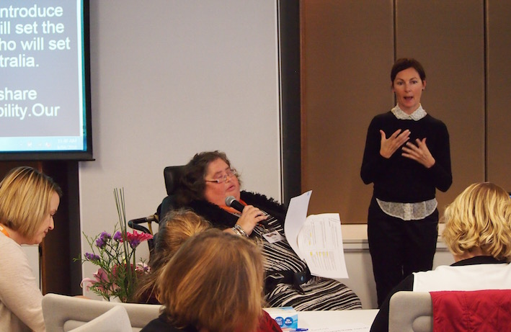

Karin Swift

“I would like to give a very brief overview about the key areas WWDA has been working on over the past few years.

The first is violence against women and girls with disability. This is a leading issue for WWDA. And WWDA has done lots of work in this area nationally and internationally.

WWDA looks at all forms of violence against women and girls with disability, including forced sterilisation. When we talk about forced sterilisation, we talk about removing body parts from inside us without our permission or knowledge so we can't have periods or babies.

Forced restraint through physically preventing us moving around, or giving us drugs so we can't move around. Why this happens is because we are women and girls and we have disability.

It can happen where we live, at home, in the community, in our group homes, institutions, hospitals and schools. People who are meant to take care of us can also cause violence. For example, support workers, partners, boyfriends, carers or family members. That violence can be physical - hitting, slapping. People who do physical care being rough.

There is sexual violence. People touching our bodies in ways we don't like or forcing us to have sex when we don't want to. Emotional violence, yelling and swearing at us, saying things that hurt us or make us feel bad about ourselves. Threatening to take away or damage our things or our equipment that we need specifically for our disability. Or even our assistance animals.

There is financial violence – stealing from us or taking control of our money. Refusing to pay for our medications or equipment. Coercion and manipulation – that means tricking us into doing things we would not normally want to do. WWDA still has so much work to do in this area.

The next area is equality for women and girls. This means participating in things equal to men and boys. It is important that women and girls are able to participate in leadership opportunities such as the event we are at today, but also non-disability related leadership events as well.

Economic empowerment – women and girls with disability can produce economically in the community the same as others. We have support to access our money in a safe way, we can access financial planning, financial literacy, financial services. Bank loans, mortgages, credit cards on an equal basis with others.

Our other area of work is sexual and reproductive rights. This is a leading area for WWDA and, again, we have done much work in this area nationally and internationally. It's important that women and girls with disability have control over what happens to their bodies.

We can have sex if we want to. We don't have sex if we don't want to. We can have intimate relationships, we can explore our sexuality if we want to. We have the right to decide if we want to have babies or not.

We have the right to access women's sexual health services and other reproductive services, such as good-quality obstetrics care when we have babies, or fertility programs. Women's health care to prevent diseases like breast cancer and cervical cancer.

Access to fertility programs. Access to information about our bodies, and periods. Access to information on preventing pregnancy. Support for if and when we want to become mothers, so we can be the best mothers we can be.

These are all human rights and WWDA still has much work to do in this area. So, that covers my very brief discussion on the work that WWDA is involved in.

Thank You.”

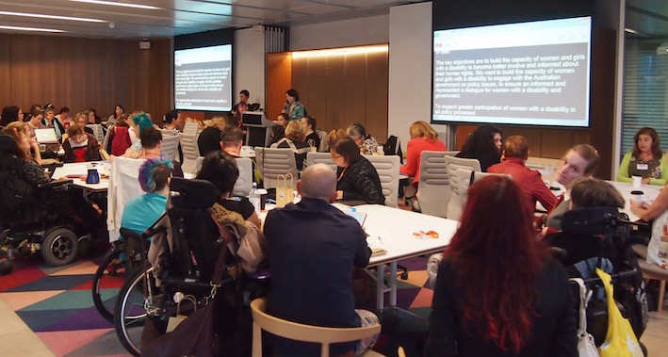

Forum Delegates

Section 9: Developing WWDA’s new strategic priorities 2017-2021

Prior to identifying the top priorities for WWDA for the next 5 years, in small groups, women with disability discussed two questions: “what is the most important human right to you” and “what are other important human rights for women and girls with disability?” After completing this exercise, each small group examined WWDA’s current strategic priorities and compared these priorities with the human rights that had been identified in their group prior to nominating between 5 -10 strategic priorities for WWDA for the next 5 years.

GROUP 1: Important human rights for women and girls with disability

- The right to live free from all forms of violence.
- Freedom to speak when I want to speak my opinion.
- The right to have a family.
- Full and equal access to women’s refuges and all violence prevention strategies and programs.
- Freedom to travel within Australia and overseas.
- Access to education equally at all levels.
- Access to workplace training.
- The right to a sexual identity.
- To have the freedom to live in the community in the place that I choose.
- The right to have a cultural identity and live in the community of my choice.
- Closure of Australian Disability Enterprises (ADE’s) (“sheltered workshops”).
- The right to be treated as a person, not a “disability”.
- The ability to speak out with an equal voice regardless of the means available to me.
- Closure of all institutions and community residential units.
- Access to all types of work.
- Equal pay for equal work.
- Technical training and apprenticeships that lead to real, sustained and meaningful paid employment.
- The right for women with disability to be meaningfully involved in the training of support workers, health workers, disability service providers, family violence workers – and to be paid as trainers with expertise, not volunteers.

GROUP 1: Strategic Priorities for WWDA 2017 - 2021

1. The right to live free from all types of violence.
2. Equality of opportunity for women and girls with disability.
3. Leadership, participation and decision-making.
4. Economic empowerment.
5. Sexual and reproductive rights.
6. Access to appropriate, affordable and accessible housing.

GROUP 2: Important human rights for women and girls with disability

- The right to live free from all forms of violence and to be safe from threat.
- Sexuality and gender diversity.
- Financial security.
- Equal opportunity in employment.
- Flexibility in employment.
- Bodily autonomy.
- Economic and political freedom.
- Long term financial stability.
- Accessible information in various languages.
- Accessible environments.
- Freedom of expression.
- Equality of access to everything!

GROUP 2: Strategic Priorities for WWDA 2017 - 2021

1. Economic empowerment.
2. Leadership, participation and decision-making.
3. The right to live free from all types of violence.
4. Sexual and reproductive rights.
5. Freedom of expression.
6. Equality of opportunity for women and girls with disability.

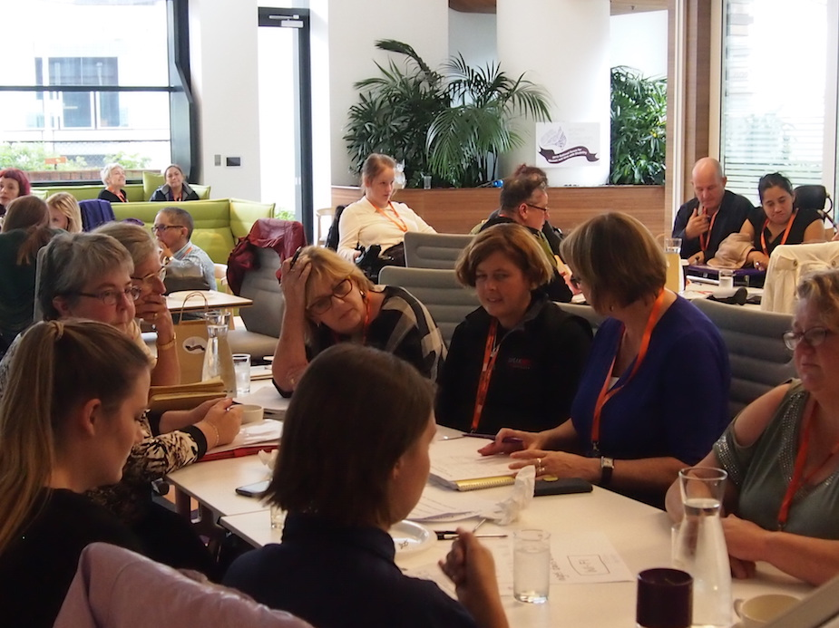

Forum Delegates

GROUP 3: Important human rights for women and girls with disability

- The right to live free from all forms of violence and to be safe from threat.
- Leadership and participation
- Economic Security
- Independence
- Equal education
- Access to justice
- To be included in the community
- Accessible and affordable transport
- Employment
- Sexual and Reproductive Rights
- Decision-making
- Bodily autonomy
- Citizenship
- Respect and dignity
- Equal opportunities
- Freedom to make choices

Forum Delegates | 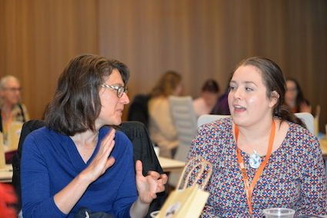  Jen (L) and Kara

GROUP 3: Strategic Priorities for WWDA 2017 - 2021

1. Leadership, participation and decision-making.
2 Sexual and reproductive rights.
3. The right to live free from all types of violence.
4. Social and economic participation.
5. Access to justice.
6. Education.

GROUP 4: Important human rights for women and girls with disability

- The right to live free from all forms of violence.
- The right to choose where and with whom I live.
- Freedom from all forms of abuse and exploitation.
- The right to education.
- Right to access the community on an equal basis.
- Access to justice
- Equality before the law
- Organisations having the right to speak out against government decisions
- To be included in the community
- The right to make our own decisions
- The right to be in charge of our own bodies
- Full inclusion

GROUP 4: Strategic Priorities for WWDA 2017 - 2021

1. The right to live free from all types of violence.
2. Leadership, participation and decision-making.
3. Sexual and reproductive rights.
4. Access to justice.
5. Economic empowerment.
6. Intersectionality.
7. Mentoring and role models.

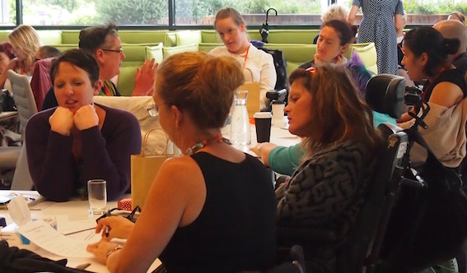  Forum Delegates | 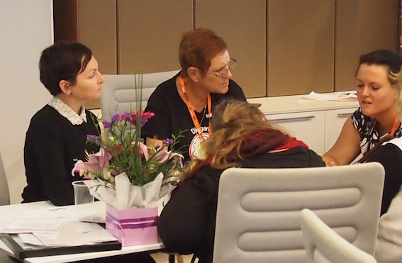  Forum Delegates

GROUP 5: Important human rights for women and girls with disability

- The right to make decisions about our own bodies
- Sexual and reproductive rights
- Freedom from all forms of violence
- Being allowed to have sex
- End of segregated employment
- Sexual identity and the freedom to make choices and decisions about sexuality
- Training and support that can achieve meaningful paid employment.
- Inclusive education
- The right to learn and know our human rights and not have them taken away
- The right to be in control of our own finances
- The right to make our own decisions and choices
- To live in the community
- Closure of institutions
- Access to education at all levels
- Leadership and mentoring
- Accessible and available information about all forms of violence
- Equality before the law
- Law reform to ensure perpetrators of violence against women and girls with disability are prosecuted

GROUP 5: Strategic Priorities for WWDA 2017 - 2021

1. The right to live free from all types of violence.
2. Leadership, participation and decision-making.
3. Sexual and reproductive rights.
4. Access to justice.
5. Finding partnerships and more resources for WWDA.
6. Equal access to mainstream services.
7. Education.

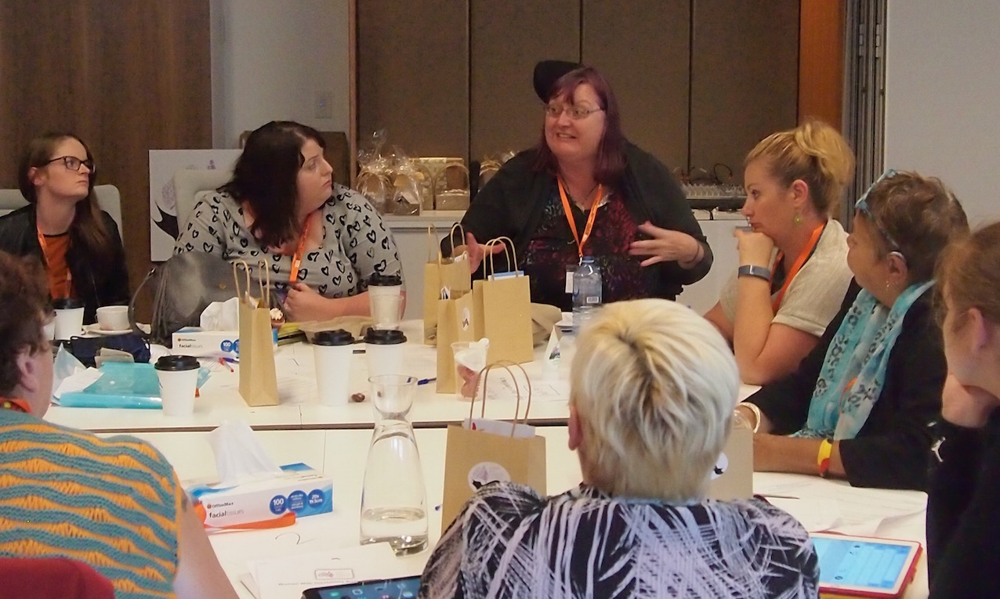

Forum Delegates

GROUP 6: Important human rights for women and girls with disability

- Safety
- Access to information
- Living independently
- The right to make decisions and speak for ourselves
- Access to education at all levels
- Meaningful work and equal pay
- Freedom of movement (travel)
- Freedom of expression
- Respect and dignity
- Accessibility
- The right to a cultural identity
- Respect for culture
- Freedom from all forms of discrimination
- Citizenship
- Access to mainstream services on an equal basis
- Bodily integrity
- Sexual and reproductive rights
- The right to information
- The right to communicate
- Empowerment
- Leadership and participation

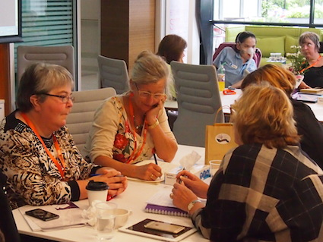  Forum Delegates | 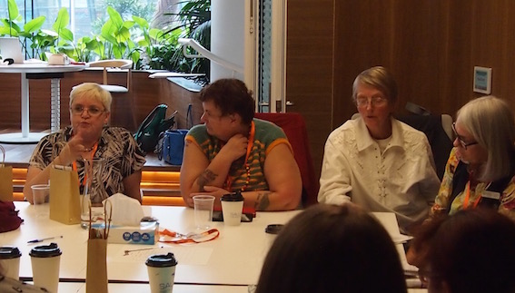  Forum Delegates

GROUP 6: Strategic Priorities for WWDA 2017 - 2021

1. The right to live free from all types of violence.
2. Mainstreaming gender and disability into all government policy.
3. Leadership, participation and decision-making.
4. Access to information.
5. Sexual and reproductive rights.
6. Mentoring and capacity building.

GROUP 7: Important human rights for women and girls with disability

- Visibility of women and girls with disability.
- Access to education.
- Accessible information.
- The right to make our own decisions and choices.
- Safe, affordable and accessible housing.
- Freedom from all forms of violence.
- Access to employment.
- The right to choose our own staff/supports.
- The right to live in the community where we choose.
- The right to choose who we live with.
- Pay equity.
- To be able to choose a career.
- Meaningful employment with equal pay.
- Safety within mainstream services (such as hospitals).
- Positive portrayal of women with disability in the media.
- Access to interpreters whenever required.
- Freedom from discrimination in housing.
- The right to use advocates of our choosing.

GROUP 7: Strategic Priorities for WWDA 2017 - 2021

1. The right to live free from all types of violence.
2. Leadership, participation and decision-making.
3. Sexual and reproductive rights.
4. Access to education at all levels.
5. Economic empowerment.
6. Access to information and communication supports.

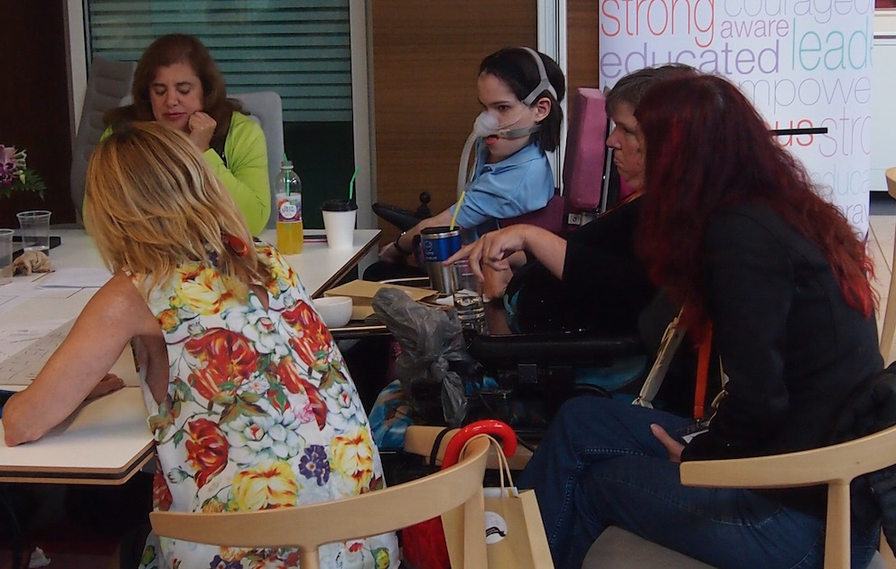

Forum Delegates

GROUP 8: Important human rights for women and girls with disability

- Appropriate, accessible and affordable housing
- The right to live independently in the community
- Closure of all institutions
- Freedom from all forms of violence
- Leadership and participation
- Access to education
- Peer support groups for young women with disability
- Self-advocacy
- The right to make our own decisions
- To communicate in the way we choose
- Safety in mainstream services
- Equality before the law
- Access to justice
- Access to interpreters and communication supports
- Quality of life
- Culturally appropriate supports, including support workers
- The right to cultural identity
- Meaningful employment
- Closure of all forms of segregated employment including Australian Disability Enterprises (ADE’s) (“sheltered workshops”).
- The right to parent and to family
- Sexual and reproductive rights
- Prohibition of forced medical interventions and treatments
- The right to self-determination
- Recognition of different forms of family
- Accessible environments
- The right to have goals and aspirations
- Sexual identity and sexual freedom.
- Access to mainstream services
- Aboriginal owned and operated services and supports

GROUP 8: Strategic Priorities for WWDA 2017 - 2021

1. The right to live free from all types of violence.
2. Sexual and reproductive rights (includes the right to parent).
3. Leadership, participation and decision-making.
4. Employment and economic security.
5. Access to appropriate, affordable and accessible housing.
6. Access to information and culturally appropriate supports.

9.1. Agreeing on the Top 5 Strategic Priorities for WWDA 2017 - 2021

Following feedback and discussions from the Groupwork, the following five KEY strategic priorities were identified as critical for WWDA to focus on over the next 5 years:

1. The right to live free from all types of violence
2. Sexual and reproductive rights
3. Leadership, participation and decision-making
4. Employment and economic security
5. Access to Justice

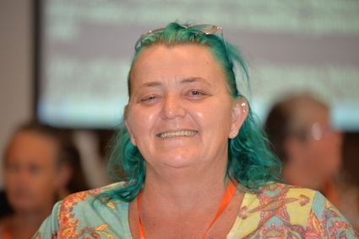  Cheryl | 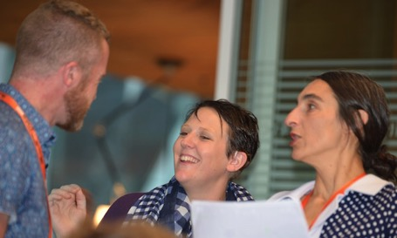  Bonnie (C), Chris (L) and Cristina

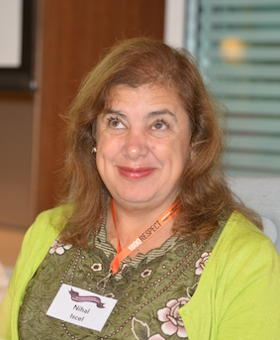  Nihal | 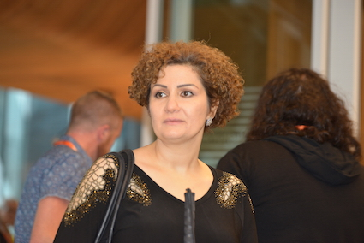  Zhila

Section 10: Actions for WWDA, government and women with disability in relation to violence, employment, sexual and reproductive rights, leadership and participation

In this session of the Forum, participants broke into small groups to focus on possible key actions around four of the key strategic priorities that had been identified. Participants identified that progressing solutions to these key priorities was a shared responsibility between Governments, WWDA and women with disability themselves.

For the purposes of the groupwork, the four priorities discussed were:

1. The right to live free from all types of violence
2. Sexual and reproductive rights
3. Leadership, participation and decision-making
4. Employment and economic security

10.1. Actions: The right to live free from all types of violence

1. Ensure that all domestic/family violence support services and programs are inclusive of, and fully accessible to all women with disability, regardless of the setting/circumstances in which they live.

2. Commission and fund a national education and awareness campaign to educate women with disability and the broader community on violence against women with disability.

3. Fund specific training programs to educate police, emergency services, transport workers, health professionals, disability service providers, etc on all forms of violence against women with disability.

4. Adequately fund Women with Disabilities Australia (WWDA) so that WWDA can continue to publish women’s stories to identify all forms of violence towards women with disability, undertake research and develop and publish practical resources for women and girls with disability about violence.

5. In consultation with organisations of and for women and girls with disability, further develop the “Stop it at the Start” campaign (https://www.respect.gov.au) to be inclusive of women and girls with disability, including all forms of violence experienced by women and girls with disability. The “Stop it at the Start” website must include a dedicated section for women and girls with disability, similar to that currently provided for Aboriginal and Torres Strait Islander peoples (https://www.respect.gov.au/campaign/atsi-materials).

6. Commission and fund a national research project (in conjunction with WWDA and networks and organisations of women and girls with disability) to better understand the forms of violence against women with disability and the range of settings in which such violence occurs.

7. Governments should cease funding services and organisations that have been found to condone, cover-up, and/or inadequately address violence against women and girls with disability (particularly in institutional settings).

8. Each State/Territory government should support the establishment of, and recurrently fund, a Statewide organisation of and for women and girls with disability. This would enable and facilitate statewide, regional, and localised advocacy on issues facing women and girls with disability, and the creation of safe spaces for women and girls with disability to share their experiences and develop agency.

9. There should be specific, quarantined funding to legal aid to enable active support of women and girls with disability who require legal supports and advocacy.

10. Ensure disability advocacy organisations are working to address all forms of violence against women and girls with disability and are collecting and providing to government, disaggregated data.

11. Develop practical solutions, in consultation with organisations of and for women and girls with disability, for regional and rural supports so that women with disability are safer in their communities.

12. Ensure that national policy frameworks and action plans (such as the National Plan to Reduce Violence Against Women and Their Children, and the National Disability Strategy, are inclusive of women and girls with disability, and provide targeted actions to address all forms of violence against women and girls with disability.

13. Fund and promote self defence education programs for women and girls with disability.

10.2. Actions: Employment of women with disability

1. Develop accessible information resources for women with disability on employment.

2. Produce accessible information resources and materials for women with disability on financial literacy.

3. Close all Australian Disability Enterprises (ADE’s) (“sheltered workshops”) and end all forms of segregated employment.

4. Develop a targeted national campaign to promote awareness of the Job Access program.

5. Implement a quota for the employment of women with disability in all Federal, State and Territory government Departments and agencies.

6. Develop a program for the mentoring of women with disability by female politicians and leaders at local, state/territory and federal levels.

7. Develop and fund a national Leadership and Mentoring Grants Program for women and girls with disability.

8. Implement flexible working hour models and part-time jobs.

9. Develop accessible information resources and training programs for women with disability on how to start your own business.

10. Each State and Territory government should create an ‘entrepreneurship fund’ for women with disability to start their own business.

11. Undertake research to identify reforms and supports required to enable women with disability to be employed by companies, government agencies, NGO’s etc, but work from home.

12. Mandatory disability access policies should be required and enforced for all public authorities/agencies.

13. Invest in training and programs to support and encourage women with disability to stand for public office at local, state/territory and federal government levels.

14. Address the issues with the Wage subsidy (supported wage) – Disability Employment Services (DES) – only lasts 26 weeks and employee then loses their job once the employer loses subsidy. Invest in a long-term approach to wage subsidy, 3-5 years (not one-off), in order to embed employee in job.

15. Reform the Job Capacity Assessment so that it is human rights based and consistent with the Convention on the Rights of Persons with Disabilities (CRPD).

16. Address the lack of accessible and affordable child care options for women with disability.

17. Reform the Disability Employment Services (DES) so that they are gendered, prioritise women with disability, collect disaggregated data, and are required to demonstrate outcomes for women with disability over a longer period (ie: 1 year, 2 years and 3 years).

18. Disability Employment Services (DES) should be required to provide and demonstrate individualised long- term support for women with disability.

19. Address the issue of violence, exploitation, abuse and discrimination of women with disability in employment, including open and supported employment.

20. The Australian Government should develop a national Employment Strategy for Women with Disability.

21. Commission ad fund research into the cost of disability and its impact of the employment participation of women with disability.

22. Communication supports/aids and equipment should not just be related/linked to employment and/or workplaces. A holistic, whole of life approach needs to be considered in relation to access to supports/aids and equipment.

23. Adequately fund Women with Disabilities Australia (WWDA) so that WWDA can employ women with disability in flexible ways.

10.3. Actions: Sexual and reproductive rights of women with disability

1. Stop violence against women and girls with disability in institutional settings by enforcing the full extent of the law – criminal offence; mandatory reporting; mandatory investigation (independent and external).

2. Develop a national mandatory reporting scheme for all disability service providers, health professionals, support workers, to report all forms of violence against women and girls with disability.

3. Undertake national law reform to prohibit forced sterilisation and other violations of sexual and reproductive rights of women and girls with disability (eg: forced contraception, forced abortion).

4. Government should abide by, and implement the Concluding Observations of the UN Committee on the Rights of Persons with Disabilities (CRPD), the Committee on the Elimination of all forms of Discrimination Against Women (CEDAW), the Committee on the Rights of the Child (CRC) and the Committee on Torture and Other Cruel, Inhuman or Degrading Treatment or Punishment (CAT) in relation to women and girls with disability.

5. Women with Disabilities Australia (WWDA) should be properly funded and resourced to enable WWDA to undertake research, undertake systemic advocacy, further develop alliances with mainstream activists and education programs, and develop and publish practical resources for women and girls with disability about sexual and reproductive rights.

6. Mandatory disability access policies should be required and enforced for all sexual health services, including hospitals, GP surgeries, clinics etc.

7. There should be mobile, accessible breast and cervical cancer screening services available to all women and girls with disability, including those in institutional settings and regional and remote geographic locations.

8. The Government should commission and fund, in partnership with organisations of and for women and girls with disability, the development of national, uniform standards for service providers on the sexual and reproductive health and rights of women and girls with disability.

9. Sexual and reproductive health education curriculum at all levels should be inclusive of the sexual and reproductive health and rights of women and girls with disability.

10. Specific, tailored resource materials and training needs to be developed and implemented for parents, (and families, carers/guardians, etc) regarding the sexual and reproductive rights of girls with disability.

11. There is a need for awareness raising among and targeted education of, all actors in the justice system (including for eg: police, judges, court officials) on the sexual and reproductive rights of women and girls with disability.

12. The Australian Government should, as a matter of urgency, investigate and address the high rate of child removal from parents (mostly mothers) with disability (currently ten times higher than parents without disability).

13. Each State/Territory government should develop and adequately fund specific and dedicated parenting support programs for parents with disability.

10.4. Actions: Leadership, Participation and Decision-Making

1. Abolish all substitute decision-making regimes and develop supported decision-making models consistent with the Convention on the Rights of persons with Disabilities (CRPD).

2. Increase funding and support to Women with Disabilities Australia (WWDA) to enable WWDA to undertake capacity building initiatives and programs for women and girls with disability.

3. The Australian Government should provide funding to Women with Disabilities Australia (WWDA) to enable staffing and further development of the WWDA Youth Network.

4. Support Women with Disabilities Australia (WWDA) to establish and develop partnerships with the private sector.

5. Develop and fund a national Leadership and Mentoring Grants Program for women and girls with disability.

6. The Australian Government Office for Women (OFW) could develop an online portal, complemented by accessible and widely disseminated information resources, on leadership and mentoring programs for women, with a specific focus on women with disability, indigenous women, and women from culturally and linguistically diverse backgrounds.

7. Support Women with Disabilities Australia (WWDA) to update and publish WWDA’s Leadership and Mentoring Toolkit for Women and Girls with Disability (“Taking the Lead”, published 2001).

8. In consultation and partnership with Women with Disabilities Australia (WWDA) and organisations of and for women and girls with disability, develop a set of human rights based standards and guidelines for media in relation to the portrayal of women and girls with disability.

9. Ensure that gender and disability are mainstreamed into all national and State/Territory policy frameworks, strategies, action plans etc.

10. Develop initiatives to profile women with disability in leadership positions and roles.

11. Develop a national mentoring program for women with disability.

Section 11: The Forum – Preparation and Logistics

This section provides a brief overview of the planning and organising of the National Forum for Women and Girls with Disability. The information in this section is supplemented by a separate accompanying document, entitled: The National Forum for Women and Girls with Disability, Appendices. This accompanying document includes the following information:
- Appendix 1: Attendee list
- Appendix 2: Forum Invitation Letter & Information Flyer [Standard Version]
- Appendix 3: Forum Invitation Letter & Information Flyer [Easy English Version]
- Appendix 4: Participant Information Survey Form
- Appendix 5: Participant Emergency Contact Form
- Appendix 6: Participant Photo/Video Consent & Release Form
- Appendix 7: Participant Information Kit [Standard Version]
- Appendix 8: Participant Information Kit [Easy English Version]
- Appendix 9: Background Reading [Easy English Version]
- Appendix 10: Forum Agenda [Standard Version]
- Appendix 11: Forum Agenda [Easy English Version]
- Appendix 12: Forum Media Release
- Appendix 13: National Forum Run Sheet

11.1. Funding and sponsorship
The Forum was made possible through one-off Project funding from the Department of Prime Minister and Cabinet ($50,000) and the Australian Department of Social Services ($10,000 through the National Disability Conference Initiative), plus extensive in-kind support provided by Medibank and Medibank Health Solutions Telehealth Pty Ltd (MHS). The member organisations of Disabled People’s Organisations Australia (DPOA) (excluding WWDA), kindly agreed to sponsor a woman/girl with disability to attend the National Forum. Given the costs and logistics associated with hosting a national forum for people with disability and the limited budget available, it was agreed that WWDA only had sufficient funding to host a one-day forum.

The total Project budget for the WWDA National Forum for Women and Girls with Disability 2016 was $60,000.

11.2. Forum Event Plan
A detailed Event Plan was developed by WWDA in the early planning stages for the National Forum. The Event Plan was submitted to the Department of Prime Minister and Cabinet for their reference and approval. Once the Event Plan was approved by the relevant Departmental officials, WWDA commenced the logistics of organising the National Forum event.

11.3. Forum Venue
The National Forum for Women and Girls with Disability was held in Melbourne, Victoria for cost efficiency, ease of transportation access and possibilities for sponsorship and in-kind support. WWDA approached Medibank Health Solutions (‘Medibank’) and they very generously offered to host the National Forum and provide the venue, catering and technical support free of charge. The National Forum was held at the head offices of Medibank in Melbourne, located at: 720 Bourke Street, Docklands, VIC, 3000. An access audit of the venue was organised and undertaken by WWDA as part of the planning for the event.

11.4. Forum Date
In relation to the date, WWDA was intending to hold the Forum as close to International Women’s Day (March 8) as possible and invite the Minister for Women, Senator the Hon Michaelia Cash, to open the National Forum. The Minister for Women however was not available at this time and the first available date was Wednesday 6 April 2016. The date, Wednesday 6 April 2016 was therefore accepted by WWDA and confirmed by the Minister’s Office.

11.5. Processes for promotion of and participation at the Forum
An invitation letter and application form was sent to women and girls with disability identified through the WWDA membership and State/Territory WWDA Networks. Given the limited funding available for the Forum, WWDA identified that it was not feasible to create an unrealistic expectation amongst women and girls with disability in Australia that WWDA would be able to fund a large number of participants to attend. In addition, given the fact that the National Forum was a one day event that require some level of expertise and prior preparation by participants, WWDA determined that the National Forum would be an invite only event to those women and girls with disability identified through the WWDA membership and State/Territory WWDA Networks.

As an adjunct to the National Forum, WWDA employed specific mechanisms to consult and engage with women and girls with disability to enable them the opportunity to contribute to the National Forum process. This included the use of platforms to consult and engage with women and girls with disability on their priority issues and potential solutions. These platforms included for example: utilising the WWDA Facebook site; the WWDA Youth Network Facebook site; the WWDA and WWDA Youth Network websites; WWDA email mailing lists, direct telephone discussions with members, the use of Twitter and so on.

11.6. Forum Participants
The National Forum for Women and Girls with Disability was attended by 45 women and girls with disability (and twelve support persons) from each State and Territory of Australia. Other attendees and delegates included:
- Senator the Hon Michaelia Cash, Minister for Women
- Ms Georgie Crozier, Victorian Shadow Minister for Families and Children; Shadow Minister for Prevention of Family Violence; and Shadow Minister for Women;
- Aunty Georgina Nicholson, Wurundjeri Tribe Council;
- Representatives from the Australian Government – Ms Lara Purdy (Department of Social Services), Ms Louise McSorley (Department of Prime Minister and Cabinet), Ms Sharon Stuart (Department of Social Services), and Ms Vicki Rundle (National Disability Insurance Agency);
- Four representatives from the National Women’s Alliances;
- Four Auslan interpreters;
- Ms Tarja Malone, 1800RESPECT Counsellor;
- Attendant Carer (Travellers Aid);
- Four WWDA Project staff;
- Eight staff from Medibank to assist through out day;
- Several additional volunteers.

11.7. Identifying the requirements of Forum participants
All invited participants were required to complete a detailed Participant Information Form that included access and support requirements, including:
- Name and Contact Information
- Transport Requirements
- Travel Arrangements
- Accommodation Requirements
- Communication and Information Requirements
- Specific Requirements During The National Forum
- Assisted Care Requirements
- Any other Access/Support Requirements

All invited participants were also required to complete an Emergency Contact Form, and a Photo/Video Release Consent Form.

WWDA supported a number of the invited participants to complete their forms over the phone, or with the support of an advocate where required.

11.8. Communication and information preparation
All invited participants were informed in the invitation letter about the aims of the National Forum, expected outcomes and what the benefits might be for them and for WWDA. They were also informed that they would be required to prepare for the National Forum by reading some essential documents that were provided to them 2 weeks in advance of the National Forum in preparation for the Forum discussions. Pre-Forum reading material was developed in a range of accessible formats, including Easy English, and included:
- Summarised information regarding the National Disability Strategy, the National Plan to Reduce Violence Against Women and Their Children, and an Introduction to Human Rights.

A detailed Participant Information Kit was developed by WWDA for every participant and support person attending the National Forum. The Participant Information Kit included:
- An introduction to Women with Disabilities Australia (WWDA)
- About the National Forum for Women and Girls with Disability
- Names of Forum Participants
- Names and Contact Details of Forum Facilitators and Support Staff
- Forum Venue Details – location, maps, photos, accessibility
- Travel Information – flight itinerary, booking confirmations, CabCharge e-tickets, taxi company details,
- Accommodation Information – individualised accommodation details, room allocation, organised, booked and pre-paid by WWDA, meals and catering
- Participant Per Diem – calculated in accordance with Australian Taxation Office (ATO) rates, pre-paid to each participant and support person prior to Forum
- Agenda for the National Forum on Women and Girls with Disability
- Emergency Information – information and contact details for closest hospital, doctor, pharmacy and after hours medical contacts;
- Stamped addressed pre-paid envelope – to enable return of taxi receipts etc.

The Participant Information Kit was developed in a range of accessible formats as per the requirement of each participant. An Easy English version, Standard version, large print version, text only version, and electronic version was developed by WWDA and provided to each participant and support person several weeks prior to the Forum.

11.9. Access
All aspects of the Forum, including the planning and organising, was fully accessible, inclusive and met the identified support requirements of each participant. An on-site audit of the venue and hotel accommodation was organised by WWDA and undertaken to assess and confirm accessibility of all venues (including getting to and from the venues) for all participants (including guide dogs). Four Auslan interpreters were booked and organised for the day of the Forum. Real time captioning of the Forum was provided by Ai Media. Note takers were provided by Medibank, along with a large number of volunteers to assist and provide support on the day. An experienced counsellor from the 1800RESPECT Service was made available by Medibank to be present for the entirety of the Forum for anyone requiring counselling support. An additional hotel room was booked and paid for by WWDA to enable any participant to have a “time out” space if required. In addition, WWDA secured the services of an attendant carer (through Travellers Aid) to be on site for the Forum to assist with any personal care requirements. All equipment hire required by participants (such as hoists, commode chairs, shower chairs, bed rails etc) was undertaken by WWDA well in advance of the Forum and delivered to the hotels and venue prior to participants arriving.

11.10. Facilitation
The National Forum was co-facilitated by Ms Cristina Ricci (WWDA Project Staff) and Ms Cashelle Dunn (WWDA Project Staff). Cristina has extensive experience in developing and delivering disability rights training nationally and internationally to Disabled Peoples Organisations (DPOs), governments and national human rights institutions. She is also accredited as a Master Human Rights Trainer with the Asia Pacific Forum of National Human Rights Institutions. Cashelle has experience in facilitating and hosting events and forums for people with disability, and in December 2015, co-facilitated the National Youth with Disability Forum held in Melbourne. WWDA also utilised the expertise of specific women with disability to co-facilitate specific sessions of the National Forum.

11.11. Media Strategy
A media release was developed and circulated on the eve of the National Forum for Women and Girls with Disability. The media release was drafted in consultation with the Media Adviser for the Minister for the Women Office and distributed via a wide range of networks and platforms, including:
- Media outlets
- WWDA website
- WWDA Youth Network website
- WWDA Facebook and Twitter
- WWDA Youth Network Facebook and Twitter
- WWDA Email distribution lists
- DPOA member networks
- Other disability networks, including WWDA’s State and Territory networks and affiliates.

During the day of the National Forum, frequent updates about proceedings were posted on WWDA’s Twitter account and WWDA Youth Network’s Twitter account (as well as participants own Twitter accounts etc) and by midday the #WWDAForum was one of the top trending subjects on Twitter.

WWDA, ‘Assessing the situation of women with disabilities in Australia: A human rights approach’, June 2011.
Ibid.

